待解决问题1

## 头像显示问题（签到）

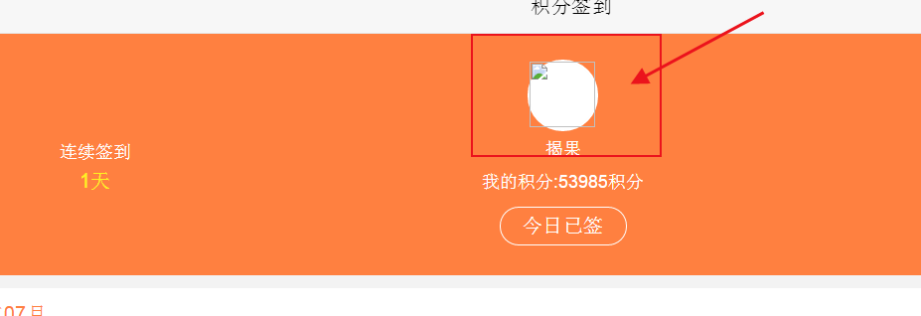

签到头像问题地址：<http://shop.rongec.com/app/index.php?i=10&c=entry&m=ewei_shopv2&do=mobile&r=sign>

Open_id

oMaz50jp9G_xRU_JT1jMaxuS5KdY

商城用户系统

2018-07-22 12:10:34 TODO debug2 runtime=0.002s ：来源:

http://shop.rongec.cn/app/index.php?i=10&c=entry&m=ewei_shopv2&do=mobile&r=member

------------

Array:

file : fetch() ;

sql2 : select * from `ims_ewei_shop_member` where openid='oMaz50jp9G_xRU_JT1jMaxuS5KdY' and uniacid='10' limit 1 ;

$params ==Array:

:uniacid : 10 ;

:openid : oMaz50jp9G_xRU_JT1jMaxuS5KdY ;

-- 商城用户信息

select * from `ims_ewei_shop_member` where openid='oMaz50jp9G_xRU_JT1jMaxuS5KdY' and uniacid='10' limit 1 ;

-- 系统用户信息

select follow from `ims_mc_mapping_fans` where openid='oMaz50jp9G_xRU_JT1jMaxuS5KdY' and uniacid='10' limit 1 ;

select * from `ims_mc_mapping_fans` where openid='oMaz50jp9G_xRU_JT1jMaxuS5KdY' and uniacid='10' limit 1 ;

微信头像：

可用：<http://wx.qlogo.cn/mmopen/HImTr9Y5bJXOQ4MepvkH30XGia86KLWCuMh7tIeoP1EFeCUFlHAnFndPeLkg9gNkTAP5pLcvRam0TTxgobrsQJwlTDnLcCDwM/0>

不可用：

[http://thirdwx.qlogo.cn/mmopen/0VFh09MPtaGMJ6WavuzaXzsiatMUibwh8JeibUcyj0iaE5GhxRoQ6qrTwhpZP6lPA0ibuLCCq6tF5qlcfGaicuAhCfliczxECwBicpFI/132](http://thirdwx.qlogo.cn/mmopen/0VFh09MPtaGMJ6WavuzaXzsiatMUibwh8JeibUcyj0iaE5GhxRoQ6qrTwhpZP6lPA0ibuLCCq6tF5qlcfGaicuAhCfliczxECwBicpFI/132132)

多了132

<http://thirdwx.qlogo.cn/mmopen/0VFh09MPtaGMJ6WavuzaXzsiatMUibwh8JeibUcyj0iaE5GhxRoQ6qrTwhpZP6lPA0ibuLCCq6tF5qlcfGaicuAhCfliczxECwBicpFI/132132>

$userinfo = $oauth_account->fansQueryInfo($_SESSION['openid']);

framework/model/mc.mod.php

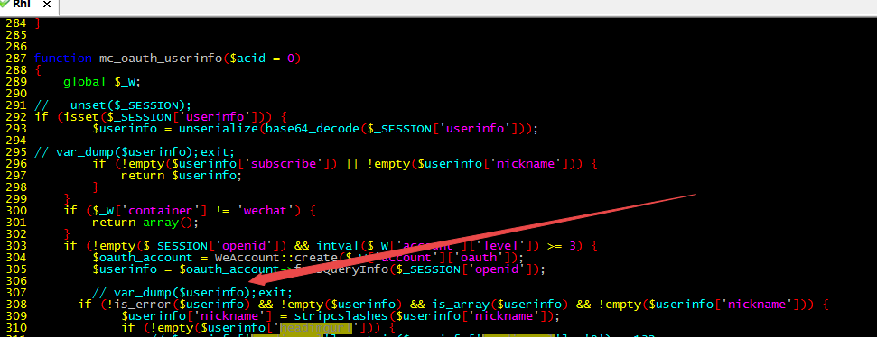

array(16) { ["subscribe"]=> int(1) ["openid"]=> string(28) "oMaz50jp9G_xRU_JT1jMaxuS5KdY" ["nickname"]=> string(6) "街墙" ["sex"]=> int(1) ["language"]=> string(5) "zh_CN" ["city"]=> string(6) "厦门" ["province"]=> string(6) "福建" ["country"]=> string(6) "中国" ["headimgurl"]=> string(139) "http://thirdwx.qlogo.cn/mmopen/0VFh09MPtaGMJ6WavuzaXzsiatMUibwh8JeibUcyj0iaE5GhxRoQ6qrTwhpZP6lPA0ibuLCCq6tF5qlcfGaicuAhCfliczxECwBicpFI/132" ["subscribe_time"]=> int(1516630274) ["remark"]=> string(0) "" ["groupid"]=> int(0) ["tagid_list"]=> array(0) { } ["subscribe_scene"]=> string(16) "ADD_SCENE_SEARCH" ["qr_scene"]=> int(0) ["qr_scene_str"]=> string(0) "" }

插入表中

D:\www\users\wc.jieqiangtec.com\addons\ewei_shopv2\core\model\member.php L373

**if** (**empty**($member) && !**empty**($openid)) {  
 $member = **array**('uniacid' => $_W['uniacid'], 'uid' => $uid, 'openid' => $openid, 'realname' => !**empty**($mc['realname']) ? $mc['realname'] : '', 'mobile' => !**empty**($mc['mobile']) ? $mc['mobile'] : '', 'nickname' => !**empty**($mc['nickname']) ? $mc['nickname'] : '', 'nickname_wechat' => !**empty**($mc['nickname']) ? $mc['nickname'] : '', 'avatar' => !**empty**($mc['avatar']) ? $mc['avatar'] : '', 'avatar_wechat' => !**empty**($mc['avatar']) ? $mc['avatar'] : '', 'gender' => !**empty**($mc['gender']) ? $mc['gender'] : '-1', 'province' => !**empty**($mc['resideprovince']) ? $mc['resideprovince'] : '', 'city' => !**empty**($mc['residecity']) ? $mc['residecity'] : '', 'area' => !**empty**($mc['residedist']) ? $mc['residedist'] : '', 'createtime' => time(), 'status' => 0);  
 pdo_insert('ewei_shop_member', $member);  
 $member['id'] = pdo_insertid();  
}

# **用户基本信息中的用户头像URL域名变更通知**

<http://www.weixinquanquan.com/n/weixinzixun/id_131.html>

UPDATE `wc2`.`ims_ewei_shop_member` SET `id`='2201', `uniacid`='10', `uid`='12', `groupid`='0', `level`='8', `agentid`='0', `openid`='oMaz50jp9G_xRU_JT1jMaxuS5KdY', `realname`='揭测试', `mobile`='18959269999', `pwd`='', `weixin`='189', `content`='', `createtime`='1516801719', `agenttime`='0', `status`='0', `isagent`='0', `clickcount`='0', `agentlevel`='0', `noticeset`=NULL, `nickname`='街墙', `credit1`='0.00', `credit2`='0.00', `birthyear`='2018', `birthmonth`='7', `birthday`='15', `gender`='1', `avatar`='http://thirdwx.qlogo.cn/mmopen/0VFh09MPtaGMJ6WavuzaXzsiatMUibwh8JeibUcyj0iaE5GhxRoQ6qrTwhpZP6lPA0ibuLCCq6tF5qlcfGaicuAhCfliczxECwBicpFI/132132', `province`='福建', `city`='厦门', `area`='', `childtime`='0', `inviter`='0', `agentnotupgrade`='0', `agentselectgoods`='0', `agentblack`='0', `fixagentid`='0', `diymemberid`='0', `diymemberfields`=NULL, `diymemberdata`=NULL, `diymemberdataid`='0', `diycommissionid`='0', `diycommissionfields`=NULL, `diycommissiondata`=NULL, `diycommissiondataid`='0', `isblack`='0', `username`='', `commission_total`='0.00', `endtime2`='0', `ispartner`='0', `partnertime`='0', `partnerstatus`='0', `partnerblack`='0', `partnerlevel`='0', `partnernotupgrade`='0', `diyglobonusid`='0', `diyglobonusdata`=NULL, `diyglobonusfields`=NULL, `isaagent`='0', `aagentlevel`='0', `aagenttime`='0', `aagentstatus`='0', `aagentblack`='0', `aagentnotupgrade`='0', `aagenttype`='0', `aagentprovinces`=NULL, `aagentcitys`=NULL, `aagentareas`=NULL, `diyaagentid`='0', `diyaagentdata`=NULL, `diyaagentfields`=NULL, `salt`=NULL, `mobileverify`='0', `mobileuser`='0', `carrier_mobile`='0', `isauthor`='0', `authortime`='0', `authorstatus`='0', `authorblack`='0', `authorlevel`='0', `authornotupgrade`='0', `diyauthorid`='0', `diyauthordata`=NULL, `diyauthorfields`=NULL, `authorid`='0', `comefrom`=NULL, `openid_qq`=NULL, `openid_wx`=NULL, `diymaxcredit`='0', `maxcredit`='0', `datavalue`='', `openid_wa`=NULL, `nickname_wechat`='街墙', `avatar_wechat`='http://thirdwx.qlogo.cn/mmopen/0VFh09MPtaGMJ6WavuzaXzsiatMUibwh8JeibUcyj0iaE5GhxRoQ6qrTwhpZP6lPA0ibuLCCq6tF5qlcfGaicuAhCfliczxECwBicpFI/132132', `updateaddress`='1', `membercardid`='', `membercardcode`='', `membershipnumber`='', `membercardactive`='0' WHERE (`id`='2201');

[root@roohl logs]# cat 20180721.log | grep 'mc_mapping_fans'

sql2 : SELECT `uid` FROM `ims_mc_mapping_fans` WHERE `uniacid` = '10' AND `openid` = 'oMaz50jp9G_xRU_JT1jMaxuS5KdY' LIMIT 1 ;

sql2 : select follow from `ims_mc_mapping_fans` where openid='oMaz50jp9G_xRU_JT1jMaxuS5KdY' and uniacid='10' limit 1 ;

sql2 : select fanid,openid,follow as followed, unfollowtime from `ims_mc_mapping_fans` where openid in ('oMaz50jp9G_xRU_JT1jMaxuS5KdY') ;

sql2 : SELECT `uid` FROM `ims_mc_mapping_fans` WHERE `uniacid` = '10' AND `openid` = 'oMaz50jp9G_xRU_JT1jMaxuS5KdY' LIMIT 1 ;

sql2 : SELECT `uid` FROM `ims_mc_mapping_fans` WHERE `uniacid` = '10' AND `openid` = 'oMaz50jp9G_xRU_JT1jMaxuS5KdY' LIMIT 1 ;

sql2 : SELECT f.* FROM `ims_mc_mapping_fans` AS f LEFT JOIN `ims_mc_fans_tag_mapping` AS m ON m.`fanid` = f.`fanid` WHERE f.`uniacid` = '10' AND f.`acid` = '10' AND f.`follow` = 1 GROUP BY f.`fanid` ORDER BY f.`followtime` DESC LIMIT 0,10 ;

Tag 被base64需要解码base64_decode

**if** (!**empty**($v['tag']) && is_string($v['tag'])) {  
 **if** (is_base64($v['tag'])) {  
 $v['tag'] = base64_decode($v['tag']);  
 }  
 **if** (is_serialized($v['tag'])) {  
 $v['tag'] = @iunserializer($v['tag']);  
 }  
 **if** (!**empty**($v['tag']['headimgurl'])) {  
 $v['tag']['avatar'] = tomedia($v['tag']['headimgurl']);  
 }  
 **if** (**empty**($v['nickname']) && !**empty**($v['tag']['nickname'])) {  
 $v['nickname'] = strip_emoji($v['tag']['nickname']);  
 }  
}

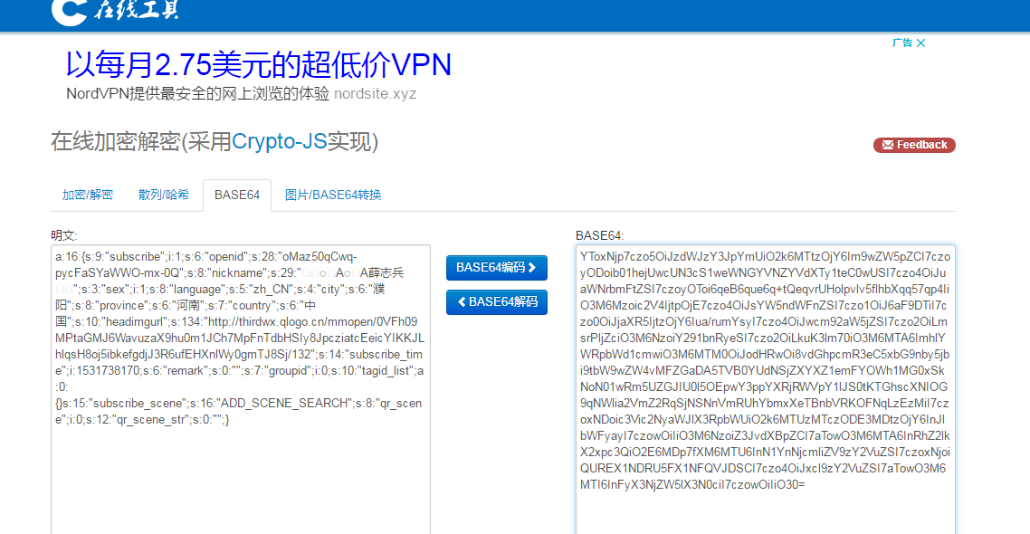

a:16:{s:9:"subscribe";i:1;s:6:"openid";s:28:"oMaz50qCwq-pycFaSYaWWO-mx-0Q";s:8:"nickname";s:29:"꧁꫞꯭A꯭A薛志兵꫞꧂";s:3:"sex";i:1;s:8:"language";s:5:"zh_CN";s:4:"city";s:6:"濮阳";s:8:"province";s:6:"河南";s:7:"country";s:6:"中国";s:10:"headimgurl";s:134:"http://thirdwx.qlogo.cn/mmopen/0VFh09MPtaGMJ6WavuzaX9hu0m1JCh7MpFnTdbHSIy8JpcziatcEeicYIKKJLhlqsH8oj5ibkefgdjJ3R6ufEHXnlWy0gmTJ8Sj/132";s:14:"subscribe_time";i:1531738170;s:6:"remark";s:0:"";s:7:"groupid";i:0;s:10:"tagid_list";a:0:{}s:15:"subscribe_scene";s:16:"ADD_SCENE_SEARCH";s:8:"qr_scene";i:0;s:12:"qr_scene_str";s:0:"";}

sql2 : SELECT COUNT(DISTINCT f.`fanid`) FROM `ims_mc_mapping_fans` AS f LEFT JOIN `ims_mc_fans_tag_mapping` AS m ON m.`fanid` = f.`fanid` WHERE f.`uniacid` = '10' AND f.`acid` = '10' AND f.`follow` = 1 ;

sql2 : SELECT count(*) AS '0' FROM `ims_mc_mapping_fans` WHERE `uniacid` = '10' AND `acid` = '10' AND `follow` = '1' LIMIT 1 ;

sql2 : SELECT * FROM `ims_mc_mapping_fans` WHERE `openid` = 'oMaz50jp9G_xRU_JT1jMaxuS5KdY' ;

sql2 : SELECT * FROM `ims_mc_mapping_fans` WHERE `openid` = 'oMaz50jp9G_xRU_JT1jMaxuS5KdY' ;

sql2 : SELECT `uid` FROM `ims_mc_mapping_fans` WHERE `uniacid` = '10' AND `openid` = 'o' LIMIT 1 ;

sql2 : SELECT `uid` FROM`ims_mc_mapping_fans` WHERE openid = 'oMaz50jp9G_xRU_JT1jMaxuS5KdY' ;

sql2 : SELECT f.* FROM `ims_mc_mapping_fans` AS f LEFT JOIN `ims_mc_fans_tag_mapping` AS m ON m.`fanid` = f.`fanid` WHERE f.`uniacid` = '10' AND f.`acid` = '10' AND f.`follow` = 1 GROUP BY f.`fanid` ORDER BY f.`followtime` DESC LIMIT 0,10 ;

sql2 : SELECT COUNT(DISTINCT f.`fanid`) FROM `ims_mc_mapping_fans` AS f LEFT JOIN `ims_mc_fans_tag_mapping` AS m ON m.`fanid` = f.`fanid` WHERE f.`uniacid` = '10' AND f.`acid` = '10' AND f.`follow` = 1 ;

sql2 : SELECT count(*) AS '0' FROM `ims_mc_mapping_fans` WHERE `uniacid` = '10' AND `acid` = '10' AND `follow` = '1' LIMIT 1 ;

sql2 : SELECT f.* FROM `ims_mc_mapping_fans` AS f LEFT JOIN `ims_mc_fans_tag_mapping` AS m ON m.`fanid` = f.`fanid` WHERE f.`uniacid` = '10' AND f.`acid` = '10' AND f.`follow` = 1 GROUP BY f.`fanid` ORDER BY f.`followtime` DESC LIMIT 0,10 ;

sql2 : SELECT COUNT(DISTINCT f.`fanid`) FROM `ims_mc_mapping_fans` AS f LEFT JOIN `ims_mc_fans_tag_mapping` AS m ON m.`fanid` = f.`fanid` WHERE f.`uniacid` = '10' AND f.`acid` = '10' AND f.`follow` = 1 ;

sql2 : SELECT count(*) AS '0' FROM `ims_mc_mapping_fans` WHERE `uniacid` = '10' AND `acid` = '10' AND `follow` = '1' LIMIT 1 ;

sql2 : SELECT f.* FROM `ims_mc_mapping_fans` AS f LEFT JOIN `ims_mc_fans_tag_mapping` AS m ON m.`fanid` = f.`fanid` WHERE f.`uniacid` = '10' AND f.`acid` = '10' AND f.`follow` = 1 GROUP BY f.`fanid` ORDER BY f.`followtime` DESC LIMIT 0,10 ;

sql2 : SELECT COUNT(DISTINCT f.`fanid`) FROM `ims_mc_mapping_fans` AS f LEFT JOIN `ims_mc_fans_tag_mapping` AS m ON m.`fanid` = f.`fanid` WHERE f.`uniacid` = '10' AND f.`acid` = '10' AND f.`follow` = 1 ;

sql2 : SELECT count(*) AS '0' FROM `ims_mc_mapping_fans` WHERE `uniacid` = '10' AND `acid` = '10' AND `follow` = '1' LIMIT 1 ;

## 分享显示介绍及图标问题

后台设置了分享的文字，图片但没有显示

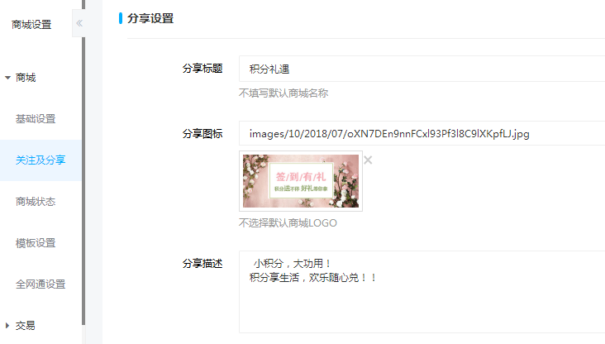

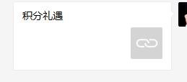

<http://shop.rongec.com/attachment/images/10/2018/01/SSuXDTYqi2Bzt0b0IA0sATT6btOi0P.png>

我:

消息中心 http://shop.rongec.com/app/index.php?i=10&c=entry&m=ewei_shopv2&do=mobile&r=shop.notice

我:

会员中心 <http://shop.rongec.com/app/index.php?i=10&c=entry&m=ewei_shopv2&do=mobile&r=member>

答复:对应自定义页面的页面介绍和封面图

<http://shop.rongec.com/web/index.php?c=site&a=entry&m=ewei_shopv2&do=web&r=diypage.page.preview&id=44>

