# **20180228**

申请试用后台管理入口_20180304

## 登录后台

<http://shop.rongec.com/web/index.php?c=user&a=login&>

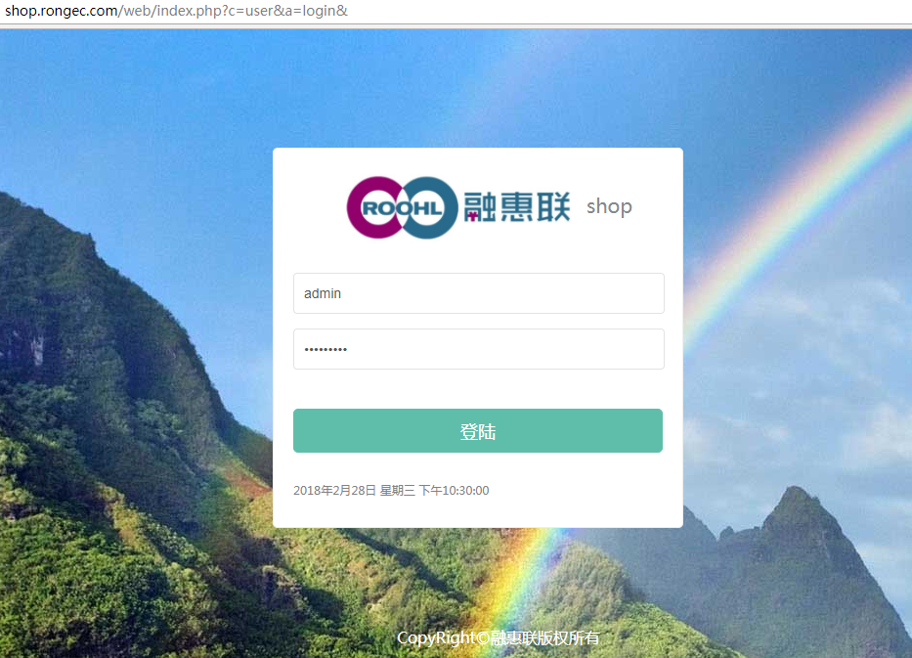

## **选择对应公众号进入**

<http://shop.rongec.com/web/index.php?c=account&a=manage&>

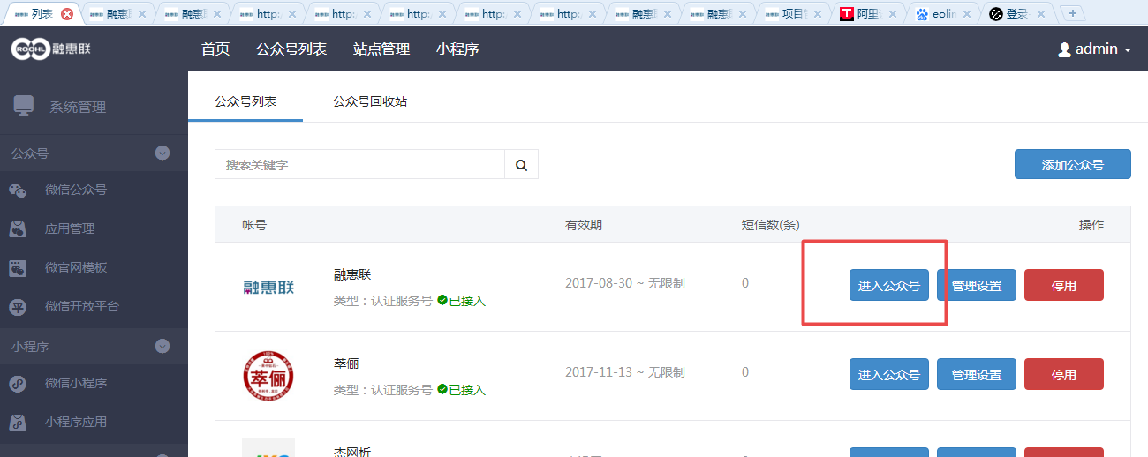

## **进入到申请试用**

<http://shop.rongec.com/web/index.php?c=platform&a=cover&eid=29>

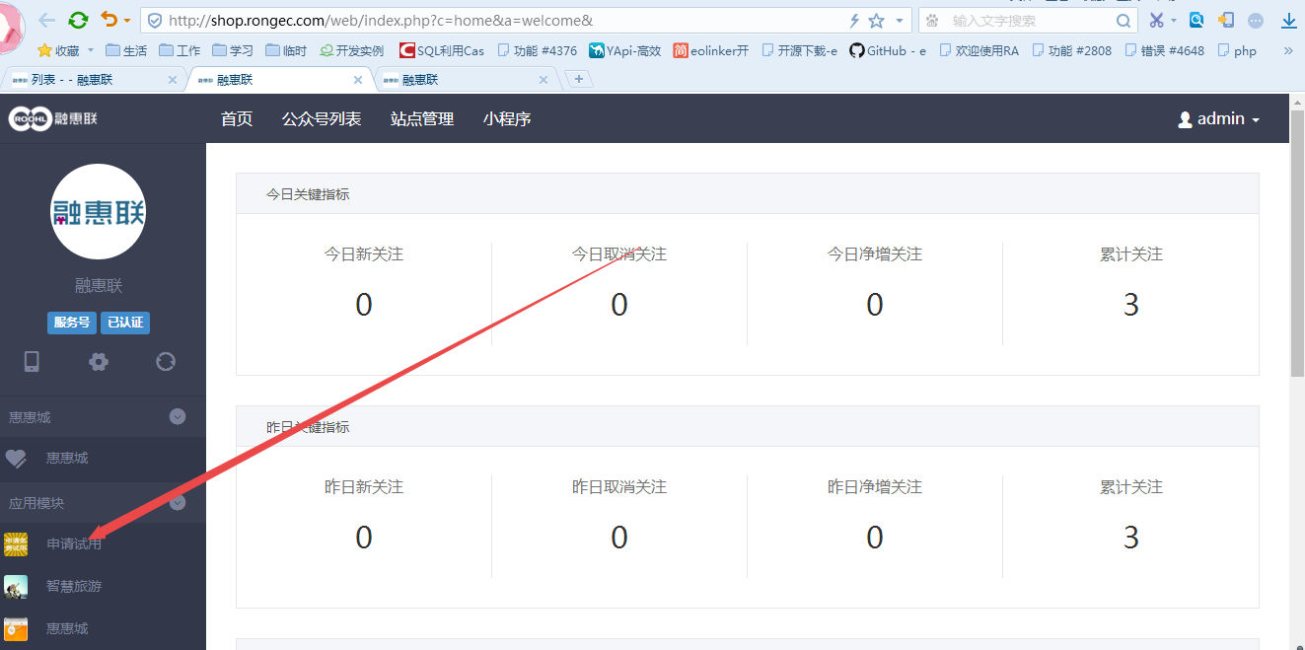

## **进入项目管理**

<http://shop.rongec.com/web/index.php?c=site&a=entry&eid=36>

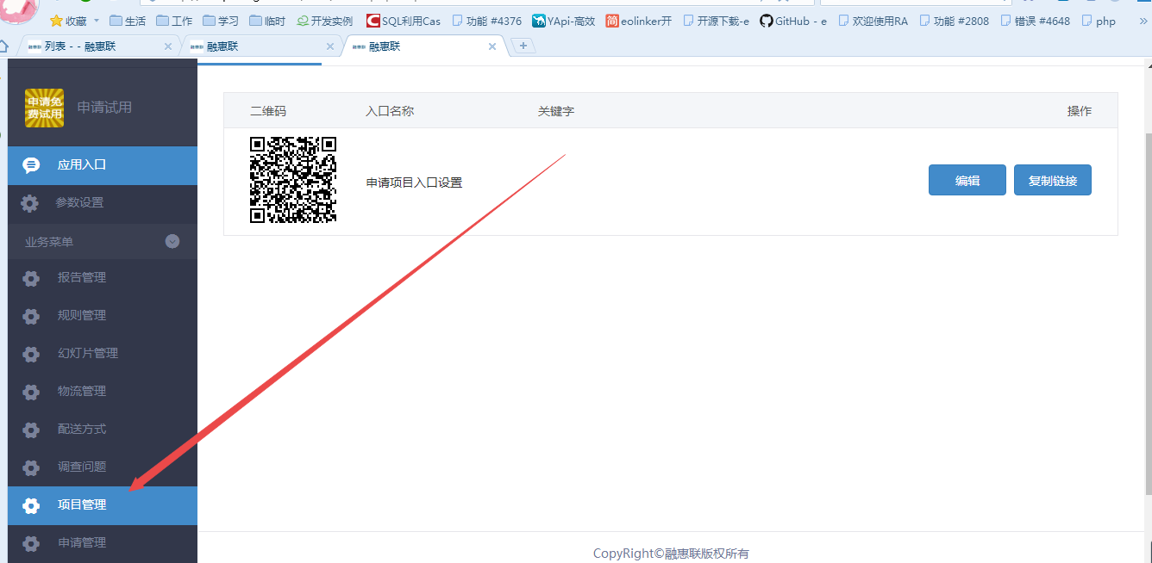

## 添加商品

<http://shop.rongec.com/web/index.php?c=site&a=entry&op=post&do=project&m=sen_appfreeitem>

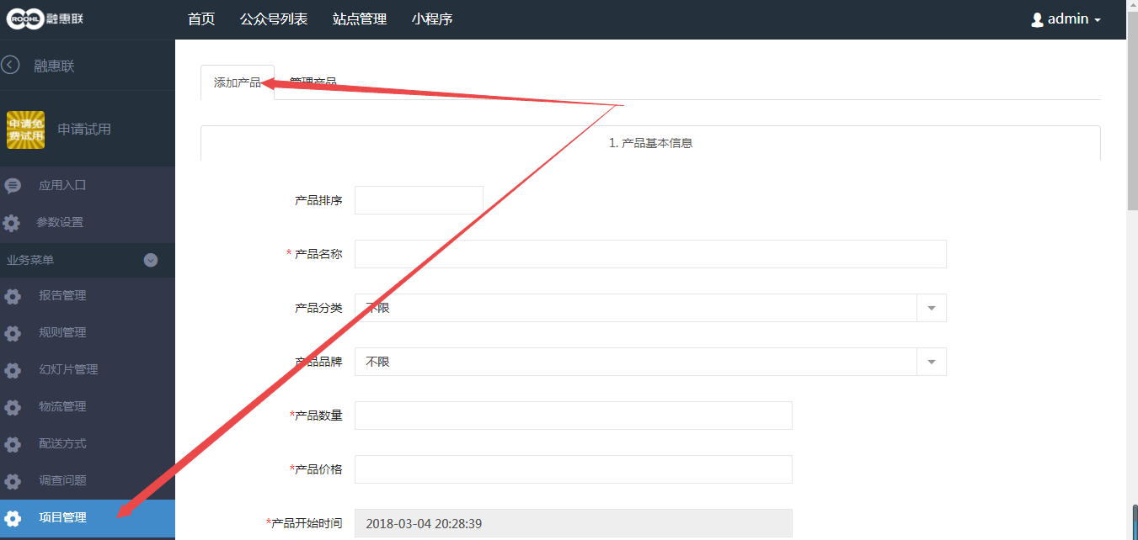

注：产品分类和产品品牌两个属性和商城（惠惠城）中关联

<http://shop.rongec.com/web/index.php?c=site&a=entry&m=ewei_shopv2&do=web&r=goods.category>

