# **20180225**

# **[[营销及活动]](http://www.shuotupu.com/forum.php?mod=forumdisplay&fid=81&filter=typeid&typeid=3) [申请试用 4.1.4开源 打开速度慢问题处理 优化分享、修复](http://www.shuotupu.com/forum.php?mod=viewthread&tid=18591)**

<http://www.shuotupu.com/forum.php?mod=viewthread&tid=18591&highlight=申请>

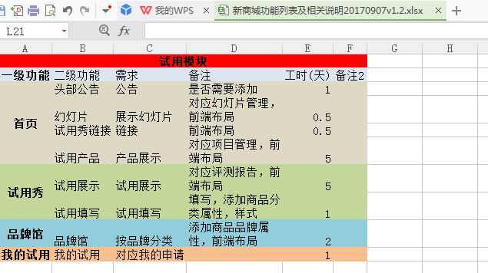

申请试用

<http://shop.rongec.cn/app/index.php?i=10&c=entry&do=list&m=sen_appfreeitem>

阿里试用

<https://pages.tmall.com/wow/baihuo/act/trial?spm=a1z0i.8295104.300.1>

添加商品分类和品牌属性

退款问题

<http://shop.rongec.com/web/index.php?c=site&a=entry&m=ewei_shopv2&do=web&r=finance.log.recharge>

certificate not match

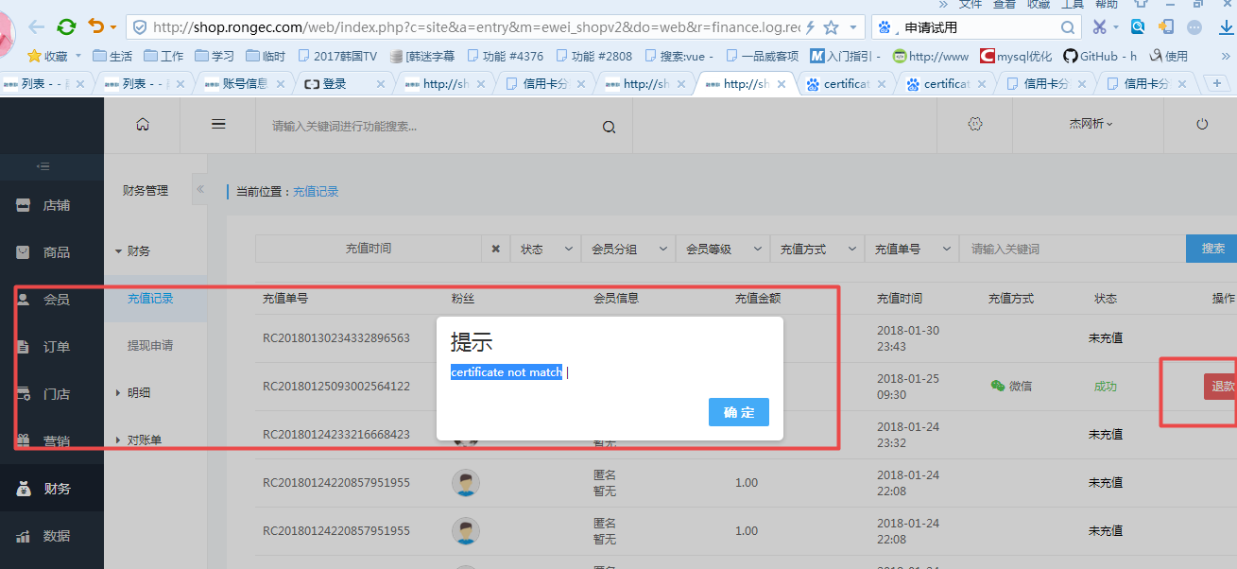

流程：

1. 管理员后台添加商品
2. 用户前台申请
3. 管理员后台审核
4. 发货
5. 用户确认收货
6. 填写评测报告

<http://shop.rongec.com/app/index.php?i=10&c=entry&orderid=14047&do=baogao&m=sen_appfreeitem>

1. 管理员后台添加商品
2. 用户前台申请
3. 管理员后台审核
4. 发货
5. 用户确认收货
6. 填写评测报告

<http://shop.rongec.com/app/index.php?i=10&c=entry&orderid=14047&do=baogao&m=sen_appfreeitem>

D:\www\users\wc.jieqiangtec.com\addons\sen_appfreeitem\site.php

doMobileBaogao

D:\www\users\wc.jieqiangtec.com\addons\sen_appfreeitem\template\mobile\baogao.html

{CSS_PATH}

精品评测

<http://shop.rongec.com/app/index.php?i=10&c=entry&op=jpcp&do=list2&m=sen_appfreeitem>

流程走通=》代码研究=》改版成阿里云

流程走通（3天）=》代码研究（2天）=》改版成阿里云（18天）

其它流程是否一致

找前端画前端界面，js动态效果做下拉加载等

内容订阅，添加品牌，推荐

融惠联：

<http://shop.rongec.cn/app/index.php?i=10&c=entry&do=list&m=sen_appfreeitem>

阿里：

<https://pages.tmall.com/wow/baihuo/act/trial?spm=a1z0i.8295104.300.1>

三体：

<https://www.we8cc.com/we8/app/index.php?i=2&c=entry&do=list&m=sen_appfreeitem&wxref=mp.weixin.qq.com#wechat_redirect>

## 上线后切忌关闭debug

/*// TODO debug

D:\www\users\wc.jieqiangtec.com\addons\sen_appfreeitem\site.php

54

85

658

1101

1749

## 20180331

### **首页幻灯片宽度调大**

520*265

<http://shop.rongec.cn/attachment/images/10/2018/01/tuzG3isd06K01U1Q6r6sLUrgTKS166.jpg>

<http://shop.rongec.cn/attachment/images/10/2018/01/aSZbAHFULtAof8WZOHZsTH5AMIF5bO.jpg>

<http://shop.rongec.cn/attachment/images/10/2018/01/wiIY42FS0NnJ7wkZ4xs0y3s7u7u2TI.jpg>



<http://zc.imaumm.com/wap/tpl/default/images/lb_left_top.png>

src: url('../css/font-awesome-4.7.0/fonts/iconfont.eot?t=1521641839605');

阿里图标库

<http://iconfont.cn/search/index?q=所有>

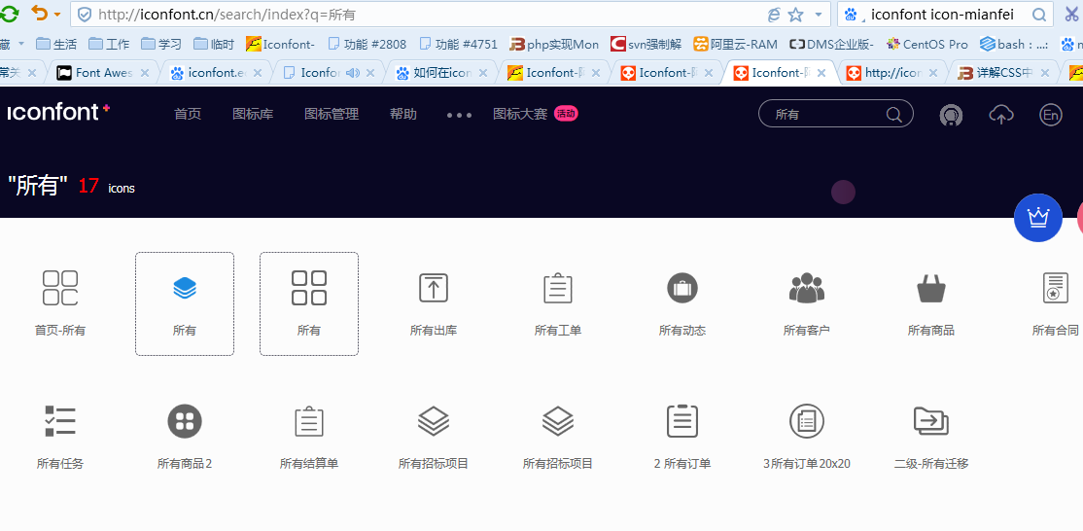

### **评论收藏，回复，点赞**

发布产品

<http://shop.rongec.cn/app/index.php?i=10&c=entry&type=1&op=post1&do=publish&m=sen_appfreeitem>

INSERT INTO `ims_sen_appfreeitem_project` SET `weid` = '10' , `displayorder` = '0' , `title` = '小米 米家空气净化器2除甲醛雾霾粉尘卧室家用智能氧吧' , `cpnumber` = '666' , `myprice` = '999' , `price` = '' , `deal_days` = '1535804760' , `isrecommand` = '1' , `ishot` = '1' , `wtname` = 'a:1:{i:0;s:2:"32";}' , `pcate` = '0' , `ccate` = '0' , `tjqian` = '0' , `tjhou` = '0' , `thumb` = 'images/10/2018/03/a60LUW58wh8TWf8wpXWUfFwcuaFptC.jpg' , `content` = '<p class="attr-list-hd tm-clear" style="margin-top: 0px; margin-bottom: 0px; padding: 5px 20px; line-height: 22px; color: rgb(153, 153, 153); font-family: tahoma, arial, 微软雅黑, sans-serif; font-size: 12px; font-variant-numeric: normal; font-variant-east-asian: normal; white-space: normal; widows: 1; background-color: rgb(255, 255, 255);"><span style="margin: 0px; padding: 0px; font-weight: 700; float: left;">产品参数：</span></p><ul id="J_AttrUL" style="list-style-type: none;" class=" list-paddingleft-2"><li><p>产品名称：Xiaomi/小米 空气净化器2</p></li><li><p>品牌:&nbsp;Xiaomi/小米</p></li><li><p>型号:&nbsp;空气净化器2</p></li><li><p>噪音:&nbsp;31-66dB</p></li><li><p>控制方式:&nbsp;按键式</p></li><li><p>滤网类型:&nbsp;复合滤网</p></li><li><p>颜色分类:&nbsp;白色</p></li><li><p>风量:&nbsp;330立方米/小时</p></li><li><p>工作原理:&nbsp;活性炭&nbsp;其他</p></li><li><p>空气净化产品类别:&nbsp;空气净化器</p></li><li><p>风量:&nbsp;301-400立方米/小时</p></li><li><p>电源方式:&nbsp;交流电</p></li><li><p>售后服务:&nbsp;全国联保</p></li><li><p>适用对象:&nbsp;商用、家用</p></li><li><p>空气净化器风量:&nbsp;301-400立方米/小时</p></li></ul><p><br/></p>' , `nosubuser` = '0' , `subsurl` = '' , `direct` = '0&#039;' , `starttime` = '1522412571' , `show_type` = '0' , `type` = '0' , `lianxiren` = 'jie' , `tel` = '18998989999' , `status` = '3' , `createtime` = '1522412984' , `brands` = '75' , `cates` = '1189' , `freight` = '10' ;

图片上传接口

<http://shop.rongec.cn/app/index.php?i=10&j=10&c=utility&a=file&do=upload&type=image>

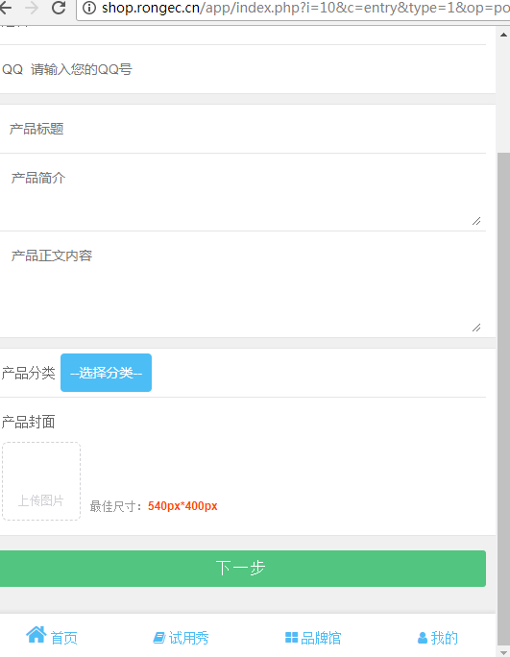

### **评论图文并茂**

评论页面

<http://shop.rongec.cn/app/index.php?i=10&c=entry&orderid=14080&do=baogao&m=sen_appfreeitem>

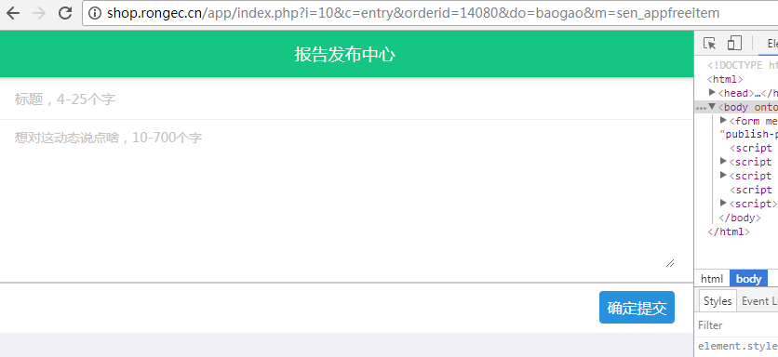

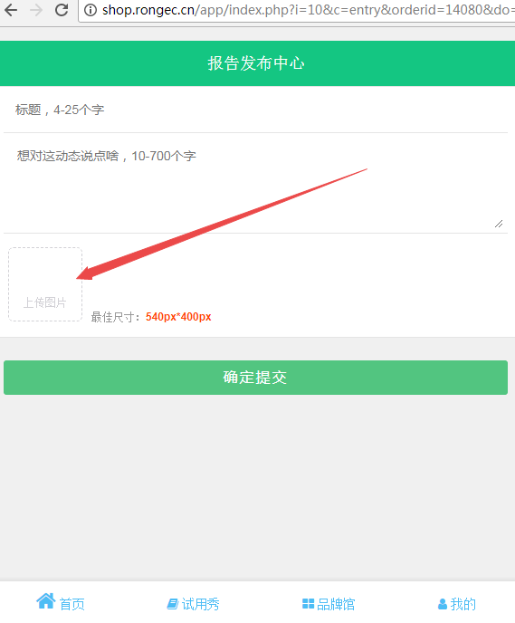SELECT * FROM `ims_sen_appfreeitem_report` LIMIT 0, 1000

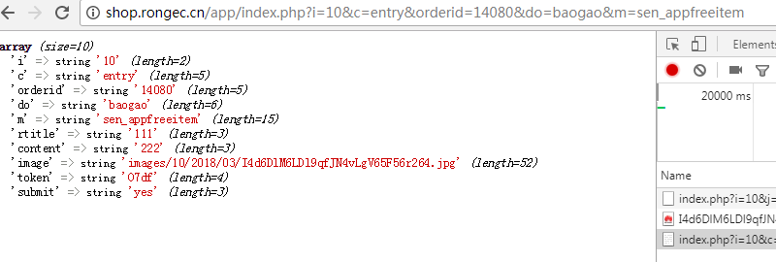

<http://shop.rongec.cn/app/index.php?i=10&c=entry&orderid=14080&do=baogao&m=sen_appfreeitem>

**array** *(size=10)*

'i' => string '10' *(length=2)*

'c' => string 'entry' *(length=5)*

'orderid' => string '14080' *(length=5)*

'do' => string 'baogao' *(length=6)*

'm' => string 'sen_appfreeitem' *(length=15)*

'rtitle' => string '111' *(length=3)*

'content' => string '222' *(length=3)*

'image' => string 'images/10/2018/03/I4d6DlM6LDl9qfJN4vLgV65F56r264.jpg' *(length=52)*

'token' => string 'O7df' *(length=4)*

'submit' => string 'yes' *(length=3)*

序列化：

**if** (!**empty**($_GPC['image'])) {  
 **foreach** ($_GPC['image'] **as** $thumb) {  
 $th[] = save_media(tomedia($thumb));  
 }  
 $data['images'] = iserializer($th);  
}

反序列化：

$item['images'] = iunserializer($item['images']);

<div class="form-group">

<label class="col-xs-12 col-sm-2 col-md-2 col-lg-1 control-label">图片</label>

<div class="col-sm-8 col-lg-9 col-xs-12">

{loop $item['images'] $i}

<img src="{$i}" style="width:100px;height:100%;">

{/loop}

</div>

</div>

商城评论表

SELECT * FROM `ims_ewei_shop_order_comment` LIMIT 0, 1000

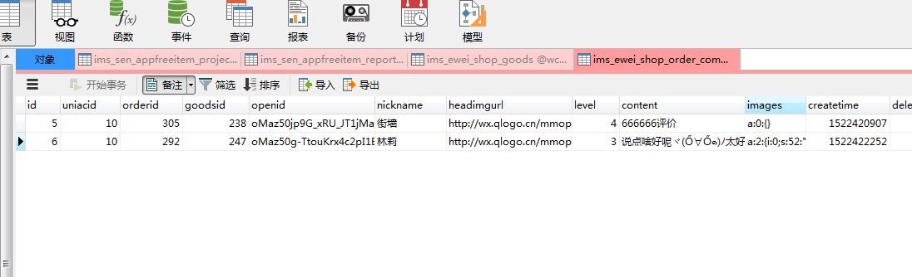

<http://shop.rongec.com/app/index.php?i=10&c=entry&m=ewei_shopv2&do=mobile>

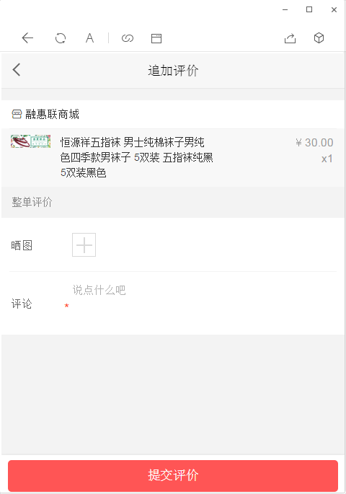

600 http://shop.rongec.com/app/index.php?i=10&c=entry&m=ewei_shopv2&do=mobile&r=goods.detail.get_comments&id=238&_=1522422920180

601 ------------

602 Array:

603 file : fetchcolumn() ;

604 sql2 : select count(*) from `ims_ewei_shop_order_comment` where goodsid='238' and level>=0 and deleted=0 and checked=0 and uniacid='10' ;

605 $params ==Array:

606 :goodsid : 238 ;

607 :uniacid : 10 ;

608

609 2018-03-30 23:17:01 TODO debug1 runtime=0s ：来源:

610 http://shop.rongec.com/app/index.php?i=10&c=entry&m=ewei_shopv2&do=mobile&r=goods.detail.get_comments&id=238&_=1522422920180

611 ------------

612 Array:

613 file : fetchcolumn() ;

614 sql2 : select count(*) from `ims_ewei_shop_order_comment` where goodsid='238' and level>=5 and deleted=0 and checked=0 and uniacid='10' ;

615 $params ==Array:

616 :goodsid : 238 ;

617 :uniacid : 10 ;

618

619 2018-03-30 23:17:01 TODO debug1 runtime=0s ：来源:

620 http://shop.rongec.com/app/index.php?i=10&c=entry&m=ewei_shopv2&do=mobile&r=goods.detail.get_comments&id=238&_=1522422920180

621 ------------

622 Array:

623 file : fetchcolumn() ;

624 sql2 : select count(*) from `ims_ewei_shop_order_comment` where goodsid='238' and level>=2 and level<=4 and deleted=0 and checked=0 and uniacid='10' ;

625 $params ==Array:

### 用户中心加状态

## 20180330

首页底部：字体变大

样式

/*body {

font-size: 16px;

D:\www\users\wc.jieqiangtec.com\addons\sen_appfreeitem\template\style\css\style.min.css

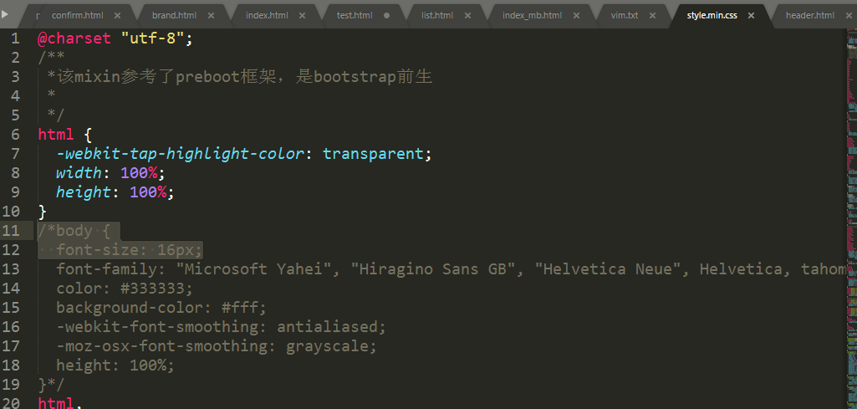

## 20180324

Cps图片不显示:img地址存入的是以前的旧域名wx.adjyc.com

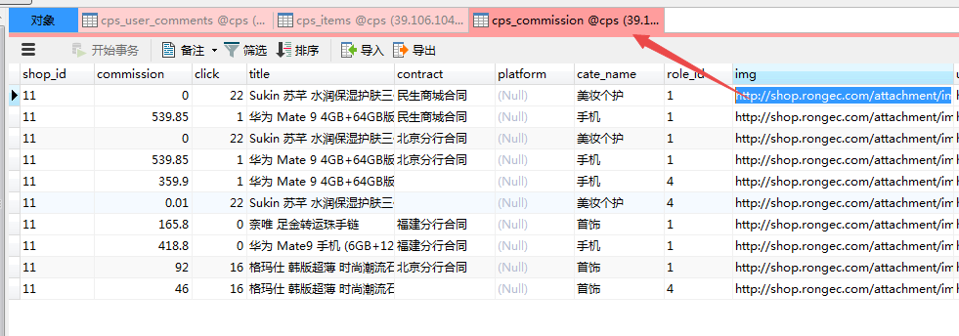

## 20180321

首页调整

## 20180318

完成支付

免邮/付邮/往期

# **调查问卷**

可以去除

<http://shop.rongec.cn/app/index.php?i=10&c=entry&orderid=14063&op=detail&do=myorder&m=sen_appfreeitem>

**[微信支付之get_brand_wcpay_request:fail_invalid appid](http://blog.csdn.net/wow4464/article/details/44647157)**

<https://www.cnblogs.com/BTMaster/p/5570189.html>

微信支付有问题

新增的支付目录

<http://shop.adjyc.com/payment/wechat/>

http://shop.adjyc.com/app/

如果是微信支付，授权目录与“支付选项”中的说明不同，应在 公众平台->微信支付->公众号支付 追加一条支付授权目录: **<http://shop.rongec.cn/app/>**

## 20180317

申请试用品牌馆，用户中心

./品牌馆_files/ =>{JS_PATH}

// $_W['openid'] = 'oMaz50jp9G_xRU_JT1jMaxuS5KdY';

$_W['fans']['from_user'] = 'oMaz50jp9G_xRU_JT1jMaxuS5KdY'; L1660

$_W['openid'] = 'oMaz50jp9G_xRU_JT1jMaxuS5KdY'; L1021

{php echo tomedia($adv['thumb']);}

{php echo date('Y-m-d H:i',$item['deal_days'])}

底部小图标

<i class="fa fa-book"></i>&nbsp;试用秀

fa-home图标怎么找

<http://fontawesome.dashgame.com/>

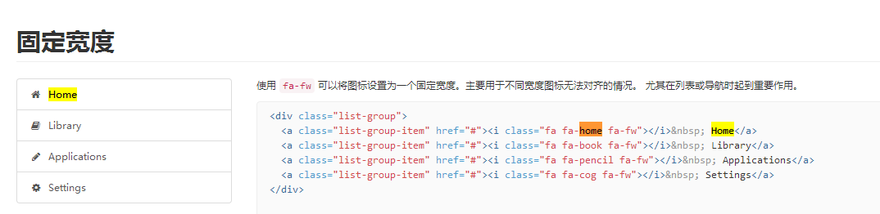

src: url('../css/font-awesome-4.7.0/fonts/iconfont.eot?t=1521641839605');

<a href="">

<div class="m-item">

<i class="iconfont icon-mianfei" style="color:#17abe3;font-size:46px;"></i>

<span class="m-item-name">免费</span>

</div>

</a>

<a href="{php echo $this->createMobileUrl('list',array('type'=>0))}" {if $type==0}class="cur"{else}class="nosel"{/if}>

<div class="m-item">

<i class="fa fa-telegram fa-3x" style="color:darkgreen"></i>

<span class="m-item-name">免邮</span>

</div>

</a>

## 20180310

申请试用页面布局，首页和评测列表

申请试用页面布局，

首页商品列表和底部导航

评测列表页面和样式完善

addons\sen_appfreeitem\site.php

addons\sen_appfreeitem\template\mobile\footerbar.html

addons\sen_appfreeitem\template\mobile\list.html

addons\sen_appfreeitem\template\mobile\list2.html

addons\sen_appfreeitem\template\style\css\style.css

## 20180305

首页

<http://shop.rongec.com/app/index.php?i=10&c=entry&m=ewei_shopv2&do=mobile>

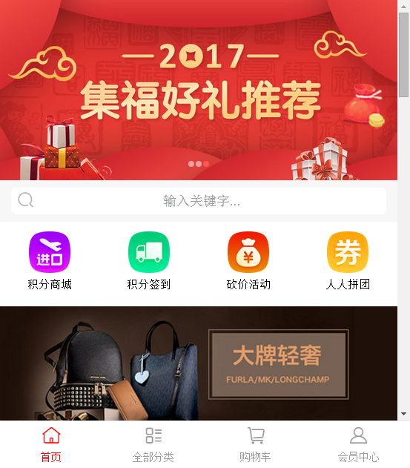

列表

<http://shop.rongec.com/app/index.php?i=10&c=entry&m=ewei_shopv2&do=mobile&r=groups>

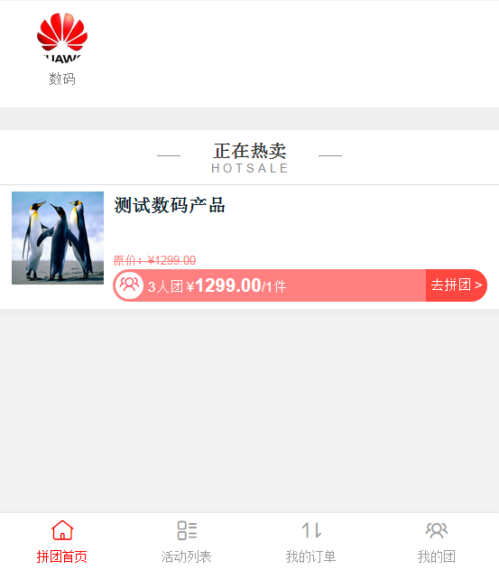

## 20180304

*添加需求：需要添加邮费字段，结算时添加

*页面仿照商城模板风格

仿照商城，添加热卖属性ishot

积分商城图片也同步更新到生成服务器

完善融惠联商城首页

## 20180303

仿照商城，添加品牌和分类

<http://shop.rongec.cn/web/index.php?c=site&a=entry&m=ewei_shopv2&do=web&r=goods.edit&id=247&goodsfrom=sale>

$categorys = m('shop')->getFullCategory(**true**);  
$brand = m('shop')->getFullBrand(**true**);

$cates = explode(',', $item['cates']);  
// 商品所有品牌  
$brands = explode(',', $item['brands']);

程序

D:\www\users\wc.jieqiangtec.com\addons\sen_appfreeitem\site.php

页面

D:\www\users\wc.jieqiangtec.com\addons\sen_appfreeitem\template\project.html

ALTER TABLE `ims_sen_appfreeitem_project`

ADD COLUMN `cates` text CHARACTER SET utf8 COLLATE utf8_general_ci NULL COMMENT '分类' AFTER `share_url`,

ADD COLUMN `brands` text CHARACTER SET utf8 COLLATE utf8_general_ci NULL COMMENT '品牌' AFTER `cates`;

CREATE TABLE `ims_sen_appfreeitem_project` (

`id` int(10) unsigned NOT NULL AUTO_INCREMENT,

`weid` int(10) unsigned NOT NULL,

`from_user` varchar(50) DEFAULT NULL,

`displayorder` int(10) unsigned NOT NULL DEFAULT '0',

`title` varchar(100) NOT NULL DEFAULT '',

`cpnumber` int(10) DEFAULT '0',

`donenum` int(10) unsigned NOT NULL DEFAULT '0',

`myprice` int(11) unsigned DEFAULT NULL,

`price` decimal(10,2) NOT NULL DEFAULT '0.00',

`finish_price` decimal(10,2) NOT NULL DEFAULT '0.00',

`starttime` int(10) unsigned DEFAULT '0',

`deal_days` int(10) unsigned NOT NULL,

`tjqian` int(11) unsigned DEFAULT NULL,

`tjhou` int(11) unsigned DEFAULT NULL,

`ishot` tinyint(1) unsigned NOT NULL DEFAULT '0',

`isrecommand` tinyint(1) unsigned DEFAULT '0',

`pcate` int(10) unsigned NOT NULL DEFAULT '0',

`ccate` int(10) unsigned NOT NULL DEFAULT '0',

`thumb` varchar(255) DEFAULT '',

`content` text NOT NULL,

`nosubuser` tinyint(1) unsigned NOT NULL,

`status` tinyint(1) unsigned NOT NULL DEFAULT '0' COMMENT '0暂停1正常2停止',

`wtname` varchar(10000) DEFAULT NULL,

`reason` varchar(255) DEFAULT NULL,

`createtime` int(10) unsigned NOT NULL,

`subsurl` varchar(500) DEFAULT NULL,

`url` varchar(255) DEFAULT NULL,

`direct` tinyint(1) NOT NULL DEFAULT '0',

`show_type` int(10) DEFAULT '0',

`type` tinyint(10) DEFAULT '0',

`lianxiren` varchar(20) DEFAULT '',

`tel` int(10) DEFAULT NULL,

`fenshu` int(11) DEFAULT NULL,

`share_title` varchar(255) DEFAULT NULL,

`share_img` varchar(255) DEFAULT NULL,

`share_content` varchar(255) DEFAULT NULL,

`share_url` varchar(255) DEFAULT NULL,

`cates` text COMMENT '分类',

`brands` text COMMENT '品牌',

PRIMARY KEY (`id`)

) ENGINE=MyISAM AUTO_INCREMENT=7 DEFAULT CHARSET=utf8;