@街墙 您好，想问问，想问问用1、商城模块配置积分商城这个流程能走通么？2、积分商城应用和商城里的积分模块两者关系

1. 如果用商城配置积分商城，商品，分类，用户中心怎么能按需求设置后，让整个流程关联？

## 商城模块配置积分商城这个流程能走通么？

答：

1. 获取积分

1.1通过积分签到

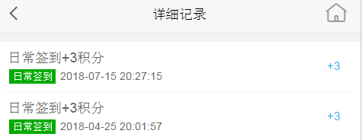

1.2 通过购买带有积分的商品

后台编辑商品营销中的**积分赠送**

<http://shop.rongec.com/web/index.php?c=site&a=entry&m=ewei_shopv2&do=web&r=goods.edit&id=227&goodsfrom=sale#tab_option>

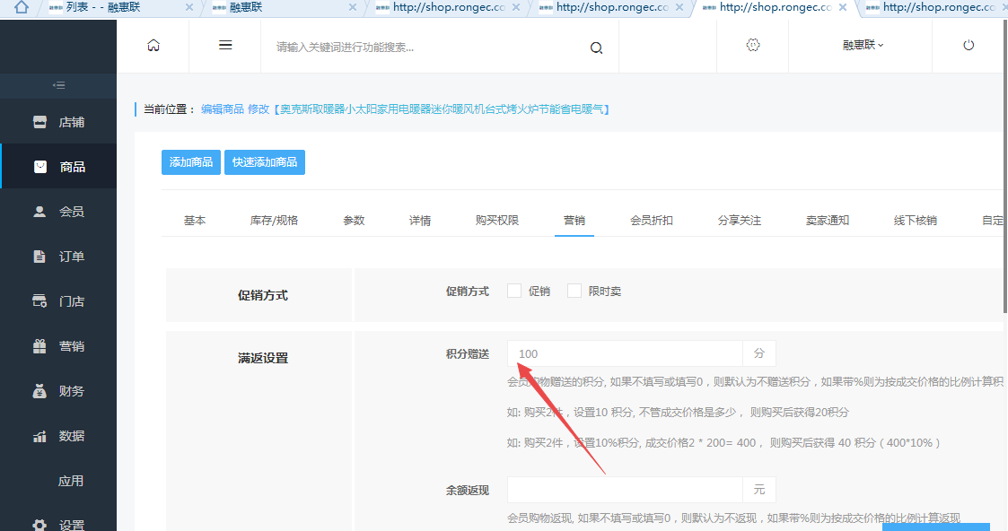

前端购买

<http://shop.rongec.com/app/index.php?i=10&c=entry&m=ewei_shopv2&do=mobile&r=goods.detail&id=227>

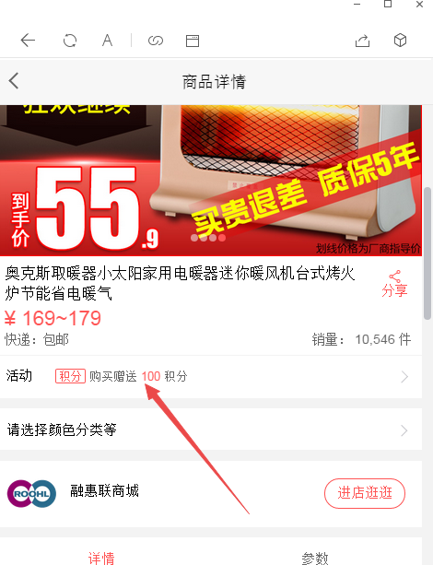

1. 积分兑换

后台编辑

<http://shop.rongec.com/web/index.php?c=site&a=entry&m=ewei_shopv2&do=web&r=creditshop.goods>

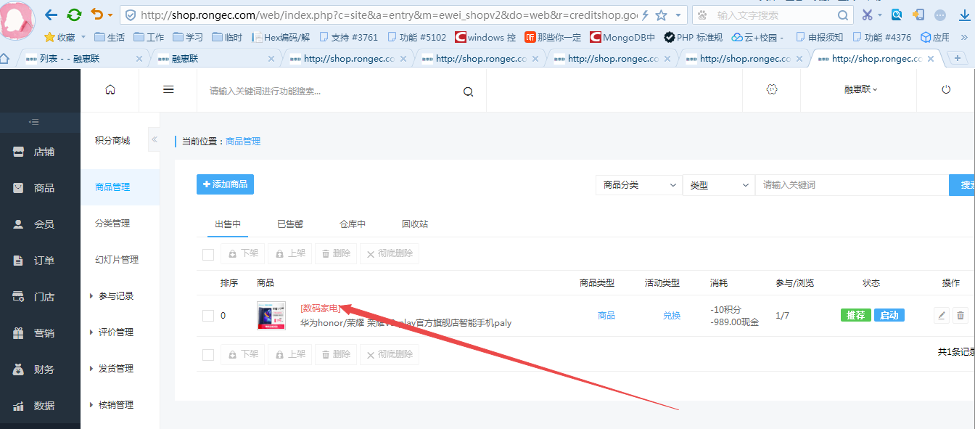

前端兑换

<http://shop.rongec.com/app/index.php?i=10&c=entry&m=ewei_shopv2&do=mobile&r=creditshop.detail&id=27>

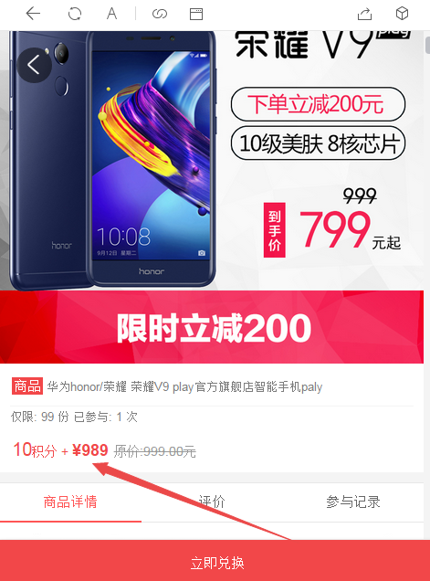

## 积分商城应用和商城里的积分模块两者关系

积分共用，同1里面的积分获取

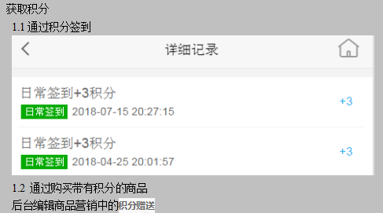

## 如果用商城配置积分商城，商品，分类，用户中心怎么能按需求设置后，让整个流程关联？

普通商城和积分商城共享用户信息和积分信息，商品和分类是相对独立的

1. 商品

可独立设置，也可快速选择商城商品

**以下商城商品不能参加积分商城兑换活动：**

虚拟、促销、秒杀活动、砍价活动商品；以及参加拼团的商品。

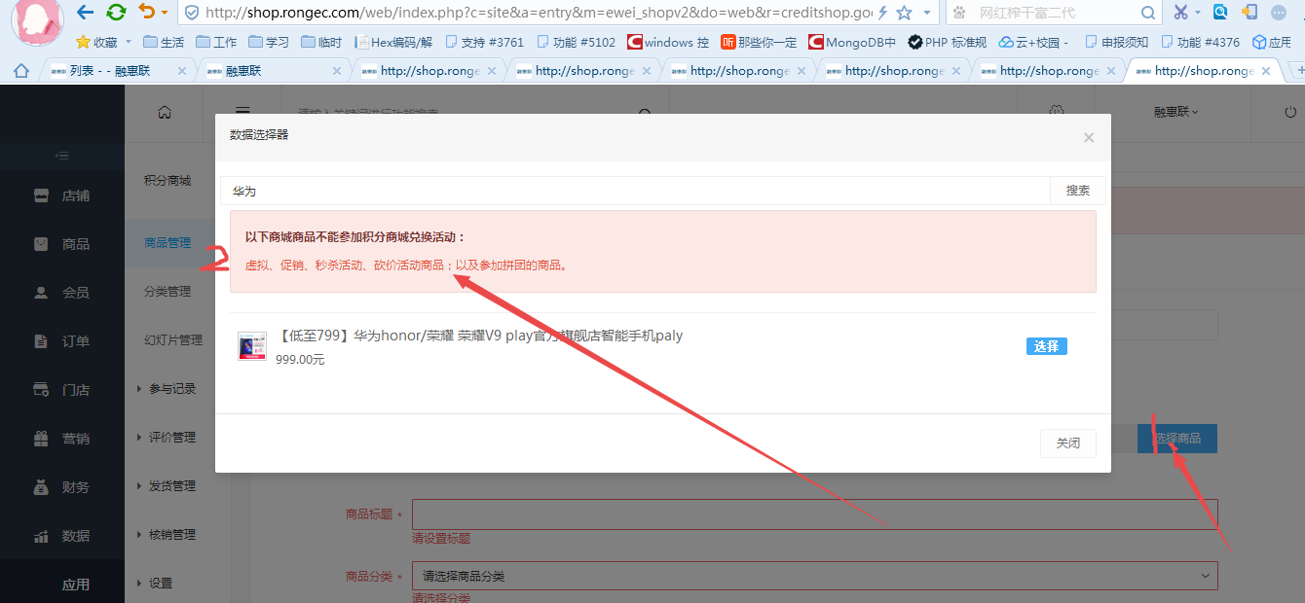

1. 分类

独立设置

1. 用户中心

<http://shop.rongec.com/app/index.php?i=10&c=entry&m=ewei_shopv2&do=mobile&r=diypage&id=44>

这个链接是从哪获取的？我这边看下哈

后台配置自定义页面

<http://shop.rongec.com/web/index.php?c=site&a=entry&m=ewei_shopv2&do=web&r=diypage.page.sys.edit&id=44>

当前位置： 编辑 商城首页 页面 (积分商城Demo)

<http://shop.rongec.com/app/index.php?i=10&c=entry&m=ewei_shopv2&do=mobile&r=sign>

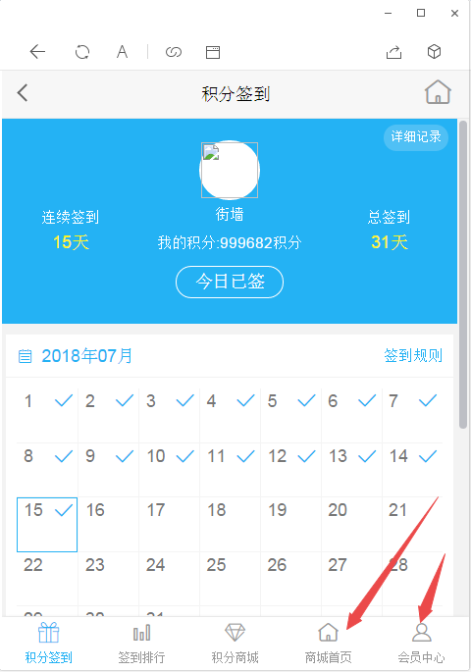

底部导航

<http://shop.rongec.com/app/index.php?i=10&c=entry&m=ewei_shopv2&do=mobile&r=sign>

D:\www\users\wc.jieqiangtec.com\addons\ewei_shopv2\plugin\sign\template\mobile\default\_menu.html

我:

http://shop.rongec.com/web/index.php?c=site&a=entry&m=ewei_shopv2&do=web&r=diypage.shop.menu

积分签到 导航可以在"店铺装修"下的"自定义菜单"先设置好菜单

我:

然后再店铺装修=》商城设置=》菜单设置 对积分签到进行选择设置

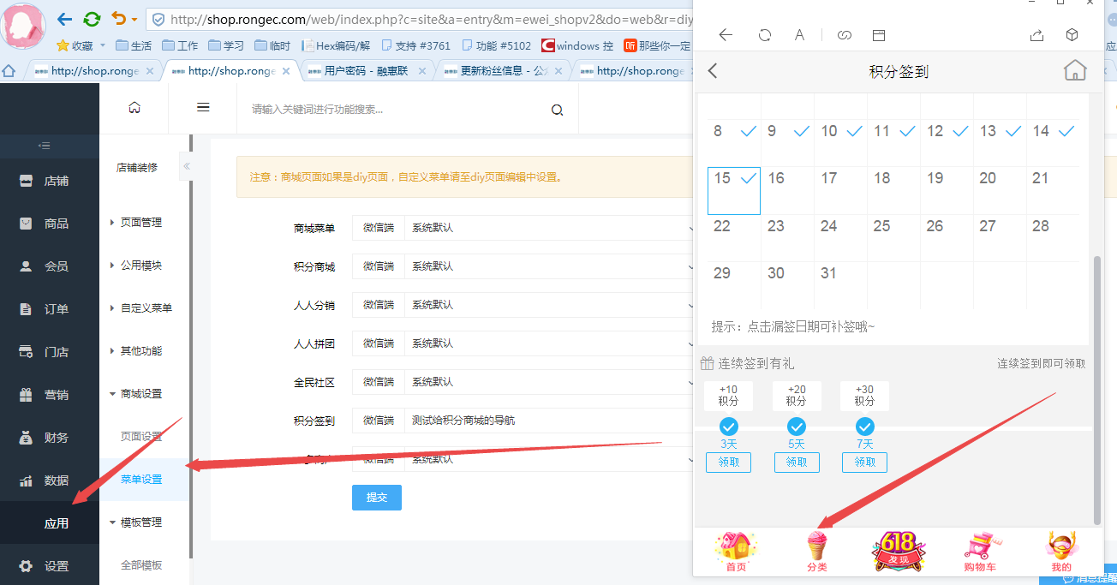

2018-07-16 00:05:20 TODO debug3 runtime=0.001s ：来源:

http://shop.rongec.cn/web/index.php?c=site&a=entry&m=ewei_shopv2&do=web&r=diypage.shop.menu

------------

Array:

file : db.class.php query() ;

sql2 : UPDATE `ims_ewei_shop_sysset` SET `plugins` = 'a:2:{s:10:"creditshop";a:20:{s:12:"set_realname";i:0;s:10:"set_mobile";i:0;s:15:"exchangekeyword";s:0:"";s:8:"sendname";s:0:"";s:7:"wishing";s:0:"";s:10:"centeropen";s:1:"0";s:9:"followurl";s:0:"";s:9:"crediturl";s:0:"";s:11:"share_title";s:0:"";s:10:"share_icon";s:0:"";s:10:"share_desc";s:0:"";s:15:"importantdetail";s:0:"";s:7:"isreply";s:1:"1";s:11:"desckeyword";s:17:"我去,我靠,222";s:12:"replykeyword";s:0:"";s:8:"isdetail";i:0;s:6:"detail";s:0:"";s:14:"isnoticedetail";i:0;s:12:"noticedetail";s:0:"";s:5:"style";s:7:"default";}s:7:"diypage";a:1:{s:4:"menu";a:16:{s:4:"shop";s:0:"";s:8:"shop_wap";s:0:"";s:10:"creditshop";s:0:"";s:14:"creditshop_wap";s:0:"";s:10:"commission";s:0:"";s:14:"commission_wap";s:0:"";s:6:"groups";s:0:"";s:10:"groups_wap";s:0:"";s:3:"sns";s:0:"";s:7:"sns_wap";s:0:"";s:4:"sign";s:2:"11";s:8:"sign_wap";s:0:"";s:7:"seckill";s:0:"";s:11:"seckill_wap";s:0:"";s:5:"merch";s:0:"";s:9:"merch_wap";s:0:"";}}}' WHERE `id` = '14' ;

$params ==Array:

:plugins : a:2:{s:10:"creditshop";a:20:{s:12:"set_realname";i:0;s:10:"set_mobile";i:0;s:15:"exchangekeyword";s:0:"";s:8:"sendname";s:0:"";s:7:"wishing";s:0:"";s:10:"centeropen";s:1:"0";s:9:"followurl";s:0:"";s:9:"crediturl";s:0:"";s:11:"share_title";s:0:"";s:10:"share_icon";s:0:"";s:10:"share_desc";s:0:"";s:15:"importantdetail";s:0:"";s:7:"isreply";s:1:"1";s:11:"desckeyword";s:17:"我去,我靠,222";s:12:"replykeyword";s:0:"";s:8:"isdetail";i:0;s:6:"detail";s:0:"";s:14:"isnoticedetail";i:0;s:12:"noticedetail";s:0:"";s:5:"style";s:7:"default";}s:7:"diypage";a:1:{s:4:"menu";a:16:{s:4:"shop";s:0:"";s:8:"shop_wap";s:0:"";s:10:"creditshop";s:0:"";s:14:"creditshop_wap";s:0:"";s:10:"commission";s:0:"";s:14:"commission_wap";s:0:"";s:6:"groups";s:0:"";s:10:"groups_wap";s:0:"";s:3:"sns";s:0:"";s:7:"sns_wap";s:0:"";s:4:"sign";s:2:"11";s:8:"sign_wap";s:0:"";s:7:"seckill";s:0:"";s:11:"seckill_wap";s:0:"";s:5:"merch";s:0:"";s:9:"merch_wap";s:0:"";}}} ;

:__id : 14 ;

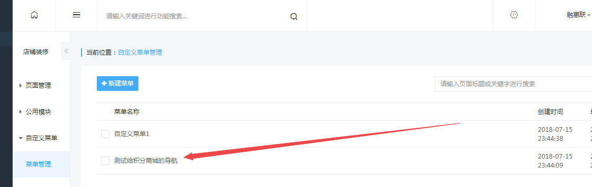

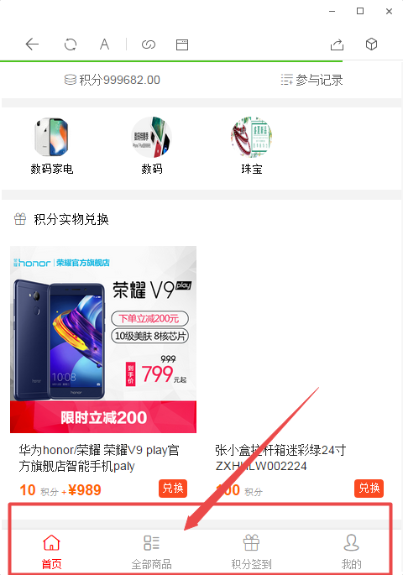

现在底部导航还不支持自定义，现在默认是这样的

SELECT * FROM `ims_ewei_shop_diypage_menu` WHERE id='1' and uniacid='10' limit 1 ;

$this->footerMenus(1, **false**, $texts)

**public function** footerMenus($diymenuid = **NULL**, $ismerch = **false**, $texts = **array**())  
{

D:\www\users\wc.jieqiangtec.com\addons\ewei_shopv2\core\inc\page_mobile.php L186

var_dump('$this->footerMenus(null1, false, $texts)==',$this->footerMenus(1, **false**, $texts));**exit**;

<http://shop.rongec.com/app/index.php?i=10&c=entry&m=ewei_shopv2&do=mobile&r=sign>

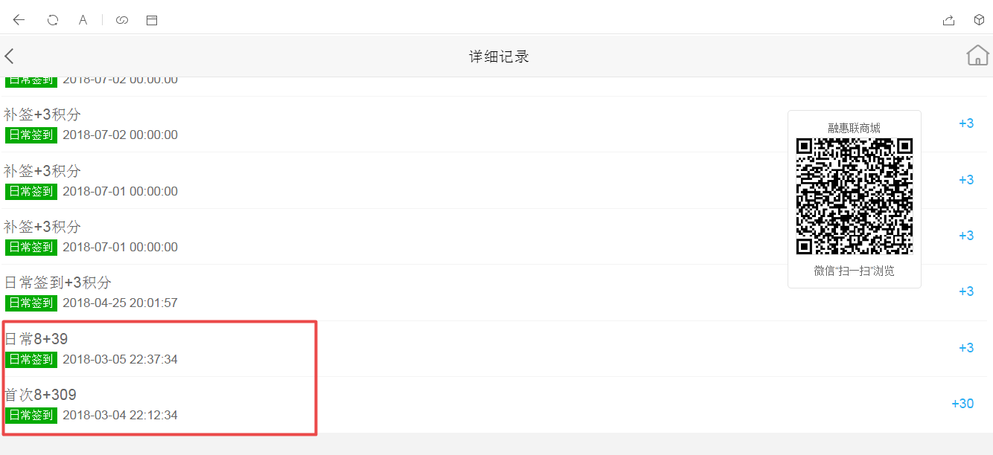

写入记录

SELECT * FROM `ims_ewei_shop_sign_records` LIMIT 0, 1000

当时由于配置积分规则：积分8商城9

积分签到

<http://shop.rongec.com/app/index.php?i=10&c=entry&m=ewei_shopv2&do=mobile&r=sign>

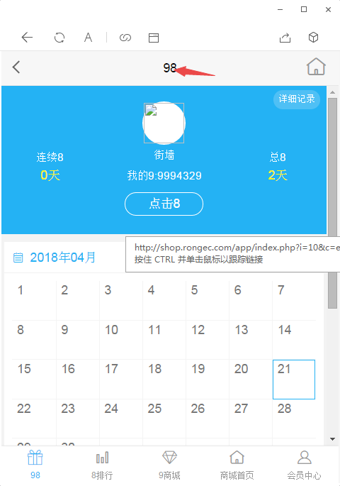

文字有问题

D:\www\users\wc.jieqiangtec.com\addons\ewei_shopv2\plugin\sign\core\model.php

$set = pdo_fetch('select * from ' . tablename('ewei_shop_sign_set') . ' where uniacid=:uniacid limit 1 ', **array**(':uniacid' => $_W['uniacid']));

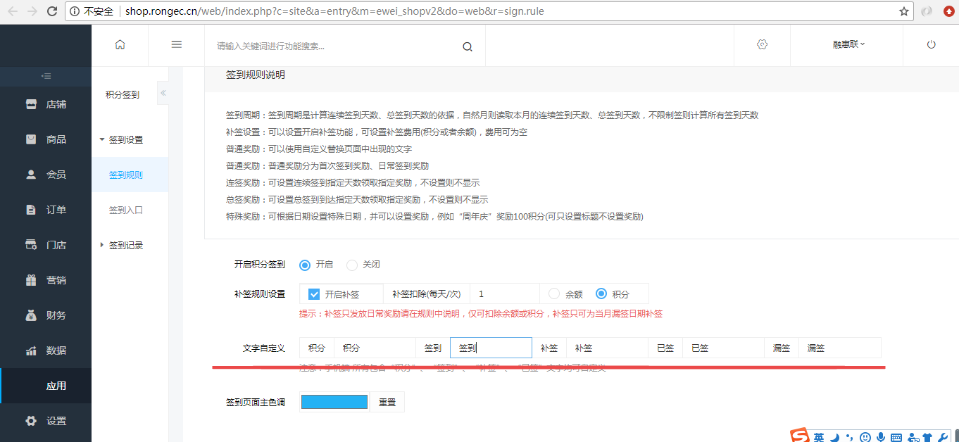

32634 2018-07-15 23:11:45 TODO debug1 runtime=0s ：来源:

32635 http://shop.rongec.com/app/index.php?i=10&c=entry&m=ewei_shopv2&do=mobile&r=sign.getrecords&page=1&_=1531667505738

32636 ------------

32637 Array:

32638 file : fetchcolumn() ;

32639 sql2 : SELECT COUNT(*) FROM `ims_ewei_shop_sign_records` log where 1 and openid='oMaz50jp9G_xRU_JT1jMaxuS5KdY' and uniacid = '10' ;

32640 $params ==Array:

32641 :uniacid : 10 ;

32642 :openid : oMaz50jp9G_xRU_JT1jMaxuS5KdY ;

32643

32644 2018-07-15 23:11:45 TODO debug4 runtime=0.001s ：来源:

32645 http://shop.rongec.com/app/index.php?i=10&c=entry&m=ewei_shopv2&do=mobile&r=sign.getrecords&page=1&_=1531667505738

32646 ------------

32647 Array:

32648 file : fetchall() ;

32649 sql2 : SELECT * FROM `ims_ewei_shop_sign_records` where 1 and openid='oMaz50jp9G_xRU_JT1jMaxuS5KdY' and uniacid = '10' ORDER BY `time` DESC LIMIT 0,10 ;

32650 $params ==Array:

32651 :uniacid : 10 ;

32652 :openid : oMaz50jp9G_xRU_JT1jMaxuS5KdY ;