统一门户3.0部署方案

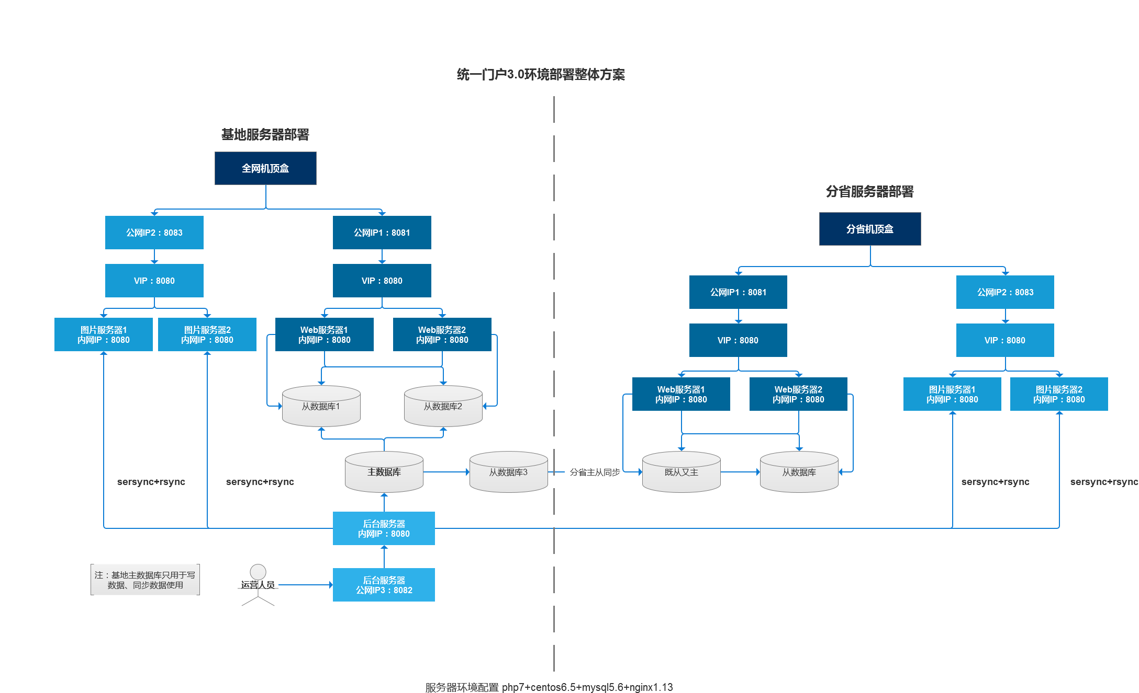

整体部署方案如图所示。

配置手册:具体配置参数都是根据需求而进行变化的，比如web服务器的一级nginx缓存时间和二级memcache的 缓存时间 这些修改配置参数以及代码即可。下面是统一门户3.0现网的具体配置文件内容。

具体服务软件配置：

Nginx.conf

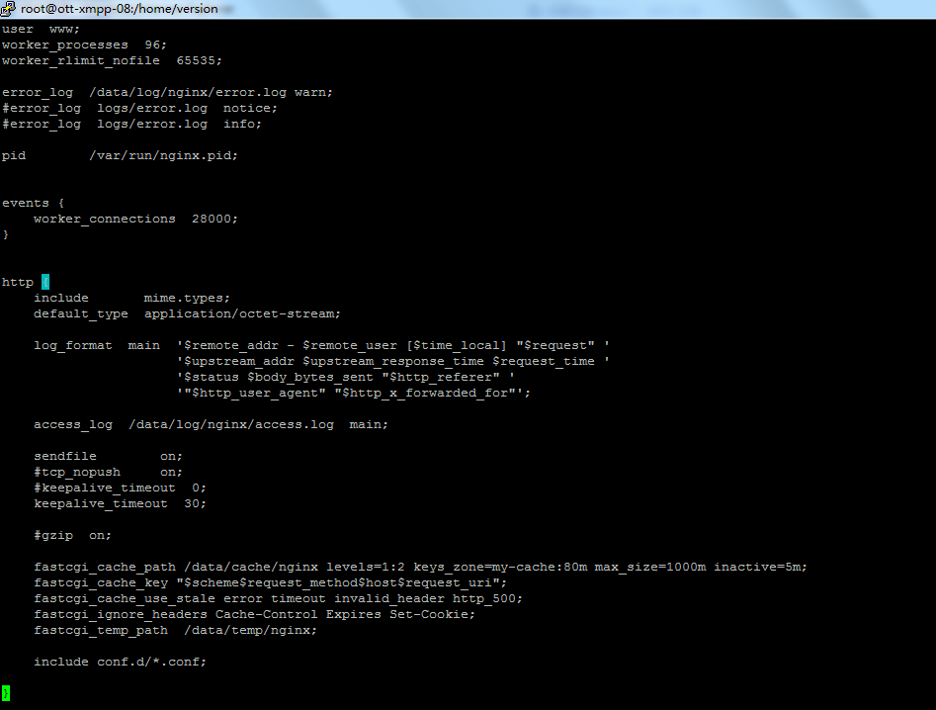

user www;

worker_processes 96;

worker_rlimit_nofile 65535;

error_log /data/log/nginx/error.log warn;

#error_log logs/error.log notice;

#error_log logs/error.log info;

pid /var/run/nginx.pid;

events {

worker_connections 28000;

}

http {

include mime.types;

default_type application/octet-stream;

log_format main '$remote_addr - $remote_user [$time_local] "$request" '

'$upstream_addr $upstream_response_time $request_time '

'$status $body_bytes_sent "$http_referer" '

'"$http_user_agent" "$http_x_forwarded_for"';

access_log /data/log/nginx/access.log main;

sendfile on;

#tcp_nopush on;

#keepalive_timeout 0;

keepalive_timeout 30;

#gzip on;

fastcgi_cache_path /data/cache/nginx levels=1:2 keys_zone=my-cache:80m max_size=1000m inactive=5m;

fastcgi_cache_key "$scheme$request_method$host$request_uri";

fastcgi_cache_use_stale error timeout invalid_header http_500;

fastcgi_ignore_headers Cache-Control Expires Set-Cookie;

fastcgi_temp_path /data/temp/nginx;

include conf.d/*.conf;

}

//conf.d/default.conf

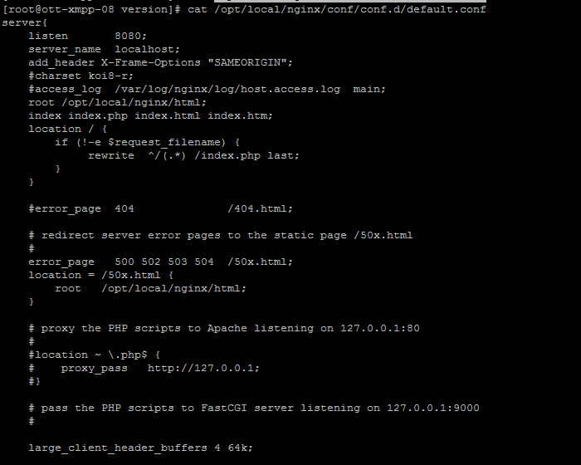

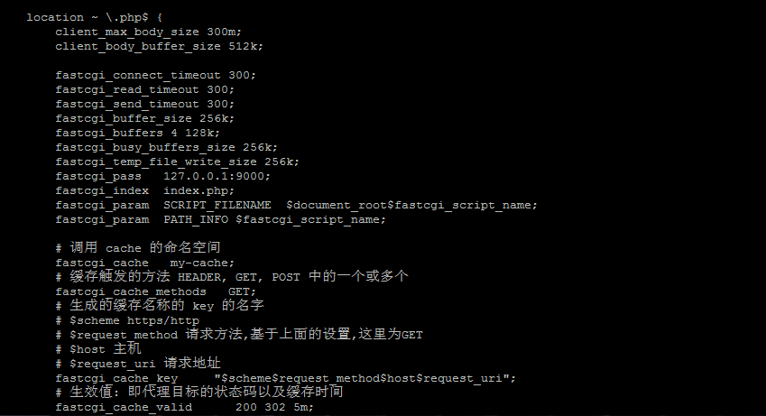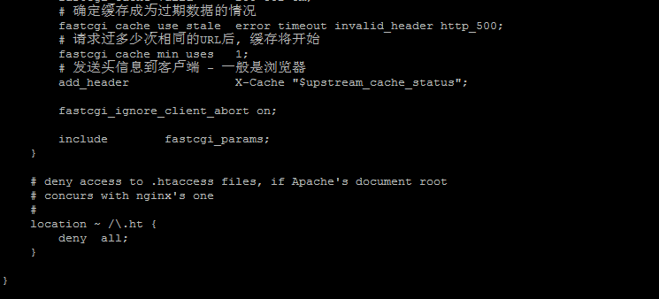

server{

listen 8080;

server_name localhost;

add_header X-Frame-Options "SAMEORIGIN";

#charset koi8-r;

#access_log /var/log/nginx/log/host.access.log main;

root /opt/local/nginx/html;

index index.php index.html index.htm;

location / {

if (!-e $request_filename) {

rewrite ^/(.*) /index.php last;

}

}

#error_page 404 /404.html;

# redirect server error pages to the static page /50x.html

#

error_page 500 502 503 504 /50x.html;

location = /50x.html {

root /opt/local/nginx/html;

}

# proxy the PHP scripts to Apache listening on 127.0.0.1:80

#

#location ~ \.php$ {

# proxy_pass http://127.0.0.1;

#}

# pass the PHP scripts to FastCGI server listening on 127.0.0.1:9000

#

large_client_header_buffers 4 64k;

location ~ \.php$ {

client_max_body_size 300m;

client_body_buffer_size 512k;

fastcgi_connect_timeout 300;

fastcgi_read_timeout 300;

fastcgi_send_timeout 300;

fastcgi_buffer_size 256k;

fastcgi_buffers 4 128k;

fastcgi_busy_buffers_size 256k;

fastcgi_temp_file_write_size 256k;

fastcgi_pass 127.0.0.1:9000;

fastcgi_index index.php;

fastcgi_param SCRIPT_FILENAME $document_root$fastcgi_script_name;

fastcgi_param PATH_INFO $fastcgi_script_name;

# 调用 cache 的命名空间

fastcgi_cache my-cache;

# 缓存触发的方法 HEADER, GET, POST 中的一个或多个

fastcgi_cache_methods GET;

# 生成的缓存名称的 key 的名字

# $scheme https/http

# $request_method 请求方法,基于上面的设置,这里为GET

# $host 主机

# $request_uri 请求地址

fastcgi_cache_key "$scheme$request_method$host$request_uri";

# 生效值: 即代理目标的状态码以及缓存时间

fastcgi_cache_valid 200 302 5m;

# 确定缓存成为过期数据的情况

fastcgi_cache_use_stale error timeout invalid_header http_500;

# 请求过多少次相同的URL后, 缓存将开始

fastcgi_cache_min_uses 1;

# 发送头信息到客户端 - 一般是浏览器

add_header X-Cache "$upstream_cache_status";

fastcgi_ignore_client_abort on;

include fastcgi_params;

}

# deny access to .htaccess files, if Apache's document root

# concurs with nginx's one

#

location ~ /\.ht {

deny all;

}

}

//php-fpm.conf

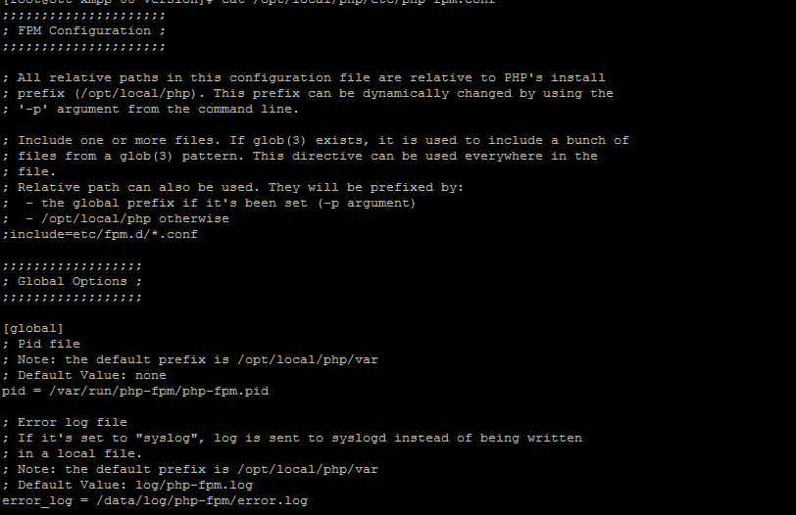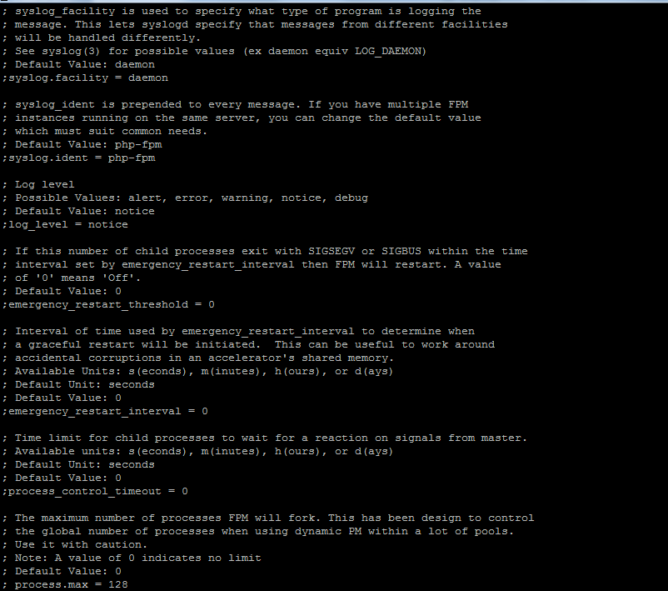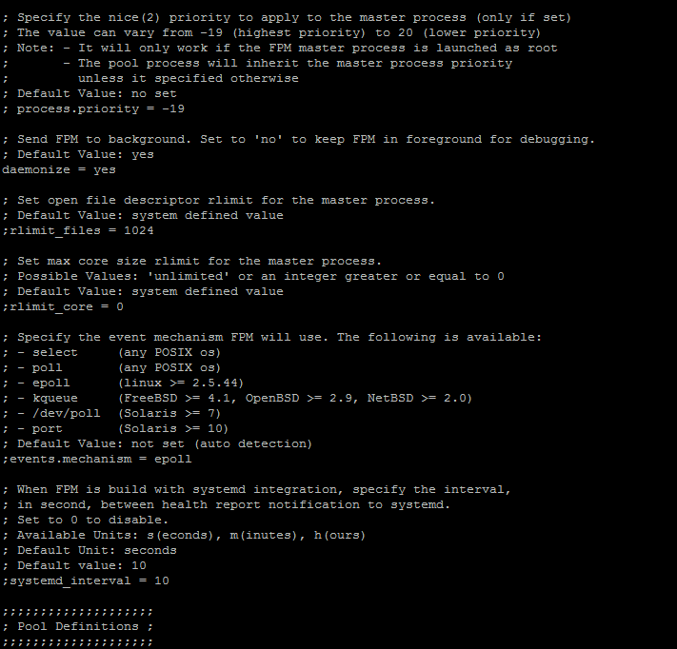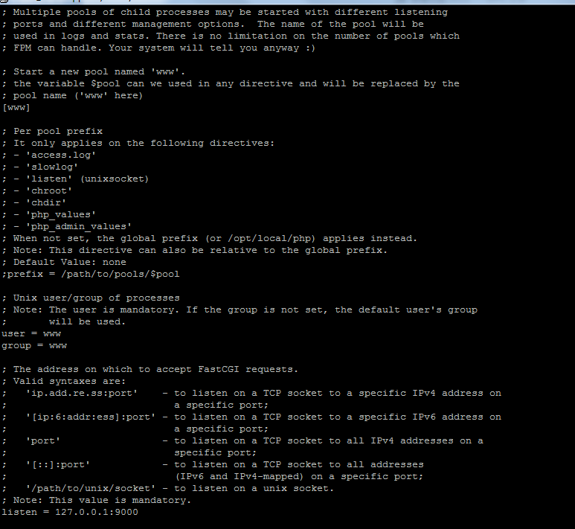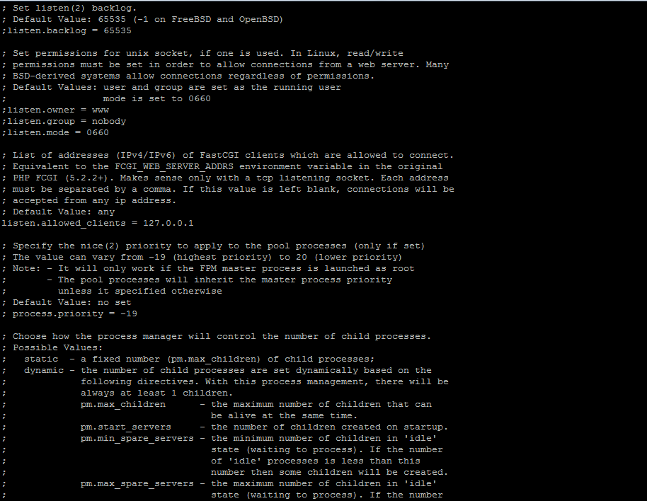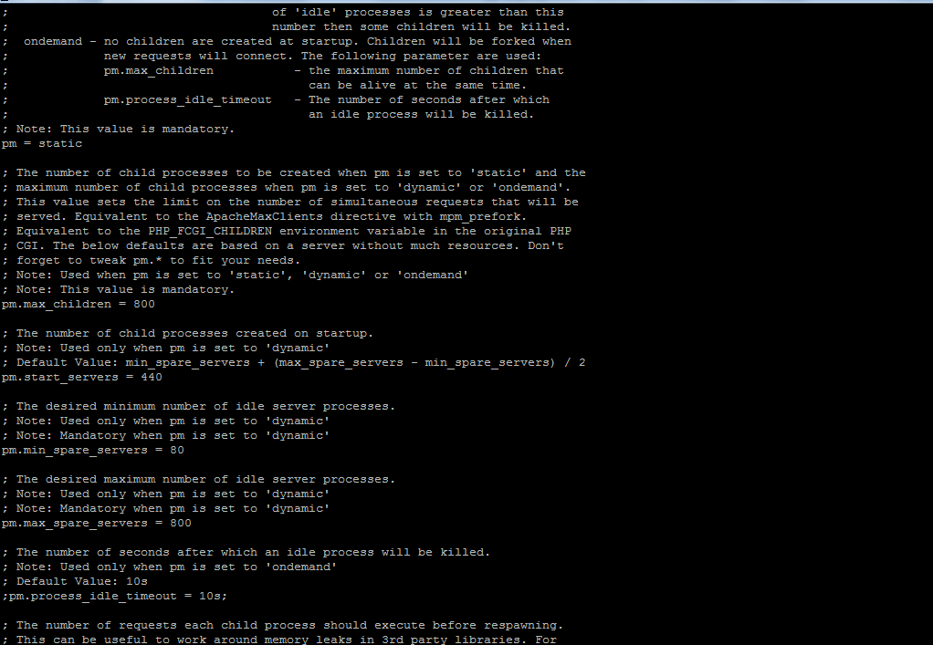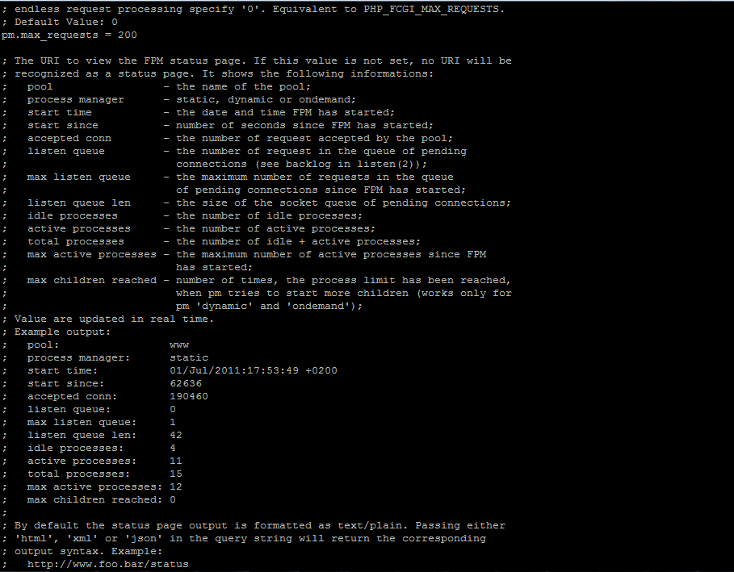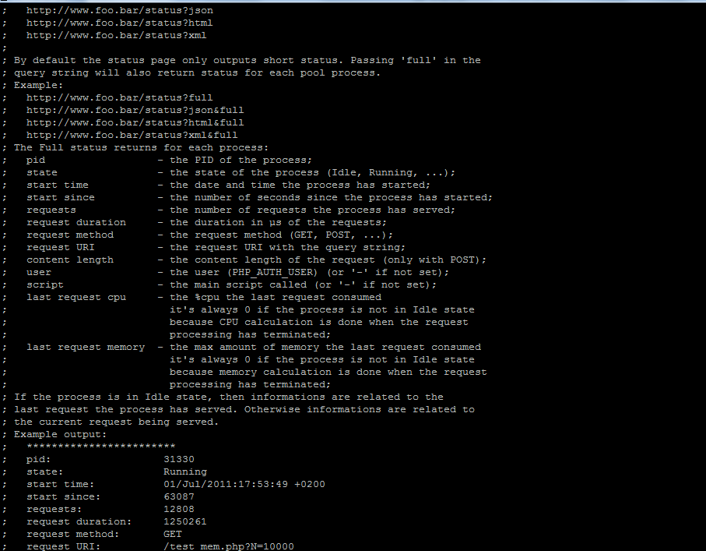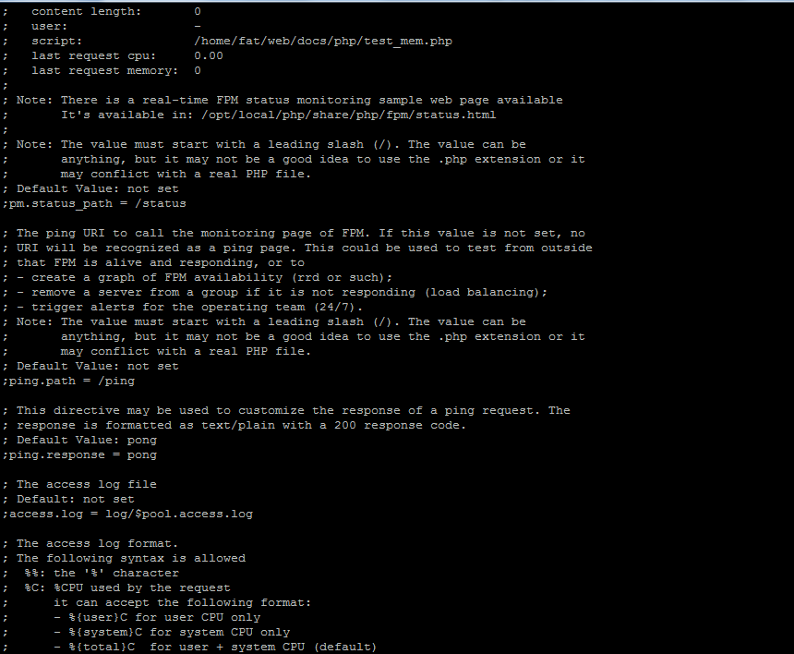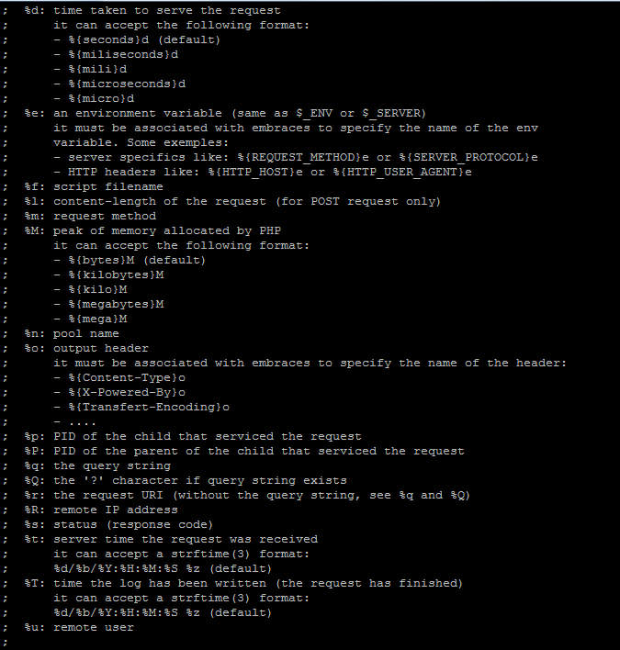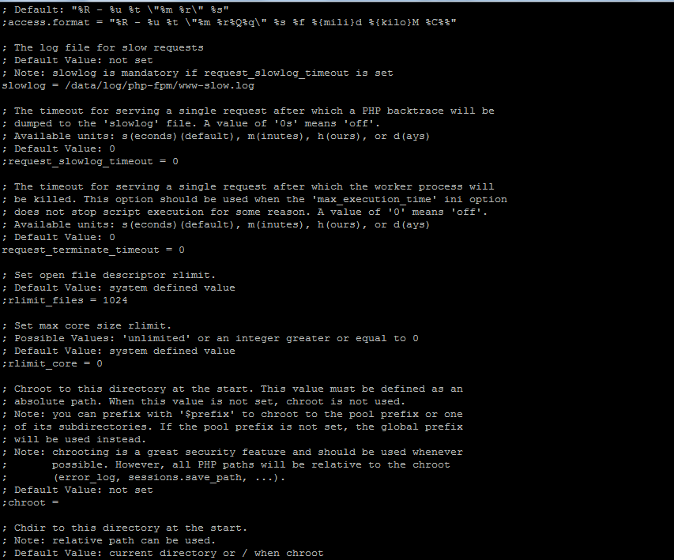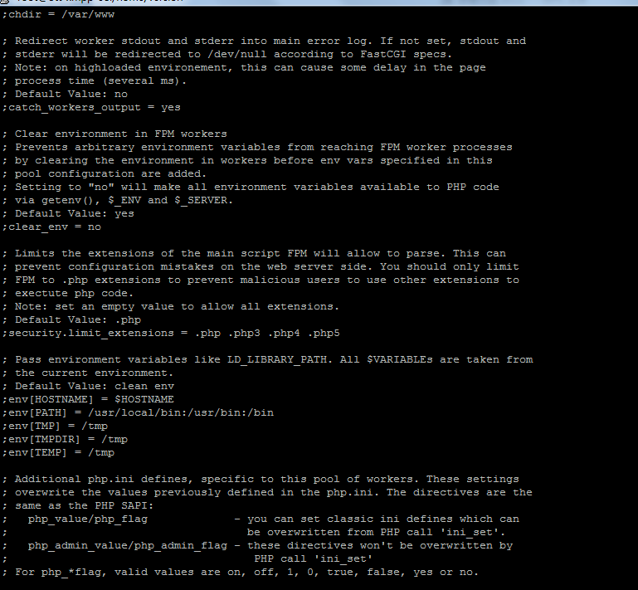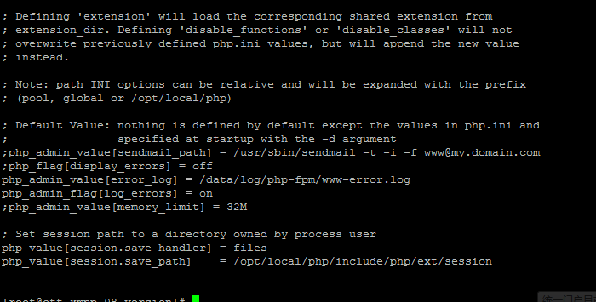

//php.ini

[PHP]

;;;;;;;;;;;;;;;;;;;

; About php.ini ;

;;;;;;;;;;;;;;;;;;;

; PHP's initialization file, generally called php.ini, is responsible for

; configuring many of the aspects of PHP's behavior.

; PHP attempts to find and load this configuration from a number of locations.

; The following is a summary of its search order:

; 1. SAPI module specific location.

; 2. The PHPRC environment variable. (As of PHP 5.2.0)

; 3. A number of predefined registry keys on Windows (As of PHP 5.2.0)

; 4. Current working directory (except CLI)

; 5. The web server's directory (for SAPI modules), or directory of PHP

; (otherwise in Windows)

; 6. The directory from the --with-config-file-path compile time option, or the

; Windows directory (C:\windows or C:\winnt)

; See the PHP docs for more specific information.

; http://www.php.net/manual/en/configuration.file.php

; The syntax of the file is extremely simple. Whitespace and Lines

; beginning with a semicolon are silently ignored (as you probably guessed).

; Section headers (e.g. [Foo]) are also silently ignored, even though

; they might mean something in the future.

; Directives following the section heading [PATH=/www/mysite] only

; apply to PHP files in the /www/mysite directory. Directives

; following the section heading [HOST=www.example.com] only apply to

; PHP files served from www.example.com. Directives set in these

; special sections cannot be overridden by user-defined INI files or

; at runtime. Currently, [PATH=] and [HOST=] sections only work under

; CGI/FastCGI.

; http://www.php.net/manual/en/ini.sections.php

; Directives are specified using the following syntax:

; directive = value

; Directive names are *case sensitive* - foo=bar is different from FOO=bar.

; Directives are variables used to configure PHP or PHP extensions.

; There is no name validation. If PHP can't find an expected

; directive because it is not set or is mistyped, a default value will be used.

; The value can be a string, a number, a PHP constant (e.g. E_ALL or M_PI), one

; of the INI constants (On, Off, True, False, Yes, No and None) or an expression

; (e.g. E_ALL & ~E_NOTICE), a quoted string ("bar"), or a reference to a

; previously set variable or directive (e.g. ${foo})

; Expressions in the INI file are limited to bitwise operators and parentheses:

; | bitwise OR

; ^ bitwise XOR

; & bitwise AND

; ~ bitwise NOT

; ! boolean NOT

; Boolean flags can be turned on using the values 1, On, True or Yes.

; They can be turned off using the values 0, Off, False or No.

; An empty string can be denoted by simply not writing anything after the equal

; sign, or by using the None keyword:

; foo = ; sets foo to an empty string

; foo = None ; sets foo to an empty string

; foo = "None" ; sets foo to the string 'None'

; If you use constants in your value, and these constants belong to a

; dynamically loaded extension (either a PHP extension or a Zend extension),

; you may only use these constants *after* the line that loads the extension.

;;;;;;;;;;;;;;;;;;;

; About this file ;

;;;;;;;;;;;;;;;;;;;

; PHP comes packaged with two INI files. One that is recommended to be used

; in production environments and one that is recommended to be used in

; development environments.

; php.ini-production contains settings which hold security, performance and

; best practices at its core. But please be aware, these settings may break

; compatibility with older or less security conscience applications. We

; recommending using the production ini in production and testing environments.

; php.ini-development is very similar to its production variant, except it's

; much more verbose when it comes to errors. We recommending using the

; development version only in development environments as errors shown to

; application users can inadvertently leak otherwise secure information.

; This 2 files are provided, by RPM, in /usr/share/doc/php-common-*/

; File used by RPM (the /etc/php.ini) is mainly the php.ini-production

;;;;;;;;;;;;;;;;;;;

; Quick Reference ;

;;;;;;;;;;;;;;;;;;;

; The following are all the settings which are different in either the production

; or development versions of the INIs with respect to PHP's default behavior.

; Please see the actual settings later in the document for more details as to why

; we recommend these changes in PHP's behavior.

; allow_call_time_pass_reference

; Default Value: On

; Development Value: Off

; Production Value: Off

; display_errors

; Default Value: On

; Development Value: On

; Production Value: Off

; display_startup_errors

; Default Value: Off

; Development Value: On

; Production Value: Off

; error_reporting

; Default Value: E_ALL & ~E_NOTICE

; Development Value: E_ALL | E_STRICT

; Production Value: E_ALL & ~E_DEPRECATED

; html_errors

; Default Value: On

; Development Value: On

; Production value: Off

; log_errors

; Default Value: Off

; Development Value: On

; Production Value: On

; magic_quotes_gpc

; Default Value: On

; Development Value: Off

; Production Value: Off

; max_input_time

; Default Value: -1 (Unlimited)

; Development Value: 60 (60 seconds)

; Production Value: 60 (60 seconds)

; output_buffering

; Default Value: Off

; Development Value: 4096

; Production Value: 4096

; register_argc_argv

; Default Value: On

; Development Value: Off

; Production Value: Off

; register_long_arrays

; Default Value: On

; Development Value: Off

; Production Value: Off

; request_order

; Default Value: None

; Development Value: "GP"

; Production Value: "GP"

; session.bug_compat_42

; Default Value: On

; Development Value: On

; Production Value: Off

; session.bug_compat_warn

; Default Value: On

; Development Value: On

; Production Value: Off

; session.gc_divisor

; Default Value: 100

; Development Value: 1000

; Production Value: 1000

; session.hash_bits_per_character

; Default Value: 4

; Development Value: 5

; Production Value: 5

; short_open_tag

; Default Value: On

; Development Value: Off

; Production Value: Off

; track_errors

; Default Value: Off

; Development Value: On

; Production Value: Off

; url_rewriter.tags

; Default Value: "a=href,area=href,frame=src,form=,fieldset="

; Development Value: "a=href,area=href,frame=src,input=src,form=fakeentry"

; Production Value: "a=href,area=href,frame=src,input=src,form=fakeentry"

; variables_order

; Default Value: "EGPCS"

; Development Value: "GPCS"

; Production Value: "GPCS"

;;;;;;;;;;;;;;;;;;;;

; php.ini Options ;

;;;;;;;;;;;;;;;;;;;;

; Name for user-defined php.ini (.htaccess) files. Default is ".user.ini"

;user_ini.filename = ".user.ini"

; To disable this feature set this option to empty value

;user_ini.filename =

; TTL for user-defined php.ini files (time-to-live) in seconds. Default is 300 seconds (5 minutes)

;user_ini.cache_ttl = 300

;;;;;;;;;;;;;;;;;;;;

; Language Options ;

;;;;;;;;;;;;;;;;;;;;

; Enable the PHP scripting language engine under Apache.

; http://www.php.net/manual/en/apache.configuration.php#ini.engine

engine = On

; This directive determines whether or not PHP will recognize code between

; <? and ?> tags as PHP source which should be processed as such. It's been

; recommended for several years that you not use the short tag "short cut" and

; instead to use the full <?php and ?> tag combination. With the wide spread use

; of XML and use of these tags by other languages, the server can become easily

; confused and end up parsing the wrong code in the wrong context. But because

; this short cut has been a feature for such a long time, it's currently still

; supported for backwards compatibility, but we recommend you don't use them.

; Default Value: On

; Development Value: Off

; Production Value: Off

; http://www.php.net/manual/en/ini.core.php#ini.short-open-tag

short_open_tag = Off

; Allow ASP-style <% %> tags.

; http://www.php.net/manual/en/ini.core.php#ini.asp-tags

asp_tags = Off

; The number of significant digits displayed in floating point numbers.

; http://www.php.net/manual/en/ini.core.php#ini.precision

precision = 14

; Enforce year 2000 compliance (will cause problems with non-compliant browsers)

; http://www.php.net/manual/en/ini.core.php#ini.y2k-compliance

y2k_compliance = On

; Output buffering is a mechanism for controlling how much output data

; (excluding headers and cookies) PHP should keep internally before pushing that

; data to the client. If your application's output exceeds this setting, PHP

; will send that data in chunks of roughly the size you specify.

; Turning on this setting and managing its maximum buffer size can yield some

; interesting side-effects depending on your application and web server.

; You may be able to send headers and cookies after you've already sent output

; through print or echo. You also may see performance benefits if your server is

; emitting less packets due to buffered output versus PHP streaming the output

; as it gets it. On production servers, 4096 bytes is a good setting for performance

; reasons.

; Note: Output buffering can also be controlled via Output Buffering Control

; functions.

; Possible Values:

; On = Enabled and buffer is unlimited. (Use with caution)

; Off = Disabled

; Integer = Enables the buffer and sets its maximum size in bytes.

; Default Value: Off

; Development Value: 4096

; Production Value: 4096

; http://www.php.net/manual/en/outcontrol.configuration.php#ini.output-buffering

output_buffering = 4096

; You can redirect all of the output of your scripts to a function. For

; example, if you set output_handler to "mb_output_handler", character

; encoding will be transparently converted to the specified encoding.

; Setting any output handler automatically turns on output buffering.

; Note: People who wrote portable scripts should not depend on this ini

; directive. Instead, explicitly set the output handler using ob_start().

; Using this ini directive may cause problems unless you know what script

; is doing.

; Note: You cannot use both "mb_output_handler" with "ob_iconv_handler"

; and you cannot use both "ob_gzhandler" and "zlib.output_compression".

; Note: output_handler must be empty if this is set 'On' !!!!

; Instead you must use zlib.output_handler.

; http://www.php.net/manual/en/outcontrol.configuration.php#ini.output-handler

;output_handler =

; Transparent output compression using the zlib library

; Valid values for this option are 'off', 'on', or a specific buffer size

; to be used for compression (default is 4KB)

; Note: Resulting chunk size may vary due to nature of compression. PHP

; outputs chunks that are few hundreds bytes each as a result of

; compression. If you prefer a larger chunk size for better

; performance, enable output_buffering in addition.

; Note: You need to use zlib.output_handler instead of the standard

; output_handler, or otherwise the output will be corrupted.

; http://www.php.net/manual/en/zlib.configuration.php#ini.zlib.output-compression

zlib.output_compression = Off

; http://www.php.net/manual/en/zlib.configuration.php#ini.zlib.output-compression-level

;zlib.output_compression_level = -1

; You cannot specify additional output handlers if zlib.output_compression

; is activated here. This setting does the same as output_handler but in

; a different order.

; http://www.php.net/manual/en/zlib.configuration.php#ini.zlib.output-handler

;zlib.output_handler =

; Implicit flush tells PHP to tell the output layer to flush itself

; automatically after every output block. This is equivalent to calling the

; PHP function flush() after each and every call to print() or echo() and each

; and every HTML block. Turning this option on has serious performance

; implications and is generally recommended for debugging purposes only.

; http://www.php.net/manual/en/outcontrol.configuration.php#ini.implicit-flush

implicit_flush = Off

; The unserialize callback function will be called (with the undefined class'

; name as parameter), if the unserializer finds an undefined class

; which should be instantiated. A warning appears if the specified function is

; not defined, or if the function doesn't include/implement the missing class.

; So only set this entry, if you really want to implement such a

; callback-function.

unserialize_callback_func =

; When floats & doubles are serialized store serialize_precision significant

; digits after the floating point. The default value ensures that when floats

; are decoded with unserialize, the data will remain the same.

serialize_precision = 100

; This directive allows you to enable and disable warnings which PHP will issue

; if you pass a value by reference at function call time. Passing values by

; reference at function call time is a deprecated feature which will be removed

; from PHP at some point in the near future. The acceptable method for passing a

; value by reference to a function is by declaring the reference in the functions

; definition, not at call time. This directive does not disable this feature, it

; only determines whether PHP will warn you about it or not. These warnings

; should enabled in development environments only.

; Default Value: On (Suppress warnings)

; Development Value: Off (Issue warnings)

; Production Value: Off (Issue warnings)

; http://www.php.net/manual/en/ini.core.php#ini.allow-call-time-pass-reference

allow_call_time_pass_reference = Off

; Safe Mode

; http://www.php.net/manual/en/ini.sect.safe-mode.php#ini.safe-mode

safe_mode = Off

; By default, Safe Mode does a UID compare check when

; opening files. If you want to relax this to a GID compare,

; then turn on safe_mode_gid.

; http://www.php.net/manual/en/ini.sect.safe-mode.php#ini.safe-mode-gid

safe_mode_gid = Off

; When safe_mode is on, UID/GID checks are bypassed when

; including files from this directory and its subdirectories.

; (directory must also be in include_path or full path must

; be used when including)

; http://www.php.net/manual/en/ini.sect.safe-mode.php#ini.safe-mode-include-dir

safe_mode_include_dir =

; When safe_mode is on, only executables located in the safe_mode_exec_dir

; will be allowed to be executed via the exec family of functions.

; http://www.php.net/manual/en/ini.sect.safe-mode.php#ini.safe-mode-exec-dir

safe_mode_exec_dir =

; Setting certain environment variables may be a potential security breach.

; This directive contains a comma-delimited list of prefixes. In Safe Mode,

; the user may only alter environment variables whose names begin with the

; prefixes supplied here. By default, users will only be able to set

; environment variables that begin with PHP_ (e.g. PHP_FOO=BAR).

; Note: If this directive is empty, PHP will let the user modify ANY

; environment variable!

; http://www.php.net/manual/en/ini.sect.safe-mode.php#ini.safe-mode-allowed-env-vars

safe_mode_allowed_env_vars = PHP_

; This directive contains a comma-delimited list of environment variables that

; the end user won't be able to change using putenv(). These variables will be

; protected even if safe_mode_allowed_env_vars is set to allow to change them.

; http://www.php.net/manual/en/ini.sect.safe-mode.php#ini.safe-mode-protected-env-vars

safe_mode_protected_env_vars = LD_LIBRARY_PATH

; open_basedir, if set, limits all file operations to the defined directory

; and below. This directive makes most sense if used in a per-directory

; or per-virtualhost web server configuration file. This directive is

; *NOT* affected by whether Safe Mode is turned On or Off.

; http://www.php.net/manual/en/ini.sect.safe-mode.php#ini.open-basedir

;open_basedir =

; This directive allows you to disable certain functions for security reasons.

; It receives a comma-delimited list of function names. This directive is

; *NOT* affected by whether Safe Mode is turned On or Off.

; http://www.php.net/manual/en/ini.sect.safe-mode.php#ini.disable-functions

disable_functions =

; This directive allows you to disable certain classes for security reasons.

; It receives a comma-delimited list of class names. This directive is

; *NOT* affected by whether Safe Mode is turned On or Off.

; http://www.php.net/manual/en/ini.sect.safe-mode.php#ini.disable-classes

disable_classes =

; Colors for Syntax Highlighting mode. Anything that's acceptable in

; <span style="color: ???????"> would work.

; http://www.php.net/manual/en/misc.configuration.php#ini.syntax-highlighting

;highlight.string = #DD0000

;highlight.comment = #FF9900

;highlight.keyword = #007700

;highlight.bg = #FFFFFF

;highlight.default = #0000BB

;highlight.html = #000000

; If enabled, the request will be allowed to complete even if the user aborts

; the request. Consider enabling it if executing long requests, which may end up

; being interrupted by the user or a browser timing out. PHP's default behavior

; is to disable this feature.

; http://www.php.net/manual/en/misc.configuration.php#ini.ignore-user-abort

;ignore_user_abort = On

; Determines the size of the realpath cache to be used by PHP. This value should

; be increased on systems where PHP opens many files to reflect the quantity of

; the file operations performed.

; http://www.php.net/manual/en/ini.core.php#ini.realpath-cache-size

;realpath_cache_size = 16k

; Duration of time, in seconds for which to cache realpath information for a given

; file or directory. For systems with rarely changing files, consider increasing this

; value.

; http://www.php.net/manual/en/ini.core.php#ini.realpath-cache-ttl

;realpath_cache_ttl = 120

;;;;;;;;;;;;;;;;;

; Miscellaneous ;

;;;;;;;;;;;;;;;;;

; Decides whether PHP may expose the fact that it is installed on the server

; (e.g. by adding its signature to the Web server header). It is no security

; threat in any way, but it makes it possible to determine whether you use PHP

; on your server or not.

; http://www.php.net/manual/en/ini.core.php#ini.expose-php

expose_php = On

;;;;;;;;;;;;;;;;;;;

; Resource Limits ;

;;;;;;;;;;;;;;;;;;;

; Maximum execution time of each script, in seconds

; http://www.php.net/manual/en/info.configuration.php#ini.max-execution-time

max_execution_time = 30

; Maximum amount of time each script may spend parsing request data. It's a good

; idea to limit this time on productions servers in order to eliminate unexpectedly

; long running scripts.

; Default Value: -1 (Unlimited)

; Development Value: 60 (60 seconds)

; Production Value: 60 (60 seconds)

; http://www.php.net/manual/en/info.configuration.php#ini.max-input-time

max_input_time = 60

; Maximum input variable nesting level

; http://www.php.net/manual/en/info.configuration.php#ini.max-input-nesting-level

;max_input_nesting_level = 64

; Maximum amount of memory a script may consume (128MB)

; http://www.php.net/manual/en/ini.core.php#ini.memory-limit

memory_limit = 128M

;;;;;;;;;;;;;;;;;;;;;;;;;;;;;;

; Error handling and logging ;

;;;;;;;;;;;;;;;;;;;;;;;;;;;;;;

; This directive informs PHP of which errors, warnings and notices you would like

; it to take action for. The recommended way of setting values for this

; directive is through the use of the error level constants and bitwise

; operators. The error level constants are below here for convenience as well as

; some common settings and their meanings.

; By default, PHP is set to take action on all errors, notices and warnings EXCEPT

; those related to E_NOTICE and E_STRICT, which together cover best practices and

; recommended coding standards in PHP. For performance reasons, this is the

; recommend error reporting setting. Your production server shouldn't be wasting

; resources complaining about best practices and coding standards. That's what

; development servers and development settings are for.

; Note: The php.ini-development file has this setting as E_ALL | E_STRICT. This

; means it pretty much reports everything which is exactly what you want during

; development and early testing.

;

; Error Level Constants:

; E_ALL - All errors and warnings (includes E_STRICT as of PHP 6.0.0)

; E_ERROR - fatal run-time errors

; E_RECOVERABLE_ERROR - almost fatal run-time errors

; E_WARNING - run-time warnings (non-fatal errors)

; E_PARSE - compile-time parse errors

; E_NOTICE - run-time notices (these are warnings which often result

; from a bug in your code, but it's possible that it was

; intentional (e.g., using an uninitialized variable and

; relying on the fact it's automatically initialized to an

; empty string)

; E_STRICT - run-time notices, enable to have PHP suggest changes

; to your code which will ensure the best interoperability

; and forward compatibility of your code

; E_CORE_ERROR - fatal errors that occur during PHP's initial startup

; E_CORE_WARNING - warnings (non-fatal errors) that occur during PHP's

; initial startup

; E_COMPILE_ERROR - fatal compile-time errors

; E_COMPILE_WARNING - compile-time warnings (non-fatal errors)

; E_USER_ERROR - user-generated error message

; E_USER_WARNING - user-generated warning message

; E_USER_NOTICE - user-generated notice message

; E_DEPRECATED - warn about code that will not work in future versions

; of PHP

; E_USER_DEPRECATED - user-generated deprecation warnings

;

; Common Values:

; E_ALL & ~E_NOTICE (Show all errors, except for notices and coding standards warnings.)

; E_ALL & ~E_NOTICE | E_STRICT (Show all errors, except for notices)

; E_COMPILE_ERROR|E_RECOVERABLE_ERROR|E_ERROR|E_CORE_ERROR (Show only errors)

; E_ALL | E_STRICT (Show all errors, warnings and notices including coding standards.)

; Default Value: E_ALL & ~E_NOTICE

; Development Value: E_ALL | E_STRICT

; Production Value: E_ALL & ~E_DEPRECATED

; http://www.php.net/manual/en/errorfunc.configuration.php#ini.error-reporting

error_reporting = E_ALL & ~E_DEPRECATED

; This directive controls whether or not and where PHP will output errors,

; notices and warnings too. Error output is very useful during development, but

; it could be very dangerous in production environments. Depending on the code

; which is triggering the error, sensitive information could potentially leak

; out of your application such as database usernames and passwords or worse.

; It's recommended that errors be logged on production servers rather than

; having the errors sent to STDOUT.

; Possible Values:

; Off = Do not display any errors

; stderr = Display errors to STDERR (affects only CGI/CLI binaries!)

; On or stdout = Display errors to STDOUT

; Default Value: On

; Development Value: On

; Production Value: Off

; http://www.php.net/manual/en/errorfunc.configuration.php#ini.display-errors

display_errors = Off

; The display of errors which occur during PHP's startup sequence are handled

; separately from display_errors. PHP's default behavior is to suppress those

; errors from clients. Turning the display of startup errors on can be useful in

; debugging configuration problems. But, it's strongly recommended that you

; leave this setting off on production servers.

; Default Value: Off

; Development Value: On

; Production Value: Off

; http://www.php.net/manual/en/errorfunc.configuration.php#ini.display-startup-errors

display_startup_errors = Off

; Besides displaying errors, PHP can also log errors to locations such as a

; server-specific log, STDERR, or a location specified by the error_log

; directive found below. While errors should not be displayed on productions

; servers they should still be monitored and logging is a great way to do that.

; Default Value: Off

; Development Value: On

; Production Value: On

; http://www.php.net/manual/en/errorfunc.configuration.php#ini.log-errors

log_errors = On

; Set maximum length of log_errors. In error_log information about the source is

; added. The default is 1024 and 0 allows to not apply any maximum length at all.

; http://www.php.net/manual/en/errorfunc.configuration.php#ini.log-errors-max-len

log_errors_max_len = 1024

; Do not log repeated messages. Repeated errors must occur in same file on same

; line unless ignore_repeated_source is set true.

; http://www.php.net/manual/en/errorfunc.configuration.php#ini.ignore-repeated-errors

ignore_repeated_errors = Off

; Ignore source of message when ignoring repeated messages. When this setting

; is On you will not log errors with repeated messages from different files or

; source lines.

; http://www.php.net/manual/en/errorfunc.configuration.php#ini.ignore-repeated-source

ignore_repeated_source = Off

; If this parameter is set to Off, then memory leaks will not be shown (on

; stdout or in the log). This has only effect in a debug compile, and if

; error reporting includes E_WARNING in the allowed list

; http://www.php.net/manual/en/errorfunc.configuration.php#ini.report-memleaks

report_memleaks = On

; This setting is on by default.

;report_zend_debug = 0

; Store the last error/warning message in $php_errormsg (boolean). Setting this value

; to On can assist in debugging and is appropriate for development servers. It should

; however be disabled on production servers.

; Default Value: Off

; Development Value: On

; Production Value: Off

; http://www.php.net/manual/en/errorfunc.configuration.php#ini.track-errors

track_errors = Off

; Turn off normal error reporting and emit XML-RPC error XML

; http://www.php.net/manual/en/errorfunc.configuration.php#ini.xmlrpc-errors

;xmlrpc_errors = 0

; An XML-RPC faultCode

;xmlrpc_error_number = 0

; When PHP displays or logs an error, it has the capability of inserting html

; links to documentation related to that error. This directive controls whether

; those HTML links appear in error messages or not. For performance and security

; reasons, it's recommended you disable this on production servers.

; Default Value: On

; Development Value: On

; Production value: Off

; http://www.php.net/manual/en/errorfunc.configuration.php#ini.html-errors

html_errors = Off

; If html_errors is set On PHP produces clickable error messages that direct

; to a page describing the error or function causing the error in detail.

; You can download a copy of the PHP manual from http://www.php.net/docs.php

; and change docref_root to the base URL of your local copy including the

; leading '/'. You must also specify the file extension being used including

; the dot. PHP's default behavior is to leave these settings empty.

; Note: Never use this feature for production boxes.

; http://www.php.net/manual/en/errorfunc.configuration.php#ini.docref-root

; Examples

;docref_root = "/phpmanual/"

; http://www.php.net/manual/en/errorfunc.configuration.php#ini.docref-ext

;docref_ext = .html

; String to output before an error message. PHP's default behavior is to leave

; this setting blank.

; http://www.php.net/manual/en/errorfunc.configuration.php#ini.error-prepend-string

; Example:

;error_prepend_string = "<font color=#ff0000>"

; String to output after an error message. PHP's default behavior is to leave

; this setting blank.

; http://www.php.net/manual/en/errorfunc.configuration.php#ini.error-append-string

; Example:

;error_append_string = "</font>"

; Log errors to specified file. PHP's default behavior is to leave this value

; empty.

; http://www.php.net/manual/en/errorfunc.configuration.php#ini.error-log

; Example:

;error_log = php_errors.log

; Log errors to syslog (Event Log on NT, not valid in Windows 95).

;error_log = syslog

;;;;;;;;;;;;;;;;;

; Data Handling ;

;;;;;;;;;;;;;;;;;

; Note - track_vars is ALWAYS enabled as of PHP 4.0.3

; The separator used in PHP generated URLs to separate arguments.

; PHP's default setting is "&".

; http://www.php.net/manual/en/ini.core.php#ini.arg-separator.output

; Example:

;arg_separator.output = "&amp;"

; List of separator(s) used by PHP to parse input URLs into variables.

; PHP's default setting is "&".

; NOTE: Every character in this directive is considered as separator!

; http://www.php.net/manual/en/ini.core.php#ini.arg-separator.input

; Example:

;arg_separator.input = ";&"

; This directive determines which super global arrays are registered when PHP

; starts up. If the register_globals directive is enabled, it also determines

; what order variables are populated into the global space. G,P,C,E & S are

; abbreviations for the following respective super globals: GET, POST, COOKIE,

; ENV and SERVER. There is a performance penalty paid for the registration of

; these arrays and because ENV is not as commonly used as the others, ENV is

; is not recommended on productions servers. You can still get access to

; the environment variables through getenv() should you need to.

; Default Value: "EGPCS"

; Development Value: "GPCS"

; Production Value: "GPCS";

; http://www.php.net/manual/en/ini.core.php#ini.variables-order

variables_order = "GPCS"

; This directive determines which super global data (G,P,C,E & S) should

; be registered into the super global array REQUEST. If so, it also determines

; the order in which that data is registered. The values for this directive are

; specified in the same manner as the variables_order directive, EXCEPT one.

; Leaving this value empty will cause PHP to use the value set in the

; variables_order directive. It does not mean it will leave the super globals

; array REQUEST empty.

; Default Value: None

; Development Value: "GP"

; Production Value: "GP"

; http://www.php.net/manual/en/ini.core.php#ini.request-order

request_order = "GP"

; Whether or not to register the EGPCS variables as global variables. You may

; want to turn this off if you don't want to clutter your scripts' global scope

; with user data. This makes most sense when coupled with track_vars - in which

; case you can access all of the GPC variables through the $HTTP_*_VARS[],

; variables.

; You should do your best to write your scripts so that they do not require

; register_globals to be on; Using form variables as globals can easily lead

; to possible security problems, if the code is not very well thought of.

; http://www.php.net/manual/en/ini.core.php#ini.register-globals

register_globals = Off

; Determines whether the deprecated long $HTTP_*_VARS type predefined variables

; are registered by PHP or not. As they are deprecated, we obviously don't

; recommend you use them. They are on by default for compatibility reasons but

; they are not recommended on production servers.

; Default Value: On

; Development Value: Off

; Production Value: Off

; http://www.php.net/manual/en/ini.core.php#ini.register-long-arrays

register_long_arrays = Off

; This directive determines whether PHP registers $argv & $argc each time it

; runs. $argv contains an array of all the arguments passed to PHP when a script

; is invoked. $argc contains an integer representing the number of arguments

; that were passed when the script was invoked. These arrays are extremely

; useful when running scripts from the command line. When this directive is

; enabled, registering these variables consumes CPU cycles and memory each time

; a script is executed. For performance reasons, this feature should be disabled

; on production servers.

; Default Value: On

; Development Value: Off

; Production Value: Off

; http://www.php.net/manual/en/ini.core.php#ini.register-argc-argv

register_argc_argv = Off

; When enabled, the SERVER and ENV variables are created when they're first

; used (Just In Time) instead of when the script starts. If these variables

; are not used within a script, having this directive on will result in a

; performance gain. The PHP directives register_globals, register_long_arrays,

; and register_argc_argv must be disabled for this directive to have any affect.

; http://www.php.net/manual/en/ini.core.php#ini.auto-globals-jit

auto_globals_jit = On

; Maximum size of POST data that PHP will accept.

; http://www.php.net/manual/en/ini.core.php#ini.post-max-size

post_max_size = 100M

; Magic quotes are a preprocessing feature of PHP where PHP will attempt to

; escape any character sequences in GET, POST, COOKIE and ENV data which might

; otherwise corrupt data being placed in resources such as databases before

; making that data available to you. Because of character encoding issues and

; non-standard SQL implementations across many databases, it's not currently

; possible for this feature to be 100% accurate. PHP's default behavior is to

; enable the feature. We strongly recommend you use the escaping mechanisms

; designed specifically for the database your using instead of relying on this

; feature. Also note, this feature has been deprecated as of PHP 5.3.0 and is

; scheduled for removal in PHP 6.

; Default Value: On

; Development Value: Off

; Production Value: Off

; http://www.php.net/manual/en/info.configuration.php#ini.magic-quotes-gpc

magic_quotes_gpc = Off

; Magic quotes for runtime-generated data, e.g. data from SQL, from exec(), etc.

; http://www.php.net/manual/en/info.configuration.php#ini.magic-quotes-runtime

magic_quotes_runtime = Off

; Use Sybase-style magic quotes (escape ' with '' instead of \').

; http://www.php.net/manual/en/sybase.configuration.php#ini.magic-quotes-sybase

magic_quotes_sybase = Off

; Automatically add files before PHP document.

; http://www.php.net/manual/en/ini.core.php#ini.auto-prepend-file

auto_prepend_file =

; Automatically add files after PHP document.

; http://www.php.net/manual/en/ini.core.php#ini.auto-append-file

auto_append_file =

; As of 4.0b4, PHP always outputs a character encoding by default in

; the Content-type: header. To disable sending of the charset, simply

; set it to be empty.

;

; PHP's built-in default is text/html

; http://www.php.net/manual/en/ini.core.php#ini.default-mimetype

default_mimetype = "text/html"

; PHP's default character set is set to empty.

; http://www.php.net/manual/en/ini.core.php#ini.default-charset

;default_charset = "iso-8859-1"

; Always populate the $HTTP_RAW_POST_DATA variable. PHP's default behavior is

; to disable this feature.

; http://www.php.net/manual/en/ini.core.php#ini.always-populate-raw-post-data

;always_populate_raw_post_data = On

;;;;;;;;;;;;;;;;;;;;;;;;;

; Paths and Directories ;

;;;;;;;;;;;;;;;;;;;;;;;;;

; UNIX: "/path1:/path2"

;include_path = ".:/php/includes"

;

; Windows: "\path1;\path2"

;include_path = ".;c:\php\includes"

;

; PHP's default setting for include_path is ".;/path/to/php/pear"

; http://www.php.net/manual/en/ini.core.php#ini.include-path

; The root of the PHP pages, used only if nonempty.

; if PHP was not compiled with FORCE_REDIRECT, you SHOULD set doc_root

; if you are running php as a CGI under any web server (other than IIS)

; see documentation for security issues. The alternate is to use the

; cgi.force_redirect configuration below

; http://www.php.net/manual/en/ini.core.php#ini.doc-root

doc_root =

; The directory under which PHP opens the script using /~username used only

; if nonempty.

; http://www.php.net/manual/en/ini.core.php#ini.user-dir

user_dir =

; Directory in which the loadable extensions (modules) reside.

; http://www.php.net/manual/en/ini.core.php#ini.extension-dir

extension_dir = "/etc/php.d/"

; Whether or not to enable the dl() function. The dl() function does NOT work

; properly in multithreaded servers, such as IIS or Zeus, and is automatically

; disabled on them.

; http://www.php.net/manual/en/info.configuration.php#ini.enable-dl

enable_dl = Off

; cgi.force_redirect is necessary to provide security running PHP as a CGI under

; most web servers. Left undefined, PHP turns this on by default. You can

; turn it off here AT YOUR OWN RISK

; **You CAN safely turn this off for IIS, in fact, you MUST.**

; http://www.php.net/manual/en/ini.core.php#ini.cgi.force-redirect

;cgi.force_redirect = 1

; if cgi.nph is enabled it will force cgi to always sent Status: 200 with

; every request. PHP's default behavior is to disable this feature.

;cgi.nph = 1

; if cgi.force_redirect is turned on, and you are not running under Apache or Netscape

; (iPlanet) web servers, you MAY need to set an environment variable name that PHP

; will look for to know it is OK to continue execution. Setting this variable MAY

; cause security issues, KNOW WHAT YOU ARE DOING FIRST.

; http://www.php.net/manual/en/ini.core.php#ini.cgi.redirect-status-env

;cgi.redirect_status_env = ;

; cgi.fix_pathinfo provides *real* PATH_INFO/PATH_TRANSLATED support for CGI. PHP's

; previous behaviour was to set PATH_TRANSLATED to SCRIPT_FILENAME, and to not grok

; what PATH_INFO is. For more information on PATH_INFO, see the cgi specs. Setting

; this to 1 will cause PHP CGI to fix its paths to conform to the spec. A setting

; of zero causes PHP to behave as before. Default is 1. You should fix your scripts

; to use SCRIPT_FILENAME rather than PATH_TRANSLATED.

; http://www.php.net/manual/en/ini.core.php#ini.cgi.fix-pathinfo

;cgi.fix_pathinfo=1

; FastCGI under IIS (on WINNT based OS) supports the ability to impersonate

; security tokens of the calling client. This allows IIS to define the

; security context that the request runs under. mod_fastcgi under Apache

; does not currently support this feature (03/17/2002)

; Set to 1 if running under IIS. Default is zero.

; http://www.php.net/manual/en/ini.core.php#ini.fastcgi.impersonate

;fastcgi.impersonate = 1;

; Disable logging through FastCGI connection. PHP's default behavior is to enable

; this feature.

;fastcgi.logging = 0

; cgi.rfc2616_headers configuration option tells PHP what type of headers to

; use when sending HTTP response code. If it's set 0 PHP sends Status: header that

; is supported by Apache. When this option is set to 1 PHP will send

; RFC2616 compliant header.

; Default is zero.

; http://www.php.net/manual/en/ini.core.php#ini.cgi.rfc2616-headers

;cgi.rfc2616_headers = 0

;;;;;;;;;;;;;;;;

; File Uploads ;

;;;;;;;;;;;;;;;;

; Whether to allow HTTP file uploads.

; http://www.php.net/manual/en/ini.core.php#ini.file-uploads

file_uploads = On

; Temporary directory for HTTP uploaded files (will use system default if not

; specified).

; http://www.php.net/manual/en/ini.core.php#ini.upload-tmp-dir

;upload_tmp_dir =

; Maximum allowed size for uploaded files.

; http://www.php.net/manual/en/ini.core.php#ini.upload-max-filesize

upload_max_filesize = 100M

;;;;;;;;;;;;;;;;;;

; Fopen wrappers ;

;;;;;;;;;;;;;;;;;;

; Whether to allow the treatment of URLs (like http:// or ftp://) as files.

; http://www.php.net/manual/en/filesystem.configuration.php#ini.allow-url-fopen

allow_url_fopen = On

; Whether to allow include/require to open URLs (like http:// or ftp://) as files.

; http://www.php.net/manual/en/filesystem.configuration.php#ini.allow-url-include

allow_url_include = Off

; Define the anonymous ftp password (your email address). PHP's default setting

; for this is empty.

; http://www.php.net/manual/en/filesystem.configuration.php#ini.from

;from="john@doe.com"

; Define the User-Agent string. PHP's default setting for this is empty.

; http://www.php.net/manual/en/filesystem.configuration.php#ini.user-agent

;user_agent="PHP"

; Default timeout for socket based streams (seconds)

; http://www.php.net/manual/en/filesystem.configuration.php#ini.default-socket-timeout

default_socket_timeout = 60

; If your scripts have to deal with files from Macintosh systems,

; or you are running on a Mac and need to deal with files from

; unix or win32 systems, setting this flag will cause PHP to

; automatically detect the EOL character in those files so that

; fgets() and file() will work regardless of the source of the file.

; http://www.php.net/manual/en/filesystem.configuration.php#ini.auto-detect-line-endings

;auto_detect_line_endings = Off

;;;;;;;;;;;;;;;;;;;;;;

; Dynamic Extensions ;

;;;;;;;;;;;;;;;;;;;;;;

; If you wish to have an extension loaded automatically, use the following

; syntax:

;

; extension=modulename.extension

;

; For example

;

; extension=msql.so

;

; ... or with a path:

;

; extension=/path/to/extension/msql.so

;

; If you only provide the name of the extension, PHP will look for it in its

; default extension directory.

;;;;

; Note: packaged extension modules are now loaded via the .ini files

; found in the directory /etc/php.d; these are loaded by default.

;;;;

;;;;;;;;;;;;;;;;;;;

; Module Settings ;

;;;;;;;;;;;;;;;;;;;

[Date]

; Defines the default timezone used by the date functions

; http://www.php.net/manual/en/datetime.configuration.php#ini.date.timezone

date.timezone =Asia/Shanghai

; http://www.php.net/manual/en/datetime.configuration.php#ini.date.default-latitude

;date.default_latitude = 31.7667

; http://www.php.net/manual/en/datetime.configuration.php#ini.date.default-longitude

;date.default_longitude = 35.2333

; http://www.php.net/manual/en/datetime.configuration.php#ini.date.sunrise-zenith

;date.sunrise_zenith = 90.583333

; http://www.php.net/manual/en/datetime.configuration.php#ini.date.sunset-zenith

;date.sunset_zenith = 90.583333

[filter]

; http://www.php.net/manual/en/filter.configuration.php#ini.filter.default

;filter.default = unsafe_raw

; http://www.php.net/manual/en/filter.configuration.php#ini.filter.default-flags

;filter.default_flags =

[iconv]

;iconv.input_encoding = ISO-8859-1

;iconv.internal_encoding = ISO-8859-1

;iconv.output_encoding = ISO-8859-1

[intl]

;intl.default_locale =

[sqlite]

; http://www.php.net/manual/en/sqlite.configuration.php#ini.sqlite.assoc-case

;sqlite.assoc_case = 0

[sqlite3]

;sqlite3.extension_dir =

[Pcre]

;PCRE library backtracking limit.

; http://www.php.net/manual/en/pcre.configuration.php#ini.pcre.backtrack-limit

;pcre.backtrack_limit=100000

;PCRE library recursion limit.

;Please note that if you set this value to a high number you may consume all

;the available process stack and eventually crash PHP (due to reaching the

;stack size limit imposed by the Operating System).

; http://www.php.net/manual/en/pcre.configuration.php#ini.pcre.recursion-limit

;pcre.recursion_limit=100000

[Pdo]

; Whether to pool ODBC connections. Can be one of "strict", "relaxed" or "off"

; http://www.php.net/manual/en/ref.pdo-odbc.php#ini.pdo-odbc.connection-pooling

;pdo_odbc.connection_pooling=strict

[Phar]

; http://www.php.net/manual/en/phar.configuration.php#ini.phar.readonly

;phar.readonly = On

; http://www.php.net/manual/en/phar.configuration.php#ini.phar.require-hash

;phar.require_hash = On

;phar.cache_list =

[Syslog]

; Whether or not to define the various syslog variables (e.g. $LOG_PID,

; $LOG_CRON, etc.). Turning it off is a good idea performance-wise. In

; runtime, you can define these variables by calling define_syslog_variables().

; http://www.php.net/manual/en/network.configuration.php#ini.define-syslog-variables

define_syslog_variables = Off

[mail function]

; For Win32 only.

; http://www.php.net/manual/en/mail.configuration.php#ini.smtp

SMTP = localhost

; http://www.php.net/manual/en/mail.configuration.php#ini.smtp-port

smtp_port = 25

; For Win32 only.

; http://www.php.net/manual/en/mail.configuration.php#ini.sendmail-from

;sendmail_from = me@example.com

; For Unix only. You may supply arguments as well (default: "sendmail -t -i").

; http://www.php.net/manual/en/mail.configuration.php#ini.sendmail-path

sendmail_path = /usr/sbin/sendmail -t -i

; Force the addition of the specified parameters to be passed as extra parameters

; to the sendmail binary. These parameters will always replace the value of

; the 5th parameter to mail(), even in safe mode.

;mail.force_extra_parameters =

; Add X-PHP-Originaiting-Script: that will include uid of the script followed by the filename

mail.add_x_header = On

; Log all mail() calls including the full path of the script, line #, to address and headers

;mail.log =

[SQL]

; http://www.php.net/manual/en/ini.core.php#ini.sql.safe-mode

sql.safe_mode = Off

[ODBC]

; http://www.php.net/manual/en/odbc.configuration.php#ini.uodbc.default-db

;odbc.default_db = Not yet implemented

; http://www.php.net/manual/en/odbc.configuration.php#ini.uodbc.default-user

;odbc.default_user = Not yet implemented

; http://www.php.net/manual/en/odbc.configuration.php#ini.uodbc.default-pw

;odbc.default_pw = Not yet implemented

; Allow or prevent persistent links.

; http://www.php.net/manual/en/odbc.configuration.php#ini.uodbc.allow-persistent

odbc.allow_persistent = On

; Check that a connection is still valid before reuse.

; http://www.php.net/manual/en/odbc.configuration.php#ini.uodbc.check-persistent

odbc.check_persistent = On

; Maximum number of persistent links. -1 means no limit.

; http://www.php.net/manual/en/odbc.configuration.php#ini.uodbc.max-persistent

odbc.max_persistent = -1

; Maximum number of links (persistent + non-persistent). -1 means no limit.

; http://www.php.net/manual/en/odbc.configuration.php#ini.uodbc.max-links

odbc.max_links = -1

; Handling of LONG fields. Returns number of bytes to variables. 0 means

; passthru.

; http://www.php.net/manual/en/odbc.configuration.php#ini.uodbc.defaultlrl

odbc.defaultlrl = 4096

; Handling of binary data. 0 means passthru, 1 return as is, 2 convert to char.

; See the documentation on odbc_binmode and odbc_longreadlen for an explanation

; of uodbc.defaultlrl and uodbc.defaultbinmode

; http://www.php.net/manual/en/odbc.configuration.php#ini.uodbc.defaultbinmode

odbc.defaultbinmode = 1

;birdstep.max_links = -1

[MySQL]

; Allow or prevent persistent links.

; http://www.php.net/manual/en/mysql.configuration.php#ini.mysql.allow-persistent

mysql.allow_persistent = On

; Maximum number of persistent links. -1 means no limit.

; http://www.php.net/manual/en/mysql.configuration.php#ini.mysql.max-persistent

mysql.max_persistent = -1

; Maximum number of links (persistent + non-persistent). -1 means no limit.

; http://www.php.net/manual/en/mysql.configuration.php#ini.mysql.max-links

mysql.max_links = -1

; Default port number for mysql_connect(). If unset, mysql_connect() will use

; the $MYSQL_TCP_PORT or the mysql-tcp entry in /etc/services or the

; compile-time value defined MYSQL_PORT (in that order). Win32 will only look

; at MYSQL_PORT.

; http://www.php.net/manual/en/mysql.configuration.php#ini.mysql.default-port

mysql.default_port =

; Default socket name for local MySQL connects. If empty, uses the built-in

; MySQL defaults.

; http://www.php.net/manual/en/mysql.configuration.php#ini.mysql.default-socket

mysql.default_socket =

; Default host for mysql_connect() (doesn't apply in safe mode).

; http://www.php.net/manual/en/mysql.configuration.php#ini.mysql.default-host

mysql.default_host =

; Default user for mysql_connect() (doesn't apply in safe mode).

; http://www.php.net/manual/en/mysql.configuration.php#ini.mysql.default-user

mysql.default_user =

; Default password for mysql_connect() (doesn't apply in safe mode).

; Note that this is generally a *bad* idea to store passwords in this file.

; *Any* user with PHP access can run 'echo get_cfg_var("mysql.default_password")

; and reveal this password! And of course, any users with read access to this

; file will be able to reveal the password as well.

; http://www.php.net/manual/en/mysql.configuration.php#ini.mysql.default-password

mysql.default_password =

; Maximum time (in seconds) for connect timeout. -1 means no limit

; http://www.php.net/manual/en/mysql.configuration.php#ini.mysql.connect-timeout

mysql.connect_timeout = 60

; Trace mode. When trace_mode is active (=On), warnings for table/index scans and

; SQL-Errors will be displayed.

; http://www.php.net/manual/en/mysql.configuration.php#ini.mysql.trace-mode

mysql.trace_mode = Off

[MySQLi]

; Maximum number of links. -1 means no limit.

; http://www.php.net/manual/en/mysqli.configuration.php#ini.mysqli.max-links

mysqli.max_links = -1

; Default port number for mysqli_connect(). If unset, mysqli_connect() will use

; the $MYSQL_TCP_PORT or the mysql-tcp entry in /etc/services or the

; compile-time value defined MYSQL_PORT (in that order). Win32 will only look

; at MYSQL_PORT.

; http://www.php.net/manual/en/mysqli.configuration.php#ini.mysqli.default-port

mysqli.default_port = 3306

; Default socket name for local MySQL connects. If empty, uses the built-in

; MySQL defaults.

; http://www.php.net/manual/en/mysqli.configuration.php#ini.mysqli.default-socket

mysqli.default_socket =

; Default host for mysql_connect() (doesn't apply in safe mode).

; http://www.php.net/manual/en/mysqli.configuration.php#ini.mysqli.default-host

mysqli.default_host =

; Default user for mysql_connect() (doesn't apply in safe mode).

; http://www.php.net/manual/en/mysqli.configuration.php#ini.mysqli.default-user

mysqli.default_user =

; Default password for mysqli_connect() (doesn't apply in safe mode).

; Note that this is generally a *bad* idea to store passwords in this file.

; *Any* user with PHP access can run 'echo get_cfg_var("mysqli.default_pw")

; and reveal this password! And of course, any users with read access to this

; file will be able to reveal the password as well.

; http://www.php.net/manual/en/mysqli.configuration.php#ini.mysqli.default-pw

mysqli.default_pw =

; Allow or prevent reconnect

mysqli.reconnect = Off

[PostgresSQL]

; Allow or prevent persistent links.

; http://www.php.net/manual/en/pgsql.configuration.php#ini.pgsql.allow-persistent

pgsql.allow_persistent = On

; Detect broken persistent links always with pg_pconnect().

; Auto reset feature requires a little overheads.

; http://www.php.net/manual/en/pgsql.configuration.php#ini.pgsql.auto-reset-persistent

pgsql.auto_reset_persistent = Off

; Maximum number of persistent links. -1 means no limit.

; http://www.php.net/manual/en/pgsql.configuration.php#ini.pgsql.max-persistent

pgsql.max_persistent = -1

; Maximum number of links (persistent+non persistent). -1 means no limit.

; http://www.php.net/manual/en/pgsql.configuration.php#ini.pgsql.max-links

pgsql.max_links = -1

; Ignore PostgreSQL backends Notice message or not.

; Notice message logging require a little overheads.

; http://www.php.net/manual/en/pgsql.configuration.php#ini.pgsql.ignore-notice

pgsql.ignore_notice = 0

; Log PostgreSQL backends Noitce message or not.

; Unless pgsql.ignore_notice=0, module cannot log notice message.

; http://www.php.net/manual/en/pgsql.configuration.php#ini.pgsql.log-notice

pgsql.log_notice = 0

[Sybase-CT]

; Allow or prevent persistent links.

; http://www.php.net/manual/en/sybase.configuration.php#ini.sybct.allow-persistent

sybct.allow_persistent = On

; Maximum number of persistent links. -1 means no limit.

; http://www.php.net/manual/en/sybase.configuration.php#ini.sybct.max-persistent

sybct.max_persistent = -1

; Maximum number of links (persistent + non-persistent). -1 means no limit.

; http://www.php.net/manual/en/sybase.configuration.php#ini.sybct.max-links

sybct.max_links = -1

; Minimum server message severity to display.

; http://www.php.net/manual/en/sybase.configuration.php#ini.sybct.min-server-severity

sybct.min_server_severity = 10

; Minimum client message severity to display.

; http://www.php.net/manual/en/sybase.configuration.php#ini.sybct.min-client-severity

sybct.min_client_severity = 10

; Set per-context timeout

; http://www.php.net/manual/en/sybase.configuration.php#ini.sybct.timeout

;sybct.timeout=

;sybct.packet_size

[bcmath]

; Number of decimal digits for all bcmath functions.

; http://www.php.net/manual/en/bc.configuration.php#ini.bcmath.scale

bcmath.scale = 0

[browscap]

; http://www.php.net/manual/en/misc.configuration.php#ini.browscap

;browscap = extra/browscap.ini

[Session]

; Handler used to store/retrieve data.

; http://www.php.net/manual/en/session.configuration.php#ini.session.save-handler

session.save_handler = files

; Argument passed to save_handler. In the case of files, this is the path

; where data files are stored. Note: Windows users have to change this

; variable in order to use PHP's session functions.

;

; As of PHP 4.0.1, you can define the path as:

;

; session.save_path = "N;/path"

;

; where N is an integer. Instead of storing all the session files in

; /path, what this will do is use subdirectories N-levels deep, and

; store the session data in those directories. This is useful if you

; or your OS have problems with lots of files in one directory, and is

; a more efficient layout for servers that handle lots of sessions.

;

; NOTE 1: PHP will not create this directory structure automatically.

; You can use the script in the ext/session dir for that purpose.

; NOTE 2: See the section on garbage collection below if you choose to

; use subdirectories for session storage

;

; The file storage module creates files using mode 600 by default.

; You can change that by using

;

; session.save_path = "N;MODE;/path"

;

; where MODE is the octal representation of the mode. Note that this

; does not overwrite the process's umask.

; http://www.php.net/manual/en/session.configuration.php#ini.session.save-path

session.save_path = "/var/lib/php/session"

; Whether to use cookies.

; http://www.php.net/manual/en/session.configuration.php#ini.session.use-cookies

session.use_cookies = 1

; http://www.php.net/manual/en/session.configuration.php#ini.session.cookie-secure

;session.cookie_secure =

; This option forces PHP to fetch and use a cookie for storing and maintaining

; the session id. We encourage this operation as it's very helpful in combatting

; session hijacking when not specifying and managing your own session id. It is

; not the end all be all of session hijacking defense, but it's a good start.

; http://www.php.net/manual/en/session.configuration.php#ini.session.use-only-cookies

session.use_only_cookies = 1

; Name of the session (used as cookie name).

; http://www.php.net/manual/en/session.configuration.php#ini.session.name

session.name = PHPSESSID

; Initialize session on request startup.

; http://www.php.net/manual/en/session.configuration.php#ini.session.auto-start

session.auto_start = 0

; Lifetime in seconds of cookie or, if 0, until browser is restarted.

; http://www.php.net/manual/en/session.configuration.php#ini.session.cookie-lifetime

session.cookie_lifetime = 0

; The path for which the cookie is valid.

; http://www.php.net/manual/en/session.configuration.php#ini.session.cookie-path

session.cookie_path = /

; The domain for which the cookie is valid.

; http://www.php.net/manual/en/session.configuration.php#ini.session.cookie-domain

session.cookie_domain =

; Whether or not to add the httpOnly flag to the cookie, which makes it inaccessible to browser scripting languages such as JavaScript.

; http://www.php.net/manual/en/session.configuration.php#ini.session.cookie-httponly

session.cookie_httponly =

; Handler used to serialize data. php is the standard serializer of PHP.

; http://www.php.net/manual/en/session.configuration.php#ini.session.serialize-handler

session.serialize_handler = php

; Defines the probability that the 'garbage collection' process is started

; on every session initialization. The probability is calculated by using

; gc_probability/gc_divisor. Where session.gc_probability is the numerator

; and gc_divisor is the denominator in the equation. Setting this value to 1

; when the session.gc_divisor value is 100 will give you approximately a 1% chance

; the gc will run on any give request.

; Default Value: 1

; Development Value: 1

; Production Value: 1

; http://www.php.net/manual/en/session.configuration.php#ini.session.gc-probability

session.gc_probability = 1

; Defines the probability that the 'garbage collection' process is started on every

; session initialization. The probability is calculated by using the following equation:

; gc_probability/gc_divisor. Where session.gc_probability is the numerator and

; session.gc_divisor is the denominator in the equation. Setting this value to 1

; when the session.gc_divisor value is 100 will give you approximately a 1% chance

; the gc will run on any give request. Increasing this value to 1000 will give you

; a 0.1% chance the gc will run on any give request. For high volume production servers,

; this is a more efficient approach.

; Default Value: 100

; Development Value: 1000

; Production Value: 1000

; http://www.php.net/manual/en/session.configuration.php#ini.session.gc-divisor

session.gc_divisor = 1000

; After this number of seconds, stored data will be seen as 'garbage' and

; cleaned up by the garbage collection process.

; http://www.php.net/manual/en/session.configuration.php#ini.session.gc-maxlifetime

session.gc_maxlifetime = 1440

; NOTE: If you are using the subdirectory option for storing session files

; (see session.save_path above), then garbage collection does *not*

; happen automatically. You will need to do your own garbage

; collection through a shell script, cron entry, or some other method.

; For example, the following script would is the equivalent of

; setting session.gc_maxlifetime to 1440 (1440 seconds = 24 minutes):

; cd /path/to/sessions; find -cmin +24 | xargs rm

; PHP 4.2 and less have an undocumented feature/bug that allows you to

; to initialize a session variable in the global scope, even when register_globals

; is disabled. PHP 4.3 and later will warn you, if this feature is used.

; You can disable the feature and the warning separately. At this time,

; the warning is only displayed, if bug_compat_42 is enabled. This feature

; introduces some serious security problems if not handled correctly. It's

; recommended that you do not use this feature on production servers. But you

; should enable this on development servers and enable the warning as well. If you

; do not enable the feature on development servers, you won't be warned when it's

; used and debugging errors caused by this can be difficult to track down.

; Default Value: On

; Development Value: On

; Production Value: Off

; http://www.php.net/manual/en/session.configuration.php#ini.session.bug-compat-42

session.bug_compat_42 = Off

; This setting controls whether or not you are warned by PHP when initializing a

; session value into the global space. session.bug_compat_42 must be enabled before

; these warnings can be issued by PHP. See the directive above for more information.

; Default Value: On

; Development Value: On

; Production Value: Off

; http://www.php.net/manual/en/session.configuration.php#ini.session.bug-compat-warn

session.bug_compat_warn = Off

; Check HTTP Referer to invalidate externally stored URLs containing ids.

; HTTP_REFERER has to contain this substring for the session to be

; considered as valid.

; http://www.php.net/manual/en/session.configuration.php#ini.session.referer-check

session.referer_check =

; How many bytes to read from the file.

; http://www.php.net/manual/en/session.configuration.php#ini.session.entropy-length

session.entropy_length = 0

; Specified here to create the session id.

; http://www.php.net/manual/en/session.configuration.php#ini.session.entropy-file

;session.entropy_file = /dev/urandom

session.entropy_file =

; http://www.php.net/manual/en/session.configuration.php#ini.session.entropy-length

;session.entropy_length = 16

; Set to {nocache,private,public,} to determine HTTP caching aspects

; or leave this empty to avoid sending anti-caching headers.

; http://www.php.net/manual/en/session.configuration.php#ini.session.cache-limiter

session.cache_limiter = nocache

; Document expires after n minutes.

; http://www.php.net/manual/en/session.configuration.php#ini.session.cache-expire

session.cache_expire = 180

; trans sid support is disabled by default.

; Use of trans sid may risk your users security.

; Use this option with caution.

; - User may send URL contains active session ID

; to other person via. email/irc/etc.

; - URL that contains active session ID may be stored

; in publically accessible computer.

; - User may access your site with the same session ID

; always using URL stored in browser's history or bookmarks.

; http://www.php.net/manual/en/session.configuration.php#ini.session.use-trans-sid

session.use_trans_sid = 0

; Select a hash function for use in generating session ids.

; Possible Values

; 0 (MD5 128 bits)

; 1 (SHA-1 160 bits)

; http://www.php.net/manual/en/session.configuration.php#ini.session.hash-function

session.hash_function = 0

; Define how many bits are stored in each character when converting

; the binary hash data to something readable.

; Possible values:

; 4 (4 bits: 0-9, a-f)

; 5 (5 bits: 0-9, a-v)

; 6 (6 bits: 0-9, a-z, A-Z, "-", ",")

; Default Value: 4

; Development Value: 5

; Production Value: 5

; http://www.php.net/manual/en/session.configuration.php#ini.session.hash-bits-per-character

session.hash_bits_per_character = 5

; The URL rewriter will look for URLs in a defined set of HTML tags.

; form/fieldset are special; if you include them here, the rewriter will

; add a hidden <input> field with the info which is otherwise appended

; to URLs. If you want XHTML conformity, remove the form entry.

; Note that all valid entries require a "=", even if no value follows.

; Default Value: "a=href,area=href,frame=src,form=,fieldset="

; Development Value: "a=href,area=href,frame=src,input=src,form=fakeentry"

; Production Value: "a=href,area=href,frame=src,input=src,form=fakeentry"

; http://www.php.net/manual/en/session.configuration.php#ini.url-rewriter.tags

url_rewriter.tags = "a=href,area=href,frame=src,input=src,form=fakeentry"

[MSSQL]

; Allow or prevent persistent links.

mssql.allow_persistent = On

; Maximum number of persistent links. -1 means no limit.

mssql.max_persistent = -1

; Maximum number of links (persistent+non persistent). -1 means no limit.

mssql.max_links = -1

; Minimum error severity to display.

mssql.min_error_severity = 10

; Minimum message severity to display.

mssql.min_message_severity = 10

; Compatibility mode with old versions of PHP 3.0.

mssql.compatability_mode = Off

; Connect timeout

;mssql.connect_timeout = 5

; Query timeout

;mssql.timeout = 60

; Valid range 0 - 2147483647. Default = 4096.

;mssql.textlimit = 4096

; Valid range 0 - 2147483647. Default = 4096.

;mssql.textsize = 4096

; Limits the number of records in each batch. 0 = all records in one batch.

;mssql.batchsize = 0

; Specify how datetime and datetim4 columns are returned

; On => Returns data converted to SQL server settings

; Off => Returns values as YYYY-MM-DD hh:mm:ss

;mssql.datetimeconvert = On

; Use NT authentication when connecting to the server

mssql.secure_connection = Off

; Specify max number of processes. -1 = library default

; msdlib defaults to 25

; FreeTDS defaults to 4096

;mssql.max_procs = -1

; Specify client character set.

; If empty or not set the client charset from freetds.comf is used

; This is only used when compiled with FreeTDS

;mssql.charset = "ISO-8859-1"

[Assertion]

; Assert(expr); active by default.

; http://www.php.net/manual/en/info.configuration.php#ini.assert.active

;assert.active = On

; Issue a PHP warning for each failed assertion.

; http://www.php.net/manual/en/info.configuration.php#ini.assert.warning

;assert.warning = On

; Don't bail out by default.

; http://www.php.net/manual/en/info.configuration.php#ini.assert.bail

;assert.bail = Off

; User-function to be called if an assertion fails.

; http://www.php.net/manual/en/info.configuration.php#ini.assert.callback

;assert.callback = 0

; Eval the expression with current error_reporting(). Set to true if you want

; error_reporting(0) around the eval().

; http://www.php.net/manual/en/info.configuration.php#ini.assert.quiet-eval

;assert.quiet_eval = 0

[COM]

; path to a file containing GUIDs, IIDs or filenames of files with TypeLibs

; http://www.php.net/manual/en/com.configuration.php#ini.com.typelib-file

;com.typelib_file =

; allow Distributed-COM calls

; http://www.php.net/manual/en/com.configuration.php#ini.com.allow-dcom

;com.allow_dcom = true

; autoregister constants of a components typlib on com_load()

; http://www.php.net/manual/en/com.configuration.php#ini.com.autoregister-typelib

;com.autoregister_typelib = true

; register constants casesensitive

; http://www.php.net/manual/en/com.configuration.php#ini.com.autoregister-casesensitive

;com.autoregister_casesensitive = false

; show warnings on duplicate constant registrations

; http://www.php.net/manual/en/com.configuration.php#ini.com.autoregister-verbose

;com.autoregister_verbose = true

[mbstring]

; language for internal character representation.

; http://www.php.net/manual/en/mbstring.configuration.php#ini.mbstring.language

;mbstring.language = Japanese

; internal/script encoding.

; Some encoding cannot work as internal encoding.

; (e.g. SJIS, BIG5, ISO-2022-*)

; http://www.php.net/manual/en/mbstring.configuration.php#ini.mbstring.internal-encoding

;mbstring.internal_encoding = EUC-JP

; http input encoding.

; http://www.php.net/manual/en/mbstring.configuration.php#ini.mbstring.http-input

;mbstring.http_input = auto

; http output encoding. mb_output_handler must be

; registered as output buffer to function

; http://www.php.net/manual/en/mbstring.configuration.php#ini.mbstring.http-output

;mbstring.http_output = SJIS

; enable automatic encoding translation according to

; mbstring.internal_encoding setting. Input chars are

; converted to internal encoding by setting this to On.

; Note: Do _not_ use automatic encoding translation for

; portable libs/applications.

; http://www.php.net/manual/en/mbstring.configuration.php#ini.mbstring.encoding-translation

;mbstring.encoding_translation = Off

; automatic encoding detection order.

; auto means

; http://www.php.net/manual/en/mbstring.configuration.php#ini.mbstring.detect-order

;mbstring.detect_order = auto

; substitute_character used when character cannot be converted

; one from another

; http://www.php.net/manual/en/mbstring.configuration.php#ini.mbstring.substitute-character

;mbstring.substitute_character = none;

; overload(replace) single byte functions by mbstring functions.

; mail(), ereg(), etc are overloaded by mb_send_mail(), mb_ereg(),

; etc. Possible values are 0,1,2,4 or combination of them.

; For example, 7 for overload everything.

; 0: No overload

; 1: Overload mail() function

; 2: Overload str*() functions

; 4: Overload ereg*() functions

; http://www.php.net/manual/en/mbstring.configuration.php#ini.mbstring.func-overload

;mbstring.func_overload = 0

; enable strict encoding detection.

;mbstring.strict_detection = Off

; This directive specifies the regex pattern of content types for which mb_output_handler()

; is activated.

; Default: mbstring.http_output_conv_mimetype=^(text/|application/xhtml\+xml)

;mbstring.http_output_conv_mimetype=

[gd]

; Tell the jpeg decode to ignore warnings and try to create

; a gd image. The warning will then be displayed as notices

; disabled by default

; http://www.php.net/manual/en/image.configuration.php#ini.image.jpeg-ignore-warning

;gd.jpeg_ignore_warning = 0

;extension=/opt/local/php/lib/php/extensions/no-debug-non-zts-20121212/gd.so

[exif]

; Exif UNICODE user comments are handled as UCS-2BE/UCS-2LE and JIS as JIS.

; With mbstring support this will automatically be converted into the encoding

; given by corresponding encode setting. When empty mbstring.internal_encoding

; is used. For the decode settings you can distinguish between motorola and

; intel byte order. A decode setting cannot be empty.

; http://www.php.net/manual/en/exif.configuration.php#ini.exif.encode-unicode

;exif.encode_unicode = ISO-8859-15

; http://www.php.net/manual/en/exif.configuration.php#ini.exif.decode-unicode-motorola

;exif.decode_unicode_motorola = UCS-2BE

; http://www.php.net/manual/en/exif.configuration.php#ini.exif.decode-unicode-intel

;exif.decode_unicode_intel = UCS-2LE

; http://www.php.net/manual/en/exif.configuration.php#ini.exif.encode-jis

;exif.encode_jis =

; http://www.php.net/manual/en/exif.configuration.php#ini.exif.decode-jis-motorola

;exif.decode_jis_motorola = JIS

; http://www.php.net/manual/en/exif.configuration.php#ini.exif.decode-jis-intel

;exif.decode_jis_intel = JIS

[Tidy]

; The path to a default tidy configuration file to use when using tidy

; http://www.php.net/manual/en/tidy.configuration.php#ini.tidy.default-config

;tidy.default_config = /usr/local/lib/php/default.tcfg

; Should tidy clean and repair output automatically?

; WARNING: Do not use this option if you are generating non-html content

; such as dynamic images

; http://www.php.net/manual/en/tidy.configuration.php#ini.tidy.clean-output

tidy.clean_output = Off

[soap]

; Enables or disables WSDL caching feature.

; http://www.php.net/manual/en/soap.configuration.php#ini.soap.wsdl-cache-enabled

soap.wsdl_cache_enabled=1

; Sets the directory name where SOAP extension will put cache files.

; http://www.php.net/manual/en/soap.configuration.php#ini.soap.wsdl-cache-dir

soap.wsdl_cache_dir="/tmp"

; (time to live) Sets the number of second while cached file will be used

; instead of original one.

; http://www.php.net/manual/en/soap.configuration.php#ini.soap.wsdl-cache-ttl

soap.wsdl_cache_ttl=86400

[sysvshm]

; A default size of the shared memory segment

;sysvshm.init_mem = 10000

extension=memcache.so

;extension_dir="/opt/local/php/lib/php/extensions/no-debug-non-zts-20121212/"

extension_dir="/opt/local/php/lib/php/extensions/no-debug-non-zts-20160303/"

; Local Variables:

; tab-width: 4

; End:

Memcache具体启动

/usr/local/memcached/bin/memcached -d -m 2048 -u root -l 127.0.0.1 -p 11211 -c 25000 -P /var/run/memcached.pid

1.  -d选项是启动一个守护进程，

2.  -m是分配给Memcached使用的内存数量，单位是MB,

3.  -u是运行Memcache的用户，我这里是root，

4.  -l是监听的服务器IP地址,

5.  -p是设置Memcache监听的端口，最好是1024以上的端口，

6.  -c选项是最大运行的并发连接数，默认是1024,按照你服务器的负载量来设定，

7.  -P是设置保存Memcache的pid文件

My.cnf 数据库配置文件

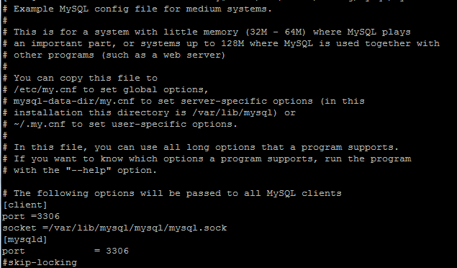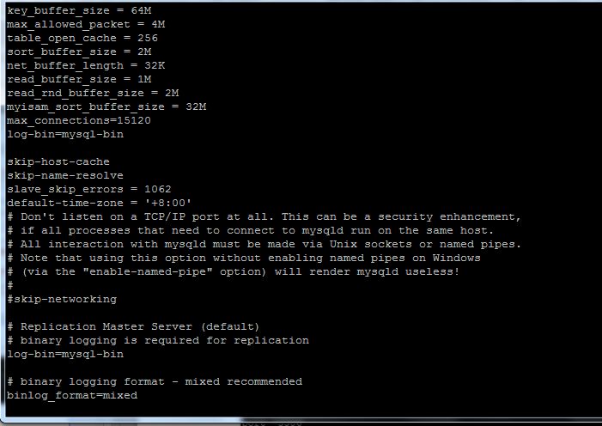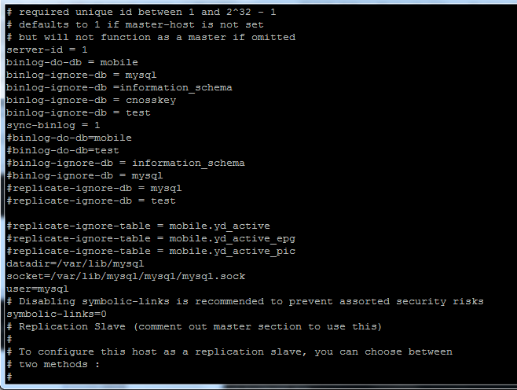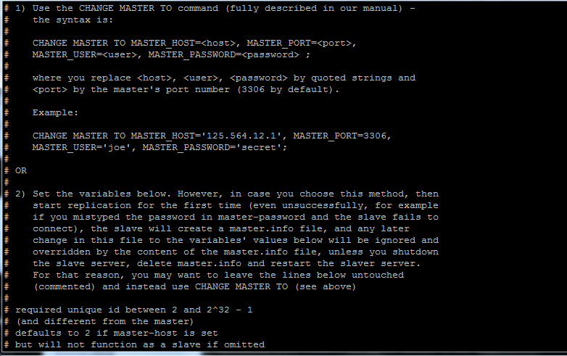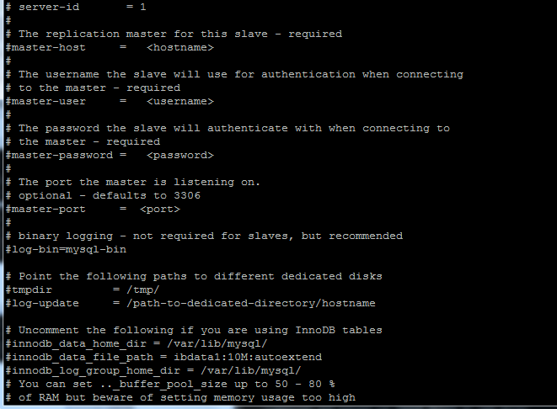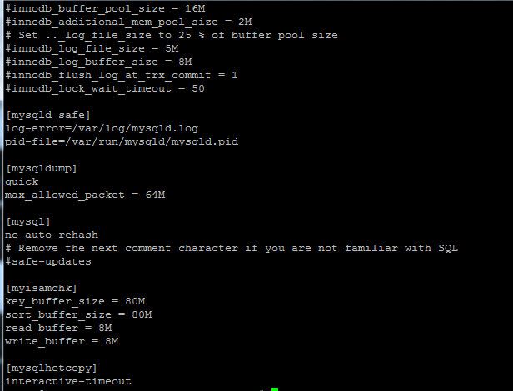

主数据库状态

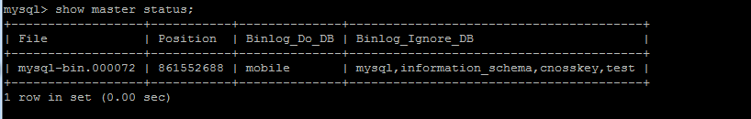

从数据库状态

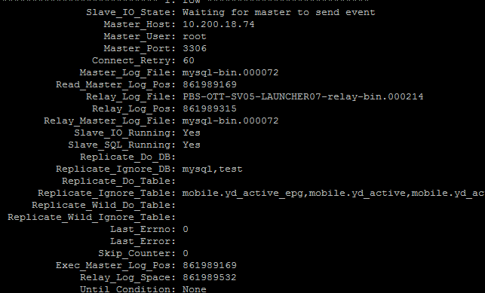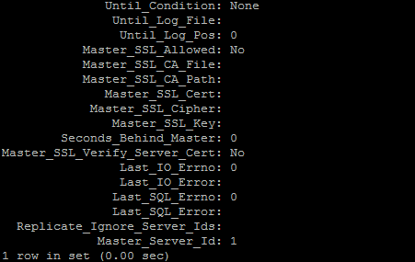

Vsftpd.conf

