<https://www.unhcr.org/refugee-statistics/>

<https://www.unhcr.org/refugee-statistics/download/?url=1Vq6Bu>

https://www.unhcr.org/refugee-statistics/download/?url=1Vq6Bu

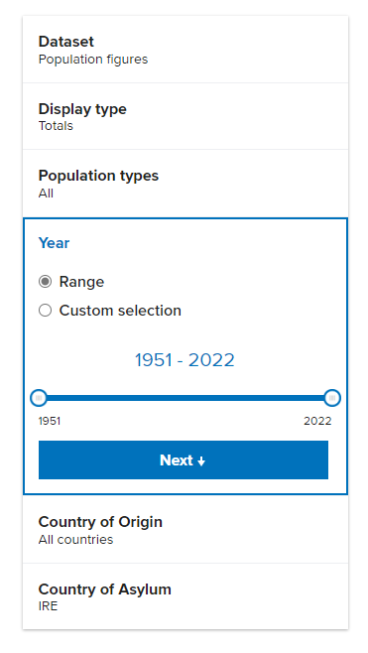

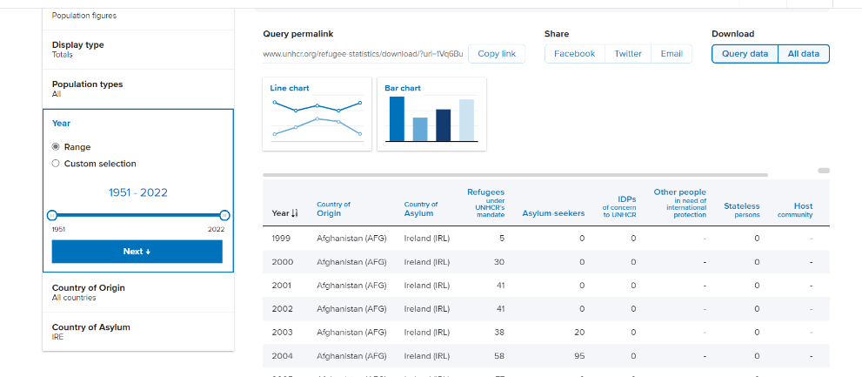

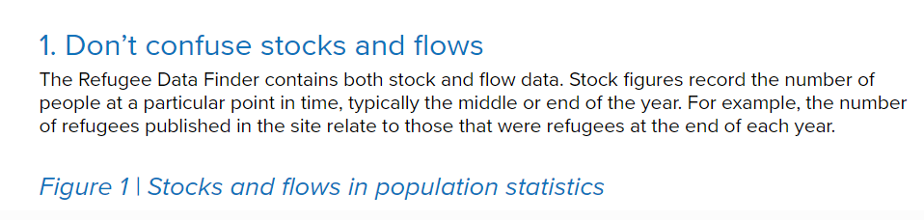

Therefore, an individual is either in the status of an asylum seeker or a refugee at any given moment. The transition from being an asylum seeker to a refugee occurs when the legal determination is made by the host country's authorities. It's important to note that the legal processes and criteria for asylum and refugee status may vary between countries.