ATM System User Manual

**Test Accounts:**

0123 JudyFeng 1235 27900.00 N

2341 GoliathLi 1236 30000.00 V

2351 WeifengSu 1237 40000.00 N

Login

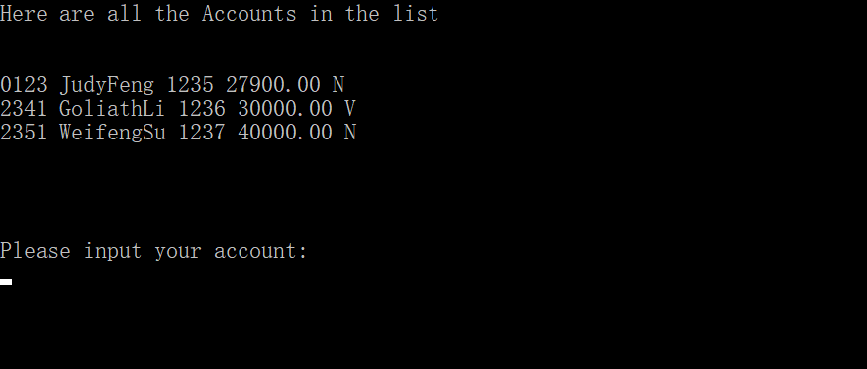

Follow the hints to input **account** and **password.**

If account and password **does not match**, the programme will **stop**.

Welcome Menu

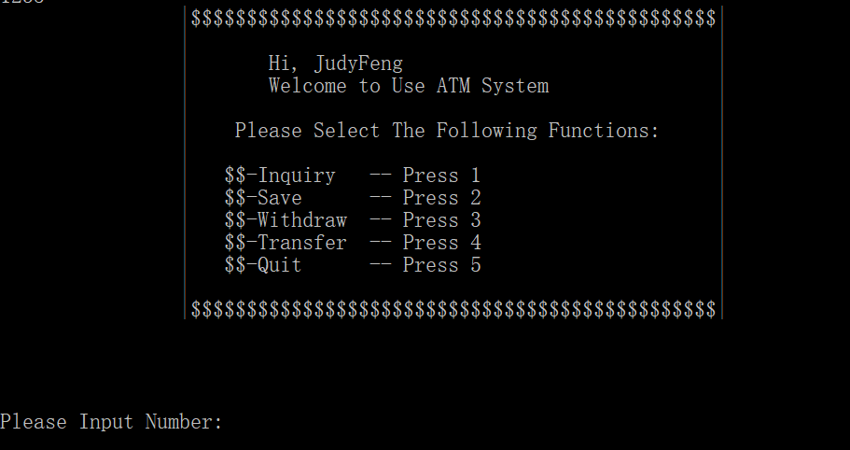

Input 1/2/3/4/5 for functions.

Inquiry

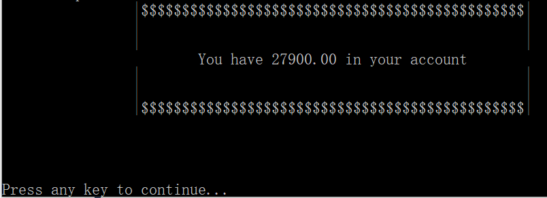

When 1 is input, balance will show like above.

Can return to main menu by pressing any key.

Save

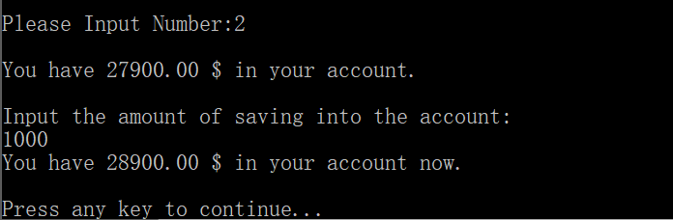

When 2 is input, your balance will show and you can **input the amount of money** that you want to save. The input value should be a **positive number**.

After saving, the balance will update and show again.

Can return to main menu by pressing any key.

Withdraw

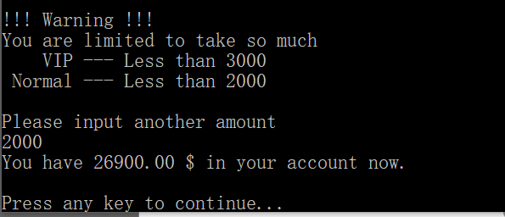

When 3 is input, you will be asked to input the amount of withdrawal.

**CAUTIONS:** For VIP account, this amount should not exceed 3000 while for normal account it should not exceed 2000.

After withdrawal, your balance will update and show.

Can return to main menu by pressing any key.

Transfer

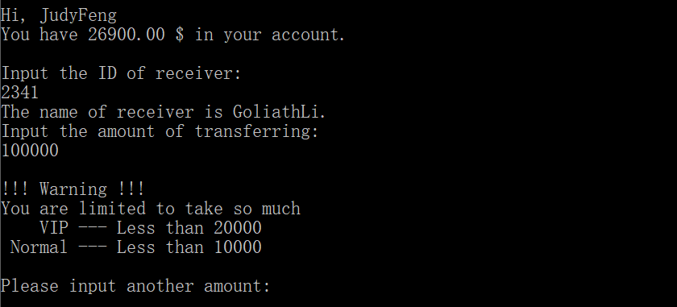

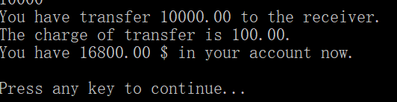

When 4 is input, your balance will show.

You can follow the tips to input the **ID of receiver**. If there is a invalid input, the system will **return to main menu automatically**.

The amount of transfer **should not exceed 20000 for VIP users** and **10000 for normal users**, repectively. If a invalid amount is input, you can follow the tips to input again.

If transfer completed successfully, **the transfer amount**, **the transfer poundage** and **the account balance** will show.

Can return to main menu by pressing any key.

Quit

Input 5 to quit the whole system.

|  |  |  |
| --- | --- | --- |
| Contribution Table | | |
| 黄子豪 | 1730026119 | 25% |
| 李俊江 | 1730026044 | 25% |
| 何朗轩 | 1730026028 | 25% |
| 吴舒扬 | 1730026119 | 25% |