**Trabajos forkeados y que se hicieron pull**

<https://github.com/Jhans18/Jhans18.github.io>

fork

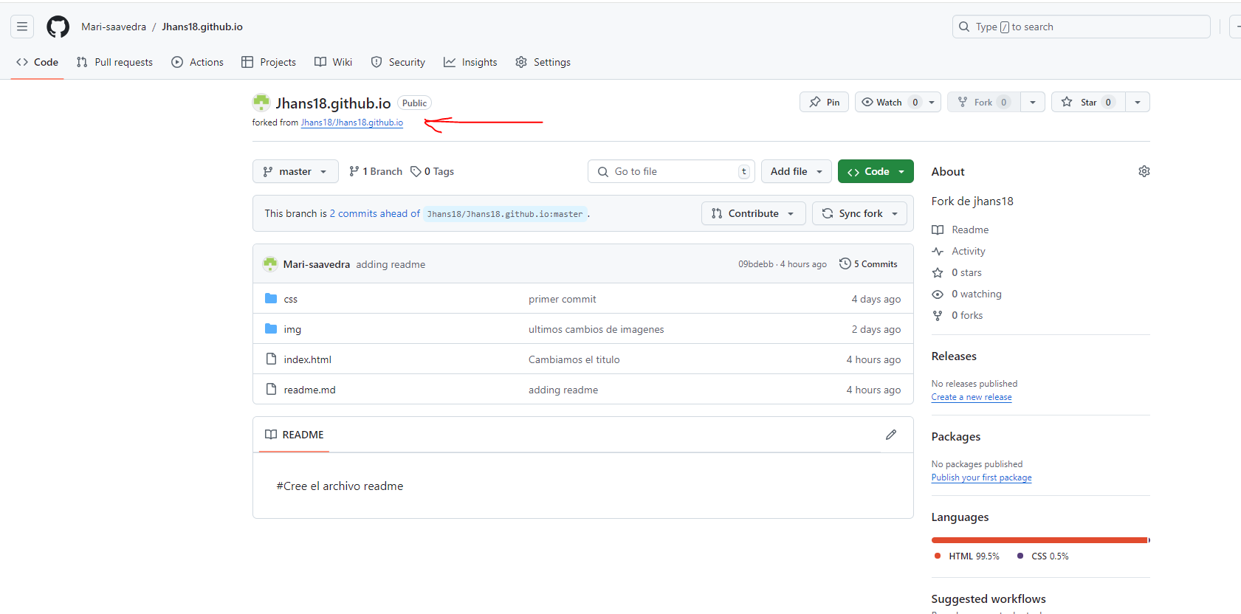

commit

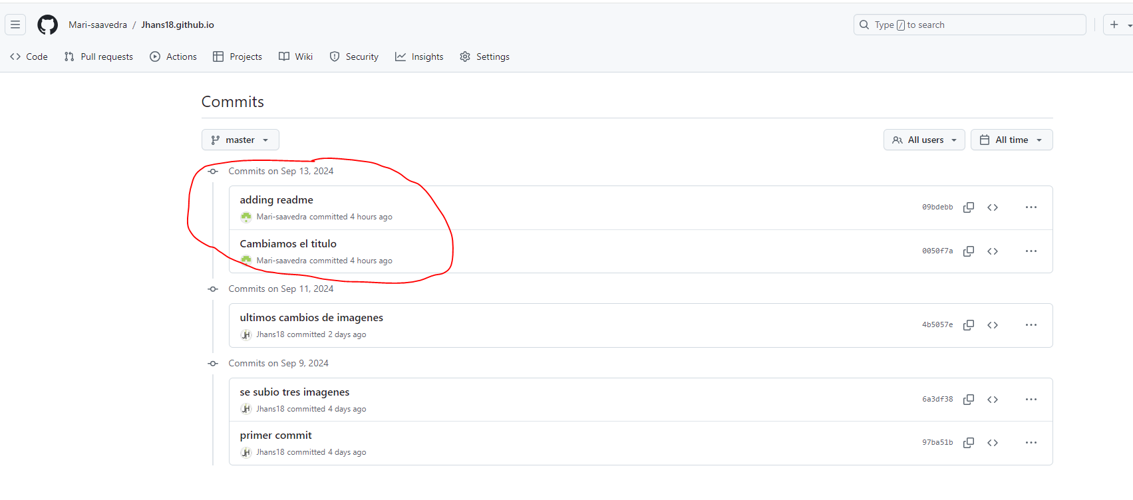

pull

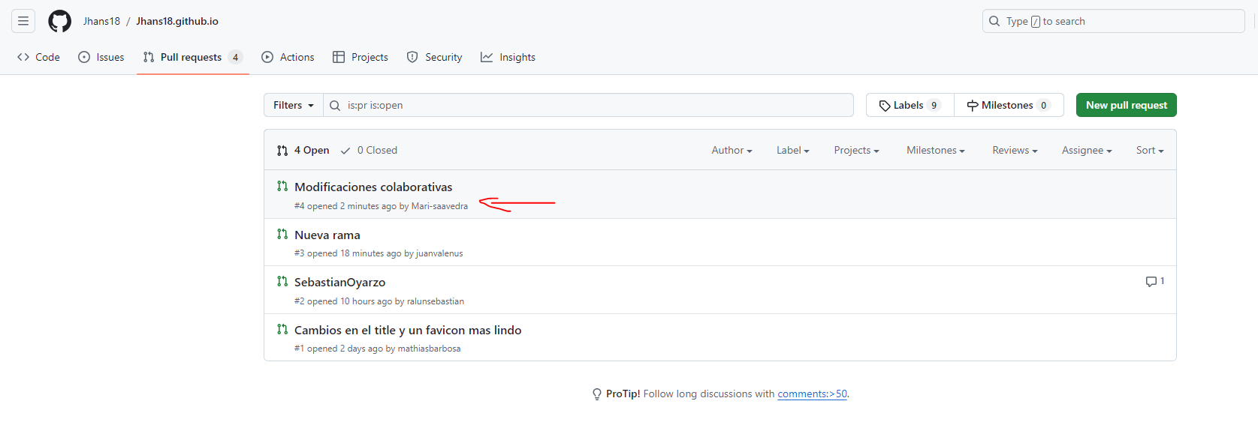

<https://github.com/juanvalenus/juanvalenus.github.io>

fork

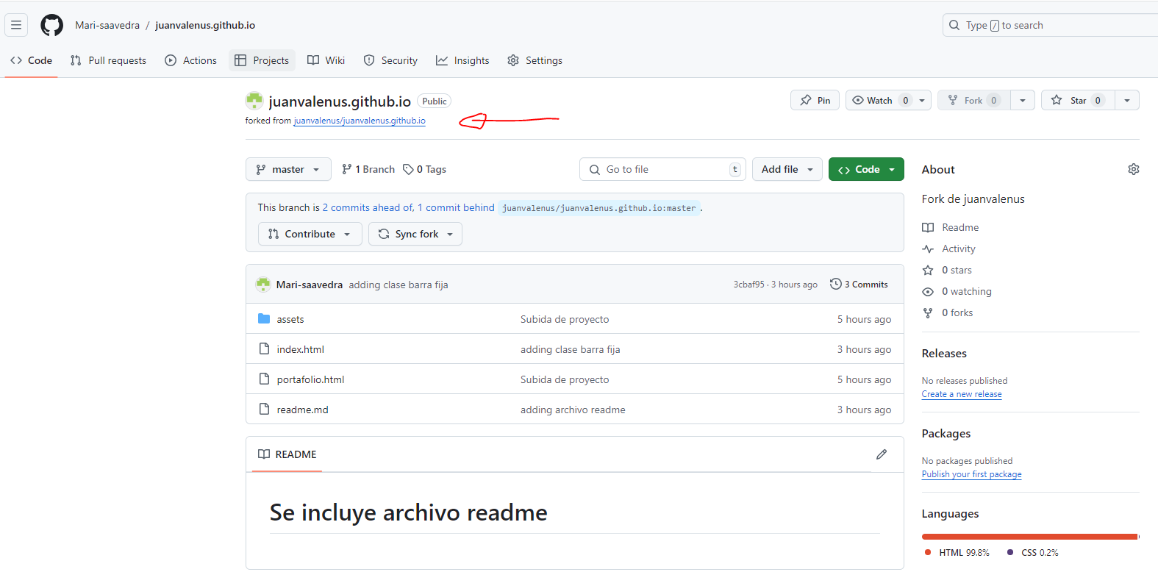

commit

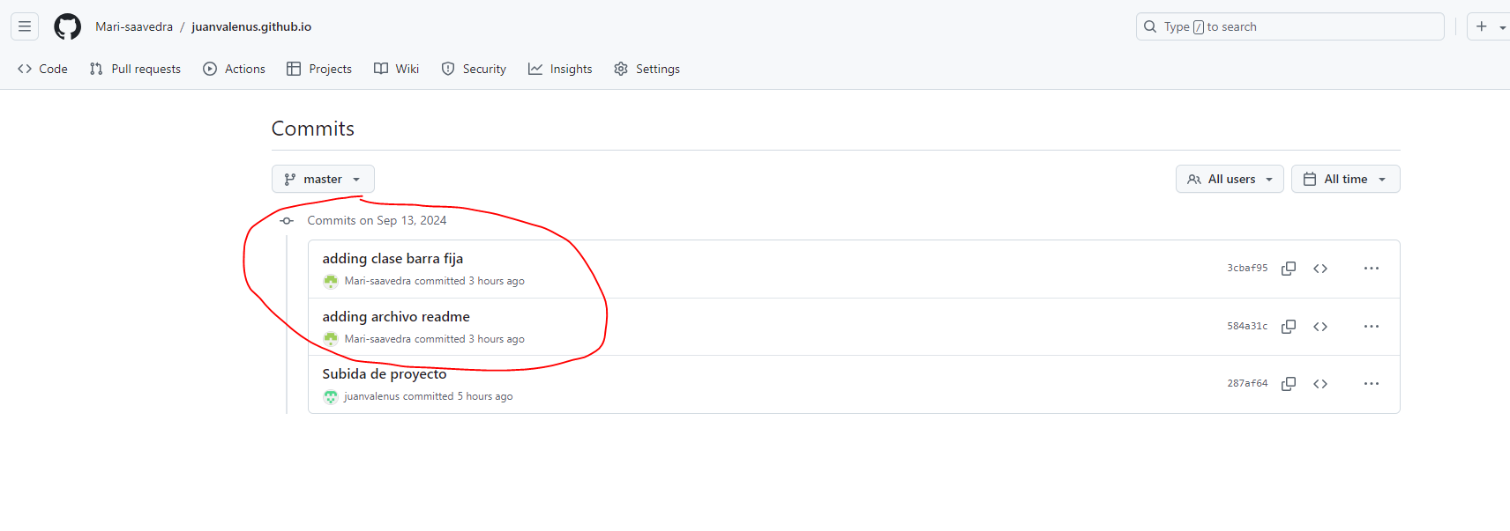

pull

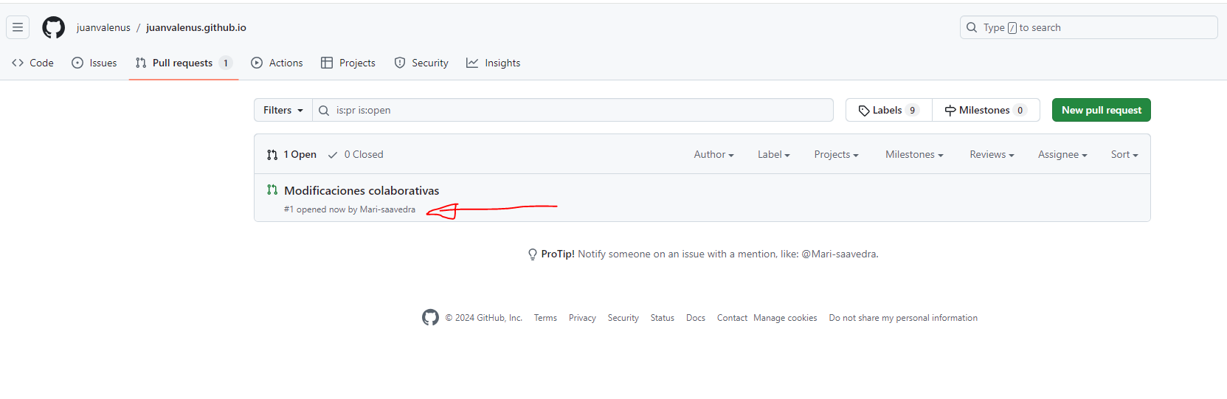

<https://github.com/ralunsebastian/ralunsebastian.github.io>

fork

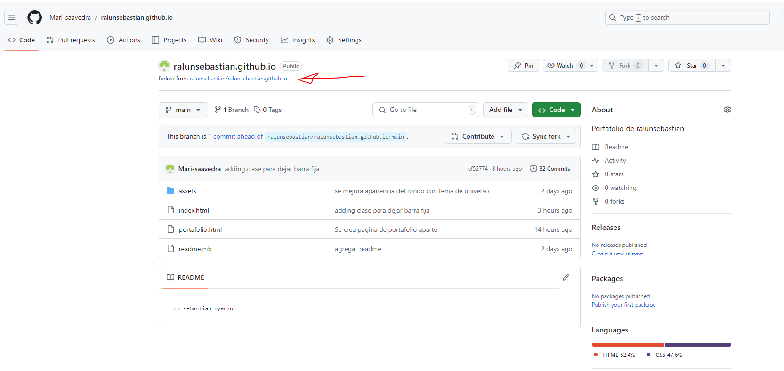

commit

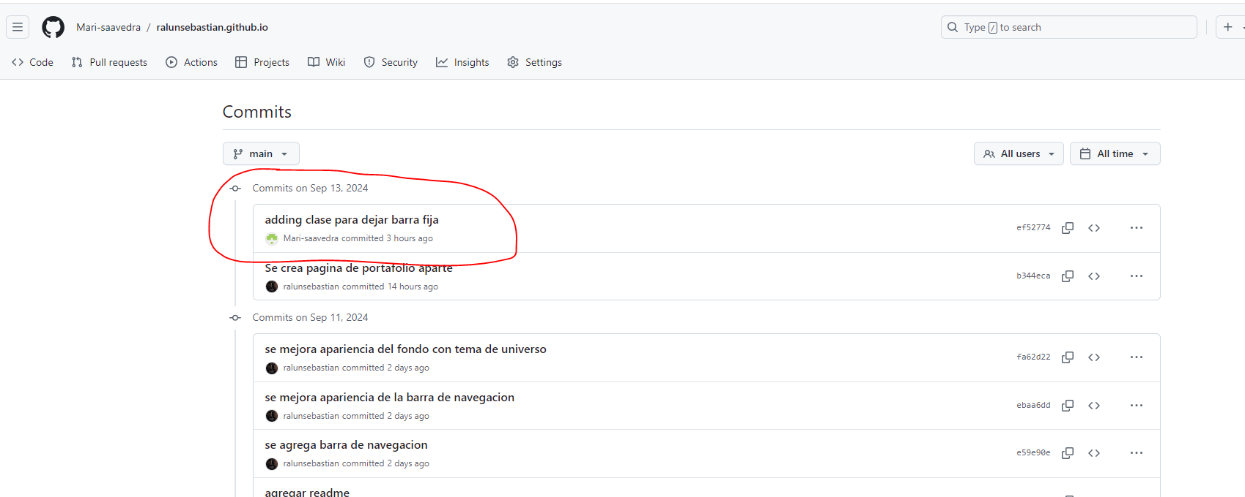

pull

