Adaptive Optics Tasks 3 and 4
Uncorrected and statically corrected system performance
This report completes Tasks 3 and 4 using the laboratory manual and the supplied AO data. Static closed-loop correction reduces the RMS wavefront error from 3.2694 µm to 0.07597 µm, a factor of about 43.0, and reduces P2V by a factor of 37.7. With an explicit 633 nm wavelength assumption, the corrected Marechal Strehl estimate is 0.566. The FWHM datasets have different image dimensions, so their widths are reported in pixels only and cannot be converted to physical units or compared as absolute spatial scales without a common sampling calibration.

1 Task requirements and analysis method
Task 3 asks for the static wavefront error, a science-camera image, an estimated Strehl ratio, and the x and y FWHM of the PSF for the uncorrected system. Task 4 repeats the same measurements after static correction. For each wavefront-error time series, the mean and sample standard deviation were calculated. FWHM was measured on horizontal and vertical profiles through the peak pixel, using the median edge signal as background and linear interpolation at half maximum.
Strehl is estimated with the Marechal approximation S = exp[-(2πσ/λ)^2], where σ is RMS WFE. The raw export columns do not state a unit or the operating wavelength. The wavefront-map scale and magnitude are treated as micrometres, and 633 nm is an explicit working assumption. If the actual wavelength is λ µm, replace 0.633 by λ in the formula. The approximation is valid only for small aberrations, so the uncorrected calculation only establishes that the Strehl is negligible under this assumption.

2 Results overview
Metric | Task 3 uncorrected | Task 4 corrected | Change
P2V WFE | 12.810 ± 0.021 µm | 0.3398 ± 0.0098 µm | reduced 37.7×
RMS WFE | 3.2694 ± 0.0053 µm | 0.07597 ± 0.00321 µm | reduced 43.0×
Strehl at 633 nm | formal estimate about 10^-457; effectively zero | 0.566 | large increase
FWHM x | 25.0 px | 30.0 px | different sampling; see note
FWHM y | 35.0 px | 34.0 px | different sampling; see note

The error values are sample standard deviations across 164 time-series values. They describe short-term variation, not the full instrument uncertainty. The discrete-pixel FWHM positioning uncertainty is approximately ±1 px.
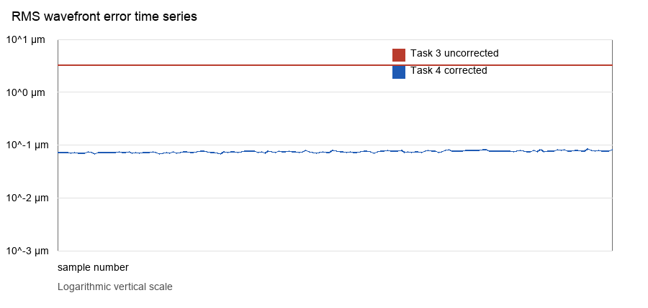
Figure 1. RMS WFE time series for the two states, on a logarithmic vertical scale. The corrected data are stable near 0.076 µm.

3 Task 3 uncorrected system performance
Across 164 samples, the uncorrected P2V WFE is 12.810 ± 0.021 µm and RMS WFE is 3.2694 ± 0.0053 µm. The RMS value is about 5.16 wavelengths at 633 nm, far beyond the Marechal approximation's validity range. Its vanishing formal Strehl should be read as a severely degraded central diffraction peak, not as a precise numerical estimate.
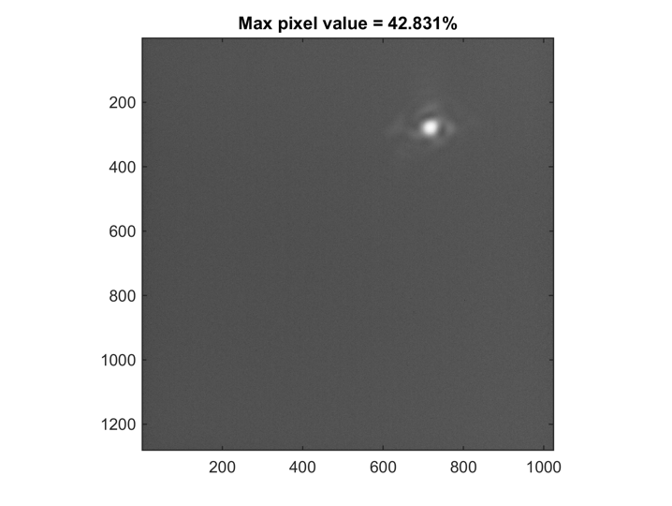
Figure 2. Supplied original Task 3 science-camera image.
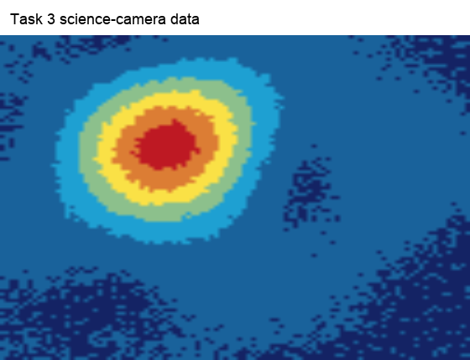
Figure 3. Intensity heatmap of the Task 3 FWHM raw array; peak at row 26, column 37.
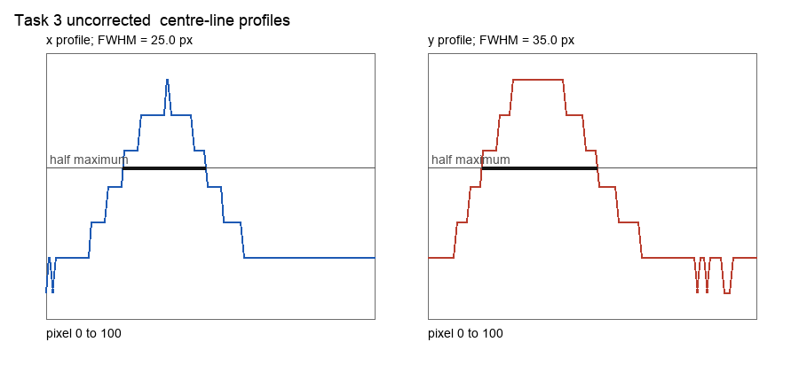
Figure 4. Task 3 central horizontal and vertical profiles. FWHM_x = 25.0 px and FWHM_y = 35.0 px.

4 Task 4 statically corrected system performance
After static correction, P2V WFE is 0.3398 ± 0.0098 µm and RMS WFE is 0.07597 ± 0.00321 µm. Substituting λ = 633 nm in the Marechal approximation gives Strehl S = 0.566. This is still below an ideal diffraction-limited system but represents a very large phase-quality improvement over the uncorrected state.
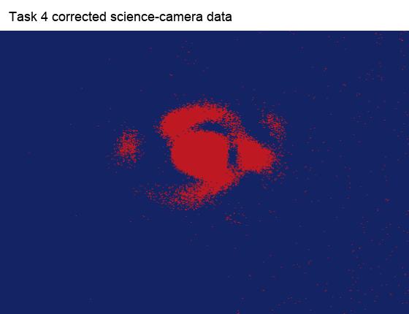
Figure 5. Intensity heatmap of the corrected Task 4 science-camera FWHM raw array; peak at row 161, column 209.
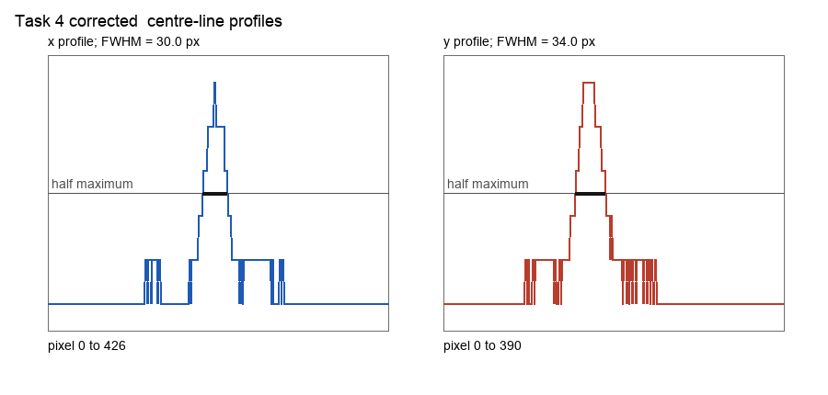
Figure 6. Task 4 central horizontal and vertical profiles. FWHM_x = 30.0 px and FWHM_y = 34.0 px.

5 Discussion and conclusion
Closed-loop correction was successful: RMS WFE falls from 3.2694 µm to 0.07597 µm, and the corrected series has low scatter. The change from nearly zero Strehl to about 0.57 is consistent with this result. FWHM_y changes from 35 px to 34 px, whereas FWHM_x changes from 25 px to 30 px. This should not be interpreted alone as worse transverse resolution, because the two raw FWHM arrays are 101 × 101 and 391 × 427, indicating different crop extents or camera sampling. A strict PSF-width comparison requires fixed exposure, pixel scale/magnification, ROI, and background method, followed by conversion from pixels to µm or arcseconds.

Conclusion
Final conclusion: the required measurements for Tasks 3 and 4 are complete. The most reliable correction-performance evidence is the roughly 43-fold RMS WFE reduction. Under the stated 633 nm assumption, Task 4 reaches a Strehl ratio of about 0.57.

6 Data sources and reproducibility
Manual: AO_0.02_00_017_211020.pdf, sections 7.4.3 and 7.4.4. Data: Task3_stat_wavefront_err.txt, Task3_FWHM_raw_data.txt, Task3_Science_image.tif, Task4_stat_wavefront_err_corr_sys.txt, and Task4_FWHM_raw_data_corr_sys.txt. FWHM uses central-peak profiles, median-edge background, and half-maximum linear interpolation. All calculations and figures are generated from these source files.

