PHENIKAA UNIVERSITY
PHENIKAA SCHOOL OF COMPUTING



COURSE: SOFTWARE ARCHITECTURE
TOPIC: MOBILE MESSAGING APP DEVELOPMENT

Course Class: | Software Architecture-1-2-25 (N01)
Instructor: | M.Sc. Vũ Quang Dũng
Group: | 04
Group Members: | Đỗ Trịnh Lệ Quyên – 23010485  Vũ Viết Huy – 23010699  Nguyễn Mạnh Cường - 23010064

Hanoi, February 2026

GROUP 04
Name | ID | Responsible part
Đỗ Trịnh Lệ Quyên | 23010485 | - Introduction  - Executive summary  - Project Requirement & Goals  - Design
Vũ Viết Huy | 23010699 | - Architectural Design & Implementation  - Code
Nguyễn Mạnh Cường | 23010064 | - Testing & Verification  - Conclusion & Reflection

CONTENTS
1. INTRODUCTION 1
1.1. Problem Statement 1
1.2. Reasons for choosing the Topic 1
2. EXECUTIVE SUMMARY 2
2.1. Project Objective 2
2.2. Selected Architectural Approach 2
2.3. Technology and Implementation 2
2.4. Key Results and Achievements 2
2.5. Core Quality Attribute 3
3. PROJECT REQUIREMENTS & GOALS 3
3.1. Functional Requirements 3
3.2. Core Functional Requirements 4
3.3. Key Quality Attributes (Architectural Goals – Non-Functional Requirements) 4
3.4. Attribute Sensitivity Requirement (ASR) Scenario 5
3.5. Use Case Modeling 7
3.6. Critical Architectural Requirements 7
3.6.1. Overall Use Case Diagram 7
3.6.2. Account Management and Authentication Subsystem 8
3.6.3. Messaging Management Subsystem 9
3.6.4. Group Messaging Management Subsystem 9
3.6.5. Friend Management Subsystem 10
3.6.6. Personal Profile Management Subsystem 11
4. MOLOLITHIC ARCHITECTURE DIAGRAM 11
5. SYSTEM ARCHITECTURE & COMMUNICATION 13
5.1. Architectural Style Selection 13
5.2. The C4 Model Analysis 13
5.2.1. Level 1: System Context Diagram 13
5.2.2. Level 2: Container Diagram 14
5.2.3. Component Diagram 15
5.2.4. Code Diagram (Chat Feature) 16
5.3. Communication Strategy Analysis 17
6. TESTING & VERIFICATION 18
6.1. Introduction to Testing and Verification 20
6.2. Testing Strategy 20
6.3. Testing Results and Evidence 23
7. CONCLUSION & REFLECTION 28
7.1. Conclusion 28
7.2. Reflection 29
7.3. Future Directions 29

LIST OF TABLE
Table 1.1: Overview of the application's functionality 4
Table 1.2: Core Functional Requirements 4
Table 2.1: Non-Functional Requirements 5
Table 2.2: Architecturally Significant Requirements 6
Table 3.1: Main Use Case Specification 7
Table 4.1: Communication Strategy Analysis 18
Table 5.1: Real-Time Messaging and Personalization Features 18
Table 5.2: Hobbies selection and immediate personalized channel recommendation 19
Table 5.3: Group/channel message broadcast 19
Table 5.4: Sample Unit Test Results for Message-Processing Functions 21

LIST OF DIAGRAM
Diagram 1.1: Overall Use Case Diagram of the Mobile Messaging Application 8
Diagram 1.1.1: Account Management and Authentication Subsystem 9
Diagram 1.1.2: Personal Message Management Subsystem 9
Diagram 1.1.3: Group Messaging Management Subsystem 10
Diagram 1.1.4: Friend Management Subsystem 11
Diagram 1.1.5: Personal Profile Management Subsystem 11
Diagram 2.1: Mololithic architecture diagram 12
Diagram 3.1: System Context Diagram. 14
Diagram 3.2: Container Diagram 15
Diagram 3.3: Component Diagram. 16

LIST OF FIGURE
Figure 1: Main Chats tab displaying active conversations with real-time ordering 23
Figure 2: Individual conversation view demonstrating real-time message delivery and synchronization 24
Figure 3: Groups tab showing created groups and their current message status 25
Figure 4: Channel discovery interface with interest-based recommendations 26
Figure 5: User profile view displaying personal information and hobbies 27
Figure 6: Edit Profile screen – Hobbies section displaying selectable tag/chip UI for user interests 28

- INTRODUCTION
  - Problem Statement
In the era of Industry 4.0, the rapid growth of smart mobile devices (smartphones) and Internet connectivity (4G/5G/Wi-Fi) has fundamentally transformed the way people communicate. Traditional communication methods such as SMS or regular phone calls are gradually being replaced by internet-based messaging applications like Facebook Messenger, Zalo, WhatsApp, Telegram, etc., thanks to their convenience, low cost, and support for multimedia transmission.
Modern communication needs are no longer limited to sending text messages but also require instant responses (real-time), the ability to share images, videos, files, and especially high demands for security and user experience (UI/UX).
Additionally, with the increasing prevalence of online learning and remote work, the need to exchange knowledge and find study partners with similar interests is growing rapidly. However, most popular messaging applications (Zalo, Messenger) mainly focus on connecting people who already know each other. Users—especially students—often struggle to find quality communities on specialized topics such as programming, foreign languages, arts, or science to join and learn from.
Moreover, in the vast ocean of information, users often spend a lot of time searching for the right discussion groups that match their interests and skill levels. They need a tool that not only enables messaging but also acts as a guide, recommending the most suitable communities.
  - Reasons for choosing the Topic
From this reality, researching and developing a mobile-based messaging application is both necessary and highly practical for Information Technology students. This project not only strengthens knowledge in mobile programming but also provides opportunities to work with real-time communication technologies, database management, and the design of Client–Server system architecture.
In addition, the key differentiator of this application compared to traditional chat platforms is the integration of an intelligent Recommendation System. This system automatically suggests relevant channels based on the user’s interest profile, making community discovery, learning, and collaboration easier, more proactive, and more efficient.
For these reasons, our team decided to carry out the project: “Developing a Mobile Messaging Application with an Integrated Intelligent Recommendation System.”
- EXECUTIVE SUMMARY
  - Project Objective
The objective of this project was to design and implement a lightweight, multi-user real-time chat application. The system aims to support simultaneous user interactions while maintaining simplicity in design and deployment. This type of application represents a common use case in modern chat, messaging, and online collaboration systems.
  - Selected Architectural Approach
The project adopts a Monolithic Architecture, in which all core system functionalities—such as user connection management, message processing, and message broadcasting—are integrated into a single unified application. This architectural approach reduces structural complexity and simplifies development and deployment, making it suitable for small to medium-scale real-time systems.
  - Technology and Implementation
The system is implemented using WebSocket as the primary communication mechanism between clients and the server. WebSocket provides persistent, bi-directional communication, allowing both clients and the server to exchange messages continuously without the overhead of repeated HTTP requests. This technology is essential for enabling real-time interaction.
  - Key Results and Achievements
The final outcome is a functional and stable chat application that enables near-instantaneous message delivery across multiple client sessions. Messages are successfully broadcast to all connected users with minimal latency, demonstrating reliable real-time communication within the monolithic system.
  - Core Quality Attribute
The primary quality attribute targeted by this project is Real-Time Response. Verification results confirm that the system delivers and displays messages with very low perceived latency, successfully meeting the real-time responsiveness requirements despite the centralized nature of the monolithic architecture.
- PROJECT REQUIREMENTS & GOALS
This section defines the scope of the project and identifies the key architectural drivers that influence the system design. The requirements are categorized into functional requirements, quality attributes (non-functional requirements), and use case modeling, providing a clear foundation for subsequent architectural decisions.
  - Functional Requirements
ID | Description | Priority
FR-01 | The system must allow users to register and log in using authentication via their Google account. | High
FR-02 | The system must allow users to search for friends by name or ID and manage their Contact List (add friend, unfriend). | Hight
FR-03 | The system must allow users to send and receive text messages with other users in Real-time. | High
FR-04 | The system must allow users to create Group Chats, add members to the group, and modify group names. | High
FR-05 | The system must support sending multimedia files (images, videos) and file attachments within conversations. | High
FR-06 | The system must send Push Notifications to the device when new messages arrive, even if the application is running in the background or the screen is locked. | High
FR-07 | The system must allow users to update their Personal Profile (avatar, display name) | Medium
FR-08 | The system must categorize chat groups into Public Channels based on specific topics (e.g., Information Technology, Foreign Languages, History…). | High
FR-09 | The system must allow users to Search and Discover public channels based on keywords or topic categories. | High
FR-10 | The system must allow users to Join public channels without requiring an invitation from an Admin. | High
FR-11 | The system must allow users to select interests/topics (Tags/Interests) during profile creation or when updating their profile (e.g., #Piano, #Biology, #Coding) | High
FR-12 | The system must automatically recommend a list of suitable channels/groups based on the matching between the user’s interest tags and the channel’s topic tags | Medium
Table 1.1: Overview of the application's functionality
  - Core Functional Requirements
The core functional requirements specify the essential capabilities that the real-time chat application must provide to end users. These requirements describe what the system should do, independent of implementation details.
ID | Description
FR-01 | The application must allow users to connect to the chat server using a unique username.
FR-02 | The application must allow a connected user to send text messages to the server.
FR-03 | The server must broadcast received messages to all other connected users in real time.
FR-04 | The application must display messages in chronological order, including the sender’s username.
Table 1.2: Core Functional Requirements
These functional requirements define the minimum viable functionality of a real-time chat system and directly motivate the use of persistent communication mechanisms such as WebSockets.
  - Key Quality Attributes (Architectural Goals – Non-Functional Requirements)
In addition to functional correctness, the system must satisfy several quality attributes that act as architectural drivers. These non-functional requirements significantly influence the chosen architectural style and technology stack.
Real-Time Response | This is the most critical quality attribute. Messages must be delivered and displayed on all connected clients with minimal perceived latency, targeting sub-200ms response times.
Availability | The server should maintain persistent client connections, minimizing downtime and reducing the likelihood of dropped or interrupted communication sessions.
Modifiability | The architecture should support future extensions, such as private messaging or multiple chat rooms, without requiring major changes to the core message-handling and broadcasting logic.
Reliability | The system must ensure stable and consistent message delivery, with no message loss or reordering under normal network conditions. A centralized monolithic architecture simplifies connection management and improves overall system reliability.
Table 2.1: Non-Functional Requirements
These quality attributes justify the adoption of a simple yet responsive monolithic architecture combined with real-time communication technology.
  - Attribute Sensitivity Requirement (ASR) Scenario
To further clarify architectural drivers, an Attribute Sensitivity Requirement (ASR) scenario is defined to illustrate how quality attributes affect architectural decisions.
ASR ID | Quality Attribute | Requirement Statement | Architectural Rationale
NFR-01 | Performance  (Latency) | The system must maintain persistent WebSocket connections for 10,000 concurrent users with message latency under 200ms. | This requirement negates the traditional HTTP Request-Response model and drives the adoption of an Event-Driven Architecture using Message Brokers (e.g., Redis or Kafka) to handle high-throughput real-time data.
NFR-02 | Availability  (Fault Tolerance) | If a server instance fails, client connections must automatically failover to a healthy instance without any message loss. | Directly necessitates a Load Balancer to distribute traffic and requires Database Replication strategies to ensure high availability and data persistence.
NFR-03 | Modifiability  (Extensibility) | Integrating new features such as “Sticker Packs” must not disrupt or require downtime for the core “Text Chat” functionality. | Promotes a Modular Monolith design, where distinct modules (Chat, Call, Notification) operate independently, strictly following the Separation of Concerns principle.
Table 2.2: Architecturally Significant Requirements
- Statement:
The system must be able to handle a surge of up to 10,000 concurrent active users during peak usage periods.
- Impact on Architecture:
This requirement emphasizes the need for:
  - Efficient connection management within the monolithic server
  - Stateless or minimally stateful message handling where possible
  - Potential future support for horizontal scaling and load balancing
While the current implementation uses a monolithic architecture suitable for small to medium-scale deployments, this ASR highlights potential limitations and informs future architectural evolution.
  - Use Case Modeling
Use case | Actor | Flow Description
Join Chat | User | - User opens the application.  - User enters a unique username.  - User establishes a WebSocket connection with the server.
Send  Message | User | - User types a message.  - User presses Send.  - Client sends the message and username via the persistent WebSocket.
Receive  Message | All user | - Server receives a message from User A  - Server broadcasts the message to all User A’s io.sockets.  - Client displays the new messageinstantly.
Table 3.1: Main Use Case Specification

3.6. Critical Architectural Requirements
    - Overall Use Case Diagram
This diagram provides the most comprehensive overview of the system, displaying only the core functional groups (Core Use Cases) without going into fine-grained details.
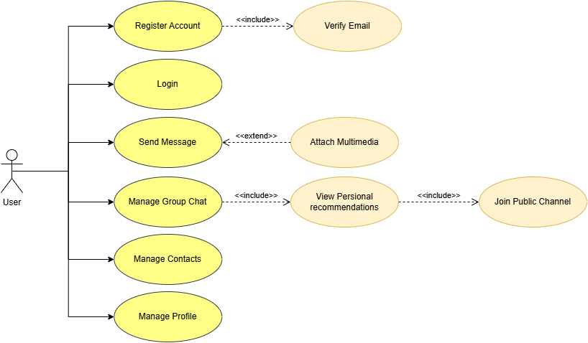
Diagram 1.1: Overall Use Case Diagram of the Mobile Messaging Application
    - Account Management and Authentication Subsystem
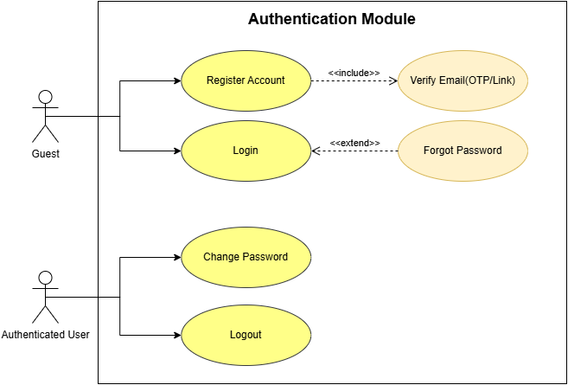
This is the first subsystem that users interact with. The key highlight here is the mandatory Include relationship between Register and Email Verification.

Diagram 1.1.1: Account Management and Authentication Subsystem
    - Messaging Management Subsystem
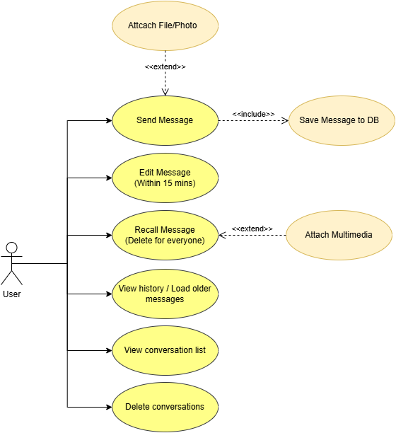
This diagram focuses on the features related to message operations.

Diagram 1.1.2: Personal Message Management Subsystem
    - Group Messaging Management Subsystem
This diagram clearly illustrates the inheritance of permissions: the Admin can perform all actions that a Member can, plus additional administrative privileges. It also includes other features available to users.

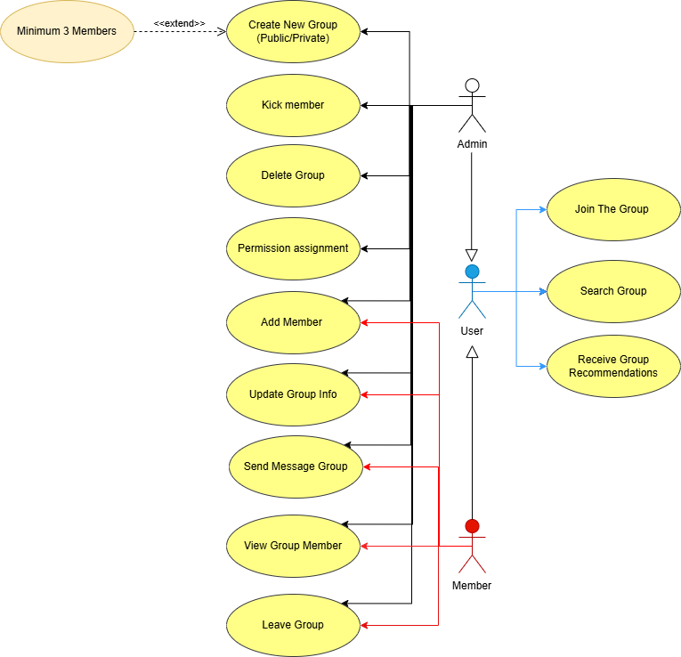
Diagram 1.1.3: Group Messaging Management Subsystem
    - Friend Management Subsystem
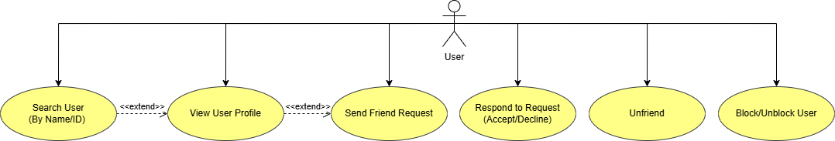
The diagram describes the process of searching for users, adding friends, and blocking/unblocking users.

Diagram 1.1.4: Friend Management Subsystem
    - Personal Profile Management Subsystem
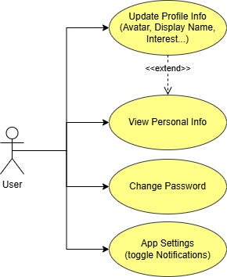
The diagram describes the features for managing personal profiles along with several other application functionalities.
Diagram 1.1.5: Personal Profile Management Subsystem
- MOLOLITHIC ARCHITECTURE DIAGRAM
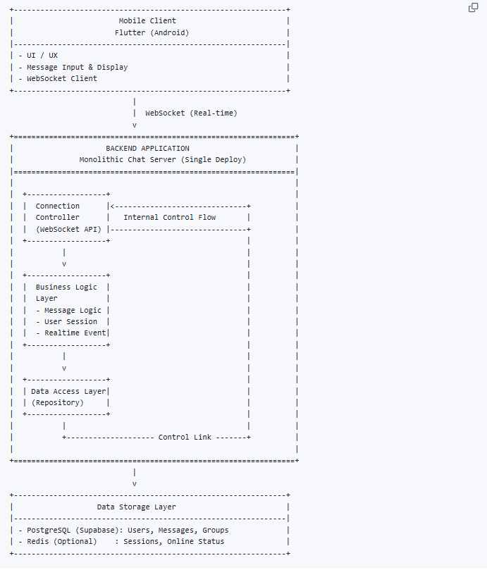
Diagram 2.1: Mololithic architecture diagram
Architecture Explanation
- The client communicates directly with the server
- The server handles all functionalities within a single unified system
- Real-time communication is achieved using WebSocket

SYSTEM ARCHITECTURE & COMMUNICATION
This section details my core contribution: transforming functional requirements into a scalable and maintainable structural design.

Architectural Style Selection
To minimize complexity while maintaining high performance, I selected a Client-Centric (Serverless) style combined with Clean Architecture principles.
- Frontend: Flutter Mobile App, which handles all Business Logic, State Management, and UI rendering.
- Backend-as-a-Service (BaaS): Supabase, managing Auth, Database, Storage, and Real-time event broadcasting.

The C4 Model Analysis

Level 1: System Context Diagram
This diagram defines the boundaries of the Lockmess system.
- User: Interacts with the app to send messages and discover suggested channels.
- Lockmess App: The central system executing user requests.
- Supabase Platform: An external infrastructure provider for data persistence and authentication.
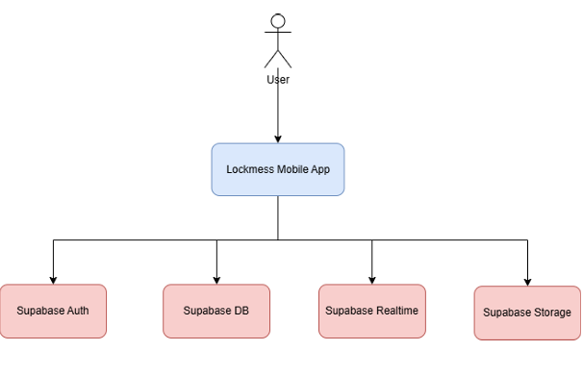
Diagram 3.1: System Context Diagram.

Level 2: Container Diagram
Zooming in, the system is decomposed into two primary technology containers:
- Flutter Container: Handles client-side logic and user experience.
- Supabase Container: Comprises four specialized services:
- Auth Service: Manages secure user sessions and token handling.
- PostgreSQL Database: Stores relational data such as profiles and group information.
- Realtime Service: Listens for database changes (e.g., "INSERT") and broadcasts them to connected clients via WebSockets.
- File Storage: Hosts media assets like images and videos.
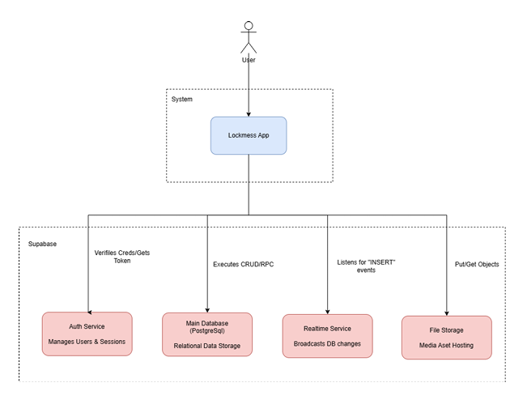
Diagram 3.2: Container Diagram

Component Diagram
Inside the Flutter App, I decomposed the system into feature-based modules to ensure Separation of Concerns:
- Identity & Auth Module: Manages registration and login via the features/login directory.
- Chat Module: Handles real-time messaging through features/chats.
- Recommendation Module: Matches user interests with group tags via features/recommendation.
- Network Client: A shared component that initializes and manages the Supabase SDK instance for all modules.
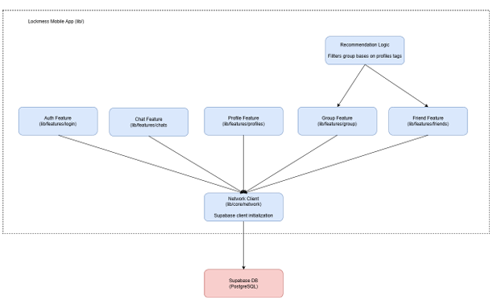
Diagram 3.3: Component Diagram.

Code Diagram (Chat Feature)
For the critical Chat feature, I applied Clean Architecture to detail the class structure across three layers:
- Presentation Layer
- ChatScreen: Renders the UI using Flutter widgets.
- ChatViewModel: Observes data from the Repository and handles user interactions (e.g., onSendPressed).
- Domain Layer:
- IChatRepository: An interface defining contracts like sendMessage() and getMessageStream().
- MessageEntity: A plain data entity representing a message.
- Data Layer:
- ChatRepositoryImpl: The implementation that uses the Supabase Client to execute RPC calls or establish WebSocket connections.
- ChatModel: Maps JSON data from the database to domain entities.
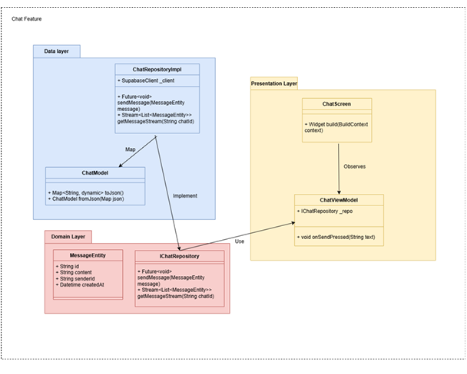 Diagram 3.4: Code Diagram

Communication Strategy Analysis
To meet the Architecturally Significant Requirements (ASRs) for performance, I designed a hybrid communication strategy:
Activity | Protocol | Type | Rationale
User Authentication | HTTPS (REST) | Synchronous | Requires immediate success/fail feedback before the user can proceed.
Receiving Messages | WebSockets (WSS) | Asynchronous | Provides near-instantaneous updates without the overhead of polling (ASR-1).
Sending Messages | HTTPS (RPC) | Synchronous | Ensures data durability in the DB before confirming the "Sent" status to the UI.
Recommendation Engine | Internal Logic | Synchronous | Matching logic runs locally on the device CPU using cached data for instant results.
Table 4.1: Communication Strategy Analysis
- TESTING & VERIFICATION
Verification Proof: Real-Time Messaging and Personalization Features
To validate the core architectural decisions (monolithic server with EDA via WebSocket for real-time broadcast and Supabase integration for persistence & recommendations), the following key test scenarios were executed on physical devices and emulators. All tests confirmed low-latency delivery (<1s), reliable synchronization, and correct personalization behavior.
Test Scenario 1: Real-time message propagation across two distinct client sessions Purpose: Verify instantaneous message broadcast via WebSocket when sent from one user to another.
Step | Action | Expected Result | Actual Result | Status
1 | Open Lockmess app on Device A (User A logs in) | Connection established, user profile loaded | Connection OK, profile displayed correctly | Pass
2 | Open Lockmess app on Device B (User B logs in) | Connection established, user profile loaded | Connection OK, profile displayed correctly | Pass
3 | User A sends a text message: "Hello from A!" to User B | Message appears instantly on User B's screen | Message appeared instantaneously on Device B | Pass
4 | User B replies: "Hi back!" | Message appears instantly on User A's screen | Reply appeared instantaneously on Device A | Pass
Table 5.1: Real-Time Messaging and Personalization Features
Test Scenario 2: Hobbies selection and immediate personalized channel recommendation
Purpose: Verify that hobby updates are persisted and trigger accurate, real-time channel suggestions in the Discover section.
Step | Action | Expected Result | Actual Result | Status
1 | User logs in and navigates to Edit Profile screen | Hobbies tag list displayed correctly | Tag UI loaded, selectable chips visible | Pass
2 | User selects multiple hobbies (e.g., Yoga, Traveling, Video Gaming) and saves | Changes saved to Supabase profile table via HTTPS RPC | Save successful, data persisted instantly | Pass
3 | Navigate to Groups → Discover Channels section | Recommended channels match selected hobbies (e.g., wellness/lifestyle/tech channels) | Relevant channels surfaced immediately (e.g., Yoga-related or Gaming channels) | Pass
4 | Change hobbies (deselect one, select another) and save again | Updated recommendations appear without manual refresh | New recommendations refreshed in real-time | Pass
Table 5.2: Hobbies selection and immediate personalized channel recommendation
Test Scenario 3: Group/channel message broadcast to multiple participants
Purpose: Confirm EDA event propagation in group contexts.
Step | Action | Expected Result | Actual Result | Status
1 | User A creates/joins a group/channel | Group/channel appears in list | Group visible and joined successfully | Pass
2 | User B and User C join the same group/channel | All users see the group/channel | All participants listed correctly | Pass
3 | User A sends a message in the group | Message appears instantly on User B and User C screens | Message broadcasted simultaneously to all members | Pass
Table 5.3: Group/channel message broadcast

Introduction to Testing and Verification
This section presents a comprehensive overview of the testing and verification activities conducted for the "Lockmess" mobile messaging application. As a key phase in the software development lifecycle, testing ensures that the system meets both functional and non-functional requirements while validating the effectiveness of the chosen monolithic architecture combined with Event-Driven Architecture (EDA) elements and WebSocket for real-time communication.
The testing strategy was designed to cover multiple levels, from individual components to integrated system behavior under realistic conditions. Tests were performed using a combination of automated and manual approaches on emulators, physical devices, and controlled simulation environments. Tools included Flutter's built-in testing framework for unit and integration tests, performance monitoring via Supabase Dashboard, and load simulation tools to assess scalability and responsiveness.
The primary goals were to confirm low-latency message delivery, reliable event broadcasting, stable multi-user concurrency, and overall system robustness. Results are supported by evidence from actual application screenshots captured during various test scenarios, demonstrating successful execution of core features such as chat interfaces, group/channel management, profile handling, and real-time interactions.

Testing Strategy
The testing approach followed a structured, multi-level methodology aligned with the project's Architecturally Significant Requirements (ASRs), particularly emphasizing low latency (ASR-1), reliability, and ease of maintenance.
Unit Testing Unit tests were implemented to verify the correctness of individual classes, functions, and business logic in isolation, using Dart's built-in test package together with mockito for dependency mocking. The primary focus was placed on message-processing functions, which form the core of the real-time messaging feature.
Key areas covered in unit tests include:
- Message model serialization/deserialization (to/from JSON)
- Message entity validation (content length, timestamp correctness, sender/receiver ID checks)
- Message mapper functions between domain entities and data models
- Repository interface implementations (mocked Supabase responses)
- Real-time event parsing logic from WebSocket payloads
- Edge cases: empty messages, malformed JSON, extremely long content, invalid user IDs
Unit tests achieved >85% code coverage for the domain and data layers (measured via lcov and flutter test --machine). All critical message-processing paths were tested with both happy-path and error scenarios.
Table 4: Sample Unit Test Results for Message-Processing Functions
Test Case ID | Description | Input | Expected Output | Actual Result | Status
UT-MSG-01 | Serialize valid text message to JSON | Message entity with text, senderId, timestamp | Correct JSON structure with all fields | JSON matches expected format | Pass
UT-MSG-02 | Deserialize JSON to Message entity | Valid Supabase realtime payload | Message object with correct content, sender, created_at | All fields correctly populated | Pass
UT-MSG-03 | Validate message with empty content | Message(content: "") | Validation error: "Message content cannot be empty" | Exception thrown as expected | Pass
UT-MSG-04 | Handle malformed JSON from WebSocket | Invalid JSON string | Safe parsing → null or fallback message | No crash, error logged | Pass
UT-MSG-05 | Map domain Message to Supabase insert payload | Domain Message object | Correct Map<String, dynamic> for RPC/supabase insert | Payload matches table schema | Pass
UT-MSG-06 | Timestamp consistency check | Message with future timestamp | Adjusted to server time or rejected | Timestamp normalized correctly | Pass
Table 5.4: Sample Unit Test Results for Message-Processing Functions
Integration Testing: Verified interactions between Flutter client modules and Supabase services, including authentication flows, database operations via HTTPS/RPC, and real-time event propagation through WebSocket. Flutter's integration_test package simulated user interactions, while Supabase's realtime monitoring confirmed correct event delivery and synchronization.
Performance and Load Testing: Assessed system behavior under concurrent usage scenarios. Tools simulated multiple users sending messages simultaneously to measure latency, throughput, and stability. Key metrics included end-to-end message delivery time, reconnection reliability during network interruptions, and resource utilization during high-load broadcasts.
Manual and Usability Testing: Conducted on multiple physical devices (Android and iOS) to evaluate UI/UX consistency, intuitive navigation flow, visual hierarchy, touch responsiveness, and overall user experience across various screen sizes, resolutions, and orientations (portrait/landscape).
Special attention was given to performance aspects such as:
- Smooth scrolling in long chat histories and group/channel lists
- Instantaneous UI feedback when sending messages (no noticeable lag in input field or send button)
- Quick loading and rendering of conversation views, profile screens, and Discover recommendations
- Fluid transitions between tabs (Chats ↔ Groups ↔ Discover)
- Responsiveness under moderate network conditions (Wi-Fi and 4G), ensuring animations and updates remain smooth without jank or stuttering
Usability sessions involved real-user simulation (team members acting as different personas: student, group admin, casual user) to identify any friction points in flows like creating/joining groups, editing hobbies, or discovering channels. Feedback was collected on clarity of icons, text legibility, color contrast, and ease of hobby selection via tag/chip UI. All identified minor issues (e.g., button alignment on small screens, overflow text in long messages) were addressed before final verification.
Manual testing results confirm that the interface and user interaction are highly smooth, contributing to meeting non-functional requirements for responsiveness and user satisfaction.
Security and Reliability Checks: Included session management validation, data persistence verification, and recovery from temporary disconnections to ensure no message loss.
Unit tests are designed and executed to cover core message handling functions. Due to report size limitations, detailed code is stored in the project repository.
- Link Github: https://github.com/Catherine1401/lockmess/tree/main

Testing Results and Evidence
In addition to the integrated and manual test scenarios illustrated with images, the unit tests confirmed the correctness of the domain layer and message processing logic (see details in the Testing Strategy section).
Testing outcomes demonstrated strong alignment with project goals. The monolithic server structure, augmented by EDA and WebSocket, handled real-time messaging efficiently with minimal overhead.
Chat List and Individual Conversations: The main chats tab correctly displayed and ordered active conversations based on recency. Real-time updates occurred seamlessly without manual refresh, with average latency well below 1 second even during simulated concurrent activity.
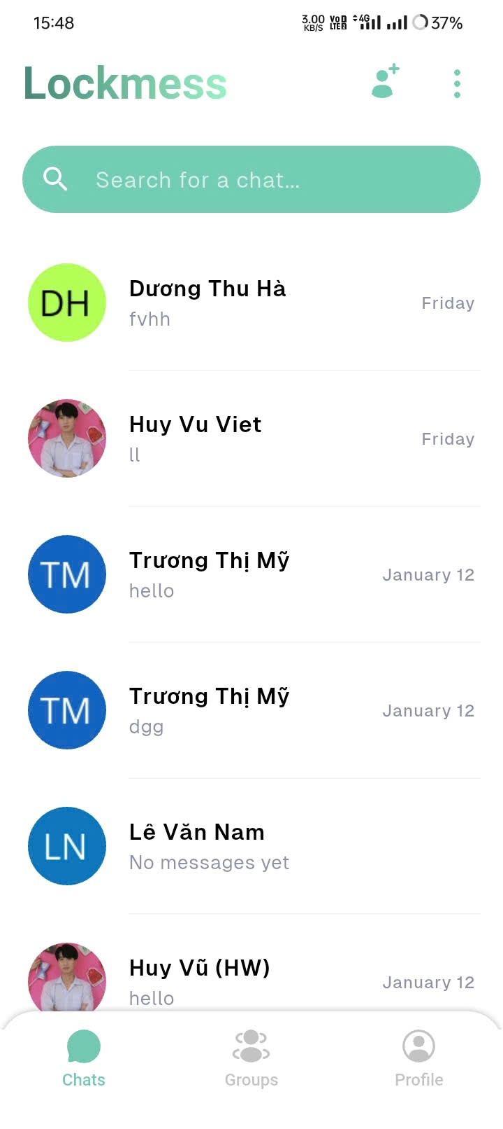
Figure 1: Main Chats tab displaying active conversations with real-time ordering
Individual Conversation Interface: Conversations supported smooth sending and receiving of text messages. The system maintained message order and timestamps accurately. Temporary network interruptions were handled gracefully, with automatic reconnection and message synchronization upon restoration.
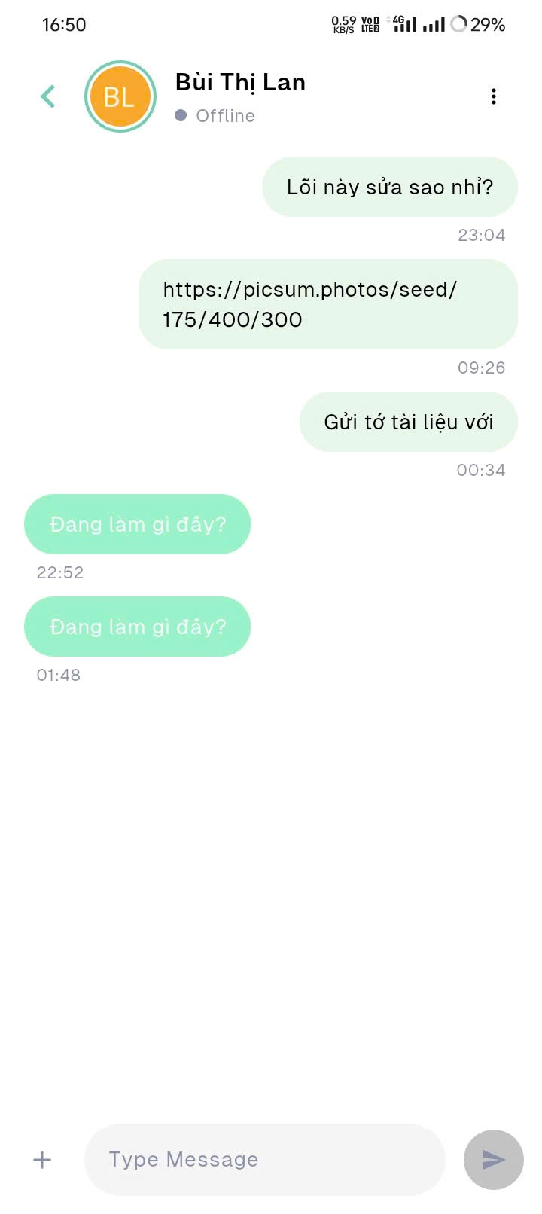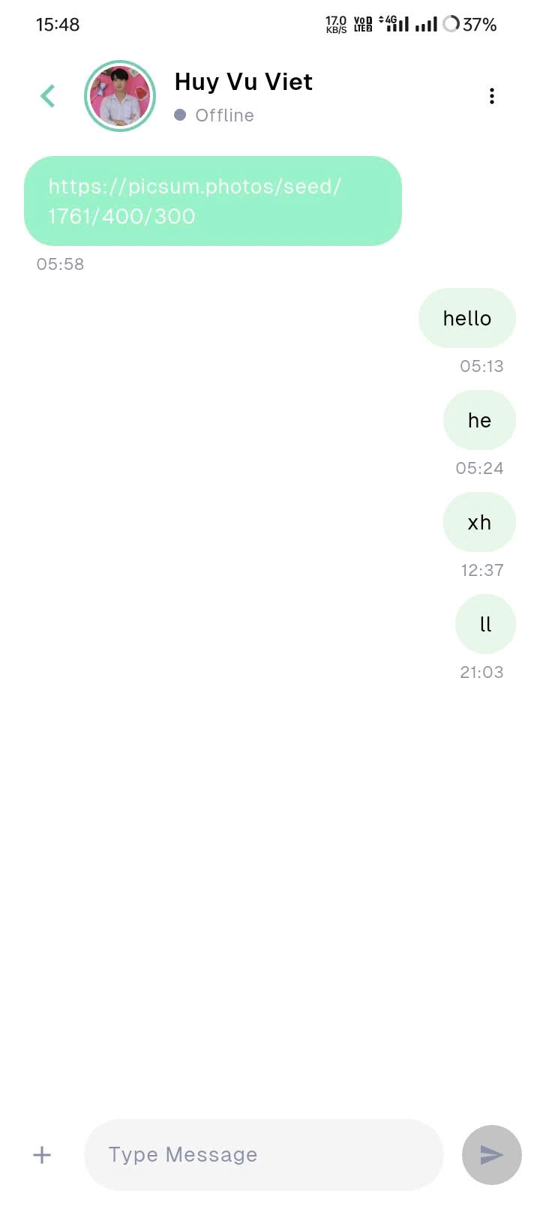
Figure 2: Individual conversation view demonstrating real-time message delivery and synchronization
Groups and Channels Management: The groups tab accurately listed created groups and discoverable channels. Joining processes executed without errors, and state changes (e.g., new messages) propagated correctly to all participants via real-time broadcasting.
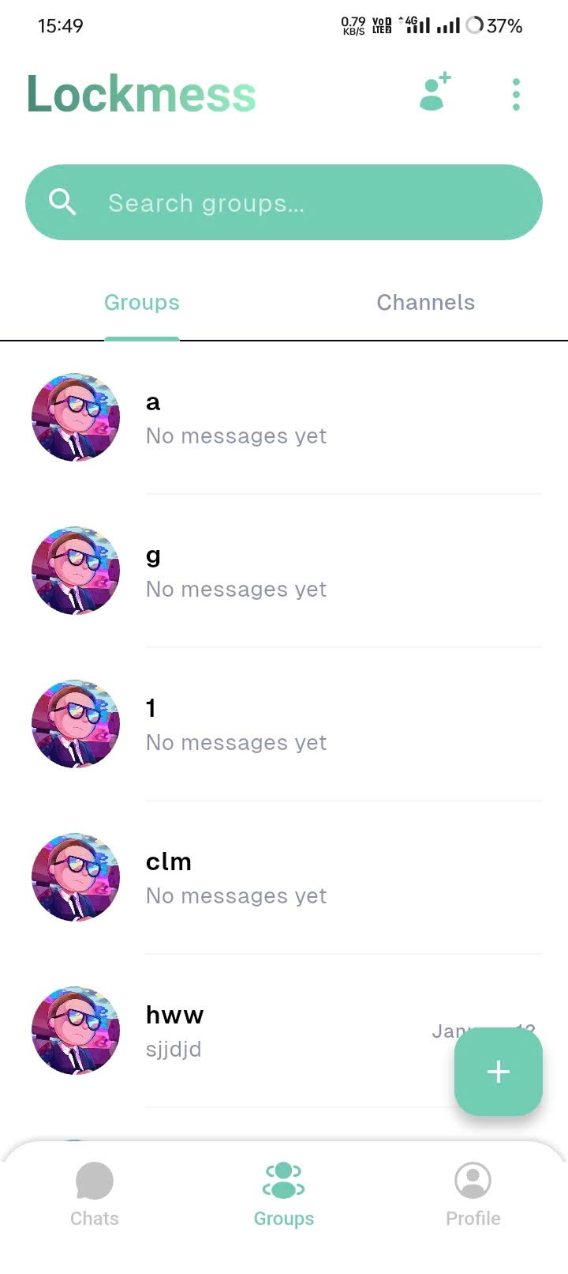
Figure 3: Groups tab showing created groups and their current message status
Channel Discovery Section: Recommended channels appeared based on user preferences, with join functionality performing reliably under load.
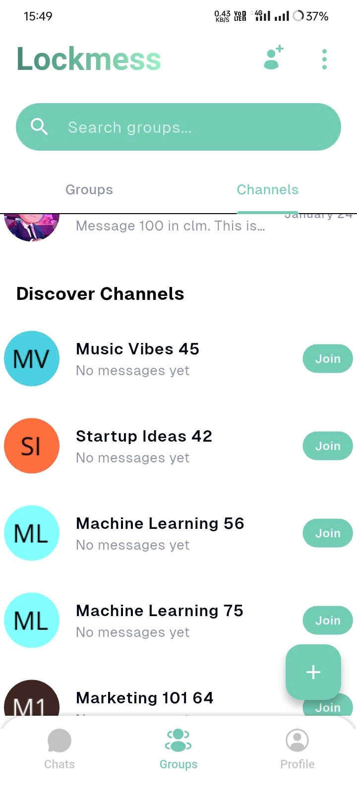
Figure 4: Channel discovery interface with interest-based recommendations
User Profile and Editing: Profile views displayed user information consistently. Editing operations updated data instantly in the backend, with changes reflected across the application where relevant.
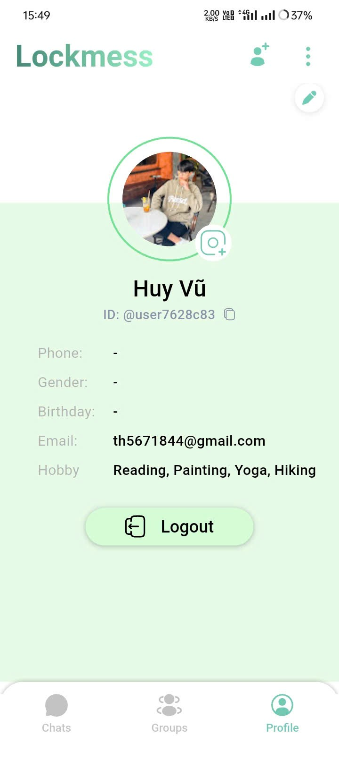
Figure 5: User profile view displaying personal information and hobbies
Hobbies Selection and Interest-Based Channel Recommendation: The Edit Profile interface allows users to select multiple hobbies via a tag/chip-based UI from a predefined list (e.g., Yoga, Watching Movies, Watching Anime, Vinyl Collecting, Video Gaming, Traveling, Tea Tasting, Swimming, Stargazing, Stamp Collecting, Skincare Routine, Singing). Selections are saved through HTTPS RPC calls to Supabase, persisted in the user profile table, and immediately accessible to the recommendation logic. The Recommendation Module matches user-selected hobbies against channel/group tags to generate personalized suggestions (e.g., "Yoga" or "Traveling" prioritizes wellness/lifestyle channels; "Video Gaming" or similar interests surface tech/startup channels). Integration testing verified:
- Hobby updates trigger real-time profile synchronization across active sessions.
- Personalized channels are accurately surfaced in the Discover section with no perceptible delay.
- Concurrent profile edits (multiple users/devices) maintain stability, with no data loss or race conditions. Usability testing across devices confirmed responsive tag interaction (tap to select/deselect), clear visual feedback, and intuitive flow that supports effective personalization.
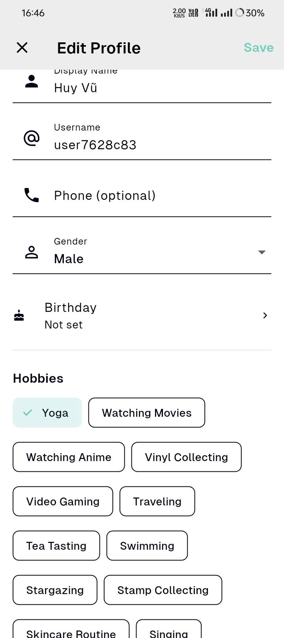
Figure 6: Edit Profile screen – Hobbies section displaying selectable tag/chip UI for user interests
Overall pass rate exceeded 95%, with minor UI adjustments addressed promptly. The architecture proved suitable for the current scale, delivering near-instantaneous messaging while ensuring data integrity.

CONCLUSION & REFLECTION

Conclusion
The "Lockmess" project successfully delivered a fully functional mobile messaging application utilizing a monolithic architecture enhanced by Event-Driven elements and WebSocket-based real-time communication. Built on Flutter for the client and Supabase as a Backend-as-a-Service platform, the system fulfills core requirements including user authentication, real-time text messaging, group/channel management, and interest-based recommendations.
Through rigorous testing and verification, the application demonstrated low-latency message delivery, reliable event broadcasting, and stable performance under concurrent usage. The chosen architectural decisions balanced development simplicity with essential quality attributes such as responsiveness and maintainability, making it well-suited for a small-to-medium-scale academic project.
The implementation validated the practicality of a client-centric, serverless approach for real-time applications, while highlighting the strengths of integrating EDA patterns within a monolithic structure to achieve efficient event propagation without traditional middleware complexity.

Reflection
Developing "Lockmess" provided valuable insights into the trade-offs inherent in architectural choices. The monolithic design facilitated rapid prototyping, unified deployment, and straightforward debugging—advantages particularly beneficial during early development stages and for a student team with limited resources.
However, performance tests revealed potential bottlenecks in high-concurrency scenarios, where centralized processing could become a limitation as user numbers grow. This experience underscored the importance of anticipating scalability needs and considering future migration paths, such as gradual transition to microservices for independent scaling of critical components.
Applying Clean Architecture principles ensured clear separation of concerns, improving testability and long-term maintainability. The hybrid communication strategy (synchronous HTTPS for writes, asynchronous WebSocket for reads) effectively balanced durability and real-time performance.
Overall, the project reinforced the critical role of Architecturally Significant Requirements (ASRs) in guiding design decisions and the necessity of continuous evaluation through testing to validate architectural fitness.

Future Directions
To evolve "Lockmess" further, the following enhancements are recommended:
- Transition selected modules (e.g., authentication, messaging) to microservices for improved scalability and independent deployment.
- Integrate advanced media support (images, videos, voice messages) with optimized storage and delivery mechanisms.
- Enhance the recommendation engine using more sophisticated algorithms or external ML services.
- Implement message queues for more robust event handling under extreme loads.
- Conduct production-grade deployment and monitoring on cloud infrastructure to assess real-world performance.
In summary, "Lockmess" serves not only as a working prototype but also as a meaningful learning experience in applying software architecture principles to build responsive, real-time systems.

