

**BUAN 6320**

**Database Foundations for Business Analytics**

**Final Project** - **Personal Investment Management System**

**Group 8:**

**●** Hrushikesh Sriramaneni - HXS220013

* Catherine Christina Ganduri - CCG220000
* Yamini Avula - YXA220018
* Koushik Gadpale - KXG220036
* Rachana Gaddam - RXG220036

**INDEX**

|  |  |  |
| --- | --- | --- |
| **S.NO** | **CONTENT** | **PAGE NO.** |
| 1. | Individual contribution of team | 3 |
| 2. | Acknowledgment | 4 |
| 3. | Business Plan | 5 |
| 4. | Strategies to consider | 5 |
| 5. | Implementation | 6-9 |
| 6. | Queries used | 9-11 |
| 7. | Stored Procedures | 12 |
| 8. | Stored Functions | 13 |
| 9. | Triggers | 13 |
| 10. | Conclusion | 14 |

**INDIVIDUAL CONTRIBUTION OF TEAM**

|  |  |
| --- | --- |
| **Contribution** | |
| Hrushikesh Sriramaneni | Contributed to the team in developing the logic of the stored procedures and functions.Helped the team to complete the project in structured manner. |
| Catherine Christina Ganduri | Contributed to the team in developing the business problem and coming up with ideas and in generating different table ideas and creating conditions for complex queries. |
| Yamini Avula | Contributed in understanding the triggers and helping the team in detailed report overview to give outputs of the queries. |
| Koushik Gadpale | Contributed to making the report and giving detailed information about the outputs of the queries. |
| Rachana Gaddam | Contributed to completing the data and analyzing in a better manner. |

**ACKNOWLEDGMENT:**

Dr. K Srikanth

Professor, Naveen Jindal School of Management

The University of Texas at Dallas

**Subject:** Submission of Personal Investment Management report.

Dear Professor,

This is the report that we were allocated on the topic as per your consultation. Personal investment management has been done with the knowledge that we have collected from the course “Database Foundations for Business Analytics”. We have worked on building a database management system for the personal investment of assets.

Thanks for your direction and priceless counsel and for giving us the opportunity to work on such a project. We will be pleased if you go through the project report carefully and we will try to answer all the questions regarding the report.

We have tried our level best to complete this report meaningfully and properly as much as possible. We do believe that our hard work will be reflected in it.

**BUSINESS PLAN:**

Budgeting, saving, and spending money over time while taking into account different financial risks and impending life events is known as personal investment. To carry out the personal investment procedures manually, it takes a great deal of time and effort. It usually involves a single person or a family.

Investment management is the upkeep of a portfolio of investments, or a group of financial assets. It can involve buying and selling assets, coming up with short- or long-term investment plans, managing the asset allocation of a portfolio, and coming up with a tax strategy.

So, by using MySQL, we are organizing different types of investments together so that we can make necessary connections between different kinds of investments that are happening in different age groups in a family. The main business goal is to do more than manage individual assets in a portfolio, which involves making sure that the portfolio stays in line with our objectives, level of risk tolerance, and financial priorities.

## **STRATEGIES TO CONSIDER:**

## Defining the family’s present financial situation.

## Figuring out how much money the different family members need to invest in.

## Making a budget to evaluate the family’s monthly disposable income after expenses and emergency savings which allows us to determine how much the family can reasonably afford to invest.

* Consider how accessible or liquid the investments the family wants to make are. If the family might need to cash in on their investments quickly, they would want to invest in more liquid assets, like stocks, rather than in something like real estate.

**IMPLEMENTATION**

1. 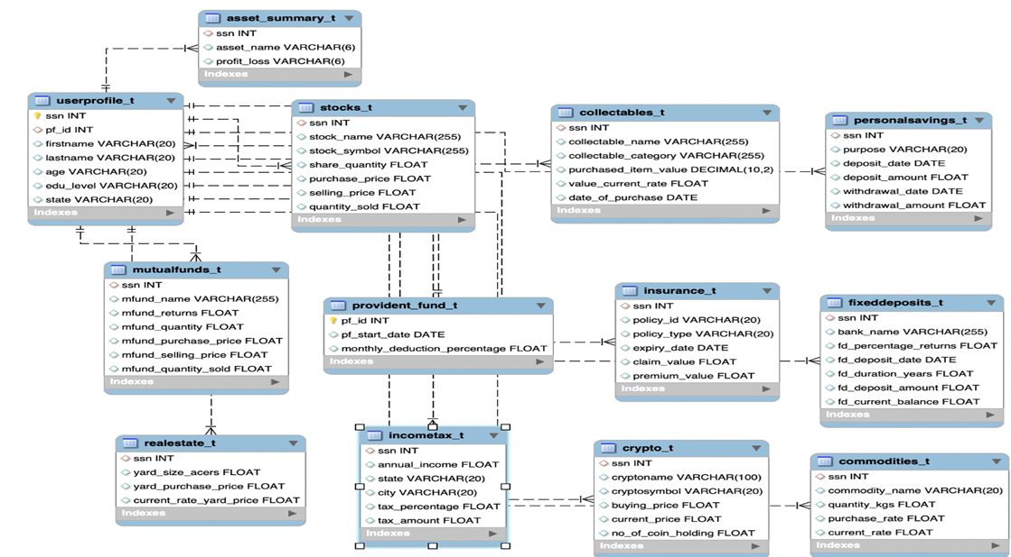**Entity-Relationship diagram:**
2. **Data Requirements:**

This database consists of a total of 13 tables which includes the following asset categories that a family is investing in-

**User profile:**

* This table contains the basic data of the all the members in a family. Each person is connected to different other investments through a primary key SSN. User profile

is connected to all the tables in the database through a one-to-many connection. The primary key is the SSN and the foreign key used is the PF ID

**Stocks:**

* Stocks are ownership interests in publicly traded businesses. In order to raise capital, businesses issue them on stock exchanges, where investors then buy and sell them based on their ability to increase in value or pay dividends. In this table, long-term financial objectives are set by purchasing and owning stocks.
* Here, SSN is referenced as foreign key in user profile table

**Crypto:**

* The family can choose to directly purchase and store one or more cryptocurrencies or decide to invest in a cryptocurrency-focused fund instead. The family has exchange-traded funds (ETFs), such as index funds and futures funds, in addition to a range of cryptocurrency investment trust.
* The crypto table calculates the profit from the difference between the buying price and the current price and the number of coin holding the each person possess.

**Mutual funds:**

* Mutual fund collects money from investors to buy stocks, bonds, and other assets. A mutual fund seeks to build a portfolio that is more diversified than the typical investor could do on their own.
* In this table, by using the SSN as a primary key, different queries are written to calculate the different returns in mutual funds.

**Collectables:**

* It is an alternative investment in a family or things that don't fit into any other category like stocks, bonds, cash, or real estate, including things that are worth significantly more than their original purchase price and are referred to as collectibles.
* In this table, profits that are maximized are calculated by using various queries by using the current value and date of purchase.

**Provident fund:**

* Employers are required to make contributions on behalf of their employees. In this table, employees contribute a percentage of their salaries to the provident fund based on the start date and the percentage of salary deducted every month.

**Insurance:**

* Different factors are taken into consideration in the table when a working professional invests in different types of policies. The return on investment is calculated by comparing different policy types in the table, the expiry date for the insurance taken based on the claim, and premium values.

**Fixed Deposits:**

* fixed deposits are important means of personal investment because the interest paid on savings or current account balances is lower than the interest paid on fixed deposit holdings. In the table, the holdings are calculated by taking the help of the deposit date, current balance, and the amount deposited.

**Personal Savings:**

* The personal savings can be the investments in different miscellaneous purposes like marriage, car, tour, education etc. Different profit calculations are made depending on the calculations between the withdrawal and deposited amounts.

**Real Estate:**

* Being a landlord of a rental property is one of the main ways that real estate investors can make money. By using the table, the person’s profit is calculated by calculating the yard size and by taking into consideration the current price.

**Commodities:**

* The worth of the Items like gold, diamonds, natural gas are calculated based on the individual weight of the items and the profit is calculated based on the difference between the purchase rate and the current rate.

**QUERIES USED:**

The following queries are being used in the database:

**1**.Users from the state Kentucky and age more than 50.

Here we get all the users whose state is Kentucky and their age is greater than 50.

**Output:**

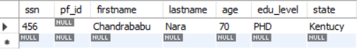

**2**.Total profit for each user across all his crypto holdings from crypto table.

Here we get the total profit for each user among all his crypto holdings.

**Output:**

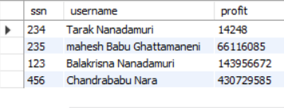

**3**.The savings of the people who pay taxes.

Here we get the savings of the people who are paying taxes.

**Output:**

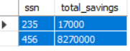

**4**.The profit and loss across real estate, mutual funds and stocks for 4 users.

Here we show the profit and loss for 4 different users in real estate,mutual funds and stocks.

**Output:**

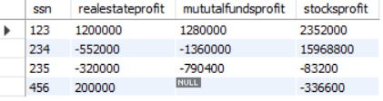

**5**.A view which shows us the list of people who have car in their collectables.

Created a view which will show us the people having car in their collectables.

**Output:**

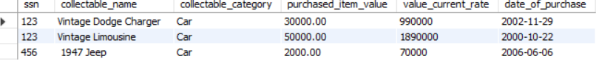

**6**.The users who pay total premium more than 1000 and total claim less than 50000.

Here we show the users who have premium more than 1000 and have their claim less than 50000

**Output:**



**7**.The users who have profit more than a million from either crypto or stocks

**Output:**

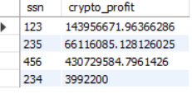

**STORED PROCEDURES:**

1.**getprofits**: stored procedure for profits/loss for a certain user across all assets.

Example query:call getprofits(234);

**Output:**

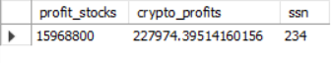

2.**mfund_assetperformance:** stored procedure for mfund asset performance

Example query:call mfund_assetperformance(234);

**Output:**



**3.crypto_calculator:** stored procedure to calculate total investments in crypto at any given time

Example query:call crypto_calculator;

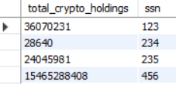

**STORED FUNCTIONS:**

**categorize_assets:**

Function to categorize assets based on their profits by high returns,medium returns and low returns.

Example query:

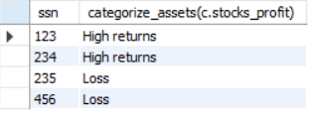

**TRIGGERS:**

Pre delete trigger on users_t:Created a trigger and used **BEFORE DELETE** on the ***user_profiles_t*** table for getting access to the older customers.

Post update trigger for stocks_t:Created a trigger and used **AFTER UPDATE** on the ***stocks_t*** table for getting to know the change history and updating the related records in stocks

Pre update trigger for incometax_audit:Created a trigger and used **BEFORE UPDATE** on the ***incometax_t*** for getting old income for users

**CONCLUSION:**

To conclude, this project is an efficient method for implementing a personal investment Management system for RDBMS Inc., that can be used for managing data from different assets.