Assignment
Read Chapter 7 of our textbook, design, and/or re-design YPL syntax for the syntactic entities equivalent to SPL non-terminals <PRINTStatement> , <expression> , <integer>, and <boolean>, then add them to YPL1 to develop YPL2—your second subset of YPL. Note “add, design, and/or re-design” means to (1) make changes to your scanner to recognize new tokens; (2) make updates to your parser to recognize new and/or changed non-terminals; and (3) make additions of needed code generation! The syntactic entities added to SPL1 to transform it into SPL2 are highlighted below.

Note Your YPL compiler must be able to support the YPL capability to

- specify unnamed literal constants with data types integer, boolean, and string (strings are usually used to label output);
- name program variables and modules with identifiers;
- define scalar variables for data types integer and boolean;
- define 1-dimensional array variables for data types integer and boolean;
- express computation using expression syntax that makes use of an “interesting” collection of unary and binary operators for operands with data types integer and boolean;
- specify an assignment-statement;
- specify several “classic” structured flow-of-control statements, including, (1) an if-statement; (2) a bounded-loop-statement ; and (3) a pretest- and/or posttest-loop-statement;
- define the main program module;
- specify assertions;
- define directly-recursive procedure subprogram modules with IN, OUT, IO parameters;
- specify a call-procedure-module-statement (with parameter passing);
- specify a return-from-procedure-module-statement;
- define directly-recursive, pure function subprogram modules with IN parameters;
- specify reference-to-function-module syntax as part of expression (with parameter passing);
- specify a return-from-function-module-statement;
Repeated to include output of integer and boolean <expression> results.
- specify an input-statement used for console text input;
- specify an output-statement used for console formatted-text output; and
- include comments.

Here is the SPL BNF for the SPL subset that we’ll call SPL2 with changes from SPL1 highlighted. Notice that <PRINTStatement> is no longer ***SIMPLIFIED*** which means that, as far as Dr. Hanna is concerned, the <PRINTStatement> syntax is complete!

<SPLProgram> ::= <PROGRAMDefinition> EOPC || ***SIMPLIFIED***

<PROGRAMDefinition> ::= PROGRAM || ***SIMPLIFIED***
{ <statement> }*
END

<statement> ::= <PRINTStatement> || ***SIMPLIFIED***

<PRINTStatement> ::= PRINT (( <string> | <expression> | ENDL ))
{ , (( <string> | <expression> | ENDL )) }* .

<expression> ::= <conjunction> { (( OR | NOR | XOR )) <conjunction> }*

<conjunction> ::= <negation> { (( AND | NAND )) <negation> }*

<negation> ::= [ NOT ] <comparison>

<comparison> ::= <comparator> [ (( < | <= | = | > | >= | (( <> | != )) )) <comparator> ]

<comparator> ::= <term> { (( + | - )) <term> }*

<term> ::= <factor> { (( * | / | % )) <factor> }*

<factor> ::= [ (( ABS | + | - )) ] <secondary> || ***SIMPLIFIED***

<secondary> ::= <primary> [ (( ^ | ** )) <primary> ]

<primary> ::= ( <expression> ) | <literal> || ***SIMPLIFIED***

<identifier> ::= <letter> { (( <letter> | <digit> | _ )) }* || ***SIMPLIFIED***

<literal> ::= <integer> | <boolean> | <string> || ***SIMPLIFIED***

<integer> ::= <digit> { <digit> }*

<boolean> ::= true | false

<string> ::= " { <ASCIICharacter> }* " || *Note* escape both \ and " with \

<digit> ::= 0 | 1 | 2 | 3 | 4 | 5 | 6 | 7 | 8 | 9

<ASCIICharacter> ::= || Every printable ASCII character in range [ ' ','~' ]

<comment> ::= ; { <ASCIICharacter> }* EOLC || single-line comment
| /* { (( <ASCIICharacter> | EOLC )) }* */ || multi-line (block) comment

Incorporate the semantic analysis and code generation design ideas you learned while studying SPL2Compiler.cpp into your YPL2Compiler.cpp. To test-and-debug YPL2Compiler.cpp, design one or more YPL2 source files that, like Dr. Hanna’s source file P4.spl, fully white-box test the logic your fledgling compiler uses to do the semantic analysis and code generation for context-independent-grammatically-correct YPL2 programs. Obviously, the STM files YPL2Compiler.cpp produces must run successfully on STM and produce the expected results.

Remember, your “YPL Language Reference” is a “living” document. As you make design changes to YPL, make corresponding changes to your language reference. You must include YPL static semantics and dynamic semantics in your language reference. These parts of the YPL language specification are absolutely essential prerequisites for the design of the YPL compiler’s semantic analyzer/code generator.

Send an email to AHanna@StMaryTX.edu with a single Word document attachment that contains (1) your version of YPL2Compiler.cpp; (2) the YPL2 source files you chose to compile; (3) the STM files your compiler generates for each YPL2 source file; (4) the corresponding STM screen shots that serve as “proof” that the STM programs are semantically-equivalent to their YPL2 counterparts; and a separate Word document attachment that is your updated “YPL Language Reference”.
Sample P4.spl Program Dialog

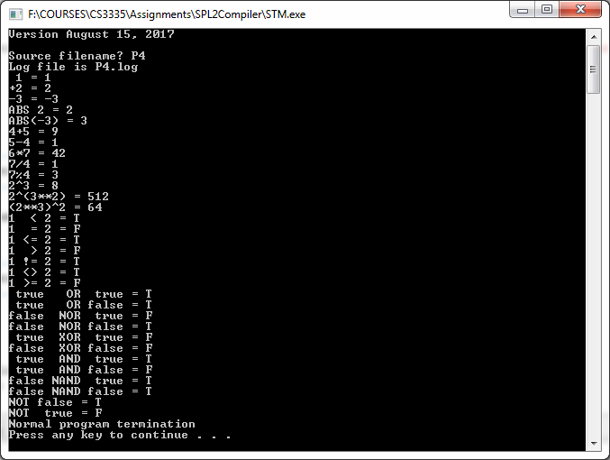
;--------------------------------------------------------------
; Dr. Art Hanna
; Program #4
; P4.spl
;--------------------------------------------------------------

PROGRAM

/*----------------------*/
/* Arithmetic operators */
/*----------------------*/
PRINT " 1 = ",1,ENDL.
PRINT "+2 = ",+2,ENDL.
PRINT "-3 = ",-3,ENDL.
PRINT "ABS 2 = ",ABS 2,ENDL.
PRINT "ABS(-3) = ",ABS(-3),ENDL.
PRINT "4+5 = ",(4+5),ENDL.
PRINT "5-4 = ",5-4,ENDL.
PRINT "6*7 = ",6*7,ENDL.
PRINT "7/4 = ",7/4,ENDL.
PRINT "7%4 = ",7%4,ENDL.
PRINT "2^3 = ",2^3,ENDL.
PRINT "2^(3**2) = ",2^(3**2),ENDL.
PRINT "(2**3)^2 = ",(2**3)^2,ENDL.

/*----------------------*/
/* Comparison operators */
/*----------------------*/
PRINT "1 < 2 = ",1 < 2,ENDL.
PRINT "1 = 2 = ",1 = 2,ENDL.
PRINT "1 <= 2 = ",1 <= 2,ENDL.
PRINT "1 > 2 = ",1 > 2,ENDL.
PRINT "1 != 2 = ",1 != 2,ENDL.
PRINT "1 <> 2 = ",1 <> 2,ENDL.
PRINT "1 >= 2 = ",1 >= 2,ENDL.

/*----------------------*/
/* Logical operators */
/*----------------------*/
PRINT " true OR true = ", true OR true,ENDL.
PRINT " true OR false = ", true OR false,ENDL.
PRINT "false NOR true = ",false NOR true,ENDL.
PRINT "false NOR false = ",false NOR false,ENDL.
PRINT " true XOR true = ", true XOR true,ENDL.
PRINT "false XOR false = ",false XOR false,ENDL.

PRINT " true AND true = ", true AND true,ENDL.
PRINT " true AND false = ", true AND false,ENDL.
PRINT "false NAND true = ",false NAND true,ENDL.
PRINT "false NAND false = ",false NAND false,ENDL.

PRINT "NOT false = ",NOT false,ENDL.
PRINT "NOT true = ",NOT true,ENDL.

END

