Assignment
Read Chapter 8 of our text book, design YPL syntax for the syntactic entities equivalent to the SPL non-terminals <FORStatement> and <assertion> then add them to YPL4 to develop YPL5. Note “design” means (1) make changes to your scanner to recognize new tokens; (2) make updates to your parser to recognize new and/or changed non-terminals; and (3) make additions of more code generation! The added syntactic entities are highlighted below.

Note Your YPL compiler must be able to support the YPL capability to

- specify unnamed literal constants with data types integer, boolean, and string (strings are usually used to label output);
- name program variables and modules with identifiers;
- define scalar variables for data types integer and boolean;
- define 1-dimensional array variables for data types integer and boolean;
- express computation using expression syntax which makes use of an “interesting” collection of unary and binary operators for operands with data types integer and boolean;
- specify an assignment-statement;
- specify several “classic” structured flow-of-control statements, including, (1) an if-statement; (2) a bounded-loop-statement; and (3) a pretest- and/or posttest-loop-statement;
- define the main program module;
- specify assertions;
- define directly-recursive procedure subprogram modules with IN, OUT, IO parameters;
- specify a call-procedure-module-statement (with parameter passing);
- specify a return-from-procedure-module-statement;
- define directly-recursive, pure function subprogram modules with IN parameters;
- specify reference-to-function-module syntax as part of expression (with parameter passing);
- specify a return-from-function-module-statement;
- specify an input-statement used for console text input;
- specify an output-statement used for console formatted-text output; and
- include comments.

Here is the SPL BNF for the SPL subset that we’ll call SPL5 with changes from SPL4 highlighted. Notice that (1) assertions <assertion> has been added; and (2) a bounded-loop-statement <FORStatement> has been added.

<SPLProgram> ::= { <dataDefinitions> }* || ***SIMPLIFIED***
<PROGRAMDefinition> EOPC

<dataDefinitions> ::= <variableDefinitions> | <constantDefinitions>

<variableDefinitions> ::= VAR <identifier> : <datatype> || ***SIMPLIFIED***
{ , <identifier> : <datatype> }* .

<constantDefinitions> ::= CON <identifier> : <datatype> := <literal>
{ , <identifier> : <datatype> := <literal> }* .

<datatype> ::= (( INT | BOOL )) || ***SIMPLIFIED***

<PROGRAMDefinition> ::= PROGRAM
{ <dataDefinitions> }*
{ <statement> }*
END

<statement> ::= { <assertion> }* || ***SIMPLIFIED***
((
<PRINTStatement>
| <INPUTStatement>
| <assignmentStatement>
| <IFStatement>
| <DOWHILEStatement>
| <FORStatement>
))
{ <assertion> }*

<assertion> :: { <expression> }

<PRINTStatement> ::= PRINT (( <string> | <expression> | ENDL ))
{ , (( <string> | <expression> | ENDL )) }* .

<INPUTStatement> ::= INPUT [ <string> ] <variable> .

<assignmentStatement> ::= <variable> { , <variable> }* := <expression> .

<IFStatement> ::= IF ( <expression> ) THEN
{ <statement> }*
{ ELIF ( <expression> ) THEN
{ <statement> }* }*
[ ELSE
{ <statement> }* ]
END

<DOWHILEStatement> ::= DO
{ <statement> }*
WHILE ( <expression> )
{ <statement> }*
END

<FORStatement> ::= FOR <variable> := <expression> TO <expression> [ BY <expression> ]
{ <statement> }*
END

<expression> ::= <conjunction> { (( OR | NOR | XOR )) <conjunction> }*

<conjunction> ::= <negation> { (( AND | NAND )) <negation> }*

<negation> ::= [ NOT ] <comparison>

<comparison> ::= <comparator> [ (( < | <= | = | > | >= | (( <> | != )) )) <comparator> ]

<comparator> ::= <term> { (( + | - )) <term> }*

<term> ::= <factor> { (( * | / | % )) <factor> }*

<factor> ::= [ (( ABS | + | - )) ] <secondary> || ***SIMPLIFIED***

<secondary> ::= <prefix> [ (( ^ | ** )) <prefix> ]

<prefix> ::= <primary>
| (( ++ | -- )) <variable>

<primary> ::= <variable> | ( <expression> ) | <literal> || ***SIMPLIFIED***

<variable> ::= <identifier> || ***SIMPLIFIED***

<identifier> ::= <letter> { (( <letter> | <digit> | _ )) }*

<literal> ::= <integer> | <boolean> | <string> || ***SIMPLIFIED***

<integer> ::= <digit> { <digit> }*

<boolean> ::= true | false

<string> ::= " { <ASCIICharacter> }* " || *Note* escape both \ and " with \

<digit> ::= 0 | 1 | 2 | 3 | 4 | 5 | 6 | 7 | 8 | 9

<ASCIICharacter> ::= || Every printable ASCII character in range [ ' ','~' ]

<comment> ::= ; { <ASCIICharacter> }* EOLC || single-line comment
| /* { (( <ASCIICharacter> | EOLC )) }* */ || multi-line (block) comment

Incorporate the semantic analysis and code generation design ideas you learned while studying SPL5Compiler.cpp into your YPL4Compiler.cpp. To test-and-debug YPL5Compiler.cpp, design one or more YPL5 source files that, like Dr. Hanna’s source files P8.spl and P9.spl, fully white-box test the logic your fledgling compiler uses to do the semantic analysis and code generation for context-independent, grammatically-correct YPL5 programs. Obviously, the STM files YPL5Compiler.cpp produces must run successfully on STM and produce the expected results.

Remember, your “YPL Language Reference” is a “living” document. As you make design changes to YPL, make corresponding changes to your language reference. You must include YPL static semantics and dynamic semantics. These parts of the YPL language specification are absolutely essential prerequisites for the design of the YPL compiler’s semantic analyzer/code generator.

Send an email to AHanna@StMaryTX.edu with a single Word document attachment that contains (1) your version of YPL5Compiler.cpp; (2) the YPL5 source files you chose to compile; (3) the STM files your compiler generates for each YPL5 source file; (4) the corresponding STM screenshots that serve as “proof” that the STM programs are semantically-equivalent to their YPL5 counterparts; and a separate Word document attachment that is your updated “YPL Language Reference”.
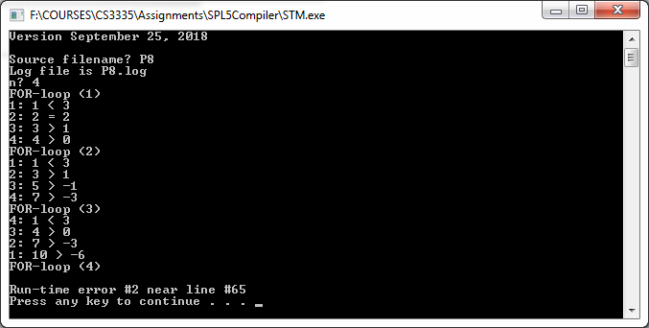

;-------------------------------------------------------------
; Dr. Art Hanna
; Problem #8
; P8.spl
;-------------------------------------------------------------

CON initialX: INT := 1.

VAR i: INT.

PROGRAM
CON initialY: INT := 3.

VAR n: INT,x: INT,y: INT.

INPUT "n? " n.

PRINT "FOR-loop (1)",ENDL.
x := initialX. y := initialY.
FOR i := 1 TO n BY 1
PRINT i,": ".
IF ( x < y ) THEN
PRINT x," < ",y,ENDL.
ELIF ( x = y ) THEN
PRINT x," = ",y,ENDL.
ELIF ( x > y ) THEN
PRINT x," > ",y,ENDL.
END
x := x+1.
y := y-1.
END

PRINT "FOR-loop (2)",ENDL.
x := initialX. y := initialY.
FOR i := 1 TO n
PRINT i,": ".
IF ( x < y ) THEN
PRINT x," < ",y,ENDL.
ELIF ( x = y ) THEN
PRINT x," = ",y,ENDL.
ELIF ( x > y ) THEN
PRINT x," > ",y,ENDL.
END
x := x+2.
y := y-2.
END

PRINT "FOR-loop (3)",ENDL.
x := initialX. y := initialY.
FOR i := n TO 1 BY -1
PRINT i,": ".
IF ( x < y ) THEN
PRINT x," < ",y,ENDL.
ELIF ( x = y ) THEN
PRINT x," = ",y,ENDL.
ELIF ( x > y ) THEN
PRINT x," > ",y,ENDL.
END
x := x+3.
y := y-3.
END

PRINT "FOR-loop (4)",ENDL.
FOR i := 1 TO n BY 1-1 ; run-time error #2 (e3 = 0)
PRINT "UNREACHABLE",ENDL.
END

END

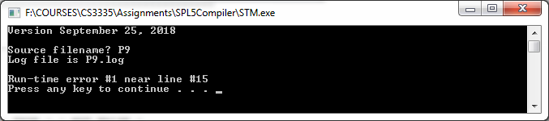

;------------------------------------------------------------
; Dr. Art Hanna
; Program #9
; P9.spl
;------------------------------------------------------------

PROGRAM
VAR x: INT,y: INT.

x := 101. y := 0.

{ ((x >= 0) AND (y != 1)) } { TRUE } { NOT FALSE }

y := x + 1.

{ x = y-1 } { y < x }

END

