Assignment
Read Chapters 9 and 10 of our text book, design YPL syntax for the syntactic entities equivalent to the SPL non-terminals <PROCEDUREDefinition>, <formalParameter>, <CALLStatement>, and <RETURNStatement> then add them to YPL5 to develop YPL6. Note “design” means to (1) make changes to your scanner to recognize new tokens; (2) make updates to your parser to recognize new and/or changed non-terminals; and (3) make additions of more code generation! The added syntactic entities are highlighted below.

Note Your YPL compiler must be able to support the YPL capability to

- specify unnamed literal constants with data types integer, boolean, and string (strings are usually used to label output);
- name program variables and modules with identifiers;
- define scalar variables for data types integer and boolean;
- define 1-dimensional array variables for data types integer and boolean;
- express computation using expression syntax which makes use of an “interesting” collection of unary and binary operators for operands with data types integer and boolean;
- specify an assignment-statement;
- specify several “classic” structured flow-of-control statements, including, (1) an if-statement; (2) a bounded-loop-statement; and (3) a pretest- and/or posttest-loop-statement;
- define the main program module;
- specify assertions;
- define directly-recursive procedure subprogram modules with IN, OUT, IO parameters;
- specify a call-procedure-module-statement (with parameter passing);
- specify a return-from-procedure-module-statement;
- define directly-recursive, pure function subprogram modules with IN parameters;
- specify reference-to-function-module syntax as part of expression (with parameter passing);
- specify a return-from-function-module-statement;
- specify an input-statement used for console text input;
- specify an output-statement used for console formatted-text output; and
- include comments.

Here is the SPL BNF for the SPL subset that we’ll call SPL6 with changes from SPL5 highlighted. Notice that (1) <SPLProgram> and <statement> have been updated; and (2) <PROCEDUREDefinition>, <formalParameter>, <CALLStatement>, and <RETURNStatement> have been added.

<SPLProgram> ::= { <dataDefinitions> }* || ***SIMPLIFIED***
{ <PROCEDUREDefinition> }*
<PROGRAMDefinition> EOPC

<dataDefinitions> ::= <variableDefinitions> | <constantDefinitions>

<variableDefinitions> ::= VAR <identifier> : <datatype> || ***SIMPLIFIED***
{ , <identifier> : <datatype> }* .

<constantDefinitions> ::= CON <identifier> : <datatype> := <literal>
{ , <identifier> : <datatype> := <literal> }* .

<datatype> ::= (( INT | BOOL )) || ***SIMPLIFIED***

<PROGRAMDefinition> ::= PROGRAM
{ <dataDefinitions> }*
{ <statement> }*
END

<PROCEDUREDefinition> ::= PROCEDURE <identifier> [ ( <formalParameter> { , < formalParameter > }* ) ]
{ <dataDefinitions> }*
{ <statement> }*
END

<formalParameter> ::= [ (( IN | OUT | IO | REF )) ] <identifier> : <datatype> || ***SIMPLIFIED***

<statement> ::= { <assertion> }* || ***SIMPLIFIED***
((
<PRINTStatement>
| <INPUTStatement>
| <assignmentStatement>
| <IFStatement>
| <DOWHILEStatement>
| <FORStatement>
| <CALLStatement>
| <RETURNStatement>
))
{ <assertion> }*

<assertion> :: { <expression> }

<PRINTStatement> ::= PRINT (( <string> | <expression> | ENDL ))
{ , (( <string> | <expression> | ENDL )) }* .

<INPUTStatement> ::= INPUT [ <string> ] <variable> .

<assignmentStatement> ::= <variable> { , <variable> }* := <expression> .

<IFStatement> ::= IF ( <expression> ) THEN
{ <statement> }*
{ ELIF ( <expression> ) THEN
{ <statement> }* }*
[ ELSE
{ <statement> }* ]
END

<DOWHILEStatement> ::= DO
{ <statement> }*
WHILE ( <expression> )
{ <statement> }*
END

<FORStatement> ::= FOR <variable> := <expression> TO <expression> [ BY <expression> ]
{ <statement> }*
END

<CALLStatement> ::= CALL <identifier> [ ( (( <expression> | <variable> ))
{ , (( <expression> | <variable> )) }* ) ] .

<RETURNStatement> ::= RETURN . || ***SIMPLIFIED***

<expression> ::= <conjunction> { (( OR | NOR | XOR )) <conjunction> }*

<conjunction> ::= <negation> { (( AND | NAND )) <negation> }*

<negation> ::= [ NOT ] <comparison>

<comparison> ::= <comparator> [ (( < | <= | = | > | >= | (( <> | != )) )) <comparator> ]

<comparator> ::= <term> { (( + | - )) <term> }*

<term> ::= <factor> { (( * | / | % )) <factor> }*

<factor> ::= [ (( ABS | + | - )) ] <secondary> || ***SIMPLIFIED***

<secondary> ::= <prefix> [ (( ^ | ** )) <prefix> ]

<prefix> ::= <primary>
| (( ++ | -- )) <variable>

<primary> ::= <variable> | ( <expression> ) | <literal> || ***SIMPLIFIED***

<variable> ::= <identifier> || ***SIMPLIFIED***

<identifier> ::= <letter> { (( <letter> | <digit> | _ )) }*

<literal> ::= <integer> | <boolean> | <string> || ***SIMPLIFIED***

<integer> ::= <digit> { <digit> }*

<boolean> ::= true | false

<string> ::= " { <ASCIICharacter> }* " || *Note* escape both \ and " with \

<digit> ::= 0 | 1 | 2 | 3 | 4 | 5 | 6 | 7 | 8 | 9

<ASCIICharacter> ::= || Every printable ASCII character in range [ ' ','~' ]

<comment> ::= ; { <ASCIICharacter> }* EOLC || single-line comment
| /* { (( <ASCIICharacter> | EOLC )) }* */ || multi-line (block) comment

Incorporate the semantic analysis and code generation design ideas you learned while studying SPL6Compiler.cpp into your YPL5Compiler.cpp. To test-and-debug YPL6Compiler.cpp, design one or more YPL6 source files that, like Dr. Hanna’s source file P10.spl and P11.spl, fully white-box test the logic your fledgling compiler uses to do the semantic analysis and code generation for context-independent-grammatically-correct YPL6 programs. Obviously, the STM files YPL6Compiler.cpp produces must run successfully on STM and produce the expected results.

Remember, your “YPL Language Reference” is a “living” document. As you make design changes to YPL, make corresponding changes to your language reference. You must include YPL static semantics and dynamic semantics. These parts of the YPL language specification are absolutely essential prerequisites for the design of the YPL compiler’s semantic analyzer/code generator.

Send an email to AHanna@StMaryTX.edu with a single Word document attachment that contains (1) your version of YPL6Compiler.cpp; (2) the YPL6 source files you chose to compile; (3) the STM files your compiler generates for each YPL6 source file; (4) the corresponding STM screen shots that serve as “proof” that the STM programs are semantically-equivalent to their YPL6 counterparts; and a separate Word document attachment that is your updated “YPL Language Reference”.
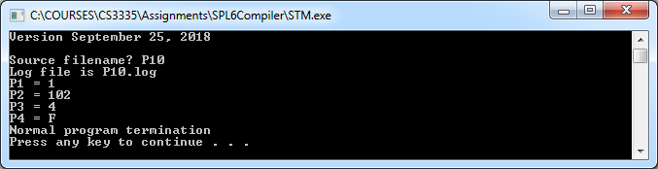

;------------------------------------------------------------
; Dr. Art Hanna
; Problem #10
; P10.spl
;------------------------------------------------------------

VAR x: INT,y: INT.

PROCEDURE P(IN in1: INT, OUT out1: INT, IO io1: INT, REF ref1: BOOL)
CON C1: INT := 101.

out1 := in1+C1.
io1 := io1+1.
ref1 := NOT ref1.
END

PROGRAM
CON P1: INT := 1.

VAR P2: INT, P3: INT.
VAR P4: BOOL.

P3 := 3.
P4 := TRUE.

CALL P(P1,P2,P3,P4).
PRINT "P1 = ",P1,ENDL.
PRINT "P2 = ",P2,ENDL.
PRINT "P3 = ",P3,ENDL.
PRINT "P4 = ",P4,ENDL.
END

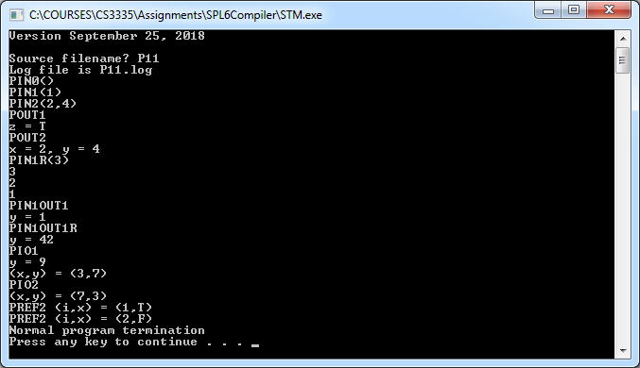

;-------------------------------------------------------------
; Dr. Art Hanna
; Problem #11
; P11.spl
;-------------------------------------------------------------

VAR x: INT,y: INT.
VAR z: BOOL.

PROCEDURE PIN0
PRINT "PIN0()",ENDL.
RETURN.
END

PROCEDURE PIN1(x: INT)
PRINT "PIN1(",x,")",ENDL.
; RETURN.
END

PROCEDURE PIN2(x: INT,IN y: INT)
PRINT "PIN2(",x,",",y,")",ENDL.
END

PROCEDURE POUT1(OUT b: BOOL)
PRINT "POUT1",ENDL.
b := true.
END

PROCEDURE POUT2(OUT x: INT,OUT y: INT)
PRINT "POUT2",ENDL.
x := 2.
y := 2*x.
RETURN.
END

PROCEDURE PIN1R(x: INT)
IF ( x > 0 ) THEN
PRINT x,ENDL.
CALL PIN1R(x-1).
END
END

PROCEDURE PIN1OUT1(IN x: INT,OUT y: INT)
PRINT "PIN1OUT1",ENDL.
y := x.
END

PROCEDURE PIN1OUT1R(x: INT,OUT y: INT)
IF ( x = 0 ) THEN
y := 42.
ELSE
CALL PIN1OUT1R(x-1,y).
END
END

PROCEDURE PIO1(IO x: INT)
PRINT "PIO1",ENDL.
x := x+2.
END

PROCEDURE PIO2(IO x1: INT,IO x2: INT)
VAR T: INT.

PRINT "PIO2",ENDL.
T := x1.
x1 := x2.
x2 := T.
END

PROCEDURE PREF2(REF i: INT,REF x: BOOL)
PRINT "PREF2 (i,x) = (",i,",",x,")",ENDL.
x := NOT x.
RETURN.
END

PROGRAM
VAR i: INT.

CALL PIN0.

CALL PIN1(1).

x := 2.
CALL PIN2(x,x+2).

CALL POUT1(z).
PRINT "z = ",z,ENDL.

CALL POUT2(x,y).
PRINT "x = ",x,", y = ",y,ENDL.

PRINT "PIN1R(3)",ENDL.
CALL PIN1R(3).

x := 1.
CALL PIN1OUT1(x,y).
PRINT "y = ",y,ENDL.

PRINT "PIN1OUT1R",ENDL.
CALL PIN1OUT1R(3,y).
PRINT "y = ",y,ENDL.

y := 7.
CALL PIO1(y).
PRINT "y = ",y,ENDL.

x := 3. y := 7.
PRINT "(x,y) = (",x,",",y,")",ENDL.
CALL PIO2(x,y).
PRINT "(x,y) = (",x,",",y,")",ENDL.

FOR i := 1 TO 2
CALL PREF2(i,z).
END

END

