Multipath signal detection by space processing for automotive radar

Sergei Shishanov, Anna Dzvonkovskaya and Boya Qin

Abstract—The paper deals with the algorithms of distinguishing the real and ghost targets, caused by a multiple reflection of the signal from the road objects (multipath propagation). In some scenarios, due to the MIMO antenna configuration and the angular relationship between primary and secondary reflections, the estimated ghost target angle may appear near the radar's boresight direction. Such false targets pose significant risks for ADAS systems, potentially triggering unintended emergency maneuvers.
The paper deals with a novel metric for distinguishing real and ghost targets. The algorithms based on this metric were analyzed. The proposed algorithms were evaluated using open radar datasets. Experimental results demonstrate the metric's effectiveness as a reliable criterion for distinguishing single and multiple reflections.

Index Terms—automotive radar, MIMO virtual antenna, ghost target, direct and multipath signal, steering vector, projection matrix, ambiguity area.

I. INTRODUCTION
T
he automotive industry has undergone significant transformations in recent years. The automotive manufacturers are developing and implementing ADAS systems based on data fusion by different sensors: LiDARs, cameras, and radars. The advantage of the mm-wave radars is possibility to detect the road objects up to hundred meters and estimate their coordinates and velocity [1]. The mm-wave radars operate effectively in bad weather conditions, such as snowfall, rain, and fog [2].
The radar measures the surrounding environment by radiating the electromagnetic waves and receive reflection echo from the objects. However, in complex road scenatious, such as dense urban environment, the signal can propagate not only along a direct path, but also can be reflected from other objects [3]. The signal reflected from object several times is called multipath signal. The multipath propagation effect can decrease the signal-to-noise ratio and generate a ghost target [3]. The ghost target is dangerous for ADAS systems, such as adaptive cruise control (ACC) and collision avoidance systems (CAS). As a result, the ADAS may initiate sudden evasive maneuvers or trigger emergency braking. Therefore, the distinguishing of the signals corresponding to real objects and ghost targets is an actual challenge.
There are some papers, which describe the identification algorithms of ghost targets caused by multipath propagation. Paper [4, 5] describes an algorithm to estimate a ghost target potential location using combination of target and reflectors geometry. In case of matching the location of detected points and potential area of ghost target, this object will be marked as a ghost target. In the paper [7], the author describes an algorithm of ghost target detection by comparison of the vehicle pose orientation and direction of the radial velocity vector. Paper [8] presents the Space-Space Adaptive Processing algorithm based on combination of transmit antenna and receive antenna.
This paper deals with the multipath detection algorithms, based on the combination of physical and MIMO virtual antenna steering vectors. The paper is organized as follows: the model of a MIMO antenna is defined in Section II; the model of direct and multipath signals is described in Section III; the proposed algorithm of ghost target detection is presented in Section IV; the experimental results are described in Section V; and the conclusions are summarized in Section VI.

II. MIMO antenna array model
MIMO (Multiple-Input Multiple-Output) antenna arrays are widely used in the automotive radars. This technology provides higher angular resolution and the accuracy of measurements. Such approach allows to reduce the size of antenna layout and the number of physical receive antennas through the use of several transmit antennas.
Typically, the separated transmit and receive antennas are used. The transmit antenna steering vector, associated with azimuth direction 𝜃_{tx}, can be described as follows:
$s_{tx}\left(θ_{tx}\right)=A_{tx}\left[\begin{matrix}\begin{matrix}1 \\ e^{i∙k∙d_{tx\left(1\right)}∙sin⁡(θ_{tx})}\end{matrix} \\ … \\ e^{i∙k∙d_{tx\left(N_{tx}-1\right)}∙sin⁡(θ_{tx})}\end{matrix}\right]$ (1)
where $A_{tx}$ is the complex amplitude of the transmit signal, k = 2π/λ, [0, d_{tx(1)},…, d_{tx(Ntx-1)}] is the transmit antenna array coordinates vector.
The spatial spectrum of the transmit antenna can be described as follows [8]:

$$P_{tx}\left(θ\right)={a_{tx}}^{H}s_{tx}\left(θ_{tx}\right)$$ | (2)

where $a_{tx}=\left[\begin{matrix}exp\left(i∙k∙[0, d_{tx\left(1\right)},…,d_{N_{tx}-1}] ·sin\left(θ_{0}\right)\right) \\ ⋮ \\ exp\left(i∙k∙[0, d_{tx\left(1\right)},…,d_{N_{tx}-1}] ·sin\left(θ_{n}\right)\right)\end{matrix}\right]$ is the transmit antenna steering vector, [𝜃₀,…, 𝜃_{n}] is the set of the arrival angles.
The receive antenna steering vector, associated with azimuth direction 𝜃_{rx}, can be described as follows:
$s_{rx}\left(θ_{rx}\right)=A_{rx}\left[\begin{matrix}\begin{matrix}1 \\ e^{i∙k∙d_{rx(1)}∙sin⁡(θ_{tx})}\end{matrix} \\ … \\ e^{i∙k∙d_{rx\left(N_{rx}-1\right)}∙sin⁡(θ_{rx})}\end{matrix}\right]$ (3)

where $A_{rx}$ is the complex amplitude of the receive signal, [0, d_{tx}(1),…, d_{tx(Ntx-1)}] is the receive antenna array coordinate vector.
The receive antenna spatial spectrum can be described as follows [8]:

$P_{rx}\left(θ\right)={a_{rx}}^{H}{ s}_{rx}\left(θ_{rx}\right)$ (4)

where $a_{rx}=\left[\begin{matrix}exp\left(i∙k∙[0, d_{rx\left(1\right)},…,d_{N_{rx}-1}]·sin\left(θ_{0}\right)\right) \\ ⋮ \\ exp\left(i∙k∙[0, d_{rx\left(1\right)},…,d_{N_{rx}-1}]·sin\left(θ_{n}\right)\right)\end{matrix}\right]$ is the receive antenna steering vector.
The MIMO signal is the transmit and receive antenna array signal combination. The MIMO steering vector can be described as vector or matrix [9]:

$s_{mimo}\left(θ_{tx},θ_{rx}\right)=s_{tx}\left(θ_{tx}\right)⊗s_{rx}\left(θ_{rx}\right)={A_{tx}∙A}_{rx}∙\left[\begin{matrix}\begin{matrix}1 \\ e^{i∙k∙\sin\left(θ_{rx}\right)∙d_{rx\left(1\right)}}\end{matrix} \\ \begin{matrix}… \\ e^{i∙k∙\sin\left(θ_{rx}\right)∙d_{rx\left(N_{rx}-1\right)}} \\ \begin{matrix}e^{i∙k∙\sin\left(θ_{tx}\right)∙d_{tx\left(N_{tx}-1\right)}} \\ …\end{matrix}\end{matrix} \\ e^{i∙k∙\sin\left(θ_{rx}\right)∙d_{rx\left(N_{rx}-1\right)}}∙e^{i∙k∙\sin\left(θ_{tx}\right)∙d_{tx\left(N_{tx}-1\right)}}\end{matrix}\right]$ (5)

$s_{mimo}\left(θ_{tx},θ_{rx}\right)={s_{tx}\left(θ_{tx}\right)}^{T}⊗s_{rx}\left(θ_{rx}\right)={A_{tx}∙A}_{rx}∙\left[\begin{aligned}\begin{matrix}1 & ⋯ & e^{i∙k∙\sin\left(θ_{tx}\right)∙d_{tx\left(N_{tx}-1\right)}}\end{matrix} \\ \begin{matrix}e^{i∙k∙\sin\left(θ_{rx}\right)∙d_{rx\left(1\right)}} & ⋯ & e^{i∙k∙\left[\sin\left(θ_{rx}\right)∙d_{rx\left(1\right)}+\sin\left(θ_{tx}\right)∙d_{tx\left(N_{tx}-1\right)}\right]}\end{matrix} \\ \begin{matrix}⋮ & ⋱ & ⋮\end{matrix} \\ \begin{matrix}e^{i∙k∙\sin\left(θ_{rx}\right)∙d_{rx\left(N_{rx}-1\right)}} & ⋯ & e^{i∙k∙φ}\end{matrix}\end{aligned}\right]$(6)
where $⊗$ is the kronecker product,
$φ=sin\left(θ_{rx}\right)∙d_{rx\left(N_{rx}-1\right)}+\sin\left(θ_{tx}\right)∙d_{tx\left(N_{tx}-1\right)}$.
The full MIMO antenna array spatial spectrum can be expressed by the equation [8]:

$$P_{mimo}={\left(a_{tx}⊗a_{rx}\right)}^{H}\left(s_{tx}\left(θ_{tx}\right)⊗s_{rx}\left(θ_{rx}\right)\right)=\left({a_{tx}}^{H}∙s_{tx}\left(θ_{tx}\right)\right)⊗\left({a_{rx}}^{H}{∙s}_{rx}\left(θ_{rx}\right)\right)=P_{tx}⊗P_{rx}$$ | (7)

Fig. 1a shows an example of MIMO antenna with 3 transmit elements (red triangles) and 4 receive elements (blue triangles). The parameter d = λ/2 is the distance between receive antenna elements, the distance between physical elements of transmit antenna is 4 times larger than the distance between receive antenna elements. Fig. 1b shows the virtual MIMO antenna array combined from physical arrays.
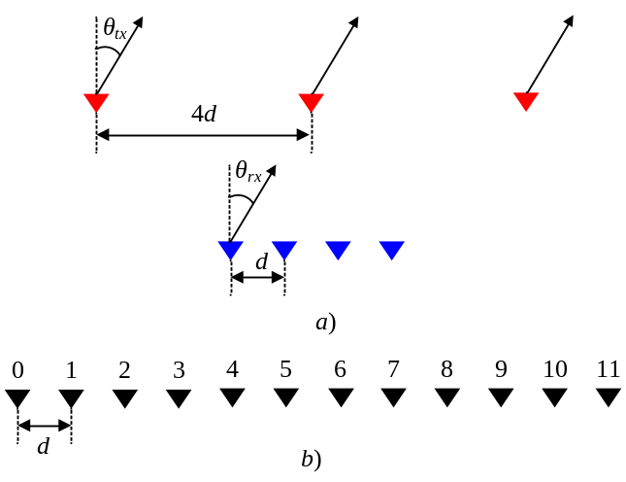
Fig. 1. MIMO antenna array. а) physical antenna, b) virtual antenna.

III. Real object and multipath ghost target
The antenna array receives signals reflected from an object only once (direct signal) as well as several times (multipath signal). The multipath signals lead the ghost targets. Therefore, distinguishing single and multiple reflections signal is an important task [10]. Fig. 2 shows the geometry of measurements in case of direct (a) and multipath signals (b).
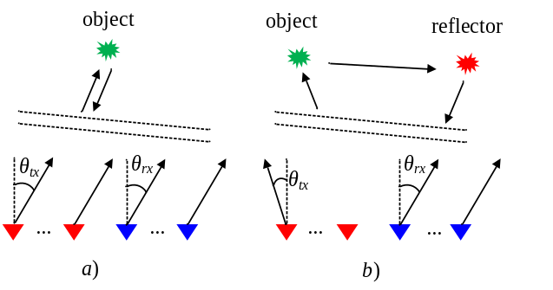
Fig. 2. Geometry of measurements. a) Direct path, b) multipath propagation

In case of a single reflection, the radiation direction is coincided with the receive direction $θ_{tx} = θ_{rx} = θ$. According to the expressions (5, 6) for the antenna array from Fig. 1, the virtual MIMO antenna array is equally-spaced uniform array with an element distance of d = 0.5λ.
In case of the multiple reflection, the radiation direction is not the same with the receive direction, θ_{tx} ≠ θ_{rx}. It leads to the phase jump between elements 4/5 and 8/9 (Fig. 1b). The phase jump depends on the geometry of the antenna array and the transmit/receive angle difference. According to the expressions (5, 6), it is analogous to modifying the geometry of a virtual antenna array relative to angles θ_{tx} and θ_{rx}.
Fig. 3 shows the 2D spectrum of MIMO antenna array shown in Fig. 1 as well as transmit, receive and virtual MIMO antenna patterns in case of a single (3а, 3b) and double reflections (3c, 3d).
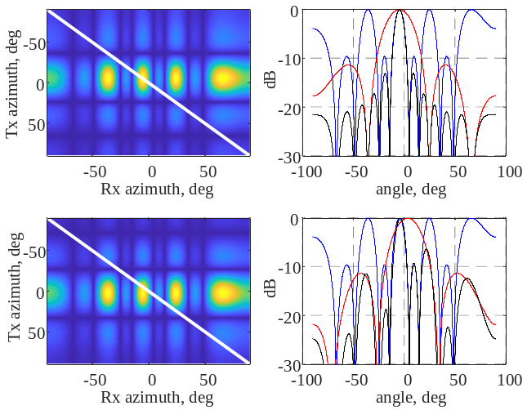
Fig. 3. Spatial spectrums. a) 2D spectrum for the single reflection (direct signal), b) transmit, receive, virtual MIMO spatial spectrums for the single reflection, c) 2D spectrum for two reflections (multipath signal), d) transmit, receive, virtual MIMO spatial spectrums for two reflections

In Fig. 3b and 3d the blue curve is the spatial spectrum of the transmit array, red curve is the spatial spectrum of the receive array, black curve is the MIMO spatial spectrum. In Fig 3b the maxima of transmit and receive patterns correspond to the same angle. In 2D spectrum, it corresponds to a peak located along the line of the same radiation and receive directions (white line) [7]. In Fig 3d the angles of the maximum of transmit and receive antenna pattern are not equal to each other. In accordance with equation (7), the spatial spectrum of the MIMO antenna is the transmit and receive antennas spectrum multiplication. The different directions in transmit and receive antennas lead to a shift of the peak of MIMO antenna pattern and thus increase a side lobe level. In 2D spectrum, this is similar to shift of maximum from white line of the same angles.
The transmit array in Fig. 1 is a sparse array with distance between elements 4λ. In this case, the phase difference between elements is the same for angles $\arcsin{(\frac{nλ}{d_{tx }})}, n∈Z$, that leads to the interference lobes formation [11].

IV. Multipath detection metric
The direction of arrival difference between the transmit, receive and virtual MIMO arrays can be used for the distinguishing the direct and multipath signals. In the N = N_{rx}⸱N_{tx} – space, the MIMO steering vector (5) corresponded to the direct path, as opposed to multipath, will be collinear with one of the vectors from (8) [9]:
$s_{MIMO}\left(α\right)=\left[\begin{matrix}\begin{matrix}1 \\ e^{i∙k∙\sin\left(α\right)∙d_{rx\left(1\right)}}\end{matrix} \\ … \\ e^{i∙k∙\sin\left(α\right)∙〈d_{rx\left(N_{rx}-1\right)}+d_{tx\left(N_{tx}-1\right)}〉}\end{matrix}\right]$ (8)
where α belongs to a certain range of the measured angles.
In other words, the steering vector (5) corresponding to the direct path belongs within the subspace spanned by one of the vectors (8), while the multipath signal vector deviates forms an angle with this subspace. The norm of the direct path signal vector (5) projected onto the subspace orthogonal to the closest vector from the set (8), as opposed to the multipath signal, will go to zero. Based on this difference, it is proposed to use the ratio of the projection residual norm to the initial norm signal vector norm as a multipath detection metric.

$r=\frac{\left\|P∙s_{MIMO}\right\|}{\left\|s_{MIMO}\right\|}$ (9)

where P = I - A⸱(A^{H}⸱A)⁻¹⸱A^{H} is the NxN projection matrix, I is identity matrix, $A=\left[\begin{matrix}a\left(θ_{1}\right) & … & a\left(θ_{k}\right)\end{matrix}\right]$,
$a\left(θ_{k}\right)={\left|\begin{matrix}1 & … & e^{i∙k∙sin⁡(θ_{k})∙〈d_{rx\left(N_{rx}-1\right)}+d_{tx\left(N_{tx}-1\right)}〉}\end{matrix}\right|}^{T}$, [$θ_{1}$…$θ_{k}$] is the vector of angles. For a direct path signal, criterion (9) tents to the inverse of the signal-to-noise ratio, because projection residual vector will be equal to the noise vector.
The vector (8) can be calculated by the angle, estimated using the physical transmit or receive antenna. Then, the projection matrix P from (9) project to the subspace orthogonal to the transmit or receive direction. The Fig. 4a shows the histogram of the ratio (9) for single and multiple reflections. The antenna array shown in Fig. 1 was used for the analysis. The physical angle was estimated by the receive antenna. It is assumed that the target SNR is equal to 10 dB, that target angle is 5º, the reflection angle is -5º. In Fig. 4a the blue curve is the histogram in case of single reflection (real target), red curve is the histogram for double reflection case (multipath). The mean value of blue histogram is 0.366.

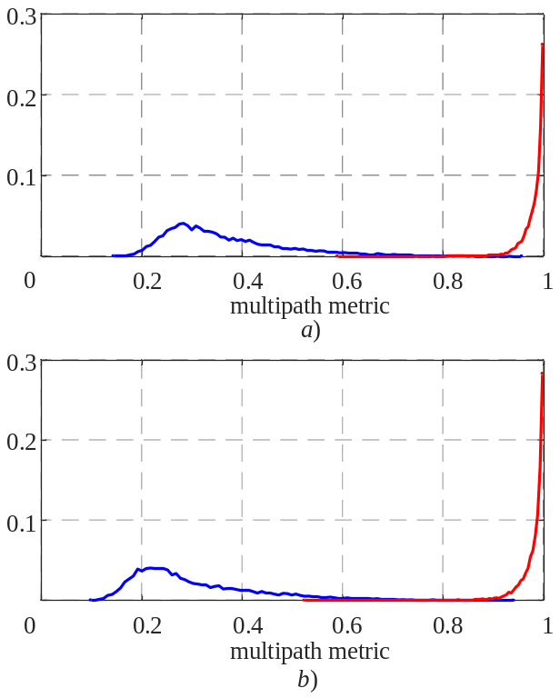
Fig. 4. Histograms of multipath metric. a) algorithm based on signal vector, b) algorithm based on signal matrix

Also, the metric (9) can be applied for the distinguishing direct and multipath signal by the signal matrix (6). For the signal matrix, the result of equation (9) will be equal to the ratio of the maximum singular values of the steering matrix before and after projection onto subspace, orthogonal to the direction estimated by physical array. The Fig. 4b shows the histogram of the ratio (9) for single and double reflections. The modeling conditions are the same with previous. In Fig. 4b the blue curve is the histogram in case of single reflection (real target), red curve is the histogram for double reflection case (multipath). The mean value of blue histogram is 0.312. The histograms in Fig. 4a and b have a gap that can be used to calculation the threshold for distinguishing direct and multipath signals.
In practice, the steering vector (5) can be superposition of the signals, reflected from multiple targets with identical range and Doppler frequency, for example, reflection from the vehicles in the adjacent road lanes [1]. The metric (9), estimated by physical array angle measurement, can’t allow to distinguish multitarget and multipath cases, because the transmit and receive antenna angle resolution is lower, than virtual MIMO antenna array. The Fig. 6 shows the transmit (red curve), receive (blue curve) and virtual MIMO array (black curve) spatial spectrums for two targets with -5º and 15º.

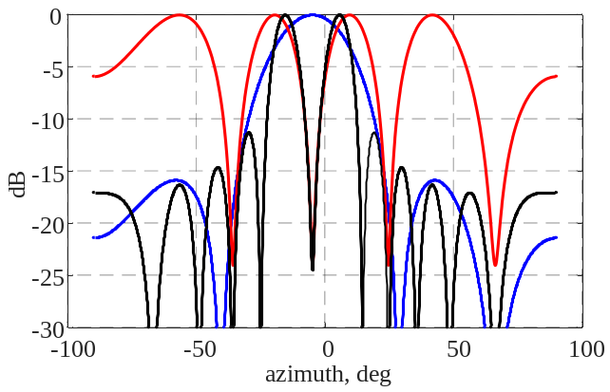
Fig. 5. Transmit (red curve), receive (blue curve) and virtual MIMO array (black curve) spatial spectrums for two targets

The MIMO spatial spectrum has 2 peaks corresponding to simulated target angles. At the same time, the spatial spectrum of the receive array has only one peak, located between the real angles. The separating real and ghost targets method, based on ratio (9) calculated by the receive antenna angle, will classify this point as multipath due to the discrepancy between the calculated and actual subspaces.
The solution of this case can be estimation vectors (8) by full MIMO array. The power of vectors (8) can be different. Weak targets with low RCS can be masked by the side lobes of the strong targets with high RCS. The iteration process based on orthogonalization maximum peaks in the spectrum of the projection residual vector can be used for angle measurement of the weak targets against strong targets. This algorithm is called Orthogonal Matching Pursuit (OMP) [12]. Typically, the maximum iteration is equal to the maximum expected number of targets. The comparison ratio (9) with threshold can be used as iteration stop criteria. The main idea of the each iteration is the projection of the residual signal vector to the subspace, orthogonal to the maximum value of the scalar product between the vectors (5) and (8).
For N targets, the residual vector converges to a noise vector after N algorithm iterations. For the multipath cases, the maximum value of the scalar product between vectors (5) and (8) will correspond to the peak correlation between the spatial spectrum of the receiving and transmitting arrays (typically matching the sidelobes of the spatial spectrum) and the ratio (9) will show minimal variation across iterations. Thus, target number estimation and direct-path/multipath signal separation can be combined into a unified procedure.
The spatial spectrums after the first (red curve), the second (blue curve) and the third (black curve) iterations for single, two targets and multipath are shown in Fig. 6a-c. The antenna array shown in Fig. 1 is used for the simulation. It is assumed that the target SNR is equal to 10 dB, that first target angle is 5º, the second target angle is -5º, the reflection angle (multipath scenario) is -5º. The dependence between ratio (9) and iteration number is shown in Fig. 6d. The blue, red and black points are one, two and multipath cases correspondingly. The green dash line is SNR.

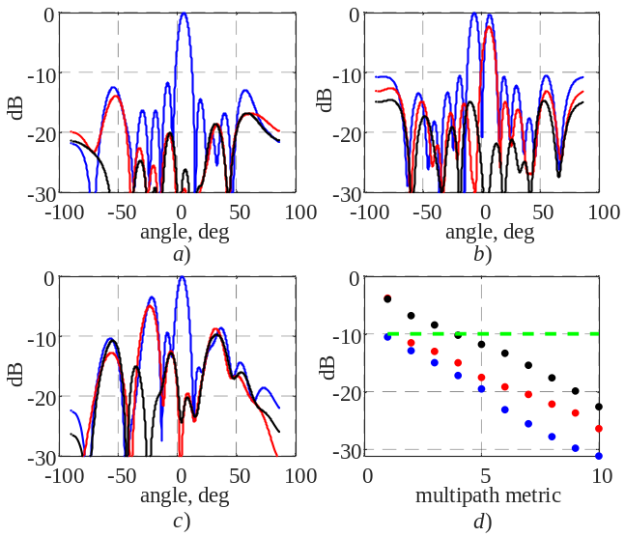
Fig. 6 – Spatial spectrum for one target (а), two targets (b), случай multipath signal (c), dependence of the multipath metric from iteration (d)

As seen in Figs. 6a and 6b, the spatial spectrum shows no pronounced peaks following the first and second algorithm iterations. The ratio (9) is lower than SNR after the first iteration for one target case and after the second iteration for two target case (Fig. 6c), meanwhile for multipath case only after the fourth iteration. Thus, the value of ratio (9) can be used for recognition one, two targets and multipath cases.
The Fig. 7 shows the histogram of ratio (9) after first (Fig. 7a) and second (Fig. 7b) iterations for one target case (blue curve), two target case (red curve) and multipath (black curve). The single-target cases can be distinguished from two-target or multipath scenarios by ratio (9) after the first iteration, the two targets and multipath case can be recognized by ratio (9) after the second iteration.

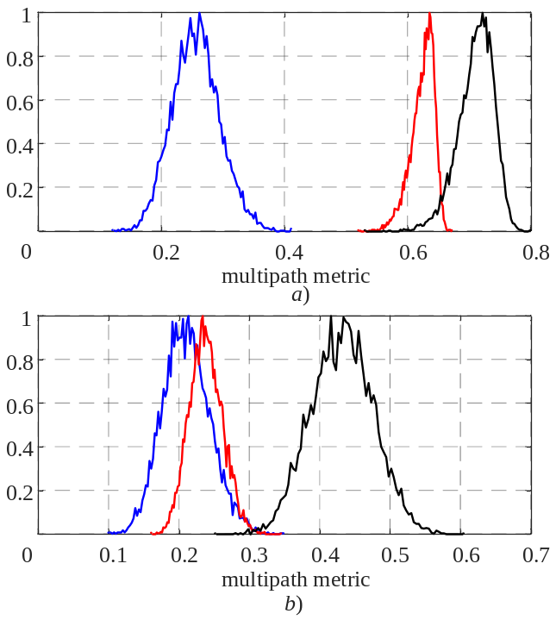
Fig. 7. Histograms of multipath metric calculated by OMP-algorithm. a) first iteration, b) second iteration

The ratio value (9) depends on the transmit and receive angles and antenna array geometry. The physical antenna interference peaks leads to incorrect distinguishing direct and multipath cases. Fig. 8 shows the ratio (9) calculated by physical antenna (blue curve), virtual MIMO antenna (black curve) angle measurement and the transmit antenna pattern (red curve) for the antenna array from Fig. 1. It is assumed that the radiation angle is equal to 0 degree, the receive angle is varied from -90 to 90 degrees. Fig. 8 shows that the multipath metric goes to zero in the ambiguity areas of the transmit array. In these areas the proposed metric doesn’t allows recognizing the real target and multipath correctly.

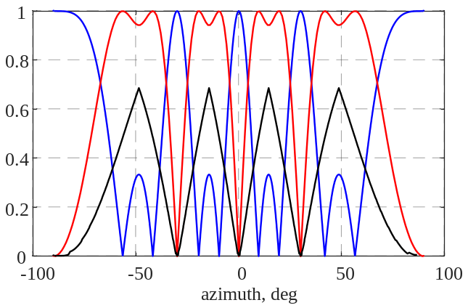
Fig. 8. Dependence between multipath metric and reflection angle

V. Experimental results
The proposed algorithm was evaluated using open datasets of the radar measurements, as described in reference [13]. The dataset provided the raw analog-to-digital-converter (ADC) data of a 77GHz mm-wave radar for the automotive scenarios. The experiment setup was assembled from the TI AWR 1843 board [14].The setup included 2 transmit antennas and 4 receive antennas, which can form a uniform MIMO virtual array with 8 elements sparsed on λ/2.
Fig. 9 shows a test field photo, range/Doppler map and geometry measurements of two pedestrians walking along the test field.

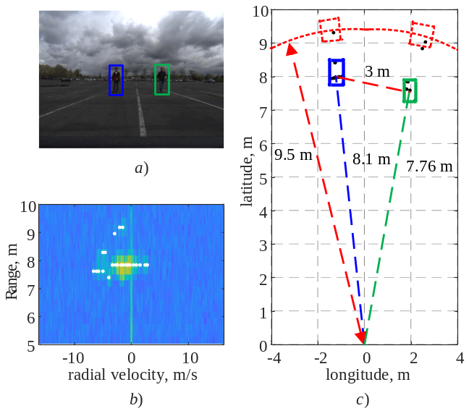
Fig. 9. Experimental scenario. a) test field photo, b) range/Doppler map, c) geometry measurements

The left and right pedestrians were marked by blue and green rectangular respectively. Their measured ranges were approximately R_{L} = 8.1 м m and R_{R} = 7.76 m. The distance between pedestrians is about 3 m. Then, the range to the multipath points caused by reflection from left and then from right pedestrian and vise versa will be equal to 9.5 m; while azimuth angles will be equal to the real pedestrian angles. Then, the theory location areas of the multipath points are marked by red rectangular [5].
The coordinate measurements by the radar were shown on Fig. 10. The grey and red points are associated as single reflection and multipath respectively. The points were marked by the metric (9) calculated using signal matrix (Fig. 9a) and signal vector (Fig. 9b). The angle estimated by physical receive antenna was used for calculation the multipath metric (9).
According to the model, the algorithm correctly recognized direct path and multipath points (Fig. 10 a and b). The 2D transmit/receive and 1D transmit, receive and virtual MIMO spatial spectrums for the single target case (pink point) are shown in Fig. 10 c and d. The 2D spatial spectrum peak is located on the line with same transmit and receive angles (white line), the transmit, receive and virtual MIMO spatial spectrums have the same maximum peak location. The 2D transmit/receive and 1D transmit, receive and virtual MIMO spatial spectrums for the multipath (black point) are shown in Fig. 10 e and f. The 2D spatial spectrum peak is shifted from the white line.
In Fig. 10 a and b, some points associated with pedestrians Fig 10. Multipath detection by physical antenna array

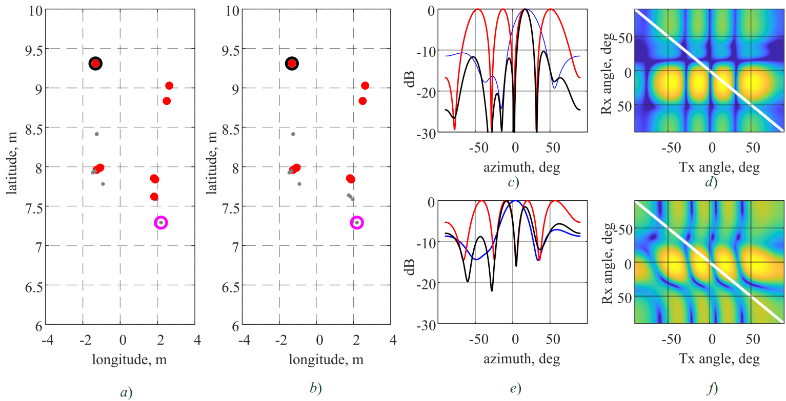
were marked as multipath. These points are corresponded to two targets in same range and Doppler frequency. The Fig. 11 shows the recognition result of one target (grey points), two targets (green points) and multipath (red points) by the OMP algorithm with proposed multipath metric.
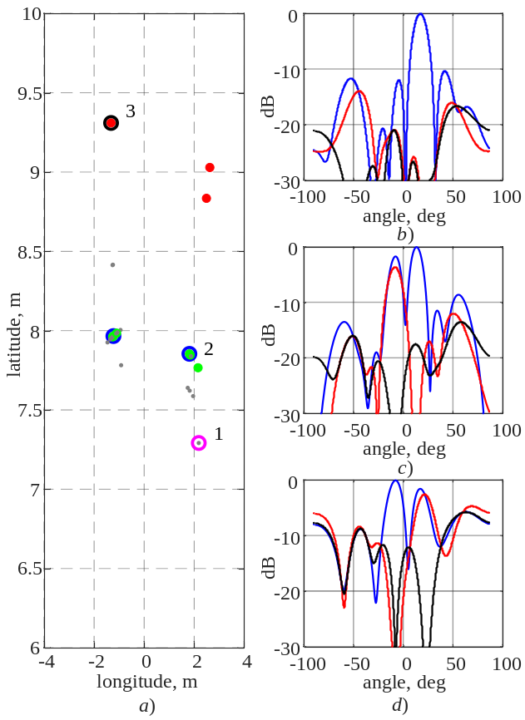
Fig. 11. Multipath detection by OMP-algorithm

Fig 12 shows the criteria value (9) after iterations of the OMP-algorithm. The blue, red and black points are the criteria value (9) for the point 1, 2, 3 from Fig 11 a. The spatial spectrums of these points are shown in Fig. 11 b-d. Pink and green dash lines are the thresholds for the separating one, two targets and multipath cases. From Fig 12, the value of the ratio (9) after the first iteration of the algorithm is lower than one target case threshold. This point was marked as one target case. In Fig 11c, there are two peaks in the spatial spectrum. From Fig 12, the value of the ratio (9) after the second iteration of the algorithm is lower than the two targets case threshold. This point was marked as two targets case. In the spatial spectrum (Fig. 11d), there are two peaks in the spatial spectrum too. However, only after the 4th iteration of the OMP algorithm the ratio (9) is lower than the two targets case threshold. This point was marked as multipath case.

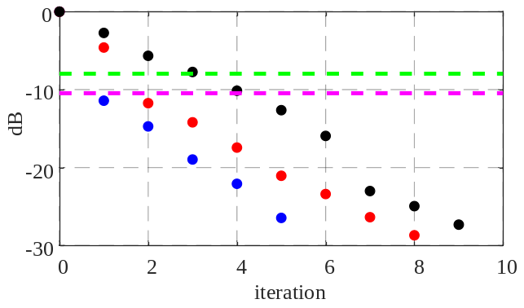Fig. 12. The multipath metric for different cases
VI. Conclusion
In complex urban and highway scenarios, the received signal by radar can reflect from objects single or multiple times. Multipath reflections can generate ghost targets and may deceive ADAS systems. Thus, the distinguishing the real and ghost targets is the actual challenge. The metric, based on the ratio between signal norm before and after steering vector projection onto an orthogonal subspace, was proposed. Two methods for the orthogonal subspace estimation were analyzed: the first method is used physical antenna (transmit or receive) angle measurement and the second method is used on full MIMO virtual antenna angle measurement. The advantage of the first method is low computational complexity than the second method. At the same time, the second method allows to detect and measure the angles of the targets with same range and Doppler frequency.
In summary, our proposed approaches mark a significant step forward in addressing the challenges of multipath detection for automotive radar measurements

References
- J. Dickman et al., “Automotive radar the key technology for autonomous driving: From detection and ranging to environmental understanding,” in Proc. IEEE Radar Conference, Philadelphia, PA, USA, May 2016.
- C. Waldschmidt, J. Hasch, and W. Menzel, “Automotive Radar – From First Efforts to Future Systems,” IEEE Journal of Microwaves, vol. 1, no.1, pp. 135–148, Jan. 2021
- T. Visentin, J. Hasch, and T. Zwick, “Analysis of multipath and DOA detection using a fully polarimetric automotive radar,” in 2017 EURAD, Oct. 2017, pp. 45–48.
- Oren Longman, Shahar Villeval and Igal Bilik, “Multipath Ghost Targets Mitigation in Automotive Environments”, 2021 IEEE Radar Conference (RadarConf21), Atlanta, USA, May 2021
- Thomas Jost, “Multipath Detection and Reflection Surface Estimation in Automotive Scenarios,” 2025 26th International Radar Symposium (IRS), Hamburg, Germany, May 2025
- Fabian Roos, “Ghost target identification by analysis of the Doppler distribution in automotive scenarios”, 2017 18th International Radar Symposium (IRS), Prague, Czech Republic, June 2017
- Oliver Biallawons and Joachim H. G. Ender, “Multipath Detection by using Space-Space Adaptive Processing (SSAP) with MIMO Radar”, 2018 International Conference on Radar (RADAR), Brisbane, Australia, August 2018
- R. Klemm, “Principles of space-time adaptive processing”, The Institution of Electrical Engineers, London, UK, 2002.
- Bernard Widrow, “Adaptive Signal Processing”, Prentice-Hall PTR, 1985
- Sujeet Milind Patole, “Automotive radars: A review of signal processing techniques”, IEEE Signal Processing Magazine, March 2017, Volume: 34, Issue: 2, pp. 22-35.
- “Radar handbook”, ed. Merrill I. Skolnik, 2nd ed., 1990
- Florian Folster and Hermann Rohling "Observation of lateral moving traffic with an automotive radar," 2006 International Radar Symposium, Krakow, Poland, May 2006
- T. T. Cai and L. Wang, “Orthogonal matching pursuit for sparse signal recovery with noise,” IEEE Transactions on Information Theory, vol. 57, no. 7, pp. 4680–4688, Jul. 2011.
- Xiangyu Gao, “RAMP-CNN: A Novel Neural Network for Enhanced Automotive Radar Object Recognition”, IEEE Sensors Journal, 2021, vol.21, Issue: 4, pp. 5119-5132
- AWR1843BOOST and IWR1843BOOST Single-Chip mmWave Sensing Solution User’s Guide (Rev. B). Texas Instruments, May 2020. 122 p. URL: https://www.ti.com/tool/AWR1843BOOST#tech-docs.


Sergei Shishanov received Ph.D. degree in radiolocation and radionavigarion from the Nizhny Novgorod State Tehnical University n.a. R.E. Alekseev, Russia in 2018. From 2010 he worked in electronic and IT industry in Russia. The scientific area of his research activity is automotive radar and signal processing algorithms.

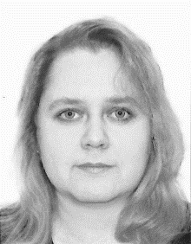
Anna Dzvonkovskaya received her Ph.D. degree in mathematical modeling from Bauman Moscow State Technical University, Russia, in 2003. Now she is at the Automotive Intelligent Solutions Department, Huawei Technologies Co, Ltd. Her research interests include automotive radar and Lidar signal processing algorithms, sensor fusion.


Boya Qin received the B.E. and Ph.D. degrees in information science and communication engineering from Zhejiang University, Hangzhou, China, in 2010 and 2015, respectively. He has been working in Huawei Technologies Co., Ltd. since 2015. He serves as an algorithm expert in automotive radar area, and his research interests lie in radar signal processing algorithms field.

Manuscript received ………… S. Shishanov, A. Dzvonkovskaya, are with Huawei Technologies Co., Ltd., Eurasia B. Qin is with Huawei Technologies Co., Ltd., China Digital Object Identifier ……………

