Allergy Nurture Nurses
CQC-registered, nurse-led remote allergy and asthma advisory service for children, young people and families
Service | CQC-registered, nurse-led remote allergy and asthma advisory service for children, young people and families.
Led by | Catherine Neale, Registered Children's Nurse and Clinical Nurse Specialist — 25+ years' nursing experience, including 7 years in specialist paediatric allergy.
Core areas | Non-IgE food allergy, eczema, allergic rhinitis, allergy-related respiratory/asthma awareness, feeding concerns and food introduction.
Purpose | Timely education, support, safety-netting and signposting for families — complementing existing NHS and community pathways, not replacing them.
Who may benefit | Families seeking non-urgent support to understand allergy-related symptoms, symptom patterns, practical next steps and when to seek further medical review.
Professional support | Allergy and asthma awareness training for nurseries, schools and education settings.
What we do not provide | Diagnosis, prescribing, allergy testing, emergency care, acute asthma/anaphylaxis management, or replacement of GP/NHS/specialist services.
Collaboration aim | To explore how the service may support local families, GP practices, community teams, schools, nurseries and commissioning priorities.
Accessibility | Remote, UK-wide support, including for families whose primary language is not English, with communication support considered where appropriate.
Why this matters
Allergic conditions in children are common, rising, and carry a real safety dimension — early education and timely signposting can reduce risk and pressure on stretched services.
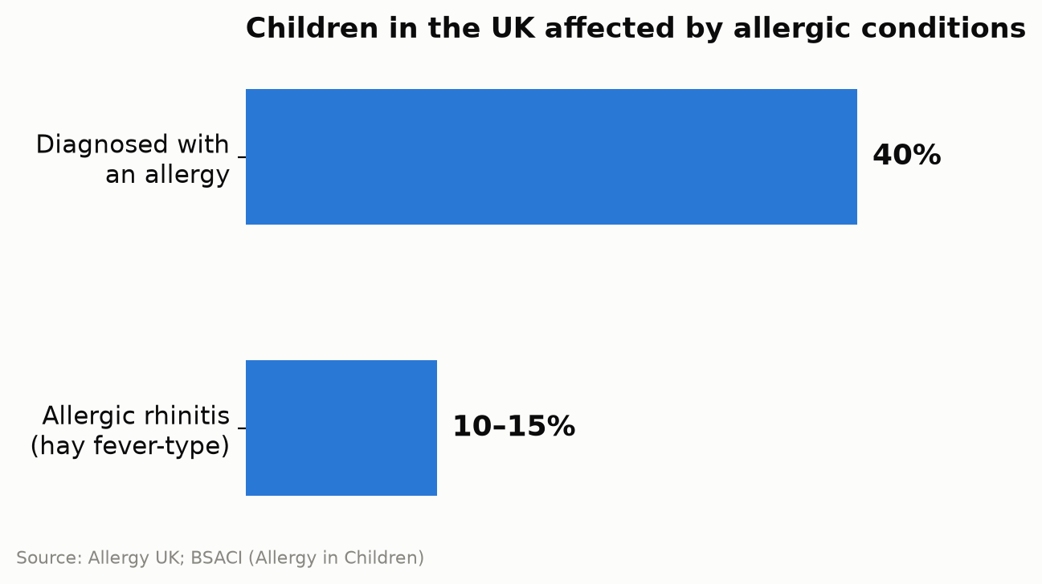
348%  rise in child (5–14) asthma hospital admissions every September vs. August — Asthma + Lung UK | 54  child deaths from asthma, England, Apr 2019–Mar 2023 — NCMD | 19  child deaths from anaphylaxis, same period — NCMD
Scope of practice
Included: non-urgent support for suspected/known Non-IgE food allergy, eczema where allergy may be a factor, allergic rhinitis, allergy-related respiratory/asthma awareness, feeding concerns, food introduction and symptom education.
Excluded: any child who is acutely unwell, or has breathing difficulty, symptoms of anaphylaxis, acute asthma symptoms, collapse, severe illness or rapid deterioration — families are directed to call 999 or attend emergency care.
Evidence and standards
Regulation | Registered with CQC; assessed against whether services are safe, effective, caring, responsive and well-led.
Professional standards | Aligned with the NMC Code: prioritise people, practise effectively, preserve safety, promote professionalism and trust.
Food allergy | NICE guidance (CG116) supports an allergy-focused clinical history, appropriate assessment and referral/signposting where needed.
Non-IgE food allergy | NICE recognises the diagnostic challenge of Non-IgE food allergy and the role of elimination/reintroduction where clinically appropriate.
Eczema and allergy | NICE guidance (CG57) recognises food allergy may need consideration in babies/children with atopic eczema in specific circumstances.
Allergic rhinitis | BSACI: allergic rhinitis affects 10–15% of UK children and can affect quality of life, school attendance and asthma control.
Asthma / respiratory risk | Asthma + Lung UK: child (5–14) asthma hospital admissions rise sharply (348%) every September vs. August.
Child mortality learning | NCMD (2019–2023): 54 child deaths from asthma, 19 from anaphylaxis — themes include asthma control, action plans, communication and education.
Accessibility | NHS England's Accessible Information Standard — identifying, recording and meeting people's communication and information needs.

