

UNDERGRADUATE PROJECT PROGESS REPORT

|  |  |
| --- | --- |
| **Project Title:** | **Dog Breed Classification using Convolutional Neural Network** |
| **Surname:** | **Fanlin** |
| **First Name:** | **Zhou** |
| **Student Number:** | **201918020209** |
| **Supervisor Name:** | **Grace Nneji** |
| **Module Code:** | **CHC 6096** |
| **Module Name:** | **Project** |
| **Date Submitted:** | **13/01/2023** |

**Table of Contents**

1. Introduction 3
   1. Background 3
   2. Aim 3
   3. Objectives 3
   4. Project Overview 4
      1. Scope 4
      2. Audience 4
2. Background Review 5
   1. Summary of existing approaches (e.g., Competitive analysis, if appropriate) 5
3. Project Technical Progress 6
   1. Methodology 6
      1. Approach 6
      2. Technology 7
   2. Testing and Evaluation 7
   3. Design and Implementation 8
4. Project Management 11
   1. Activities 11
   2. Schedule 12
   3. Project Version Management 13
   4. Project Data Management 13
   5. Project Deliverables 13
5. Professional Issues and Risk: 13
   1. Risk Analysis 13
6. References 15
7. Introduction
   1. Background

Dogs are the most common animals in people’s daily life for many years and dogs had become the friendly partner. Currently, all around us there were so many different kinds of dogs and new breed dogs that we had never seen before. [1] However, there are many different kinds of dogs due to genetic reasons. Now many different breeds of dogs are interbreeding with each other to produce new breeds. Differences between various aspects of the breed have become one of the most important reasons for dog classification. The number of dog breeds certified by the FCI reached 356 in 2022. [2] Only many dog breeds are known by human. However, for the vast majority of dog breeds, humans are not very good at distinguishing which dog breeds are which.

Recently experts have used many different of traditional image classification methods to classify dogs. In 2012, J Liu et al. used the dog breed recognition method based on local localization for classification. [3] Based on the data set established by J Liu et al., X Wang et al. proposed the dog breed recognition method using Grassmann manifold in 2014. [4] However, these methods are very time-consuming and these methods just can be written under certain conditions with high accuracy. In addition, datasets need to be fully labeled, and the cost of preprocessing is high.

* 1. Aim

In this study, I will adopt a transfer learning method. Dog breed classification is achieved by using a pre-trained model. A pre-trained model is a preserved model that has been previously trained on a large dataset. Therefore, a model pre-trained across the entire ImageNet dataset is selected and used to extract the features of the image for input into a customized small-scale output network.

* 1. Objectives

The objectives are as follow:

1. Understand the background of the dog breed classification by using deep learning. Using the transfer learning’s pretrained framework to complete the classification.
2. Identify the dataset about dog breed classification. It must include train, valid, test, size of images about ImageNet.
3. The pre-trained model will be used as a fixed image feature extractor.
4. Adding a global averaging pooling layer and fully connected layers for the classification of dog breeds.
   1. Project Overview

This study is based on convolutional neural network about deep learning, using the pre-training model in transfer learning to classify dog breeds.

* + 1. Scope

This design has realized the classification of 120 common dog breeds. In view of the problems of high time and cost in literature [3-4], the reason why dog breed identification is commonly used in the actual environment is fully considered. And the accuracy of image recognition. The convolutional neural network is used as the design basis for dog breed recognition.

The significant of this project are as follows:

1. Learning the existing model through application migration greatly reduces the time cost and data resource overhead.
2. Pre-processing and augmentation of dataset will be analyzed for the improvement of the model performance.
3. Using convolutional neural network can improve the accuracy of classification.

With the application of a transfer learning, the pre-trained model with be trained on the pre-processed dataset for an efficient classification of the 120 dog breeds.

* + 1. Audience

The audience of dog breed classification can follow:

1. Children: Kids don't have very good cognitive skills with dogs. It can help children identify different breeds of dogs.
2. Government: It can provide information about different dog breeds for the government.
3. Dog lovers: Dog breed classification can be more informative for people who love dogs and want to buy them as pets.
4. Doctor: It can provide doctors with knowledge of different dogs to help them understand dogs better.
5. Background Review
   1. Summary of existing approaches (e.g., Competitive analysis, if appropriate)

This section describes previous current attempts to investigate different approaches of deep learning application for dog breed. Raduly et al. 's [5] study is based on fine-tuning of CNN, the result of which is replicable of the original Stanford dog dataset using the proposed method. Similarly, Liu et al. [6] reported an accuracy of 67% for 133 dog breeds from the Columbia Dogs Dataset by combining SIFT descriptors and color histograms on the SVM classifier with landmark data. Lai et al. [7,8] introduced a deep learning method by transfer learning on convolutional neural networks (CNN) and achieved 86.63% accuracy on the same dataset in [6].

Kumar et al. [9] used principal component analysis (PCA) to analyze 8,351 dog images and achieved 90% accuracy. Jain et al. [10] took convolutional neural network as the basis for predicting dog breeds and cited Res-Net model, making the accuracy rate reach 84.578%. Borwarnginn et al. [11] achieved an accuracy rate of 89.92% for 133 dog breeds by using the pre-trained convolutional neural network. Jiongxin et al. [12] established geometric and appearance models of the dog breeds and their facial parts based on samples, thus completing 133 dog breeds and 8351 images with 67% accuracy. Based on the neural network retraining image classification model, Dabrowski and Michalik [13] adopted the transfer learning method to achieve 70% accuracy. Vrbani et al. [14] used a trained model to classify a set of X-ray images with an overall accuracy of 94.76%.

In summary, it is shown that the application of convolutional neural network has the advantages of automatic feature extraction, strong feature extraction ability and end-to-end training. Thus, applying it to the challenge faced in dog breed identification will improve the cost and technical difficulty in traditional identification methods.

Table 1: Summary of existing methods for dog breed classification

|  |  |  |
| --- | --- | --- |
| Researchers | Their Model | Performance Metrics |
| Kumar et al. [9] | ResNet + PCA | Accuracy = 90% |
| Jain et al. [10] | Res-Net | Accuracy = 84.578% |
| Borwarnginn et al. [11] | Pretrained | Accuracy = 88.92% |
| Jiongxin et al. [12] | Not find | Accuracy = 67% |
| Dbrowski and Michalik [13] | Re-trained | Accuracy = 70% |
| Vrbani et al. [14] | Pretrained | Accuracy = 94.76% |

1. Project Technical Progress
   1. Methodology
      1. Approach

In the design and implementation, dog breed recognition will be implemented using a a pre-trained model. The pre-trained model is a model created to solve the problems in the past. When you solve a problem, instead of training a new model from scratch, you can start with models that have been trained on similar problems.

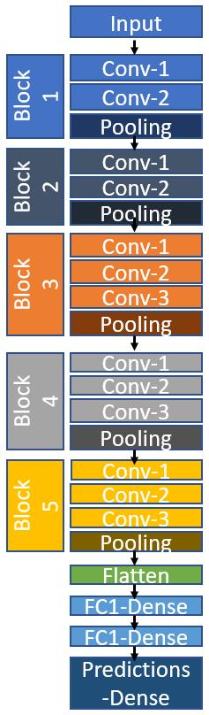

Figure 1: The pre-trained architecture for this project [8].

Dataset:

<https://www.kaggle.com/competitions/dog-breed-identification/data>

This data set provides a training set and a test set. The data set included 120 dog breeds. Each image has a unique file name.

a. Total number of dataset: 20581

b. The number of train: 10222

c. The number of test: 10357

d. Size of image (length * breadth * channel): 224*224*3

* + 1. Technology

1. GPU: Intel Core 15 8th Gen

2. Memory: 8GB

3. Disk space: 256GB

Software Requirements:

1. Win 10 64-bits

2. Framework: Tensorflow

3. Language: Python

4. Pre-trained model: Xception，VGG-16, ResNet50

5. Libraries: Numpy, matplotlib, keras

* 1. Testing and Evaluation

There are two parts to testing and evaluation. First, the first part is completed including loss and accuracy graphs for training and testing data on dog breed classification. In addition, we will discuss the evaluation of dog breed recognition. The following evaluation criteria are used as indicators of the diagnostic performance of our model: Accuracy (ACC), precision (PRC), recall, sensitivity (SEN), specificity. The metrics are explained below.

True Positive (TP): indicates that the number of positive classes is predicted to be positive

True Negative (true negative, TN): predicts the number of negative classes as negative

False Positive (FP): Predict the number of negative classes to positive classes (Type I error)

False Negative(false negative, FN) : predicts the number of positive classes as negative classes → misses (Type II error)

|  |  |  |
| --- | --- | --- |
|  | Positive | Negative |
| True | True Positive (TP) | True Negative (TN) |
| False | False Positive (FP) | False Negative (FN) |

* 1. 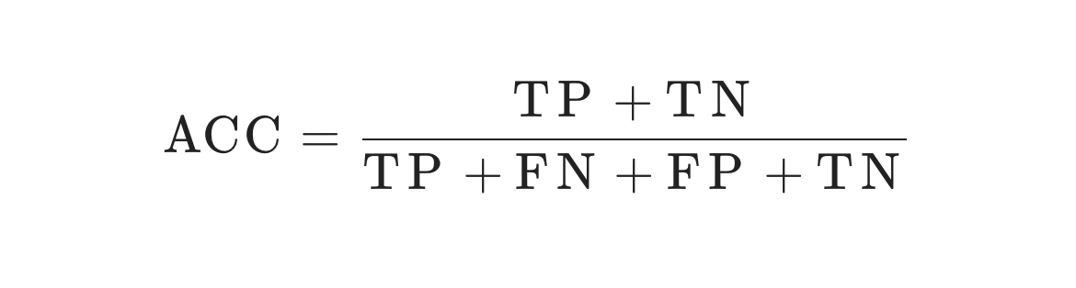Design and Implementation

This section describes in detail all of the progress that has been designed or developed and implemented to date. My project used three different models for evaluation of the data separately. Initially, the VGG-16 model was used. Due to inappropriate data set. As a result, data processing and final training results are not ideal. Next, the data is trained using ResNet50 and Xception models. Among them, ResNet50 has achieved better test results. The rest of the design process and implementation are shown below.

Pretrained model:

1. VGG-16:

Epochs: 20

Final training accuracy: 48.5%

Final validation accuracy: 51.3%

The first figure is train loss and validation loss. The next figure is train acc and validation accuracy.

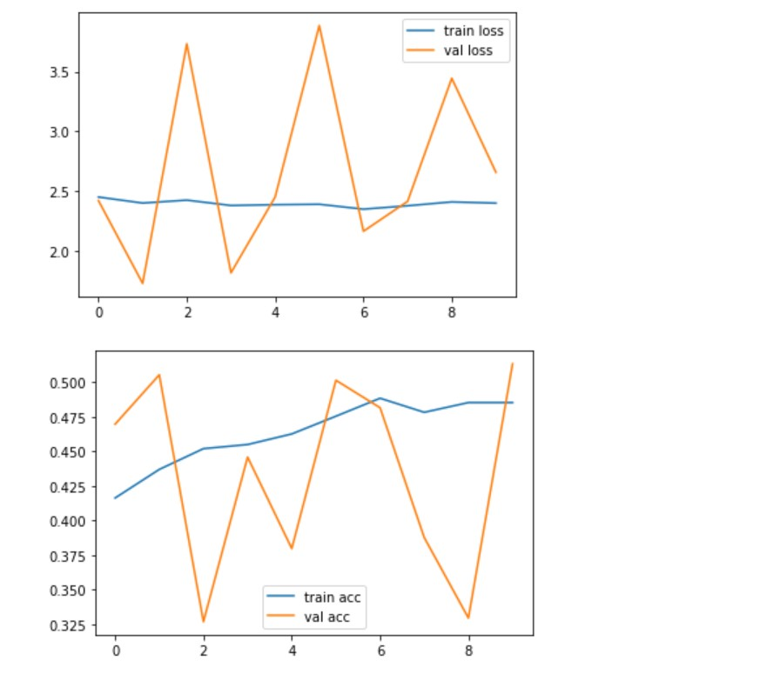

1. ResNet50:

Epochs: 50

Final training accuracy: 95%

Final validation accuracy: 81.2%

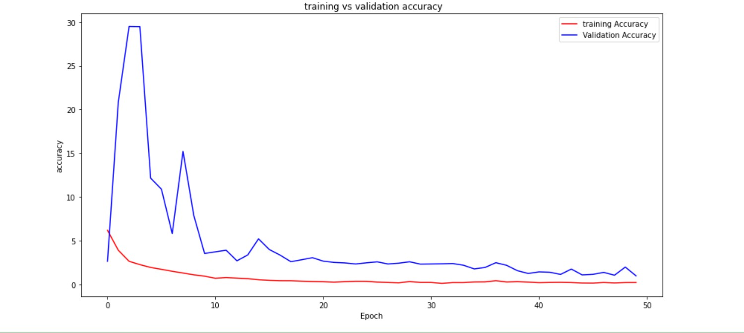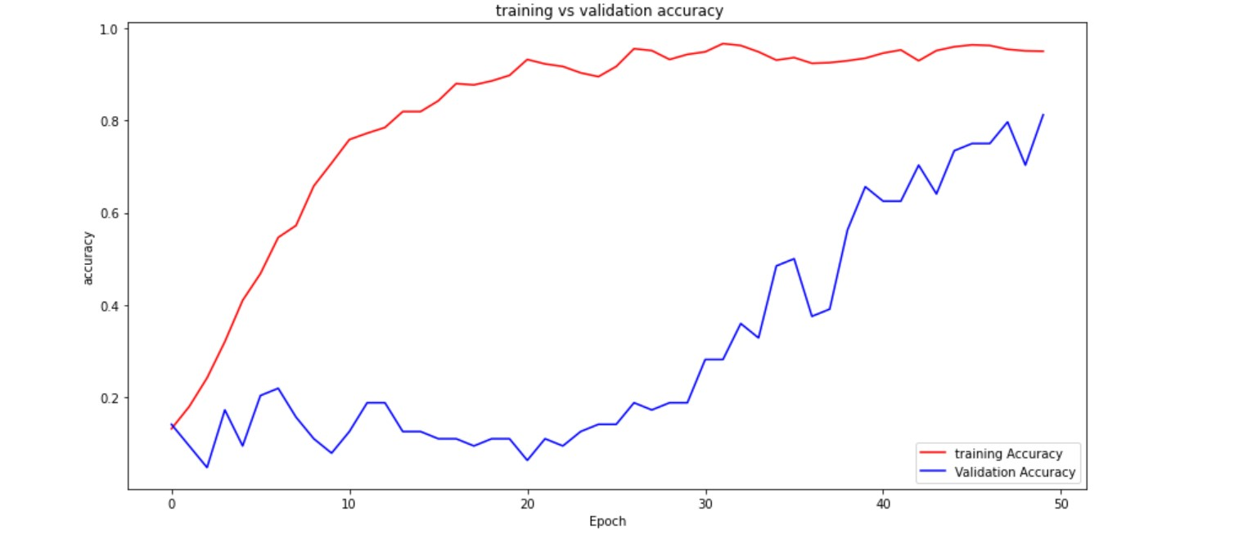The figures are training accuracy and validation accuracy.

1. Xception:

Epochs:15

Final training accuracy: 91.7%

Final validation accuracy: 72%

The first figure is train loss and validation loss. The next figure is train acc and validation accuracy.

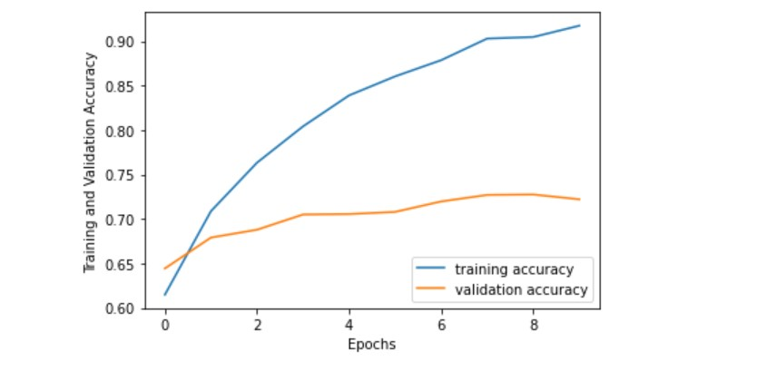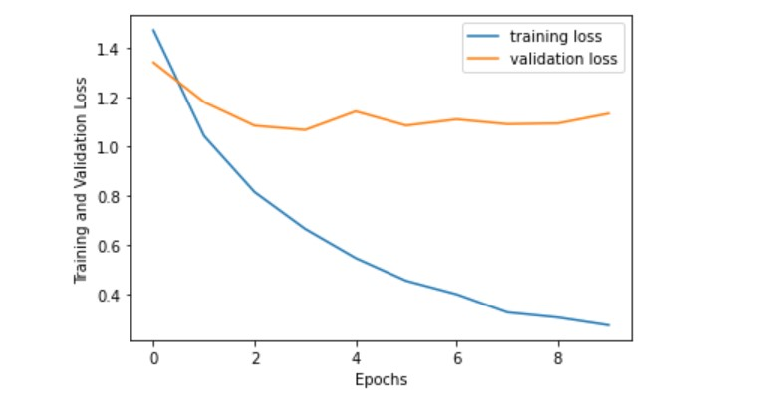

1. Project Management
   1. Activities
2. Image preprocessing needs to select corresponding data sets for data set organization.
3. The data set is then trained and validated.
4. After the data set is organized, the images stored in the folder are read in. The read image is stored as a tensor of the height * width * channel shape.
5. Select the corresponding model and implement the model in your code.
6. Using transfer learning can speed up and effectively improve efficiency. Then model training is conducted to correct the errors on dataset.
7. Improve the data and modified every codes use different methods about deep learning.
8. Prepare the progress report.
9. Finish the testing code.
10. Write the final report and create poster.
    1. 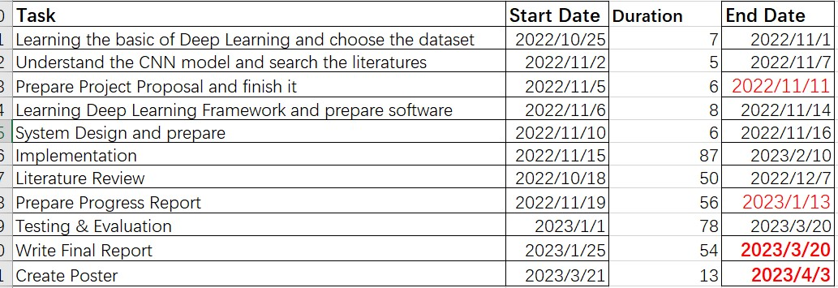Schedule

Figure 3: The schedule

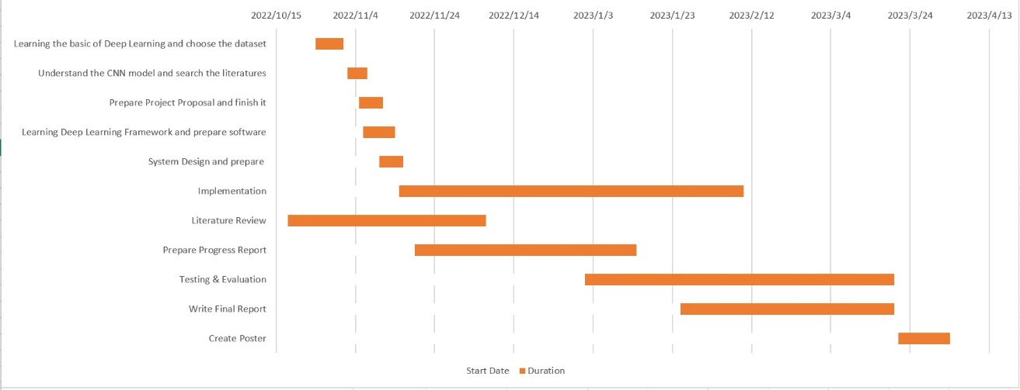

Figure 3: Gantt

* 1. Project Version Management

1. The modified tasks store in a folder every once in a while.
2. Project source codes are logged in a folder of Gitee.
   1. Project Data Management
3. Store the literatures that need to use in a folder.
4. The minutes of each meeting are stored in a folder.
5. Record each project logs and save it to a folder.
6. Organize every reports into a folder.
7. Store all files on demand into Gitee.
   1. Project Deliverables
8. Finish the project proposal
9. Finish the progress report
10. Final report.
11. Make source code to the zip file.
12. Create poster.
13. Professional Issues and Risk:
    1. Risk Analysis

The analysis identifies multiple potential threats to the project, explains why these threats might occur, and finds ways to address these factors. When quantifying risks, factors considered are the probability or likelihood of occurrence and the impact or severity of the risk at the time of occurrence. This information helps to optimize project efficiency and performance.

|  |  |  |  |  |  |
| --- | --- | --- | --- | --- | --- |
| Potential risks | potential | Severity | Likelihood | Risk | mitigation |
| Bad program | programming is too complicated. | 5 | 1 | 5 | It can be done through study and practice. In addition, use efficient and professional programming techniques to solve, |
| The final test results is not good | The program is lack of testing. | 4 | 2 | 8 | This can be solved by testing the code more thoroughly. |
| The model gets terrible accuracy when run it | Data sets cannot be trained well in this model. | 2 | 3 | 6 | Data enhancement is performed on the data set. Resize the dataset and add more data to the dataset. |
| Date loss | Data is not processed and saved properly. | 3 | 3 | 9 | This can be solved by ensuring that the program backs up data in the event of a sudden loss. |
| Miss the deadline | Poor GPU system is used in training model | 4 | 3 | 12 | Use a better configuration training model or a different GPU system. |

5.2 Professional issues

My project does not involve copyright and plagiarism. The project's data set is the ImageNet data set obtained from kaggle.com. It belongs to the development data set. My project borrows from Github open source code. It's public code. It can be used to study dog classification recognition.

1. References

[1] P. Borwarnginn, K. Thongkanchorn, S. Kanchanapreechakorn, and W. Kusakunniran, “Breakthrough conventional based approach for dog breed classification using CNN with transfer learning,” 2019 11th International Conference on Information Technology and Electrical Engineering (ICITEE), 2019.

[2] FCI International Championship. [Online]. Available: https://www.fci.be/en/FCI-International-Championship-41.html. [Accessed: 08-Nov-2022].

[3] J. Liu, A. Kanazawa, D. Jacobs, and P. Belhumeur, “Dog breed classification using part localization,” Computer Vision – ECCV 2012, pp. 172–185, 2012.

[4] X. Wang, V. Ly, S. Sorensen, and C. Kambhamettu, “Dog breed classification via landmarks,” 2014 IEEE International Conference on Image Processing (ICIP), 2014.

[5] Z. Raduly, C. Sulyok, Z. Vadaszi, and A. Zolde, “Dog breed identification using Deep Learning,” 2018 IEEE 16th International Symposium on Intelligent Systems and Informatics (SISY), Sep. 2018.

[6] J. X. Liu, A. Kanazawa, D. Jacobs, P. Belhumeur. Dog breed classification using part localization. In Proceedings of the 12th European Conference on Computer Vision, Springer, Florence, Italy, pp.172–185, 2002. DOI: 10.1007/ 978-3-642-33718-5_13.

[7] K. Lai, X. Y. Tu, S. Yanushkevich. Dog identification using soft biometrics and neural networks. In Proceedings of International Joint Conference on Neural Networks, IEEE, Budapest, Hungary, pp.1–8, 2019. DOI: 10.1109/ IJCNN.2019.8851971.

[8] X. Y. Tu, K. Lai, S. Yanushkevich. Transfer learning on convolutional neural networks for dog identification. In Proceedings of the 9th IEEE International Conference on Software Engineering and Service Science, IEEE, Beijing, China, pp.357–360, 2018. DOI: 10.1109/ICSESS.2018. 8663718.

[9] Kumar, A. and Kumar, A., 2020, December. Dog breed classifier for facial recognition using convolutional neural networks. In 2020 3rd International Conference on Intelligent Sustainable Systems (ICISS) (pp. 508- 513). IEEE.

[10] Jain, R., Singh, A. and Kumar, P., 2020. Dog Breed Classification Using Transfer Learning. ICCII 2018, p.579.

[11] Borwarnginn, P., Kusakunniran, W., Karnjanapreechakorn, S. and Thongkanchorn, K., 2021. Knowing Your Dog Breed: Identifying a Dog Breed with Deep Learning. International Journal of Automation and Computing, 18(1), pp.45-54.

[12] Liu, Jiongxin, Angjoo Kanazawa, David Jacobs, and Peter Belhumeur. Dog Breed Classification Using Part Localization.

[13] Dąbrowski, Marek, Tomasz Michalik. How Effective is Transfer Learning Method for Image Classification. Position Papers of the Federated Conference on Computer Science and Information Systems, vol. 12, 3– 9 https://doi.org/10.15439/2017f526 ISSN 2300-5963 ACSIS

[14] Vrbančič, G., Pečnik, Š. and Podgorelec, V., 2020, August. Identification of COVID-19 X-ray Images using CNN with Optimized Tuning of Transfer Learning. In 2020 International Conference on INnovations in Intelligent SysTems and Applications (INISTA) (pp. 1- 8). IEEE.