Creating Repository in GitHub

Step 1 Click new nearby repository

Step 2 Give the repository name

Step 3 select the "Add README"

Step 4 Click Create Repository

Adding Content to README file

Step 1 Open the repository create

Step 2 Open README.md in edit mode and add the content

Step 3 Click commit changes

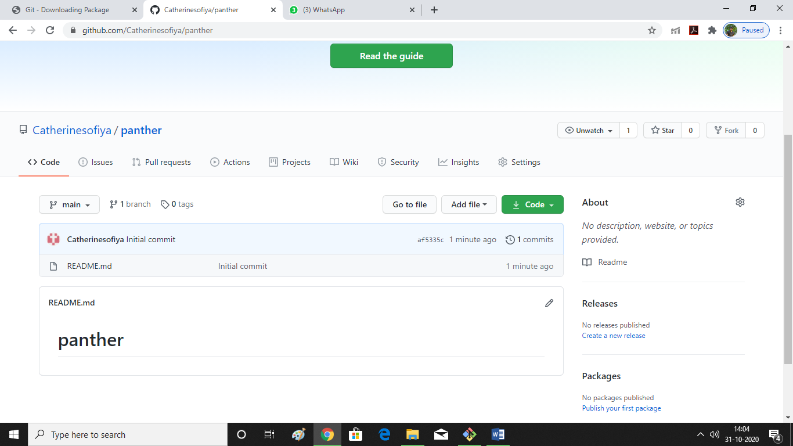

Allwyn@DESKTOP-UQC0R3I MINGW64 ~

$ ls

'3D Objects'/

AppData/

'Application Data'@

Contacts/

Cookies@

Desktop/

Documents/

Downloads/

Favorites/

hulk/

IBA_IOAPDATA/

IntelGraphicsProfiles/

Links/

'Local Settings'@

MicrosoftEdgeBackups/

Music/

'My Documents'@

NetHood@

NTUSER.DAT

ntuser.dat.LOG1

ntuser.dat.LOG2

NTUSER.DAT{fd9a35db-49fe-11e9-aa2c-248a07783950}.TM.blf

NTUSER.DAT{fd9a35db-49fe-11e9-aa2c-248a07783950}.TMContainer00000000000000000001.regtrans-ms

NTUSER.DAT{fd9a35db-49fe-11e9-aa2c-248a07783950}.TMContainer00000000000000000002.regtrans-ms

ntuser.ini

OneDrive/

Pictures/

PrintHood@

Recent@

Roaming/

'Saved Games'/

Searches/

SendTo@

'Start Menu'@

Templates@

Videos/

Allwyn@DESKTOP-UQC0R3I MINGW64 ~

$ git clone https://github.com/Catherinesofiya/panther.git

Cloning into 'panther'...

remote: Enumerating objects: 3, done.

remote: Counting objects: 100% (3/3), done.

remote: Total 3 (delta 0), reused 0 (delta 0), pack-reused 0

Receiving objects: 100% (3/3), done.

Allwyn@DESKTOP-UQC0R3I MINGW64 ~

$ ls

'3D Objects'/

AppData/

'Application Data'@

Contacts/

Cookies@

Desktop/

Documents/

Downloads/

Favorites/

hulk/

IBA_IOAPDATA/

IntelGraphicsProfiles/

Links/

'Local Settings'@

MicrosoftEdgeBackups/

Music/

'My Documents'@

NetHood@

NTUSER.DAT

ntuser.dat.LOG1

ntuser.dat.LOG2

NTUSER.DAT{fd9a35db-49fe-11e9-aa2c-248a07783950}.TM.blf

NTUSER.DAT{fd9a35db-49fe-11e9-aa2c-248a07783950}.TMContainer00000000000000000001.regtrans-ms

NTUSER.DAT{fd9a35db-49fe-11e9-aa2c-248a07783950}.TMContainer00000000000000000002.regtrans-ms

ntuser.ini

OneDrive/

panther/

Pictures/

PrintHood@

Recent@

Roaming/

'Saved Games'/

Searches/

SendTo@

'Start Menu'@

Templates@

Videos/

Allwyn@DESKTOP-UQC0R3I MINGW64 ~

$

Moving to the repositoryAllwyn@DESKTOP-UQC0R3I MINGW64 ~

$ pwd

/c/Users/Allwyn

Allwyn@DESKTOP-UQC0R3I MINGW64 ~

$ cd panther

Allwyn@DESKTOP-UQC0R3I MINGW64 ~/panther (main)

$

Adding files to the repository-add command