高三英语高考真题练习
I. Vocabulary
A. alert B. classify C. commit D. delicately AB. gentle AC. impose
AD. labels BC. moderation BD. relieve CD. signals ABC. simply
Let's say you've decided you want to eat more healthfully. However, you don't have time to carefully plan menus for meals or read food __41__ at the supermarket. Since you really__42__ yourself to a healthier lifestyle, a little help would come in handy, wouldn't it? This is where a "choice architect" can help__43__some of the burden of doing it all yourself. Choice architects are people who organize the contexts in which customers make decisions. For example, the person who decides the layout of your local supermarket-including which shelf the peanut butter goes on, and how the oranges are piled up—is a choice architect.
Governments don't have to__44__healthier lifestyles through laws, for example, smoking bans. Rather, if given an environment created by a choice architect-one that encourages us to choose what is best-we will do the right things. In other words, there will be designs that gently push customers toward making healthier choices, without removing freedom of choice. This idea combines freedom to choose with__45__hints from choice architects, who aim to help people live longer, healthier, and happier lives.
The British and Swedish governments have introduced a so-called "traffic light system" to __46__foods as healthy or unhealthy. This means that customers can see at a glance how much fat, sugar, and salt each product contains__47__by looking at the lights on the package. A green light __48__that the amounts of the three nutrients are healthy; yellow indicates that the customer should be__49__; and red means that the food is high in at least one of the three nutrients and should be eaten in __50__. The customer is given important health information, but is still free to decide what to choose.

II. Cloze
Research has shown that two-thirds of human conversation is taken up not with discussion of the cultural or political problems of the day, not heated debates about films we've just watched or books we've just finished reading, but plain and simple __51__.
Language is our greatest treasure as a species, and what do we __52__ do with it? We gossip. About others' behaviour and private lives, such as who's doing what with whom, who's in and who's out-and why; how to deal with difficult __53__ situations involving children, lovers, and colleagues.
So why are we keen on gossiping? Are we just natural __54__, of both time and words? Or do we talk a lot about nothing in particular simply to avoid facing up to the really important issues of life? It's not the case according to Professor Robin Dunbar. In fact, in his latest book, Grooming, Gossip and the Evolution of Language, the psychologist says gossip is one of these really__55__issues.
Dunbar __56__ the traditional view that language was developed by the men at the early stage of social development in order to organize their manly hunting activities more effectively, or even to promote the exchange of poetic stories about their origins and the supernatural. Instead he suggests that language evolved among women. We don't spend two-thirds of our time gossiping just because we can talk, argues Dunbar—__57__, he goes on to say, language evolved specifically to allow us to gossip.
Dunbar arrived at his cheery theory by studying the __58__ of the higher primates（灵长类动物）like monkeys. By means of grooming--cleaning the fur by brushing it, monkeys form groups with other individuals on whom they can rely for support in the event of some kind of conflict within the group or__59__ from outside it.
As we human beings evolve from a particular branch of the primate family, Dunbar __60__ that at one time in our history we did much the same. Grouping together made sense because the bigger the group, the greater the __61__ it provided; on the other hand, the bigger the group, the greater the stresses of living close to others. Grooming helped to __62__ the pressure and calm everybody down.
But as the groups got bigger and bigger, the amount of time spent in grooming activities also had to be __63__ to maintain its effectiveness. Clearly, a more __64__ kind of grooming was needed, and thus language evolved as a kind of vocal（有声的）grooming which allowed humans to develop relationship with ever-larger groups by exchanging information over a wider network of individuals than would be possible by one-to-one __65__ contact.

51. A. claim B. description C. gossip D. language
52. A. occasionally B. habitually C. independently D. originally
53. A. social B. political C. historical D. cultural
54. A. admirers B. masters C. users D. wasters
55. A. vital B. sensitive C. ideal D. difficult
56. A. confirms B. rejects C. outlines D. broadens
57. A. for instance B. in addition C. on the contrary D. as a result
58. A. motivation B. appearance C. emotion D. behaviour
59. A. attack B. contact C. inspection D. assistance
60. A. recalls B. denies C. concludes D. confesses
61. A. prospect B. responsibility C. leadership D. protection
62. A. measure B. show C. maintain D. ease
63. A. saved B. extended C. consumed D. gained
64. A. common B. efficient C. scientific D. Thoughtful
65. A. indirect B. daily C. physical D. secret

III. Reading
(A)
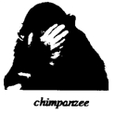
Most people agree that honesty is a good thing. But does Mother Nature agree? Animals can't talk, but can they lie in other ways? Can they lie with their bodies and behavior? Animal experts may not call it lying, but they do agree that many animals, from birds to chimpanzees, behave dishonestly to fool other animals. Why? Dishonesty often helps them survive.
Many kinds of birds are very successful at fooling other animals. For example, a bird called the plover sometimes pretends to be hurt in order to protect its young. When a predator（猎食动物）gets close to its nest, the plover leads the predator away from the nest. How? It pretends to have a broken wing. The predator follows the "hurt" adult, leaving the baby birds safe in the nest.
Another kind of bird, the scrub jay, buries its food so it always has something to eat. Scrub jays are also thieves. They watch where others bury their food and steal it. But clever scrub jays seem to know when a thief is watching them. So they go back later, unbury the food, and bury it again somewhere else.
Birds called cuckoos have found a way to have babies without doing much work. How? They don't make nests. Instead, they get into other birds' nests secretly. Then they lay their eggs and fly away. When the baby birds come out, their adoptive parents feed them.
Chimpanzees, or chimps, can also be sneaky. After a fight, the losing chimp will give its hand to the other. When the winning chimp puts out its hand, too, the chimps are friendly again. But an animal expert once saw a losing chimp take the winner's hand and start fighting again.
Chimps are sneaky in other ways, too. When chimps find food that they love, such as bananas, it is natural for them to cry out. Then other chimps come running. But some clever chimps learn to cry very softly when they find food. That way, other chimps don't hear them, and they don't need to share their food.
As children, many of us learn the saying "You can't fool Mother Nature." But maybe you can't trust her, either.

66. A plover protects its young from a predator by______.
A. getting closer to its young B. driving away the adult predator
C. leaving its young in another nest D. pretending to be injured

67. By "Chimpanzees, or chimps, can also be sneaky" (paragraph 5), the author means______.
A. chimps are ready to attack others B. chimps are sometimes dishonest
C. chimps are jealous of the winners D. chimps can be selfish too

68. Which of the following is true according to the passage?
A. Some chimps lower their cry to keep food away from others.
B. The losing chimp won the fight by taking the winner's hand.
C. Cuckoos fool their adoptive parents by making no nests.
D. Some clever scrub jays often steal their food back.

69. Which of the following might be the best title of the passage?
A. Do animals lie? B. Does Mother Nature fool animals?
C. How do animals learn to lie? D. How does honesty help animals survive?

(B)
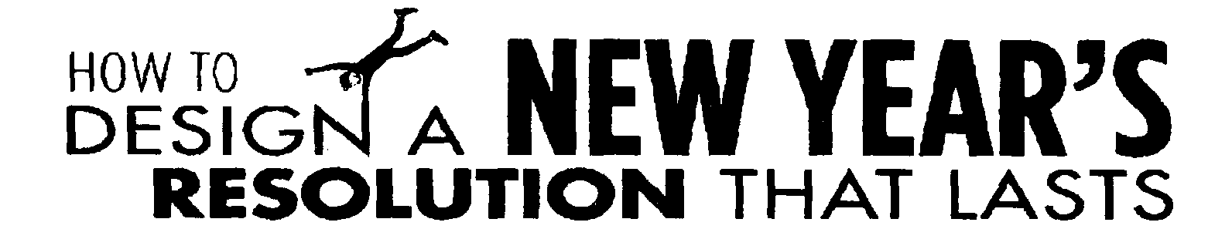

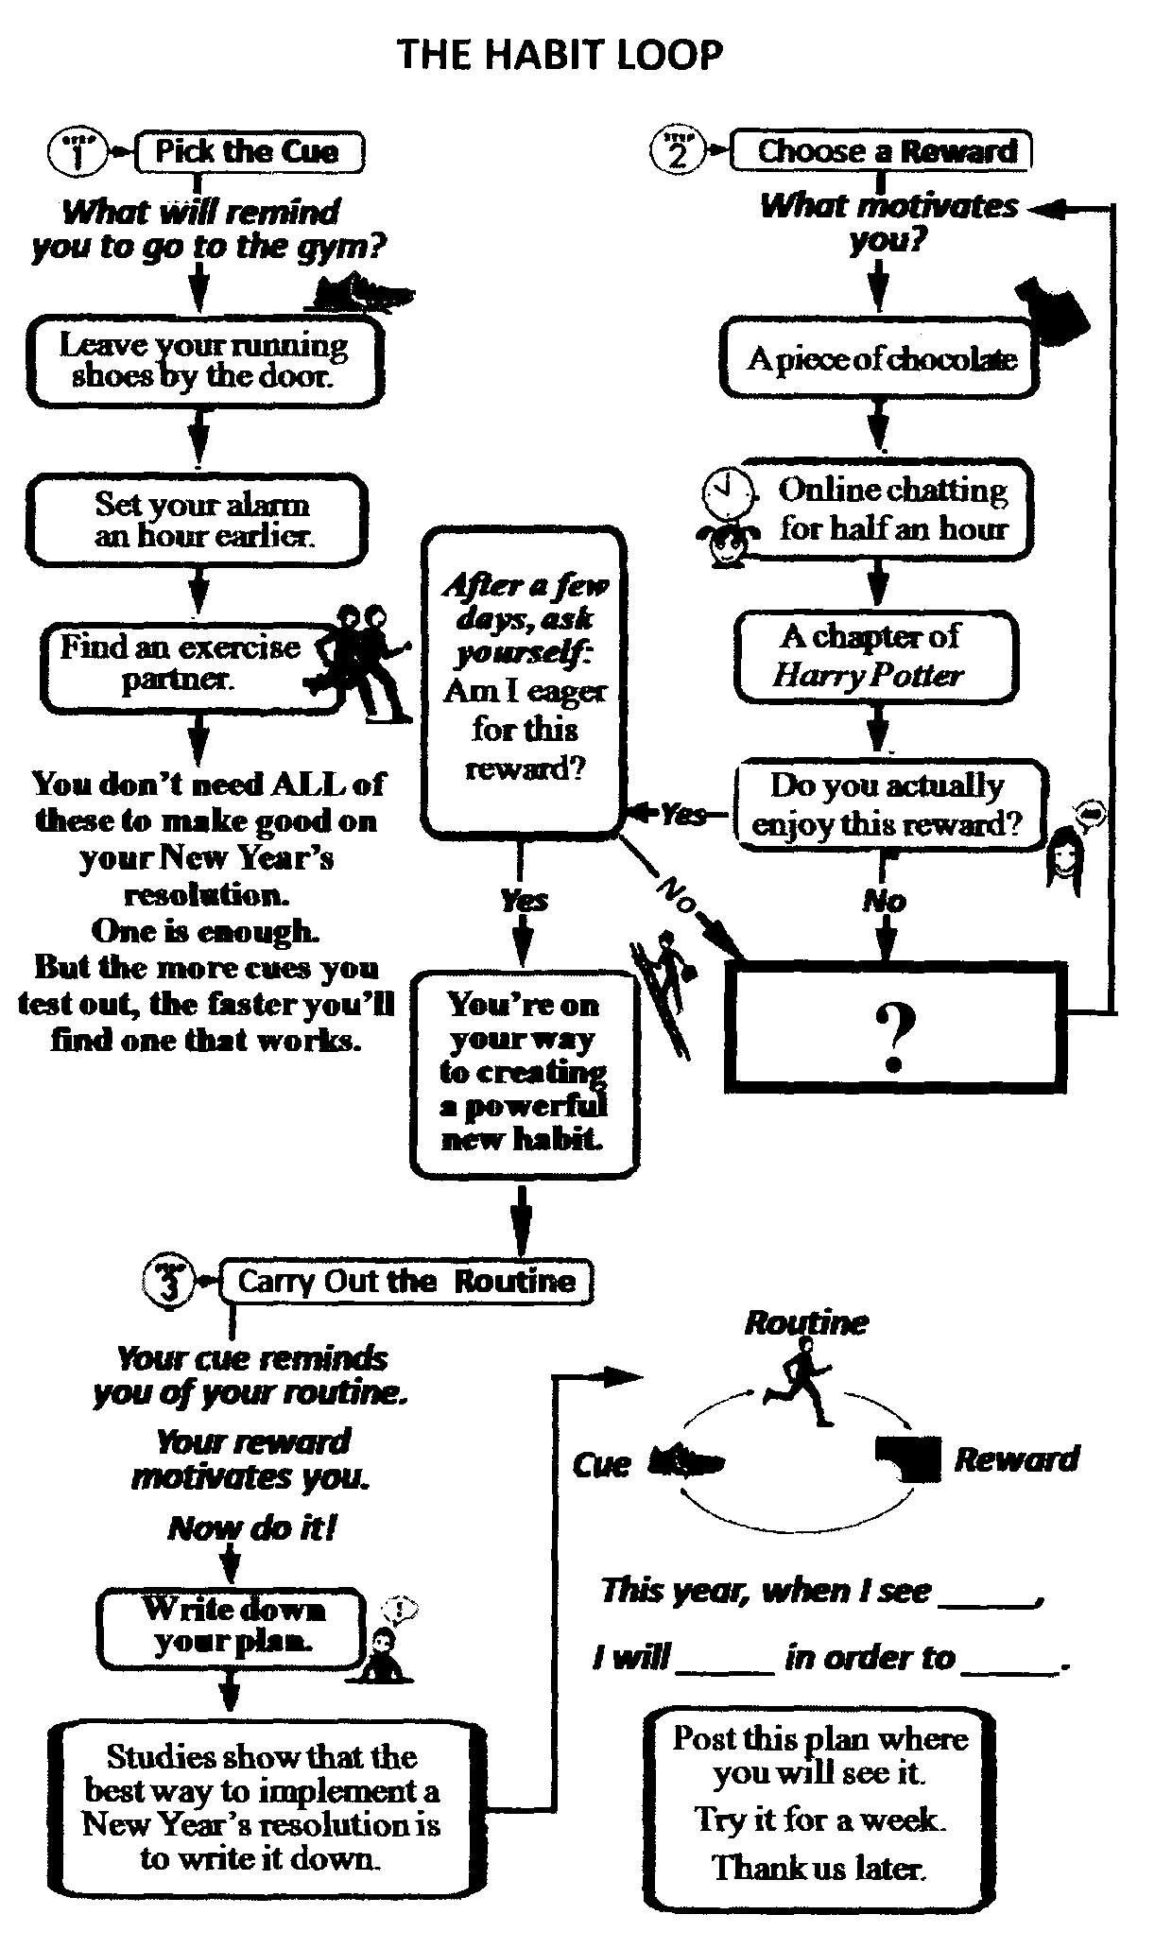
Let's say you want to hit the gym more regularly this year. How do you make that happen? Consider putting the habit loop to use.
Here's how it works:
A habit is a 3-step process. First, there's a cue, something that tells your brain to operate automatically. Then there's a routine. And finally, a reward, which helps your brain learn to desire the behavior. It's what you can use to create-or break-habits of your own.
Here's how to apply it:
Choose a cue, like leaving your running shoes by the door, then pick. a reward-say, a piece of chocolate when you get home from the gym. That way, the cue and the reward become interconnected. Finally, when you see the shoes, your brain will start longing for the reward, which will make it easier to work out day after day. The best part? In a couple of weeks, you won't need the chocolate at all. Your brain will come to see the workout itself as the reward. Which is the whole point, right?

70. Which of the following best fits in the box with a “?” in THE HABIT LOOP?
A. Pick a new cue. B. Form a new habit.
C. Choose a new reward. D. Design a new resolution.

71. According to THE HABIT LOOP, you can stick to your plan most effectively by______.
A. changing the routine B. trying it for a week
C. adjusting your goal D. writing it down

72. What's the purpose of putting the habit loop to use?
A. To test out different kinds of cues.
B. To do something as a habit even without rewards.
C. To work out the best New Year's resolution.
D. To motivate yourself with satisfactory rewards.

73. “This year when I see the Harry Potter poster, I will read 30 pages of an English novel or an English newspaper in order to watch TV for half an hour." What is the cue in this resolution?
A. The Harry Potter poster.
B. Reading 30 pages of an English novel.
C. An English newspaper.
D. Watching TV for half an hour.

(C)
If you could be anybody in the world, who would it be? Your neighbour or a super star? A few people have experienced what it might be like to step into the skin of another person, thanks to an unusual virtual reality（虚拟现实）device. Rikke Wahl, an actress, model and artist, was one of the participants in a body swapping experiment at the Be Another lab, a project developed by a group of artists based in Barcelona. She swapped with her partner, an actor, using a machine called The Machine to Be Another and temporarily became a man. "As I looked down, I saw my whole body as a man, dressed in my partner's pants," she said. "That's the picture I remember best."
The set-up is relatively simple. Both users wear a virtual reality headset with a camera on the top. The video from each camera is sent to the other person, so what you see is the exact view of your partner. If she moves her arm, you see it. If you move your arm, she sees it.
To get used to seeing another person's body without actually having control of it, participants start by raising their arms and legs very slowly, so that the other can follow along. Eventually, this kind of slow synchronised（同步的）movement becomes comfortable, and participants really start to feel as though they are living in another person's body.
Using such technology promises to alter people's behaviour afterwards-potentially for the better. Studies have shown that virtual reality can be effective in fighting racism-the bias（偏见）that humans have against those who don't look or sound like them. Researchers at the University of Barcelona gave people a questionnaire called the Implicit Association Test, which measures the strength of people's associations between, for instance, black people and adjectives such as good, bad, athletic or awkward. Then they asked them to control the body of a dark skinned digital character using virtual reality glasses, before taking the test again. This time, the participants' bias scores were lower. The idea is that once you've "put yourself in another's shoes" you're less likely to think ill of them, because your brain has internalised the feeling of being that person.
The creators of The Machine to Be Another hope to achieve a similar result. "At the end of body swapping, people feel like holding each other in their arms," says Arthur Pointeau, a programmer with the project. "It's a really nice way to have this kind of experience. I would really, really recommend it to everyone."

74. The word "swapping" (paragraph 1) is closest in meaning to______.
A. building B. exchanging C. controlling D. transplanting

75. We can infer from the experiment at the Be Another lab that______.
A. our feelings are related to our bodily experience
B. we can learn to take control of other people's bodies
C. participants will live more passionately after the experiment
D. The Machine to Be Another can help people change their sexes

76. In the Implicit Association Test, before the participants used virtual reality glasses to control a dark skinned digital character, ______.
A. they fought strongly against racism
B. they scored lower on the test for racism
C. they changed their behaviour dramatically
D. they were more biased against those unlike them

77. It can be concluded from the passage that______.
A. technology helps people realize their dreams
B. our biases could be eliminated through experiments
C. virtual reality helps promote understanding among people
D. our points of view about others need changing constantly

(D)（非真题）

A. You aren’t like anybody else
B. You already do lots of things well
C. Turn your back on too many rules
D. Check the rules about dos and don’ts
E. Whatever the presentation, public speaking is tough
F. The one thing you don’t want is for them to fall asleep
G. So trying to force a whole set of rules into it will just make things worse

Public Speaking Training
- Get a coach
78 , so get help. Since there are about a billion companies out there all ready to offer you public speaking training and courses, here are some things to look for when deciding the training that’s right for you.
- Focus on positives
Any training you do to become more effective at public speaking should always focus on the positive aspects of what you already do well. Nothing can hurt confidence more than being told that you aren’t doing well. 79 , so good public speaking training should develop those instead of telling you what you shouldn’t do.
- 80
If you find a public speaking course that looks as though it’s going to give you lots of dos and don’ts, walk away! Your brain is so full of what you’re going to be talking about. 81 . As far as we’re concerned, there are basically no hard and fast rules about public speaking. Your audience can be your friends.
- You are a special person not a clone
Most importantly, good public speaking training should treat you as a special one, with your own personal habits. 82 . Your training course should help you bring out your personality, not try to turn you into someone you’re not.

Keys
41. AD 42. C 43.BD 44. AC 45.AB 46. B 47. ABC 48.CD 49. A
50. BC
51. C 52. B 53. A 54. D 55. A 56. B 57. C 58. D 59. A 60. C
61. D 62. D 63. B 64. B 65. C 66. D 67. B 68. A 69. A 70. C
71.D 72.B 73.A 74.B 75.A 76.D 77.C
78-82 EBCGA

