Benefits of Learning Coding

Contents

Make Your Own Website 1

Become a Career Coder 1

Start a Business 2

Understand How Computers Work 2

Summary 3

Applying it to my career 3

Works Cited 3

Learning coding empowers you to do many things you wouldn’t otherwise be able to do. These things include hand-crafting your own websites, becoming a career coder or even starting a technology business. Most importantly, you’ll be able to understand the technology shaping your world.

You’ve undoubtedly heard or read somewhere that everyone needs to learn coding, right? Well, people say that for a reason! Whether you’re looking for a career in the industry, starting a new hobby or just wanting to understand technology, you can benefit from learning coding.

Here are some of the things that learning coding can empower you to do.

## Make Your Own Website

It’s incredible to think how much the world has changed since 1991, when the World Wide Web first started. The web has taken over our lives and it’s showing no sign of stopping.

Who knows where the web will take us in the future? Perhaps in another 10 years every person will have their own website. If one thing’s certain, it’s that a website is a very valuable thing to have these days.

Webpage

If you own a business, a web presence is a must. If you don’t, you still might want a personal blog or portfolio site to sell your skills to prospective employers. Of course, your ability to create and maintain a website is severely limited unless you learn HTML and CSS code, the code that all websites run on.

## Become a Career Coder

Looking for a career change? The humble computer programmer is quite possibly one of the most underrated professions out there. The demand for coders far exceeds the supply, so you’ll have no troubles finding a job. In fact, it’s projected to grow at a rate of 30% between 2010 and 2020. That’s twice as fast as most other jobs.

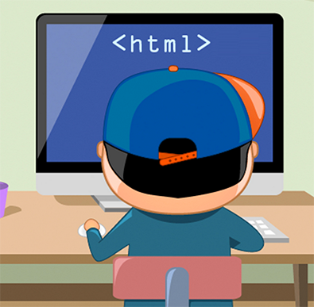And because the supply of coders around the world is so low, the pay is quite attractive too. Google and Facebook employees, for instance, are paid a base salary of ~$125K.

## Start a Business

Let’s say you’ve got an idea for a software product or web business. You want to create the next Facebook. But you’re short on cash, and being able to hire a team of coders is a pie in the sky. Why not learn code and build the product yourself?

It’s a path that many entrepreneurs are choosing to go down. They’ve started off with virtually no coding knowledge and have gone on to build their own small software businesses. For example, Nick D’Aloisio famously sold his iPhone app, Summly, to Yahoo! for $30m.

Some of the kinds of businesses you can start include…

* selling software
* selling mobile apps
* e-commerce
* selling your coding time.

If you do have a product idea, there’s no reason to sit twiddling your thumbs waiting for money to fall out of the sky. If you can learn code, you’ll not only be able to realize your product, but also know the source code of your software inside out.

## Understand How Computers Work

This is probably the biggest benefit of all, and the one that will apply to you no matter who you are or why you’re interested in learning code. After all, you use the Internet, mobile phones, computers and software in your daily life. Isn’t it a bit strange that you don’t fully understand how these technologies work?

With any luck, you’ll be able to discover ways in which coding can help you in your everyday life or job. You may decide to write your own scripts, to perform routine tasks like sending emails, handling data, editing text or doing calculations.

Understanding how software and coding works is definitely valuable for anyone, in any walk of life.

**Internet**

In·ter·net [ˈin(t)ərˌnet]

A global computer network providing a variety of information and communication facilities, consisting of interconnected networks using standardized communication protocols:

## Summary

* Benefits of Learning Coding
* Make you own website
* Career prospects
* More independence in business
* Understanding the technology we use everyday

### Applying it to my career

Knowing coding will allow me to show my works to more people.

# Works Cited

Code Conquest. (2015). *Benefits of Learning Coding*. Retrieved Janurary 24, 2018, from <http://www.codeconquest.com/what-is-coding/benefits/>