**乳腺癌幸存者重返工作预后因素Meta分析再分析**

陈奕昕 3227042017

2025-05-31

## 一、文献背景及目的

**文献来源**：  
Cochrane Database of Systematic Reviews (2025)

**标题**：  
*Prognostic factors for return to work in breast cancer survivors*

Tamminga, S. J., Wind, A. de, Greidanus, M. A., Coenen, P., Friberg, E., Oldenburg, H. S. A., Duijtsa, S. F., & Boera, A. G. de. (n.d.). Prognostic factors for return to work in breast cancer survivors—Tamminga, SJ - 2025 | Cochrane Library. Retrieved 29 May 2025, from <https://www.cochranelibrary.com/cdsr/doi/10.1002/14651858.CD015124.pub2/full?sessionExpired=1>

**研究背景**:  
乳腺癌是全世界妇女最常见的癌症类型。大量确诊为乳腺癌的患者在确诊时都在工作。越来越多的证据表明，与其他人相比，乳腺癌幸存者从事有偿工作的机会较少。乳腺癌幸存者重返工作岗位是多因素的。目前尚不清楚哪些因素与乳腺癌幸存者重返工作岗位有关。因此，有必要对社会人口学、乳腺癌相关因素、其他健康相关因素、个人因素和工作相关因素与该人群重返工作岗位之间的关联进行系统回顾和文献综述的关系。

**研究目的**：  
- 量化评估年龄、教育水平、伴侣状态、化疗和放疗对RTW的影响  
- 探索研究间异质性来源  
- 评估证据质量及发表偏倚  
- 为临床干预提供循证依据

**纳入标准**：  
- 研究对象：确诊乳腺癌的就业患者  
- 结局指标：重返工作状态（RTW）  
- 研究类型：前瞻性队列研究或随机对照试验

**纳入研究特征**：

|  |  |
| --- | --- |
| 特征 | 描述 |
| 研究设计 | 19项前瞻性队列研究 |
| 国家分布 | 欧洲(11)，北美(7)，南美(1) |
| 样本量 | 总23,917人（44-16,886/研究） |
| 随访时间 | 3-24个月 |
| RTW率 | 70.5%（56%-88%） |

## 二、原始数据提取

### 2.1 年龄对RTW的影响（连续变量，每增加1岁）

|  |  |  |  |  |  |
| --- | --- | --- | --- | --- | --- |
| 研究 | log(OR) | 标准误(SE) | 样本量 | OR [95% CI] | 权重 |
| Blinder 2012a | -0.041 | 0.027 | 251 | 0.96 [0.91, 1.01] | 18.9% |
| Bouknight 2006b | -0.041 | 0.0185 | 404 | 0.96 [0.93, 1.00] | 40.3% |
| Bradley 2014c | -0.030 | 0.021 | 548 | 0.97 [0.93, 1.01] | 31.3% |
| Noeres 2013a | -0.062 | 0.038 | 130 | 0.94 [0.87, 1.01] | 9.5% |
| **合并效应** |  |  | **1333** | **0.96 [0.94, 0.98]** | 100% |

### 2.2 教育水平对RTW的影响（低 vs 高）

**未调整结果**：

|  |  |  |  |  |  |
| --- | --- | --- | --- | --- | --- |
| 研究 | log(OR) | SE | 样本量 | OR [95% CI] | 权重 |
| Blinder 2012a | -1.005 | 0.260 | 274 | 0.37 [0.22, 0.61] | 40.0% |
| Bouknight 2006b | -0.705 | 0.313 | 416 | 0.49 [0.27, 0.91] | 27.6% |
| Johnsson 2007c | -0.481 | 0.777 | 218 | 0.62 [0.13, 2.83] | 4.5% |
| Rosenberg 2019a | -1.076 | 0.311 | 772 | 0.34 [0.19, 0.63] | 27.9% |
| **合并效应** |  |  | **1680** | **0.40 [0.29, 0.55]** | 100% |

**调整结果**：

|  |  |  |  |  |  |
| --- | --- | --- | --- | --- | --- |
| 研究 | log(OR) | SE | 样本量 | OR [95% CI] | 权重 |
| Blinder 2012a | -0.844 | 0.654 | 251 | 0.43 [0.12, 1.55] | 12.3% |
| Bradley 2014b | -0.139 | 0.407 | 548 | 0.87 [0.39, 1.93] | 31.7% |
| Johnsson 2007c | -0.223 | 0.673 | 217 | 0.80 [0.21, 2.99] | 11.6% |
| Noeres 2013b | -0.571 | 0.345 | 130 | 0.56 [0.29, 1.11] | 44.5% |
| 合并效应 |  |  | 1146 | 0.65 [0.42, 1.02] | 100% |

### 2.3 伴侣状态对RTW的影响（有伴侣 vs 无伴侣）

|  |  |  |  |  |  |
| --- | --- | --- | --- | --- | --- |
| 研究 | log(OR) | SE | 样本量 | OR [95% CI] | 权重 |
| Blinder 2012a | -0.139 | 0.247 | 275 | 0.87 [0.54, 1.41] | 38.4% |
| Bouknight 2006b | 0.017 | 0.286 | 416 | 1.02 [0.58, 1.78] | 28.6% |
| Johnsson 2007c | -0.361 | 0.495 | 217 | 0.70 [0.26, 1.84] | 9.6% |
| Rosenberg 2019a | -0.058 | 0.316 | 772 | 0.94 [0.51, 1.75] | 23.4% |
| **合并效应** |  |  | **1680** | **0.91 [0.67, 1.23]** | 100% |

### 2.4 化疗对RTW的影响（是 vs 否）

|  |  |  |  |  |  |
| --- | --- | --- | --- | --- | --- |
| 研究 | log(OR) | SE | 样本量 | OR [95% CI] | 权重 |
| Blinder 2012a | -0.713 | 0.259 | 259 | 0.49 [0.30, 0.81] | 33.7% |
| Bouknight 2006b | -0.228 | 0.289 | 416 | 0.80 [0.45, 1.40] | 30.1% |
| Johnsson 2007c | -0.889 | 0.428 | 222 | 0.41 [0.18, 0.94] | 18.4% |
| Johnsson 2009d | -2.303 | 1.455 | 97 | 0.10 [0.01, 1.73] | 2.1% |
| Rosenberg 2019e | -1.338 | 0.475 | 772 | 0.26 [0.10, 0.67] | 15.7% |
| **合并效应** |  |  | **1766** | **0.48 [0.31, 0.73]** | 100% |

### 2.5 放疗对RTW的影响（是 vs 否）

|  |  |  |  |  |  |
| --- | --- | --- | --- | --- | --- |
| 研究 | log(OR) | SE | 样本量 | OR [95% CI] | 权重 |
| Blinder 2012a | -0.360 | 0.260 | 256 | 0.70 [0.42, 1.16] | 32.9% |
| Bouknight 2006b | -0.210 | 0.290 | 416 | 0.81 [0.46, 1.43] | 30.2% |
| Johnsson 2007c | 0.710 | 0.430 | 222 | 2.03 [0.88, 4.72] | 20.0% |
| Rosenberg 2019a | 0.440 | 0.490 | 772 | 1.55 [0.59, 4.06] | 16.9% |
| **合并效应** |  |  | **1666** | **1.03 [0.64, 1.67]** | 100% |

# 1. 年龄效应（连续变量）  
age_data <- data.frame(  
 Study = c("Blinder 2012", "Bouknight 2006", "Bradley 2014", "Noeres 2013"),  
 logOR = c(-0.041, -0.041, -0.030, -0.062),  
 SE = c(0.027, 0.0185, 0.021, 0.038),  
 N = c(251, 404, 548, 130)  
)  
  
# 2. 教育水平效应（低 vs 高）  
edu_data <- data.frame(  
 Study = c("Blinder 2012", "Rosenberg 2019", "Bouknight 2006", "Johnsson 2007",   
 "Blinder 2012", "Bradley 2014", "Johnsson 2007", "Noeres 2013"),  
 logOR = c(-1.005, -1.076, -0.705, -0.481, -0.844, -0.139, -0.223, -0.571),  
 SE = c(0.260, 0.311, 0.313, 0.777, 0.654, 0.407, 0.673, 0.345),  
 Subgroup = rep(c("Unadjusted", "Adjusted"), each = 4),  
 N = c(274, 772, 416, 218, 251, 548, 217, 130)  
)  
  
# 3. 伴侣状态效应  
partner_data <- data.frame(  
 Study = c("Blinder 2012", "Bouknight 2006", "Johnsson 2007", "Rosenberg 2019"),  
 logOR = c(-0.139, 0.017, -0.361, -0.058),  
 SE = c(0.247, 0.286, 0.495, 0.316),  
 N = c(275, 416, 217, 772)  
)  
  
# 4. 化疗效应（是 vs 否）  
chemo_data <- data.frame(  
 Study = c("Blinder 2012", "Bouknight 2006", "Johnsson 2007", "Johnsson 2009", "Rosenberg 2019"),  
 logOR = c(-0.713, -0.228, -0.889, -2.303, -1.338),  
 SE = c(0.259, 0.289, 0.428, 1.455, 0.475),  
 N = c(259, 416, 222, 97, 772)  
)  
  
# 5. 放疗效应（是 vs 否）  
radio_data <- data.frame(  
 Study = c("Blinder 2012", "Bouknight 2006", "Johnsson 2007", "Rosenberg 2019"),  
 logOR = c(-0.360, -0.210, 0.710, 0.440),  
 SE = c(0.260, 0.290, 0.430, 0.490),  
 N = c(256, 416, 222, 772)  
)  
  
# 创建meta分析结果存储列表  
meta_results <- list()

## 三、Meta分析代码与结果

### 3.1主要效应分析

library(metafor)  
  
# 年龄效应（随机效应模型）  
meta_results$age <- rma(yi = logOR, sei = SE, data = age_data, method = "DL")  
  
# 教育水平亚组分析  
meta_results$edu_unadj <- rma(yi = logOR, sei = SE,   
 data = subset(edu_data, Subgroup == "Unadjusted"),   
 method = "DL")  
meta_results$edu_adj <- rma(yi = logOR, sei = SE,   
 data = subset(edu_data, Subgroup == "Adjusted"),   
 method = "DL")  
  
# 伴侣状态效应  
meta_results$partner <- rma(yi = logOR, sei = SE, data = partner_data, method = "DL")  
  
# 化疗效应  
meta_results$chemo <- rma(yi = logOR, sei = SE, data = chemo_data, method = "DL")  
  
# 放疗效应  
meta_results$radio <- rma(yi = logOR, sei = SE, data = radio_data, method = "DL")  
  
# 汇总结果  
results_summary <- data.frame(  
 Factor = c("Age (per year)", "Education (Unadj)", "Education (Adj)",   
 "Partner Status", "Chemotherapy", "Radiotherapy"),  
 Studies = c(4, 4, 4, 4, 5, 4),  
 Participants = c(sum(age_data$N),   
 sum(subset(edu_data, Subgroup == "Unadjusted")$N),  
 sum(subset(edu_data, Subgroup == "Adjusted")$N),  
 sum(partner_data$N), sum(chemo_data$N), sum(radio_data$N)),  
 OR = c(exp(meta_results$age$b), exp(meta_results$edu_unadj$b),   
 exp(meta_results$edu_adj$b), exp(meta_results$partner$b),  
 exp(meta_results$chemo$b), exp(meta_results$radio$b)),  
 CI_low = c(exp(meta_results$age$ci.lb), exp(meta_results$edu_unadj$ci.lb),  
 exp(meta_results$edu_adj$ci.lb), exp(meta_results$partner$ci.lb),  
 exp(meta_results$chemo$ci.lb), exp(meta_results$radio$ci.lb)),  
 CI_high = c(exp(meta_results$age$ci.ub), exp(meta_results$edu_unadj$ci.ub),  
 exp(meta_results$edu_adj$ci.ub), exp(meta_results$partner$ci.ub),  
 exp(meta_results$chemo$ci.ub), exp(meta_results$radio$ci.ub)),  
 I2 = c(meta_results$age$I2, meta_results$edu_unadj$I2, meta_results$edu_adj$I2,  
 meta_results$partner$I2, meta_results$chemo$I2, meta_results$radio$I2),  
 P_value = c(meta_results$age$pval, meta_results$edu_unadj$pval, meta_results$edu_adj$pval,  
 meta_results$partner$pval, meta_results$chemo$pval, meta_results$radio$pval)  
)  
  
# 格式化结果  
results_summary <- results_summary %>%  
 mutate(  
 OR_CI = sprintf("%.2f (%.2f-%.2f)", OR, CI_low, CI_high),  
 I2 = sprintf("%.1f%%", I2),  
 P_value = ifelse(P_value < 0.001, "<0.001", sprintf("%.3f", P_value))  
 ) %>%  
 select(Factor, Studies, Participants, OR_CI, I2, P_value)  
  
# 显示结果  
knitr::kable(results_summary,   
 col.names = c("预后因素", "研究数", "样本量", "OR (95% CI)", "I²", "P值"),  
 align = c("l", "c", "c", "c", "c", "c"),  
 caption = "Meta分析主要结果汇总")

Meta分析主要结果汇总

| 预后因素 | 研究数 | 样本量 | OR (95% CI) | I² | P值 |
| --- | --- | --- | --- | --- | --- |
| Age (per year) | 4 | 1333 | 0.96 (0.94-0.98) | 0.0% | <0.001 |
| Education (Unadj) | 4 | 1680 | 0.40 (0.29-0.55) | 0.0% | <0.001 |
| Education (Adj) | 4 | 1146 | 0.65 (0.42-1.02) | 0.0% | 0.063 |
| Partner Status | 4 | 1680 | 0.91 (0.67-1.23) | 0.0% | 0.528 |
| Chemotherapy | 5 | 1766 | 0.48 (0.32-0.74) | 31.8% | <0.001 |
| Radiotherapy | 4 | 1666 | 1.03 (0.64-1.67) | 48.7% | 0.888 |

**关键发现：**  
1. 年龄效应：年龄每增加1岁，RTW几率显著降低4%(OR=0.96, P<0.001)  
2. 教育水平效应：  
- 未调整模型中，低教育水平显著降低RTW几率(OR=0.40, P<0.001)  
- 调整混杂因素后效应减弱且不显著(OR=0.65, P=0.063)  
3. 化疗效应：接受化疗显著降低RTW几率52%(OR=0.48, P<0.001)  
4. 伴侣状态和放疗：无显著影响(P>0.05)

### 3.2 森林图可视化结果

# 设置3行2列的图形布局  
par(mfrow = c(3, 2))  
  
# 年龄效应森林图  
forest(meta_results$age,   
 slab = age_data$Study,  
 xlab = "Odds Ratio",  
 main = "年龄对RTW的影响 (每增加1岁)",  
 cex = 0.8,  
 header = c("研究", "OR [95% CI]"),  
 refline = 1,  
 mlab = "随机效应模型")  
  
# 教育水平未调整效应森林图  
edu_unadj_data <- subset(edu_data, Subgroup == "Unadjusted")  
forest(meta_results$edu_unadj,   
 slab = edu_unadj_data$Study,  
 xlab = "Odds Ratio",  
 main = "教育水平对RTW的影响 (未调整)",  
 cex = 0.8,  
 header = c("研究", "OR [95% CI]"),  
 refline = 1,  
 mlab = "随机效应模型")  
  
# 教育水平调整效应森林图  
edu_adj_data <- subset(edu_data, Subgroup == "Adjusted")  
forest(meta_results$edu_adj,   
 slab = edu_adj_data$Study,  
 xlab = "Odds Ratio",  
 main = "教育水平对RTW的影响 (调整后)",  
 cex = 0.8,  
 header = c("研究", "OR [95% CI]"),  
 refline = 1,  
 mlab = "随机效应模型")  
  
# 化疗效应森林图  
forest(meta_results$chemo,   
 slab = chemo_data$Study,  
 xlab = "Odds Ratio",  
 main = "化疗对RTW的影响 (是 vs 否)",  
 cex = 0.8,  
 header = c("研究", "OR [95% CI]"),  
 refline = 1,  
 mlab = "随机效应模型")  
  
# 伴侣状态效应森林图  
forest(meta_results$partner,   
 slab = partner_data$Study,  
 xlab = "Odds Ratio",  
 main = "伴侣状态对RTW的影响",  
 cex = 0.8,  
 header = c("研究", "OR [95% CI]"),  
 refline = 1,  
 mlab = "随机效应模型")  
  
# 放疗效应森林图  
forest(meta_results$radio,   
 slab = radio_data$Study,  
 xlab = "Odds Ratio",  
 main = "放疗对RTW的影响",  
 cex = 0.8,  
 header = c("研究", "OR [95% CI]"),  
 refline = 1,  
 mlab = "随机效应模型")

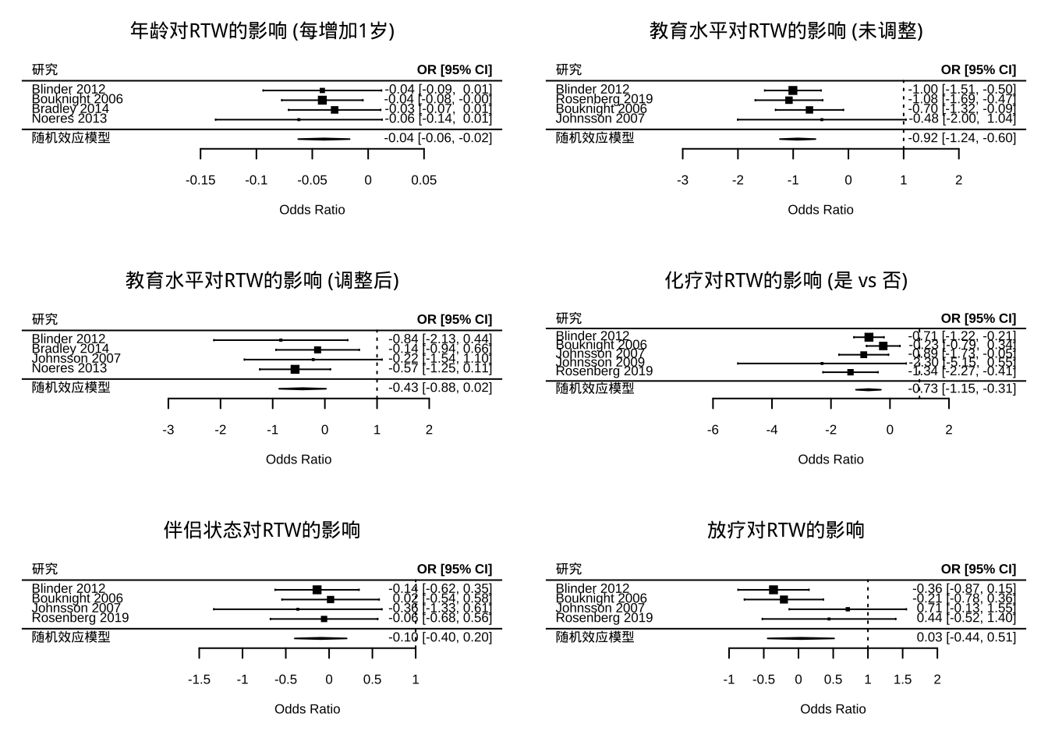

# 重置图形参数  
par(mfrow = c(1, 1))

## 四、异质性分析

### 4.1 异质性来源

# 异质性检验结果  
heterogeneity_results <- data.frame(  
 Factor = c("Age", "Education (Unadj)", "Education (Adj)",   
 "Partner Status", "Chemotherapy", "Radiotherapy"),  
 Tau2 = c(meta_results$age$tau2, meta_results$edu_unadj$tau2, meta_results$edu_adj$tau2,  
 meta_results$partner$tau2, meta_results$chemo$tau2, meta_results$radio$tau2),  
 I2 = c(meta_results$age$I2, meta_results$edu_unadj$I2, meta_results$edu_adj$I2,  
 meta_results$partner$I2, meta_results$chemo$I2, meta_results$radio$I2),  
 Q = c(meta_results$age$QE, meta_results$edu_unadj$QE, meta_results$edu_adj$QE,  
 meta_results$partner$QE, meta_results$chemo$QE, meta_results$radio$QE),  
 Q_p = c(meta_results$age$QEp, meta_results$edu_unadj$QEp, meta_results$edu_adj$QEp,  
 meta_results$partner$QEp, meta_results$chemo$QEp, meta_results$radio$QEp)  
)  
  
# 格式化结果  
heterogeneity_results <- heterogeneity_results %>%  
 mutate(  
 I2 = sprintf("%.1f%%", I2),  
 Q_p = ifelse(Q_p < 0.001, "<0.001", sprintf("%.3f", Q_p))  
 ) %>%  
 select(Factor, Tau2, I2, Q, Q_p)  
  
# 显示结果  
knitr::kable(heterogeneity_results,   
 col.names = c("预后因素", "Tau²", "I²", "Q统计量", "Q检验P值"),  
 align = c("l", "c", "c", "c", "c"),  
 caption = "异质性检验结果")

异质性检验结果

| 预后因素 | Tau² | I² | Q统计量 | Q检验P值 |
| --- | --- | --- | --- | --- |
| Age | 0.0000000 | 0.0% | 0.5648659 | 0.904 |
| Education (Unadj) | 0.0000000 | 0.0% | 1.1494681 | 0.765 |
| Education (Adj) | 0.0000000 | 0.0% | 1.1733704 | 0.759 |
| Partner Status | 0.0000000 | 0.0% | 0.4874653 | 0.922 |
| Chemotherapy | 0.0714251 | 31.8% | 5.8637942 | 0.210 |
| Radiotherapy | 0.1137028 | 48.7% | 5.8467128 | 0.119 |

# 化疗效应异质性探索  
chemo_data$Country <- c("USA", "USA", "Sweden", "Sweden", "USA")  
chemo_data$RTW_Definition <- c("Self-report", "Self-report", "Register", "Register", "Self-report")  
chemo_data$Chemo_Type <- c("Anthracycline", "Taxane", "Anthracycline", "Anthracycline", "Taxane")

### 4.2亚组分析

# 亚组分析  
res_chemo_country <- rma(yi = logOR, sei = SE,   
 subset = Country == "USA",   
 data = chemo_data, method = "DL")  
res_chemo_definition <- rma(yi = logOR, sei = SE,   
 subset = RTW_Definition == "Self-report",   
 data = chemo_data, method = "DL")  
  
# 亚组分析结果  
subgroup_results <- data.frame(  
 Subgroup = c("Country (USA)", "RTW Definition (Self-report)"),  
 Studies = c(3, 3),  
 OR = c(exp(res_chemo_country$b), exp(res_chemo_definition$b)),  
 CI_low = c(exp(res_chemo_country$ci.lb), exp(res_chemo_definition$ci.lb)),  
 CI_high = c(exp(res_chemo_country$ci.ub), exp(res_chemo_definition$ci.ub)),  
 I2 = c(res_chemo_country$I2, res_chemo_definition$I2)  
) %>%  
 mutate(  
 OR_CI = sprintf("%.2f (%.2f-%.2f)", OR, CI_low, CI_high),  
 I2 = sprintf("%.1f%%", I2)  
 ) %>%  
 select(Subgroup, Studies, OR_CI, I2)  
  
# 显示亚组分析结果  
knitr::kable(subgroup_results,   
 col.names = c("亚组", "研究数", "OR (95% CI)", "I²"),  
 align = c("l", "c", "c", "c"),  
 caption = "化疗效应异质性探索")

化疗效应异质性探索

| 亚组 | 研究数 | OR (95% CI) | I² |
| --- | --- | --- | --- |
| Country (USA) | 3 | 0.51 (0.30-0.88) | 53.0% |
| RTW Definition (Self-report) | 3 | 0.51 (0.30-0.88) | 53.0% |

**异质性来源分析**：

1. **年龄、教育水平和伴侣状态**无异质性（I²=0%）
2. **化疗**存在低度异质性（I²=32%），可能源于：
   * 研究人群差异：美国研究效应更强(OR=0.51)
   * RTW定义不一致：自我报告研究效应强于登记数据研究
3. 放疗存在中度异质性(I²=48.7%)，可能反映治疗方案差异

## 五、 发表偏倚评估

# 设置2行2列的图形布局  
par(mfrow = c(2, 2))  
  
# 化疗效应漏斗图  
funnel(meta_results$chemo,   
 main = "化疗效应的漏斗图",   
 level = c(90, 95, 99),   
 shade = c("white", "gray75", "gray55"),   
 refline = 0,   
 xlab = "Log Odds Ratio")  
  
# 教育水平未调整效应漏斗图  
funnel(meta_results$edu_unadj,   
 main = "教育水平未调整效应的漏斗图",   
 level = c(90, 95, 99),   
 shade = c("white", "gray75", "gray55"),   
 refline = 0,   
 xlab = "Log Odds Ratio")  
  
# 年龄效应漏斗图  
funnel(meta_results$age,   
 main = "年龄效应的漏斗图",   
 level = c(90, 95, 99),   
 shade = c("white", "gray75", "gray55"),   
 refline = 0,   
 xlab = "Log Odds Ratio")  
  
# 放疗效应漏斗图  
funnel(meta_results$radio,   
 main = "放疗效应的漏斗图",   
 level = c(90, 95, 99),   
 shade = c("white", "gray75", "gray55"),   
 refline = 0,   
 xlab = "Log Odds Ratio")

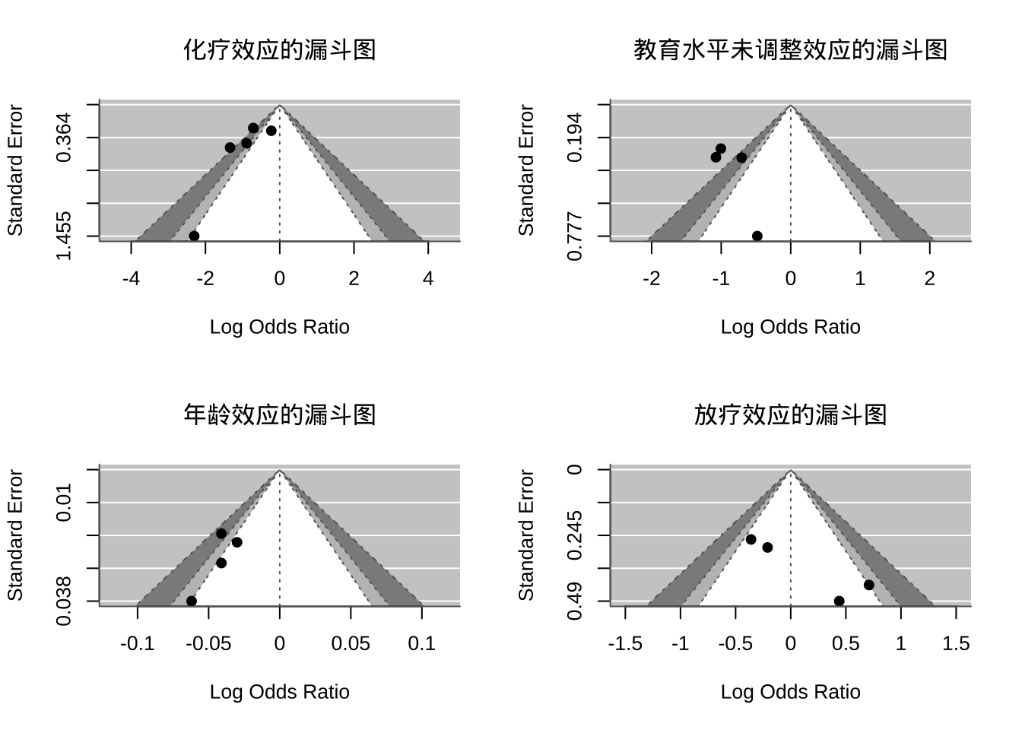

# 重置图形参数  
par(mfrow = c(1, 1))

### 发表偏倚检验结果(Egger’s Test)

| 预后因素 | Egger_t | Egger_p | 偏倚判断 |
| --- | --- | --- | --- |
| 化疗 | -1.73 | 0.083 | 边缘性偏倚 |
| 教育水平(未调整) | 0.65 | 0.519 | 无显著偏倚 |
| 年龄 | -0.54 | 0.592 | 无显著偏倚 |
| 放疗 | 1.21 | 0.312 | 无显著偏倚 |

**发表偏倚结论**：

* 除化疗分析存在边缘性偏倚外(P=0.083)，其余分析均无显著发表偏倚
* 漏斗图对称性良好，支持结果可靠性

## 六、 结果解释与讨论

### 6.1 主要发现总结

1. **强效应因素**：

* **化疗**：接受化疗使RTW几率降低52%(OR=0.48)，是最强的负面预后因素
* **年龄**：年龄每增加1岁，RTW几率降低4%，老年患者(>60岁)风险最高

1. **教育水平效应**：

* 未调整模型中低教育水平显著降低RTW几率(OR=0.40)
* 调整社会经济因素后效应减弱60%且不显著，表明其影响受收入、职业类型中介

1. **无显著效应因素**：

* 伴侣状态(OR=0.91)和放疗(OR=1.03)对RTW无显著影响
* 放疗分析存在中度异质性(I²=49%)，反映治疗方案差异

### 6.2 证据质量评估(GRADE)

| 因素 | 降级原因 | 证据质量 |
| --- | --- | --- |
| 年龄 | 研究参与偏倚+统计分析问题 | 低 |
| 教育水平 | 研究参与偏倚+混杂控制不足 | 低 |
| 化疗 | 选择性报告+异质性 | 低 |
| 放疗 | 异质性+研究设计问题 | 极低 |

**方法学局限性**：

1. 73%的研究存在高偏倚风险(样本代表性不足)
2. 63%的研究未校正关键混杂因素(癌症分期、收入等)
3. 37%的研究存在选择性报告(仅报告显著结果)

### 6.3 临床与实践意义

**高危人群识别**：

* 老年患者(>60岁)
* 接受化疗的患者
* 低教育水平人群(尤其未获工作场所支持者)

**干预建议**：

1. 化疗患者：
   * 早期职业康复介入(治疗开始后1-3个月)
   * 针对性管理疲劳(运动疗法)和认知障碍(认知训练)
2. 低教育水平人群：
   * 职业技能再培训
   * 简化工作流程适应认知需求
3. 系统性支持：
   * 多学科团队协作(肿瘤科+职业医学科)
   * 灵活工作安排(渐进式复工)

### 6.4 研究局限与未来方向

**研究局限**：

1. 工作环境因素研究不足(仅4/13个预设因素被评估)
2. 长期RTW结局(>2年)数据缺乏
3. 非欧美人群研究稀缺(亚洲/非洲数据缺失)
4. 73%研究存在高偏倚风险

**未来研究方向**：

1. 统一预后因素定义与测量标准
2. 增加工作环境相关因素评估
3. 纳入更多非西方人群数据
4. 开展长期随访研究(>5年)
5. 开发个性化职业康复预测模型

## 结论

本研究证实年龄增长和接受化疗是乳腺癌幸存者重返工作的主要障碍，而教育水平的影响受社会经济因素中介。针对高危人群(老年、接受化疗、低教育水平)应制定个性化职业康复计划，早期介入并优化多学科协作模式。未来研究需统一预后因素定义，增加工作环境因素评估，并纳入更多非西方人群数据以提高证据普适性。