Mono Solar Cell Incoming Inspection Specification
PV IQC WORK INSTRUCTION · PV-IQC-WI-001 · REV A2
Document No.: PV-IQC-WI-001 Effective: 2026-10-01 Revision: A2
Scope: incoming visual, EL, dimensional and electrical inspection for 182 mm / 210 mm mono PERC and TOPCon cells.

1. Purpose
Define unified inspection conditions, sampling rules and acceptance criteria for solar cells, prevent micro-cracks, edge chips, broken fingers, power-class mixing and electrical failures from entering stringing and lamination.

2. Reference Documents
- GB/T 2828.1 Sampling procedures for inspection by attributes
- IEC 61215-1 Terrestrial photovoltaic modules - design qualification
- PV-IQC-SP-002 PV Glass AQL Sampling Plan
- Supplier technical agreement and power-class approval sheet

3. Inspection Conditions

3.1 Visual Inspection
Perform visual inspection under 1,000–1,500 lux white LED light on a black anti-static mat. Viewing distance 300–400 mm; inspect each cell for at least 8 seconds.

3.2 EL Inspection
EL inspection shall be performed in a dark room or light-tight fixture. Test current shall follow the supplier agreement, typically 1/10 Isc. The image must clearly show busbars, fingers and edges.

3.3 Dimensions and Electrical Performance
Measure dimensions with an image measuring system or dedicated gauges; measure thickness with a micrometer. Pull 3 cells per lot for efficiency, FF, Voc and Isc at 25 ±2°C.

4. Inspection Items and Acceptance Criteria
Item | Requirement | Class | Method
Edge chip | Depth ≤0.5 mm; cumulative length ≤1.0 mm per edge | MAJ | Visual + caliper
Corner chip | ≤0.8 mm; must not affect busbar or finger | MAJ | Visual + caliper
Crack | No visible crack permitted | CR | Visual + EL
Stain / color | No finger marks, oil, water marks or lot-level color deviation | MIN | Visual
EL micro-crack | No through micro-crack; others per technical agreement | MAJ | EL
Broken finger | ≤2 broken fingers; no broken busbar | MAJ | EL
Black spot / mix | No black spot or power-class mixing | MAJ | EL + sorter
Cell size | 182.0 ±0.2 mm / 210.0 ±0.2 mm | MAJ | Image measurement
Diagonal | Diagonal difference ≤0.5 mm | MAJ | Image measurement
Thickness | 130 ±10 μm per agreement | MIN | Micrometer
Electrical | Efficiency, FF, Voc and Isc meet approved class | CR | IV tester
Packaging | Moisture-proof and shock-proof; clear lot and class labels | MIN | Visual
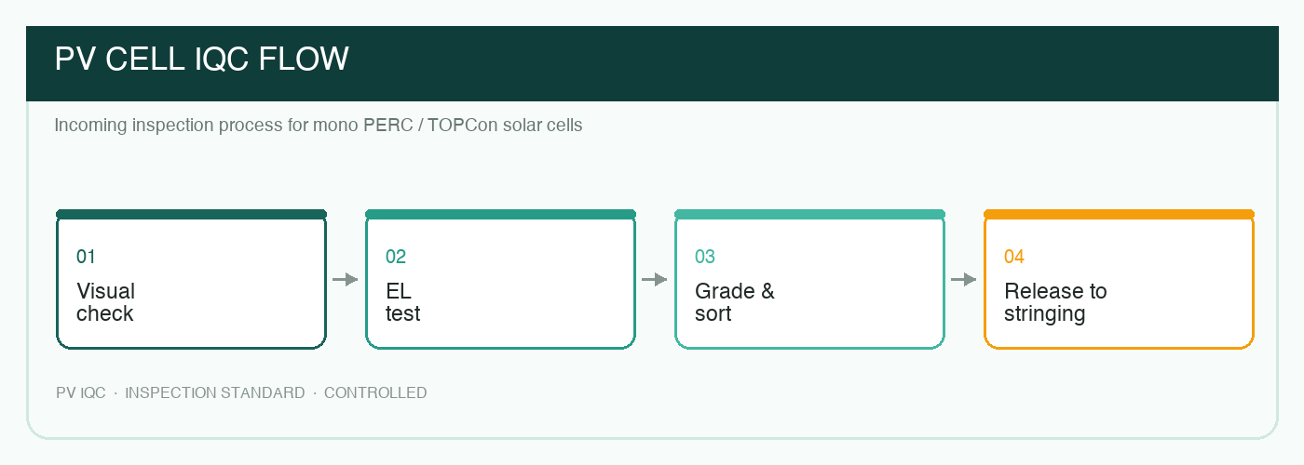
Figure 1 Cell incoming inspection flow: visual → EL → grade → release

5. Sampling and Lot Disposition
One inspection lot consists of the same supplier, model, power class and production lot. Visual and dimensional inspection follow AQL sampling; EL sample at least 5% and no fewer than 10 cells; electrical performance sample 3 cells per lot.
Any critical defect rejects the lot. If major defects reach the rejection number, the lot is rejected. Minor defects may be accepted by deviation with quality and process engineering approval.

6. Packaging and Storage
- Use anti-static and moisture-barrier packaging with separators between cells.
- Labels must show supplier, model, power class, quantity, lot, date and RoHS status.
- Complete inspection and release within 24 hours after opening; reseal unused cells.

7. Nonconformance
Isolate the lot and notify purchasing, SQE and the supplier when a through crack, power-class mix or repeated lot rejection is found. The supplier shall provide containment within 24 hours and an 8D report within 5 working days.

Revision History
Version | Date | Change | Owner
A0 | 2024-05-10 | Initial release | PV Quality
A1 | 2025-08-01 | Add TOPCon EL criteria | PV Quality
A2 | 2026-10-01 | Update 210 mm dimensions and sampling | PV Quality

