**1. Store raw data into hdfs location**

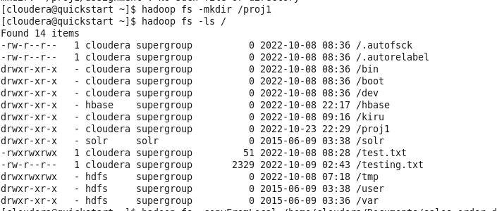





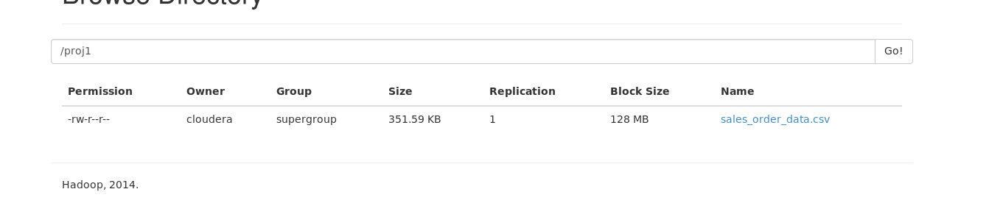

**2. Create a internal hive table "sales_order_csv" which will store csv data sales_order_csv .. make sure to skip header row while creating table**



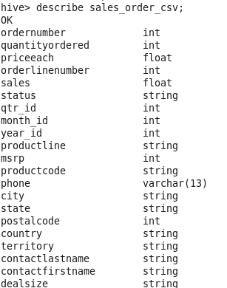

**3.Load data from hdfs path into "sales_order_csv"**



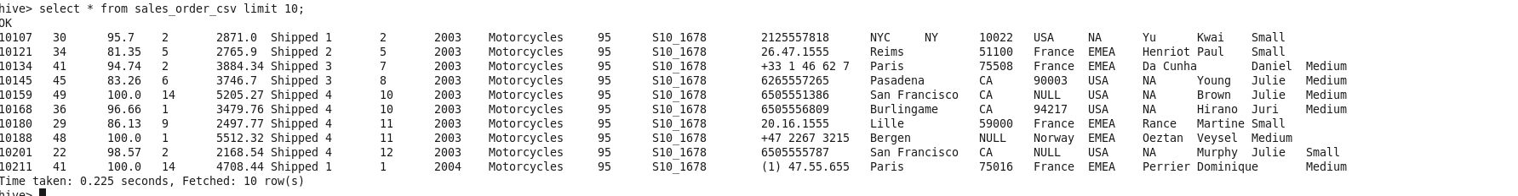

**4.Create an internal hive table which will store data in ORC format "sales_order_orc"**



**5. Load data from "sales_order_csv" into "sales_order_orc"**

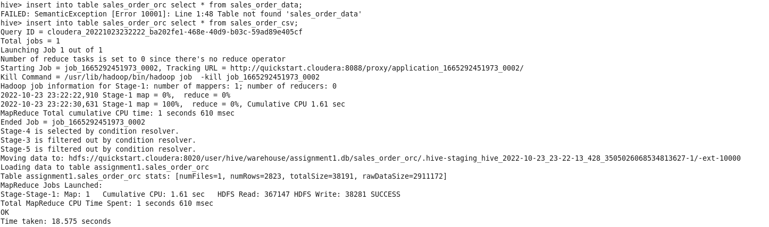

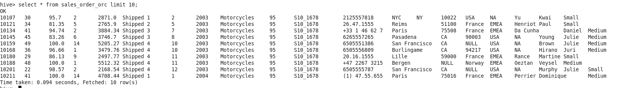

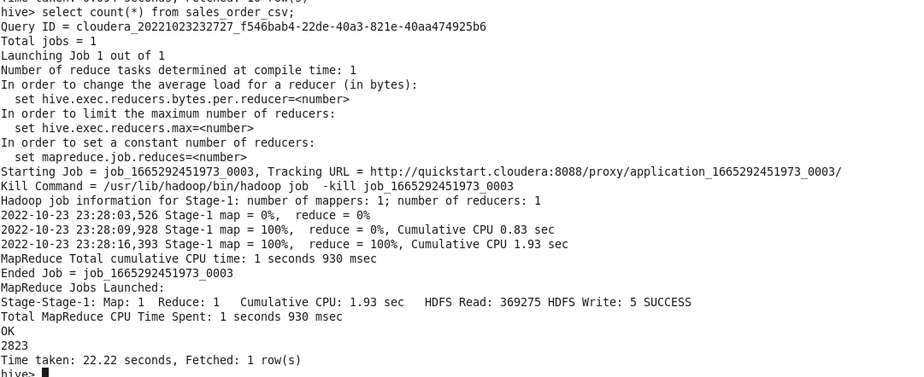

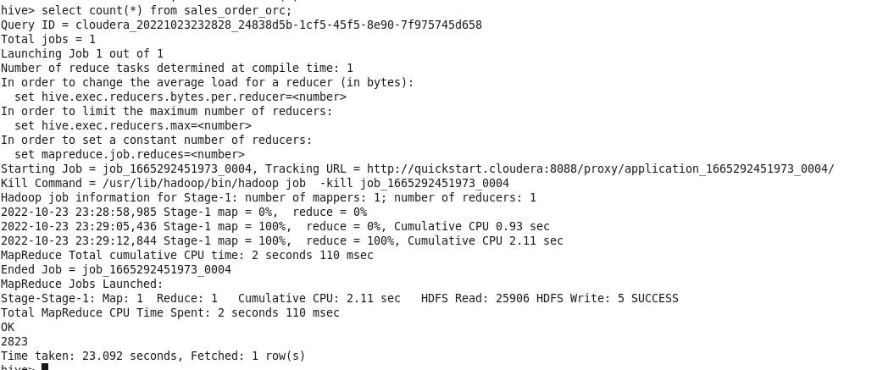

1. **Calculate total sales per year**

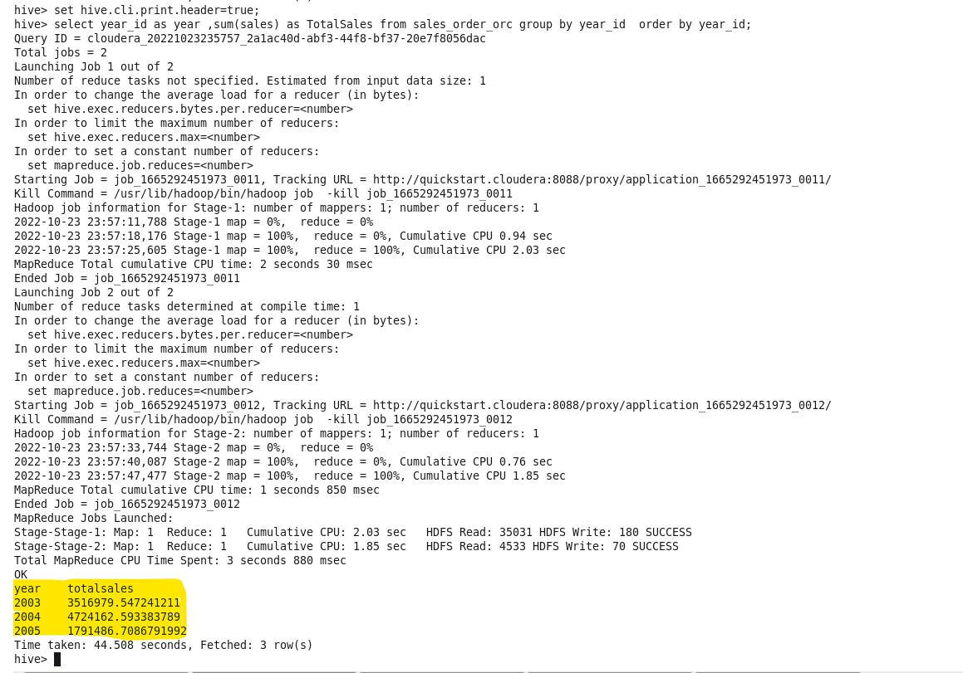

1. **Find a product for which maximum orders were placed**

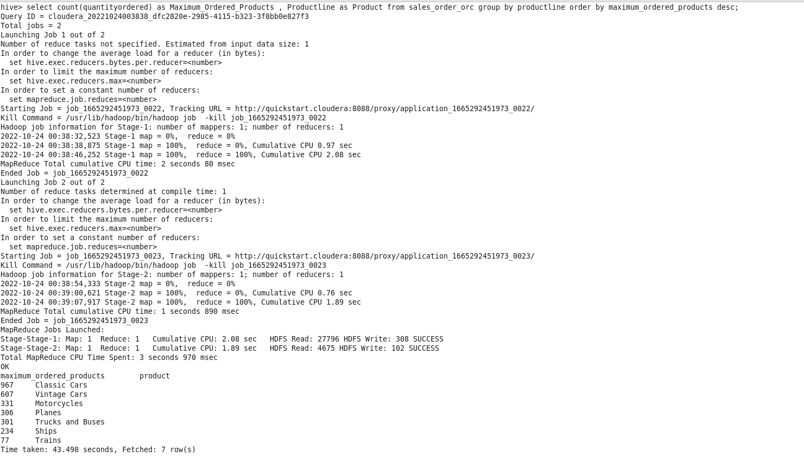

1. **Calculate the total sales for each quarter**

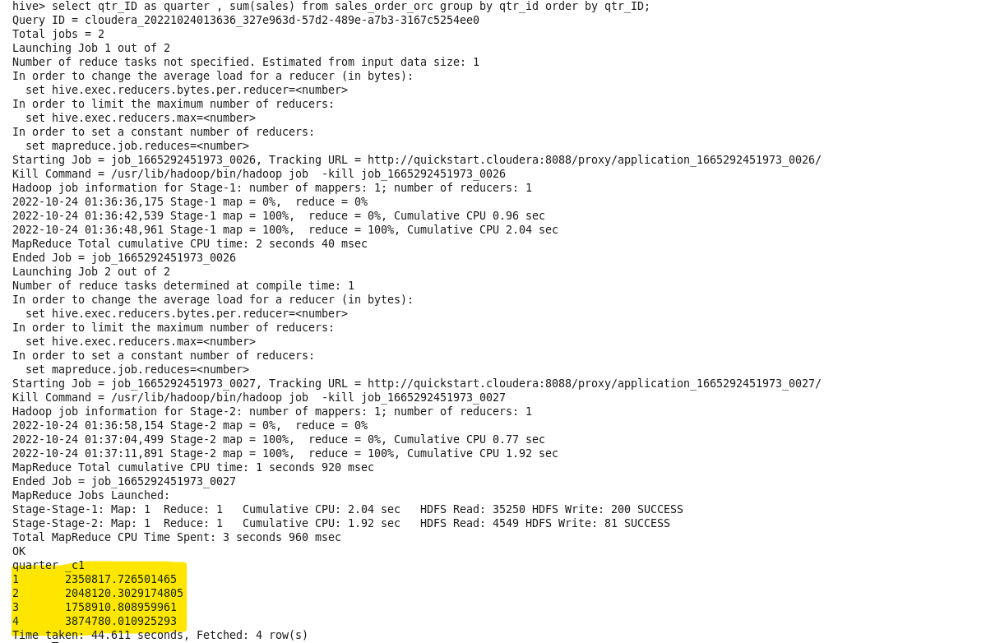

1. **In which quarter sales was minimum**

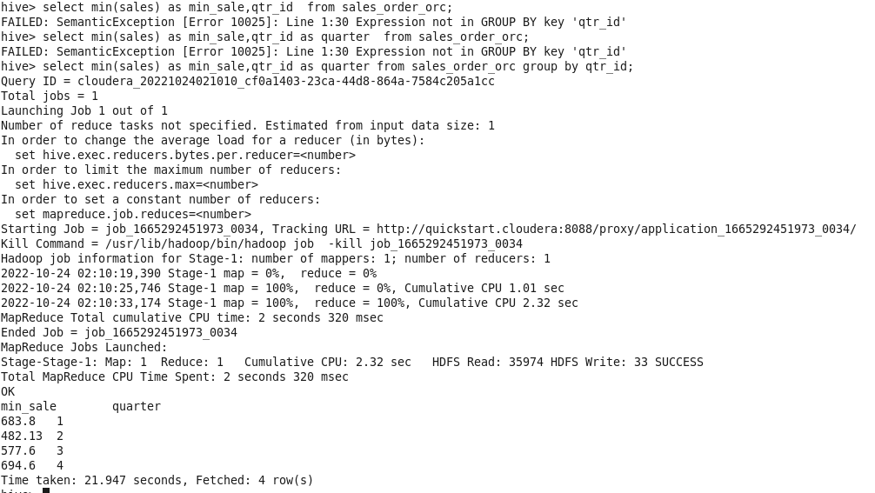

1. **In which country sales was maximum and in which country sales was minimum**

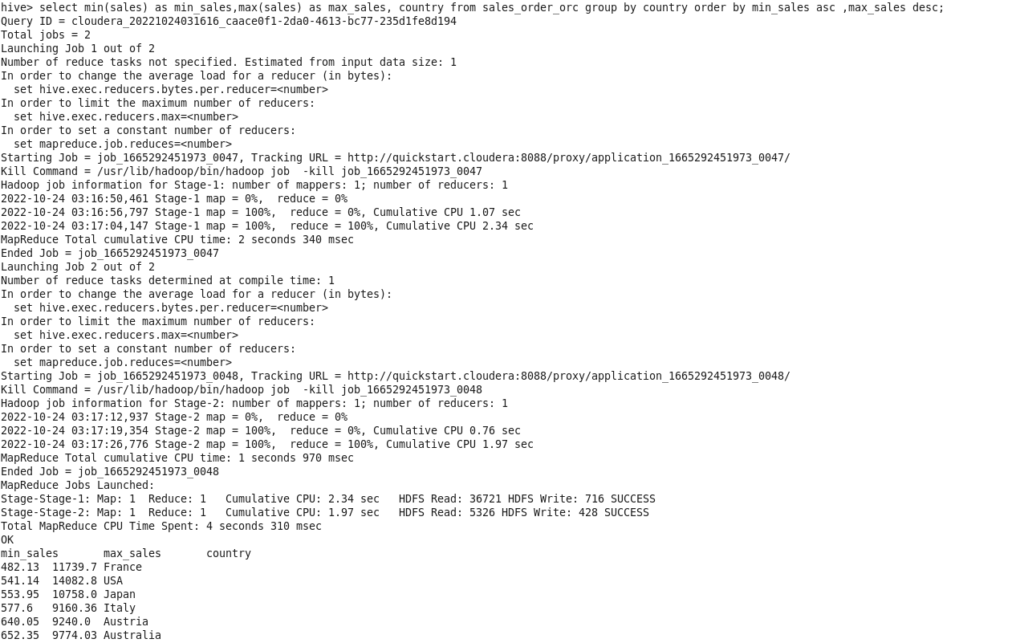

**F. Calculate quarterly sales for each city**

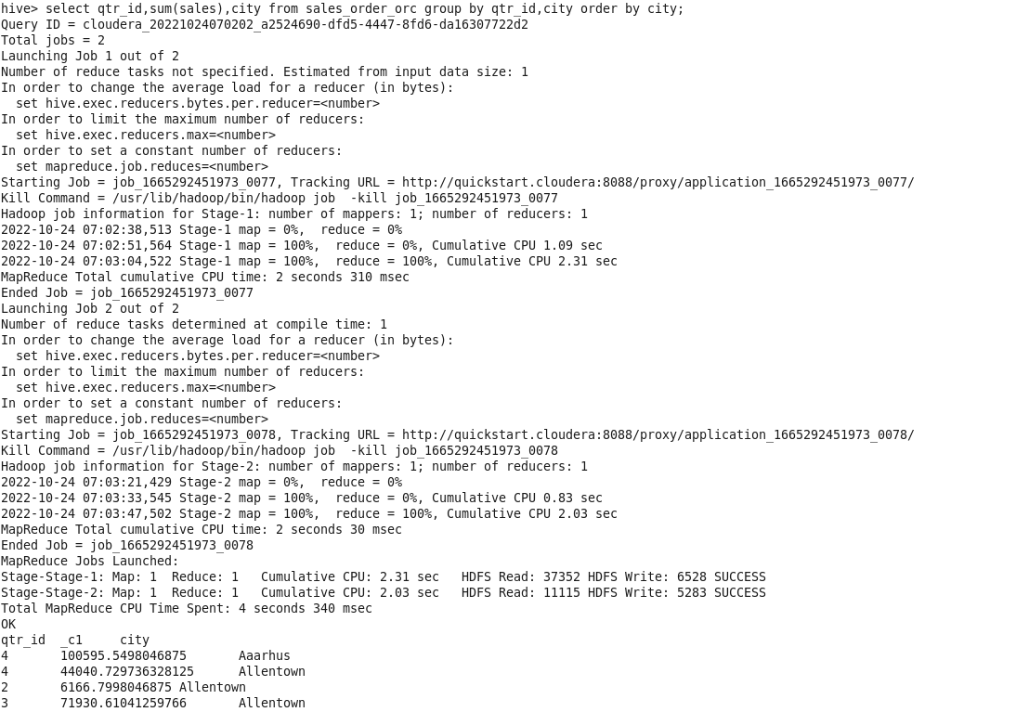

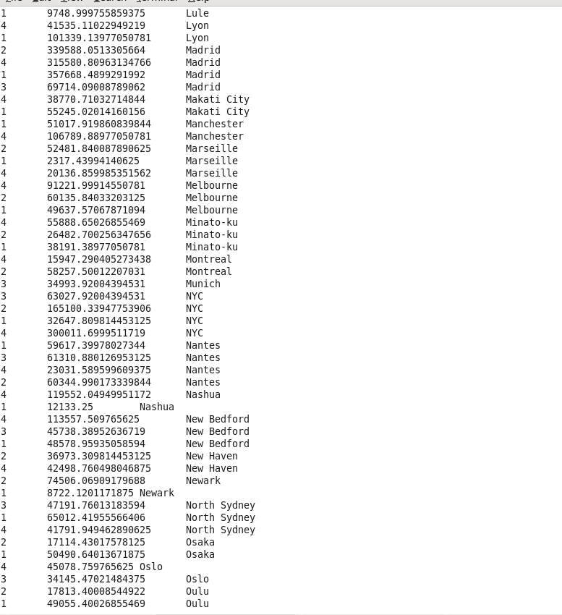

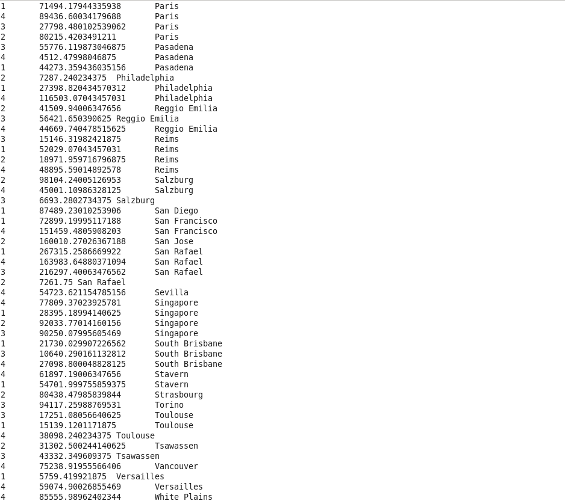

**g. Find a month for each year in which maximum number of quantities were sold**

