In this lab, implement the functionalities of shopping cart using AngularJS framework. (Keep in the mind that all labs belong to your project1, which is 15% of your grade!)

The shopping cart has three functions:

1. Add items to shopping cart
2. Remove an item from shopping cart
3. Show the total prices in the shopping cart.

Please submit your JS and two html (menuAng.html and cart.html) files ( 8 points) and the screen shot( 2 points to D2L.

You are also required to load all files to your github account, and share the link with me by adding it to your submission comment box on D2L.

Please download the project folder from my github account.( <https://github.com/Cathy81/cart-lab> ) It has all files where you can use as the starting points. Then you need to

* Modify menuAng.html so it can add items to cart.
* Create cart.html to show the items and total price. It also has “remove” button to delete items from the cart.
* Modify cart.js file which contains all data (ng model) and functions (ng Controller)for shopping cart

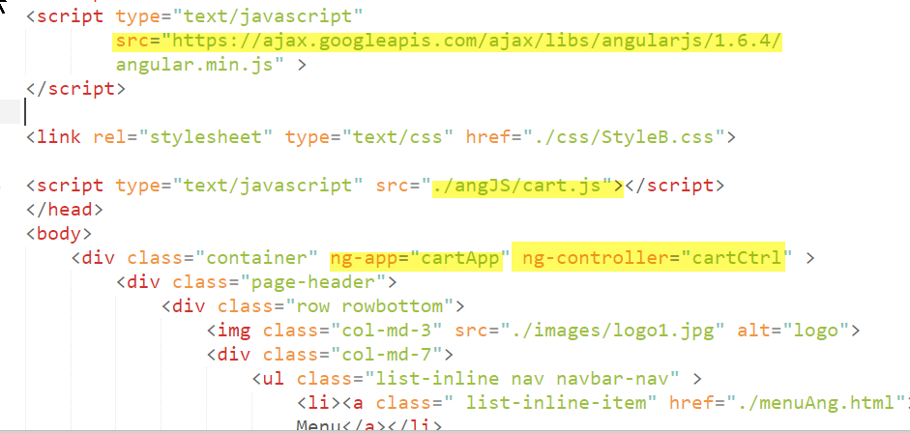

menuAng.html

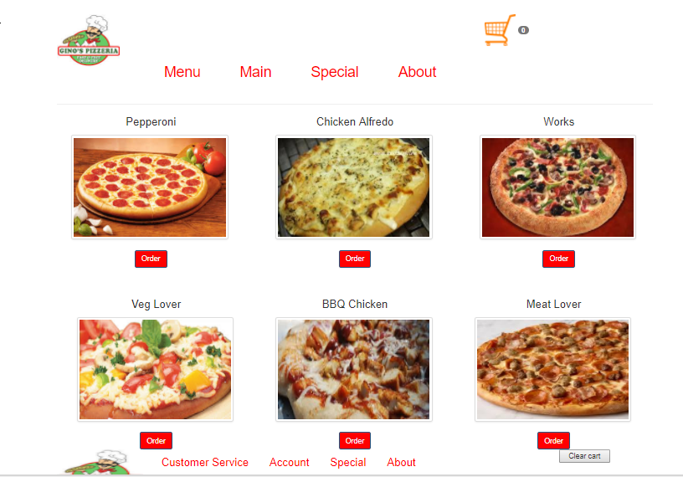

cart.html

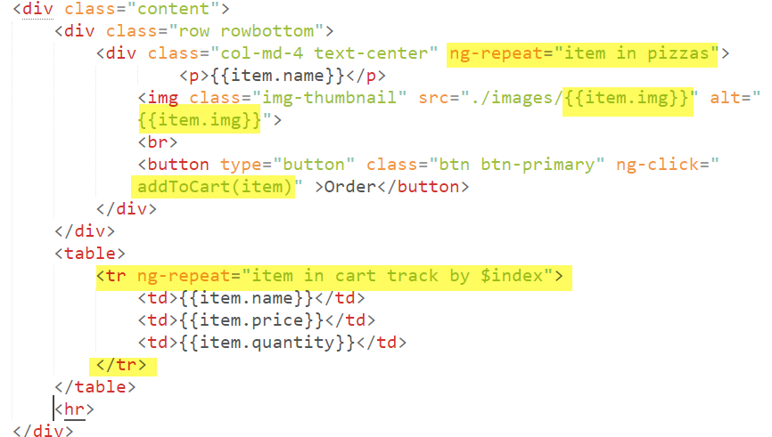

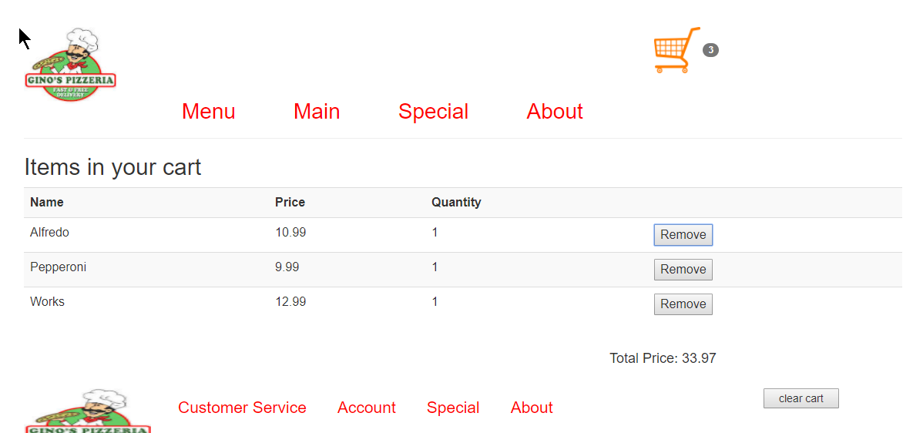

Requirements

|  |  |
| --- | --- |
| Question | Hints |
| Q1) Add two more pizza objs in cart.js. Then go back to menuAng.html to see how it affects the web page |  |
| Q2): Implement the function “addToCart() in cart.js.  Hint: we will use  localStorage.setItem("cart", JSON.stringify($scope.cart));  to exchange data among the web pages | You may need to reset cart in localStorage: |
| Q3) Implement the function  removeFromCart() in cart.js | Hint: update cart in localStorage and update the total price |
| Q4) Implement clearCart() which removes all info in the localStorage in cart.js | Clear local storage |
| Q5) implement the function calcTotalPrice() in cart.js |  |
| Q6) Create cart.html to use the functions, and call calcTotalPrice() using ng-init |  |

Copy your screen shot here: