Create a repo

Set Up Git

git config --global user.name "YOUR NAME"

git config --global user.email "YOUR EMAIL ADDRESS"

cd into the directory



Fork A Repo

https://help.github.com/articles/fork-a-repo/

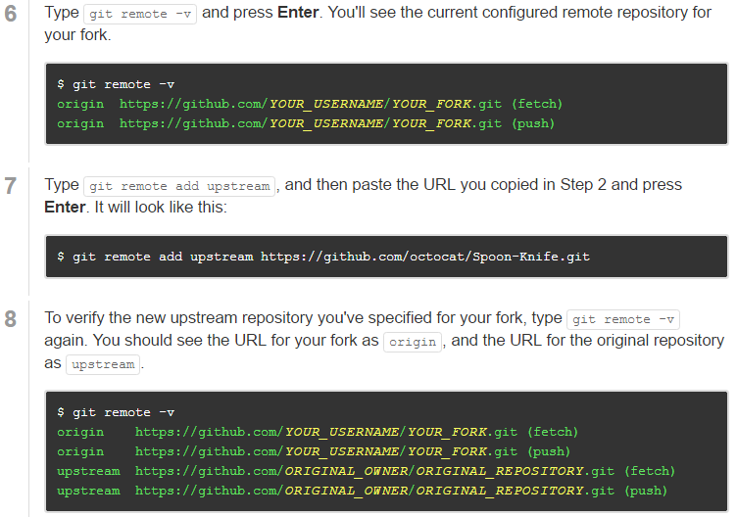

Syncing a fork

https://help.github.com/articles/syncing-a-fork/

Create a new branch

https://github.com/Kunena/Kunena-Forum/wiki/Create-a-new-branch-with-git-and-manage-branches

git checkout -b [name_of_your_new_branch]

git push origin [name_of_your_new_branch]

git branch (see all branches created)

git checkout <branch_name> (move between branches)

publish local change to origin(your copied repo under your account)

