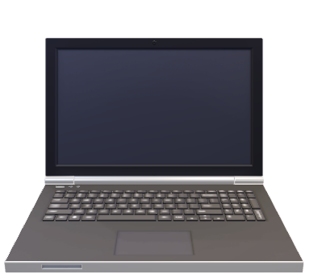This sleek and stylish notebook is designed for those who value both functionality and elegance. Whether you're jotting down ideas, sketching, or organizing your thoughts, this notebook provides the perfect space for creativity and productivity. The high-quality paper ensures smooth writing with minimal bleed-through, while the durable cover protects your notes, making it ideal for everyday use.

Available in a variety of sizes and colors, it’s compact enough to fit in your bag yet spacious enough to capture your most important thoughts. Whether you're at work, school, or on the go, this notebook will be your perfect companion. Elevate your writing experience with a notebook that combines practicality with a touch of sophistication.