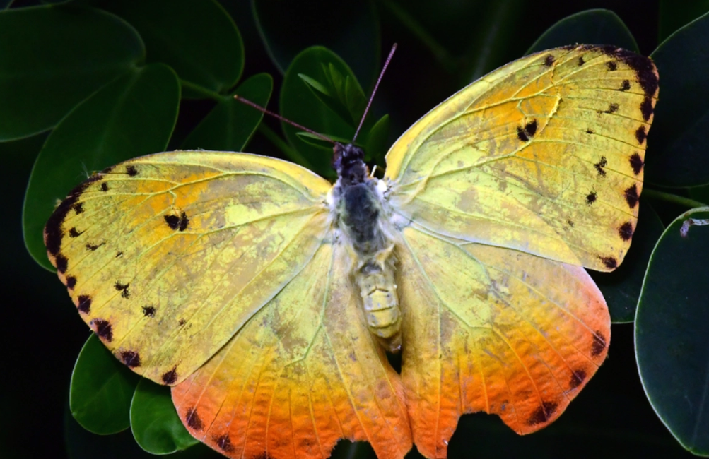

Butterflies are colorful, winged insects belonging to the order Lepidoptera. They undergo a complete metamorphosis, transitioning from egg to larva (caterpillar), then to pupa (chrysalis), and finally emerging as adults. Their wings are covered in tiny scales, creating vibrant patterns that serve for camouflage, warning, or mimicry. Found in diverse habitats, they play a crucial role as pollinators, contributing to plant reproduction and biodiversity.