



Welcome!

Hello Whip-Ma-Whop-Ma-Hoppers! It’s almost the weekend of our fantastic event, so here’s all the information you need to get you excited and raring to hop!

Meet the team

Here are the three key faces you need to know this weekend. Please give them a ring, or stop them as they pass by, if you have any questions, problems, or just want a dance!



Serious stuff

Here’s the serious but important bit about keeping safe during the weekend. It is expected that you behave in a safe and considerate manner which includes careful floorcraft but we understand that accidents can happen. Laura Cook and Sarah Weinberg are first aid trained so can deal with minor injuries. In case of an emergency, please call Campus Security on 01904 323333 as they will be the quickest to the scene and will contact emergency services if required.

We want to make sure everybody has the best weekend possible so if you are having any problems with another individual or feel that somebody is in any way violating the terms of the code of conduct then please speak to one of the above contacts and they will deal with the situation as necessary. Please do not give any unsolicited feedback in the workshops or on the social dancefloor. To see our full code of conduct, please see the event website.

Now that’s out of the way, here’s the fun bit...

Timetable

|  |  |
| --- | --- |
| **FRIDAY 12TH FEBRUARY** | |
| 19:30-00:00 | Welcome Dance & Registration |
| **SATURDAY 13TH FEBRUARY** | |
| 10:00-12:30 | Workshop 1 |
| 12:30-14:00 | Break |
| 14:00-16:30 | Workshop 2 |
| 16:30-17:00 | Break |
| 17:00-18:00 | Taster 1- Steals with Robyn & Scott |
| 18:00-20:00 | Break |
| 20:00-00:00 | Social Dance- Fairytale Ball Theme |
| 00:00-02:30 | After Party |
| **SUNDAY 14TH FEBRUARY** | |
| 11:00-13:30 | Workshop 3 |
| 13:30-14:45 | Break |
| 14:45-15:45 | Taster 2- Jazzing Up Your Strolls with Matt & Jenny |
| 15:45-16:00 | Break |
| 16:00-17:00 | Taster 3- Pre- Lindyhop Dances with Cat & Cam |
| 17:00-18:30 | Break |
| 18:30-22:30 | Social Dance- Spots or Stripes Theme |

Rooms for each stream of workshops will be on your individual timetable included in your welcome pack.

General information

Registration

Registration will take place at the first social on Friday night at the De Grey Rooms. You will be able to pick up your welcome pack which includes your timetable, wristband, and t-shirt (if you ordered one).  
If you are unable to make it to the first social for registration, please register in Vanbrugh Dining Hall, 9.30-10am on Saturday.

Workshops

Our three workshop locations are the Ron Cooke Hub (Hoppers/Improvers), Vanbrugh Dining Hall (Boppers/Intermediate), and Hendrix Hall/James Hall (Toppers/Advanced). All three locations are on the University Campus.

There will also be three taster classes for everyone during the weekend, which will all take place in Vanbrugh Dining Hall.

Please note that our campus is split into two parts; most of our workshops are based on the Heslington West campus, however the Ron Cooke Hub is on the Heslington East campus. Please take this into account when estimating travel times. There is a free bus service which runs between the campuses, and this takes 5 minutes.

Getting to campus by bus

There are buses from the train station to the campus running approximately every 7.5 minutes. It takes roughly 20 minutes to reach the university, and the buses also stop in the city centre. Catch either the 66 FirstYork or the 44 Unibus.

Taxis

A taxi from the train station to the University costs approximately £7 to £8.   
Below are some taxi numbers which may be of use this weekend:

* Getaway Cars – 01904 707070
* Streamline – 01904656565
* 659 Taxis – 01904 659659

Driving to socials

For detailed driving instructions, see the other attached pdf.

Campus Map (Heslington West):

Follow this link to find an interactive google map that shows you workshop locations, event locations, and where to get food:

<https://www.google.com/maps/d/edit?mid=zUR65rJ3bw3E.kcG4OrKVH0dw&usp=sharing> 

Workshop Locations Key:

Vanbrugh Dining Hall

Hendrix Hall

James Hall

Workshop directions: Vanbrugh Dining Hall (Heslington West)

Arriving by bus

To get to Vanbrugh Dining Hall, catch either the 66 FirstYork or the 44 Unibus and get off at the Library bus stop.

From the library bus stop, you must cross the road and continue in that direction. There is a sheltered walkway that will take you to the entrance of Vanbrugh (on your right). Entering Vanbrugh, follow the corridor until you see Vanbrugh Reception on your right. The Vanbrugh Dining Hall is on your left, through the double doors and straight ahead.

Arriving by car

The University of York website recommends you ‘approach the University from the junction of the A64 and A1079 on the east of the city, from where the University is signposted’.

The University postcode is YO10 5DD.

Parking

Parking is limited, but free at weekends. There are various car parks located near Vanbrugh Dining Hall:



Workshop directions: Hendrix Hall (Heslington West)

Arriving by bus

To get to Hendrix Hall, catch either the 66 FirstYork or the 44 Unibus and get off at the Heslington Hall bus stop.

Cross the road and then turn right as you step off the bus, and follow the path until you reach a small turning (leading to a little delivery area). Turn left, and walk towards the covered walkway, entering a long carpet area. Follow the long carpet until you are nearly outside, then stop. Turn to your right, and you will see the entrance to Hendrix Hall!

Arriving by car

The University of York website recommends you ‘approach the University from the junction of the A64 and A1079 on the east of the city, from where the University is signposted’.

The University postcode is YO10 5DD.

Parking is limited, but free at weekends. The nearest car park is Campus Central Car Park: 

Workshop directions: James Hall (Heslington West)

Arriving by bus

To get to James Hall, catch either the 66 FirstYork or the 44 Unibus and get off at the Library bus stop.

From the library bus stop, you must cross the road and continue in that direction. There is a sheltered walkway that will take you to the entrance of Vanbrugh (on your right). Entering Vanbrugh, follow the corridor until you see Vanbrugh Reception on your right. Walk past Vanbrugh Reception and out of the automatic doors, through a small parking/delivery area. On your left is a bridge across the lovely lake. Intrepidly, cross the dangerous waters (beware piranhas and geese). Once safely across, follow the covered walkway until you are inside a building. You have successfully reached James Hall.

Arriving by car

The University of York website recommends you ‘approach the University from the junction of the A64 and A1079 on the east of the city, from where the University is signposted’.

The University postcode is YO10 5DD.

Parking is limited, but free at weekends. There are various car parks located near Vanbrugh Dining Hall. Once parked, follow the ‘bus directions’ to reach James Hall.



Workshop directions: The Ron Cooke Hub (Heslington East)

Arriving by bus

To get to the Ron Cooke Hub, catch the 66 FirstYork and get off at the Ron Cooke Hub bus stop.

From the Ron Cooke Hub bus stop, simply enter the large building with lots of windows that will be straight ahead of you as you get off the bus. It even has the words ‘Ron Cooke Hub’ on it in large letters – you can’t miss it!

Arriving by car

The University of York website recommends you ‘approach the University from the junction of the A64 and A1079 on the east of the city, from where the University is signposted’.

The University postcode is YO10 5DD.

Parking is limited, but free at weekends. There are two car parks near the Ron Cooke Hub. These are Field Lane car park, and Kimberlow car park.



Friday Social: Represent Your Scene

We’ll be starting off the weekend with a social at the beautiful De Grey Rooms. The theme is ‘Represent Your Scene’. Wear your swing society colours, something that represents where you’re travelling from or some society merchandise- I know nothing can beat our wonderful UoY safety pants, but we’re expecting some original ideas!   
Address:  
 De Grey Rooms  
 St. Leonards Place  
 York  
 YO1 7HB  
  
Parking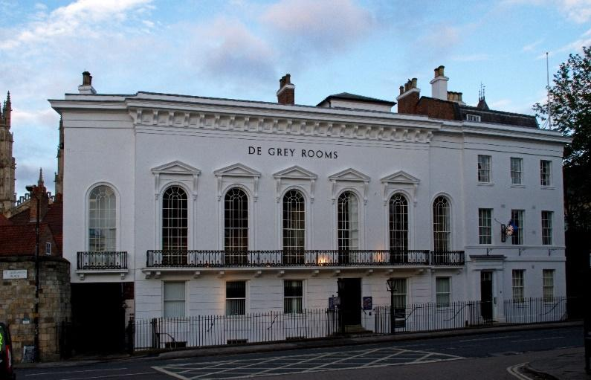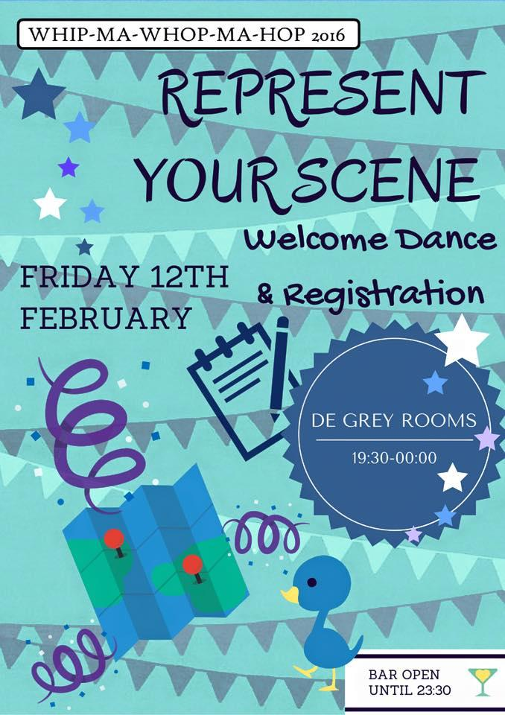

The nearest car park is Bootham Row car park. From The De Grey Rooms, take a slight left onto Bootham, A19. Take the first right onto Bootham Row, and take the first right again onto Percy Street. The car park is on this street.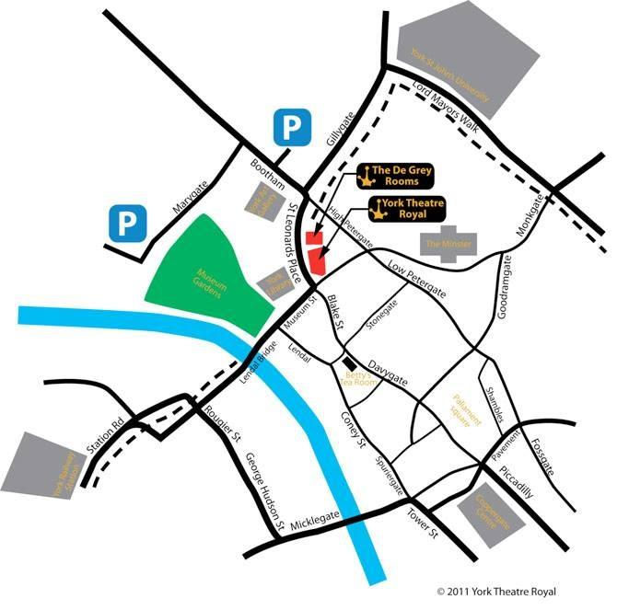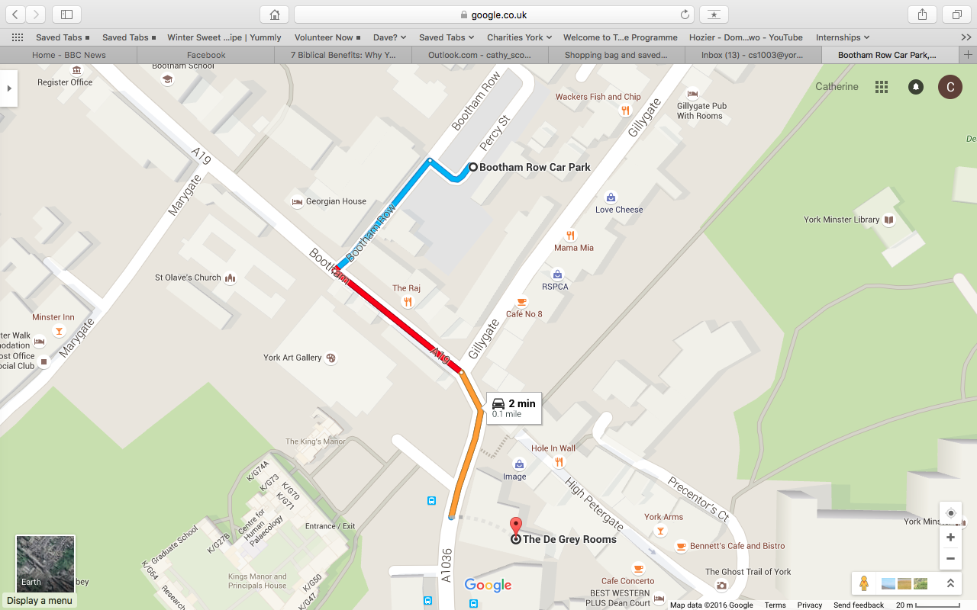

Saturday Social: Fairytale Ball

Are you ready for our big Saturday night social? Whip-Ma-Whop-Ma-Hop 2016 is proud to present the Fairytale Ball at the magical Guildhall! Whether you’re dressed as a prince or a princess, a frog or a toad, a witch or just plain evil, be prepared for a magical evening of spell-binding swing-outs and tantalising tuck-turns…

This social venue is licensed so you can bring your own alcohol.

Address:  
 York Guildhall  
 St. Helen’s Square  
 York   
 YO1 9QN  
  
Carriages are at midnight – but wait! The night isn't over yet…

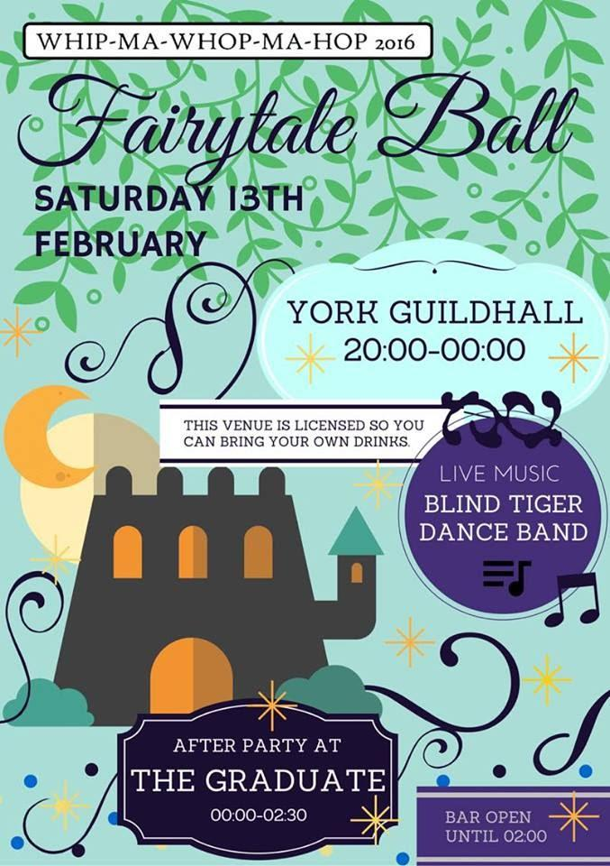

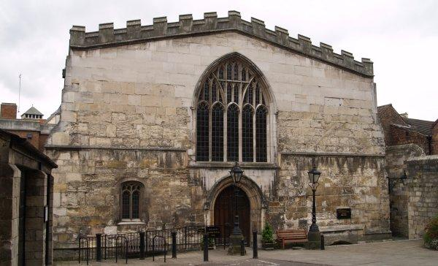

After Party- Three is the Magic Number

Just when you thought the night couldn't get any better- you are cordially invited to join us for an after party at The Graduate. Conveniently, The Graduate is less than a two minute walk from Guildhall.   
  
The DJs will play three blues songs, three lindy songs, and three songs of their own choice. After all, three is the magic number!

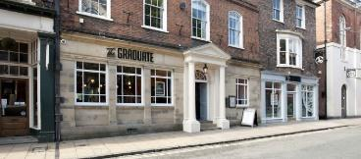

Address:  
 The Graduate  
 6-12 Lendal  
 York  
 YO1 8AA

Parking

Nearby car parks are NCP Queen Street (YO24 1AD), Esplanade Car Park (YO1 6FZ), NCP Tanner Row (YO1 6JL), NCP Piccadilly (YO1 9NX), Q-Park Shambles (YO1 7NT). Further parking is marked on the map: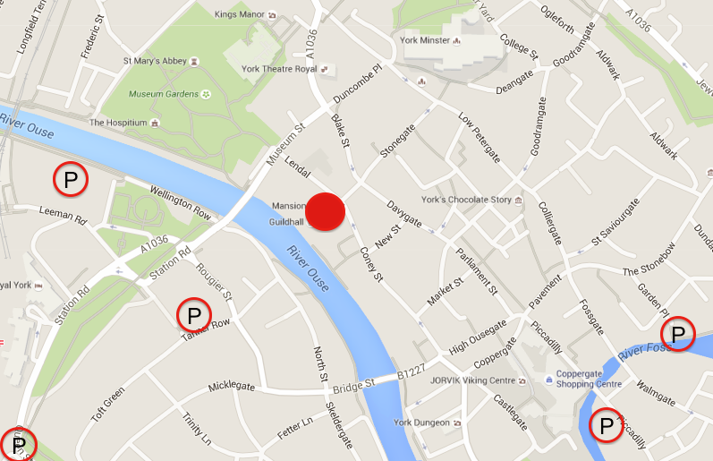

Sunday Social: Spots or Stripes

Think you're exhausted after two days of dancing? Think again! Dress in your finest spotty or stripy attire (whether it be a whole outfit or just a bowtie or headscarf), put your dancing shoes back on and get up on your feet for one last social dance.  
Thanks to an entire weekend of workshops you'll have lots of new moves to show off…

Address:  
 Clements Hall  
 Nunthorpe Road  
 York  
 YO23 1BW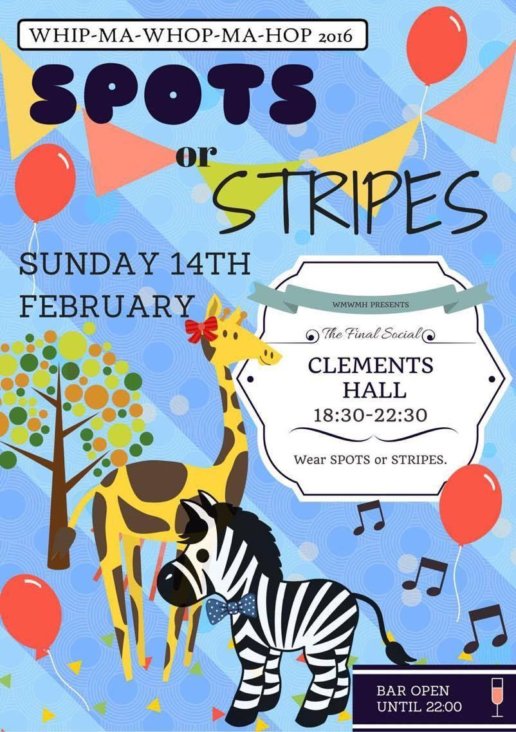

(SatNav: use YO23 1BP or YO23 1BS to navigate to the front of the building on Nunthorpe Road)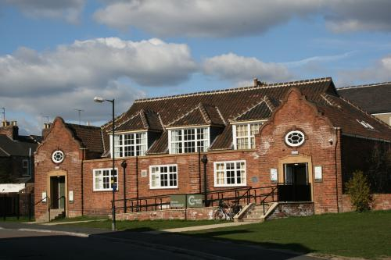

Parking

The nearest car parks are at Nunnery Lane or Bishopthorpe Road.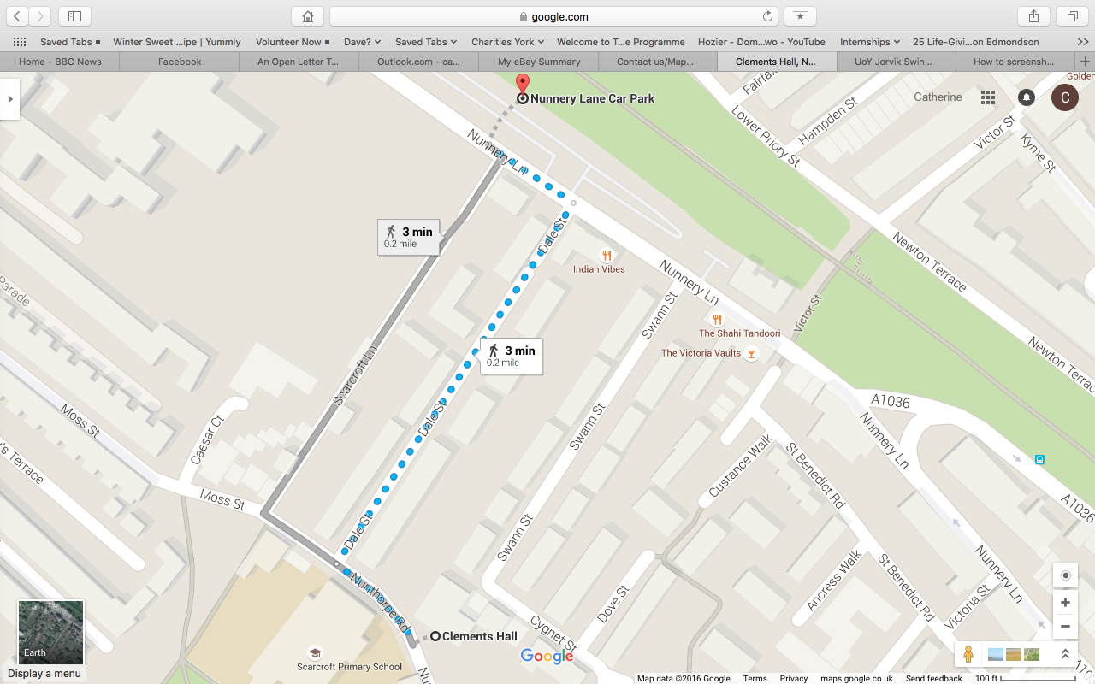

Nunnery Lane car park:

To get from Nunnery Lane Car Park to Clements Hall, simply turn tight out of the car park onto nunnery lane, and either take the Scarcroft Lane, (which is almost directly opposite the car park), or Dale Street (the street parallel to Scarcroft Lane) following it until you reach Nunthorpe Road. Turn Left, and Clements Hall is on your right, opposite Scarcroft Primary School.

Bishopthorpe Road car park:

To get from the car park to Clements Hall, turn out of the car park onto Scarcroft Road, and take the first right onto Nunthorpe Road. Keep going straight until you read Scarcroft Primary School, and Clements Hall will be on your right. 

Direction from Clements Hall to the Railway Station  
To get to the railway station from Clements Hall, with Clements Hall behind you, turn right onto Nunthorpe Road, and take the first right onto Dale Street. At the end of the road, turn left onto Nunnery Lane, and go straight, crossing Blossom Street onto Queen Street. Continue walking for about 300 metres, and the station will be on your left. 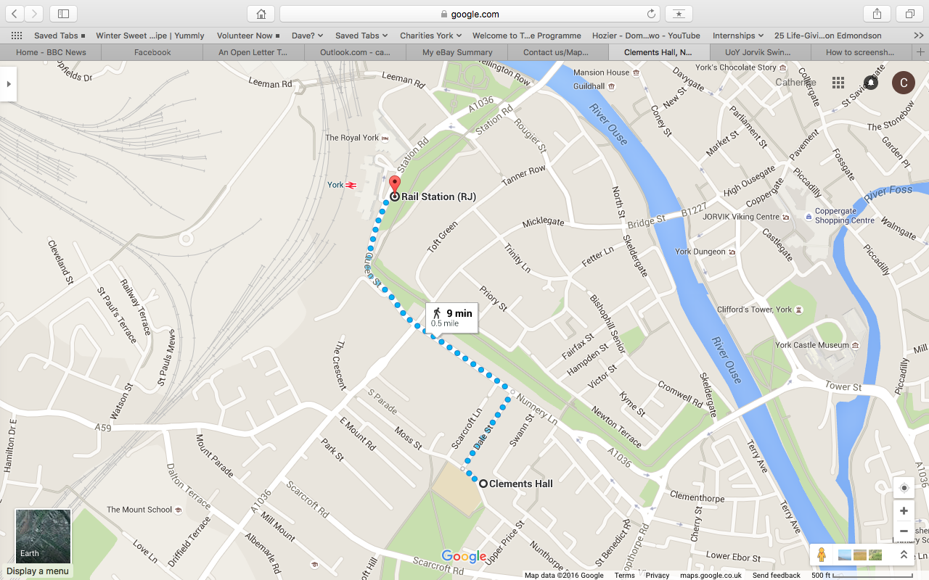

Finally…

We hope you really enjoy Whip-Ma-Whop-Ma-Hop 2016! Go all out, dance with lots of people and most of all, have fun!  
  
Thanks…  
We’d like to thank Scott Cupit, Robyn Larsen, Cat Foley, Cam Mitchell, Matt Lane and Jenny Clapp for coming to teach for us this weekend.  
  
Big thanks also to Alex Parker, Matt Lane, George Jackson, Laura Cook, Chris Gammie, Ella Corbin and Matilda Marshall for offering to DJ at the social dances.

And last but not least, thanks to the committee who have worked really hard to organise this weekend:

Sarah Weinberg, *President*

Laura Cook,   
*Events Coordinator*

Vikki Gale,   
*Performance Coordinator*

Cathy Scott,   
*Newbie Rep*

Bethan Thomas, *Treasurer*

Grace Sansom,   
*Teaching Coordinator*

Tabitha Spear, *Merchandise Rep*

Nick Chan,   
*Newbie Rep*

Tilly Baker Hine,   
*Secretary*

Imogen Harris,   
*Press & Publicity Officer*

Emily Walker,   
*Social Secretary*

