Paddy Stand lone Pairing program

User Manual

Author: Cathy Wu | FedUni

Reviewer: Andrew Jones | FedUni

Date: 2020/12/21

1. Navigate to your Documents:

For example, my is C:\Users\weili\ Documents, your will be in a format of “C:\Users\myusername\Documents\”.

1. Paste the Paddy Folder into the Documents folder

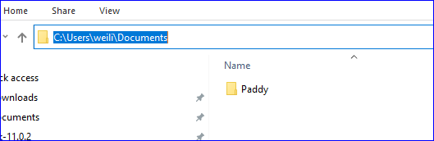

1. Open the Paddy folder you can see four files as shown in the screenshot below:

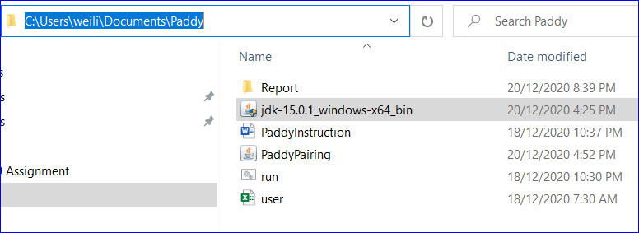

1. Download JDK-15 for your operation system: <https://www.oracle.com/java/technologies/javase-jdk15-downloads.html>

For example, “Windows” system should download “jdk-15.0.1_windows-x64_bin.exe”



1. Install JDK

* Run the downloaded installer
* By default, JDK is installed in directory "C:\Program Files\Java\jdk-15.0.1", Accept the defaults and follow the screen instructions to install JDK.

1. To set the PATH variable permanently, add the full path of the jdk-15\bin directory to the PATH variable.
   1. Navigate to Control Panel\System and Security\System
   2. Click "Advanced system settings" on the left pane.

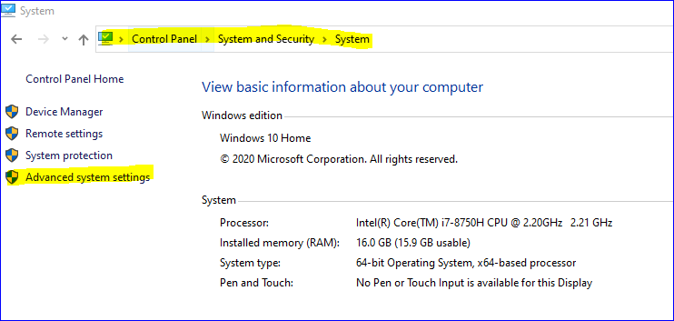

* 1. Switch to "Advanced" tab ⇒ Click "Environment Variables" button.

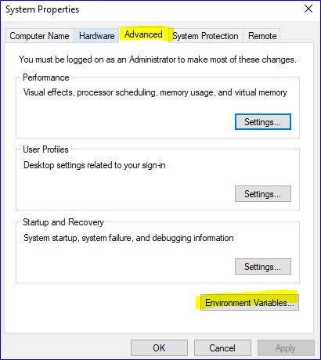

* 1. Under "System Variables" (the bottom pane), scroll down to select variable "Path" ⇒ Click "Edit...".

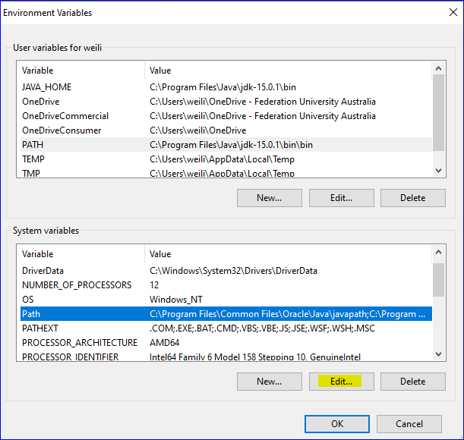

* 1. Click "New" ⇒ Click "Browse" and paste your JDK's "bin" directory: "c:\Program Files\Java\jdk-15.1.\bin.

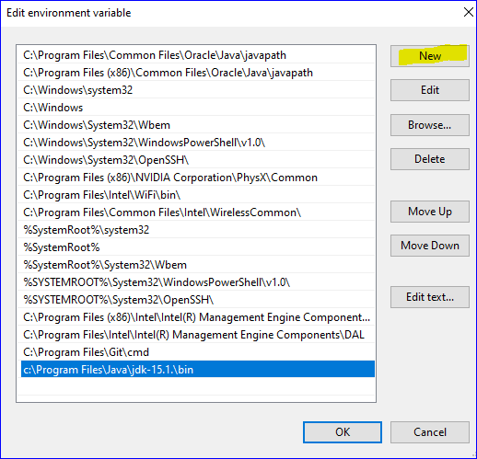

1. Open the spreadsheet, enter/update the users details and then save.

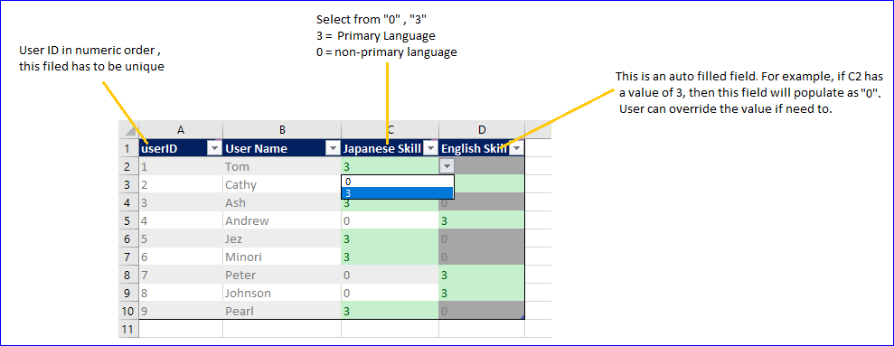

1. Double click the Run.bat to run the program

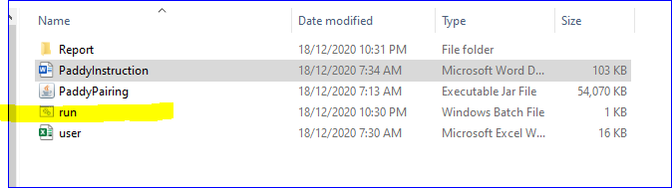

1. Double click report folder, you will find the report is now sitting in the folder

