* Run the Code
* The following options will display

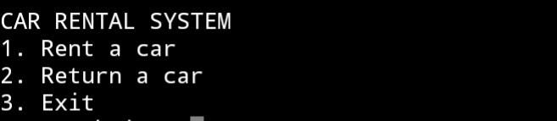

* Select if you are 1[RENT A CAR] , 2[RETURN A CAR] or 3[EXIT] If you don't want to proceed.
* When you select [RENT A CAR] this will show.



* Enter available cars [ 2020 TOYOTA CAMRY, 2019 HONDA CIVIC, 2018 FORD MUSTANG] to proceed.
* ​After that, the following options will display [ RENTAL PERIOD DAYS and RENTAL CONFIRMED]

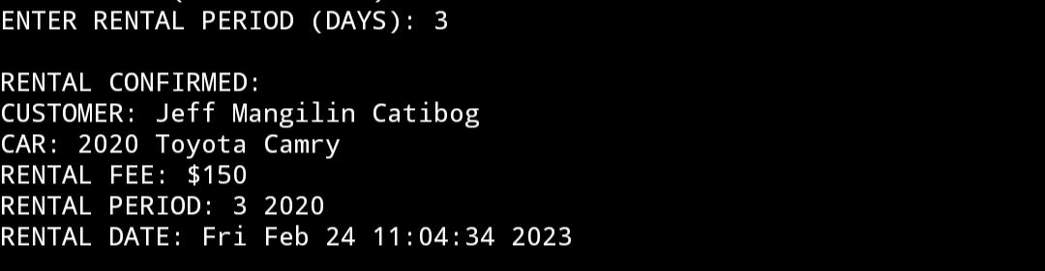

* 1[CUSTOMER] Your Customer.
* ​2[CAR] Vehicle selected by your client.
* ​3[RENTAL FEE] Paid for the rental vehicle.
* ​4[RENTAL PERIOD] The time between rent due dates.