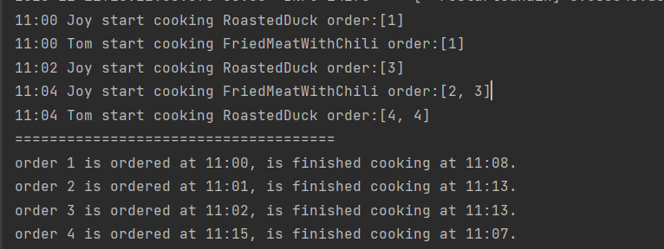

Fix order finished time is not correct:

Fix: [4,4] Roasted Duck is only ordered one in order4

The same dish object is added into the array twice.

===========================================================