SDA’s homeworks

**Academics’ Attitudes towards Integrating Social Networking into Education.**

Link PREZI - https://prezi.com/view/gARMgQNK1oWlHjunTNN3/

Student: Ologu Catinca-Ioana

Grupa : 314AC

Table of content

1. Introduction: The Usage of Social Networking in Higher Education (HE)

2. Educational Practices: Opportunities and Challenges

2.1. Opportunities of Employing Social Networking in Education

2.2. Accessibility

Accessibility of Knowledge

Accessibility of People

2.3. Flexibility

2.4. Involvement in Collaboration and Team Working

2.5. Challenges of Employing Social Networking in Education

Student Productivity and Time Management Skills

Lack of Training

Time-consuming and Overabundance of Information Shared

Lecturer–Student Online and Offline Relationships

Faculty Members’ Online Identity

3. Using Social Networking with Students

3.1. Reasons Why Students Are Already on Social Networking Sites

Accessibility and Availability on Smartphones

Flexibility in Learning and Communication

Interactive and Attractive Applications

3.2. Integration of Social Networking Platforms in Teaching

In-class vs online/Social Networking Teaching: Interactivity with other students and Interactivity with teachers

Extra Materials or Discussion Spaces to Supplement In-class Teaching. Collaborative learning

Distance-Learning Students. / Active enrollment

Practical Ways of Using Social Networking for Teaching Purposes. Learning performance

3.3. Strengths and Limitations of Using Social Networking in Teaching

Motivations for Academics to Use Social Networking in Teaching

Generating and Improving Content by Students

Developing More Critical and Reflective Thinking

Enhancing Students’ Communication Skills

Limitations of Employing Social Networking in Teaching

4. Integrating Social Networking into Education: a Student’s Perspective to enhance the Acquisition of Skills

4.1. Description and Justification

4.2. Study’s Objectives

3.3. Study Design and Method

4.4. Discussion and Results

5. Conclusions

6. References

1. Introduction: The Usage of Social Networking in Higher Education (HE)

The usage of social networking is a good opportunity to facilitate the interaction between students and teachers in the academic environment.This phenomen of using social networking in HE comes from the need of students of being in contact with all the informations and all the social media all the time,and from from the need of teachers to make the subject much closer to the tastes of the current student, the modern student, born and raised in the century of speed.

The Social Networking was very easily accepted by the young people because they always use the networking not only for fun,they use the networking to sharing each others informations,documents and also for information distribution and communication to support teaching activity. This method helps the universities to keep up with technologie and change the traditional style of teaching and learning, so the university will attract only the elite students.

The main objectives of this method are to discover the motives for the use of social networks by higher education students , to recognize the impact of social networking tools in learning and education generally, to analyse the problems that students might face when using social networks, and to determine whether the traditional learning methods need to be changed in the era of Web?

2. Educational Practices: Opportunities and Challenges

2.1. Opportunities of Employing Social Networking in Education

There is a lot of opportunities of employing social networking in education, for exemple, in this time difficult for everyone the social networking is the strongest key to keep the connection student-university and student-teacher,being the only accepted way to succed.

I wanna speak of one of those platforms of social networking that a lot of people use it, including my university, I talk about „Microsoft Teams”, a social networking that helps us a lot to do the classes and so we don't have to waste time with the recoveries when we’re all back to the work „in class”.

2.2. Accessibility

These platformes,”Teams”, ”Zoom”, „WhatsApp Web”, „Discord”, are so

accessible both from the point of view of the accessibility of the students / teachers and of the accessibility of the knowledge. It tested it during of this period of home schooling that this implementation of social networking in education is so convenient. For example, my college schedule coincides with the one in the online environment,so we are in time with abolished all the matter thus managing not to miss the university year. For teachers it is also a comfortable and safe environment to take their courses there because is a friendly environement.

2.3. Flexibility

Learning on an online social platform it is very advantageous in terms of the program because the program is so flexible, we are not obliged to stay 3 hours in a course and in a lab, we can make with out time whatever we want, in our terms and in our condition, we can not go to the course because the courses are registered and we can see the recordings and this way all the students are in advantage, and the lecteurs either, they are explaneing a thing only once, not for hundred of time for each student.

2.4. Involvement in Collaboration and Team Working

After a lot of researches, many people emphasized that social comportament of learning is as important as the cognitive comportamnet.

Team work is the fundament motivation of the students for working, beacause being able to advise and help, work becomes easier and easier. It’s so good to know that it’s exit a support for each of student, it’s formed a community of young students for help with homework quizzes, just about anything.

Figure 1 represents the statistics of student-teacher and student-student communication.

2.5. Challenges of Employing Social Networking in Education

Employing Social Networking in Education become more and more relevant in higher education. This phenomenon is being observed in many higher learning institutions around the word.

There are visible changes and also challenges in this adventure which must improve the educational system in higher education. The new generation loves a lot the employs social networking in education because is so easy to use in this age of tehnology.

The time consumed during the teaching process is very broad which is very tiring for everyone, both teachers and students make an extra effort in the different activities they have to perform, which is quite harmful for humans to spend around 8-10 hours in front of the laptop / computer / phone, all those radiation are not exactly friendly to the human body.

In Figure 1 in figure one you can see the time interval dependence, student-teacher on the interval of hours. It can be seen that students are the ones who use the internet the most.

Also in the table above you can see the activities and procedures of students and pupils in the online environment.

The relationship beetwen student and teachers is more weaker in online’s platformes than in the courses face to face, human interaction „in class” has a much greater influence on the student and the teacher can see the reactions of his students during the teaching, so the concerns can be discussed much more quickly and safely. In real courses the technical problems are so small, compared to online platforms when if the microphone goes wrong all the meeating is ruined. Also, the students can crack the courses, they can be logged on the platform with the individual account and after they they should do any other activity that does not belong to the study area.

3. Using Social Networking with Students

3.1. Reasons Why Students Are Already on Social Networking Sites

Students are already on Social Networking Sites because they are always up to date with technology, they were practically born with technology in their arms.

The majority of users the Social Networking System are youngster in higher education. They often use Social Networking System to stay in touch with their offline friends or bolster existing connections rather than developing new affairs.

Students also report that they are using chatting, text messaging, blogging, and online communities, such as „Facebook” and „WhatsApp”, for educational activities, including collaboration on school projects. „Facebook”, „Twitter”, and „YouTube” are the tools most used by the students because users, and especially students, interact and exchange knowledge in very easily accessible ways.The students loves to be in contact with others all the time,because the young people always need the confirmation of the others,I don’t no why.... ,but all the times a confirmation is sought.

Students loves the Social Networking Sites because they already have all thesee sites on their

Smartphone, with a simple gesture on the screen they have all the information a few centimeters away.

Within the last decade, online social networks and their applications have penetrated our daily life. They have managed to transform young people’s way of living while becoming one of the most important means of communication and entertainment, everyone having their favorite apps on the phone, especially the young generation, that is, we could say, on the threshold of media dependence.

3.2. Integration of Social Networking Platforms in Teaching

At the moment we all know the crisis we are facing, the virus that froze the planet,

so we are immobilized at home and the only way to go at school is to go at online school.

The activity „in class” it can no longer be realized,so we have to we must adapt to the new conditions and move our activity to the online environment. Of course, the online activity does not compare with that „in class”,at the university the students can talk freely with their lecteurs, the conection between them beeing much more strong and the and the teaching process is much easier to do on both sides than we do on online platforms. Student-teacher interaction is achieved but slower and synchronization is not the best, but all of us is doing his best.

Extra Materials are so important in the Social Networking Platforms cause the lack of face-to-face communication leads to a much greater need for information , so the extra material is welcome all the time, this can be accompanied by an extra session of discussions from the teachers.

„Several studies, claim that OSN create new perspectives in the process of acquiring knowledge. Mainly, social networking sites allow students to participate in formal (e.g., study of course material) and informal (e.g., look for useful information everywhere) learning conditions. Studentscanmatchwithpeoplewithasimilarwayofthinkingandexchangeknowledgein an informal way (e.g., exchange of their educational experiences) for educational purposes [. For instance, ﬁrst-year students can get all the necessary information they need about their faculty by just discussing with older ones, which will help them to get used to their new academic life.”

3.3. Strengths and Limitations of Using Social Networking in Teaching

Strengths in using Social Networking in Teaching

are that students are enrolled in the online environment all the time and they can be connected to information and they and they also manage to solidify their own knowledge which prepares them for the future and for their engeenering career. All this „Using Social Networking in Teaching” it shoudn’t replace al all the courses „in class”,people have to improve their communication skills and talking online with a camera and a microphone is not the optimal option to improve those skills. There must be limitations of Employing Social Networking in Teaching

to prevent the roboticization of the higher education system, student development is not just about the technical side, the emotion side is a crucial element in its development in the engineering field.

4. Integrating Social Networking into Education: a Student’s Perspective to enhance the Acquisition of Skills

4.1. Description and Justification

I think that Integratig Social Networking into Education is is a method of being synchronized with technology ,my and all my mates of the university use „Moodle”,that is an interactive platform where we have all the courses and the necessary documentation. The teachers put us on this platform, every week, the courses and also they can give us online tests, they put on the platform training test witch help us to learn better for the final exams.

4.2. Study’s Objectives

The study’s objectives are to help by any possible means the student to evolve, to manage to reach a level of self-knowledge and self-control so that he can manage all the information he finds on his own to succeed. The main purpose of the study is for the student to take the information useful for him, not to mechanically learn for exams, beaucause the mechanically learned information is lost in a second because the brain has not understood it in its depth.

4.3. Study Design and Method

From my point of view each other has its own method of study, because we each perceive things in different ways. For me, the best thing is to learn at home alone by writing on paper all the things that I do not understand and shearching on internet or on youtube’s tutorials for more informations of i can’t handle with my actually stuf. For me repetition is the mother of learning. For what I know, many people are influnced by this quote.

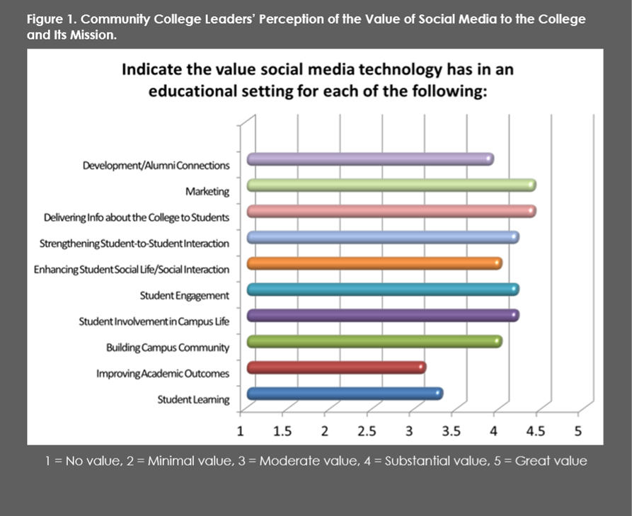

The chart above shows a review, a ranking of the most popular online activities.

4.4. Discussion and Results

From which I have tested and seen lately, social networking into education is one of the modern solution fot the traditional school. These social and learning sites bring students the assurance that they have the needs for final tests and not only. We live in the age of technology and this is what we are always busy with, we must change the traditional methods with the modern ones and we must constantly find faster and more efficient methods to implement them. In my university the things that involve the social media and networking in educations are at the highest point of the country.

In all this complicated and unexpected period that represents a challenge for humanity, social networking is the is the only way to be safe and keep up to date without losing the essentials.

Interpretation of results:

The graph above shows the student-student interactivity.

The graph above shows the student-teachers interactivity.

The graph above shows the colaborative learning of students.

The graph above shows the student’s active enrollement.

The graph above shows the student’s learning performances.

5. Conclusions

All this being presented, the usage of social networking in higher education is the new form of higher education, a method that would be well implemented in lower education because these children either has the right of a new perspective, but it’s important not to forget our origins, studying on the school / faculty benches is a unique experience in the life of any human being. I am a fan of the faculty in reality. Now, teachers and students teachers and students are forced to stay in the online environment throughout the hours, so students will always be encouraged and helped in all course subjects. Also the student-teacher discussions will take place in a private system, so the students have all the support of their university.

A very important thing would be to say, that in this period where social learning platforms are the power, the number of homeworks is double compared to the times when we were doing school "in class", we would have to have a constant balance in what we do not fall into any extreme.

6. References

* „The 3rd International Conference on e-Learning ICEL 2011, 23-24 November 2011, Bandung, Indonesia

Study of Social Networking Usage in Higher Education Environment”

* „Social Media Use in Higher Education: A Review

Georgios Zachos *, Efrosyni-Alkisti Paraskevopoulou-Kollia and Ioannis Anagnostopoulos”

* „Computers in Human Behavior -journal homepage: [www.elsevier.com/locate/comphumbeh](http://www.elsevier.com/locate/comphumbeh)”
* „Social Networking & Its Impact on Education-System in Contemporary Era”
* „Factors which motivate the use of social networks by students”
* „Social software: teaching tool or not?

Marija Matešić, Kristina Vučković, Zdravko Dovedan”

* „SOCIAL MEDIA

a literature review and research directions IN HIGHER EDUCATION”

* „SOCIAL MEDIA IN HIGHER EDUCATION FROM STUDENTS’ PERSPECTIVE”