# Introduction to Git and GitHub

Natasha Watkins

January 23, 2018

git and GitHub are tools used for **version control**

Version control:

� tracks changes made to your work

� prevents you from losing work (for example, accidentally deleting a file)

� allows you to go back to an old version of you work (undo changes)

**Git** is a widely used, open source **version control system**

� Does not require an internet connection to use

� Usually used with the **command prompt** - there are also desktop applications (such as GitHub Desktop)

**GitHub** is a (mostly) free hosting service for your Git repositories

� Makes it simple to collaborate and share code/documents on the internet

� Acts as an online backup of your project

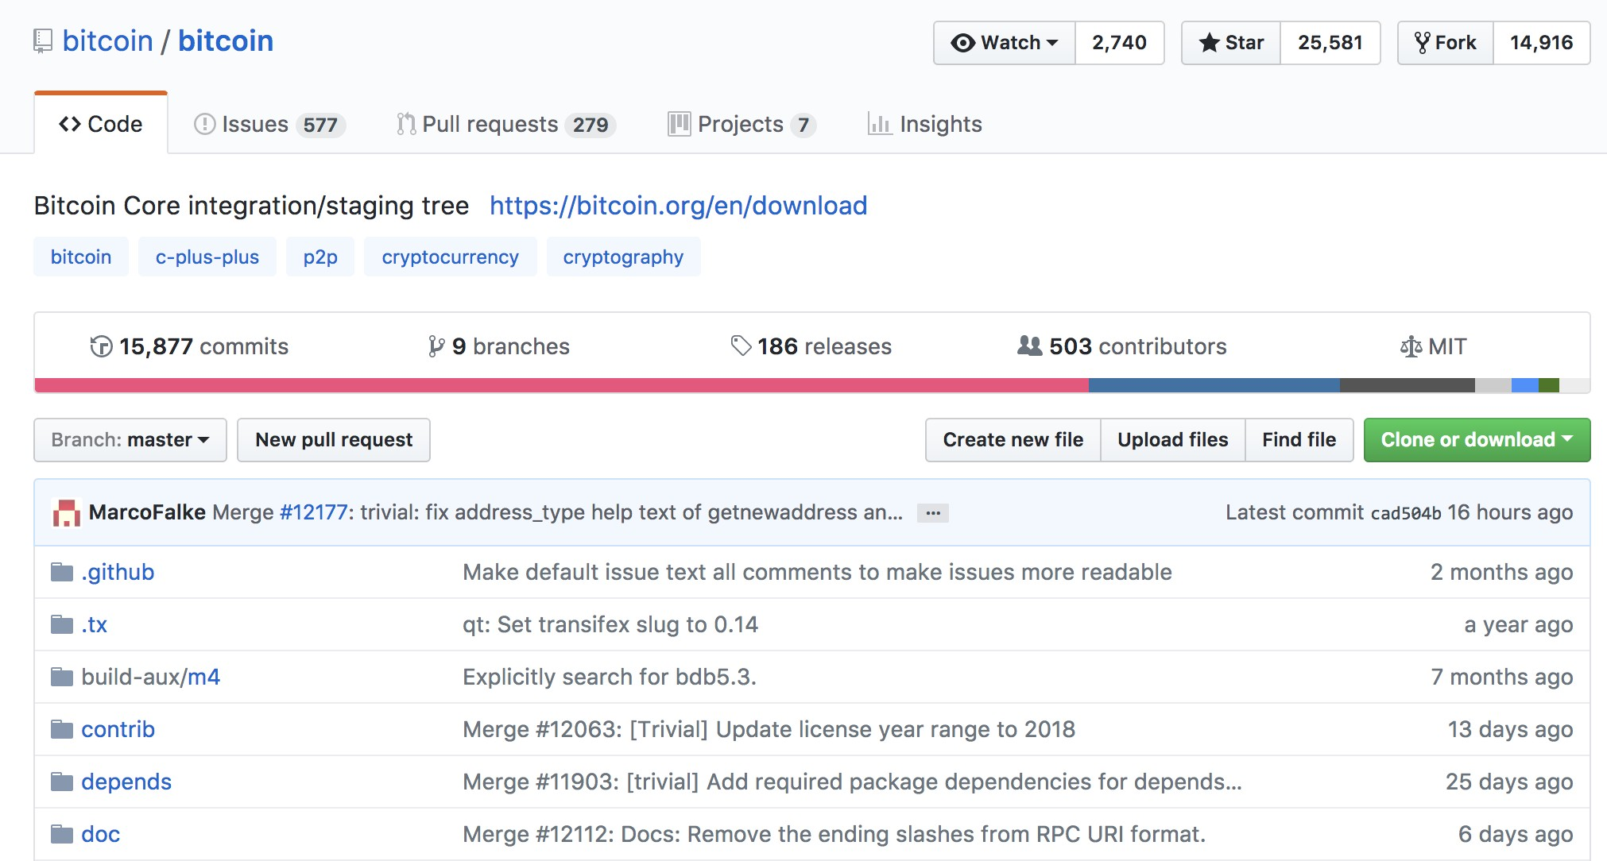<https://github.com/bitcoin/bitcoin>

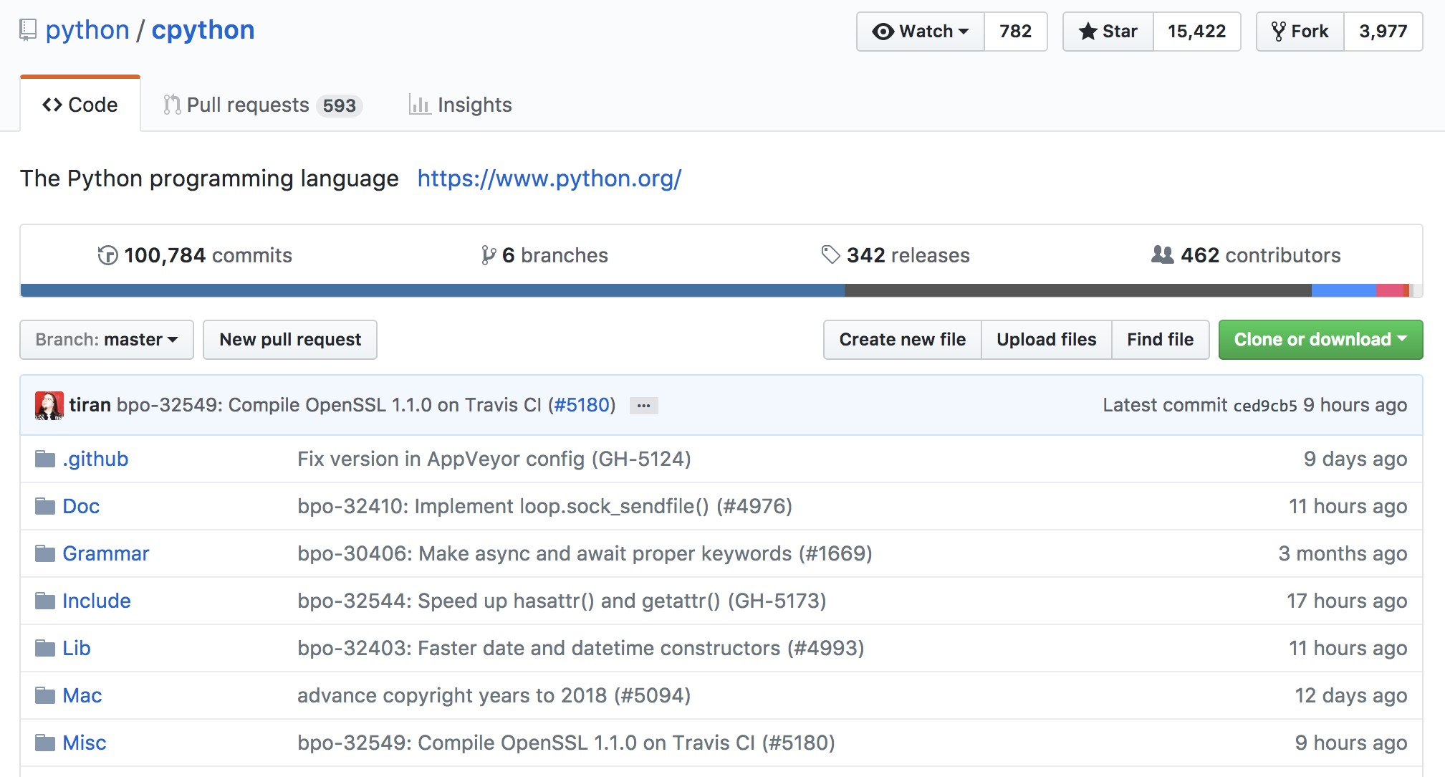<https://github.com/python/cpython>

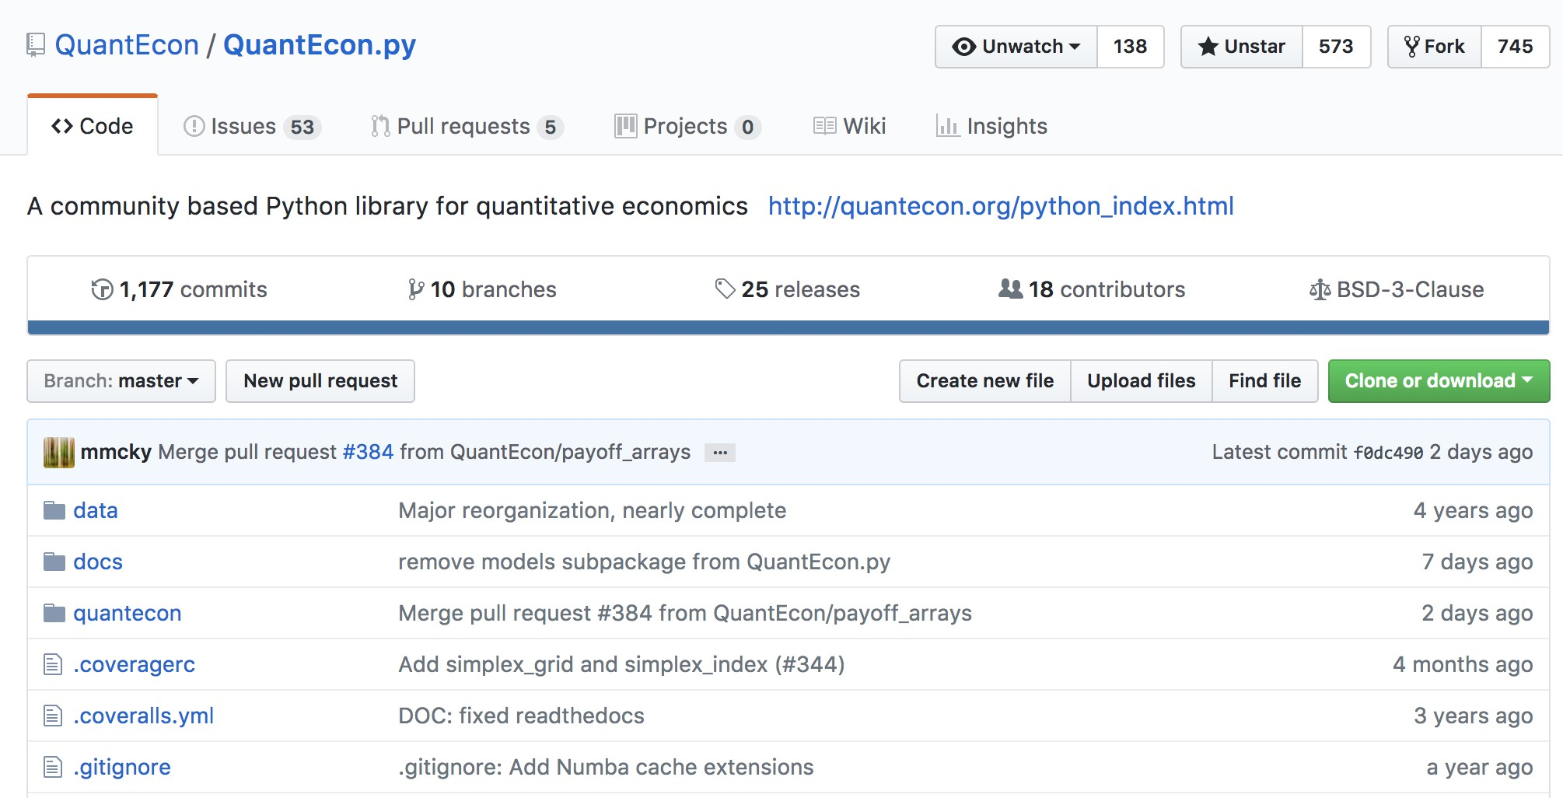<https://github.com/QuantEcon/QuantEcon.py>

� Git will be used to access course materials and submit assignments during the Shenzhen Winter Camp

� Learning Git and GitHub will also be very useful for your own projects, such as a thesis or group assignment

1. Go to <https://git-scm.com/download/win>
2. The download should start automatically
3. Open the .exe file and start setup
4. Follow the setup instructions and leave the default selections
5. **Recommended:** Change the text editor to **nano** if you are unfamiliar with **vim**

|  |  |  |  |
| --- | --- | --- | --- |
| “飞 Git 2.15.1.2 Set u p | | | 1 - 1 口 I X |
|  |
| Choosing the default editor used by Git 心  Which editor would you like Git to use? | | | |
| @ Use the ano editor by default  (NEW!) GNU nano is a small and friendly text editor running in the console window. This is the recommended option.  0 Use Yim (the ubiquitous teKt editor) asGit's default editor  The Vim edit or , while powerful, can be hard to use . It is the default editor of Git for Windows only for historical reasons.  C1 Use Notepad++ as Git's default editor  (NEW!) Notepad++ is a popular GUI editor that can be used by G 止  https://git-for-windows,github,10/ | | | |
|  | I |  | |
| I < Back II Next > I I Cancel I | |
|  | |

D > < 弓．一．..=. 亘 今 Q. 0-

Now that we have Git installed, open up **Windows PowerShell**

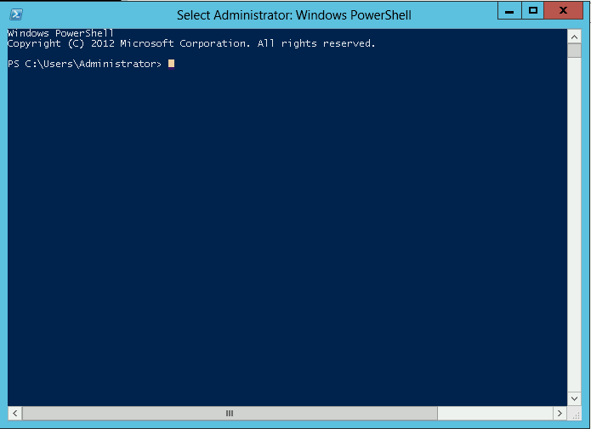

Check that Git is working by typing git and hitting enter

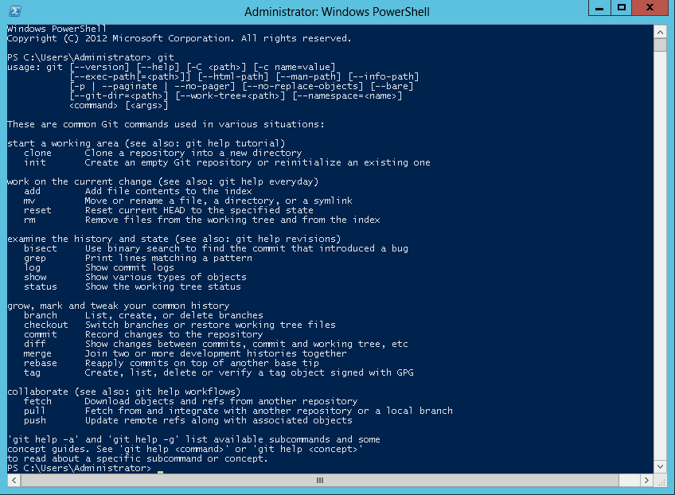

We need to configure Git to recognize us as the user

In the **prompt**, type:

� git config --global user.name "Your Name"

� git config --global user.email ["email@web.com"](mailto:email@web.com)

**Note:** Please make sure you have access to this email!

We will also need to set up an account on GitHub

1. Open <https://github.com/>
2. Sign up for GitHub using the same email you entered into the prompt

A **repository** is like a folder that contains your project’s files, as well as the history of changes to the files

Instead of creating a new repository, we will be downloading (or

**cloning**) one from QuantEcon The repository is located at

<https://github.com/QuantEcon/ShenzhenWinterCamp>

You will first need to **fork** the ShenzhenWinterCamp repository

� **Forking** means to copy a repository into your own GitHub account

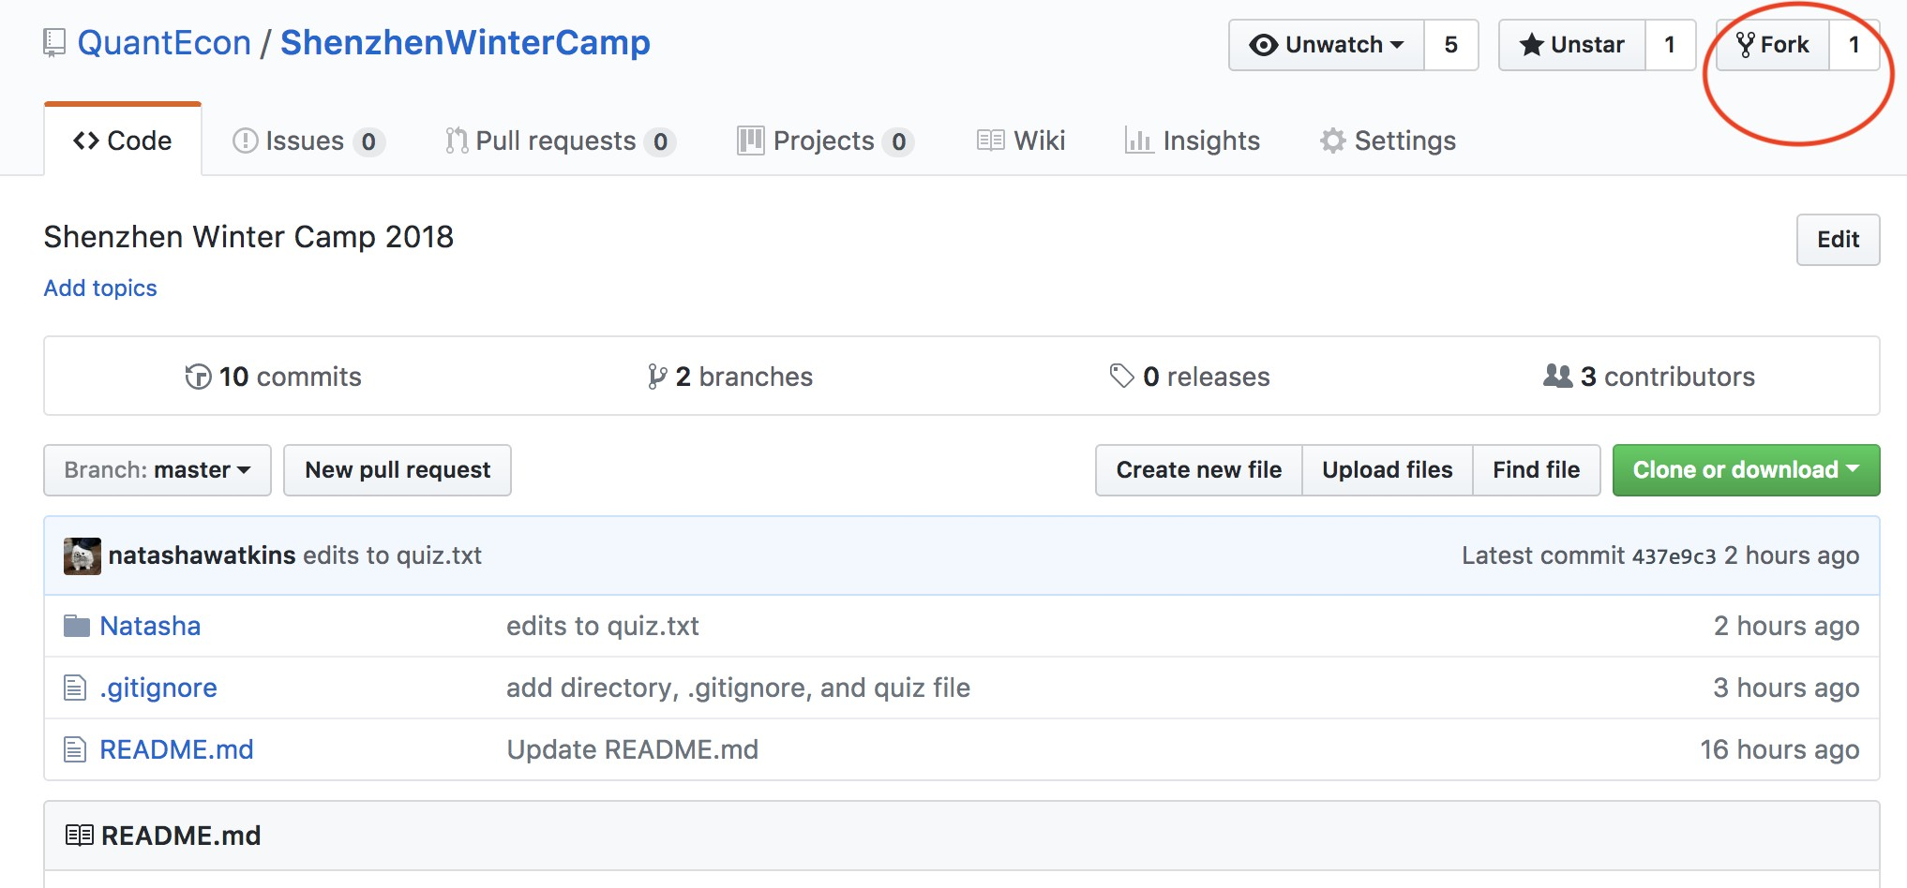� Go to the ShenzhenWinterCamp repository and click the fork button on the upper right

You should now have a repository called ShenzhenWinterCamp in your **own** GitHub account

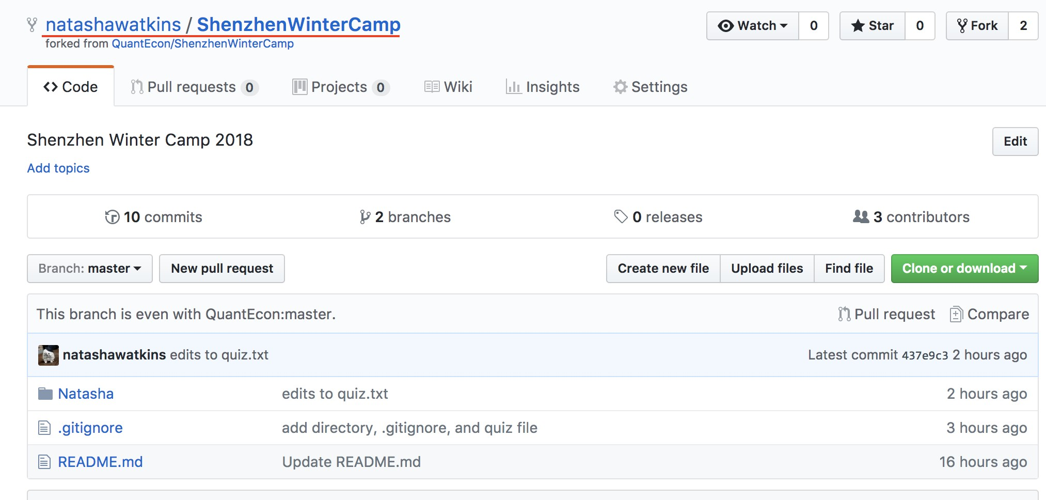

Next we need to copy (or **clone**) the repository to your local computer

1. On your repository’s GitHub page, click the **Clone or download** button and copy the url

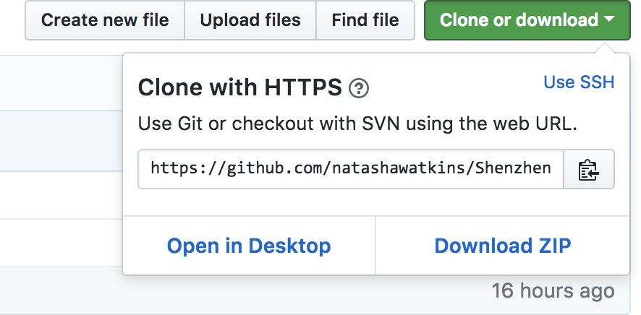

1. Navigate to somewhere on your computer (maybe the Desktop) where you would like to save the folder

cd *∼*/Desktop

1. In the **prompt**, type

git clone

and paste the url (to paste, right click in the PowerShell window)

1. You should now see a folder called ShenzhenWinterCamp on your Desktop
2. Navigate to the repository using the **prompt**

cd *∼*/Desktop/ShenzhenWinterCamp

**Helpful prompt commands:**

� cd - change directory

� cd .. - move back one level in directory

� pwd - print working directory

� ls - list files in working directory

Before we start editing files in the repository, I want you to set up a **branch** in the repository

� A **branch** allows you to make changes to your files without having to worry about the main version

� Used when adding new features to your project

� When you are finished, changes in the branch are **merged**

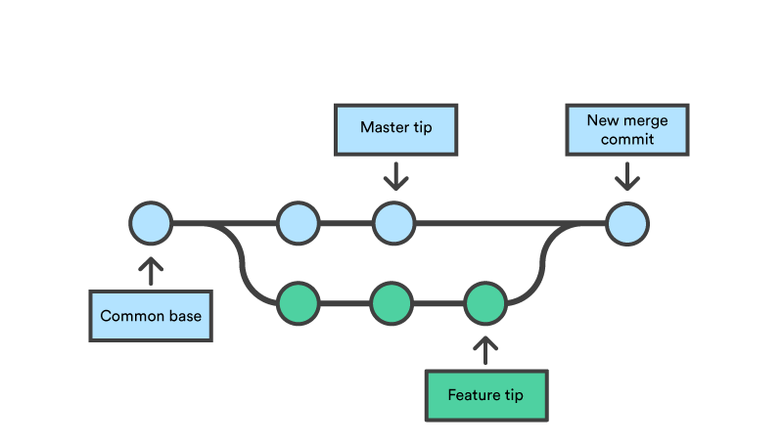into the main version1

1Image source: [https://www.atlassian.com/git/tutorials/using-](https://www.atlassian.com/git/tutorials/using-branches/git-merge)branches/git-merge

Create a branch called your-name by typing the following command in the prompt

git checkout -b "YOUR-NAME"

� -b is used to create a new branch

...and adding/editing files in a Git repository

**Task:** Open Natasha/quiz.txt and complete the quiz

� You may use the internet to help you answer the questions

� When you are finished, save the file

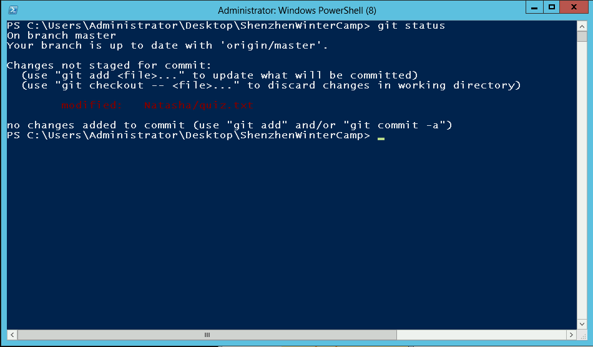Git is aware that you have modified a file in the repository Try typing git status

You can view the changes you made to quiz.txt in the prompt Try typing git diff

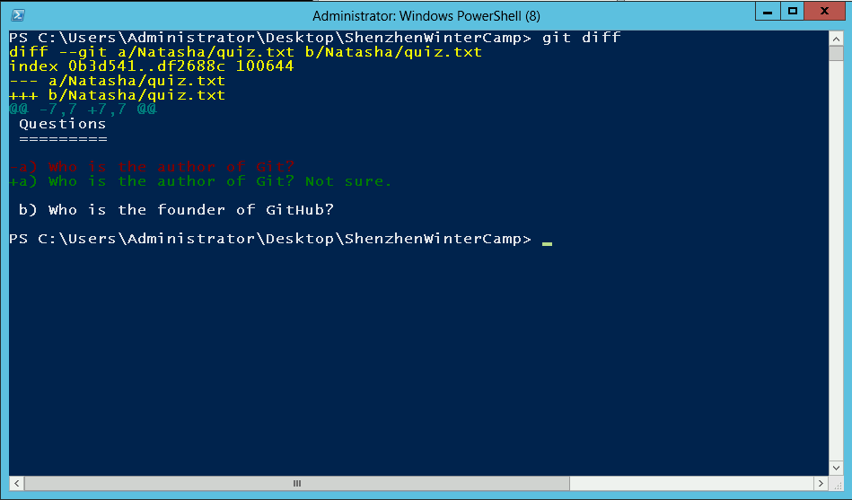

� Once you have finished an edit, you want to update Git’s latest “snapshot” of your repository

� First you should move changes into the **staging area**, where edits are organized before they are **committed**

� Type

git add Natasha/quiz.txt

to add the file to the staging area

� Type git status to check you have added the file you want to the staging area

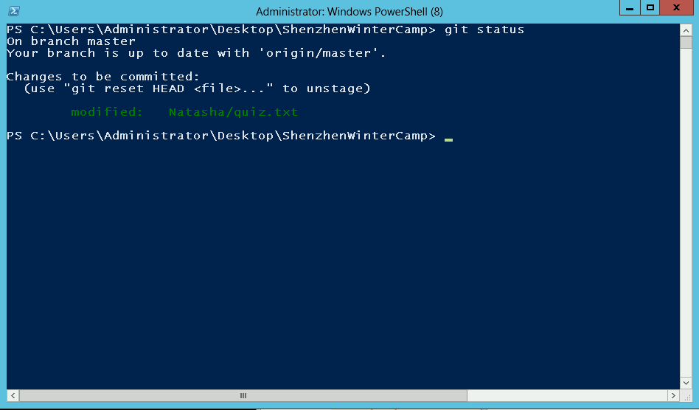

� If you are happy with the changes that are staged, you should now **commit** them to your repository

� **Commits** are permanent snapshots of your repository

� A descriptive message of the changes made should accompany a commit

git commit -m "Add answers to quiz.txt"

� Commit messages are useful when looking through the history of commits to the repository

� Type the following command to view the log

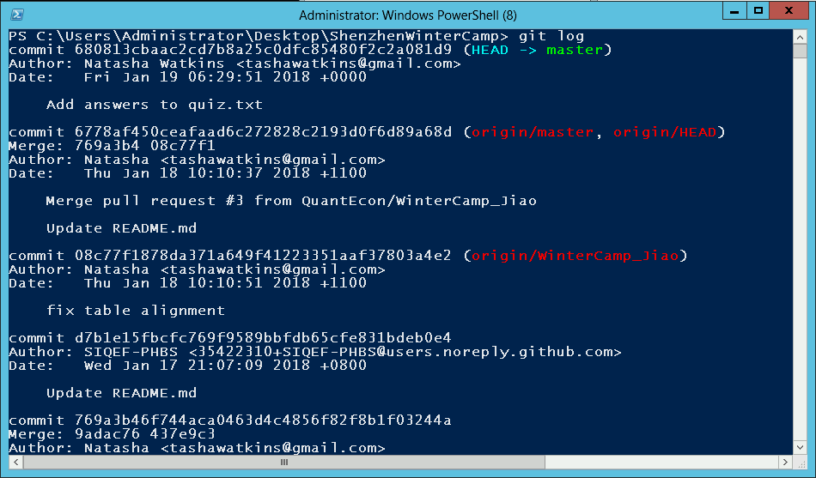git log

Now we’re going to correct each other’s quiz answers!

� You will make a **pull request** on GitHub with your quiz answers committed to your branch

� A pull request asks the maintainer of the repository to **merge**

the changes into the main version (master)

� First we need to **push** (upload) the changes to GitHub

git push origin <branch-name>

� Navigate to the **original** repository:

<https://github.com/QuantEcon/ShenzhenWinterCamp>

� Click **Compare & pull request**

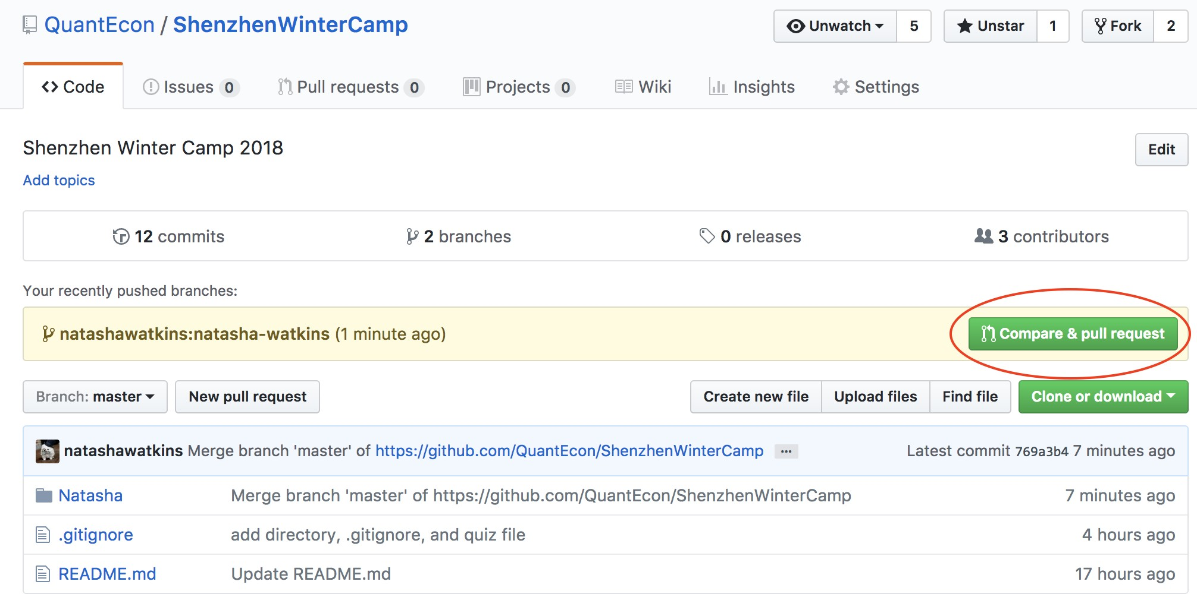

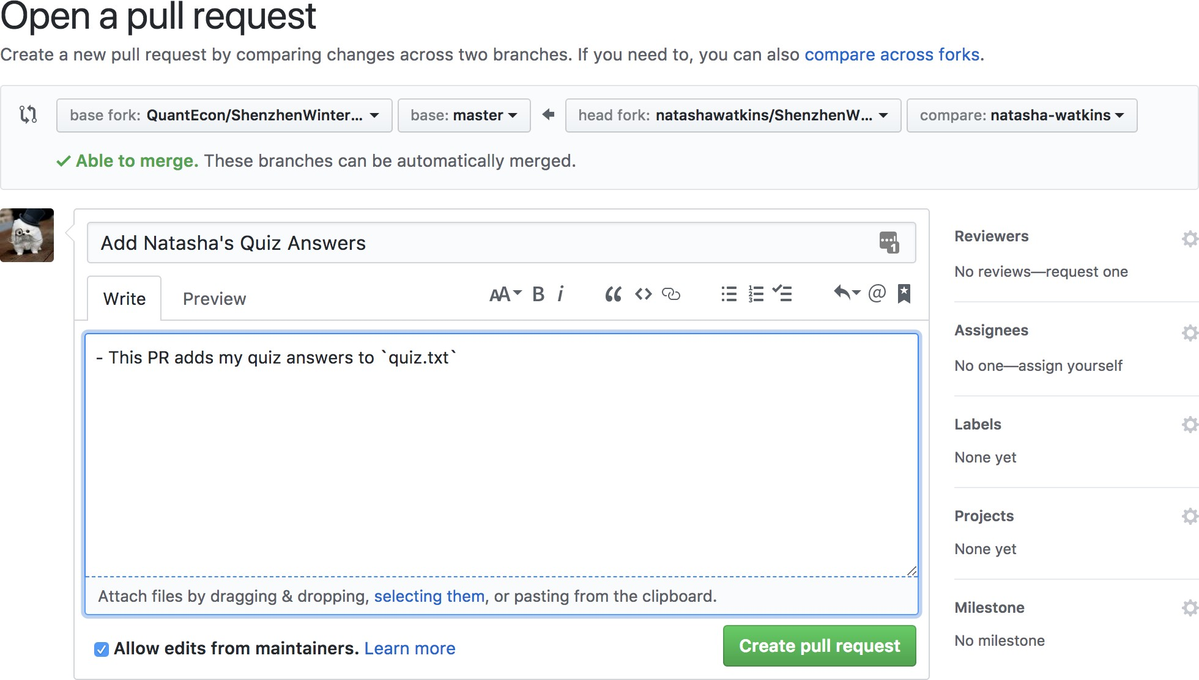

1. Make a pull request to the original repository with your quiz answers
2. Give a score to the quiz of the person sitting next to you - go to their PR and view changes

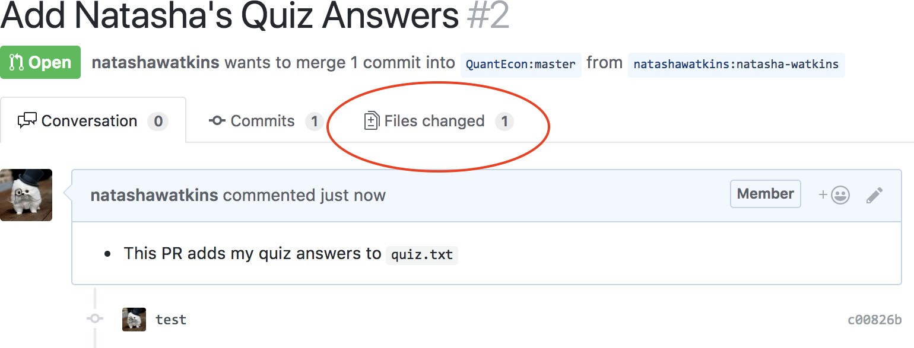

1. Add the score in a comment on the pull request

� Version Control with Git (<https://swcarpentry.github.io/git-novice/>)

� Git cheatsheet from Atlassian ([https://www.atlassian.](https://www.atlassian.com/git/tutorials/atlassian-git-cheatsheet) [com/git/tutorials/atlassian-git-cheatsheet](https://www.atlassian.com/git/tutorials/atlassian-git-cheatsheet))