### 作业1

1. 数组与指针

1.

#include<stdio.h>

const int n = 5;

int main(){

int a[4];

for(int i = 0; i < n; ++ i){

scanf("%d", &a[i]);

}

for(int i = 0; i < n - 1; ++ i){ //冒泡排序

for(int j = 0; j < n - i - 1; ++ j){

if(a[j] < a[j + 1]){

int t = a[j];

a[j] = a[j + 1];

a[j + 1] = t;

}

}

}

for(int i = 0; i < n; ++ i) printf("%d ", a[i]);

return 0;

}

**验证：**

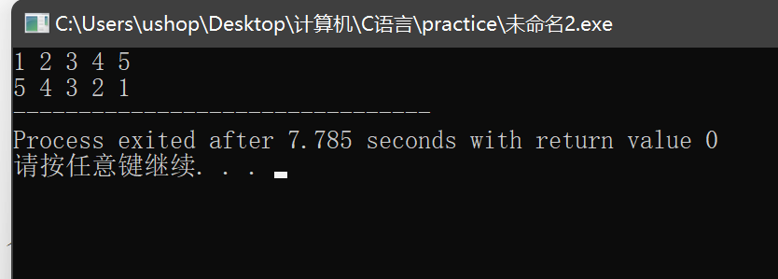

+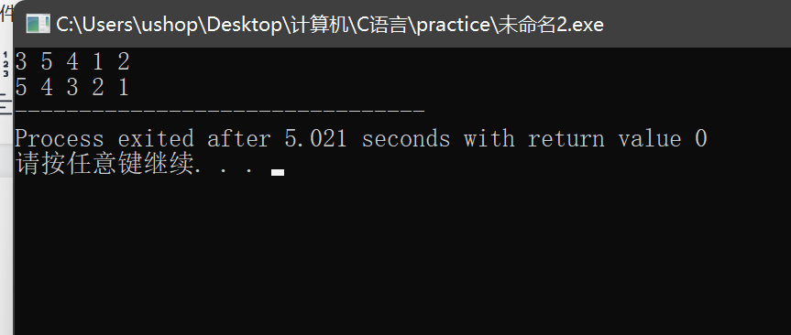

2.

#include<stdio.h>

const int n = 3;

int main()

{

int a[3][3]={1,2,3,4,5,6,7,8,9};

int b[3][3];

for(int i = 0; i < n; ++ i) //另设一个b数组储存转置后的矩阵

for(int j = 0; j < n; ++ j){

b[j][i] = a[i][j];

}

for(int i = 0; i < n; ++ i){

for(int j = 0; j < n; ++ j){

a[i][j] = b[i][j];

printf("%d ", a[i][j]);

}

printf("\n");

}

return 0;

}

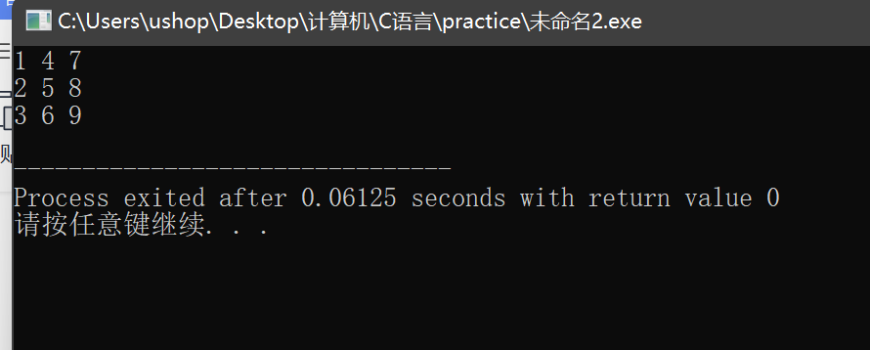

3.

#include<stdio.h>

const int n = 4;

int main()

{

int a[ ][4]={0,1,2,3,1,4,5,6,2,5,7,8,3,6,8,9};

int found=1;

//判断方阵是否为对称阵，若不是，found置为0

for(int i = 0; i < n; ++ i){

for(int j = 0; j < n; ++ j){

printf("%d ", a[i][j]);

}

puts("");

}

puts("");

for(int i = 0; i < n; ++ i){

for(int j = 0; j < n; ++ j){

if(a[i][j] != a[j][i]){

found = 0;

break;

}

}

if(!found) break;

}

if (found==0)

printf("no\n");

else

printf("yes\n");

return 0;}

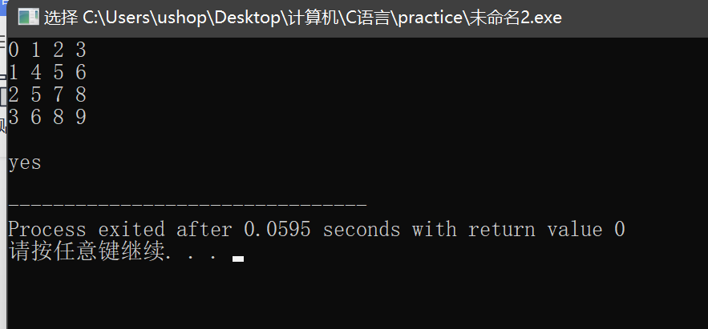

4.

#include<stdio.h>

const int n = 5;

int main()

{ int num[5]={1,3,5,4,2};

int *p;

int max = 0;

for(int i = 0; i < n; ++ i)

if(num[i] > max){

max = num[i];

p = num + i;

}

int t = *p; //指针交换

*p = num[n - 1];

num[n - 1] = t;

for(int i = 0; i < n; ++ i) printf("%d ", *(num + i));

return 0;

}

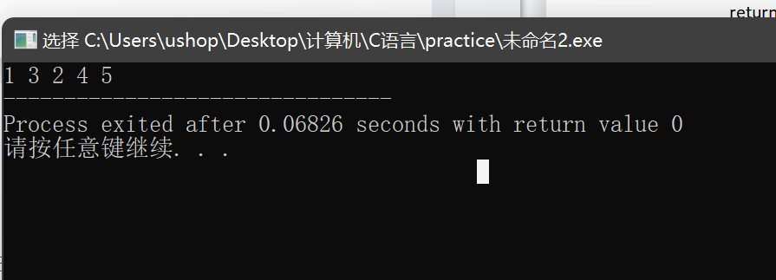

5.

#include<stdio.h>

#define N 7

int main()

{

int a[N]={1, 2, 3, 4, 11, 12, 13};

int *p = a;

for(int i = 0; i < N / 2; ++ i){

int t = *(p + i);

*(p + i) = *(p + N - 1 - i);

*(p + N - 1 - i) = t;

}

for(int *p = a; p < a + N; ++ p) printf("%d ", *p); //偏移

return 0;

}

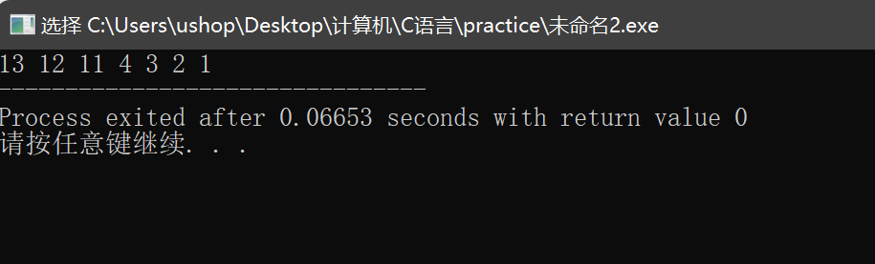

6.

#include<stdio.h>

#define N 7

int main()

{

int a[N]={1, 2, 3, 4, 11, 12, 13};

int *p = a;

for(int i = 0; i < N / 2; ++ i){ //指针移动

int t = *(p + i);

*(p + i) = *(p + N - 1 - i);

*(p + N - 1 - i) = t;

}

for(int *p = a; p < a + N; ++ p) printf("%d ", *p);

return 0;

}

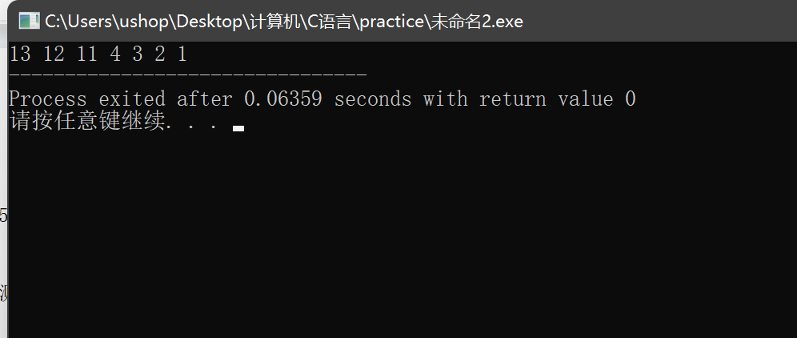

7.

#include<stdio.h>

#define N 12

int main()

{

int a[3][4]={1,3,5,7,9,11,13,15,17,19,21,23};

for(int *p = a[0]; p < a[0] + 12; ++ p){

printf("%d ", *p);

}

return 0;

}

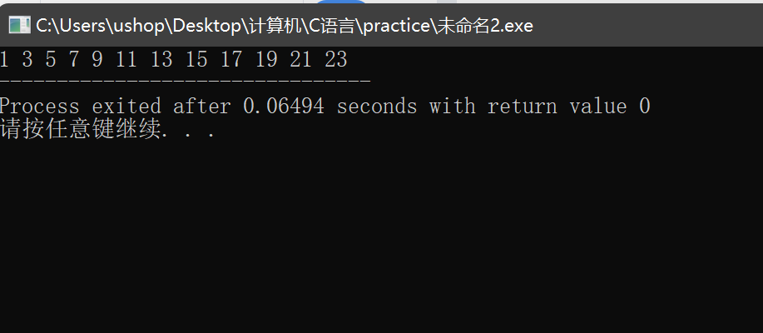

8.

#include<stdio.h>

#define N 12

int main()

{

int a[3][4]={1,3,5,7,9,11,13,15,17,19,21,23};

int (*p)[4] = a; //行指针

for(int i = 0; i < 3; ++ i){

for(int j = 0; j < 4; ++ j){

printf("%2d ", *(*(p + i) + j));

}

puts("");

}

return 0;

}

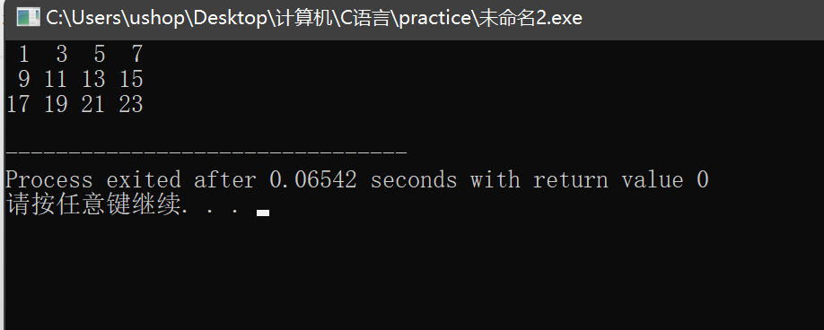

9.

（1）

#include<stdio.h>

#define N 12

int fac(int n){

if(n == 1) return 1;

return n * fac(n - 1); //递归

}

int main( )

{

int m;

float k;

printf("input m:");

scanf("%d",&m);

k = fac(m);

printf("result=%f",k);

}

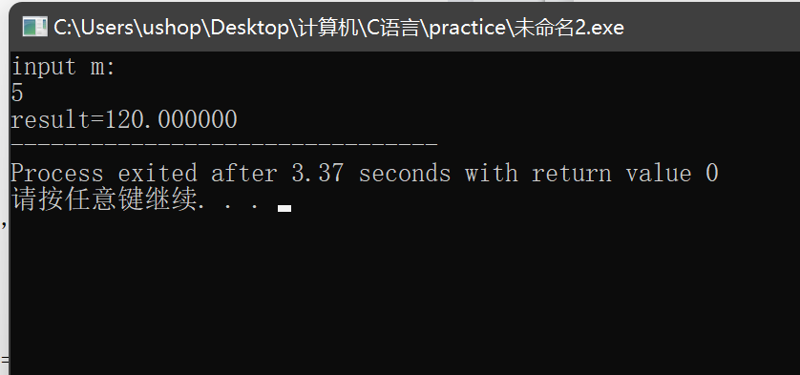

（2）

#include<stdio.h> //通过指针传地址间接改变值

#define N 12

void fac(int *n){

int sum = 1;

for(int i = *n; i >= 1; -- i){

sum *= i;

}

*n = sum; //利用指针可以不用返回值

}

int main( )

{

int m;

float k;

printf("input m:");

scanf("%d",&m);

fac(&m);

k = m;

printf("result=%f",k);

}

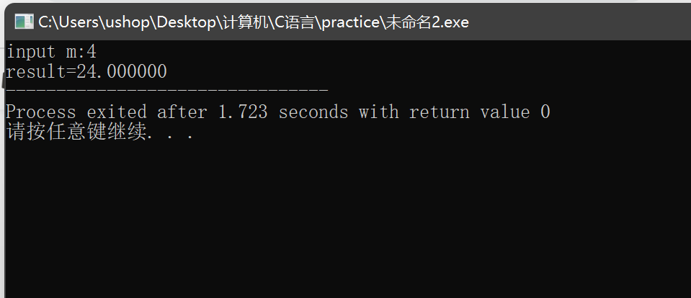

10.

#include<stdio.h>

#include<string.h>

#define N 12

char *strcat(char *s1, char *s2){

char *s = s1;

int i = sizeof(s1);

for(int j = 0; s2[j] != '\0'; ++ j){

s[i++] = s2[j]; //一个一个字符传送

}

s[i] = '\0';

return s;

}

int main( )

{

char str1[30] = "I learn ", *str2 = "C language.";

char *s;

s = strcat(str1,str2);//strcat函数的返回值是指针

printf("%s\n", s);

}

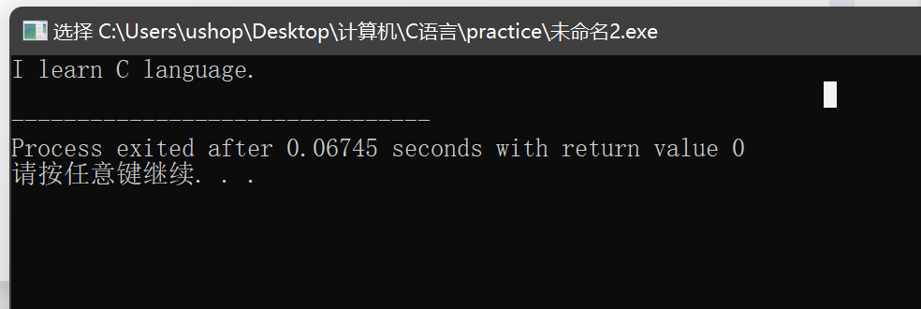

11.

#include<stdio.h>

#include<string.h>

int uniquePaths(int m, int n) {

//补充函数，返回路径数

if(m == 1 || n == 1) return 1; //边界出口

return uniquePaths(m - 1, n) + uniquePaths(m, n - 1); //两种选择

}

int main(){

int m=3,n=2;

int k=uniquePaths(m,n);

printf("共有%d条路径",k);

return 0;

}

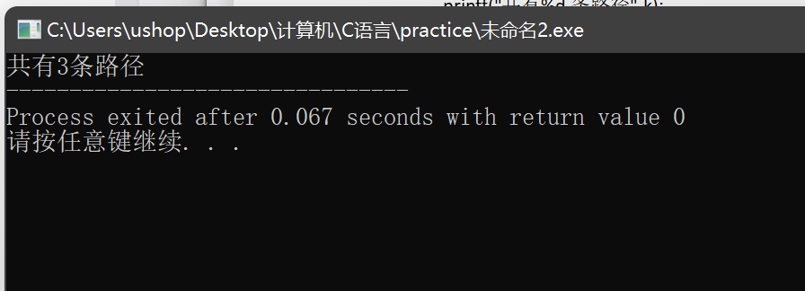

12.

#include<stdio.h>

#include<string.h>

int uniquePathsWithObstacles(int* obstacleGrid, int obstacleGridRowSize, int obstacleGridColSize){

//补充函数，返回路径数

int r = obstacleGridRowSize, c = obstacleGridColSize;

int *b = obstacleGrid;

if( *(b + (r - 1) * 3 + c - 1) == 1) return 0; //障碍物不能走

if(r == 1 || c == 1) return 1;

return uniquePathsWithObstacles(b, r - 1, c) + uniquePathsWithObstacles(b, r, c - 1);

}

int main(){

int a[3][3]={0,0,0,0,1,0,0,0,0};

int k=uniquePathsWithObstacles(a[0],3,3);

printf("共有%d条路径",k);

return 0;

}

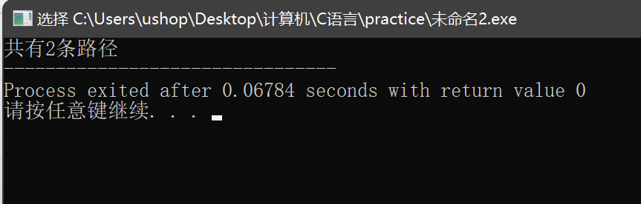

13.

#include<stdio.h>

#include<string.h>

void rotate(int* matrix, int matrixRowSize, int matrixColSize){

//补充函数，实现原地旋转功能

//先上下颠倒再转置

for(int i = 0; i < matrixRowSize / 2; ++ i){

for(int j = 0; j < matrixColSize; ++ j){ //上下颠倒

int t = *(matrix + i * matrixColSize + j);

*(matrix + i * matrixColSize + j) = *(matrix + (matrixRowSize - i - 1) * matrixColSize + j);

*(matrix + (matrixRowSize - i - 1) * matrixColSize + j) = t;

}

}

for(int i = 0; i < matrixColSize; ++ i){ //转置

for(int j = 0; j < i; ++ j){

int t = *(matrix + i * matrixColSize + j);

*(matrix + i * matrixColSize + j) = *(matrix + j * matrixColSize + i);

*(matrix + j * matrixColSize + i) = t;

}

}

}

int main(){

int a[3][3]={1,2,3,4,5,6,7,8,9};

rotate(a[0],3,3);

int *p;

for(p=a[0];p<a[0]+9;p++)

{

if((p-a[0])%3==0) printf("\n");

printf("%4d",*p);

}

return 0;

}

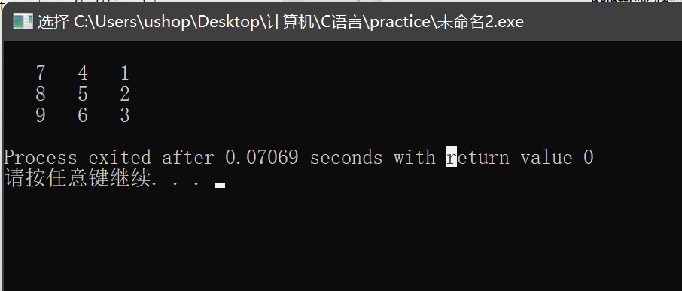

14.

#include<stdio.h>

#include<string.h>

//给定一个包含 m x n 个元素的矩阵（m 行, n 列），请按照顺时针螺旋顺序，返回矩阵中的所有元素。

int res[100]; //不放全局变量会出错

int *spiralOrder(int* matrix, int matrixRowSize, int matrixColSize)

{

int c1 = 0, r1 = 0, rh = matrixRowSize - 1, ch = matrixColSize - 1, count = 0;

while(1) //蛇形 4个方向一个循环

{

for(int j = c1; j <= ch; ++ j) res[count ++] = *(matrix + c1 * matrixColSize + j);

if(++ r1 > rh) break;

for(int i = r1; i <= rh; ++ i) res[count ++] = *(matrix + i * matrixColSize + ch);

if(-- ch < c1) break;

for(int j = ch; j >= c1; -- j) res[count ++] = *(matrix + rh * matrixColSize + j);

if(-- rh < r1) break;

for(int i = rh; i >= r1; -- i) res[count ++] = *(matrix + i * matrixColSize + c1);

if(++ c1 > ch) break;

}

// for(int i = 0; i < 9; ++ i) printf("%d ", res[i]);

// puts("");

return res;

}

int main(){

int a[3][3]={1,2,3,4,5,6,7,8,9};

int matrixRowSize=3,matrixColSize=3;

int *returnnum=spiralOrder(a[0], matrixRowSize, matrixColSize);

int *p;

for(p=returnnum;p<returnnum+9;p++)

{

printf("%4d",*p);

}

return 0;

}

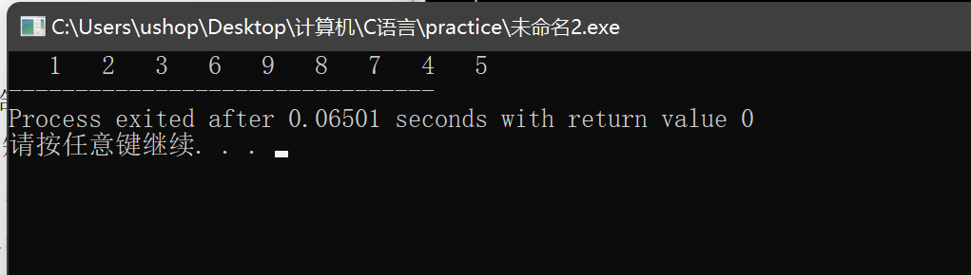

1. 字符串与指针

1.

#include<stdio.h>

#include<string.h>

int main(){

char *s = "I love China!";

puts(s);

return 0;

}

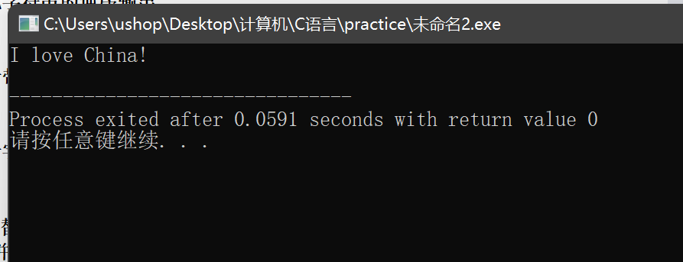

2.

#include<stdio.h>

#include<string.h>

int main(){

char *a = "I am student";

char *b = a; //让b指向a的地址

puts(b);

return 0;

}

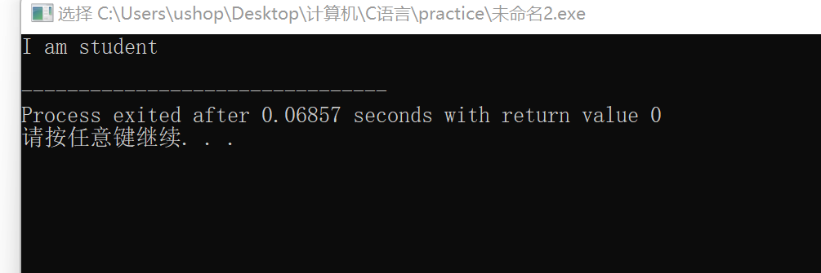

3.

#include<stdio.h>

#include<string.h>

int main(){

char a[50] = "I love "; //用字符数组形式或者申请空间 否则无法实现

char b[] = "China";

strcat(a, b);

puts(a);

return 0;

}

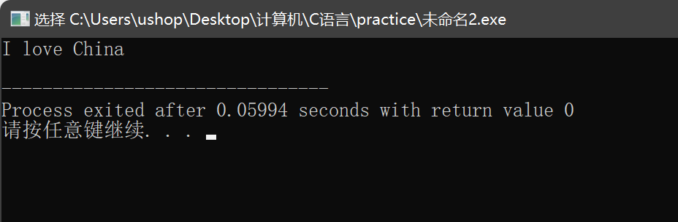

4.

#include<stdio.h>

#include<string.h>

int main(){

char a[] = "I love China!"; //如果用字符数组，那开的数组大小就是字符串的大小

//printf("%d", sizeof(a));

for(int i = sizeof(a) - 2; i >= 0; -- i) //最后一位是休止符

printf("%c", a[i]); //不能用a + i 因为这是单个字符输出 但a + i是字符串

return 0;

}

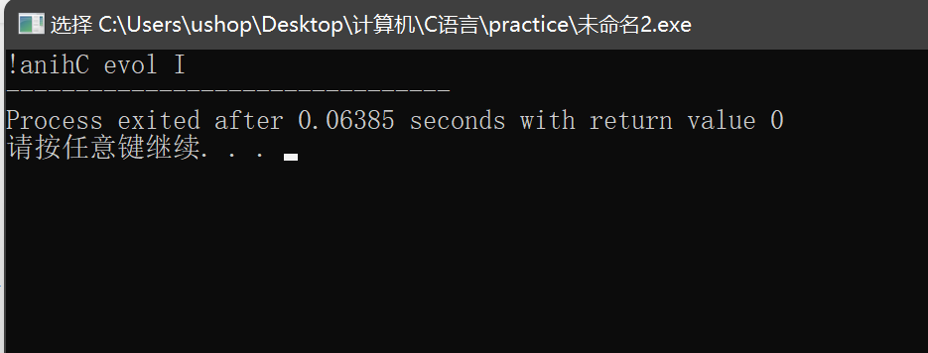

5.

#include<stdio.h>

#include<string.h>

int main(){

char s[100];

gets(s);

int cnt = 0; //计数

puts("数字：");

for(int i = 0; i < strlen(s); ++ i){

if(s[i] >= '0' && s[i] <= '9'){

++ cnt;

printf("%c ", s[i]);

}

}

puts("");

puts("数字个数：");

printf("%d", cnt);

return 0;

}

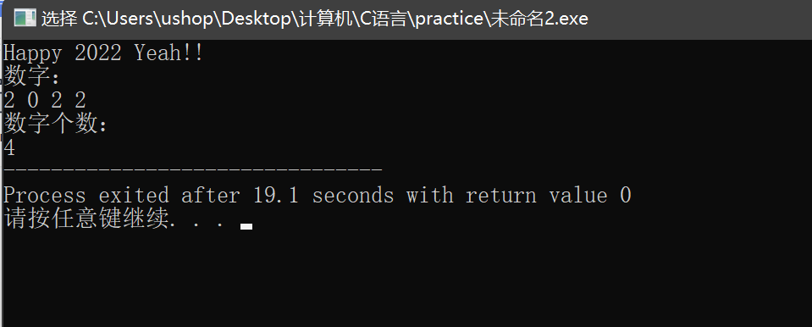

6.

#include<stdio.h>

#include<string.h>

int main(){

char s[100];

gets(s);

int cnt = 0;

bool word = true; //标记单词首字母

for(int i = 0; s[i] != '\0'; ++ i){

if(s[i] != ' ' && word){ //不是空格且是单词首字母

++ cnt;

word = false; //防止重复统计

}

else if(s[i] == ' '){ //是空格则把标记量改为真

word = true;

}

}

printf("单词个数：");

printf("%d", cnt);

return 0;

}

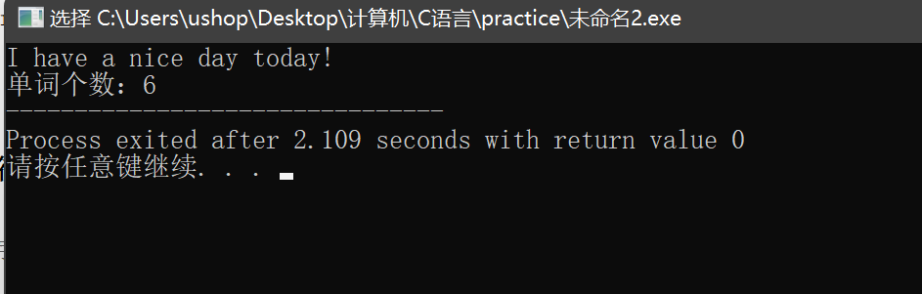

7.

#include<stdio.h>

#include<string.h>

int main(){

char s[100];

gets(s);

int cnt = 0;

for(int i = 0; s[i] != '\0'; ++ i){

if(s[i] == 't'){

s[i] = 'e'; ++ cnt;

}

else if(s[i] == 'T'){

s[i] = 'E'; ++ cnt;

}

}

puts("替换后的字符串：");

puts(s);

printf("替换个数：");

printf("%d", cnt);

return 0;

}

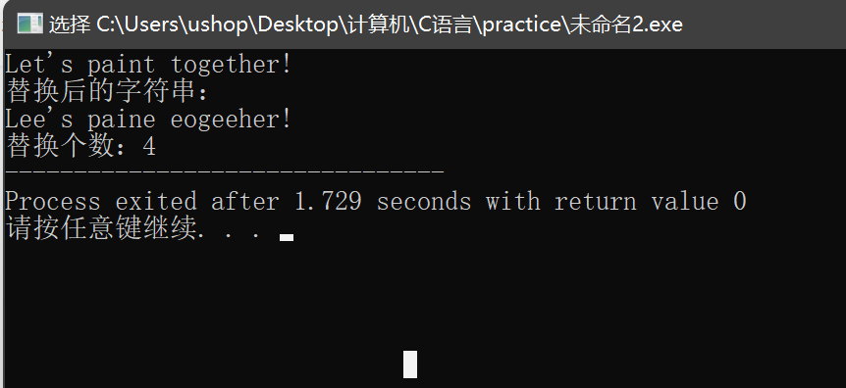

8.

#include<stdio.h>

#include<string.h>

char s[7][10] = {"Monday", "Tuesday", "Wednesday", "Thursday", "Friday", "Satday", "Sunday"};

//字符串常量

int main(){

int week;

scanf("%d", &week);

char (*p)[10] = s;

puts(*(p + week - 1));

return 0;

}

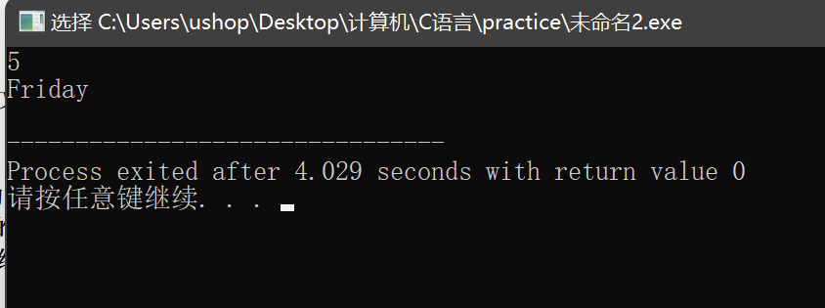

9.

#include<stdio.h>

#include<string.h>

#include<stdlib.h>

const int N = 105;

int cmp(const void *a, const void *b){ //自定义比较

return strlen((char*)a) > strlen((char*)b);

}

int main(){

char s[5][N];

for(int i = 0; i < 5; ++ i) gets(s[i]);

qsort(s, 5, sizeof(s[0]), cmp); //快排

char s1[N];

for(int i = 0; i < 5; ++ i){

if(strlen(s[i]) < 3) s1[i] = ' ';

else s1[i] = *(s[i] + 2);

}

puts("新字符串是：");

puts(s1);

return 0;

}

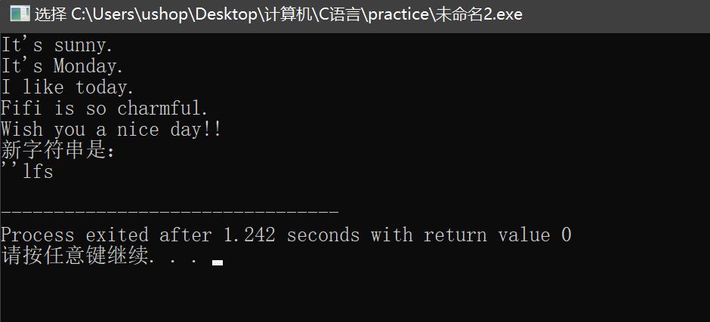

10.

#include<stdio.h>

#include<string.h>

#include<stdlib.h>

#include<time.h>

void swap(int *a, int *b){

int t = *a;

*a = *b;

*b = t;

return;

}

void Arr(int *array, int n){

srand((int) time(0)); //随机函数

for(int i = 0; i < n; ++ i){

array[i] = rand() % 100;

}

for(int i = 0; i < n - 1; ++ i){

for(int j = 0; j < n - i - 1; ++ j){

if(array[j] > array[j + 1]) swap(&array[j], &array[j + 1]);

}

}

return;

}

int main(){

int n;

int *array = NULL;

scanf("%d", &n);

array = (int*)malloc(sizeof(int) * n);

Arr(array, n);

for(int *p = array; p < array + n; ++ p) printf("%d ", *p);

return 0;

}

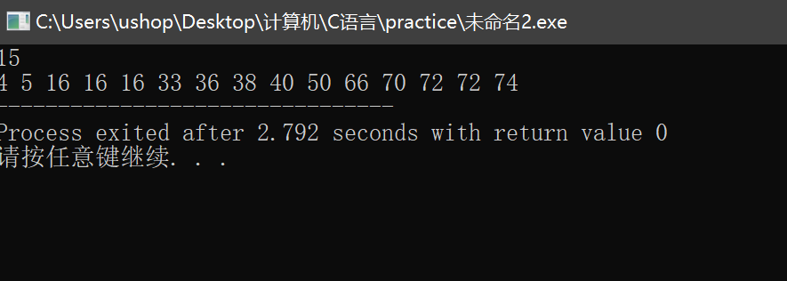

1. 位操作
2. 判断系统是逻辑右移还是算术右移。

#include<stdio.h>

#include<string.h>

#include<stdlib.h>

#include<time.h>

int main() {

char x=0xfe; //-2

int y=x>>1;

printf("%d",y);

return 0;

}

因为输出是-1，说明带符号，则首位是1。所以我的系统是算术右移（高位补1）。

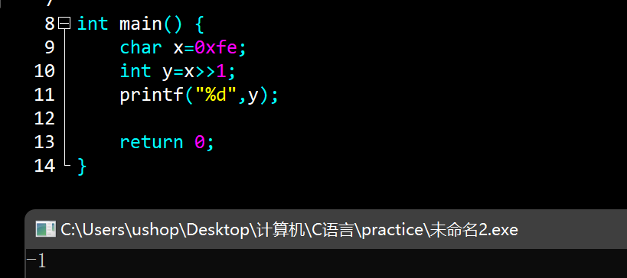

2.

#include<stdio.h>

#include<string.h>

#include<stdlib.h>

#include<time.h>

int main() {

char x = 0xfe;

int y = 0x0001;

printf("%d",x | y);

return 0;

}

x是char类型的负数，y是int类型。x比y短。从结果来看，输出的是-1，说明结果8位之后的高位是0，这说明在进行逻辑运算时，本系统会在较短的负数前面补0.

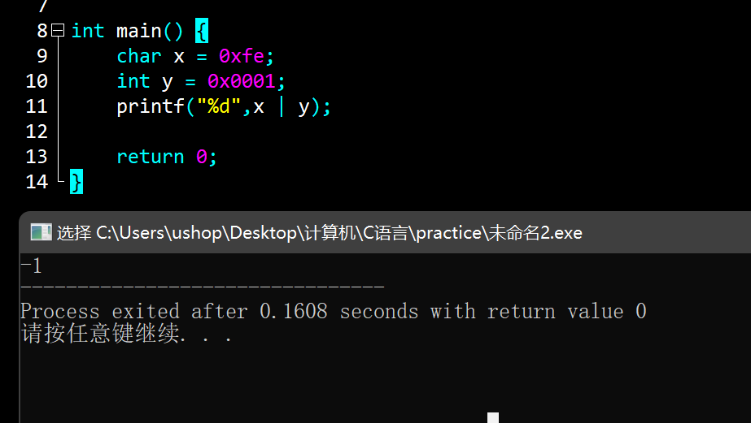

3.

#include<stdio.h>

#include<string.h>

#include<stdlib.h>

const char str[] = "0123456789ABCDEF";

int main() {

int x;

char ans[10], cnt = 0;

scanf("%d", &x);

//printf("%d\n", x >> 4);

while(x){

int i = x & 15; //printf("%d\n", x); //与15相与可以取出后四位

ans[cnt ++] = str[i];

x >>= 4; //printf("%d\n", x); //右移四位处理后续

}

ans[cnt] = '\0';

strrev(ans); //翻转

puts(ans);

//printf("%x", x);

return 0;

}

正数：

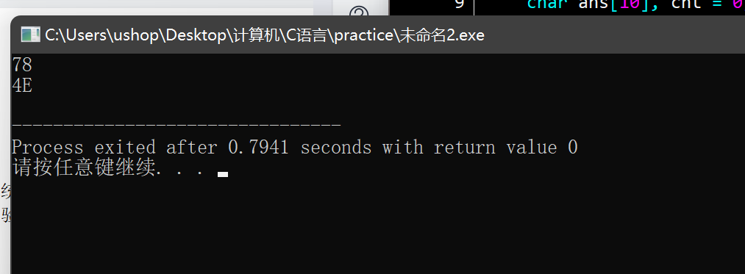

负数：

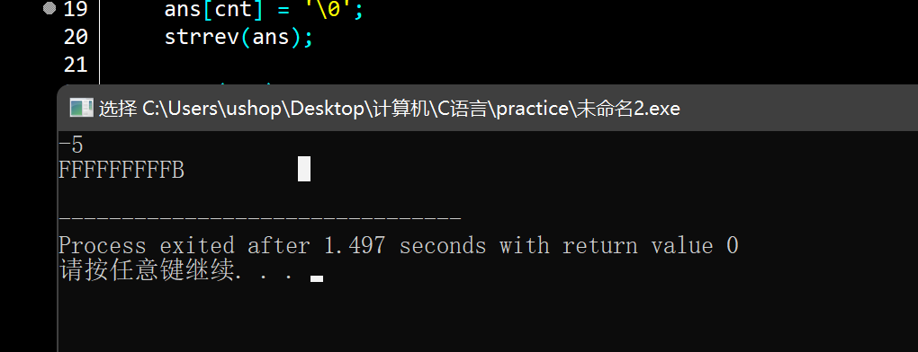

4.

#include<stdio.h>

int main() {

int x;

scanf("%d", &x);

unsigned i = 1 << 31; //从int的最高位开始（是31不是32）

for(; i; i >>= 1){ //每次往右移动一位（不要忘记等于号）

printf("%d", x & i ? 1 : 0); //如果该位是1则相与结果大于0（是实际数字）

}

return 0;

}

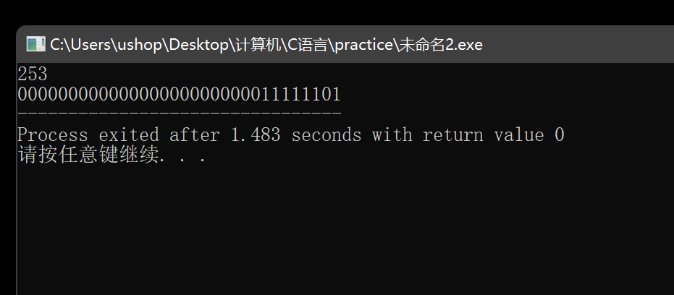

5.

#include<stdio.h>

#include<string.h>

#include<math.h>

const char str[20] = "0123456789ABCDEF";

int main() {

char s[17], ansx[4], s1[17];

int ans = 0, tmp;

bool flag = false;

gets(s);

strcpy(s1, s);

for(int i = 0; i < 16; i += 4) { //十六进制部分

int tmp = 0;

for(int j = 0; j < 4; ++ j) {

if(s[i + j] == '1') {

tmp += pow(2, 3 - j);

}

}

ansx[i / 4] = str[tmp];

}

ansx[4] = '\0'; //两个字符串的存储地址是挨着的

puts(ansx);

strcpy(s, s1);

//printf("%c\n", s[0]);

if(s[0] == '1') { //处理负数

flag = true;

if(s[15] == '1') s[15] = '0';

else {

s[15] = '1';

int i = 14;

while(s[i] = '0') s[i --] = '1';

s[i] = '0';

}

for(int i = 0; i < 16; ++ i) s[i] = '0' + '1' - s[i];

}

//puts(s);

for(int i = 0; i < 16; ++ i) {

if(s[i] == '1')

ans += pow(2, 15 - i);

}

if(flag) printf("-");

printf("%d", ans);

return 0;

}

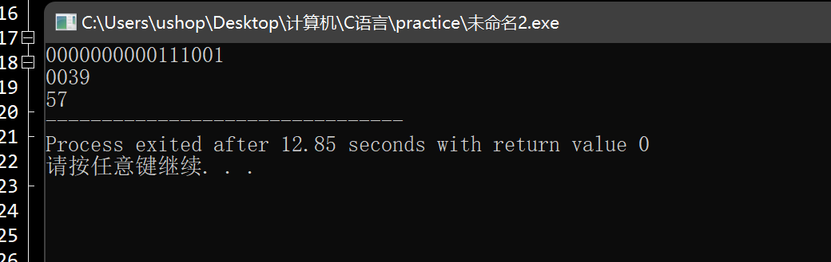

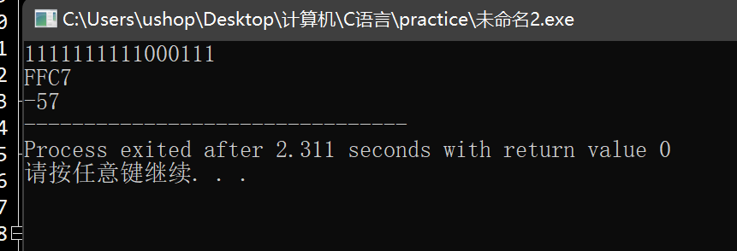

6.

#include<stdio.h>

#include<string.h>

#include<stdlib.h>

struct S {

int a : 3;

int b : 5;

int c : 6;

int d : 9;

}st;

int main() {

st.a = 95; st.b = 25; st.c = 25; st.d = 105;

printf("%10d %10d %10d %10d\n", st.a, st.b, st.c, st.d);

printf("%10x %10x %10x %10x\n", st.a, st.b, st.c, st.d);

char s1[30], s2[30], s3[30], s4[30];

itoa(st.a, s1, 2);

itoa(st.b, s2, 2);

itoa(st.c, s3, 2);

itoa(st.d, s4, 2);

printf("%s\n %s\n %s\n %s\n", s1, s2, s3, s4);

return 0;

}

//高位会截断

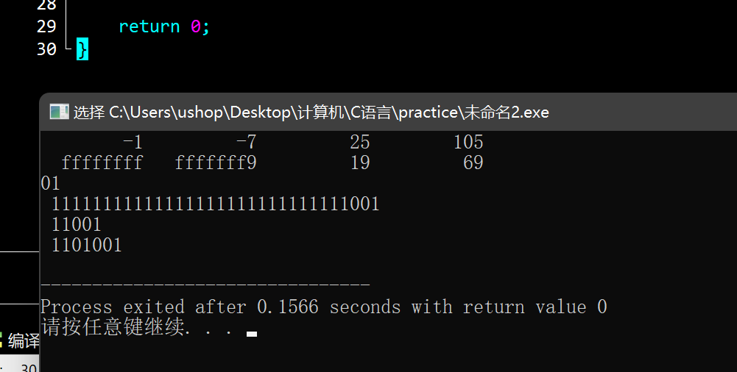

7.

#include <stdio.h>

#include <string.h>

#include <math.h>

char str[42], s[40];

int main() {

gets(str);

int n = 0;

for(int i = 0; str[i] != '\0'; ++ i){ //去掉空格

if(str[i] != ' '){

s[n ++] = str[i];

}

}

if(s[0] == '1') printf("-"); //判断符号位

int e = 0;

for(int i = 1; i < 9; ++ i){ //计算指数位

e = e * 2 + s[i] - '0';

}

e -= 127;

int zs = 1; //因为IEEE标准制会去掉首位的1，所以这里初始值设置为1

float xs = 0.0, ans = 0.0; //zs是整数，xs是小数，ans存答案

for(int i = 9; i < 9 + e; ++ i){ //整数处理

zs = zs * 2 + s[i] - '0';

}

double w = 0.5; //注意不要用int

for(int i = 9 + e; i < n; ++ i){ //小数处理

xs += (s[i] - '0') * w;

w /= 2;

}

ans = zs + xs;

printf("%f", ans);

return 0;

}

