**Software Design Document**

**Version 1.1**

**November 12th, 2017**

**Student Calendar Integration Application**

**BYU-Idaho CS364 Software Engineering**

**Authors**

**Project Manager**

Michael Carey

**Team Leads**

Landon Shumway  
Robert Nelson  
Adam Shumway  
Daniel Craig

**Team 1 - UML / Class Diagrams**

Austin Golding  
Marcus Rhodes  
Jonathan Comeau  
Dallin Snell  
Kylor Kersavage  
Michael Flindt

**Team 2 - Use Cases**

Aaron Shore  
Brian Robertson  
Joseph Keene  
Jacob Keene  
Zane West  
Rex Nesbit

**Team 3 - Data Modeling / Database**

John Memmott  
Jefferson Santos  
Keith Wheeler  
Tyler Sorenson  
Brandon Hartshorn

**Team 4 - UX / UI**

Micah Wilson  
Jason Catmull  
Sebastian Calle  
Marcus Hedgecock  
Jonah Green  
Fernando Gomez

**Revision History**

| **Name** | **Date** | **Reason for Changes** | **Version** |
| --- | --- | --- | --- |
| Initial | 11/4/2017 | First Draft | 1.0 |
| Draft | 11/12/2017 | Second Draft | 1.1 |

**Table of Contents**

Table of Contents

Software Design Document 1

Version 1.1 1

November 12th, 2017 1

Student Calendar Integration Application 1

BYU-Idaho CS364 Software Engineering 1

Authors 2

Project Manager 2

Team Leads 2

Team 1 - UML / Class Diagrams 2

Team 2 - Use Cases 2

Team 3 - Data Modeling / Database 2

Team 4 - UX / UI 3

Revision History 4

Table of Contents 5

1.0 Introduction 6

1.1 Purpose 6

1.2 Scope 6

1.3 Context 6

1.4 Summary 6

1.5 References 7

2.0 Glossary 7

3.0 Use Cases 7

3.1 Identified Stakeholders and Design Concerns 7

3.2 List of Use Cases 8

3.3 Use Case Diagrams 8

3.4 Use Cases 10

4.0 Design Overview 10

4.1 System Architecture 10

4.2.0 Design Viewpoint 1 10

4.2.0.1 Design View 1 10

4.2.0.2 Design Rationale 11

4.3 System Interfaces 11

4.4 Constraints and Assumptions 11

5.0 Data Design 11

5.1 Entity Relationship Diagram 12

5.2 Internal Software Data Structure 12

5.3 Global Data Structure 12

6.0 User Interface Design 12

6.1 Description of User Interface 13

6.2 User Interface Images 13

6.2.1 Main Calendar View UX flow chart 13

Index 23

**1.0 Introduction**

**1.1 Purpose**

Content goes here: Lorem ipsum dolor sit amet, consectetur adipiscing elit, sed do eiusmod tempor incididunt ut labore et dolore magna aliqua. Ut enim ad minim veniam, quis nostrud exercitation ullamco laboris nisi ut aliquip ex ea commodo consequat. Duis aute irure dolor in reprehenderit in voluptate velit esse cillum dolore eu fugiat nulla pariatur. Excepteur sint occaecat cupidatat non proident, sunt in culpa qui officia deserunt mollit anim id est laborum.

**1.2 Scope**

Content goes here: Lorem ipsum dolor sit amet, consectetur adipiscing elit, sed do eiusmod tempor incididunt ut labore et dolore magna aliqua. Ut enim ad minim veniam, quis nostrud exercitation ullamco laboris nisi ut aliquip ex ea commodo consequat. Duis aute irure dolor in reprehenderit in voluptate velit esse cillum dolore eu fugiat nulla pariatur. Excepteur sint occaecat cupidatat non proident, sunt in culpa qui officia deserunt mollit anim id est laborum.

**1.3 Context**

Content goes here: Lorem ipsum dolor sit amet, consectetur adipiscing elit, sed do eiusmod tempor incididunt ut labore et dolore magna aliqua. Ut enim ad minim veniam, quis nostrud exercitation ullamco laboris nisi ut aliquip ex ea commodo consequat. Duis aute irure dolor in reprehenderit in voluptate velit esse cillum dolore eu fugiat nulla pariatur. Excepteur sint occaecat cupidatat non proident, sunt in culpa qui officia deserunt mollit anim id est laborum.

**1.4 Summary**

Content goes here: Lorem ipsum dolor sit amet, consectetur adipiscing elit, sed do eiusmod tempor incididunt ut labore et dolore magna aliqua. Ut enim ad minim veniam, quis nostrud exercitation ullamco laboris nisi ut aliquip ex ea commodo consequat. Duis aute irure dolor in reprehenderit in voluptate velit esse cillum dolore eu fugiat nulla pariatur. Excepteur sint occaecat cupidatat non proident, sunt in culpa qui officia deserunt mollit anim id est laborum.

**1.5 References**

Content goes here: Lorem ipsum dolor sit amet, consectetur adipiscing elit, sed do eiusmod tempor incididunt ut labore et dolore magna aliqua. Ut enim ad minim veniam, quis nostrud exercitation ullamco laboris nisi ut aliquip ex ea commodo consequat. Duis aute irure dolor in reprehenderit in voluptate velit esse cillum dolore eu fugiat nulla pariatur. Excepteur sint occaecat cupidatat non proident, sunt in culpa qui officia deserunt mollit anim id est laborum.

**2.0 Glossary**

Content goes here: Lorem ipsum dolor sit amet, consectetur adipiscing elit, sed do eiusmod tempor incididunt ut labore et dolore magna aliqua. Ut enim ad minim veniam, quis nostrud exercitation ullamco laboris nisi ut aliquip ex ea commodo consequat. Duis aute irure dolor in reprehenderit in voluptate velit esse cillum dolore eu fugiat nulla pariatur. Excepteur sint occaecat cupidatat non proident, sunt in culpa qui officia deserunt mollit anim id est laborum.

**3.0 Use Cases**

Content goes here: Lorem ipsum dolor sit amet, consectetur adipiscing elit, sed do eiusmod tempor incididunt ut labore et dolore magna aliqua. Ut enim ad minim veniam, quis nostrud exercitation ullamco laboris nisi ut aliquip ex ea commodo consequat. Duis aute irure dolor in reprehenderit in voluptate velit esse cillum dolore eu fugiat nulla pariatur. Excepteur sint occaecat cupidatat non proident, sunt in culpa qui officia deserunt mollit anim id est laborum.

**3.1 Identified Stakeholders and Design Concerns**

**3.1.1 Calendar Manager**

**3.1.1.1 Information**

The Calendar Manager is a user who works with student tasks, events, assignments, reminders, etc. There are several users who fall into the Calendar Manager category. Each user can perform similar actions, but for different reasons. For example, a teacher may want to highlight a test deadline for his or her students. A student may want to set reminders about a test or homework deadline throughout the week. 3.1.1.1.1 Teacher 3.1.1.1.2 Event Coordinator 3.1.1.1.3 Student

**3.1.2 Student Calendar**

**3.1.2.1 Information**

The Student Calendar represents the system and the actions it takes.

**3.1.3 Administrative**

**3.1.3.1 Administrative User Information**

The Administrative User is a user who oversees account creation and administration.

**3.1.4 Public User**

**3.1.4.1 Public User Information**

The Public User is a generic user to represent the general user. They have been validated through the security measures and created a personal Student Calendar account.

**3.2 List of Use Cases**

Content goes here: Lorem ipsum dolor sit amet, consectetur adipiscing elit, sed do eiusmod tempor incididunt ut labore et dolore magna aliqua. Ut enim ad minim veniam, quis nostrud exercitation ullamco laboris nisi ut aliquip ex ea commodo consequat. Duis aute irure dolor in reprehenderit in voluptate velit esse cillum dolore eu fugiat nulla pariatur. Excepteur sint occaecat cupidatat non proident, sunt in culpa qui officia deserunt mollit anim id est laborum.

**3.3 Use Case Diagrams**

Content goes here: Lorem ipsum dolor sit amet, consectetur adipiscing elit, sed do eiusmod tempor incididunt ut labore et dolore magna aliqua. Ut enim ad minim veniam, quis nostrud exercitation ullamco laboris nisi ut aliquip ex ea commodo consequat. Duis aute irure dolor in reprehenderit in voluptate velit esse cillum dolore eu fugiat nulla pariatur. Excepteur sint occaecat cupidatat non proident, sunt in culpa qui officia deserunt mollit anim id est laborum.

####3.3.1 Login Use Cases: login

| **Data** | **Description** |
| --- | --- |
| ScreenShot/Mockup: |  |
| Page Title: | Login |
| Parent User Story: | N/A |
| Actor(s)/Persona(s): | BYUI Student or Professor |
| Pre-conditions/Product(s) Required: | 1. The user has created an account.  2. The user has navigated to the login page. |
| Post-conditions/Product(s) Produced: | 1. The user is now logged in.  2. The calendar application now reflects the user's information and upcoming events. |
| Links: | None. |
| Description/Notes: | 1. The application will provide e-mail address and password fields for authentication.  2. A user enters their username and password into the corresponding fields.  3. The user clicks the LOGIN button.  4. The user's credentials are verified via database query, and the user is presented with their calendar. |
| Security: | 1. The password will be salted and hashed before entered into the database.  2. The database will feature sanitized inputs to prevent SQL injection. |

**3.4 Use Cases**

Content goes here: Lorem ipsum dolor sit amet, consectetur adipiscing elit, sed do eiusmod tempor incididunt ut labore et dolore magna aliqua. Ut enim ad minim veniam, quis nostrud exercitation ullamco laboris nisi ut aliquip ex ea commodo consequat. Duis aute irure dolor in reprehenderit in voluptate velit esse cillum dolore eu fugiat nulla pariatur. Excepteur sint occaecat cupidatat non proident, sunt in culpa qui officia deserunt mollit anim id est laborum.

**4.0 Design Overview**

Content goes here: Lorem ipsum dolor sit amet, consectetur adipiscing elit, sed do eiusmod tempor incididunt ut labore et dolore magna aliqua. Ut enim ad minim veniam, quis nostrud exercitation ullamco laboris nisi ut aliquip ex ea commodo consequat. Duis aute irure dolor in reprehenderit in voluptate velit esse cillum dolore eu fugiat nulla pariatur. Excepteur sint occaecat cupidatat non proident, sunt in culpa qui officia deserunt mollit anim id est laborum.

**4.1 System Architecture**

Content goes here: Lorem ipsum dolor sit amet, consectetur adipiscing elit, sed do eiusmod tempor incididunt ut labore et dolore magna aliqua. Ut enim ad minim veniam, quis nostrud exercitation ullamco laboris nisi ut aliquip ex ea commodo consequat. Duis aute irure dolor in reprehenderit in voluptate velit esse cillum dolore eu fugiat nulla pariatur. Excepteur sint occaecat cupidatat non proident, sunt in culpa qui officia deserunt mollit anim id est laborum.

**4.2.0 Design Viewpoint 1**

Content goes here: Lorem ipsum dolor sit amet, consectetur adipiscing elit, sed do eiusmod tempor incididunt ut labore et dolore magna aliqua. Ut enim ad minim veniam, quis nostrud exercitation ullamco laboris nisi ut aliquip ex ea commodo consequat. Duis aute irure dolor in reprehenderit in voluptate velit esse cillum dolore eu fugiat nulla pariatur. Excepteur sint occaecat cupidatat non proident, sunt in culpa qui officia deserunt mollit anim id est laborum.

**4.2.0.1 Design View 1**

Content goes here: Lorem ipsum dolor sit amet, consectetur adipiscing elit, sed do eiusmod tempor incididunt ut labore et dolore magna aliqua. Ut enim ad minim veniam, quis nostrud exercitation ullamco laboris nisi ut aliquip ex ea commodo consequat. Duis aute irure dolor in reprehenderit in voluptate velit esse cillum dolore eu fugiat nulla pariatur. Excepteur sint occaecat cupidatat non proident, sunt in culpa qui officia deserunt mollit anim id est laborum.

**4.2.0.2 Design Rationale**

Content goes here: Lorem ipsum dolor sit amet, consectetur adipiscing elit, sed do eiusmod tempor incididunt ut labore et dolore magna aliqua. Ut enim ad minim veniam, quis nostrud exercitation ullamco laboris nisi ut aliquip ex ea commodo consequat. Duis aute irure dolor in reprehenderit in voluptate velit esse cillum dolore eu fugiat nulla pariatur. Excepteur sint occaecat cupidatat non proident, sunt in culpa qui officia deserunt mollit anim id est laborum.

**4.3 System Interfaces**

Content goes here: Lorem ipsum dolor sit amet, consectetur adipiscing elit, sed do eiusmod tempor incididunt ut labore et dolore magna aliqua. Ut enim ad minim veniam, quis nostrud exercitation ullamco laboris nisi ut aliquip ex ea commodo consequat. Duis aute irure dolor in reprehenderit in voluptate velit esse cillum dolore eu fugiat nulla pariatur. Excepteur sint occaecat cupidatat non proident, sunt in culpa qui officia deserunt mollit anim id est laborum.

**4.4 Constraints and Assumptions**

Content goes here: Lorem ipsum dolor sit amet, consectetur adipiscing elit, sed do eiusmod tempor incididunt ut labore et dolore magna aliqua. Ut enim ad minim veniam, quis nostrud exercitation ullamco laboris nisi ut aliquip ex ea commodo consequat. Duis aute irure dolor in reprehenderit in voluptate velit esse cillum dolore eu fugiat nulla pariatur. Excepteur sint occaecat cupidatat non proident, sunt in culpa qui officia deserunt mollit anim id est laborum.

**5.0 Data Design**

Content goes here: Lorem ipsum dolor sit amet, consectetur adipiscing elit, sed do eiusmod tempor incididunt ut labore et dolore magna aliqua. Ut enim ad minim veniam, quis nostrud exercitation ullamco laboris nisi ut aliquip ex ea commodo consequat. Duis aute irure dolor in reprehenderit in voluptate velit esse cillum dolore eu fugiat nulla pariatur. Excepteur sint occaecat cupidatat non proident, sunt in culpa qui officia deserunt mollit anim id est laborum.

**5.1 Entity Relationship Diagram**

Image goes here  
Content goes here: Lorem ipsum dolor sit amet, consectetur adipiscing elit, sed do eiusmod tempor incididunt ut labore et dolore magna aliqua. Ut enim ad minim veniam, quis nostrud exercitation ullamco laboris nisi ut aliquip ex ea commodo consequat. Duis aute irure dolor in reprehenderit in voluptate velit esse cillum dolore eu fugiat nulla pariatur. Excepteur sint occaecat cupidatat non proident, sunt in culpa qui officia deserunt mollit anim id est laborum.

**5.2 Internal Software Data Structure**

Content goes here: Lorem ipsum dolor sit amet, consectetur adipiscing elit, sed do eiusmod tempor incididunt ut labore et dolore magna aliqua. Ut enim ad minim veniam, quis nostrud exercitation ullamco laboris nisi ut aliquip ex ea commodo consequat. Duis aute irure dolor in reprehenderit in voluptate velit esse cillum dolore eu fugiat nulla pariatur. Excepteur sint occaecat cupidatat non proident, sunt in culpa qui officia deserunt mollit anim id est laborum.

**5.3 Global Data Structure**

Content goes here: Lorem ipsum dolor sit amet, consectetur adipiscing elit, sed do eiusmod tempor incididunt ut labore et dolore magna aliqua. Ut enim ad minim veniam, quis nostrud exercitation ullamco laboris nisi ut aliquip ex ea commodo consequat. Duis aute irure dolor in reprehenderit in voluptate velit esse cillum dolore eu fugiat nulla pariatur. Excepteur sint occaecat cupidatat non proident, sunt in culpa qui officia deserunt mollit anim id est laborum.

**6.0 User Interface Design**

Content goes here: Lorem ipsum dolor sit amet, consectetur adipiscing elit, sed do eiusmod tempor incididunt ut labore et dolore magna aliqua. Ut enim ad minim veniam, quis nostrud exercitation ullamco laboris nisi ut aliquip ex ea commodo consequat. Duis aute irure dolor in reprehenderit in voluptate velit esse cillum dolore eu fugiat nulla pariatur. Excepteur sint occaecat cupidatat non proident, sunt in culpa qui officia deserunt mollit anim id est laborum.

**6.1 Description of User Interface**

Content goes here: Lorem ipsum dolor sit amet, consectetur adipiscing elit, sed do eiusmod tempor incididunt ut labore et dolore magna aliqua. Ut enim ad minim veniam, quis nostrud exercitation ullamco laboris nisi ut aliquip ex ea commodo consequat. Duis aute irure dolor in reprehenderit in voluptate velit esse cillum dolore eu fugiat nulla pariatur. Excepteur sint occaecat cupidatat non proident, sunt in culpa qui officia deserunt mollit anim id est laborum.

**6.2 User Interface Images**

**6.2.1 Main Calendar View UX flow chart**

[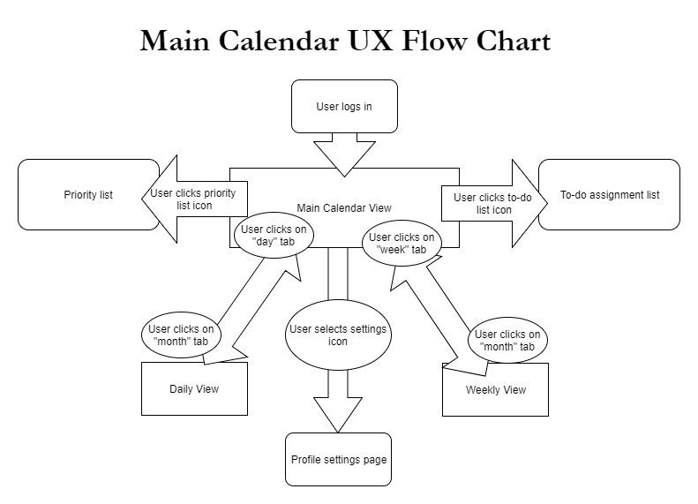](https://github.com/MCLifeLeader/CS364/blob/master/SDD/resources/Main%20Calendar%20UX%20Flow%20chart.jpg)

**Description:This image displays which features of the student calendar application are associated with the Main Calendar view and how the user can navigate between the pages.**

6.2.4.0

[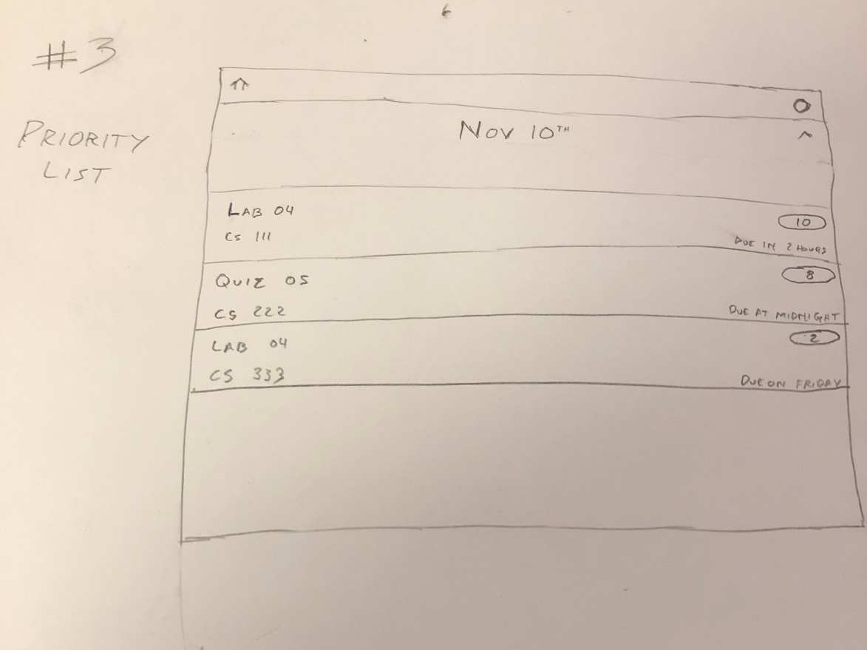](https://github.com/MCLifeLeader/CS364/blob/master/SDD/resources/3.2.4.0.jpg)

6.2.6.0

[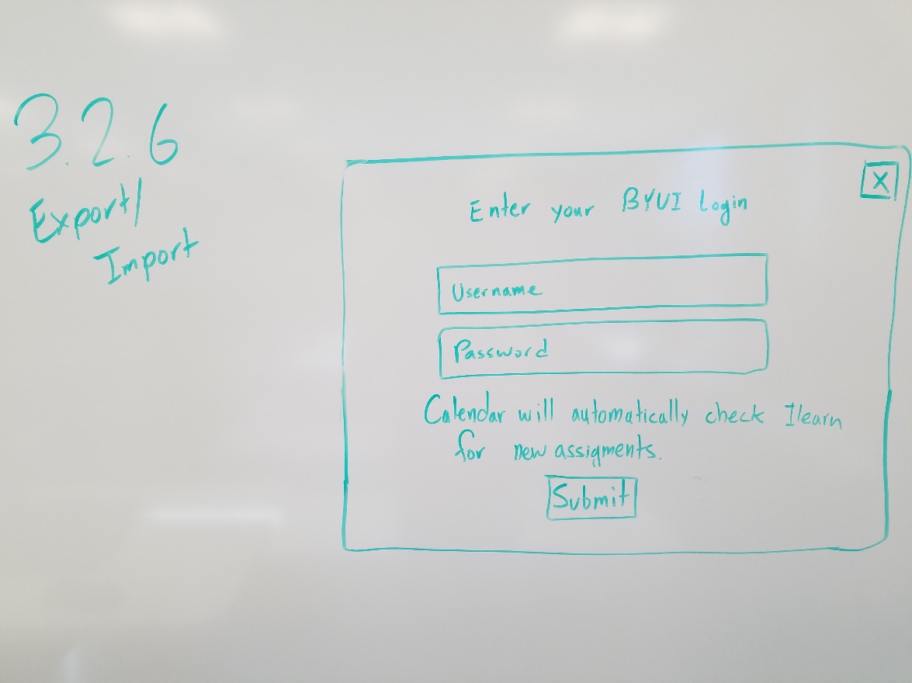](https://github.com/MCLifeLeader/CS364/blob/master/SDD/resources/3.2.6.0.jpg)

6.2.8.0

[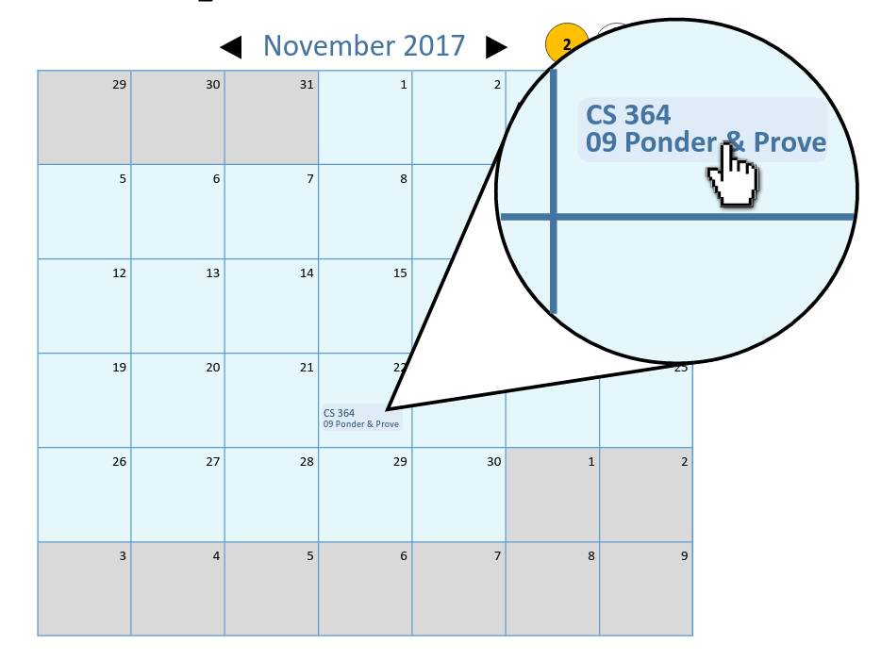](https://github.com/MCLifeLeader/CS364/blob/master/SDD/resources/3.2.8.0.png)

[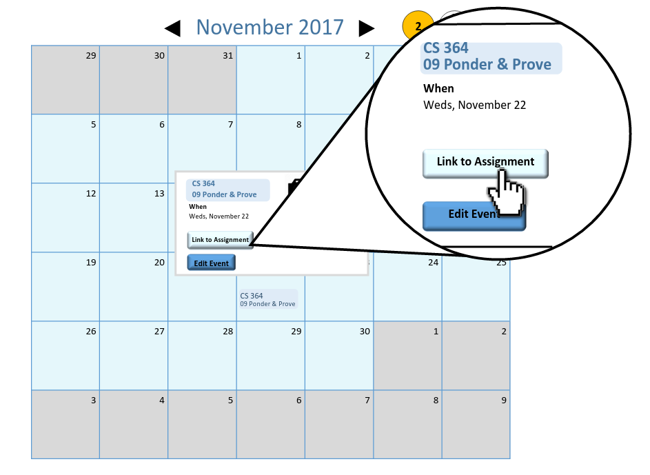](https://github.com/MCLifeLeader/CS364/blob/master/SDD/resources/3.2.8.1.png)

[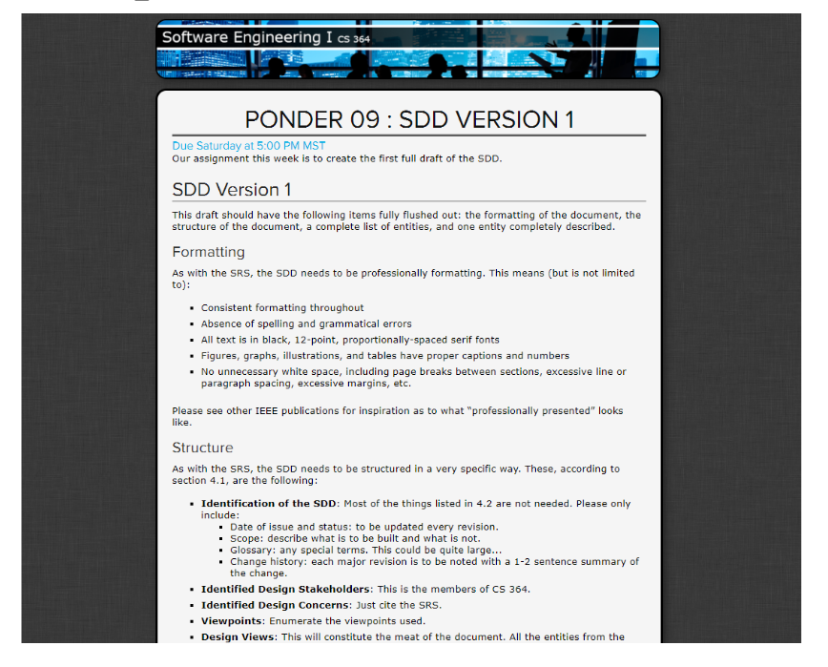](https://github.com/MCLifeLeader/CS364/blob/master/SDD/resources/3.2.8.2.png)

6.2.9.0

[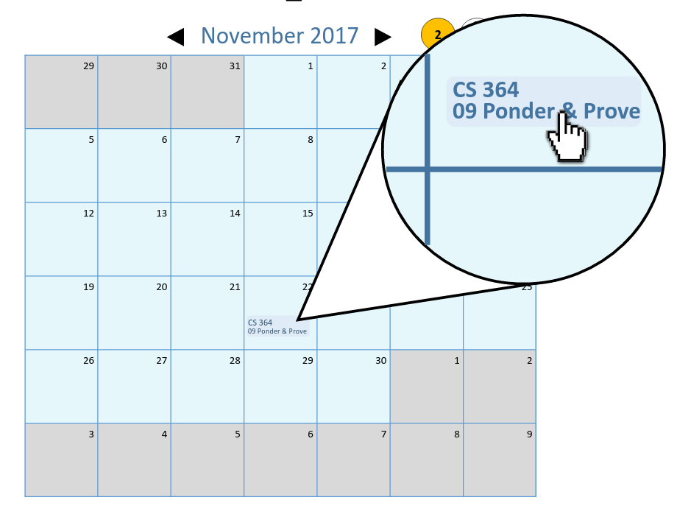](https://github.com/MCLifeLeader/CS364/blob/master/SDD/resources/3.2.9.0.png)

[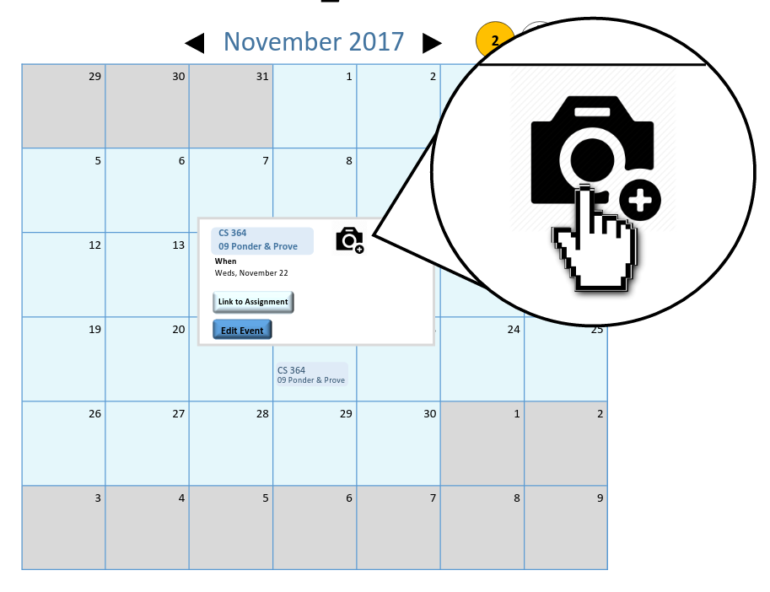](https://github.com/MCLifeLeader/CS364/blob/master/SDD/resources/3.2.9.1.png)

[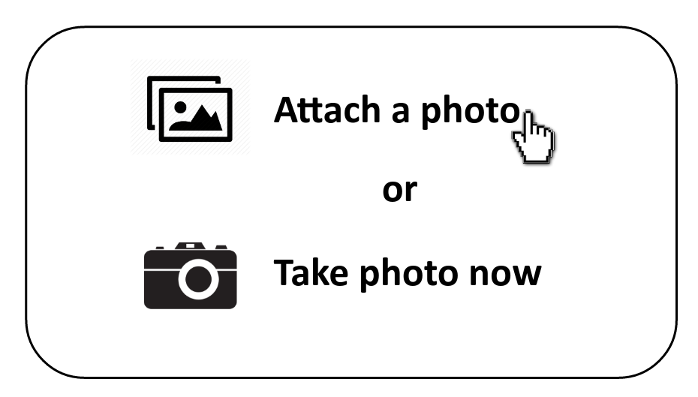](https://github.com/MCLifeLeader/CS364/blob/master/SDD/resources/3.2.9.2.png)

6.2.10.0

[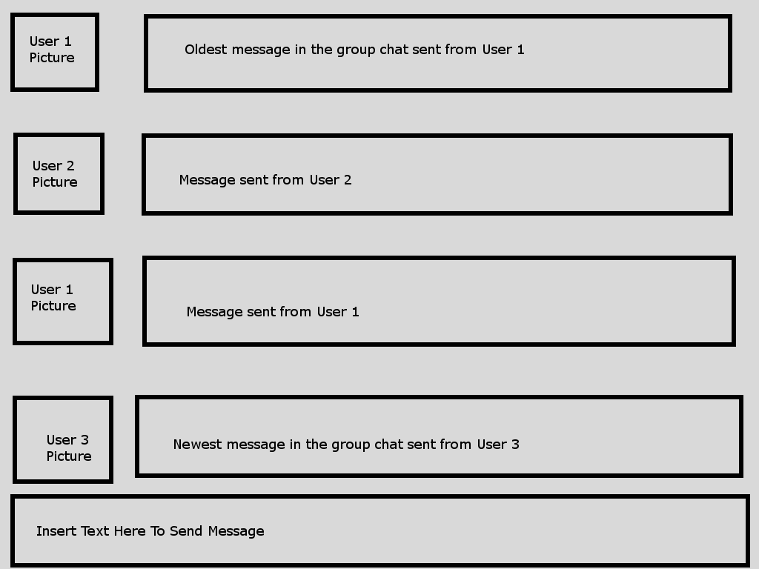](https://github.com/MCLifeLeader/CS364/blob/master/SDD/resources/3.2.10.0.png)

6.2.16.0

[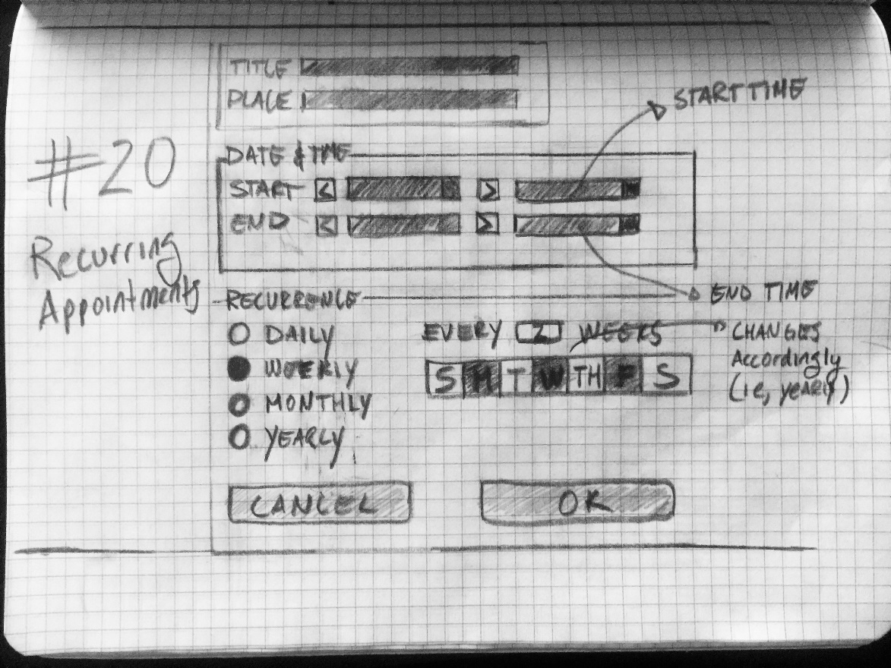](https://github.com/MCLifeLeader/CS364/blob/master/SDD/resources/3.2.16.0.jpg)

6.2.20.0

[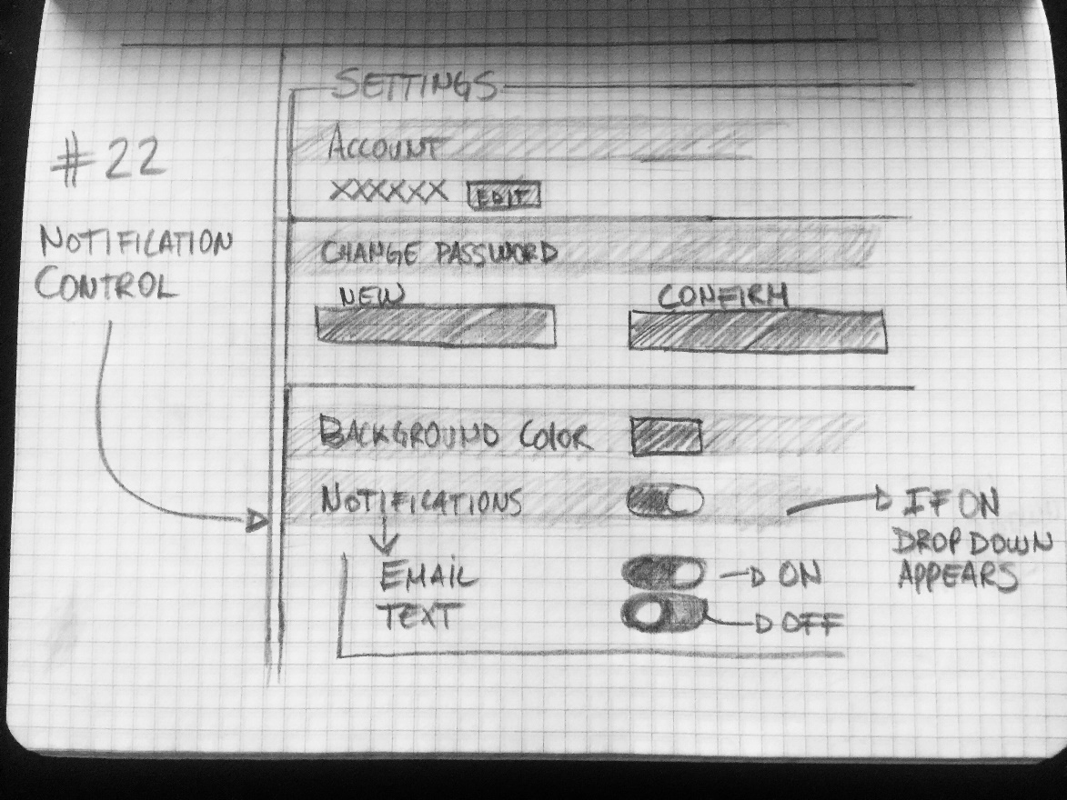](https://github.com/MCLifeLeader/CS364/blob/master/SDD/resources/3.2.20.0.jpg)

6.2.22.0

[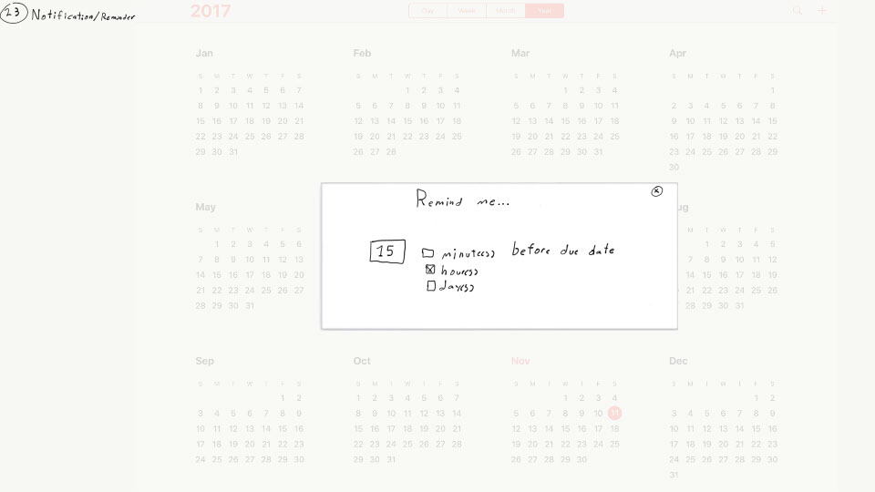](https://github.com/MCLifeLeader/CS364/blob/master/SDD/resources/3.2.22.0.jpg)

6.2.23.0

[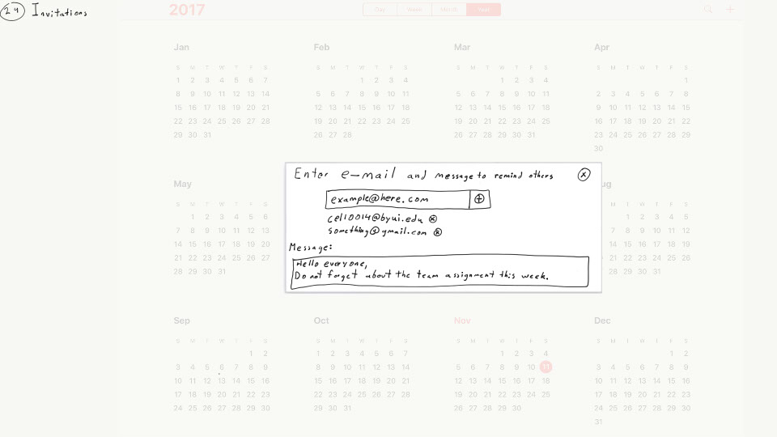](https://github.com/MCLifeLeader/CS364/blob/master/SDD/resources/3.2.23.0.jpg)

6.2.25.0

[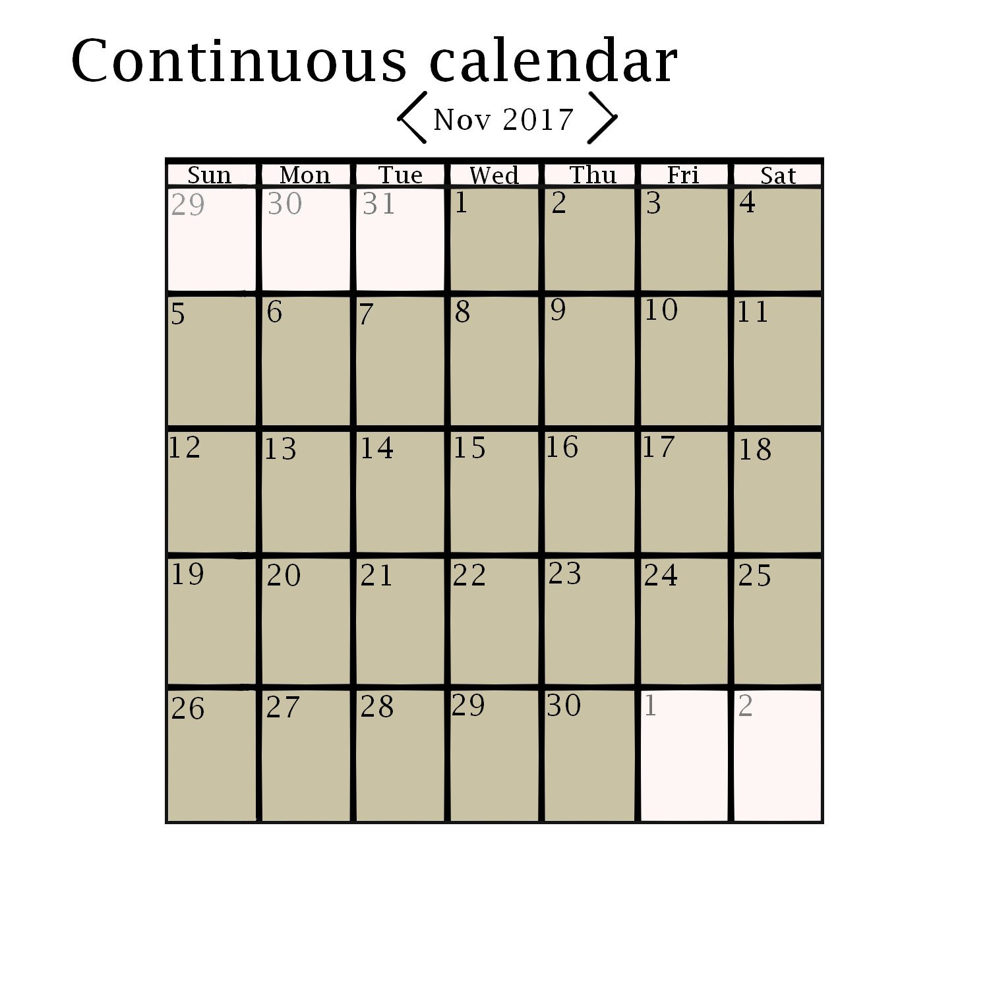](https://github.com/MCLifeLeader/CS364/blob/master/SDD/resources/3.2.25.0.jpg)

6.2.26.0

[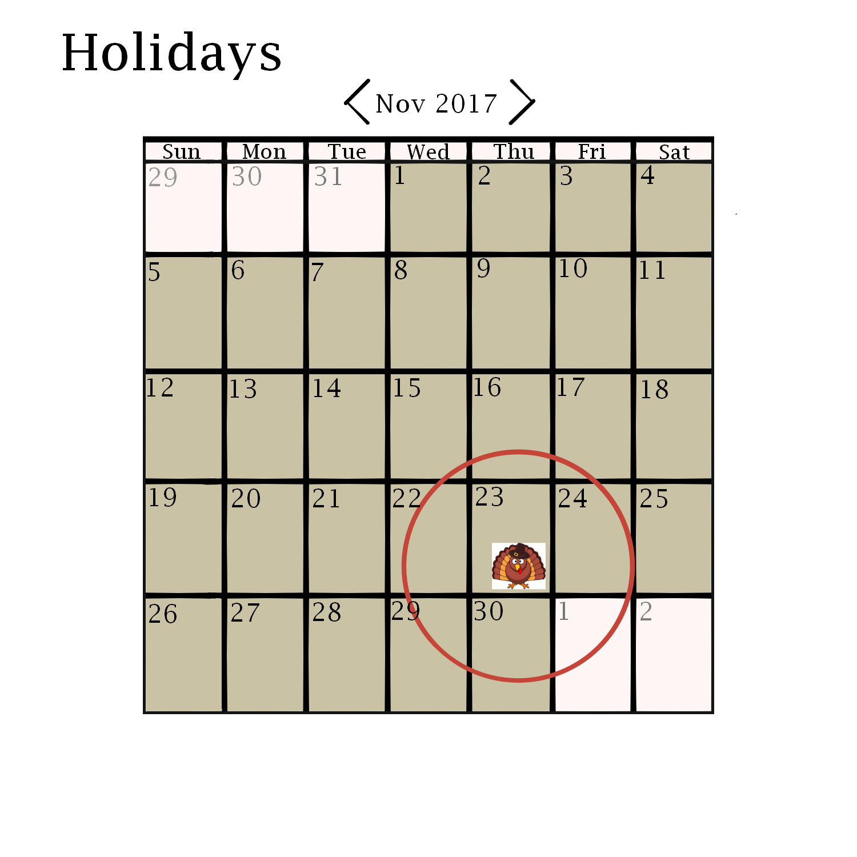](https://github.com/MCLifeLeader/CS364/blob/master/SDD/resources/3.2.26.0.jpg)

6.2.43.0

[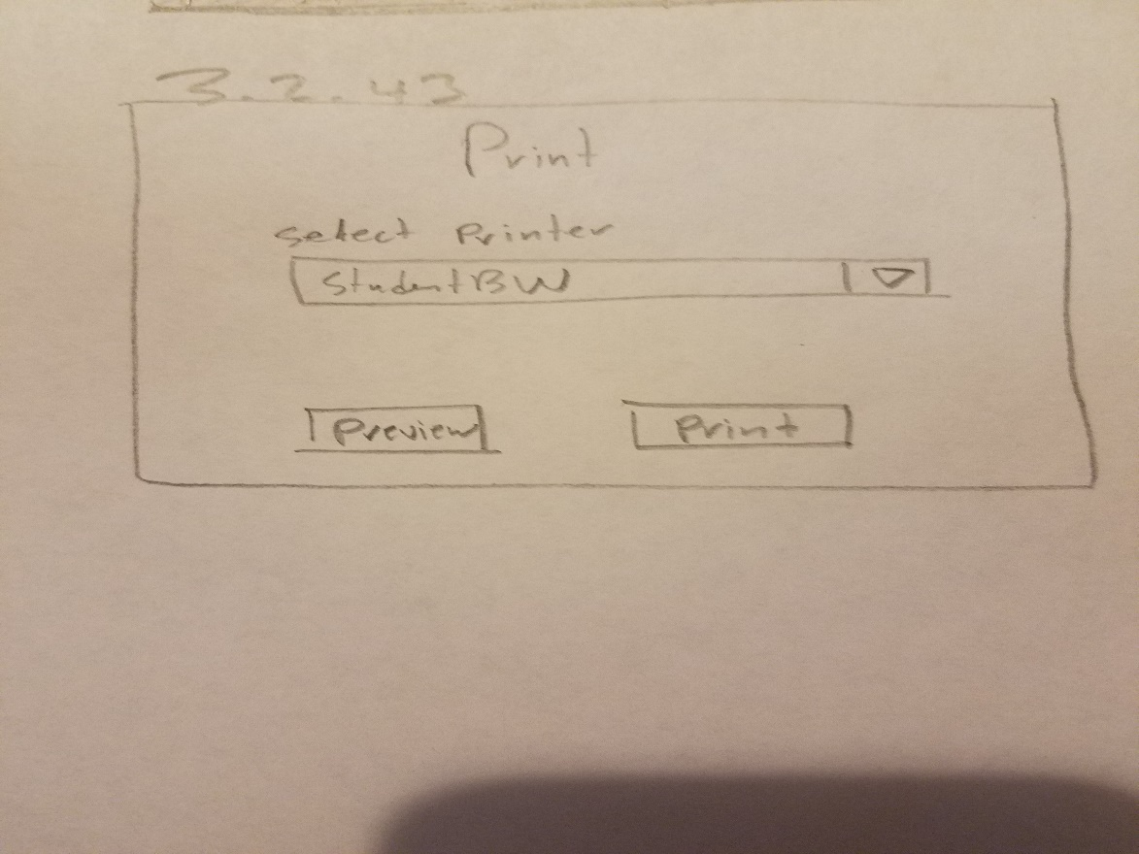](https://github.com/MCLifeLeader/CS364/blob/master/SDD/resources/3.2.43.0.jpg)

6.2.50.0

[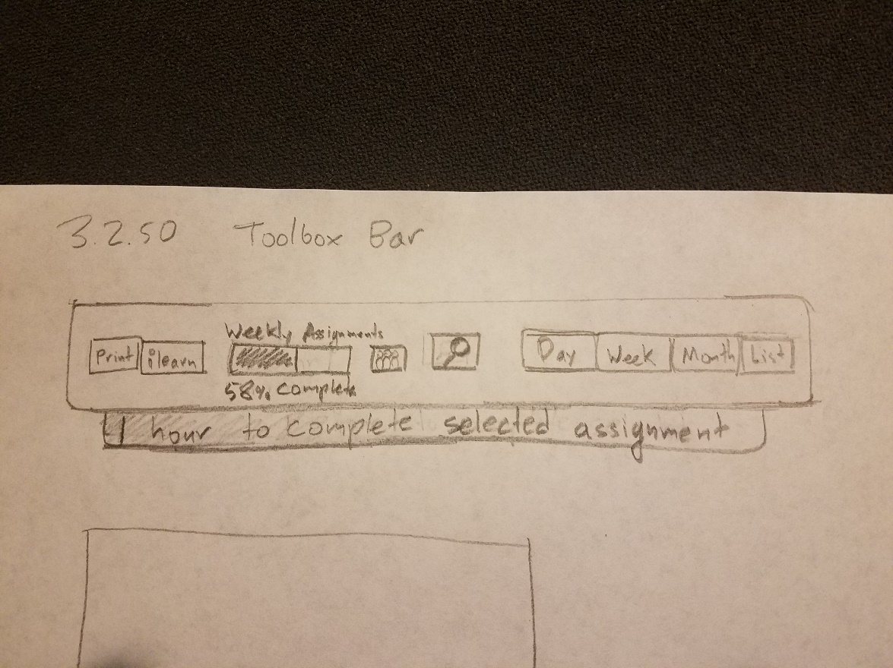](https://github.com/MCLifeLeader/CS364/blob/master/SDD/resources/3.2.50.0.jpg)

**Index**