1.Can we change the input dimension (784) in `fc1`? Why or why not?
No, since the images being analyzed are 28x28 pixels (784 total), reducing the input dimension would remove information from the image — it would no longer be the same image.

2. Can we change the output dimension (10) in `fc3`? Why or why not?
No, because this outputs 10 logits (predictions) for each digit 0-9. This must be 10, otherwise there will not be predictions for every digit. It would completely break the model.

3. Can we change the dimensions of the hidden layers (`256` or `128`)? Why or why not?
Yes, because these layers condense the initial 784-dimension vector into smaller vectors. It might affect the intelligence and output, but these layers can be adjusted with image size. They are hyperparameters.

Step 7: Analysis
Write a short report discussing the following points:
1. **Effect of Data Size:**
How did the amount of training data (10% vs 30%) affect your model’s generalization performance?
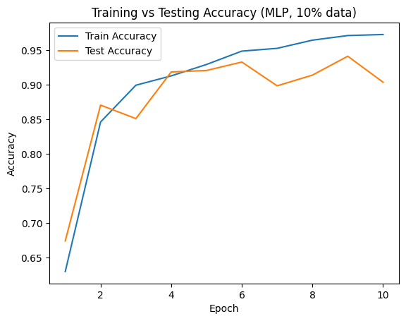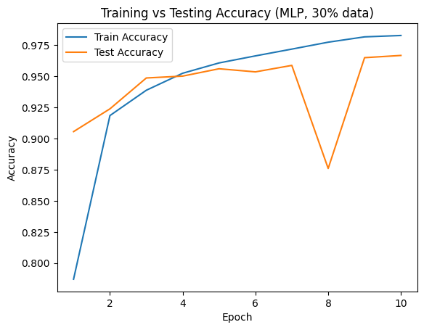
Using 30% of the training data improved the model’s generalization performance from when it was using 10% in the final epoch (88% -> 96%) and it improved its accuracy quicker at the start (first epoch 67% -> 90%). However, the improvement after that was marginal and less consistent than the model with 10% of the dataset (notice the big drop in epoch 8 for the 30% model).

2. **Effect of Model Architecture:**
How did different network architectures (MLP vs CNN) impact generalization?
Using CNN instead of MLP seemed to improve performance even before I started messing with hyper parameters (96% -> 98% in the final epoch). It also learned faster than the MLP (90% -> 95% in epoch 1) but after that the improvements were very marginal, even more so than the MLP with 30% of the dataset.

3. **Effect of Learning Rate:**
How did the choice of learning rate (and/or use of a learning rate scheduler) influence **convergence** speed and final performance?
I found that lower learning rates tended to slow convergence speed while larger learning rates made the convergence happen quicker. LR schedulers also slowed convergence speed. In general, lower learning rates improved final performance, as did using LR schedulers.

4. **Effective Design Choices:**
Which design decisions (e.g., number of layers, hidden dimension, activation functions, batch size) in your experiments contributed most to improving the model's generalization performance?
I found that adjusting the learning rate via hardcoding it or using schedulers contributed to the most improvement. Reducing batch size did improve performance, not by as much.

5. **Limitations and Improvement Strategies:**
What limitations or challenges did you observe in your experiments (e.g., overfitting, slow convergence, unstable training)?
Suggest one or two strategies that could further improve model performance.
I’d say overfitting was the biggest issue I ran into when trying to improve the model. I found that most changes I made with the LR lowered generalization performance, and it took a lot of tweaking to find one that improved the performance of the final epoch.
I think I could improve the model performance further by adding more transforms when training. I imagine this would help fight overfitting as the model could encounter more variations while training.

Use of AI (ChatGPT):
Asked how the MLP model works (showed it the code) to help answer questions 1-3
Asked it to create a code skeleton for CNN (see attached file)
I used it for debugging and explaining pytorch functions. Many of the comments I wrote are based off information it gave me when I asked how certain functions worked.
I also gave it code I had written and asked for suggestions on improvements. This often came down to reordering certain functions or adding activation functions in certain areas.

