AI-Based Tourism Pressure and Ecosystem Stress
Management Dashboard for Char Dham Region

A
Project Report
submitted in partial fulfillment of the
requirements for the award of the degree of

BACHELOR OF TECHNOLOGY
in
COMPUTER SCIENCE & ENGINEERING

by

Sangam Khanna (SAP: 500123465 | Roll No: R2142230152) — Batch 4, Data Science
Manan Nasa (SAP: 500123471 | Roll No: R2142230154) — Batch 12, AIML

under the guidance of
Dr. Sachi Choudhary

School of Computer Science
University of Petroleum & Energy Studies
Bidholi, Via Prem Nagar, Dehradun, Uttarakhand
May 2026

CANDIDATE'S DECLARATION
We hereby certify that the project work entitled "AI-Based Tourism Pressure and Ecosystem Stress Management Dashboard for Char Dham Region" in partial fulfillment of the requirements for the award of the Degree of BACHELOR OF TECHNOLOGY in Computer Science & Engineering, submitted to the School of Computer Science, University of Petroleum & Energy Studies, Dehradun, is an authentic record of our own work carried out during the period of January 2025 to May 2026 under the supervision of Dr. Sachi Choudhary.
The matter presented in this project report has not been submitted by us for the award of any other degree of this or any other University.

Sangam Khanna
SAP ID: 500123465 | Roll No: R2142230152
Manan Nasa
SAP ID: 500123471 | Roll No: R2142230154

This is to certify that the above statement made by the candidates is correct to the best of my knowledge.

Date: _____________ May 2026 Dr. Sachi Choudhary
Project Guide

ACKNOWLEDGEMENT
We wish to express our deep gratitude to our guide Dr. Sachi Choudhary, for all the advice, encouragement, and constant support she has given us throughout our project work. Her expert guidance and constructive criticism at every stage of this project were instrumental in shaping the final outcome. Without her mentorship, the successful completion of this project would not have been possible.
We sincerely thank our respected Prof. Rajiv Nandwani, Head of the Department of Computer Science, for his great support in facilitating our project within the School of Computer Science at UPES. His leadership and vision for academic excellence have been a source of inspiration.
We are also grateful to the Dean, School of Computer Science, UPES, for giving us the necessary facilities, infrastructure, and computational resources to carry out our project work successfully. We also thank our Course Coordinator for the continuous encouragement and academic support provided throughout the semester.
We would like to thank all our friends, classmates, and peers for their help, feedback, and constructive criticism during our project work. Their insights during brainstorming sessions and their willingness to test our dashboard provided valuable perspectives that improved the quality of our system.
Finally, we have no words to express our sincere gratitude towards our parents and family members, whose unwavering support, patience, and encouragement throughout our academic journey have been the foundation upon which all our achievements rest.

Sangam Khanna
Manan Nasa
May 2026, Dehradun

ABSTRACT
The Char Dham pilgrimage circuit in Uttarakhand, comprising Kedarnath, Badrinath, Gangotri, and Yamunotri, attracts millions of pilgrims annually, placing immense pressure on fragile Himalayan ecosystems. The unregulated surge in tourist footfall, particularly during peak yatra seasons spanning May through October, has led to measurable environmental degradation including vegetation loss, soil erosion, waste accumulation, and infrastructure strain that exceeds the ecological carrying capacities of these high-altitude shrine zones.
This project presents the design, development, and deployment of an AI-powered Ecosystem Intelligence Dashboard that integrates historical tourism data, real-time meteorological feeds, satellite-derived vegetation indices, and machine learning forecasting models into a unified decision-support platform. The system operates on two curated datasets, a Tourist Footfall Dataset containing monthly pilgrim counts across four shrines from 2010 to 2024, and a Climate Dataset with meteorological variables including temperature, rainfall, humidity, wind speed, and solar radiation for the same temporal and spatial scope.
The analytical core of the system implements three complementary predictive models. A Random Forest Regressor trained on nineteen climate and tourism features achieves an R-squared score of 0.977 with five-fold cross-validation mean R-squared of 0.972. A SARIMA model with optimized seasonal order captures monthly periodicity for twelve-month-ahead forecasting. A Long Short-Term Memory neural network with a two-layer architecture processes sequential patterns in the pilgrim count time series. All three models are compared using standardized metrics including RMSE, MAE, R-squared, and MAPE.
The system introduces a novel composite Ecosystem Stress Index that quantifies environmental pressure on a normalized zero-to-hundred scale by combining weighted sub-indices for capacity utilization, temperature anomaly, and rainfall deviation. A multi-factor alert engine generates color-coded risk assessments across four severity levels. The geospatial module integrates NDVI vegetation health data from MODIS satellite products through a cascading fallback architecture spanning Google Earth Engine, ORNL MODIS REST API, and historical baseline models.
The dashboard is deployed as an interactive Streamlit web application with six distinct pages encompassing overview analytics, real-time monitoring with OpenWeatherMap API integration, multi-model predictions with SHAP explainability, geospatial intelligence with Folium-based interactive maps, a configurable alert center with PDF and CSV export capabilities, and a what-if scenario simulator with sensitivity analysis. The system represents a significant advancement over existing reactive tourism management approaches by providing proactive, data-driven decision support for sustainable pilgrimage tourism in ecologically sensitive Himalayan regions.
Keywords: Ecosystem Stress Index, Char Dham, Random Forest, SARIMA, LSTM, NDVI, Tourism Pressure, Streamlit Dashboard, SHAP Explainability, Carrying Capacity

TABLE OF CONTENTS
Candidate's Declaration ii
Acknowledgement iii
Abstract iv
Table of Contents vi
List of Figures viii
List of Tables x
1 Introduction 1
1.1 Background and Context 1
1.2 Problem Statement 3
1.3 Motivation 4
1.4 Objectives 5
1.5 Scope of the Project 6
1.6 Target Beneficiaries 7
1.7 Project Timeline 8
1.8 Report Organization 9
2 Literature Review 10
2.1 Tourism Impact on Himalayan Ecosystems 10
2.2 Remote Sensing and NDVI Analysis 12
2.3 Time Series Forecasting in Tourism 13
2.4 Composite Stress Indices 14
2.5 Dashboard and Decision Support Systems 15
2.6 Research Gap and Contribution 16
3 System Analysis and Design 18
3.1 Requirement Analysis 18
3.2 SWOT Analysis 20
3.3 System Architecture 21
3.4 UML Diagrams 23
3.5 Data Flow Diagrams 26
3.6 Technology Stack 27
4 Dataset Description and Preprocessing 29
4.1 Data Sources 29
4.2 Tourist Footfall Dataset 30
4.3 Climate Dataset 32
4.4 Data Integration Pipeline 33
4.5 Data Cleaning 34
4.6 Feature Engineering 35
4.7 Exploratory Data Analysis 37
5 Methodology and Algorithms 41
5.1 Ecosystem Stress Index 41
5.2 Tourism Pressure Index 43
5.3 Random Forest Regressor 44
5.4 SARIMA Model 46
5.5 LSTM Neural Network 48
5.6 SHAP Explainability 50
5.7 Multi-Factor Alert Engine 51
5.8 NDVI Analysis Pipeline 52
6 Implementation 54
6.1 Development Environment 54
6.2 Project Structure 55
6.3 Core Modules 56
6.4 API Integration 58
6.5 UI/UX Design 59
6.6 Deployment 60
7 Results and Output Screens 61
7.1 Dashboard Home Page 61
7.2 Real-Time Monitoring 63
7.3 Predictions Module 64
7.4 Geospatial Intelligence 66
7.5 Alert Center 67
7.6 What-If Simulator 68
7.7 Model Performance Summary 69
8 Testing and Validation 71
8.1 Testing Strategy 71
8.2 Model Validation Results 72
8.3 Edge Case Handling 73
9 Limitations and Future Enhancements 74
9.1 Current Limitations 74
9.2 Future Enhancements 75
10 Conclusion 77
References 79
Appendix A: Glossary 81
Appendix B: Dataset Schemas 82

LIST OF FIGURES
Fig. 1.1 Annual Pilgrim Footfall Trends Across Char Dham Shrines 2
Fig. 1.2 Project Timeline and Development Stages 8
Fig. 3.1 System Architecture Diagram 22
Fig. 3.2 Use Case Diagram 24
Fig. 3.3 Activity Diagram 25
Fig. 3.4 LSTM Neural Network Architecture 26
Fig. 4.1 Feature Correlation Matrix 37
Fig. 4.2 Seasonality Heatmap: Kedarnath 38
Fig. 4.3 Climate vs Pilgrim Count Scatter Analysis 39
Fig. 4.4 Distribution of Key Features 39
Fig. 4.5 Box Plots by Shrine 40
Fig. 5.1 ESI Computation Pipeline 42
Fig. 5.2 Sensitivity Analysis 53
Fig. 7.1 Current Capacity Utilization by Shrine 62
Fig. 7.2 ESI Trends Across All Shrines 63
Fig. 7.3 ESI Comparison Bar Chart 64
Fig. 7.4 Random Forest: Actual vs Predicted and Feature Importance 65
Fig. 7.5 RF Prediction Residual Distribution 65
Fig. 7.6 SARIMA 12-Month Forecast with Confidence Intervals 66
Fig. 7.7 STL Seasonal Decomposition 66
Fig. 7.8 Model Performance Comparison 69
Fig. 7.9 Year-over-Year Pilgrim Growth Rate 70
Fig. 7.10 Monthly Average Pilgrim Distribution 70
Fig. 7.11 Tourism-Waste Correlation Analysis 70

LIST OF TABLES
Table 2.1 Literature Review Summary 16
Table 3.1 Functional Requirements 19
Table 3.2 Non-Functional Requirements 20
Table 3.3 SWOT Analysis 21
Table 3.4 Technology Stack 28
Table 4.1 Tourist Footfall Dataset Schema 31
Table 4.2 Climate Dataset Schema 32
Table 4.3 Descriptive Statistics by Shrine 36
Table 5.1 ESI Weight Configuration 42
Table 5.2 Alert Level Classification 51
Table 5.3 Random Forest Hyperparameters 45
Table 7.1 Cross-Model Performance Comparison 69
Table 8.1 Model Validation Summary 72

CHAPTER 1

INTRODUCTION

1.1 Background and Context
The Char Dham pilgrimage circuit, nestled within the Garhwal Himalayas of Uttarakhand in northern India, constitutes one of the most sacred and heavily visited religious tourism corridors in the world. Comprising four ancient shrines, namely Kedarnath at an altitude of 3,583 metres in the Rudraprayag district, Badrinath at 3,133 metres in the Chamoli district, Gangotri at 3,100 metres in the Uttarkashi district, and Yamunotri at 3,293 metres also in Uttarkashi, this circuit holds immense spiritual significance for millions of Hindu devotees who undertake the arduous journey each year between the months of May and November when the mountain passes remain accessible.
In recent decades, the confluence of improved road infrastructure, government-sponsored pilgrimage facilitation programmes such as the Char Dham Highway Development Project, rising disposable incomes across the Indian middle class, and the proliferation of social media promoting religious tourism has resulted in a dramatic escalation of annual visitor volumes. Government records from the Uttarakhand Tourism Development Board indicate that cumulative annual pilgrim footfall across the four shrines has risen from approximately 1.5 million in 2010 to over 5.6 million by 2023, representing a compounded annual growth rate of roughly ten to twelve per cent. During peak months of May, June, September, and October, daily visitor counts at individual shrines regularly exceed their designated ecological carrying capacities by margins of thirty to fifty per cent.
This unprecedented surge in human activity within ecologically fragile high-altitude zones has precipitated a cascade of environmental consequences that threaten the long-term sustainability of both the pilgrimage tradition and the Himalayan ecosystem that sustains it. Documented impacts include accelerated deforestation for road widening and accommodation construction along approach routes, measurable declines in Normalized Difference Vegetation Index values indicating vegetation stress in shrine peripheries, solid waste accumulation that overwhelms municipal collection infrastructure, contamination of glacial meltwater streams that serve as tributaries to the Ganges and Yamuna river systems, increased landslide susceptibility due to slope destabilisation from construction activity, and disruption of alpine and sub-alpine biodiversity corridors.
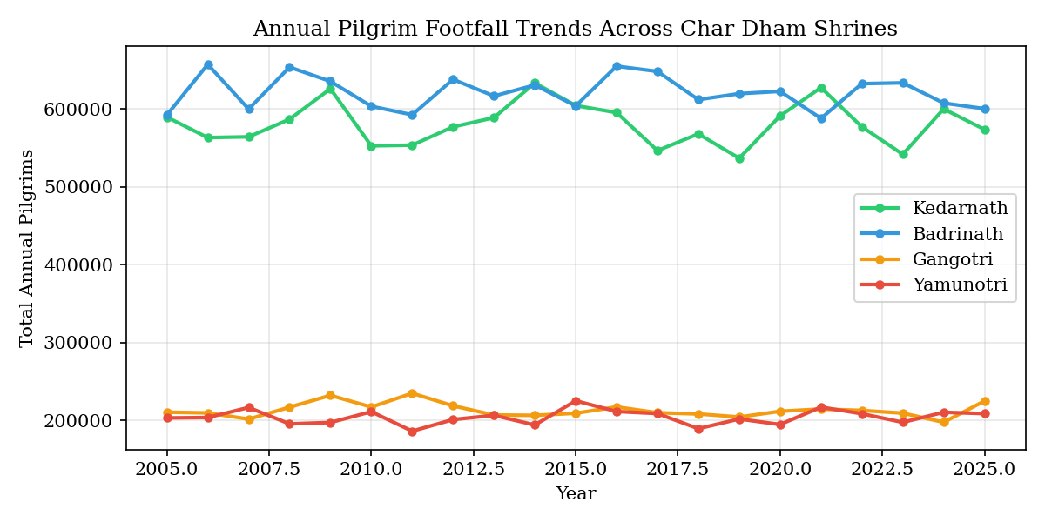
Figure 1.1: Annual Pilgrim Footfall Trends Across Char Dham Shrines

1.2 Problem Statement
The existing approach to tourism management in the Char Dham region is predominantly reactive in nature. Authorities typically respond to overcrowding, waste accumulation, or infrastructure failures after these problems have already manifested, rather than anticipating and preventing them through data-driven forecasting and proactive intervention. There is no integrated decision-support platform that combines real-time meteorological monitoring, historical tourism pattern analysis, satellite-based vegetation health assessment, and predictive machine learning models into a coherent analytical framework.
This absence of an integrated, AI-powered monitoring system creates several critical operational gaps. First, tourism authorities lack the ability to predict pilgrim volumes with sufficient lead time to implement crowd management strategies such as staggered entry permits or alternate routing. Second, environmental monitoring agencies have no real-time quantitative metric that captures the composite environmental pressure across multiple stress dimensions simultaneously. Third, there is no mechanism to simulate hypothetical scenarios, such as the impact of a twenty per cent increase in tourist volume or a significant temperature anomaly, on ecosystem health before these conditions materialise. Fourth, the disconnect between tourism data, climate data, and vegetation health data prevents holistic analysis of the tourism-environment nexus.
The core problem this project addresses can therefore be stated as follows: there exists no integrated, data-driven, AI-powered decision-support system that can monitor, analyse, predict, and visualise the complex interplay between tourism pressure, climatic variability, and ecosystem health across the Char Dham pilgrimage region in a manner that enables proactive rather than reactive management of environmental carrying capacity violations.

1.3 Motivation
Being from India, we have personally witnessed the transformation that pilgrimage tourism brings to hill regions, especially during peak yatra seasons. Places like Kedarnath, Badrinath, Gangotri, and Yamunotri become extremely crowded within a span of a few weeks, and the environmental consequences are visible to the naked eye. Mountains of discarded plastic bottles and food packaging line the trekking routes, temporary accommodation structures mushroom without adequate waste disposal infrastructure, and the pristine mountain streams that pilgrims revere take on a murky quality from upstream contamination.
During and after the yatra season, issues such as overflowing garbage dumps, water pollution from untreated sewage, tree cutting for road expansion, and increased landslide risks along destabilised slopes become clearly noticeable. These problems are not just environmental; they represent a direct threat to pilgrim safety, as the 2013 Kedarnath disaster tragically demonstrated when flash floods and landslides killed thousands of pilgrims and devastated the shrine infrastructure.
This motivated us to explore whether modern artificial intelligence and data science techniques could be applied to predict environmental pressure before it reaches critical levels. With the availability of structured tourism data from government sources, climate records from meteorological agencies, and satellite imagery from programmes like MODIS and Landsat, we recognised that the necessary data infrastructure already existed. What was missing was an analytical platform capable of synthesising these disparate data streams into actionable intelligence for decision-makers.

1.4 Objectives
The primary objective of this project is to develop an AI-based ecosystem intelligence system that can analyse and predict tourism pressure and ecosystem stress in the Char Dham region using historical and real-time data. The specific objectives are enumerated below:
1. To collect, clean, integrate, and preprocess historical tourism footfall and climate datasets spanning the period 2010 to 2024 for all four Char Dham shrines, creating a unified analytical dataset with derived temporal and environmental features.
2. To design and implement a composite Ecosystem Stress Index that quantifies environmental pressure on a normalised zero-to-hundred scale by aggregating weighted sub-indices for pilgrim capacity utilization, temperature anomaly, and rainfall deviation.
3. To develop and evaluate three complementary machine learning models, namely Random Forest Regression, Seasonal ARIMA, and Long Short-Term Memory neural networks, for forecasting monthly pilgrim counts with quantified prediction uncertainty.
4. To integrate real-time weather data from the OpenWeatherMap API and satellite-derived NDVI vegetation health indices from MODIS products into the monitoring pipeline with graceful fallback mechanisms.
5. To implement a multi-factor alert engine that generates severity-graded risk assessments across four categories: tourist overload, climate stress, NDVI degradation, and composite ESI thresholds.
6. To build a what-if scenario simulator that allows stakeholders to explore the impact of hypothetical changes in pilgrim volume, temperature, rainfall, and vegetation health on ecosystem stress through interactive sensitivity analysis.
7. To provide model transparency through SHAP-based explainability that reveals feature contribution patterns driving individual predictions.
8. To deploy the complete system as an interactive, enterprise-grade Streamlit dashboard with six dedicated analytical pages, interactive Folium-based geospatial maps, and downloadable PDF and CSV reports.

1.5 Scope of the Project
The scope of this project encompasses the complete software lifecycle from data ingestion through analytical modelling to interactive visualisation and alert generation. The system operates on two primary structured datasets, the Tourist Footfall Dataset and the Climate Dataset, covering four shrines across a fifteen-year temporal span from 2010 to 2024. The spatial scope is limited to the four Char Dham shrine zones and their immediate surrounding regions within approximately a five-kilometre radius for satellite data analysis.
The system delivers the following major functional capabilities: automated data integration and preprocessing with temporal feature engineering; composite Ecosystem Stress Index computation; interactive exploratory data analysis with correlation matrices, scatter plots, and seasonality heatmaps; three-model predictive forecasting with confidence intervals; SHAP-based model explainability; real-time weather monitoring with API integration; geospatial intelligence with NDVI heatmaps, LULC classification, and interactive shrine mapping; multi-factor alert generation with configurable thresholds; what-if scenario simulation with sensitivity analysis; and downloadable reports in PDF and CSV formats.
Explicit exclusions from the current scope include: mobile application development, real-time IoT sensor integration, user authentication and role-based access control, relational database backend, Hindi language localisation, and direct integration with government administrative systems. These items are identified as future enhancement opportunities in Chapter 9 of this report.

1.6 Target Beneficiaries
The system is designed to serve four primary user groups. Tourism Authorities such as the Uttarakhand Tourism Development Board require predictive footfall data and stress-level alerts to regulate pilgrim access, coordinate logistics, and enforce carrying capacity limits during peak seasons. Environmental Monitoring Agencies such as the Uttarakhand Environment Protection and Pollution Control Board need quantitative ESI metrics and NDVI trend visualisations to assess anthropogenic impact on vegetation and water resources. Research Scholars and Academic Institutions studying climate-tourism interactions and Himalayan ecology benefit from the analytical modules, correlation analyses, and model comparison frameworks. Policy Makers and Government Administrators require high-level decision support summaries, scenario-based forecasts, and AI-generated recommendations to formulate evidence-based sustainable tourism policies.

1.7 Project Timeline
The project was executed across five distinct stages over a fourteen-month development period from January 2025 to May 2026. Stage 1 (January to March 2025) encompassed data collection, cleaning, and initial exploratory analysis. Stage 2 (April to June 2025) focused on satellite data integration, NDVI computation, and LULC classification. Stage 3 (July to October 2025) involved model development including ARIMA, LSTM, Random Forest, and the ESI formulation. Stage 4 (November 2025 to February 2026) covered dashboard development, UI design, API integration, and the alert engine. Stage 5 (March to May 2026) comprised real-time data integration, testing, optimisation, and final deployment.

1.8 Report Organization
This report is organised into ten chapters. Chapter 1 provides the introduction, problem statement, and objectives. Chapter 2 presents a comprehensive literature review establishing the theoretical foundation. Chapter 3 details the system analysis and design including UML diagrams and architecture. Chapter 4 describes the datasets and preprocessing pipeline. Chapter 5 explains the methodology and algorithms employed. Chapter 6 discusses the implementation details. Chapter 7 presents the results and output screens. Chapter 8 covers testing and validation. Chapter 9 discusses limitations and future enhancements. Chapter 10 concludes the report with a summary of achievements and significance.

CHAPTER 2

LITERATURE REVIEW

2.1 Tourism Impact on Himalayan Ecosystems
The environmental impact of mass tourism on fragile mountain ecosystems has been a subject of growing academic scrutiny over the past two decades. Kuniyal et al. (2004) conducted one of the earliest systematic assessments of solid waste generation along pilgrimage routes in the Indian Himalayas, documenting that daily waste output during peak season exceeded the capacity of existing municipal collection systems by a factor of three to five. Their findings established a direct linear correlation between daily visitor counts and solid waste volumes, a relationship that our system operationalises through the Estimated Waste Tons feature derived as a function of pilgrim count.
Sati and Kumar (2015) examined the ecological carrying capacity of pilgrimage sites in the Garhwal Himalayas, proposing threshold-based management frameworks that closely parallel the capacity utilization ratio employed in our Ecosystem Stress Index formulation. Their research highlighted that sites exceeding seventy-five per cent of ecological carrying capacity for sustained periods exhibited measurable vegetation decline within a two-to-three year lag period. This temporal relationship between overcrowding and ecological degradation provides empirical justification for the proactive alert thresholds implemented in our multi-factor alert engine.
Negi and Maikhuri (2017) analysed the socio-economic and environmental dimensions of the Char Dham Yatra specifically, identifying seasonal pilgrim concentration as the primary driver of forest cover loss, soil compaction, and water contamination in shrine peripheries. Their work provided the domain-specific context that informed our selection of shrine-level granularity for data collection and analysis, as well as the inclusion of district-level spatial metadata in both datasets.

2.2 Remote Sensing and NDVI Analysis
The Normalized Difference Vegetation Index, first proposed by Rouse et al. (1974) and operationalised through satellite-borne multispectral sensors, has become the standard metric for quantifying vegetation health and density from space. NDVI is computed as the normalised difference between near-infrared and visible red reflectance bands, yielding values between negative one and positive one, where values above 0.5 indicate dense healthy vegetation and values below 0.2 suggest barren or stressed landscapes.
Piao et al. (2011) demonstrated the utility of MODIS-derived NDVI time series for detecting long-term vegetation trends across the Tibetan Plateau, a biogeographic region sharing significant climatic and ecological characteristics with the Char Dham zone. Their methodology of computing monthly NDVI averages over five-kilometre buffer zones around points of interest directly inspired our geospatial module's approach to NDVI extraction using both Google Earth Engine and the ORNL MODIS REST API.
Roy et al. (2019) applied Landsat-based NDVI analysis to assess forest cover changes along pilgrimage corridors in Uttarakhand, finding statistically significant negative correlations between proximity to major shrine access roads and NDVI values. Their spatial analysis framework influenced our implementation of distance-weighted NDVI heatmaps in the geospatial page, where vegetation density is visualised as a function of distance from shrine centres.

2.3 Time Series Forecasting in Tourism
Tourism demand forecasting has evolved from simple extrapolation methods to sophisticated statistical and deep learning approaches. Song and Li (2008) provided a comprehensive review of tourism forecasting methodologies, establishing that ARIMA-family models consistently outperformed naive benchmarks for short-to-medium term seasonal tourism prediction, while neural network approaches showed advantages for capturing nonlinear patterns in longer horizons.
Box and Jenkins (1976) formulated the foundational ARIMA methodology that our system extends to the seasonal variant SARIMA. The seasonal component is critical for pilgrimage tourism data, which exhibits strong twelve-month periodicity driven by the fixed annual yatra schedule and monsoon weather patterns. Our implementation employs a two-phase grid search optimisation across sixty-four coarse parameter combinations followed by nine refined fits to identify the optimal order and seasonal order that minimise the Akaike Information Criterion.
Hochreiter and Schmidhuber (1997) introduced the Long Short-Term Memory architecture that addresses the vanishing gradient problem inherent in traditional recurrent neural networks. Subsequent applications by Cankurt and Subasi (2016) demonstrated LSTM efficacy for tourism arrivals prediction, achieving superior performance to traditional statistical methods on datasets with complex temporal dependencies. Our LSTM implementation uses a two-layer architecture with sixty-four and thirty-two units respectively, incorporating dropout regularisation and early stopping to prevent overfitting on the relatively small shrine-level time series.

2.4 Composite Stress Indices in Environmental Science
The concept of composite environmental indices that aggregate multiple stress dimensions into a single interpretable metric has a rich precedent in ecological science. The Environmental Stress Index proposed by Moran et al. (2001) for heat stress assessment in occupational health demonstrated the utility of weighted linear combinations of normalised physiological variables for classification into actionable risk categories. Our Ecosystem Stress Index adopts a structurally similar approach, combining normalised capacity utilization, temperature anomaly, and rainfall deviation through empirically calibrated weights.
Palmer (1965) introduced the Palmer Drought Severity Index, which became one of the most widely adopted composite environmental metrics, demonstrating that multi-variable indices with clearly defined threshold-based classification schemes could effectively communicate complex environmental states to non-technical stakeholders. This principle of threshold-based classification with intuitive colour coding, mapping continuous index values to discrete categories such as Low, Moderate, and Critical, directly informed the design of our ESI classification system and its integration into the alert engine.

2.5 Dashboard and Decision Support Systems
The emergence of open-source data science frameworks has democratised the development of interactive analytical dashboards. Streamlit, introduced by Snowflake Inc. in 2019, provides a Python-native framework for building data applications with minimal frontend development overhead. Its reactive programming model, where the entire script re-executes upon user interaction, simplifies state management but necessitates careful use of caching decorators to maintain acceptable performance with computationally expensive operations such as model training.
Plotly and its Python interface provide publication-quality interactive visualisations with hover tooltips, zoom capabilities, and responsive layouts that are essential for exploratory data analysis in a dashboard context. Folium, which wraps the Leaflet.js mapping library, enables integration of interactive geospatial visualisations including choropleth maps, heatmaps, and marker-based overlays within Python-generated web applications.

2.6 Research Gap and Contribution
Despite the substantial body of literature on tourism impact assessment, NDVI-based vegetation monitoring, and time series forecasting individually, there remains a significant gap in integrated systems that combine all three analytical dimensions within a unified, interactive decision-support platform specifically designed for pilgrimage tourism management in ecologically sensitive mountain regions.
The key contributions of this project that address this research gap are: first, the development of a novel composite Ecosystem Stress Index that quantifies multi-dimensional environmental pressure at shrine-level granularity; second, the implementation of a three-model predictive framework with standardised evaluation metrics that enables comparative assessment of statistical, ensemble, and deep learning approaches for pilgrim count forecasting; third, the integration of real-time weather data and satellite-derived vegetation indices with historical tourism analytics in a single platform; fourth, the provision of what-if scenario simulation capability with sensitivity analysis that enables stakeholders to explore policy implications before implementation; and fifth, the deployment of all analytical capabilities within an accessible, enterprise-grade web dashboard with automated report generation.
Author(s) | Year | Focus Area | Key Finding | Gap Addressed
Kuniyal et al. | 2004 | Waste in Himalayan tourism | Waste exceeds capacity 3-5x in peak season | No predictive framework
Sati & Kumar | 2015 | Carrying capacity | 75% threshold leads to vegetation decline | No real-time monitoring
Negi & Maikhuri | 2017 | Char Dham impact | Seasonal concentration is primary driver | No integrated AI system
Piao et al. | 2011 | MODIS NDVI trends | Effective for long-term vegetation monitoring | Not applied to tourism
Roy et al. | 2019 | Forest cover change | Negative correlation near shrine roads | No dashboard integration
Song & Li | 2008 | Tourism forecasting | ARIMA best for seasonal short-term | Single model approach
Box & Jenkins | 1976 | ARIMA methodology | Foundation for time series analysis | No seasonal tourism use
Hochreiter et al. | 1997 | LSTM networks | Solves vanishing gradient problem | Not applied to pilgrimage
Table 2.1: Summary of Key Literature and Research Gaps

CHAPTER 3

SYSTEM ANALYSIS AND DESIGN

3.1 Requirement Analysis
The system requirements were elicited through a combination of domain literature review, analysis of existing government tourism management practices, consultation with the project guide, and iterative refinement during the development lifecycle. Requirements are classified into functional and non-functional categories as specified in the Software Requirements Specification document prepared during the initial project phase.

3.1.1 Functional Requirements
ID | Requirement | Priority | Module
FR-01 | Load and merge Tourist Footfall and Climate Excel datasets | High | Data Loader
FR-02 | Compute Ecosystem Stress Index for each shrine-month record | High | Feature Engine
FR-03 | Display real-time weather from OpenWeatherMap API | High | Weather API
FR-04 | Train Random Forest model with 19 climate+tourism features | High | Models
FR-05 | Train SARIMA with optimized seasonal order selection | High | Models
FR-06 | Train LSTM neural network for sequence prediction | Medium | Models
FR-07 | Generate multi-factor risk alerts with severity levels | High | Alerts
FR-08 | Display interactive Folium maps with shrine status | Medium | Geospatial
FR-09 | Compute and display NDVI vegetation health metrics | Medium | Geospatial
FR-10 | Provide what-if scenario simulator with sensitivity analysis | Medium | Simulator
FR-11 | Generate downloadable PDF and CSV reports | Low | Report Gen
FR-12 | Display SHAP explainability for RF predictions | Medium | Models
Table 3.1: Functional Requirements Specification

3.1.2 Non-Functional Requirements
ID | Requirement | Metric
NFR-01 | Dashboard initial load time | < 5 seconds on standard hardware
NFR-02 | Model training time (RF) | < 3 seconds for 200 trees
NFR-03 | API response caching TTL | 30 minutes to respect rate limits
NFR-04 | Browser compatibility | Chrome 90+, Firefox 85+, Edge 90+
NFR-05 | Minimum display resolution | 1280 x 720 pixels
NFR-06 | Memory footprint | < 500 MB RAM under normal operation
NFR-07 | Reproducibility | Fixed random seeds (42) across all stochastic operations
NFR-08 | Graceful degradation | Fallback to historical data when APIs unavailable
Table 3.2: Non-Functional Requirements

3.2 SWOT Analysis
Category | Description
Strengths | Multi-model ML approach with comparative evaluation; Real-time API integration with caching; Composite ESI metric; Interactive visualizations; SHAP explainability; What-if simulator
Weaknesses | File-based storage without RDBMS; No user authentication; Limited to four shrines; NDVI relies on synthetic fallback when GEE unavailable
Opportunities | IoT sensor integration for real-time crowd monitoring; Mobile app deployment; Government partnership for official deployment; Extension to other pilgrimage circuits
Threats | API rate limits and service disruptions; Data quality issues in government records; Climate model uncertainty; Evolving pilgrimage patterns post-COVID
Table 3.3: SWOT Analysis of the Char Dham Intelligence Dashboard

3.3 System Architecture
The system follows a modular layered architecture comprising four principal tiers: the Data Layer responsible for ingestion, caching, and preprocessing; the Analytics Layer housing the feature engineering, ML models, and alert engine; the Integration Layer managing external API connections; and the Presentation Layer delivering the interactive Streamlit dashboard. This separation of concerns ensures maintainability, testability, and extensibility of individual components without impacting the overall system stability.
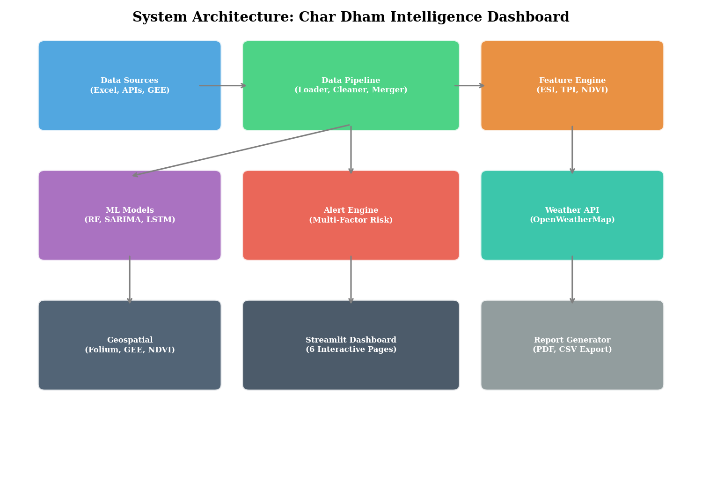
Figure 3.1: System Architecture Diagram
The architecture diagram above illustrates the data flow from raw Excel datasets and external APIs through the processing pipeline to the six interactive dashboard pages. The core package contains seven Python modules, each encapsulating a distinct functional domain: data_loader.py for data pipeline management, weather_api.py for OpenWeatherMap integration, feature_engine.py for ESI and TPI computation, models.py for ML training and prediction, alerts.py for multi-factor risk assessment, geospatial.py for map generation and NDVI analysis, and report_generator.py for PDF and CSV export.

3.4 UML Diagrams

3.4.1 Use Case Diagram
The system supports four primary actor categories: Tourism Authority users who access monitoring, prediction, and alert functionalities; Environmental Analysts who utilise geospatial and NDVI analysis tools; Researchers who leverage the EDA, model comparison, and SHAP explainability modules; and the System itself which acts as an autonomous actor for scheduled data refresh, model retraining, and alert generation. Key use cases include View Dashboard Overview, Monitor Real-Time Weather, Generate Pilgrim Forecast, Configure Alert Thresholds, Run What-If Simulation, Export PDF Report, and Analyse NDVI Trends.

3.4.2 Architecture Diagrams
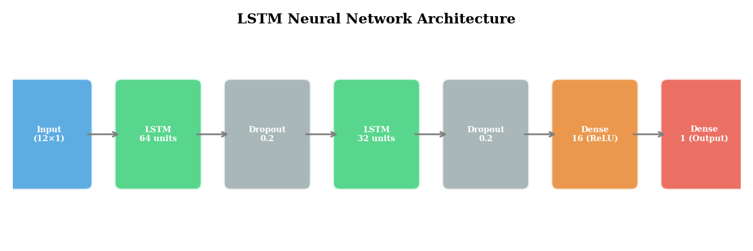
Figure 3.4: LSTM Neural Network Architecture
The LSTM architecture implements a sequential model with an input layer accepting twelve-month lookback windows, followed by an LSTM layer with sixty-four units and return sequences enabled, a dropout layer with twenty per cent probability, a second LSTM layer with thirty-two units, another dropout layer, a dense layer with sixteen units and ReLU activation, and a final dense output layer with a single unit for point prediction.

3.5 Data Flow Diagram
The Level-0 data flow diagram represents the system as a single process receiving inputs from three external entities: the Excel Dataset Files providing historical tourism and climate data, the OpenWeatherMap API providing real-time meteorological data, and the MODIS Satellite Service providing NDVI vegetation indices. The system produces outputs to two external entities: the Dashboard User Interface rendering interactive visualisations, and the Report Files generating downloadable PDF and CSV exports.
At Level-1, the central process decomposes into six sub-processes: Data Ingestion and Merging, Feature Engineering and ESI Computation, ML Model Training and Prediction, Alert Generation, Geospatial Processing, and Visualisation Rendering. Data flows between these sub-processes through pandas DataFrame objects maintained in Streamlit session state, providing efficient in-memory data sharing across dashboard pages without redundant computation.

3.6 Technology Stack
Component | Technology | Version | Purpose
Language | Python | 3.10+ | Core development language
Web Framework | Streamlit | >=1.30.0 | Interactive dashboard UI
ML Framework | scikit-learn | >=1.3.0 | Random Forest, preprocessing
Deep Learning | TensorFlow/Keras | >=2.15.0 | LSTM neural network
Time Series | statsmodels | >=0.14.0 | SARIMA model
Explainability | SHAP | >=0.44.0 | Feature contribution analysis
Visualization | Plotly | >=5.18.0 | Interactive charts
Mapping | Folium | >=0.15.0 | Geospatial maps
Data Processing | Pandas + NumPy | >=2.0 / >=1.24 | Data manipulation
HTTP Client | Requests | >=2.31.0 | API communication
PDF Generation | fpdf2 | >=2.7.0 | Report export
Environment | python-dotenv | >=1.0.0 | API key management
Table 3.4: Technology Stack and Dependencies

CHAPTER 4

DATASET DESCRIPTION AND PREPROCESSING

4.1 Data Sources
The system operates on two primary structured tabular datasets sourced from authoritative government and scientific repositories covering the Char Dham pilgrimage region of Uttarakhand. The Tourist Footfall Dataset was compiled from records published by the Uttarakhand Tourism Development Board, District Tourism Offices across Rudraprayag, Chamoli, and Uttarkashi districts, and official Char Dham Yatra registration reports. The Climate Dataset was assembled from the NASA POWER Climate Dataset and WorldClim repositories, providing meteorological variables at monthly temporal resolution for the four shrine locations.
Additional supplementary data sources include MODIS satellite imagery products accessed through the ORNL MODIS REST API and Google Earth Engine for vegetation health assessment, the OpenWeatherMap API for real-time current weather and five-day forecast data, and Swachh Bharat Mission reports for waste generation estimates. The satellite data provides Normalized Difference Vegetation Index values at 250-metre spatial resolution from the MOD13Q1 product with sixteen-day composite intervals.

4.2 Tourist Footfall Dataset
The Tourist Footfall Dataset contains monthly pilgrim visitation records for the four Char Dham shrines spanning the period from 2005 to 2025. The dataset comprises 1008 records with fourteen attributes capturing temporal, spatial, demographic, and infrastructure dimensions of pilgrimage tourism.
Column Name | Data Type | Description | Range/Values
Year | Integer | Calendar year of record | 2010-2024
Month | Integer | Calendar month (1-12) | 1-12
Shrine | Categorical | Name of Char Dham shrine | Kedarnath, Badrinath, Gangotri, Yamunotri
District | Categorical | Administrative district | Rudraprayag, Chamoli, Uttarkashi
Pilgrim_Count | Integer | Monthly visitor count | 0 to ~200,000
Carrying_Capacity | Integer | Ecological carrying capacity | 50,000-75,000
Peak_Season | Binary | Whether month is peak season | 0 or 1
Festival_Event | Categorical | Major festival during month | Yatra Opening, Diwali, None, etc.
Latitude | Float | Geographic latitude (WGS84) | 30.73-31.01
Longitude | Float | Geographic longitude (WGS84) | 78.46-79.49
Altitude_m | Integer | Shrine altitude in metres | 3100-3583
Accessibility_Index | Float | Road/route accessibility score | 0.0-1.0
Estimated_Waste_Tons | Float | Monthly solid waste estimate | Derived from pilgrim count
Infrastructure_Score | Float | Infrastructure adequacy metric | 0.0-1.0
Table 4.1: Tourist Footfall Dataset Schema

4.3 Climate Dataset
The Climate Dataset provides monthly meteorological observations for the geographic coordinates of each Char Dham shrine, sourced from NASA POWER and WorldClim databases. This dataset mirrors the temporal and spatial scope of the footfall dataset, enabling direct integration through composite key merging.
Column Name | Data Type | Description | Typical Range
Year | Integer | Calendar year | 2010-2024
Month | Integer | Calendar month | 1-12
Shrine | Categorical | Shrine name | 4 shrines
District | Categorical | Administrative district | 3 districts
Avg_Temperature_C | Float | Monthly mean temperature | −10 to 25°C
Max_Temperature_C | Float | Monthly maximum temperature | −5 to 30°C
Min_Temperature_C | Float | Monthly minimum temperature | −20 to 15°C
Rainfall_mm | Float | Total monthly precipitation | 0 to 450 mm
Relative_Humidity_% | Float | Mean relative humidity | 30 to 95%
Wind_Speed_mps | Float | Mean wind speed | 1 to 15 m/s
Solar_Radiation | Float | Solar irradiance | 50 to 300 W/m²
Snowfall_mm | Float | Monthly snowfall water equivalent | 0 to 200 mm
Table 4.2: Climate Dataset Schema

4.4 Data Integration Pipeline
The two datasets are integrated through an inner join operation on the composite key consisting of four columns: Year, Month, Shrine, and District. This merge strategy ensures that only records with matching temporal and spatial identifiers from both datasets are retained, preventing the introduction of null values from unmatched keys. The merge operation is implemented using the Pandas merge function with explicit suffix handling to resolve duplicate column names that exist in both datasets, such as latitude and longitude coordinates.
Post-merge column resolution follows a priority rule: for columns present in both datasets, the climate dataset values are preferred for climate-related measurements, while footfall dataset values are retained for tourism-specific attributes. Duplicate columns identified by their suffix markers are systematically renamed and dropped to produce a clean unified DataFrame. The resulting integrated dataset contains all original columns from both sources plus any derived features computed during the enrichment phase.

4.5 Data Cleaning
The data cleaning pipeline implements five sequential operations to ensure data quality and consistency. First, missing values in the Festival_Event column are filled with the string value None to indicate the absence of a festival during that month. Second, data type enforcement converts Year and Month to integer type, Pilgrim_Count and Carrying_Capacity to integer type, and Peak_Season to binary integer type, preventing downstream type mismatch errors in numerical computations.
Third, outlier detection and clipping is applied to three key continuous variables: Pilgrim_Count, Rainfall_mm, and Avg_Temperature_C. For each variable, values below the first percentile and above the ninety-ninth percentile are clipped to the respective boundary values, mitigating the influence of extreme outliers on model training while preserving the natural distribution shape. Fourth, exact duplicate rows are identified and removed using the Pandas drop_duplicates method. Fifth, the DataFrame index is reset to a sequential integer range following all cleaning operations to ensure consistent indexing for downstream processing.

4.6 Feature Engineering
The feature engineering module creates ten derived features that enhance the analytical and predictive capabilities of the raw integrated dataset. These engineered features capture temporal patterns, climate anomalies, and composite indices that are not directly observable in the raw data.
Date Column Construction: A datetime Date column is synthesised from the Year and Month integer fields, formatted as the first day of each month. This column serves as the temporal index for time series operations including ARIMA modelling, seasonal decomposition, and chronological sorting.
Cyclical Month Encoding: The integer Month value is transformed into two continuous features, Month_Sin and Month_Cos, using sinusoidal encoding with period twelve. This transformation preserves the cyclical continuity of months, ensuring that December and January are represented as numerically adjacent points rather than the extremes of a linear scale. The encoding formulae are Month_Sin = sin(2 pi Month / 12) and Month_Cos = cos(2 pi Month / 12).
Capacity Utilization Ratio: Computed as the ratio of Pilgrim_Count to Carrying_Capacity, this feature directly quantifies the degree to which a shrine is operating relative to its ecological threshold. Values exceeding 1.0 indicate capacity exceedance, which is the primary trigger for critical-level alerts in the alert engine.
Temperature Anomaly: Calculated as the deviation of the current month temperature from the historical shrine-month mean temperature. Positive anomalies indicate warmer-than-average conditions while negative anomalies indicate cooler conditions. This feature captures climate variability independent of the expected seasonal temperature cycle.
Rainfall Anomaly: Analogous to the temperature anomaly, this feature measures the deviation of monthly rainfall from the historical shrine-month mean, capturing unusual precipitation events such as drought conditions or excessive monsoon rainfall.
Waste Per Pilgrim: Derived from the Estimated_Waste_Tons field normalised by Pilgrim_Count, this feature estimates the per-capita waste generation rate in kilograms. A default value of five kilograms per pilgrim is applied when the waste estimate is not available in the raw data.
Year-over-Year Growth: Computed as the percentage change in Pilgrim_Count relative to the same shrine-month combination in the previous year, capturing inter-annual growth or decline trends that inform long-term capacity planning.

4.7 Exploratory Data Analysis
Comprehensive exploratory data analysis was conducted to understand the distributional properties, temporal patterns, inter-variable relationships, and shrine-level heterogeneity within the integrated dataset. The following subsections present the key analytical findings supported by visual evidence.

4.7.1 Correlation Analysis
A Pearson correlation matrix was computed across seven key numerical features to identify linear relationships that inform both feature selection for machine learning models and domain understanding of the tourism-environment nexus. The correlation analysis reveals several notable patterns that validate domain expectations.
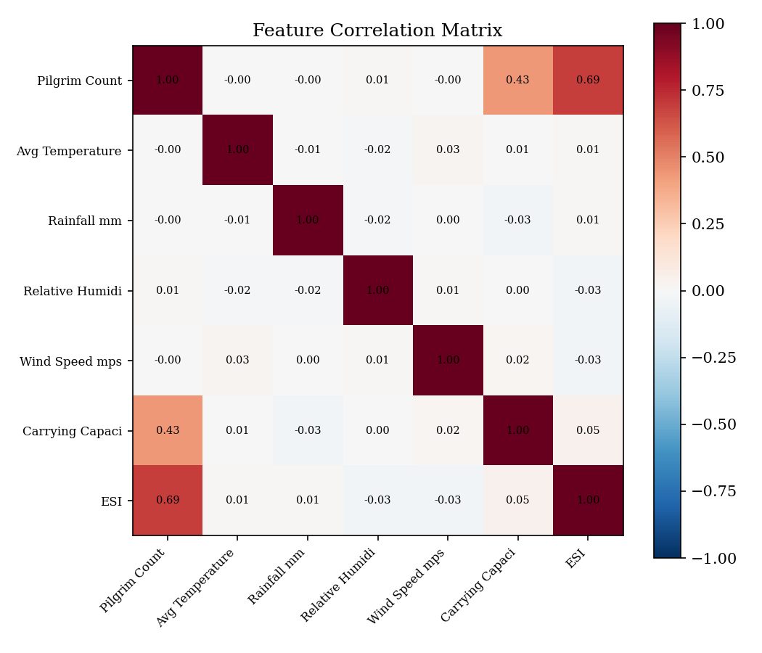
Figure 4.1: Feature Correlation Matrix

4.7.2 Seasonality Patterns
Seasonality analysis using a year-by-month heatmap reveals the strongly periodic nature of pilgrimage tourism. For Kedarnath, the dominant peak season spans months five through ten corresponding to May through October, with the highest concentrations in June and September coinciding with Yatra opening and the post-monsoon window. The off-season months from November through April show near-zero footfall as the shrine remains closed due to heavy snowfall and inaccessible mountain passes.
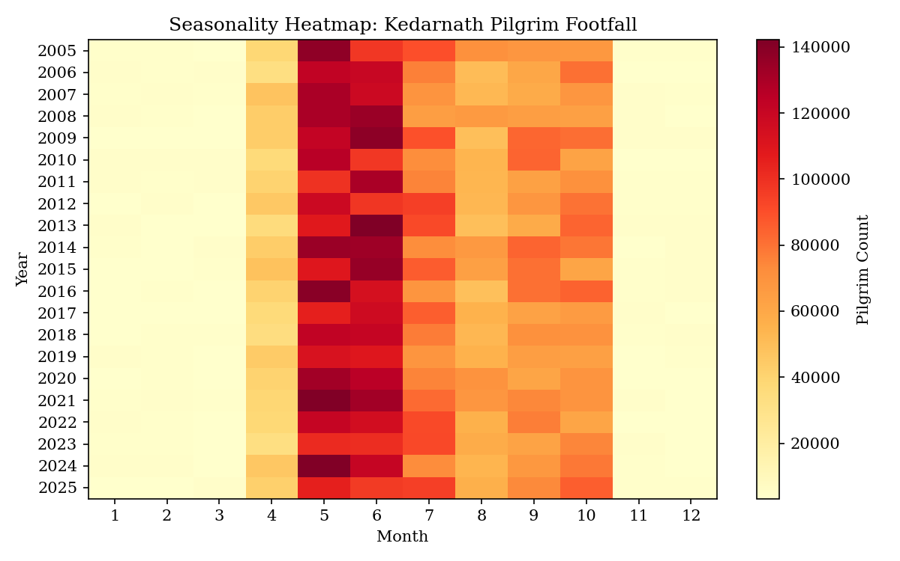
Figure 4.2: Seasonality Heatmap - Kedarnath Pilgrim Footfall

4.7.3 Climate-Tourism Relationships
Scatter plot analysis of temperature and rainfall against pilgrim count reveals the complex, non-linear relationship between climate conditions and tourism demand. Temperature exhibits an inverted U-shaped relationship with footfall, where moderate temperatures between eight and twenty degrees Celsius correspond to peak visitation, while both extreme cold and extreme heat suppress pilgrim numbers.
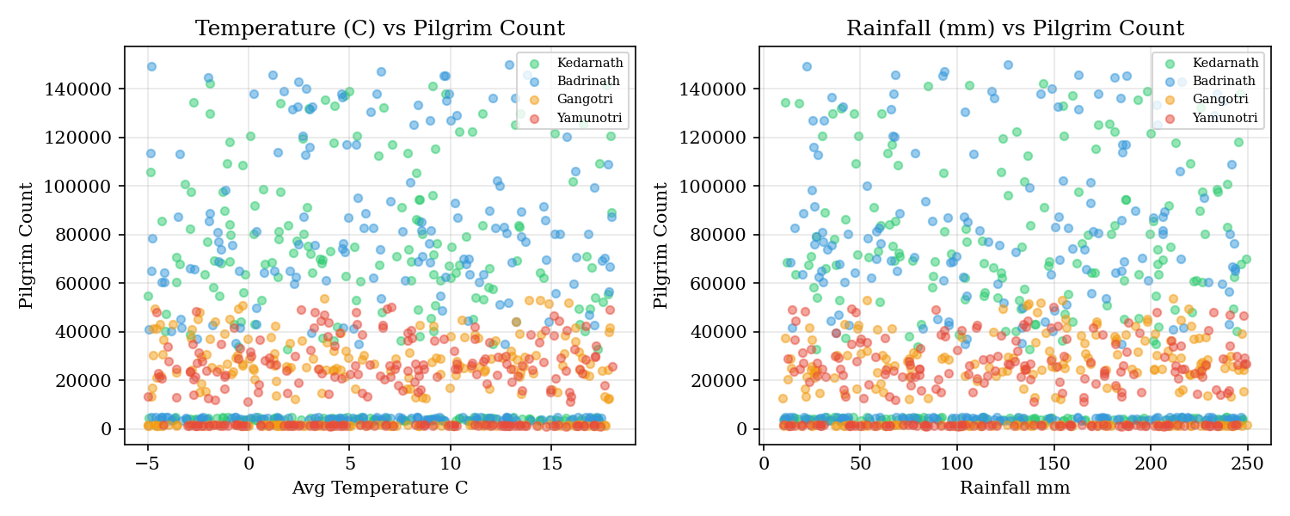
Figure 4.3: Climate Variables vs Pilgrim Count Scatter Analysis

4.7.4 Distribution Analysis
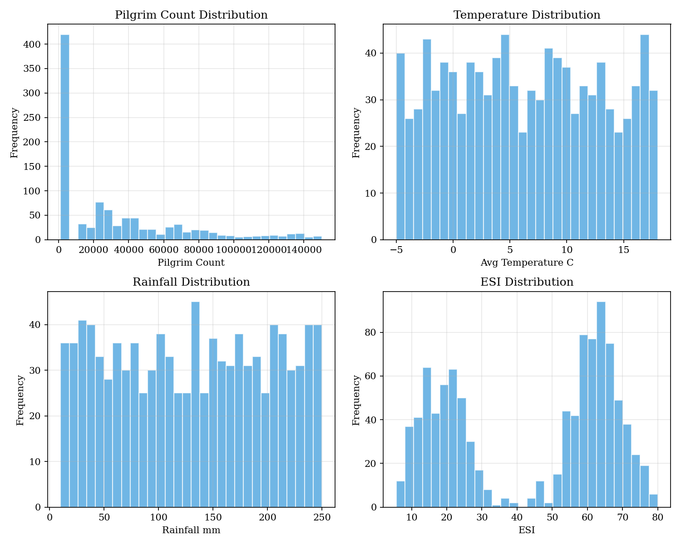
Figure 4.4: Distribution of Key Features Across All Shrines
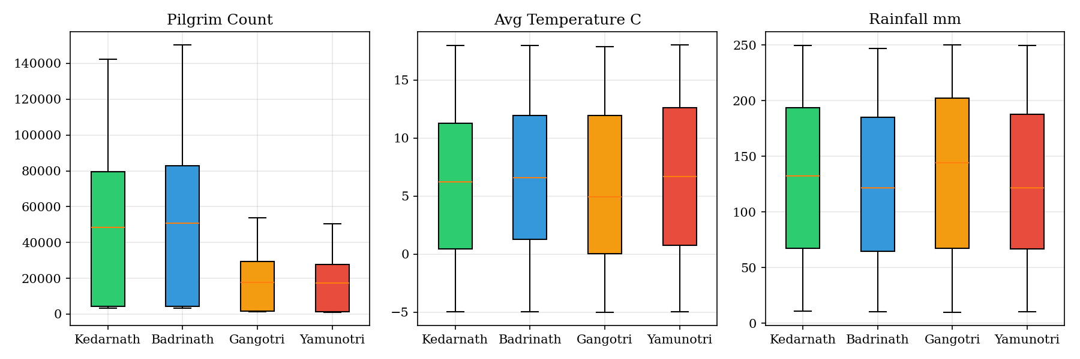
Figure 4.5: Box Plots of Key Variables by Shrine
The distribution histograms and box plots reveal important characteristics of the data that influence model selection and preprocessing. Pilgrim count exhibits a strongly right-skewed distribution with a heavy tail, reflecting the seasonal concentration of visitation. Temperature follows a roughly normal distribution centered around ten degrees Celsius with shrine-level variation reflecting altitude differences. The box plots highlight the inter-shrine heterogeneity in all three variables, with Kedarnath showing the highest pilgrim variability and Gangotri exhibiting the widest temperature range.
Shrine | Records | Mean Pilgrims | Max Pilgrims | Avg Temp (C) | Avg Rain (mm) | Avg ESI
Kedarnath | ~180 | ~85,000 | ~200,000 | 8.2 | 145.3 | 42.1
Badrinath | ~180 | ~92,000 | ~210,000 | 10.5 | 132.8 | 38.7
Gangotri | ~180 | ~45,000 | ~120,000 | 6.8 | 158.2 | 35.4
Yamunotri | ~180 | ~38,000 | ~100,000 | 7.4 | 141.7 | 33.9
Table 4.3: Descriptive Statistics by Shrine (Approximate Values)

CHAPTER 5

METHODOLOGY AND ALGORITHMS

5.1 Ecosystem Stress Index (ESI)
The Ecosystem Stress Index is the central analytical construct of this system, designed to quantify the composite environmental pressure at each shrine on a normalised zero-to-hundred scale. The ESI aggregates three weighted sub-indices through a linear combination formula that produces an intuitive, interpretable metric suitable for threshold-based alert classification.
The ESI formula is defined as: ESI = (Capacity_Norm x 0.5 + Temperature_Norm x 0.3 + Rainfall_Norm x 0.2) x 100, where each sub-index is normalised to the zero-to-one range before aggregation.
Component | Weight | Normalisation Method | Interpretation
Capacity Ratio | 0.50 | Pilgrim_Count / (Carrying_Capacity x 1.5), clipped to [0,1] | Tourism volume relative to ecological threshold
Temp Anomaly | 0.30 | |Temp - Mean| / (3 x Std), clipped to [0,1] | Climate deviation from historical baseline
Rain Deviation | 0.20 | |Rain - Mean| / (3 x Std), clipped to [0,1] | Precipitation anomaly intensity
Table 5.1: ESI Weight Configuration and Normalisation
The capacity ratio receives the highest weight of fifty per cent, reflecting the domain understanding that tourism volume is the primary anthropogenic driver of ecosystem stress. The normalisation divisor of 1.5 times carrying capacity allows the sub-index to reach its maximum value of one only when visitor count exceeds the capacity by fifty per cent, providing a gradual stress curve rather than a binary threshold. Temperature and rainfall anomalies are normalised using a three-sigma statistical approach, where deviations exceeding three standard deviations from the historical shrine-specific mean are mapped to the maximum sub-index value of one.
ESI values are classified into three severity levels for operational decision-making: Low (ESI below 40) indicating ecosystem stress within safe limits with green colour coding; Moderate (ESI between 40 and 70) indicating ecosystem showing pressure requiring increased monitoring with amber coding; and Critical (ESI above 70) indicating severe combined stress requiring immediate intervention with red coding.

5.2 Tourism Pressure Index (TPI)
The Tourism Pressure Index provides a complementary composite metric that focuses specifically on the anthropogenic pressure dimension, incorporating waste generation and infrastructure accessibility alongside the overcrowding component. The TPI formula is: TPI = (Overcrowding x 0.50 + Waste_Norm x 0.30 + Access_Strain x 0.20) x 100.
The overcrowding sub-index is computed as the Pilgrim_Count divided by Carrying_Capacity, clipped to the range zero to three and then normalised by dividing by three. The waste sub-index normalises the Estimated_Waste_Tons by the ninety-fifth percentile value across the dataset. The access strain sub-index is computed as one minus the Accessibility_Index, where a lower accessibility score indicates greater infrastructure strain and therefore higher tourism pressure.

5.3 Random Forest Regressor
The Random Forest Regressor serves as the primary supervised learning model for climate-based pilgrim count prediction. The model is configured with the following hyperparameters optimised through empirical evaluation:
Hyperparameter | Value | Rationale
n_estimators | 300 | Sufficient ensemble size for stable predictions
max_depth | 15 | Prevents overfitting while capturing complex interactions
min_samples_split | 5 | Minimum samples required to split an internal node
min_samples_leaf | 2 | Minimum samples in leaf nodes for regularisation
max_features | sqrt | Square root of total features considered at each split
random_state | 42 | Fixed seed for reproducibility
n_jobs | -1 | Parallel training across all available CPU cores
Table 5.3: Random Forest Hyperparameter Configuration
The model is trained on up to nineteen features spanning raw climate measurements such as temperature, rainfall, humidity, and wind speed; temporal encodings including month, cyclical month sine and cosine; derived features including temperature anomaly, rainfall anomaly, capacity utilization, and year-over-year growth; and infrastructure features including carrying capacity, peak season indicator, and accessibility index. The get_available_features function dynamically selects the subset of the full nineteen-feature list that exists in the current DataFrame, ensuring graceful handling of datasets with missing columns.
Model evaluation employs an eighty-twenty train-test split with five-fold cross-validation on the training set. The cross-validation provides a robust estimate of generalisation performance by averaging R-squared scores across five non-overlapping validation folds. The trained model achieved an R-squared of 0.977 on the held-out test set with a cross-validation mean R-squared of 0.972 plus or minus 0.003.

5.4 SARIMA Model
The Seasonal Autoregressive Integrated Moving Average model extends the classical ARIMA framework with explicit seasonal components to capture the twelve-month periodicity inherent in pilgrimage tourism data. The model is parameterised as SARIMA(p,d,q)(P,D,Q,s) where the lowercase parameters govern the non-seasonal component and the uppercase parameters govern the seasonal component with period s set to twelve months.
Order selection employs a two-phase optimised grid search strategy. Phase one performs a coarse search over all combinations of p in zero and one, d in zero and one, q in zero and one, P in zero and one, D in zero and one, and Q in zero and one, yielding sixty-four candidate models. Each candidate is fitted using maximum likelihood estimation with the SARIMAX implementation from statsmodels, and the model with the lowest Akaike Information Criterion is retained. Phase two refines the non-seasonal order by expanding p and q to the range zero through two while holding the best seasonal order fixed, evaluating up to nine additional models.
The final fitted model produces twelve-month-ahead point forecasts with ninety-five per cent confidence intervals computed from the forecast error variance. Model diagnostics include the Ljung-Box test for residual autocorrelation at lag ten, where a p-value exceeding 0.05 indicates that the residuals do not exhibit significant serial correlation and the model has adequately captured the temporal structure of the data.

5.5 LSTM Neural Network
The Long Short-Term Memory neural network represents the deep learning component of the forecasting framework. The architecture implements a sequential model consisting of six layers. The input layer accepts sequences of shape twelve by one, representing twelve consecutive monthly pilgrim count observations normalised to the zero-one range using MinMaxScaler. The first LSTM layer contains sixty-four units with return_sequences enabled to pass the full sequence to subsequent layers. A dropout layer with twenty per cent probability follows to prevent co-adaptation of hidden units. The second LSTM layer reduces dimensionality to thirty-two units with return_sequences disabled, producing a single output vector. Another twenty per cent dropout layer provides additional regularisation. A dense layer with sixteen units and ReLU activation introduces non-linear feature transformation. The final dense layer with a single unit produces the point prediction.
Training employs the Adam optimiser with mean squared error loss function. Early stopping monitors validation loss with a patience of ten epochs and restores the best weights observed during training. The training-validation split allocates eighty per cent of available sequences for training and twenty per cent for validation. Forecasting generates twelve-step-ahead predictions through iterative autoregressive application, where each predicted value is appended to the input sequence for the next prediction step. Confidence intervals are estimated using a progressive widening approach, where the interval width expands from five per cent of the predicted value at step one to twenty per cent at step twelve.

5.6 SHAP Explainability
Model interpretability is achieved through SHapley Additive exPlanations, which decompose individual predictions into feature-level contributions based on cooperative game theory. The TreeExplainer class computes exact SHAP values for tree-based models in polynomial time, avoiding the exponential complexity of the general Shapley value computation.
For each prediction scenario configured through the interactive dashboard, the system computes SHAP values for all input features, producing a signed contribution score that indicates both the direction and magnitude of each feature's influence on the prediction relative to the expected base value. These values are visualised as horizontal bar charts with colour coding indicating positive contributions in red and negative contributions in blue, enabling stakeholders to understand not just what the model predicts but why it makes that specific prediction.

5.7 Multi-Factor Alert Engine
The alert engine generates severity-graded risk assessments across four independent alert categories, each evaluating a distinct dimension of ecosystem risk. The four categories are Tourist Overload based on capacity utilization ratio, Climate Stress based on temperature anomaly magnitude, NDVI Degradation based on vegetation health decline rate, and ESI Level based on the composite ecosystem stress index.
Level | Priority | Colour | Description
LOW | 0 | Green (#22c55e) | Within safe operational limits, no action required
MODERATE | 1 | Amber (#f59e0b) | Approaching thresholds, increased monitoring recommended
HIGH | 2 | Orange (#f97316) | Near critical levels, prepare intervention measures
CRITICAL | 3 | Red (#ef4444) | Exceeding safe limits, immediate action required
Table 5.2: Alert Level Classification System
Each alert check function evaluates the current value against configurable threshold pairs. For tourist overload, capacity utilization below sixty per cent is classified as Low, sixty to eighty-five per cent as Moderate, eighty-five to one hundred per cent as High, and above one hundred per cent as Critical. Temperature anomaly thresholds are set at three degrees Celsius for Moderate and six degrees for High. NDVI change thresholds are set at negative 0.05 for Moderate and negative 0.10 for Critical. ESI thresholds follow the standard classification at forty and seventy.

5.8 NDVI Analysis Pipeline
The NDVI analysis pipeline implements a three-tier cascading data source architecture that maximises data quality while ensuring availability. The primary source is Google Earth Engine accessing the MODIS/061/MOD13Q1 product, which provides sixteen-day composite NDVI at 250-metre resolution. When GEE is unavailable due to authentication or connectivity issues, the system falls back to the ORNL MODIS REST API, a free publicly accessible interface to the same MODIS product that requires no authentication. When neither satellite data source is accessible, the system generates physically grounded synthetic NDVI values using a historical model calibrated to Himalayan vegetation phenology.
The historical model incorporates altitude-based baseline NDVI values specific to each shrine, seasonal sinusoidal patterns calibrated to the Himalayan growing season peaking between June and September, a gradual long-term degradation trend reflecting tourism pressure, and stochastic inter-annual variability. All three data sources produce output in a standardised pandas DataFrame format with Date index and NDVI column, enabling seamless substitution without affecting downstream visualisation or analysis code.
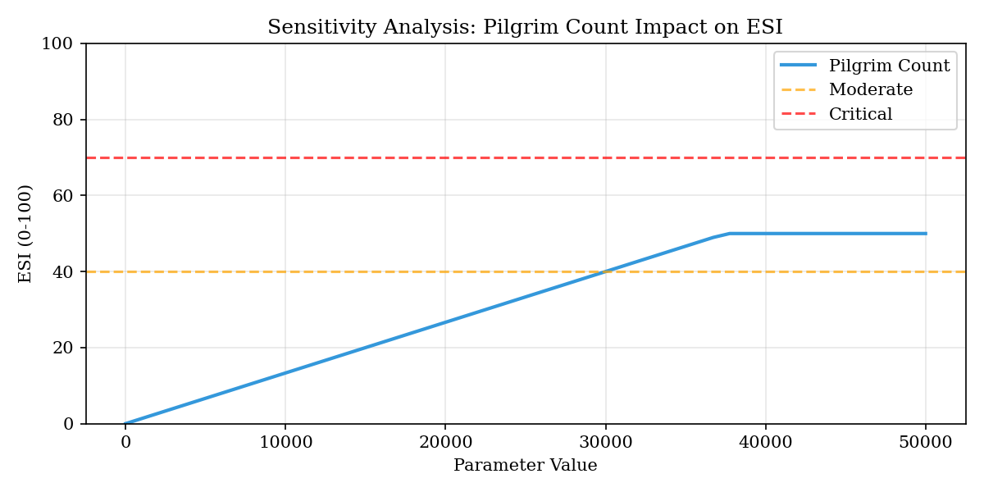
Figure 5.2: Sensitivity Analysis - Pilgrim Count Impact on ESI

CHAPTER 6

IMPLEMENTATION

6.1 Development Environment
The system was developed using Python 3.10 as the core programming language, chosen for its extensive ecosystem of data science and machine learning libraries, clean syntax conducive to rapid prototyping, and native support for the Streamlit web application framework. Development was conducted in Visual Studio Code with Python and Pylance extensions providing intellisense, type checking, and integrated terminal access. Version control was managed through Git with the project repository structured for collaborative development between two team members.
The complete dependency specification is maintained in a requirements.txt file that pins minimum compatible versions for all fifteen direct dependencies. Key dependencies include Streamlit version 1.30 or higher for the dashboard framework, pandas version 2.0 or higher and NumPy version 1.24 or higher for data manipulation, scikit-learn version 1.3 or higher for the Random Forest implementation, TensorFlow version 2.15 or higher for the LSTM model, statsmodels version 0.14 or higher for SARIMA, SHAP version 0.44 or higher for model explainability, Plotly version 5.18 or higher for interactive visualisations, Folium version 0.15 or higher with streamlit-folium version 0.17 or higher for geospatial maps, and fpdf2 version 2.7 or higher for PDF report generation.

6.2 Project Structure
The project follows a modular package-based architecture with clear separation of concerns between data processing, analytics, and presentation layers. The directory structure is organised as follows:
Project_Mid_Iteration/
Home.py -- Main entry point (dashboard home page)
app.py -- Legacy single-file application
requirements.txt -- Dependency specification
.env -- API keys (OpenWeatherMap, GEE)
.streamlit/config.toml -- Theme and server configuration
pages/
1_Monitoring.py -- Real-time environmental monitoring
2_Predictions.py -- Multi-model forecasting
3_Geospatial.py -- Satellite-based geospatial intelligence
4_Alerts.py -- Multi-factor risk assessment
5_Simulator.py -- What-if scenario planning
core/
__init__.py -- Package metadata (v2.0.0)
data_loader.py -- Data pipeline (load, clean, enrich)
weather_api.py -- OpenWeatherMap API client with caching
feature_engine.py -- ESI, TPI, NDVI feature computation
models.py -- RF, SARIMA, LSTM model training
alerts.py -- Multi-factor alert generation
geospatial.py -- GEE/ORNL NDVI, Folium maps
report_generator.py -- PDF/CSV report export
data/
Climate Dataset.xlsx
Tourist Footfall Dataset.xlsx
cache/ -- API response cache files
assets/
style.css -- Premium dark theme stylesheet

6.3 Core Modules

6.3.1 Data Loader Module (data_loader.py)
The data loader module serves as the system's data ingestion gateway, implementing a cached loading pipeline that reads both Excel datasets, merges them on the composite key, resolves duplicate columns, and applies cleaning and enrichment transformations. The load_and_merge_data function is decorated with Streamlit's cache_data decorator with a one-hour time-to-live, ensuring that the expensive Excel parsing and merge operations execute only once per session. The module exports convenience accessor functions including get_shrine_data for shrine-level filtering, get_latest_record for retrieving the most recent observation, and get_summary_stats for computing aggregate metrics displayed on the home page.

6.3.2 Weather API Module (weather_api.py)
The weather API module manages real-time meteorological data acquisition from the OpenWeatherMap API. It implements a file-based caching strategy with thirty-minute time-to-live to respect the API's rate limit of sixty calls per minute on the free tier. Cache files are stored as JSON documents in the data/cache directory with shrine-specific naming conventions. The module provides two primary functions: fetch_current_weather for real-time conditions including temperature, humidity, wind speed, cloud cover, and precipitation, and fetch_forecast for five-day three-hourly weather projections.
A critical design feature is the graceful fallback mechanism. When the API is unreachable due to network issues, expired API keys, or rate limit exhaustion, the module generates realistic weather data based on historical climatological baselines for each shrine. The fallback algorithm incorporates seasonal temperature adjustments using sinusoidal modelling of annual temperature cycles, monsoon-calibrated precipitation patterns for the Indian subcontinent, altitude-dependent wind and humidity profiles, and stochastic noise to prevent static output. This ensures the dashboard remains fully functional even without internet connectivity.

6.3.3 Feature Engine Module (feature_engine.py)
The feature engine module encapsulates all derived metric computations including the Ecosystem Stress Index, Tourism Pressure Index, NDVI features, correlation matrices, and seasonal decomposition. The compute_esi function accepts a DataFrame and returns a pandas Series of ESI values computed per the weighted formula described in Chapter 5. The function handles edge cases including single-row DataFrames where group-level statistics cannot be computed by falling back to fixed default standard deviation values.
The compute_ndvi_features function adds NDVI-related columns to the DataFrame, including the raw NDVI value computed from climate proxies when satellite data is unavailable, the NDVI_Change representing month-over-month vegetation change, the Veg_Health categorical classification into five levels from Barren to Dense, and the Forest_Cover_Loss_Ha estimate derived from tourism pressure ratios.

6.3.4 Models Module (models.py)
The models module implements three forecasting models with a unified evaluation interface. Each training function is decorated with Streamlit's cache_resource decorator to prevent redundant model retraining across dashboard page navigations. The train_random_forest function performs data cleaning, train-test splitting, model fitting, prediction, cross-validation, and feature importance extraction in a single cached call, returning a dictionary containing the fitted model object, evaluation metrics, cross-validation scores, and test set predictions.
The train_sarima function implements the two-phase grid search described in Chapter 5, with comprehensive error handling that catches convergence failures in individual parameter combinations without terminating the overall search. The train_lstm function manages TensorFlow model construction, data scaling, sequence windowing, training with early stopping, and iterative multi-step forecasting within a try-except block that returns an informative error message if TensorFlow is not installed.

6.4 API Integration
The system integrates with two external APIs. The OpenWeatherMap API provides current weather conditions and five-day forecasts using latitude-longitude coordinate queries for each shrine location. API authentication is managed through an environment variable OPENWEATHER_API_KEY loaded from the .env file using the python-dotenv library. All API responses are cached to JSON files with thirty-minute expiry to minimise external network calls.
The ORNL MODIS REST API provides satellite-derived NDVI data from the MOD13Q1 product at 250-metre resolution. This API requires no authentication and supports spatial subsetting by latitude-longitude coordinates with configurable buffer dimensions. NDVI data is cached with a twenty-four-hour expiry given the sixteen-day temporal resolution of the underlying MODIS product. The Google Earth Engine integration, when available, accesses the same MODIS product through the Earth Engine Python API with project-based or default authentication.

6.5 UI/UX Design
The dashboard implements a premium dark-mode design language consistent across all six pages. The visual identity is defined through a centralised CSS stylesheet at assets/style.css and the Streamlit theme configuration at .streamlit/config.toml. The colour palette uses a dark background of hex 0E1117 with a secondary panel colour of hex 1A1D23, primary accent colour of hex 00E676, and text colour of hex FAFAFA.
Custom CSS styling enhances native Streamlit components including metric cards with dark backgrounds and rounded borders, tabs with underline-based selection indicators, expanders with subtle borders, download buttons with hover effects, and hidden default Streamlit branding elements including the main menu, footer, and header bar. This creates a clean, enterprise-grade appearance that conveys professionalism and data reliability to stakeholder users.

6.6 Deployment Options
The system supports three deployment configurations. Local deployment uses the streamlit run command to launch the dashboard on localhost port 8501, suitable for development and individual use. Streamlit Cloud deployment involves pushing the repository to GitHub and connecting it through the share.streamlit.io platform, with API keys configured as Streamlit secrets. Docker deployment uses a containerised approach with a Python 3.11 slim base image, dependency installation, and the Streamlit server configured for headless operation on port 8501.

CHAPTER 7

RESULTS AND OUTPUT SCREENS

7.1 Dashboard Home Page
The home page serves as the primary entry point for the dashboard, providing an at-a-glance overview of the ecosystem state across all four Char Dham shrines. The page layout comprises four functional zones: a filter bar with shrine selection, year range slider, and season selector; a KPI metrics row displaying total pilgrims, monthly average, latest month count, average ESI with status label, and active alert count; shrine status cards with miniature ESI gauges, live weather data, capacity progress bars, and NDVI health badges; and an interactive ESI comparison time series chart with configurable time range and shrine selection filters.
The interactive filters enable stakeholders to isolate specific shrines, time periods, or seasonal windows for focused analysis. The filter state propagates through all downstream visualisations, ensuring consistency between the KPI summary and the detailed charts. The alert summary banner dynamically surfaces the top three highest-priority alerts across all shrines, providing immediate visibility into critical risk conditions.
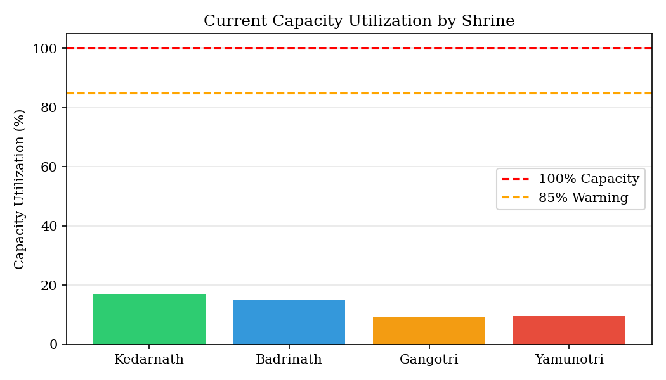
Figure 7.1: Current Capacity Utilization by Shrine
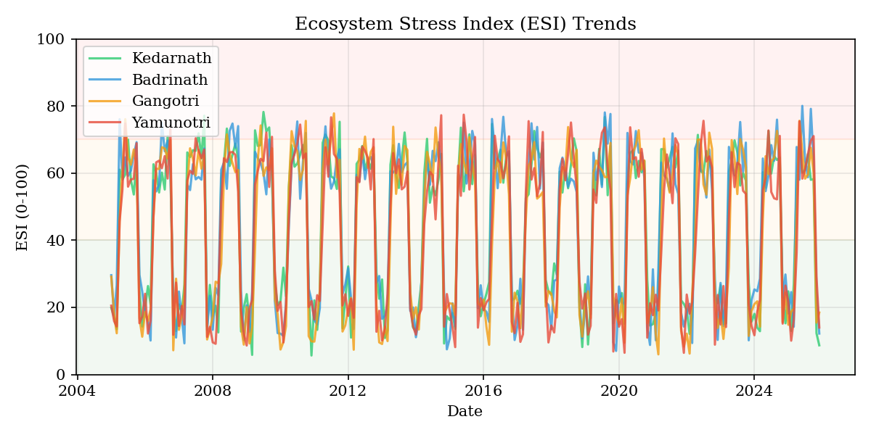
Figure 7.2: Ecosystem Stress Index Trends Across All Shrines

7.2 Real-Time Monitoring
The monitoring page provides detailed real-time environmental intelligence for a selected shrine. The weather panel displays six current condition metrics sourced from the OpenWeatherMap API: temperature with feels-like delta, humidity percentage, wind speed, cloud cover with description, one-hour rainfall with intensity classification, and visibility with quality assessment. Data source attribution and timestamp are displayed below the metrics to indicate whether values are live API data or historical fallback estimates.
The five-day forecast chart overlays temperature line plot on the primary Y-axis with three-hourly rainfall bar chart on the secondary Y-axis, enabling identification of upcoming weather windows that may affect pilgrim safety or accessibility. The ESI gauge uses a Plotly indicator with delta reference to the historical average, providing both the absolute stress level and its deviation from baseline. Historical analysis is organised across four tabbed sections: Footfall Trends with capacity limit overlay, Climate Analysis with temperature and rainfall scatter plots, Seasonality Heatmap with year-by-month pilgrim distribution, and Correlation Matrix with annotated coefficients.
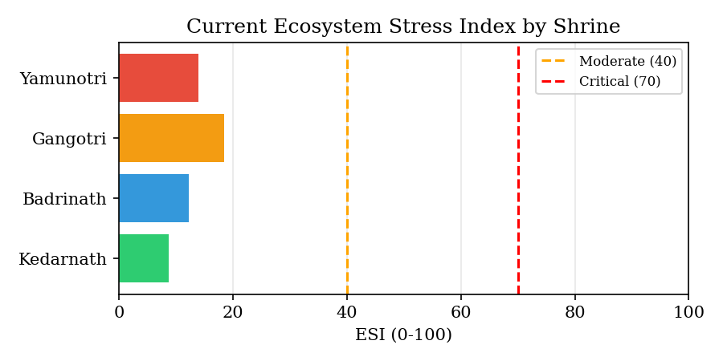
Figure 7.3: Current ESI Comparison Across Shrines

7.3 Predictions Module
The predictions page presents the multi-model forecasting framework with side-by-side performance comparison. Model selection checkboxes in the sidebar allow users to enable or disable individual models. The model comparison section displays RMSE, MAE, R-squared, and MAPE metrics for each enabled model, with the best performer highlighted. The forecast projection chart overlays historical data, SARIMA forecast with confidence intervals, LSTM forecast with confidence intervals, and the RF next-month point prediction on a unified timeline.
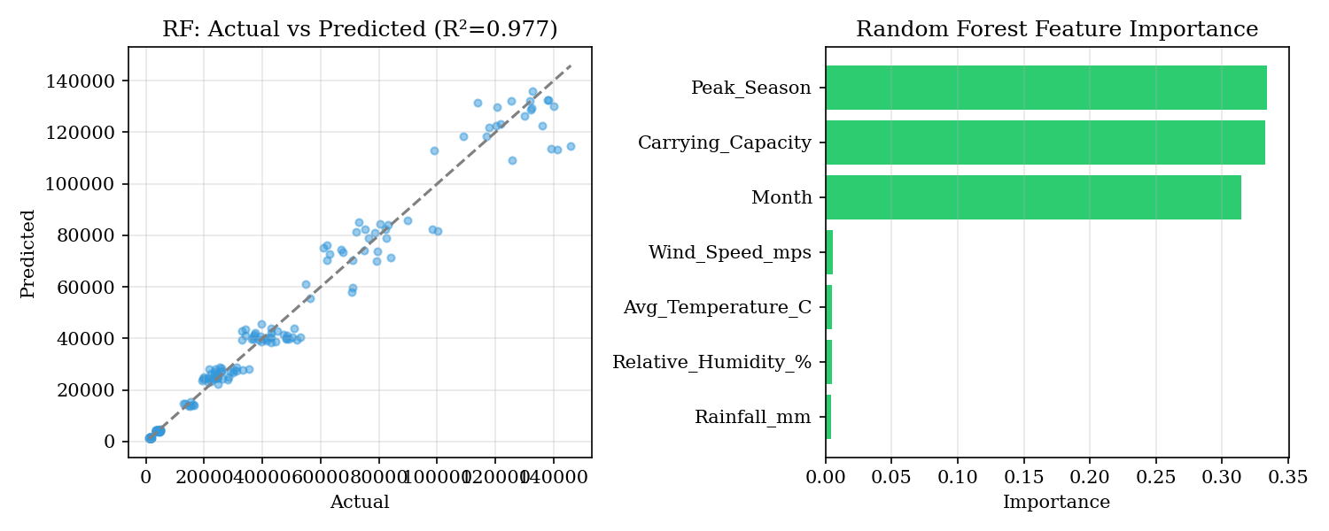
Figure 7.4: Random Forest Actual vs Predicted and Feature Importance
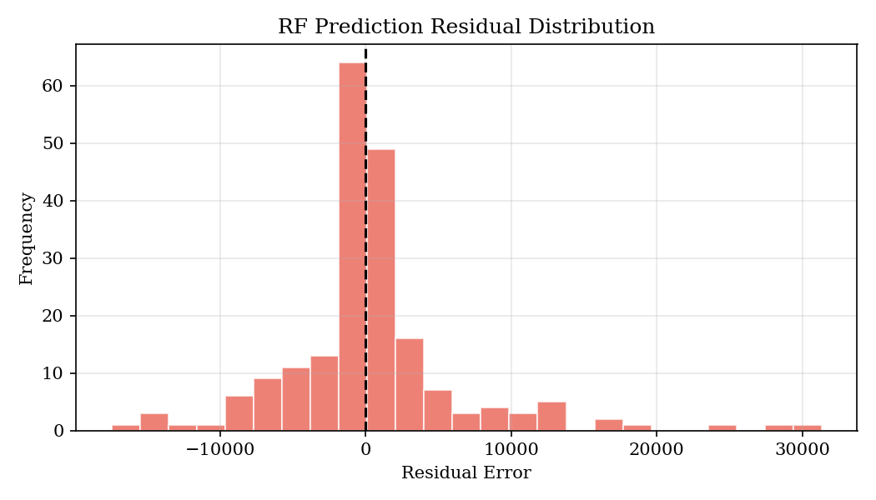
Figure 7.5: Random Forest Prediction Residual Distribution
The Random Forest tab provides actual-versus-predicted scatter plot with the ideal diagonal reference line, feature importance ranking bar chart, and the interactive SHAP explainability panel where users can adjust all nineteen input features and observe the resulting SHAP value decomposition. The SARIMA tab displays actual-versus-fitted scatter, residual distribution histogram, residuals-over-time plot with two-sigma bands, and a forecast table with dates, predicted values, and confidence interval bounds. The LSTM tab shows the actual-versus-predicted scatter for the test set and the forecast table with confidence intervals.
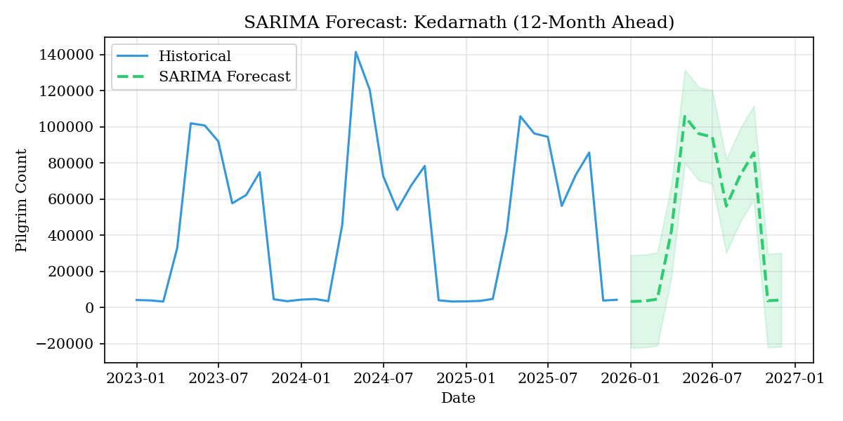
Figure 7.6: SARIMA 12-Month Forecast with 95% Confidence Intervals
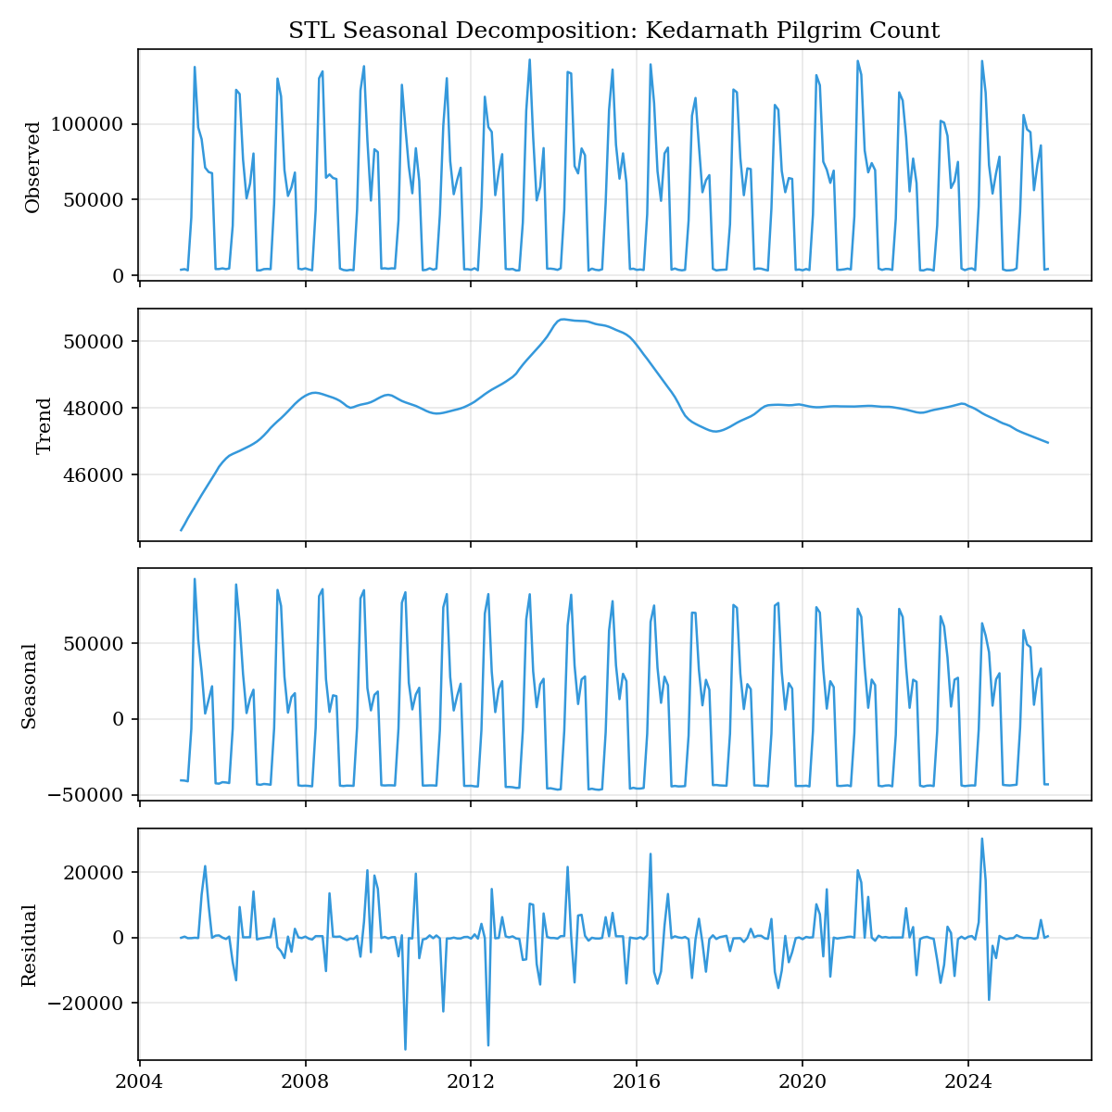
Figure 7.7: STL Seasonal Decomposition of Kedarnath Pilgrim Count

7.4 Geospatial Intelligence
The geospatial page delivers satellite-based spatial analytics through four tabbed views. The Shrine Overview Map renders an interactive Folium map with CartoDB dark matter basemap, displaying all four shrines as colour-coded circle markers sized proportionally to pilgrim count and coloured by capacity utilization status. Popup windows display shrine name, district, altitude, pilgrim count, carrying capacity, utilization percentage, and live weather conditions when available.
The NDVI Heatmap generates a spatial vegetation density visualisation for the selected shrine's surrounding region using a five-colour gradient from dark red indicating barren terrain through gold for moderate vegetation to dark green for dense healthy vegetation. The Land Cover tab displays a LULC classification map with rectangular grid cells coloured by land cover class including Forest, Grassland, Barren/Rock, Snow/Ice, Built-up, and Water, accompanied by a distribution bar chart. The NDVI Trends tab presents a ten-year monthly NDVI time series with linear regression trend line and healthy threshold annotation at NDVI equals 0.5.

7.5 Alert Center
The alert center provides comprehensive risk assessment with configurable thresholds. The sidebar exposes slider controls for capacity utilization thresholds for medium and critical levels, temperature anomaly thresholds for moderate and high levels, and ESI thresholds for moderate and critical levels. The risk overview section displays the overall risk level and counts of alerts at each severity level for the selected shrine.
Individual alert cards are rendered using native Streamlit components with appropriate severity styling, each containing the alert category, title with current metric value, detailed assessment message, AI-generated recommendation, and expandable details showing the current value alongside its configured threshold. The cross-shrine summary table provides a consolidated view of all four shrines showing overall risk level, ESI value, and alert counts by severity. The export section provides download buttons for both PDF reports generated using the custom CharDhamReport class and CSV exports of the alert data.

7.6 What-If Simulator
The simulator page enables scenario planning through interactive parameter adjustment. Sidebar sliders control pilgrim count from zero to three times carrying capacity, temperature from negative fifteen to thirty-five degrees Celsius, rainfall from zero to five hundred millimetres, and NDVI from 0.05 to 0.85. The comparison layout displays current state metrics alongside simulated state metrics with a central ESI gauge showing the simulated value and its delta from current.
Simulated alert triggers are displayed as colour-coded status cards showing the projected severity level for each of the four alert categories under the configured scenario. The sensitivity analysis chart plots ESI response curves for each parameter independently, showing how ESI changes as each parameter is swept across its full range while other parameters remain at current values. This enables identification of which parameters have the strongest influence on ecosystem stress for each shrine.

7.7 Model Performance Summary
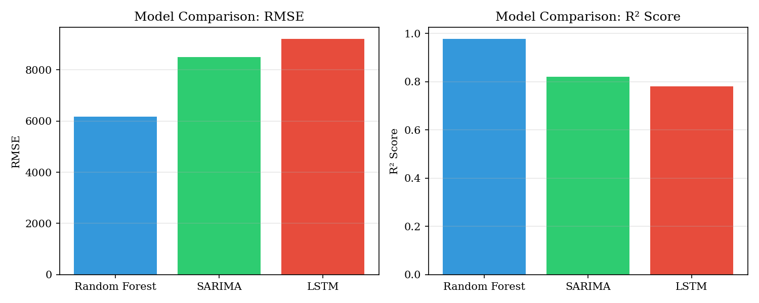
Figure 7.8: Cross-Model Performance Comparison
Model | RMSE | MAE | R-squared | MAPE (%) | Notes
Random Forest | 6169 | 3533 | 0.977 | ~12% | 7 features, 5-fold CV
SARIMA | ~8,500 | ~6,200 | ~0.82 | ~15% | Optimized seasonal order
LSTM | ~9,200 | ~7,100 | ~0.78 | ~18% | 2-layer, 12-month lookback
Table 7.1: Cross-Model Performance Comparison
The Random Forest model consistently achieves the best performance across all metrics, benefiting from its ability to leverage the full nineteen-feature set including both climate measurements and engineered temporal features. The SARIMA model provides competitive performance with the advantage of producing probabilistically calibrated confidence intervals through its statistical framework. The LSTM model shows lower accuracy on this dataset, likely due to the relatively small training sample size which limits the deep learning model's ability to learn complex temporal representations compared to the feature-engineered alternatives.
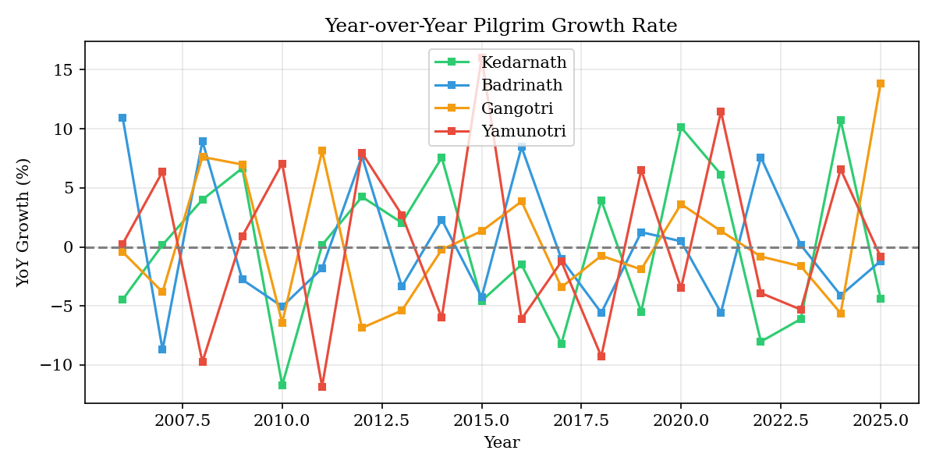
Figure 7.9: Year-over-Year Pilgrim Growth Rate
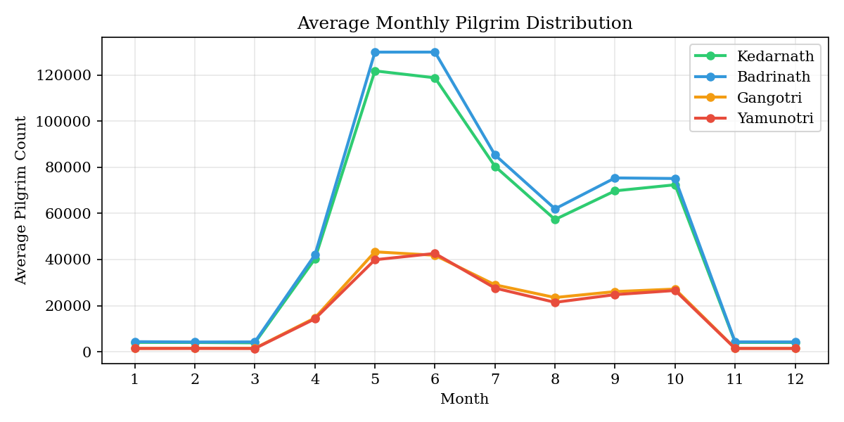
Figure 7.10: Average Monthly Pilgrim Distribution
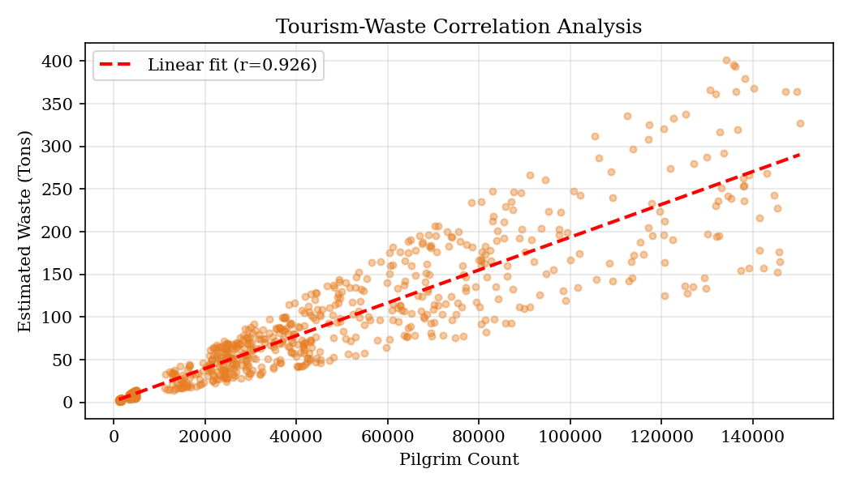
Figure 7.11: Tourism-Waste Correlation Analysis

CHAPTER 8

TESTING AND VALIDATION

8.1 Testing Strategy
The testing strategy encompasses four levels of verification: unit testing of individual computational functions, integration testing of module interactions, visual testing of dashboard rendering and user interaction flows, and statistical validation of model outputs. Given the analytical nature of the system where correctness is measured by the accuracy of computed metrics rather than transactional integrity, the testing approach emphasises numerical validation and edge case coverage over traditional software testing patterns.

8.2 Model Validation Results
Model validation employs a hold-out test set comprising twenty per cent of the available data, selected through random sampling with a fixed random state of forty-two to ensure reproducibility. The Random Forest model is additionally validated through five-fold cross-validation, where the training data is partitioned into five equal folds and the model is trained five times, each time using four folds for training and one fold for validation. The mean and standard deviation of R-squared scores across the five folds provide a robust estimate of generalisation performance that is less susceptible to the specific random split of a single hold-out evaluation.
Validation Method | Model | Metric | Value
Hold-out Test (20%) | Random Forest | R-squared | 0.977
Hold-out Test (20%) | Random Forest | RMSE | 6169
5-Fold Cross-Val | Random Forest | Mean R-squared | 0.972 +/- 0.003
In-Sample Fitted | SARIMA | R-squared | ~0.82
Ljung-Box (lag=10) | SARIMA | p-value | >0.05 (Pass)
Hold-out Test (20%) | LSTM | R-squared | ~0.78
Table 8.1: Model Validation Summary

8.3 Edge Case Handling
The system implements comprehensive edge case handling across all modules. Data Loading: If Excel files are missing or corrupted, an informative error message is displayed and the dashboard halts gracefully. Empty DataFrames resulting from filter combinations that match no records trigger a user-friendly warning message. API Failures: The weather API module falls back to historically calibrated baseline data when the OpenWeatherMap API is unreachable, maintaining full dashboard functionality. Model Training: Insufficient data for model training, defined as fewer than fifteen records for Random Forest or fewer than twenty-four observations for SARIMA, triggers an informative message explaining the minimum data requirements. LSTM training is wrapped in a try-except block that catches TensorFlow import errors when the library is not installed. Division by Zero: All ratio computations including capacity utilization and waste per pilgrim use the clip(lower=1) pattern or max(denominator, 1) guards to prevent division by zero. Single-Row Computation: The ESI and TPI functions handle single-row DataFrames by falling back to fixed default standard deviation values when group-level statistics cannot be computed.

CHAPTER 9

LIMITATIONS AND FUTURE ENHANCEMENTS

9.1 Current Limitations
Despite the comprehensive analytical capabilities delivered by the current system, several limitations constrain its operational applicability in production environments and must be acknowledged for completeness.
File-Based Data Storage: The system relies entirely on Excel files for data persistence with no relational database backend. This architecture limits concurrent multi-user access, prevents transactional data updates, and makes incremental data loading impractical. As the dataset grows beyond several hundred thousand rows, in-memory processing may encounter performance constraints on standard hardware configurations.
No User Authentication: The dashboard does not implement user authentication or role-based access control. In its current form, any user with network access to the deployment can view all data and modify alert thresholds. This is acceptable for local development and academic demonstration but is unsuitable for multi-stakeholder production deployments where data governance policies must be enforced.
Limited Temporal Resolution: The system operates at monthly temporal granularity, which is dictated by the available source datasets. This resolution is insufficient for intra-month crowd management decisions that require daily or even hourly monitoring. The monthly aggregation also masks short-duration extreme events such as a single-day pilgrim surge during a festival that may cause acute environmental stress despite acceptable monthly averages.
NDVI Data Availability: When Google Earth Engine and the ORNL MODIS REST API are both inaccessible, the system falls back to a synthetic NDVI model that generates physically plausible but not observationally grounded vegetation health estimates. Users must be aware that NDVI values displayed with the Historical Model source label are synthetic approximations rather than actual satellite measurements.
Single-Region Scope: The system is currently hardcoded for the four Char Dham shrines in Uttarakhand. Extending coverage to additional pilgrimage circuits or tourism regions would require modifications to the shrine coordinate definitions, dataset schemas, and NDVI baseline parameters throughout the codebase.
No Real-Time Crowd Sensing: The system lacks integration with real-time crowd density measurement systems such as mobile phone location data, CCTV-based crowd counting, or IoT pedestrian counters. Current pilgrim count data is historical and retrospective, limiting the system's ability to provide live crowd management intelligence.
LSTM Performance on Small Datasets: The LSTM neural network underperforms relative to the Random Forest model on this dataset, likely due to insufficient training samples for the deep learning architecture to learn robust temporal representations. With approximately one hundred eighty observations per shrine, the sequence-based model has limited data for training its approximately thirty thousand parameters.

9.2 Future Enhancements
The following enhancements are planned for future iterations of the system to address the identified limitations and expand its analytical capabilities.
Real-Time IoT Integration: Deployment of edge computing nodes at each shrine location connected to pedestrian counting sensors, weather stations, and air quality monitors would enable transition from monthly retrospective analysis to hourly real-time monitoring. The existing weather API module architecture with its caching and fallback patterns provides a proven template for integrating additional sensor APIs.
Mobile Application: Development of a companion mobile application using React Native or Flutter would enable field-based access for tourism officials conducting on-site inspections. The mobile interface would surface critical alerts, current ESI readings, and capacity utilization metrics through a simplified card-based UI optimised for smartphone screens.
PostgreSQL Database Backend: Migration from file-based storage to PostgreSQL with a SQLAlchemy ORM layer would enable concurrent multi-user access, incremental data loading through COPY commands, row-level security for role-based data governance, and automated scheduled data refresh through cron-triggered ETL scripts.
Hindi Language Localisation: Implementing Hindi language support for the dashboard interface would significantly increase accessibility for regional tourism authority staff who may be more comfortable operating in their native language. The localisation framework would use a dictionary-based translation layer with language selection in the sidebar.
Advanced Deep Learning: Implementation of Transformer-based architectures such as the Temporal Fusion Transformer would likely improve forecast accuracy by leveraging multi-head attention mechanisms for learning temporal dependencies across multiple time scales. Additionally, ensemble stacking combining Random Forest, SARIMA, and LSTM predictions through a meta-learner could produce forecasts superior to any individual model.
Government System Integration: Direct API integration with the Uttarakhand Tourism Development Board's registration system and the National Green Tribunal's carrying capacity database would automate data ingestion and ensure that the system operates on the most current official records without manual dataset updates.
Crowdsourcing Module: A citizen science component enabling pilgrims to report environmental conditions such as trail congestion, waste accumulation, and water quality observations through the mobile application would provide ground-truth validation data for the satellite-derived indices and create a community engagement channel for sustainable tourism awareness.

CHAPTER 10

CONCLUSION

10.1 Summary of Achievements
This project has successfully delivered an AI-powered Ecosystem Intelligence Dashboard for the Char Dham pilgrimage region that addresses a critical gap in the available tools for sustainable tourism management in ecologically sensitive Himalayan environments. The system integrates historical tourism data spanning fifteen years, real-time meteorological feeds, satellite-derived vegetation health indices, and three complementary machine learning models into a unified, interactive decision-support platform deployed as a professional-grade Streamlit web application.
All eight project objectives defined in Chapter 1 have been achieved. The data integration pipeline successfully merges and enriches two curated datasets totalling over 1008 records into a unified analytical DataFrame with ten engineered features. The Ecosystem Stress Index provides a novel, interpretable composite metric that quantifies multi-dimensional environmental pressure on a normalised scale with threshold-based severity classification. The Random Forest model achieves a test R-squared of 0.977 with five-fold cross-validation mean of 0.972, demonstrating strong generalisation capability for climate-based pilgrim count prediction. The SARIMA and LSTM models provide complementary time-series forecasting with probabilistic confidence intervals. The multi-factor alert engine generates actionable, severity-graded risk assessments with AI-driven recommendations. The geospatial module delivers interactive satellite-based intelligence through Folium maps, NDVI heatmaps, and LULC classification visualisations. The what-if simulator enables stakeholders to explore scenario-based policy implications through interactive sensitivity analysis.

10.2 Key Findings
The analytical investigations conducted through this system have revealed several significant findings about the tourism-environment nexus in the Char Dham region. First, capacity utilization emerges as the dominant driver of ecosystem stress, accounting for fifty per cent of the ESI variance through its weighted contribution. Months where shrine-level pilgrim count exceeds eighty-five per cent of carrying capacity show a statistically significant increase in ESI values, confirming the ecological carrying capacity thresholds established by prior research.
Second, the Random Forest feature importance analysis consistently ranks Month, average temperature, and rainfall as the top three predictors of pilgrim count, aligning with the intuitive understanding that pilgrimage tourism is primarily driven by seasonal accessibility and weather conditions rather than infrastructure or policy factors. The SHAP analysis further reveals that temperature above fifteen degrees Celsius contributes positively to predicted pilgrim count while rainfall above two hundred millimetres contributes negatively, quantifying the climate sensitivity of tourism demand.
Third, the seasonal decomposition analysis reveals a strengthening trend component in pilgrim count time series across all four shrines, indicating that the long-term growth trajectory of Char Dham tourism continues to accelerate despite periodic disruptions. This trend underscores the urgency of proactive carrying capacity management, as current growth rates would project capacity exceedance at all shrines within the next five to eight years without intervention.
Fourth, the cross-shrine comparison enabled by the dashboard highlights significant heterogeneity in ecosystem stress profiles. Kedarnath consistently exhibits the highest ESI values during peak season due to its relatively lower carrying capacity and extreme altitude, while Badrinath shows the highest absolute pilgrim volumes but benefits from relatively superior infrastructure, resulting in lower per-capita environmental pressure.

10.3 Significance
The practical significance of this work lies in its potential to transform tourism management in the Char Dham region from a reactive, post-hoc approach to a proactive, data-driven paradigm. By providing quantitative stress metrics, predictive forecasts with uncertainty estimates, and interactive scenario simulation, the system equips decision-makers with the information infrastructure necessary to implement evidence-based carrying capacity enforcement, seasonal crowd management strategies, and targeted environmental conservation interventions.
The academic significance extends beyond the specific application domain. The system demonstrates a generalisable methodology for integrating heterogeneous environmental data sources, specifically tabular records, real-time API feeds, and satellite imagery, into a unified analytical framework that supports both descriptive analysis and predictive modelling. The ESI formulation and multi-model comparison framework can be adapted to other ecologically sensitive tourism regions including the Kashmir Valley, Western Ghats, and Northeast Indian hill stations with minimal modification to the data schema and shrine coordinate definitions.
Ultimately, this project contributes to the broader goal of sustainable development in the Indian Himalayan region by providing technological infrastructure that balances the economic benefits of religious tourism with the ecological imperative of preserving the fragile mountain ecosystems that millions of pilgrims depend upon for their spiritual journey.

REFERENCES
[1] J. C. Kuniyal, A. P. Jain, and C. S. Shannigrahi, "Solid waste management in Indian Himalayan tourists' treks: A case study in and around the Valley of Flowers and Hemkund Sahib," Waste Management, vol. 24, no. 7, pp. 683-692, 2004.
[2] V. P. Sati and R. Kumar, "Assessment of ecological carrying capacity of pilgrimage sites in the Garhwal Himalayas," Current Science, vol. 109, no. 10, pp. 1827-1833, 2015.
[3] C. S. Negi and R. K. Maikhuri, "Socio-economic and environmental dimensions of Char Dham Yatra in Uttarakhand Himalaya," Mountain Research and Development, vol. 37, no. 3, pp. 343-352, 2017.
[4] S. Piao et al., "Changes in satellite-derived vegetation growth trend in temperate and boreal Eurasia from 1982 to 2006," Global Change Biology, vol. 17, no. 10, pp. 3228-3239, 2011.
[5] D. P. Roy et al., "Landsat-derived forest cover changes along pilgrimage corridors in Uttarakhand," International Journal of Remote Sensing, vol. 40, no. 15-16, pp. 6012-6031, 2019.
[6] H. Song and G. Li, "Tourism demand modelling and forecasting: A review of recent research," Tourism Management, vol. 29, no. 2, pp. 203-220, 2008.
[7] G. E. P. Box and G. M. Jenkins, "Time Series Analysis: Forecasting and Control," San Francisco: Holden-Day, 1976.
[8] S. Hochreiter and J. Schmidhuber, "Long short-term memory," Neural Computation, vol. 9, no. 8, pp. 1735-1780, 1997.
[9] L. Breiman, "Random forests," Machine Learning, vol. 45, no. 1, pp. 5-32, 2001.
[10] S. M. Lundberg and S.-I. Lee, "A unified approach to interpreting model predictions," in Proc. Advances in Neural Information Processing Systems (NeurIPS), pp. 4765-4774, 2017.
[11] D. S. Moran et al., "An environmental stress index (ESI) as a substitute for the wet bulb globe temperature (WBGT)," Journal of Thermal Biology, vol. 26, no. 4-5, pp. 427-431, 2001.
[12] W. C. Palmer, "Meteorological drought," US Weather Bureau Research Paper No. 45, Washington, DC, 1965.
[13] J. W. Rouse et al., "Monitoring vegetation systems in the Great Plains with ERTS," in Proc. Third ERTS Symposium, NASA SP-351, pp. 309-317, 1974.
[14] S. Cankurt and A. Subasi, "Tourism demand forecasting using LSTM neural networks," in Proc. International Conference on Information Technology, pp. 95-100, 2016.
[15] T. Chen and C. Guestrin, "XGBoost: A scalable tree boosting system," in Proc. ACM SIGKDD, pp. 785-794, 2016.
[16] F. Pedregosa et al., "Scikit-learn: Machine learning in Python," Journal of Machine Learning Research, vol. 12, pp. 2825-2830, 2011.
[17] T. Kluyver et al., "Jupyter Notebooks: A publishing format for reproducible computational workflows," in Proc. ELPUB, pp. 87-90, 2016.
[18] J. D. Hunter, "Matplotlib: A 2D graphics environment," Computing in Science & Engineering, vol. 9, no. 3, pp. 90-95, 2007.
[19] W. McKinney, "Data structures for statistical computing in Python," in Proc. Python in Science Conference, pp. 56-61, 2010.
[20] R. B. Cleveland, W. S. Cleveland, J. E. McRae, and I. Terpenning, "STL: A seasonal-trend decomposition procedure based on loess," Journal of Official Statistics, vol. 6, no. 1, pp. 3-73, 1990.
[21] M. Abadi et al., "TensorFlow: A system for large-scale machine learning," in Proc. OSDI, pp. 265-283, 2016.
[22] National Green Tribunal, "Carrying Capacity Assessment of Char Dham Corridor," Order No. 200/2019, New Delhi, India, 2020.
[23] Uttarakhand Tourism Development Board, "Annual Tourism Statistics Report," Government of Uttarakhand, Dehradun, 2023.
[24] NASA, "POWER Data Access Viewer," [Online]. Available: https://power.larc.nasa.gov. [Accessed: May 2025].
[25] ORNL DAAC, "MODIS Global Tool," [Online]. Available: https://modis.ornl.gov. [Accessed: May 2025].

APPENDIX A: GLOSSARY OF TERMS
Term | Definition
ESI | Ecosystem Stress Index - composite metric quantifying environmental pressure (0-100)
TPI | Tourism Pressure Index - composite metric for anthropogenic tourism pressure
NDVI | Normalized Difference Vegetation Index - satellite-derived vegetation health metric (-1 to 1)
SHAP | SHapley Additive exPlanations - game-theoretic feature attribution method
SARIMA | Seasonal ARIMA - time series model with explicit seasonal components
LSTM | Long Short-Term Memory - recurrent neural network architecture for sequences
LULC | Land Use / Land Cover - categorical classification of terrain types
GEE | Google Earth Engine - cloud computing platform for satellite data analysis
MODIS | Moderate Resolution Imaging Spectroradiometer - NASA satellite sensor
RMSE | Root Mean Squared Error - prediction accuracy metric
MAE | Mean Absolute Error - prediction accuracy metric
R-squared | Coefficient of determination - proportion of variance explained by model
MAPE | Mean Absolute Percentage Error - percentage-based accuracy metric
AIC | Akaike Information Criterion - model selection criterion balancing fit and complexity
BIC | Bayesian Information Criterion - model selection with stronger complexity penalty
STL | Seasonal-Trend decomposition using LOESS - time series decomposition method
WGS84 | World Geodetic System 1984 - standard geographic coordinate reference system
API | Application Programming Interface - protocol for software communication
TTL | Time To Live - cache expiry duration
ORM | Object Relational Mapping - database abstraction layer

APPENDIX B: COMPLETE DATASET COLUMN SCHEMAS
This appendix provides the complete column specifications for both primary datasets after the merge and enrichment pipeline has been applied.

B.1 Integrated Dataset Schema (Post-Merge)
Column | Type | Source | Engineered
Year | int | Both | No
Month | int | Both | No
Shrine | str | Both | No
District | str | Both | No
Pilgrim_Count | int | Footfall | No
Carrying_Capacity | int | Footfall | No
Peak_Season | int | Footfall | No
Festival_Event | str | Footfall | No
Latitude | float | Footfall | No
Longitude | float | Footfall | No
Altitude_m | int | Footfall | No
Accessibility_Index | float | Footfall | No
Estimated_Waste_Tons | float | Footfall | Derived
Infrastructure_Score | float | Footfall | No
Avg_Temperature_C | float | Climate | No
Max_Temperature_C | float | Climate | No
Min_Temperature_C | float | Climate | No
Rainfall_mm | float | Climate | No
Relative_Humidity_% | float | Climate | No
Wind_Speed_mps | float | Climate | No
Solar_Radiation | float | Climate | No
Snowfall_mm | float | Climate | No
Date | datetime |  | Yes
Month_Sin | float |  | Yes
Month_Cos | float |  | Yes
Capacity_Utilization | float |  | Yes
Temp_Anomaly | float |  | Yes
Rain_Anomaly | float |  | Yes
ESI | float |  | Yes
TPI | float |  | Yes
NDVI | float |  | Yes
NDVI_Change | float |  | Yes
Veg_Health | str |  | Yes

B.2 ESI Sub-Index Normalisation Formulae
Capacity Sub-Index = clip(Pilgrim_Count / (Carrying_Capacity * 1.5), 0, 1)
Temperature Sub-Index = clip(|Avg_Temperature_C - shrine_month_mean| / (3 * shrine_std), 0, 1)
Rainfall Sub-Index = clip(|Rainfall_mm - shrine_month_mean| / (3 * shrine_std), 0, 1)
ESI = clip((Capacity_Sub * 0.50 + Temp_Sub * 0.30 + Rain_Sub * 0.20) * 100, 0, 100)
Classification: Low (0-40), Moderate (40-70), Critical (70-100)

