Bug 17

Problem: for current code (changeset 582) GUI tests error in testMenuItemsPresent (German/English problem) remain. => 2 problems:

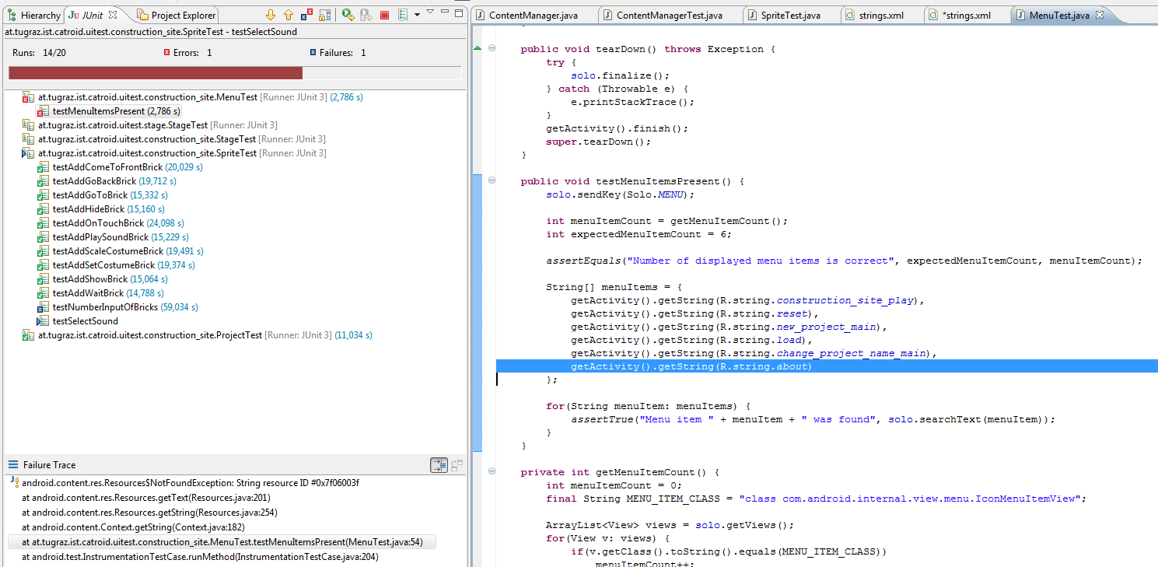
a) not all tests were run before checkin
b) not enough tests (does for each German string resource also an English string exist?)

