Program Structure

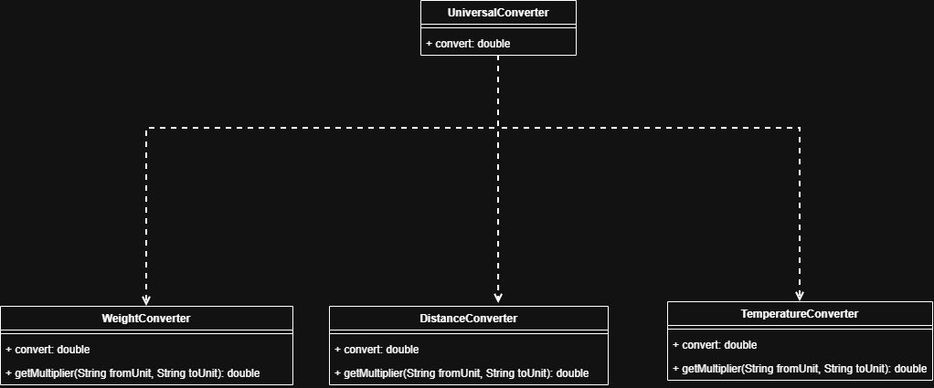

Top-down Integration
Unit under test | List of Stubs/Drivers | result | Stub’s return value | Expected results | Actual results | Pass/Fail/No run
UniversalConverter,  WeightConverter | DistanceConverter ,TemperatureConverter |  | DistanceConverter: 1000  TemperatureConverter:273 | 10kilogram->  10000gram | 0.01gram | Fail
UniversalConverter,  DistanceConverter | TemperatureConverter, WeightConverter |  | TemperatureConverter:273 | 1 kilometer->  1000 meter | 1000 meter | Pass
UniversalConverter,  TemperatureConverter | DistanceConverter,  WeightConverter |  | DistanceConverter: 1000  WeightConverter: 1 | 0 C->  273.15 K | 273.15 K | Pass
UniversalConverter,  WeightConverter,  DistanceConverter,  ,TemperatureConverter | - |  |  | Temperature: 0 C->  273.15 K  Distance: 1 kilometer->  1000 meter  Weight: 1000 gram -> 1 kilogram | Temperature: 273.15 K  Distance: 1000 meter  Weight: 1000000 kilogram | Fail

Bottom-up Integration
Unit under test | List of Stubs/Drivers | result | Stub’s return value | Expected results | Actual results | Pass/Fail/No run
WeightConverter | WegihtDriver |  | - | 10kilogram->  10000gram | 0.01gram | Fail
DistanceConverter, | DistanceDriver |  | - | 1 kilometer->  1000 meter | 1000 meter | Pass
TemperatureConverter | TempDirver |  | - | 0 C->  273.15 K | 273.15 K | Pass
UniversalConverter,  WeightConverter,  DistanceConverter,  ,TemperatureConverter | Main |  |  | Temperature:  0 C ->  273.15 K  Distance: 1 kilometer->  1000 meter  Weight: 1000 gram -> 1 kilogram | Temperature: 273.15 K  Distance: 1000 meter  Weight: 1000000 kilogram | Fail

