LUMEN
SERVIRE USER MANUAL
M0.1 Research Distribution
Continuity • Understanding • Provenance • Trust

Version 0.1 | September 2026
Illuminates.One

About this manual
This manual is the operational guide for the Lumen M0.1 Research Distribution. It is written for researchers running Lumen locally with Docker, MongoDB and an Ollama model provider. It focuses on the Servire workspace and the researcher-facing component interfaces available from it.
SCOPE M0.1 is an experimental research distribution. The screens in this manual are taken from the frozen M0.1 release and show real operating states from an end-to-end installation test.

What Servire does
Servire is the operational control plane for Lumen. It provides one workspace from which you can validate dependencies, start and stop the Stack, inspect health and logs, and open the interfaces for the managed Lumen components.

Terminology
- Lumen - the complete system, including Servire and all managed services.
- The Stack - the managed Lumen services considered together while Servire is running.
- Trace - a recorded interaction sequence captured by Vestigare.
- Replay - a Repetere experiment that re-executes a recorded trace against a selected model.
- Prepared replay - a replay made available to Fiducia for scheduled execution.

M0.1 component map
Component | Role | Default port
Fiducia | Replay orchestration and scheduling | 11430
Praebere | Model provider and model lifecycle | 11431
Rogare | Conversational client | 11432
Pontis | Communication bridge | 11435
Moderari | Orchestrator | 11436
Repetere | Replay and experiment operator | 11437
Vestigare | Trace recorder | 11438
Servire | Operational control plane | 11439
Nuntius | Bootstrap and service communication | 11440

1. Before you begin

Research distribution package
Your research package should contain the Docker Compose definition, the HAProxy configuration, the Lumen Research Distribution licence and supporting documentation. Registry credentials and the Lumen installation registration key may be supplied separately.

Prerequisites
- Docker Desktop with Docker Compose available.
- Ollama installed and running on the host or another reachable machine.
- At least one suitable Ollama model already available.
- Network access to registry.illuminates.one for the initial image pull and to Illuminates.One when Lumen performs periodic authorization.

Two separate credentials
The private registry credential controls access to the Lumen Docker image. The Lumen registration key controls authorization of the installed Research Distribution. They are separate mechanisms and should be treated separately.
RESEARCH LICENCE By installing, starting, accessing or using the Lumen M0.1 Research Distribution you accept the Research Distribution licence terms presented at first start.

Persistent data
Docker Compose creates persistent volumes for the Lumen workspace, Servire data and MongoDB data. These volumes belong to the local installation and are not part of the distributed Lumen image.

2. Install and start Lumen

Authenticate to the private registry
1 | Open a terminal in the directory containing the distribution package.

2 | Run: docker login registry.illuminates.one

3 | Enter the researcher-specific registry username and password when prompted. A successful login confirms that Docker can authenticate to the private registry.

Start the distribution
1 | Ensure Ollama is running.

2 | Run: docker compose up -d

3 | Allow Docker to pull the frozen Lumen M0.1 image and the required supporting images.

4 | When the containers are running, open Servire at http://localhost:11439. If accessing Lumen from another machine on the LAN, use the Docker host address with port 11439.

REQUIRED FILE Keep haproxy.cfg in the same distribution directory as the Compose file. The HAProxy service bind-mounts this file; if it is missing, the user-facing Lumen ports will not start correctly.

First start
On first start, Servire presents the Lumen M0.1 Research Licence. Read the licence and accept it to continue. Servire then provides the registration and authorization flow for the installation. A correctly authorized installation displays AUTHORISED together with its lease information.

3. Servire: validate and start the Stack
The Servire home page is the operational starting point. The top navigation opens each component inside the unified workspace. Stack Health summarizes the current state; Stack Actions exposes the permitted lifecycle actions; the Operational Log records what Servire and the managed components are doing.
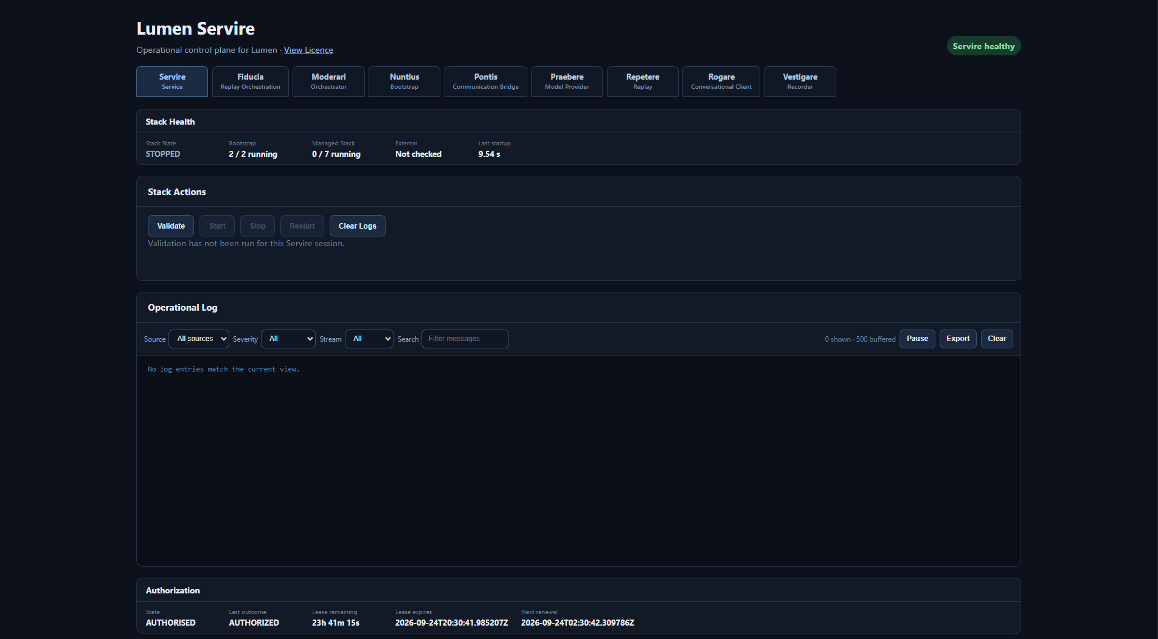
Figure 1. Servire before validation: Stack state, lifecycle controls, operational log and authorization status.

Validate
Select Validate before starting the Stack. Validation checks the prerequisites and configuration required for a controlled start. If validation succeeds, Servire reports that validation passed and enables the appropriate next action.
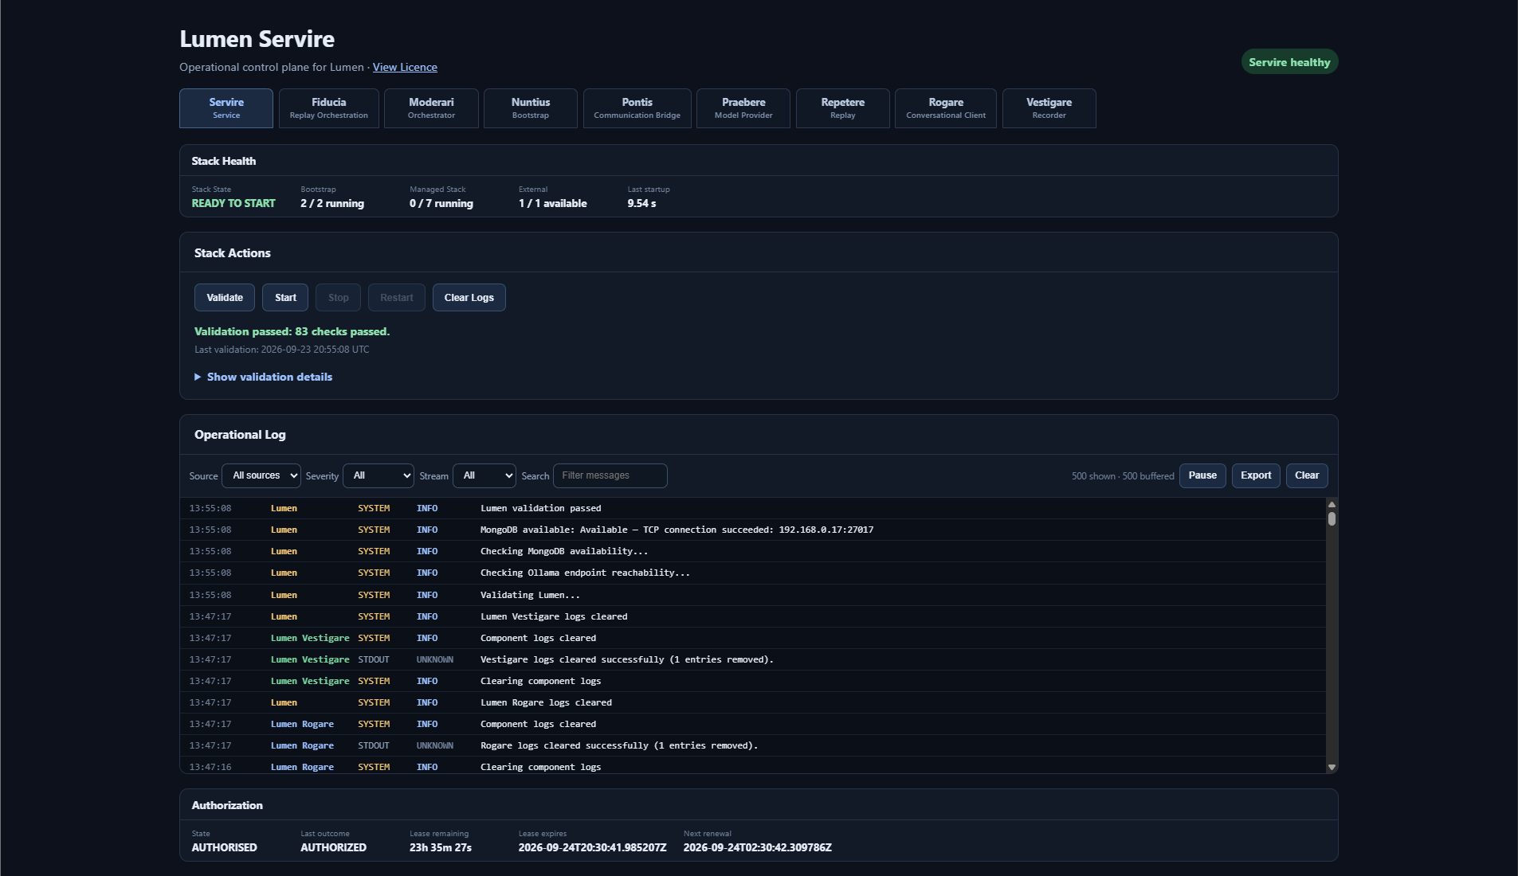
Figure 2. Servire after successful validation. The Operational Log shows the validation sequence and the Stack is ready to start.

Start
Select Start. Servire starts the managed components in dependency order and reports progress in the Operational Log. Do not treat an individual component becoming available as completion of the whole start sequence; wait for the Stack to reach its ready state.
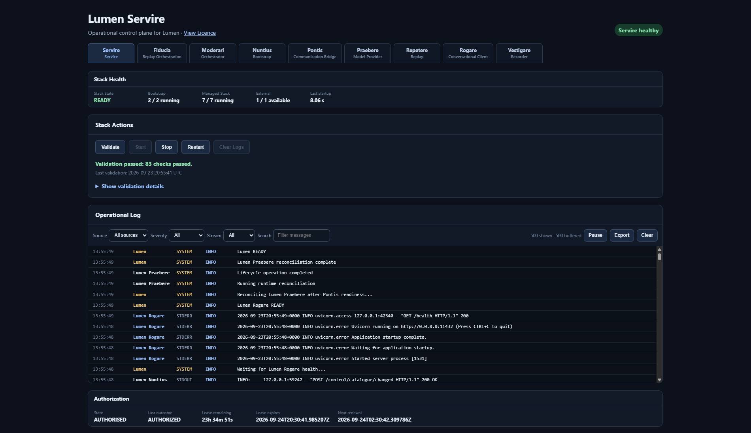
Figure 3. Servire during/after Stack start-up with the Operational Log populated by component readiness events.
HEALTHY END STATE A normal start finishes with the managed components available and Lumen READY in the operational sequence.

4. Servire: health, dependencies and configuration

Managed Components and External Dependencies
The lower Servire workspace separates managed Lumen components from external dependencies. Managed component cards show implementation, dependencies, health, launch information, state and process information. External Dependencies shows the provider and persistence services that Lumen relies on.
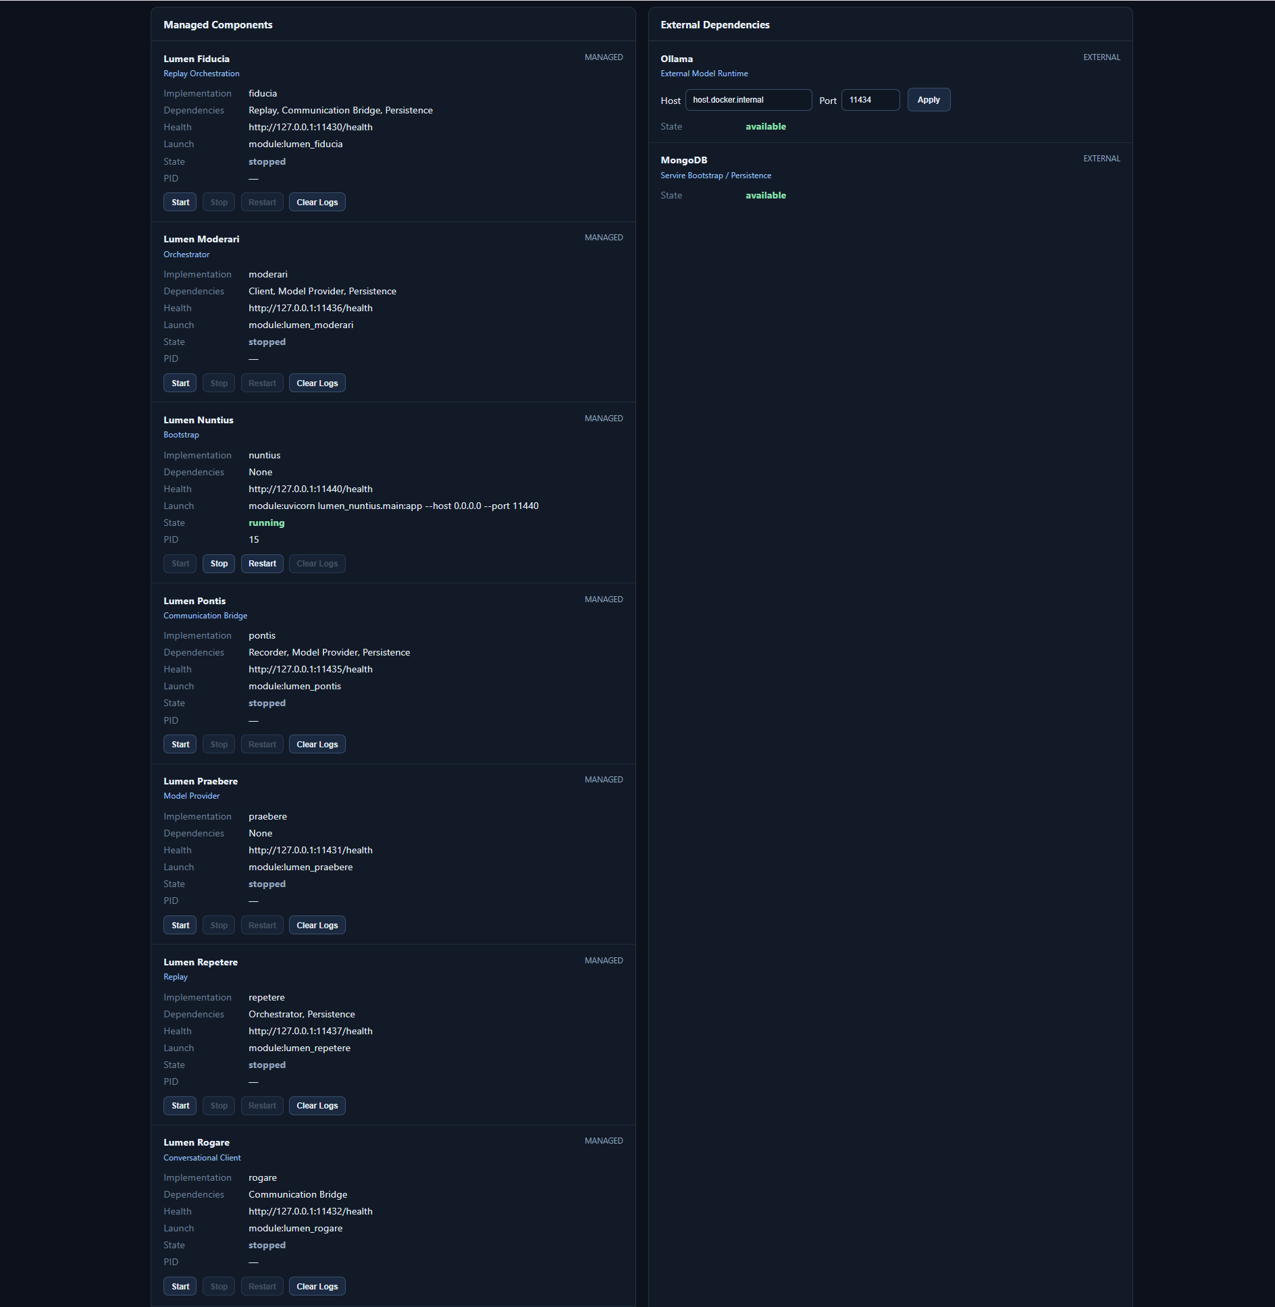
Figure 4. Managed Components alongside External Dependencies. Ollama and MongoDB are shown separately from the managed Stack.

Ollama
Set the Ollama host and port to the endpoint reachable from the Lumen container, select Apply, and confirm that the state becomes available. Provider discovery and model lifecycle are then handled through Praebere.

Configuration
The Configuration area provides the resolved runtime configuration for each component. Expand a component to inspect its implementation, working directory, launch command, configuration file, health endpoint, dependencies and interfaces. The detailed configuration control can be used where a component exposes it.
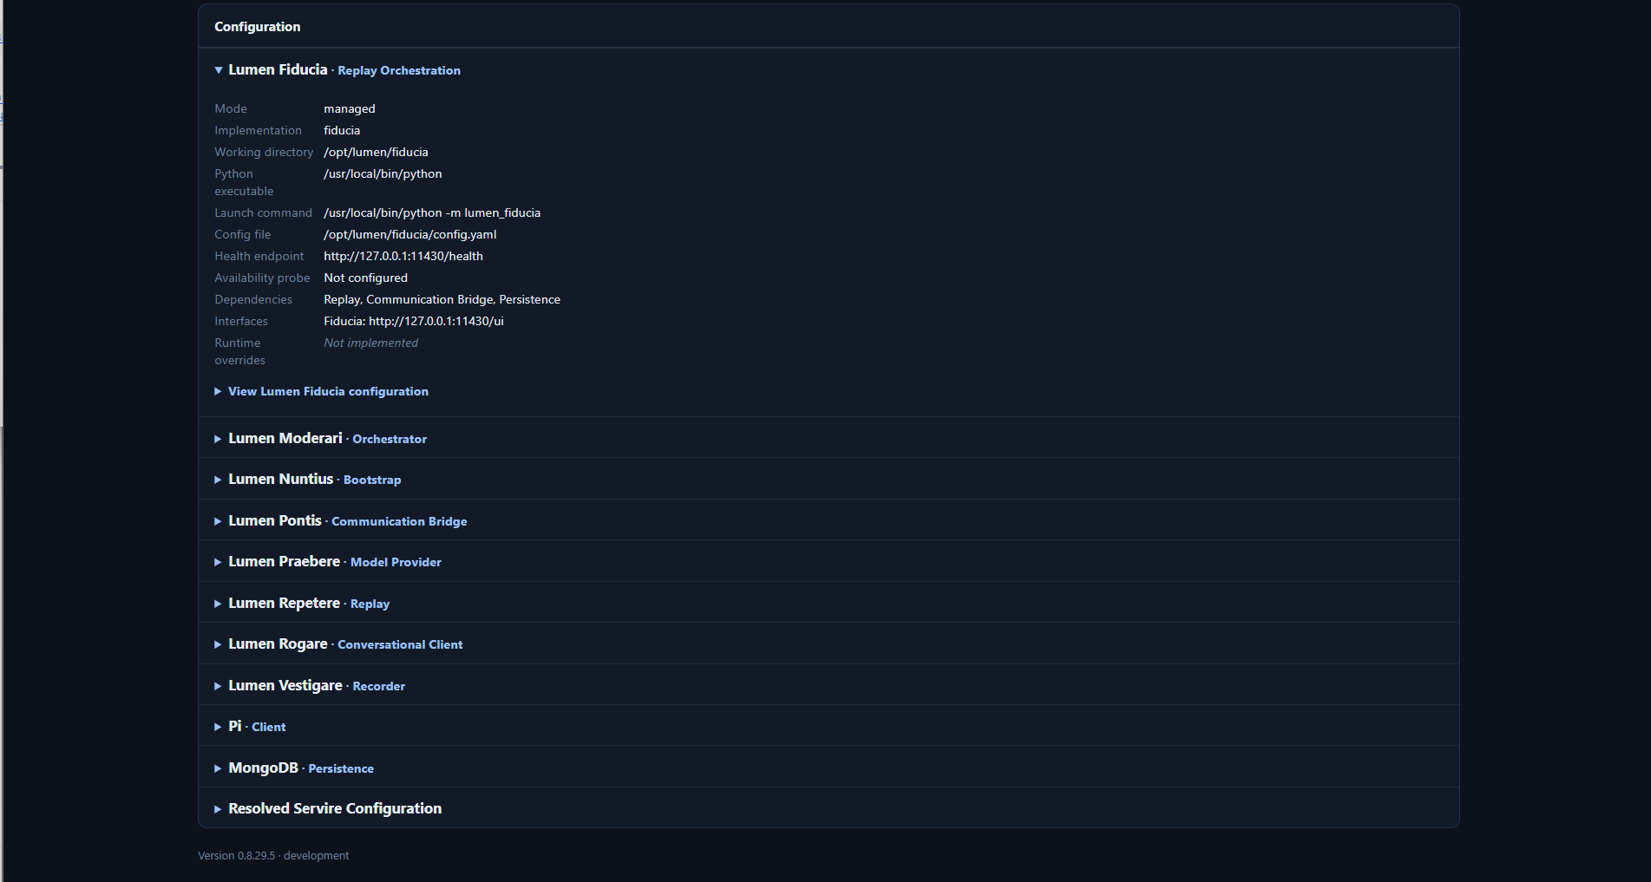
Figure 5. Configuration with Fiducia expanded as a representative component. The same inspection pattern applies to the other components.
USE CONFIGURATION FOR INSPECTION For normal research operation you should not need to edit internal component configuration. Use these views primarily to understand and diagnose the running M0.1 installation.

5. Nuntius: communication and bootstrap visibility
Nuntius provides visibility into Lumen service communication and bootstrap activity. Its interface is useful when confirming that requests are flowing between components and when investigating service-level communication.
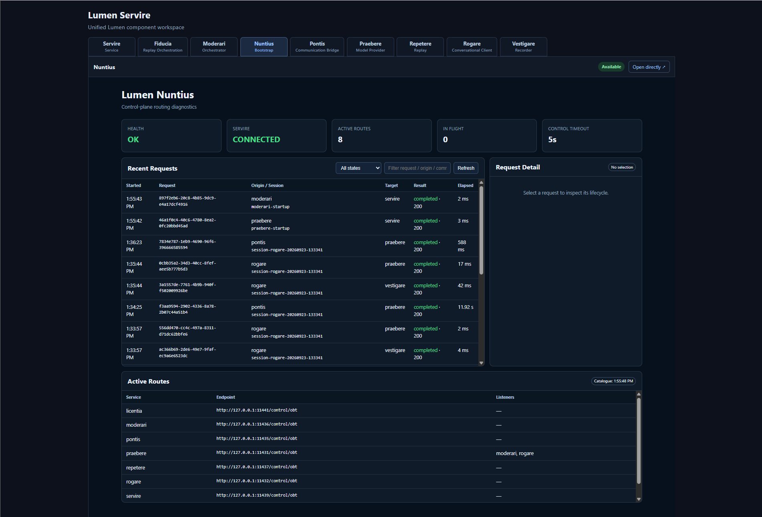
Figure 6. Nuntius showing a connected state, recent requests, request detail and active routes.

What to look for
- A healthy/connected state at the top of the view.
- Recent Requests for request method, route, target and result.
- Request Detail when a request is selected.
- Active Routes to confirm the component routes known to Nuntius.

6. Praebere: model provider and model lifecycle
Praebere is the model-provider control surface. In M0.1 the provider is Ollama. Praebere discovers available models, tracks provider state and coordinates model selection/reservation for active Lumen work.
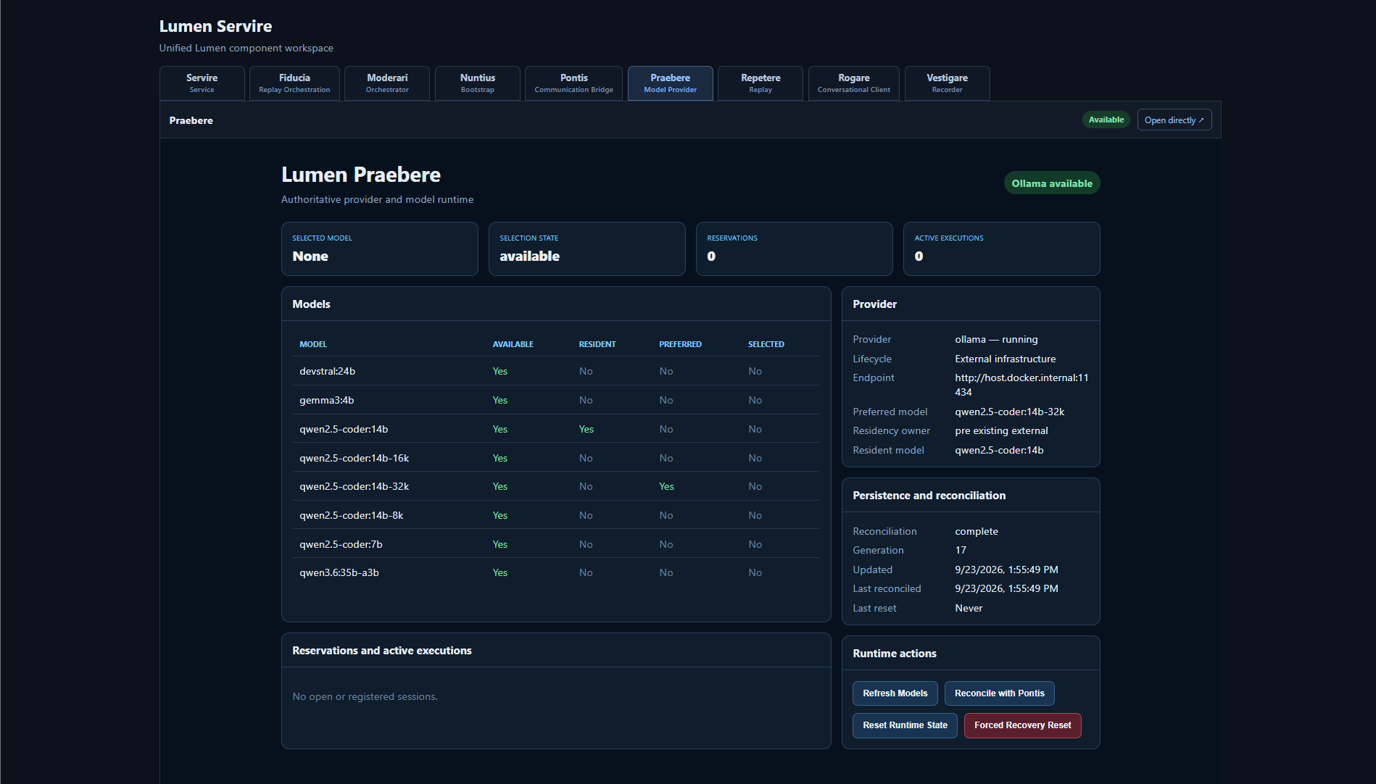
Figure 7. Praebere with Ollama available and the discovered model catalogue visible.

Model catalogue
The Models table shows the models discovered from the provider and their current availability/lifecycle information. Use Refresh Models when the Ollama catalogue has changed and you need Praebere to discover the current provider state.

Selected and reserved models
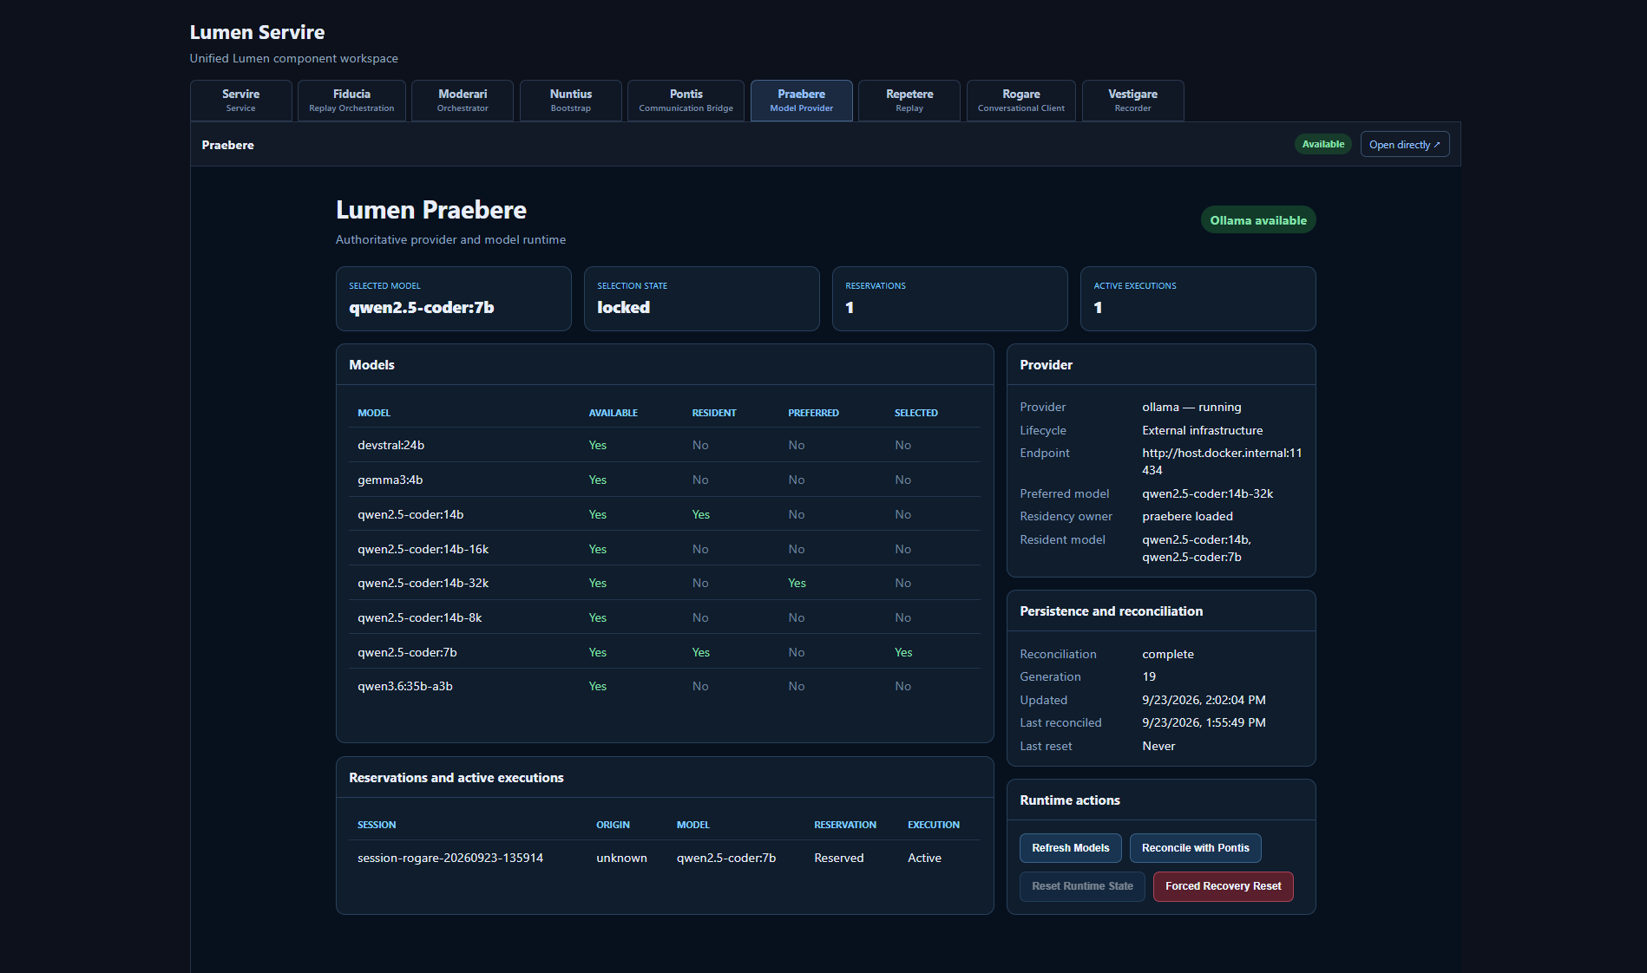
Figure 8. Praebere while a model is selected and reserved by active Lumen work.
A reservation indicates that the model is currently owned by an active execution/session lifecycle. Do not force model changes merely to clear a reservation; end the owning session or execution normally whenever possible.
PROVIDER RECOVERY If Ollama is stopped or becomes unreachable, Lumen may release affected lifecycle state. Restore Ollama, confirm provider health, and refresh the model catalogue before continuing.

7. Rogare: run a conversation
Rogare is the conversational client. It creates a Lumen session, selects a model through Praebere and sends conversation turns through the Lumen execution path.
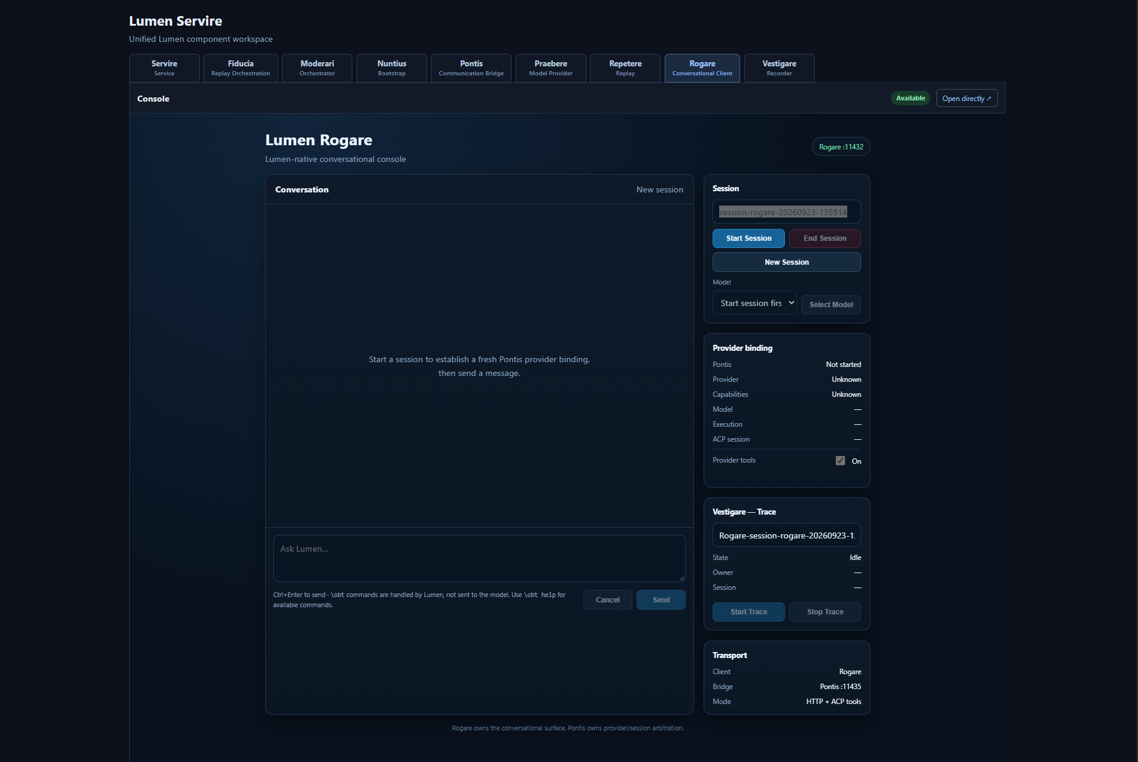
Figure 9. Rogare before a session is created.

Create a session and select a model
1 | Select New Session.

2 | Choose the required model from the model selector.

3 | Confirm that Provider Binding and Bridge / Trace show the expected ready state before sending research prompts.

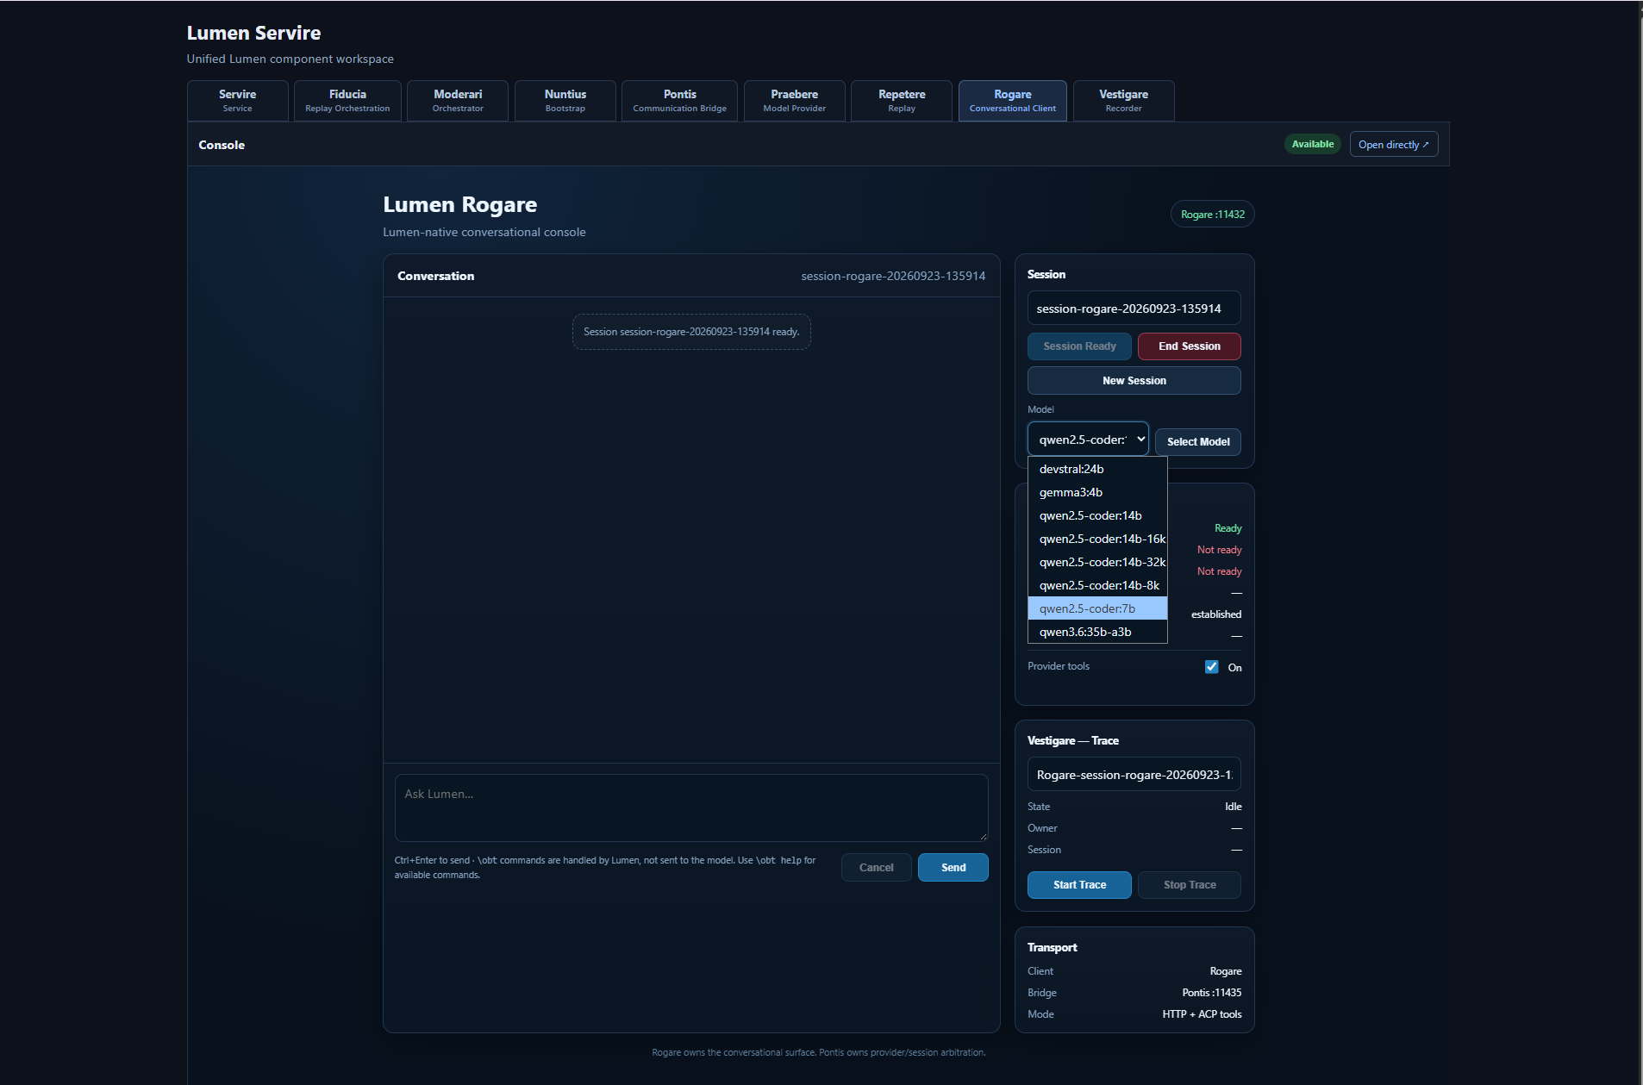
Figure 10. Rogare model selection with the available provider models shown.
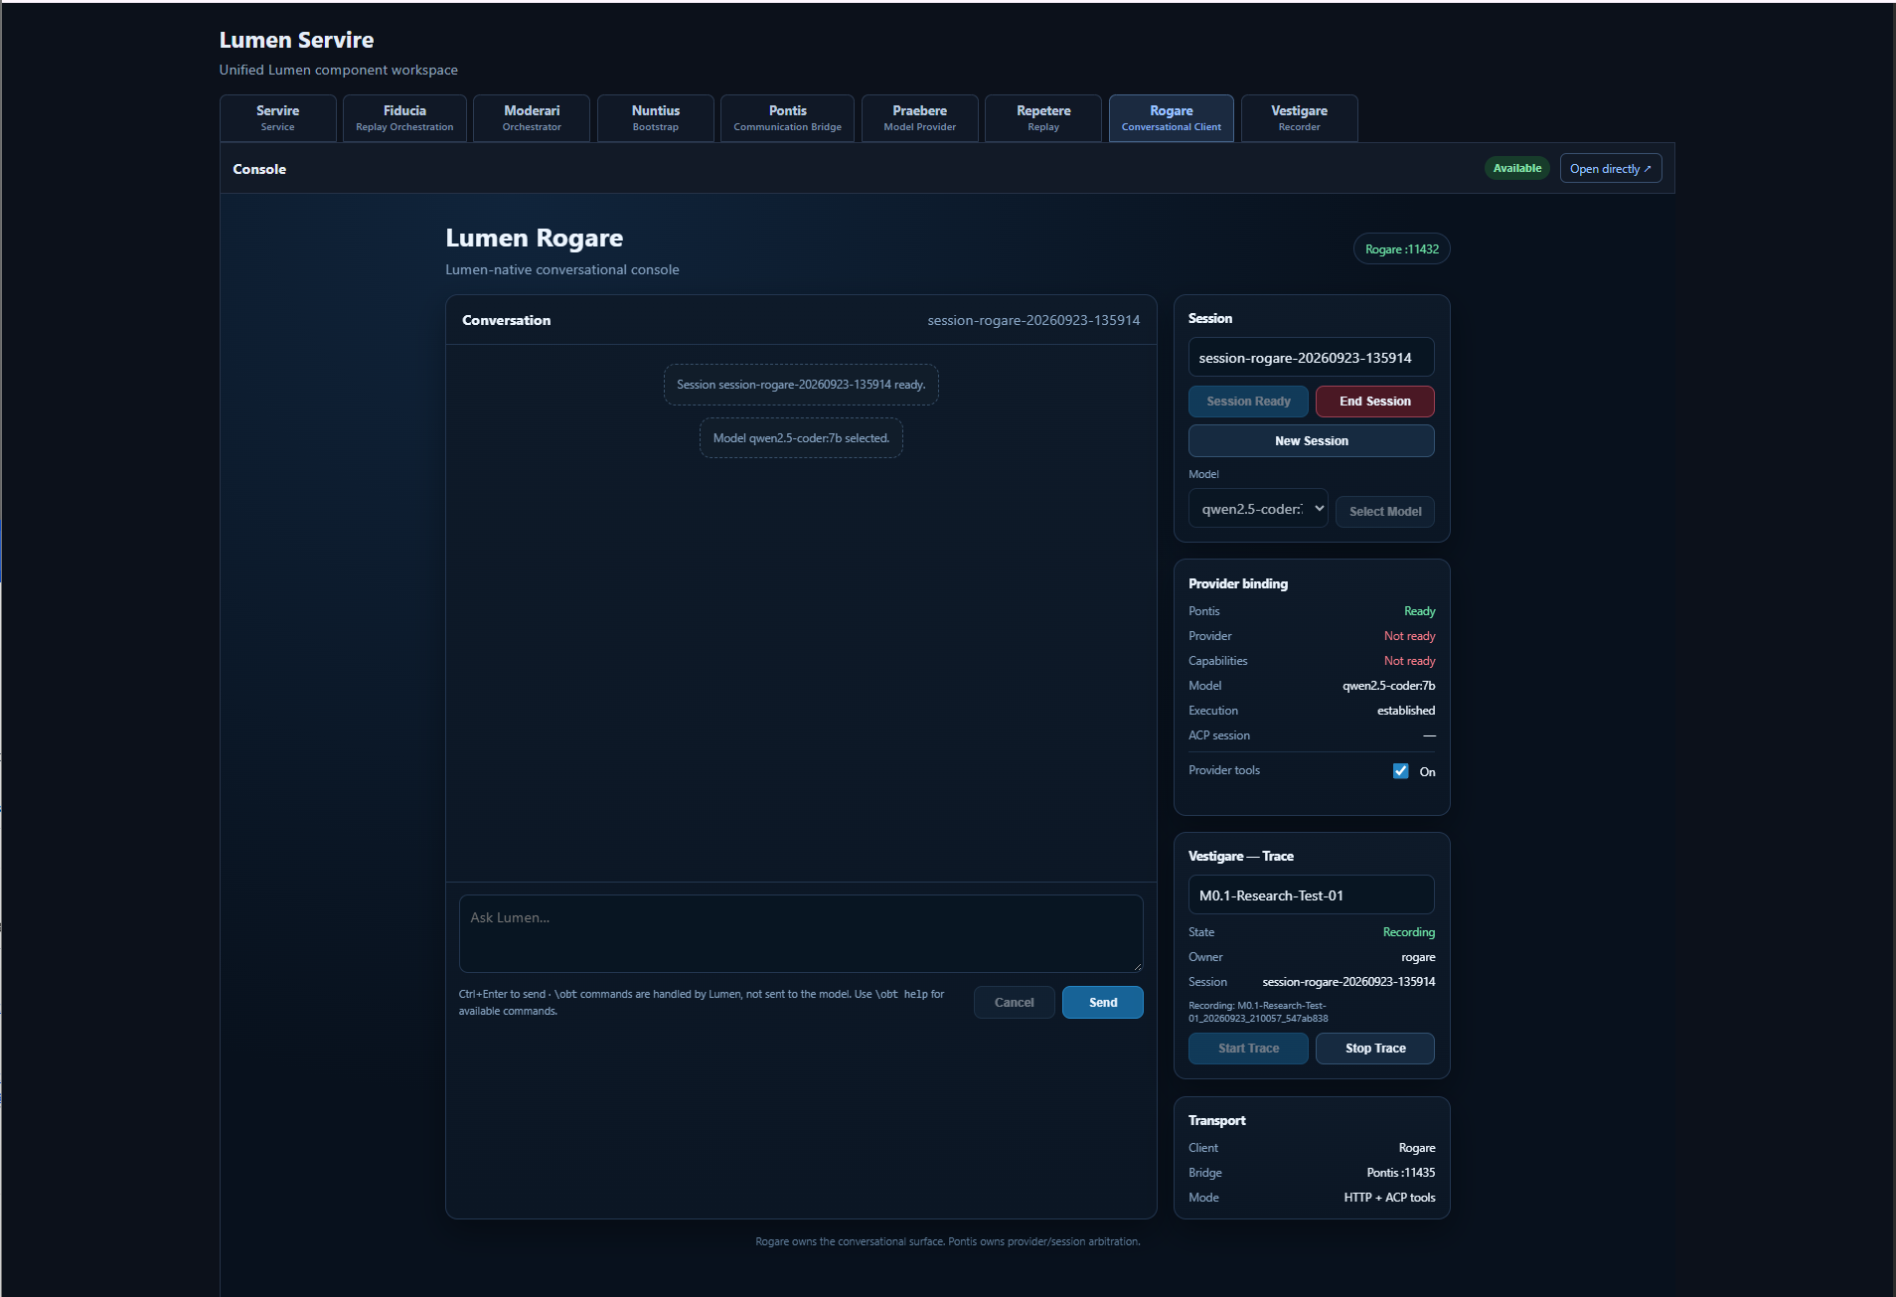
Figure 11. Rogare after model selection, with provider binding and bridge/trace state visible.

Send a prompt
Enter the prompt and select Send. The response appears in the conversation area. The right-hand panels retain the session, provider binding, bridge/trace and request context needed to understand the execution.
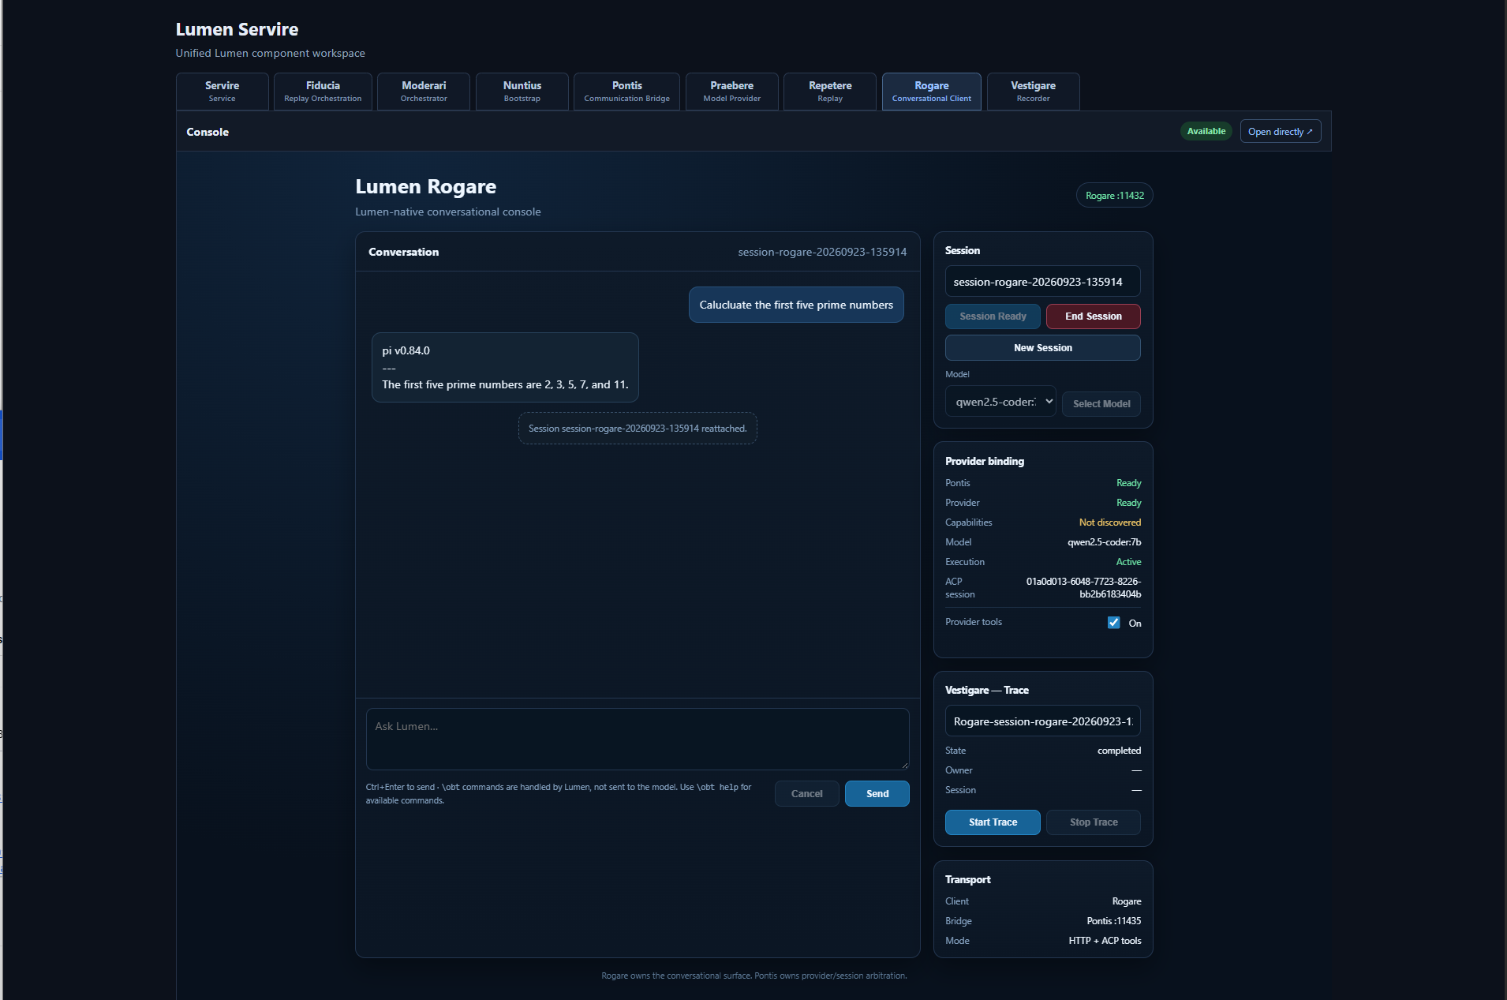
Figure 12. A completed Rogare interaction with the session and model state retained alongside the conversation.

End the session
Use End Session when the conversation is complete. Normal session termination allows Pontis and Praebere to release the execution and model lifecycle cleanly. Force-close controls are intended for exceptional recovery, not routine use.

8. Moderari and Pontis: inspect execution state

Moderari
Moderari exposes orchestration and system-prompt policy information for active sessions. The interface shows session state and the effective prompt policy applied to execution.
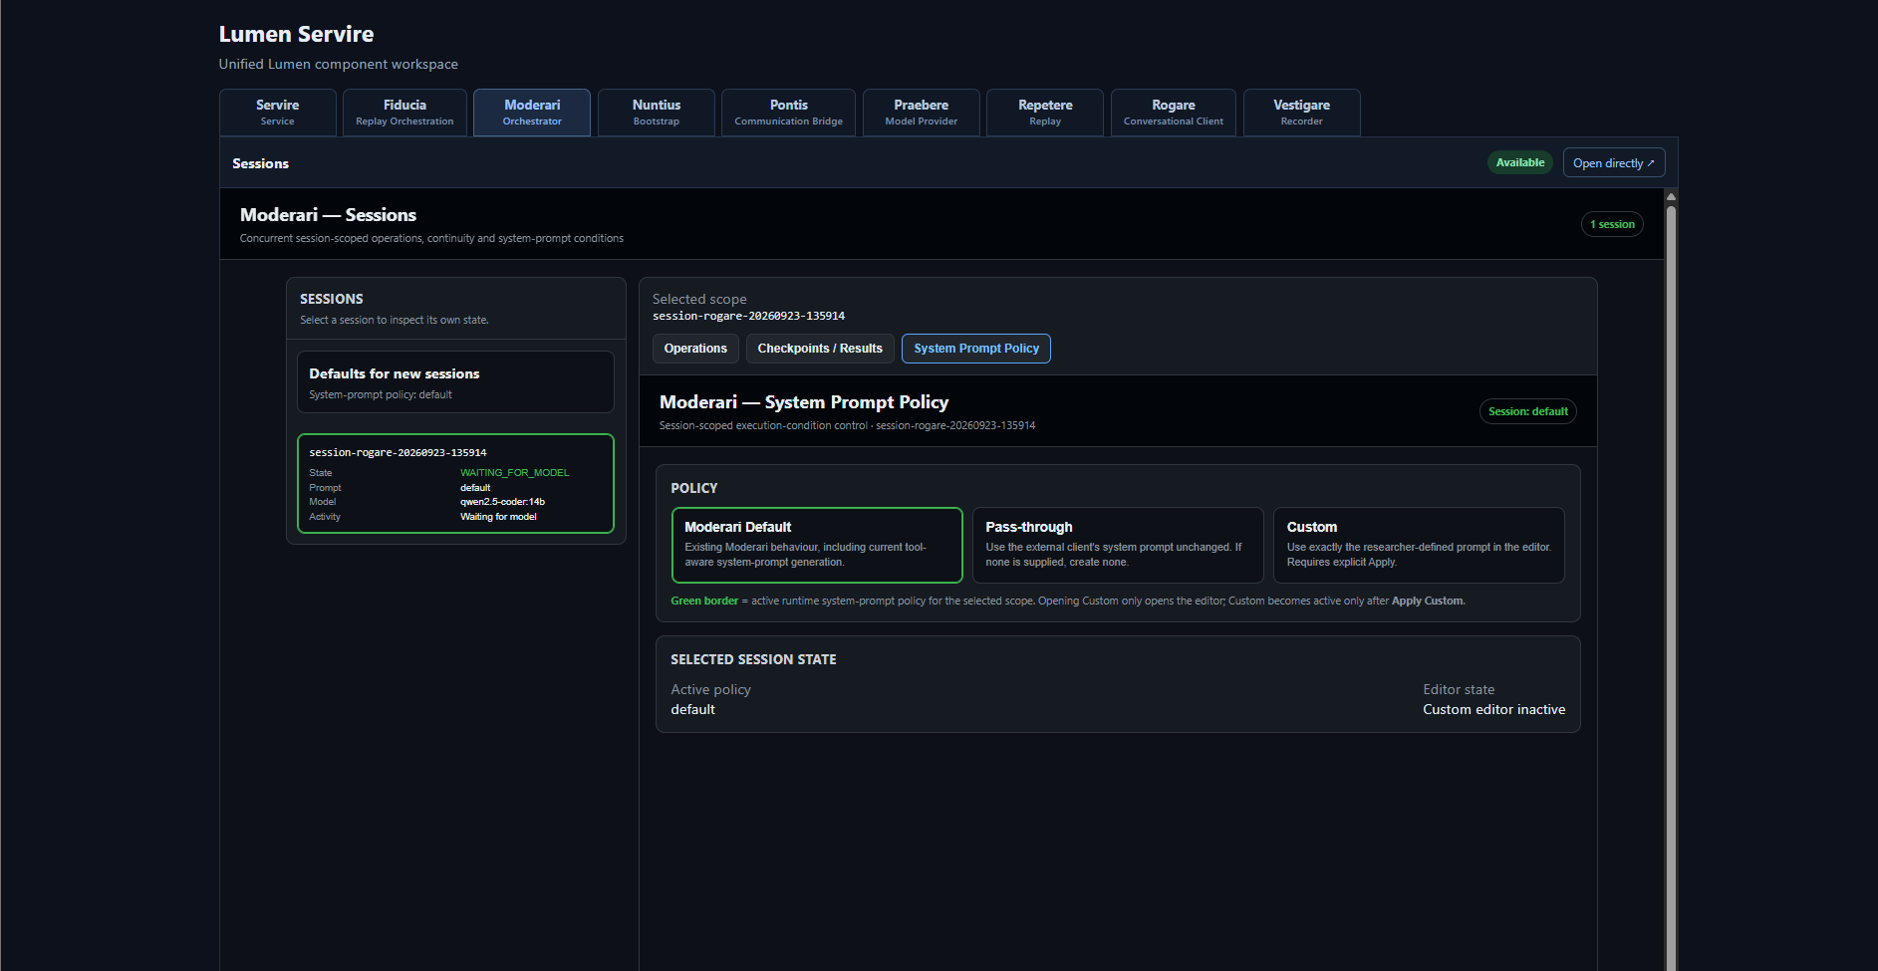
Figure 13. Moderari session view showing system-prompt policy and the active session context.
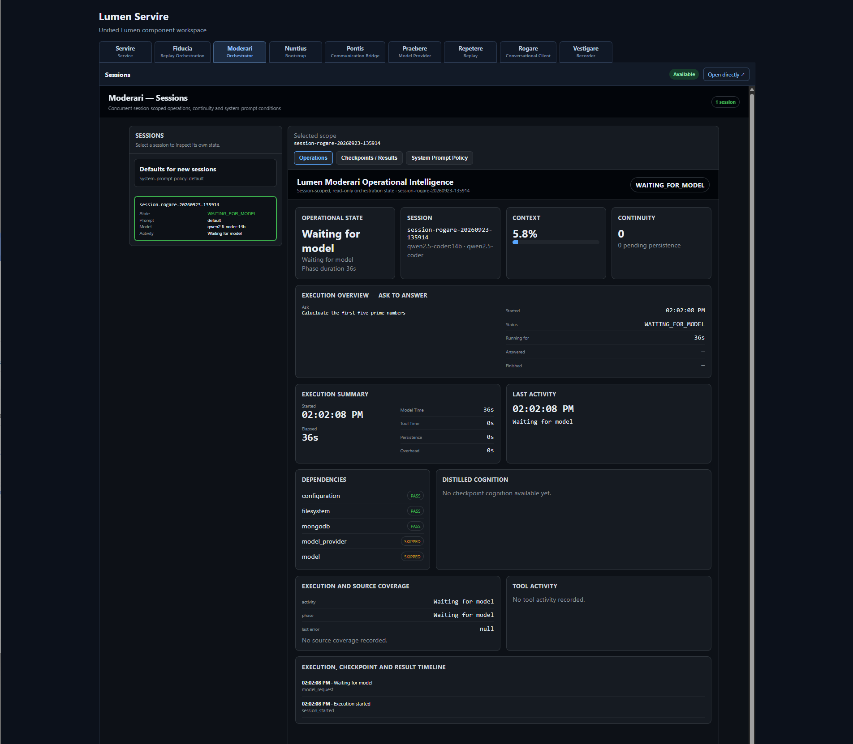
Figure 14. Moderari operational intelligence view for the active session.

Pontis
Pontis is the communication bridge between Lumen orchestration and Pi. Its UI is primarily an operational inspection surface: it shows active execution/session information and the current bridge state.
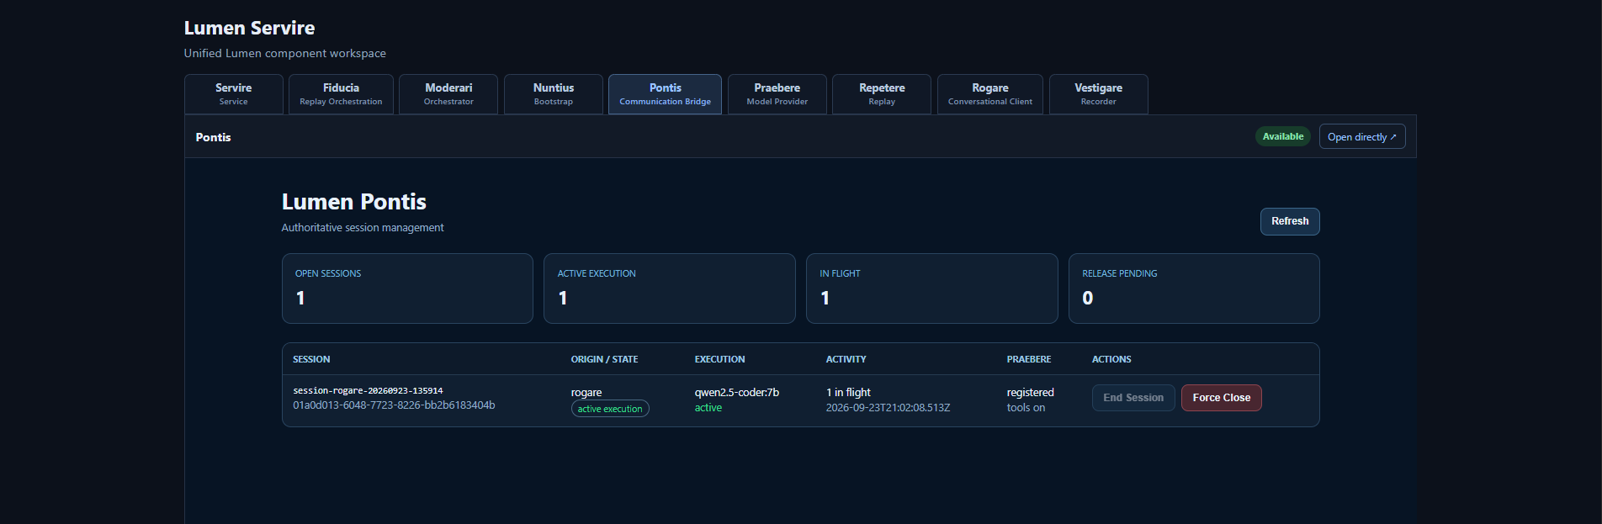
Figure 15. Pontis with an active session visible.
RESEARCHER GUIDANCE Rogare is the normal place to conduct a conversation. Moderari and Pontis are useful when you need to inspect how that conversation is being orchestrated and bridged.

9. Vestigare: record and inspect traces
Vestigare records the interaction path transparently. A completed recording becomes a trace that can be inspected directly and used as the source for Repetere replay experiments.
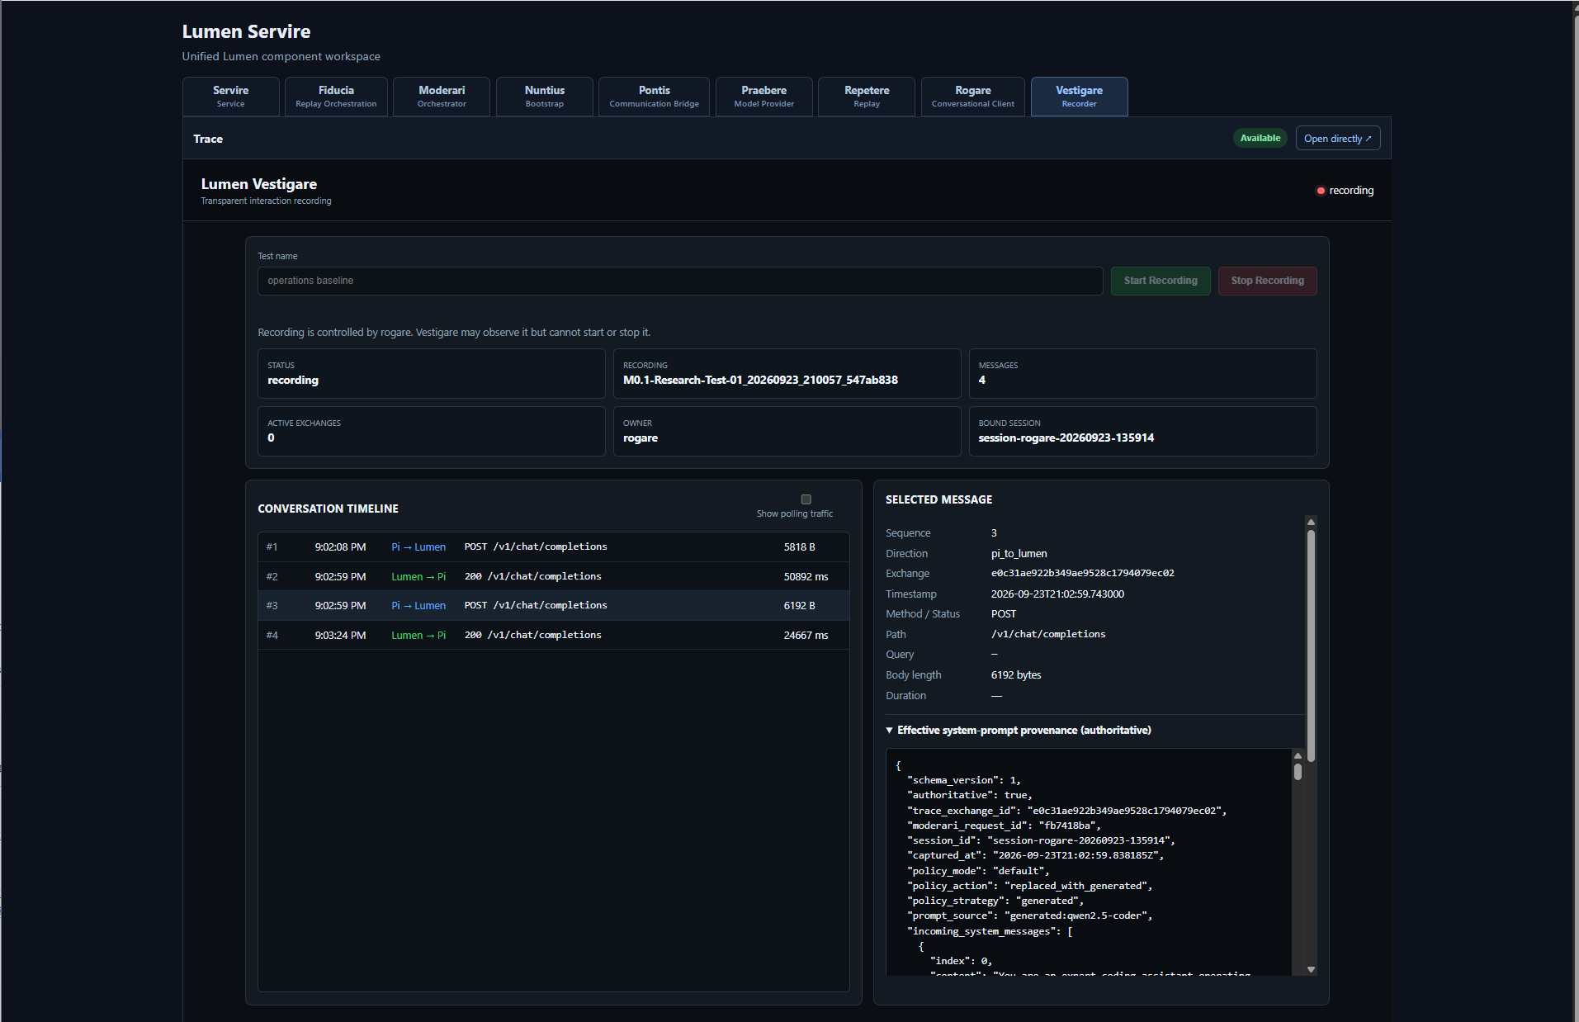
Figure 16. Vestigare with a completed trace, conversation timeline and selected-message detail.

Trace workflow
1 | Give the recording a meaningful test name.

2 | Start recording before the interaction you want to capture.

3 | Run the target conversation or execution.

4 | Stop the recording when the test is complete.

5 | Inspect the Conversation Timeline. Select a message to inspect its recorded detail.

The trace records the ordered exchanges that passed through the observed path. The timeline makes direction, endpoint, timing and message-level detail visible without requiring the researcher to reconstruct the interaction from application logs.

10. Repetere: stage and replay a trace
Repetere turns a recorded trace into a controlled replay experiment. The Operator workflow is deliberately explicit: import a trace, stage it, run the replay, then review the result.
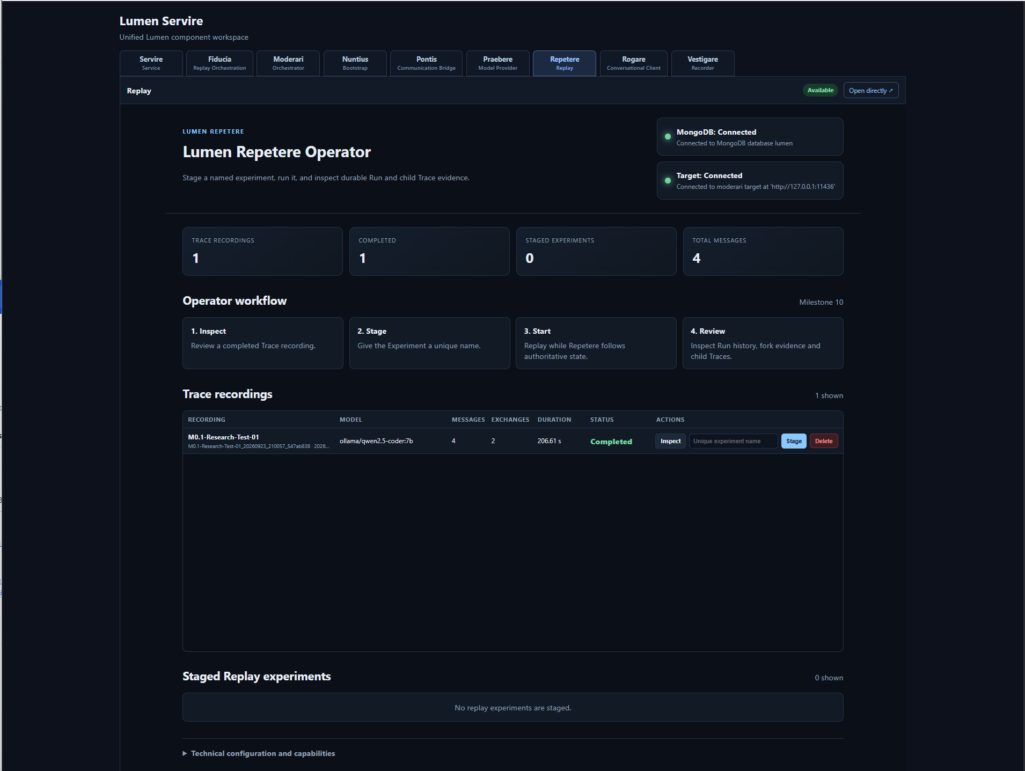
Figure 17. Repetere with a trace recording available and no experiment staged yet.

Stage the trace
Use the action on the trace row to stage the recording. The Staged Replay experiments area then exposes the experiment controls and replay model selection.
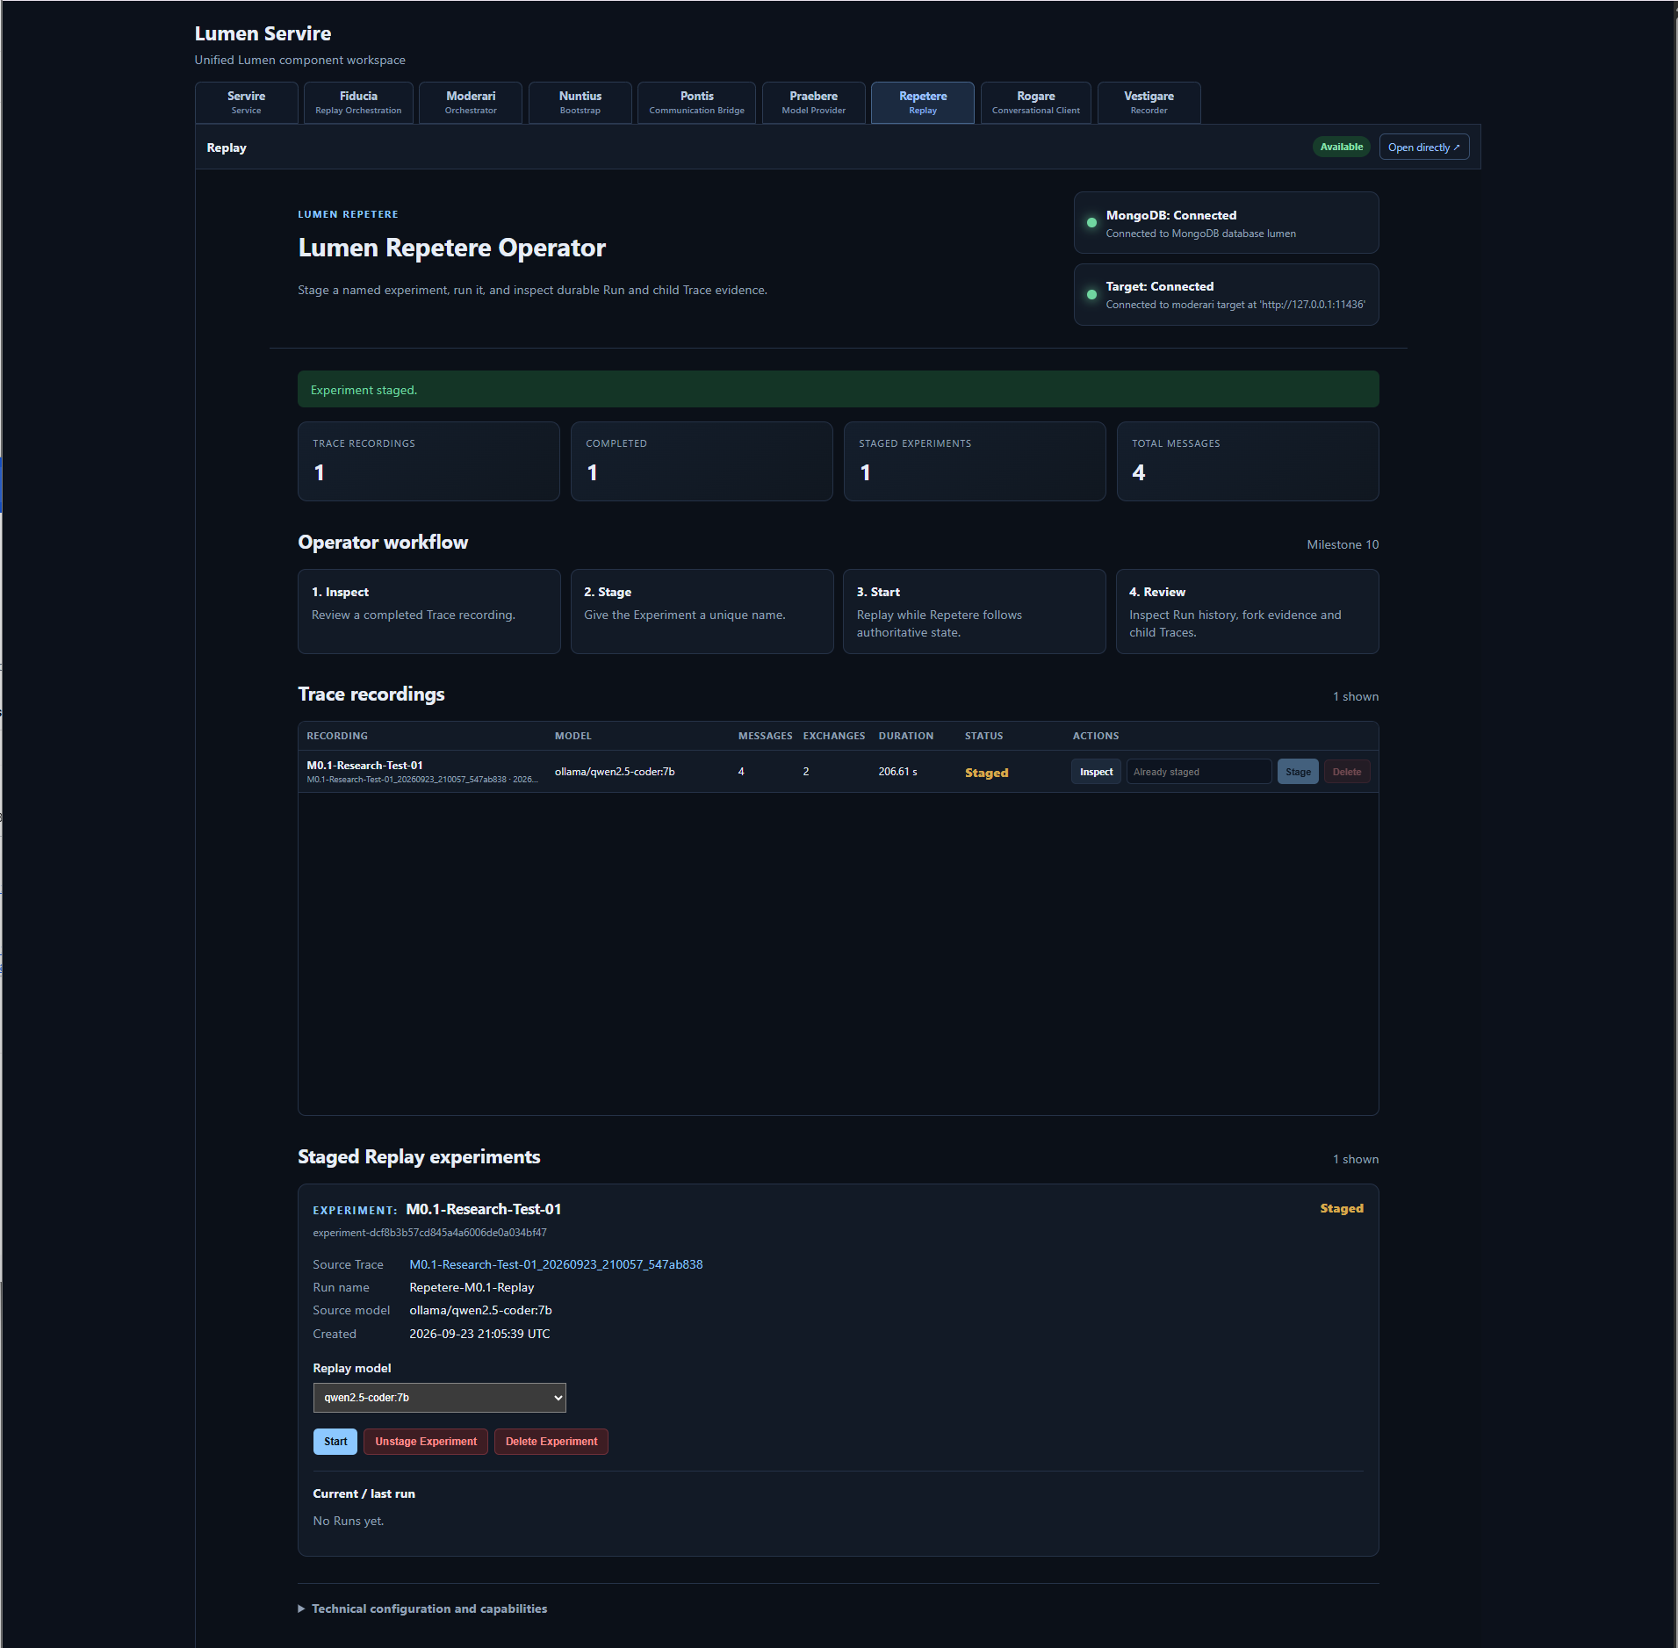
Figure 18. A trace staged as a replay experiment and ready to run.

Run the replay
Choose the replay model and start the run. Repetere reserves the required model through Praebere and displays current run state while the replay is executing.
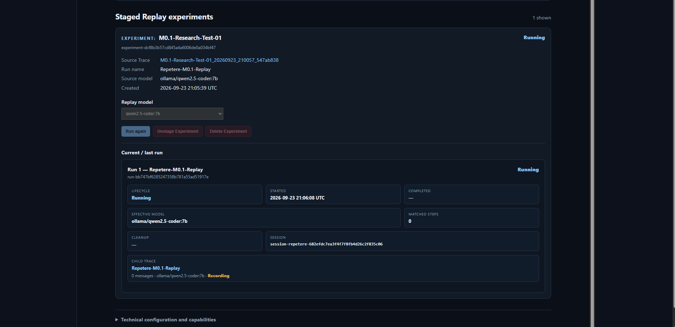
Figure 19. A staged experiment with an active replay run and current run state.

Review completion
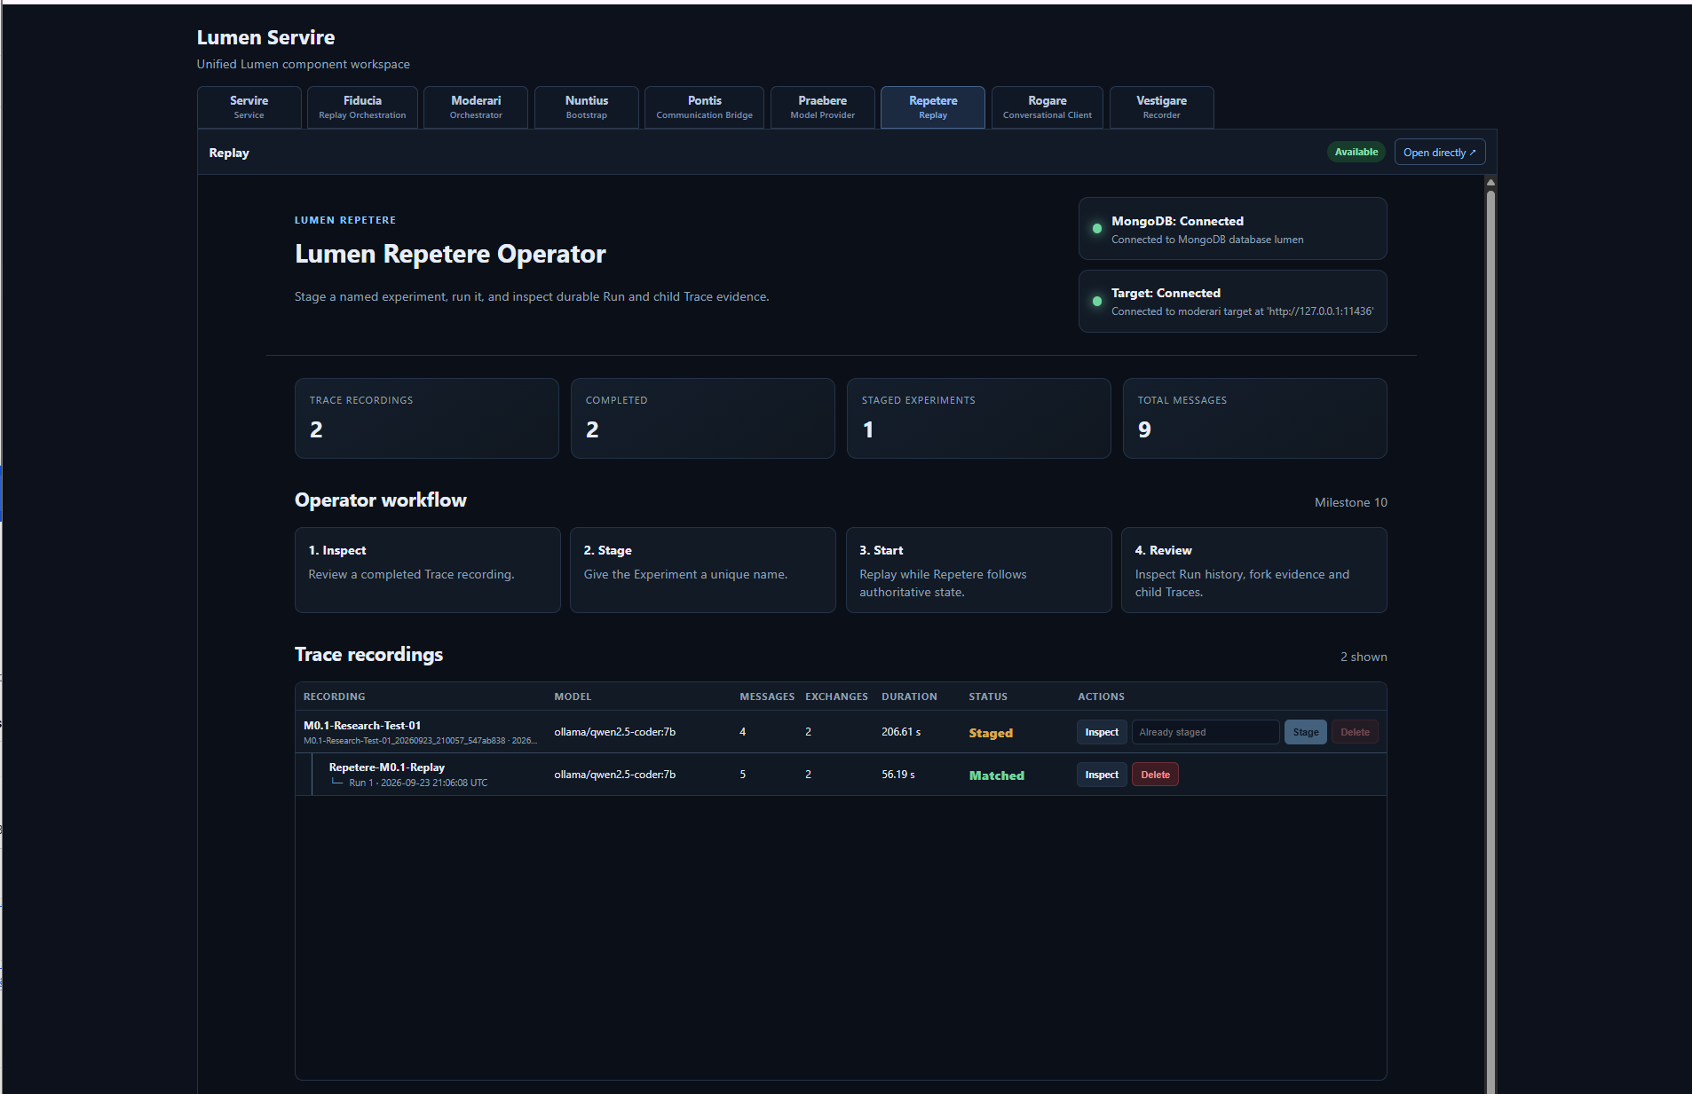
Figure 20. Repetere after replay completion, with the trace and experiment/run status visible.
A completed run preserves the experiment/run relationship so that the researcher can distinguish the original trace from subsequent replay executions. Where the replay diverges from the recording, the resulting child trace is retained as a separate trace relationship rather than overwriting the original evidence.

11. Repetere: model selection and repeat experiments
A staged experiment can be replayed against a different discovered model. This is useful for controlled comparisons while preserving the original trace as the common input.
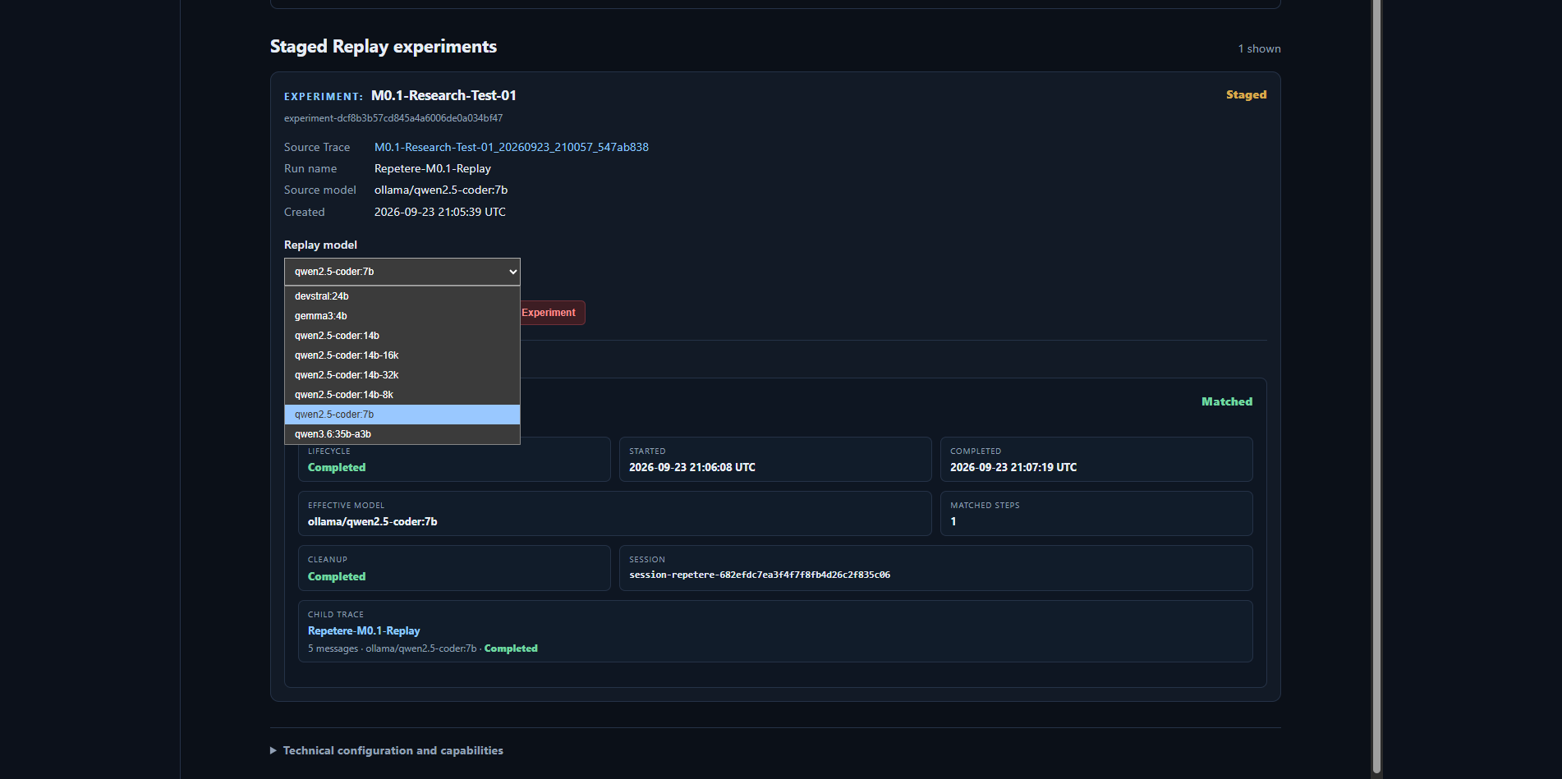
Figure 21. Replay model selector showing models available for a staged experiment.
Select the intended model before starting the next run. Repetere validates and reserves the model through the normal Lumen model lifecycle; the run should fail cleanly rather than silently substituting a different model if the requested model cannot be made available.
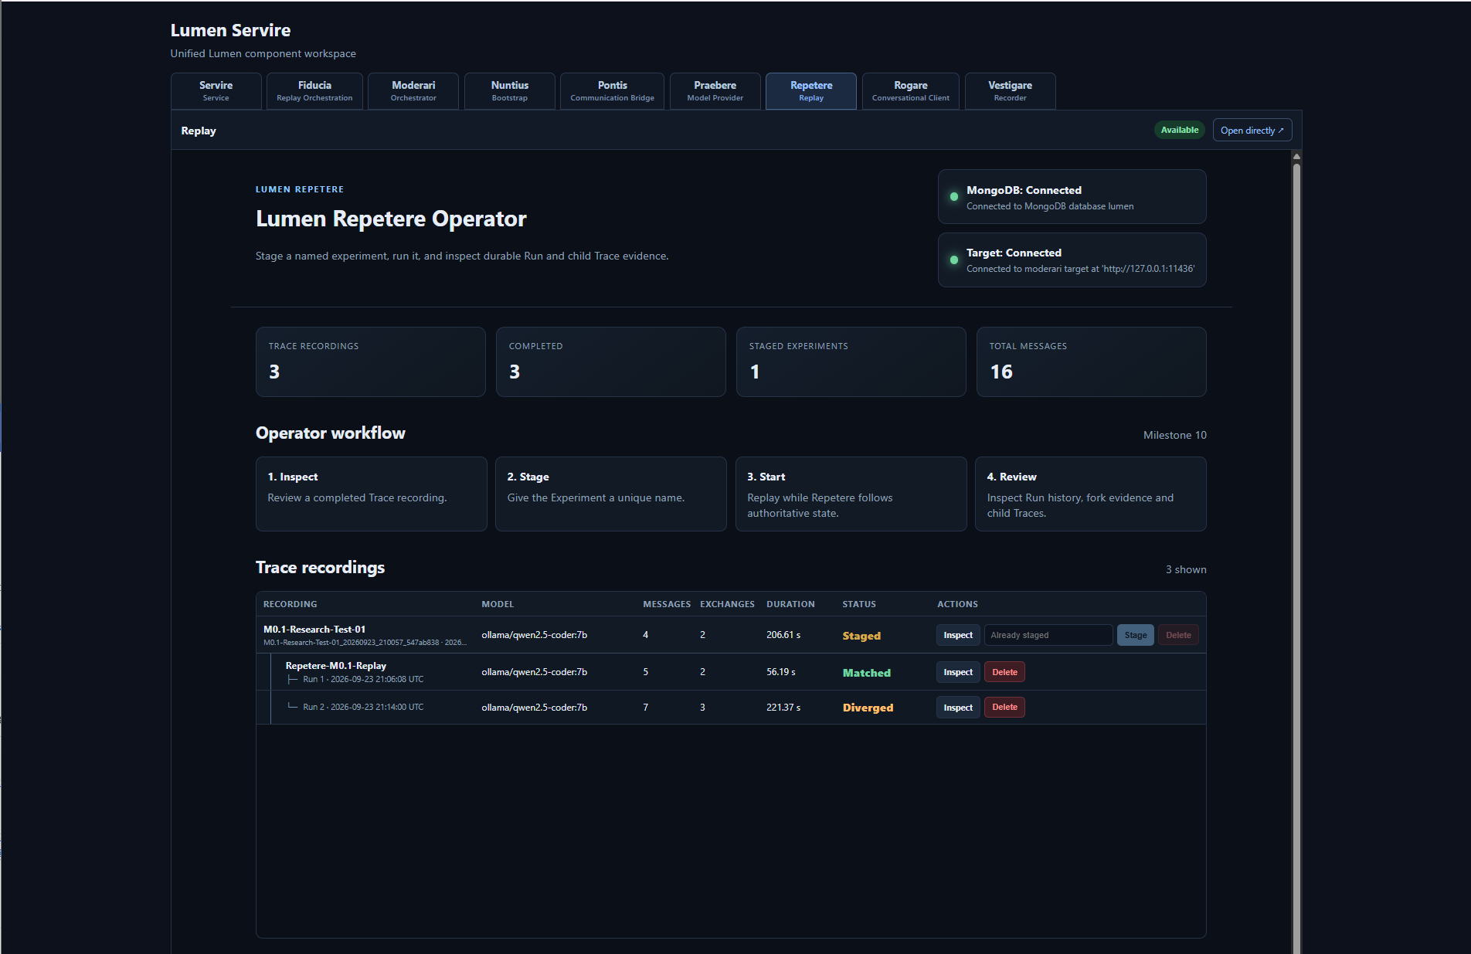
Figure 22. Repetere with multiple trace/replay records after repeated experimental work.
EXPERIMENTAL DISCIPLINE Use meaningful trace and experiment names and change one intended variable at a time. Lumen preserves provenance, but clear experimental naming makes later interpretation substantially easier.

12. Fiducia: schedule a prepared replay
Fiducia schedules prepared Repetere work. A replay must first be made available/prepared in Repetere; Fiducia then exposes it as a schedulable replay target.
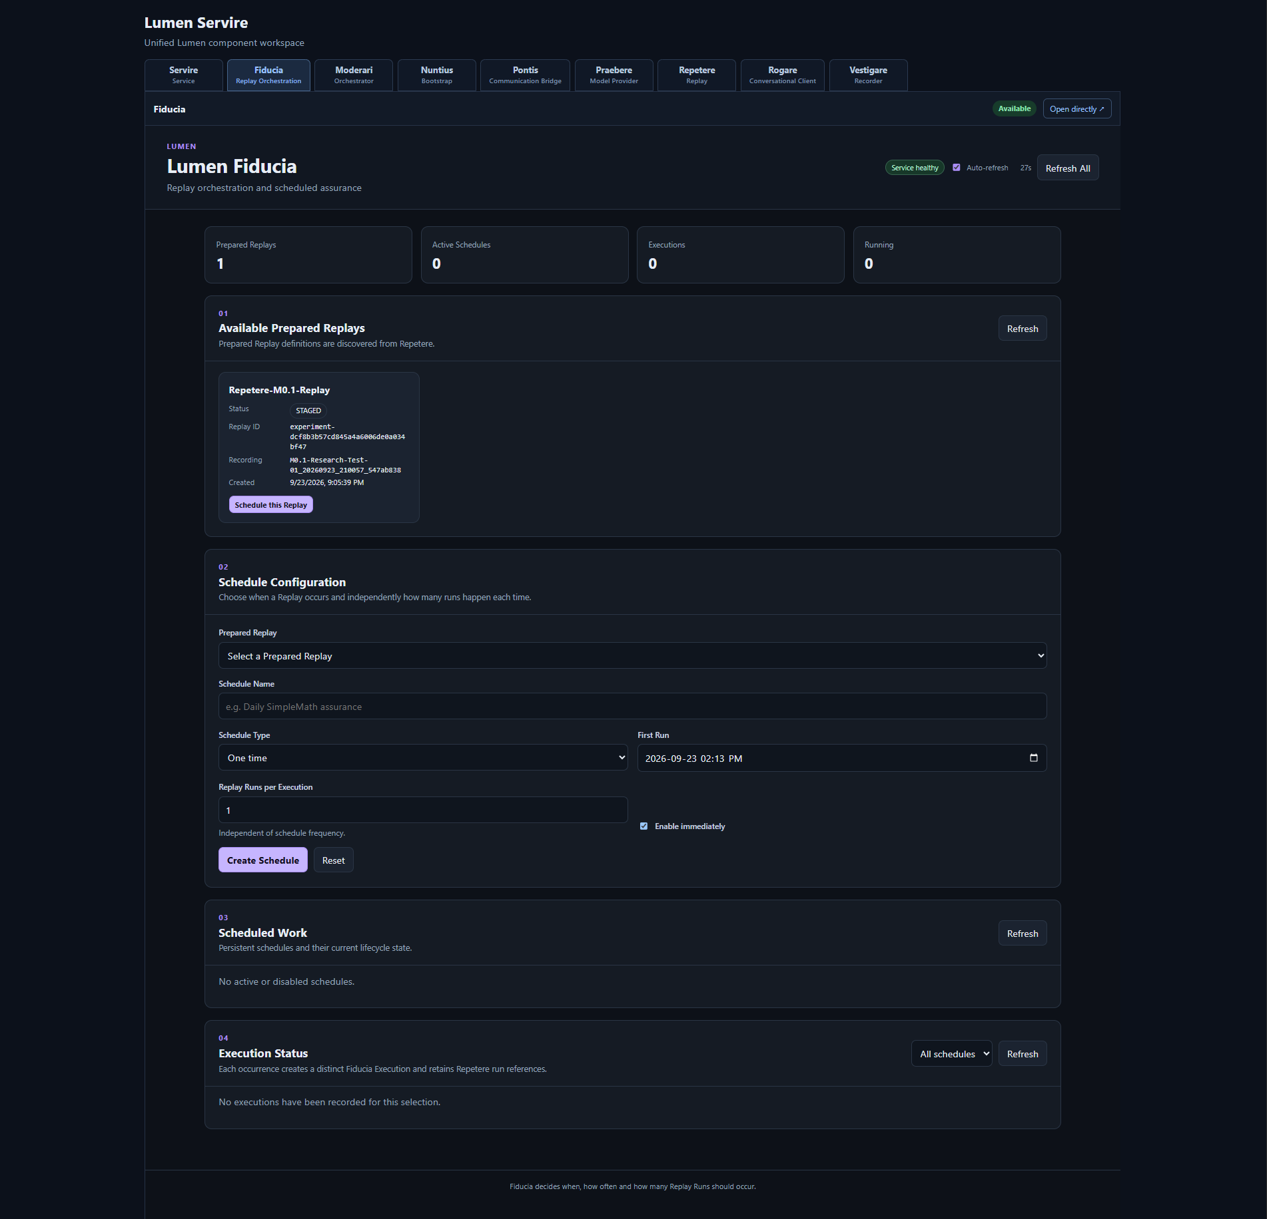
Figure 23. Fiducia with an available prepared replay and the Schedule Configuration form.

Create a schedule
1 | Select the prepared replay.

2 | Give the schedule a meaningful name.

3 | Choose the schedule type and enter the required date/time or recurrence values.

4 | Set the replay run limit as appropriate for the research task.

5 | Select Create Schedule.

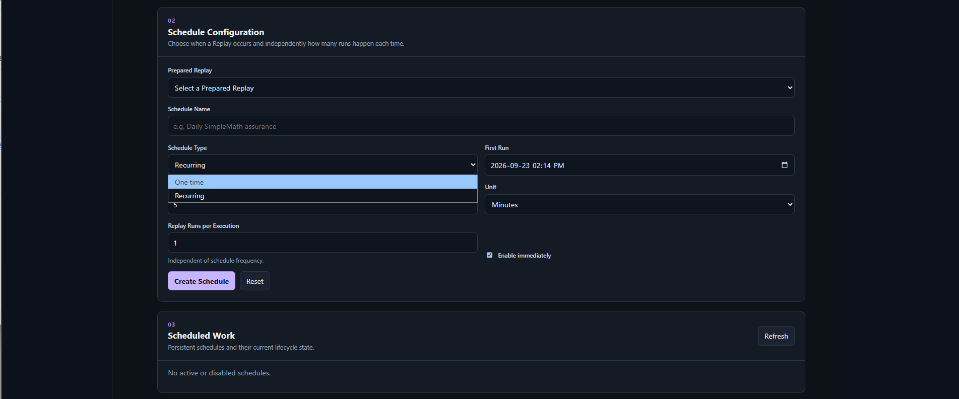
Figure 24. Fiducia schedule configuration with the schedule type selector open.

Scheduled work
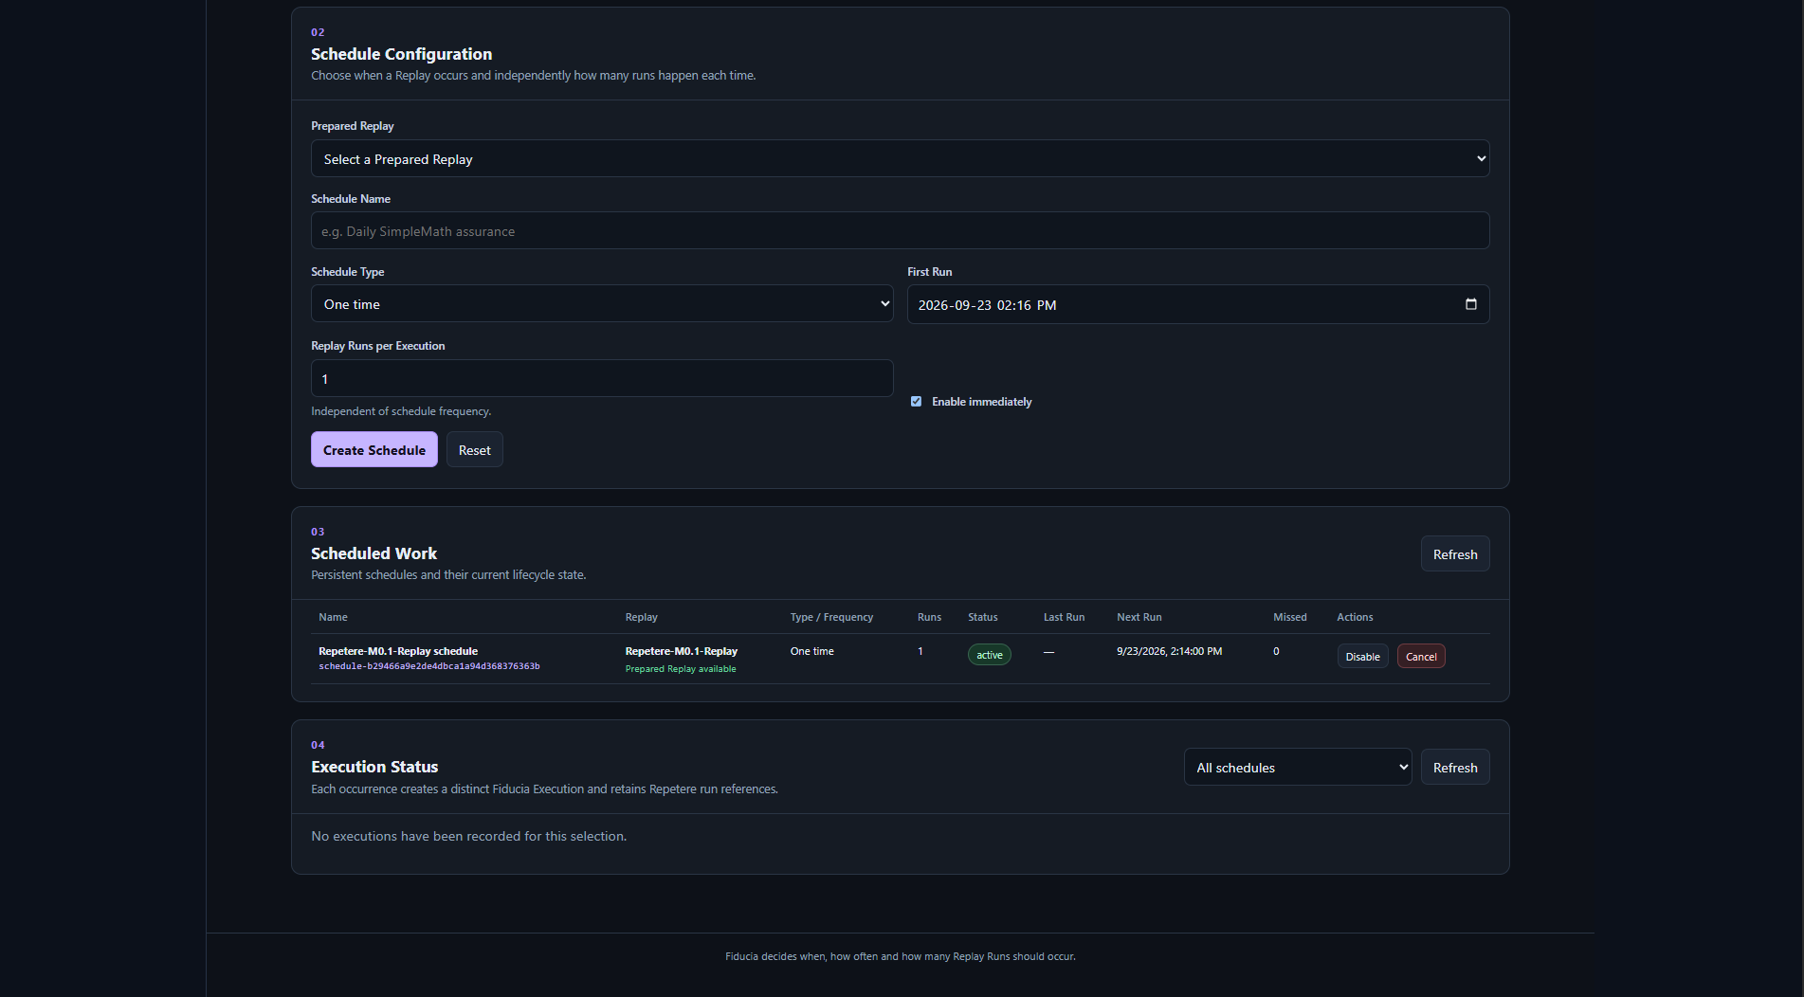
Figure 25. A newly created Fiducia schedule listed under Scheduled Work.
Scheduled Work shows the schedule definition and its next execution information. Use the controls in this area to manage the schedule rather than modifying the underlying replay experiment while a scheduled execution is pending.

13. Fiducia: execution status
When a schedule fires, Fiducia records the execution independently from the schedule definition. This makes it possible to see whether scheduled work ran, what it invoked and the resulting execution state.
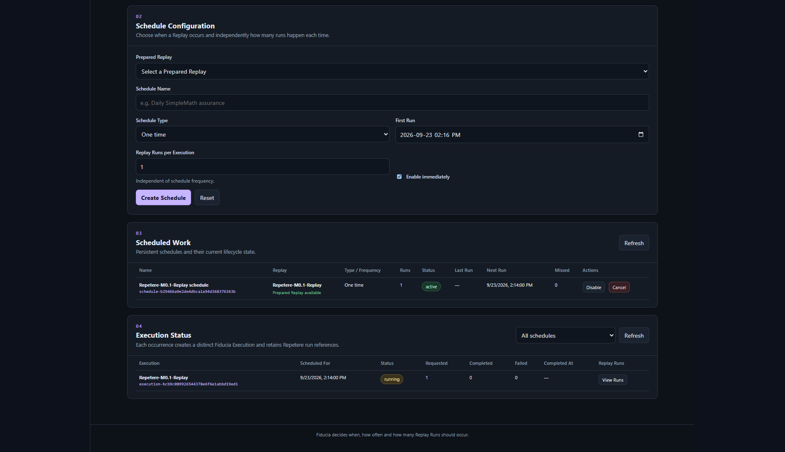
Figure 26. Fiducia showing scheduled work together with execution status.
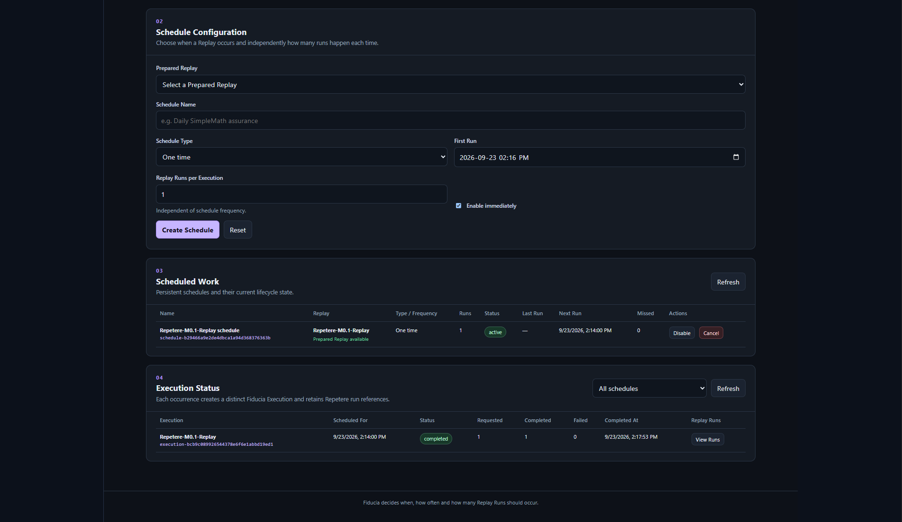
Figure 27. Fiducia after an additional scheduled execution, preserving both schedule and execution information.

Interpreting the view
- Scheduled Work describes what is planned.
- Execution Status describes what has actually run.
- Use the status and timing information together when investigating a missed or unexpected execution.
- Return to Repetere for replay-specific experiment/run detail.

14. Normal shutdown and restart

End active work first
Before stopping the Stack, end active Rogare sessions and allow replay or scheduled work to reach a terminal state where practical. This lets Pontis, Praebere and the orchestration components release their lifecycle state normally.

Stop the Stack from Servire
Use Servire lifecycle controls for normal managed Stack shutdown. The Operational Log shows component shutdown progress. If you are shutting down the complete Docker distribution, stop the managed Stack first and then stop the Compose application.

Stop Docker containers
From the distribution directory run: docker compose down
Do not add -v unless you intentionally want to delete the installation data volumes. A normal down/up cycle should preserve the local workspace, Servire data and MongoDB data.

Restart
Run docker compose up -d, open Servire, validate the external dependencies if required, and start the Stack. Periodic Lumen authorization is handled by the authorization mechanism; a temporary connectivity failure does not necessarily cause immediate loss of operation.
DO NOT DELETE VOLUMES CASUALLY Removing the Compose volumes is a destructive reset of the local installation state. Use it only when you deliberately want a clean installation test.

15. Troubleshooting

Servire opens but the Stack will not validate
- Confirm Ollama is running and reachable at the endpoint configured under External Dependencies.
- Confirm MongoDB reports available.
- Review the Operational Log for the first failed validation rather than only the final summary.
- If the provider catalogue changed, open Praebere and refresh the models after Ollama is healthy.

HAProxy container exits at startup
Confirm that haproxy.cfg exists as a normal file beside the Compose file. A missing bind-mount source can be created by Docker as a directory, which then causes a file-versus-directory mount failure when HAProxy starts.

Registry pull fails
- Run docker login registry.illuminates.one again using the researcher-specific registry credential.
- Confirm that the machine has network/DNS access to the registry hostname.
- If a VPN is active and DNS queries fail, test without the VPN or correct the VPN DNS path.

Authorization fails
Registry authentication and Lumen authorization are separate. A successful Docker pull does not authorize the installation. Confirm that the correct Lumen registration key was supplied and that the installation can reach Illuminates.One for authorization.

Known M0.1 limitation
DOCKER LOG EXPORT Operational log export is a known M0.1 limitation when Servire is running in the Docker distribution. Log viewing inside Servire remains available.

16. Operational reference

Normal researcher path
1 | Start Docker Compose.

2 | Open Servire and confirm authorization.

3 | Confirm Ollama and MongoDB are available.

4 | Validate the Stack.

5 | Start the Stack and wait for Lumen READY.

6 | Use Rogare for a conversation, optionally recording it with Vestigare.

7 | Use Repetere to stage and replay a trace.

8 | Use Fiducia when a prepared replay needs scheduled execution.

9 | End active sessions/work, then stop the Stack when finished.

Research evidence chain
The researcher-facing flow can be read as an evidence chain: Rogare creates an interaction; Vestigare records it; Repetere replays it under controlled conditions; Fiducia can schedule prepared replay work; Servire provides operational control and health visibility across the complete system.

When to use each UI
Need | Open
Start, stop, validate, inspect logs | Servire
Inspect service communication | Nuntius
Inspect/select provider models | Praebere
Conduct a conversation | Rogare
Inspect orchestration policy/state | Moderari
Inspect bridge/session state | Pontis
Record or inspect a trace | Vestigare
Stage/run/review a replay | Repetere
Schedule a prepared replay | Fiducia

Appendix A. Release information
Product: Lumen M0.1 Research Distribution
Manual: SERVIRE USER MANUAL v0.1
Publisher: Illuminates.One
Release status: Research distribution / experimental
Manual date: September 2026

Distribution image
The M0.1 distribution is delivered from the private Illuminates.One registry. The researcher package uses Docker Compose to pull and run the frozen Lumen image together with the required supporting services.

Licence and authorization
Operation requires acceptance of the Lumen M0.1 Research Distribution Licence and periodic licence authorization with Illuminates.One. The Research Distribution must be able to communicate with Illuminates.One as required to validate its continuing authorization to operate.

Support information to retain
- Lumen/Servire version shown in the interface.
- Relevant Operational Log entries.
- Component and provider health state.
- Trace, experiment, run or schedule identifiers relevant to the issue.
- Whether the issue occurred before validation, during Stack start, during a session/replay, or during shutdown.

