**Analysis and Modelling of Locomotion**

Report on kinematic and kinetic gait analysis – Spring 2018

Student name: Magali Cattin

Section: Bioengineering

Sciper: 236251

**General information:**

This project will lead you through a series of exercises to familiarize you with the course content and to give you through computing experience some of the main analysis techniques involved in human motion analysis. Each student will receive a dataset which is different from other students and should provide an individual report.

The results must be handled back by completing the underlying report’s template. It should then be saved as pdf and sent back through the Moodle webpage of the class in due time. The report will be graded and count as 50% of the final grade.

In case of problems related to this project, please contact the teaching assistants:

* Mathieu Falbriard [mathieu.falbriard@epfl.ch](mailto:mathieu.falbriard@epfl.ch)
* Matteo Mancuso [matteo.mancuso@epfl.ch](mailto:matteo.mancuso@epfl.ch)

Or directly the professor:

* Kamiar Aminian [kamiar.aminian@epfl.ch](mailto:kamiar.aminian@epfl.ch)

# Setting up

## Install Matlab

If not already available on your machine, please install Matlab from the EPFL repository:  
[http://soft-epfl.epfl.ch/students/matlab](http://soft-epfl.epfl.ch/students/matlab/tah_en.cgi)

## Download the data

Go on the Moodle page of the course and download the dataset file which is assigned to you. To find which dataset you should use, go on Moodle, open the file “Assigned Dataset” listed in Week 1 documents and find your Sciper number in the list. Then download the dataset number which correspond to your Sciper number and provide the name of data file here:

Data file name: amlWalkingDataStruct6.mat

## Structure of the data

To load in Matlab environment the dataset from 1.B, you can either double click on the dataset file “amlWalkingDataStructX.mat” (where X is your dataset number) or use the Matlab command load(‘path_to_amlWalkingDataStructX.mat’). Here is the structure of the dataset file:

Each matrix is expressed as $[row×column]$

* data
  + imu.[left/right]
    - gyro: $N×3$ *matrix where N is the total number of samples and where the columns represent the 3 technical frame axis [X, Y, Z] of the gyroscope. Data are expressed in deg/s.*
    - accel: $N×3$*matrix where N is the total number of samples and where the columns represent the 3 technical frame axis [X, Y, Z] of the accelerometer. Data are expressed in g.*
    - accelstatic: $J×3$ *matrix where J is the total number of samples and where the columns represent the 3 technical frame axis [X, Y, Z] of the accelerometer. Data are expressed in g. accelstatic corresponds to a motion less period.*
    - midswings: $K×1$ *vector where K is the total number of midswings and where the ith sample correspond to the index of the ith midswing event.*
    - calibmatrix*: $3×3$ rotation matrix which aligns the technical frame [X, Y, Z] of the IMU’s sensors with the anatomical frame of the foot. Such a vector DT (3x1) in technical frame is expressed in anatomical frame by DA= calibmatrix*DT.*
    - fs: *gyroscope and accelerometer sampling frequency in Hz.*
    - time: $N×1$ *vector that stores the timestamps of each sample. Data are expressed in seconds.*
  + insoles
    - [left/right].pressure: $M×99$ *matrix where M is the total number of samples and where the columns represent the pressure measured by the each ith pressure cells in the insole ($i∈[1,99])$. Data are expressed in kPa.*
    - [left/right].area: $1×99$ *matrix where the columns represent the area of the ith pressure cell in the insole $i∈[1,99])$. Data are expressed in mm2.*
    - fs: *pressure insole sampling frequency in Hz.*
    - time: $M×1$ *vector that stores the timestamps of each sample. Data are expressed in seconds.*
  + *motioncameras*
    - static:
      * time: $Q×1$ *vector that stores the timestamps of each sample. Data are expressed in seconds.*
      * fs: *the motion cameras sampling frequency in Hz.*
      * [left/right]CenterFoot: $Q×3$ *matrix where Q is the total number of samples and where the columns represent the position of the marker in the [X,Y,Z] general frame. Data are expressed in mm. Figure 2 shows the position of this marker on the foot.*
      * [left/right]MedialFoot: $Q×3$ *matrix where Q is the total number of samples and where the columns represent the position of the marker in the [X,Y,Z] general frame. Data are expressed in mm. Figure 2 shows the position of this marker on the foot.*
      * [left/right]LateralFoot: $Q×3$ *matrix where Q is the total number of samples and where the columns represent the position of the marker in the [X,Y,Z] general frame. Data are expressed in mm. Figure 2 shows the position (1) of this marker on the foot.*
      * [left/right]LateralMalleolus: $Q×3$ *matrix where Q is the total number of samples and where the columns represent the position of the marker in the [X,Y,Z] general frame. Data are expressed in mm. Figure 2 shows the position (2) of this marker on the foot.*
      * [left/right]MedialMalleolus: $Q×3$ *matrix where Q is the total number of samples and where the columns represent the position of the marker in the [X,Y,Z] general frame. Data are expressed in mm. Figure 2 shows the position (3) of this marker on the foot.*
    - walking*:*
      * *Same content as in* static *but without the malleolus markers.*

You can access any of these fields using the “.” connector. For example, if you want to access the accelerometer data of the IMU on the left foot, you can type: data.imu.left.accel.

## Matlab script

Please download the file named “*amlMatlabScript.m*” under Week 1 in Moodle. Save this file in the same directory as the dataset you downloaded in 1.B and rename it in the following way “*<last name>_<first name>_AML.m*” where you must replace *<last name>* by your last name and *<first name>* by your first name (e.g. Zola_Emile_AML.m). **This file must contain all the Matlab code that you wrote for this report**.

## Structure of the script

Please respect the structure of the Matlab script we provided and add your code where “<<< ENTER YOUR CODE HERE >>>” is written. Also, for some exercises we ask you to provide the detailed results of your algorithms. This is done through the use of an output structure named “scriptOutResults” which you will have to fill in at the end of some exercises. Please do not change the name of the fields of this output structure. Finally, note that we introduced two functions (alignGyroscopeTF2AF, get3DRotationMatrixA2B) at the end of the script to help you with the assignments.

## Matlab tips

Below is a list of Matlab functions you may need for this project:

* Figure()
* Plot()
* Subplot()
* Norm()
* Diff()
* Sum()
* Min()
* Max()
* Mean()
* Trapz()
* Linspace()

We strongly recommend that you use the official Matlab webpage for help, or use the helpcommand before the function of interest. For example, if you want to have more information about the plot() function, you can type help plot in the Matlab console.

## Submit your project

Before submitting your project, please create a .zip file which contains:

1. This document completed with your results.
2. Your Matlab script named *“<last name>_<first name>_AML.m”* where you must replace *<last name>* by your last name and *<first name>* by your first name.
3. The output structure automatically saved in the same directory as your Matlab script. This file should have to following name: *“<last name>_<first name>_outStruct.mat”.*

Please name your .zip file as such: *“<last name>_<first name>_AMLProject.zip”* where you must replace *<last name>* by your last name and *<first name>* by your first name. You can then go under Week 4 of the class Moodle page and submit this .zip file using the link “Electronical submission for projects”.

# Assignement 1: Temporal and spatial gait analysis

As seen during the lectures, gait temporal events detection plays an important role in walking analysis. There are several systems for measuring such events, each have their own advantages and drawbacks. In the literature, force plates are often used as reference system as they provide direct information about the ground reaction forces applied on the foot and, therefore, allow an accurate detection of initial contact and toe-off. However, force plates are limited to laboratory usage as their setup requires an environment dependent and time-consuming calibration of the force sensors.

The goal of this assignment is to introduce two other methods that are used outdoor using wearable sensors. Before starting, we recommend that you read the publication by Mariani et al. (2013) [1] on « Quantitative estimation of foot-flat and stance phase of gait using foot-worn inertial sensors ».

The objective of this assignment is to be familiar with temporal gait analysis through two measurement techniques: foot-worn Inertial Measurement Units (IMU) and plantar pressure measurement insole. In addition, body segment angles estimation from gyroscope is introduced.

## Temporal gait analysis with gyroscope (20 pts)

1) From the Matlab data structure you downloaded in section 1.B, plot the three components of the gyroscope sensors, **in the anatomical frame**, using the Matlab function plot. Note that you need to align the technical frame of the IMU with the anatomical frame of the foot. You can do this by using the function alignGyroscopeTF2AF that we provided with the script. Observe the signal and provide the label of the column corresponding to the pitch angular velocity, _pitch (justify your answer).

*From the definition of the pitch axis when walking, the z-axis appears to be best candidate since it exhibits the highest variability in amplitude of the measured signal, the angular velocity.*

2) Consider the content of data.imu.[left/right].midswings to segment the _pitch (i.e. pitch angular velocity) in midswing-to-midswing cycles. Write a script to detect for both feet all initial contact (IC), all terminal contact (TC) and the mid-stance events during all foot-flat as in chapter 2. Once again, use the alignGyroscopeTF2AF function to align the technical frame of the gyroscope with the anatomical frame of the foot. You can save the results of IC and TC for each foot in a mat file.

3) Add in the frame below a graph showing at least two gait cycles from the right foot with the results of your IC and TC events detection, mid-stance during foot flat (FF) and midswing (MS). Do not forget to add the labels on each axis of the graph and a legend for all the signals.

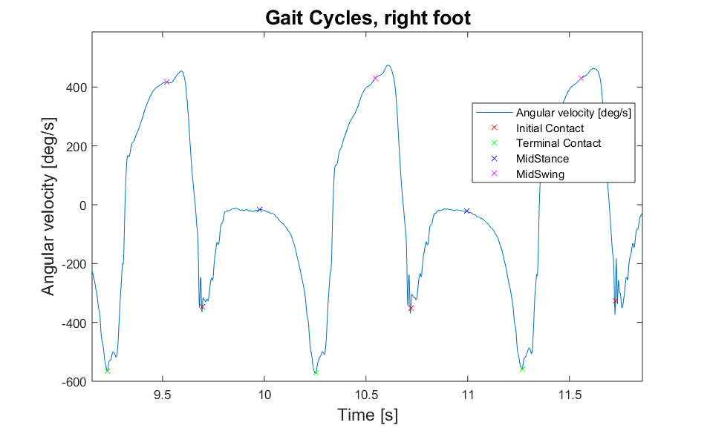

4) Complete your script to estimate, for each gait cycle, the parameters in the table below. Compute the mean and standard deviation (STD) over all gait cycles and fill the blanks in the table.

|  |  |  |  |  |  |
| --- | --- | --- | --- | --- | --- |
| **Parameter** | | **Left leg** | | **Right leg** | |
| **Label** | **Units** | **Mean** | **STD** | **Mean** | **STD** |
| Stance phase duration | ms | *0.5672* | *0.0239* | *0.5540* | *0.0097* |
| Gait cycle time | ms | *1.0189* | *0.0151* | *1.0172* | *0.0159* |
| Cadence | steps/min | *117.7966* | *1.7240* | *117.9987* | *1.8549* |

5) Compare the mean cadence of the right leg to the right leg and discuss the results.

*The mean cadences on the right and on the left side appear very similar: the left cadence is lower of 0.2022 step/min which represents 0.17% of the right cadence. It could thus be assumed that the gait is very symmetric.*

6) Estimate the coefficient of variation (in %) of the gait cycle time obtained from of the right foot.

*CV_GCT = 0.0156*

How do you judge this variability?

*It is very low. The coefficient of variation corresponds to the relative variability (ratio between the standard deviation and the mean), the lower it is, the less spread the distribution is around the mean which means that the gait is very regular.*

## Foot angle estimation with gyroscope (Bonus: 5pts)

1) Consider _pitch at a gait cycle *i* starting at foot_flat(*i*) and ending at foot_flat(*i+1*). Estimate the foot rotation in sagittal plane (pitch_angle) by using the script trapz(). You should obtain a signal similar to the one below:

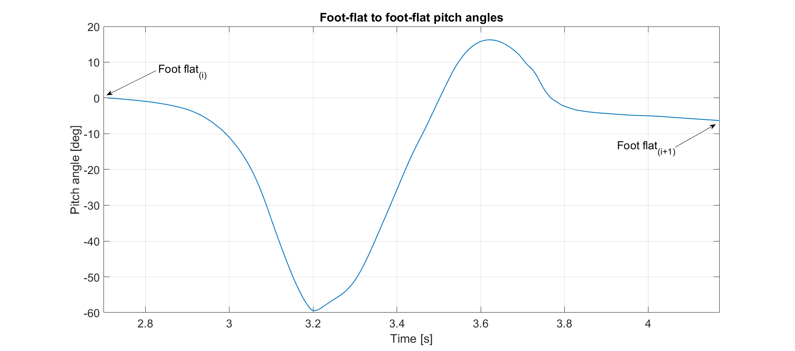

2) We expect same pitch_angle at the beginning of each cycle. Estimate the difference of pitch_angle at foot_flat (i+1) and foot_flat(i). Explain the source of error for this difference and propose a model to this error and correct the pitch_angle(t)

3) Plot the estimated pitch_angle before and after correction of error in the following box.

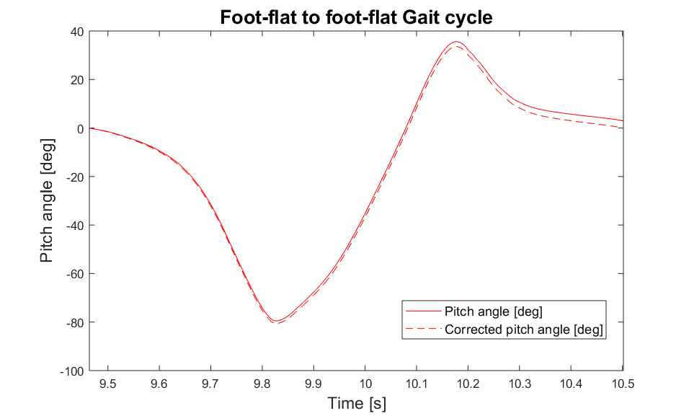

# ASSIGNEMENT 2: FRAME & ORIENTATIONS

In addition to temporal analysis, information about the foot’s position and orientation in space is relevant for clinicians [2]. In the literature, the gold standard for 3D motion analysis are stereo photogrammetry-based motion capture and reflective markers.

The goal of this assignment is to understand some of the basic steps required when performing 3D motion analysis with cameras-based motion capture. We will address issues such as alignment of the marker based technical frame (TF) with the anatomical frame (AF). Moreover, meaningful angles for the spatial analysis of gait will be studied.

## Anatomical calibration of foot-worn sensor (10 pts)

As explained during the Chapter 3 lectures, IMUs measure 3D kinematics (i.e. angular velocity, acceleration) in their own technical frame. If this technical frame is not aligned with the anatomical frame of the segment it is affixed to (in this case the foot), it becomes very complicated to understand the meaning of each individual IMU axis. Moreover, if we remove the IMU from the foot and place it again, it is very likely that the orientation of the technical frame with respect to the segment anatomical frame will be different than for the previous trial. Therefore we need to estimate the rotation matrix, which aligns the IMU technical frame with the foot anatomical frame. **We use static phase (i.e. motionless period) for this alignment**.

In this part, you need to complete your Matlab script to align only the y-axis of the IMU technical frame (Y_IMU_TF) with the anatomical y-axis of the foot (Y_AF). We assume that the gravity vector measured by the accelerometer during static phases (subject not moving and standing on a flat ground) should be aligned with Y_AF since Earth’s gravitational acceleration is perpendicular to the ground. The data in data.imu.[left/right].accelstatic represent the foot-worn accelerometer measurements while the subject was standing still on the treadmill. Figure 1 gives an example of the afore mentioned static situation.

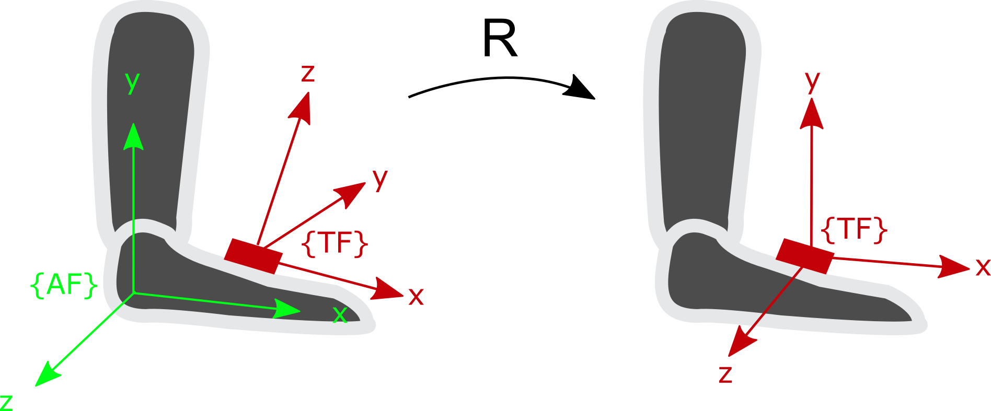

* {AF}: The **anatomical frame** of the foot
* {TF}: The **technical frame** of the IMU.
* **g**: Acceleration due to **Earth gravity**.

**g**

Figure 1 - The anatomical frame {AF} of the right foot, technical frame {TF} of the IMU and gravity vector (g). R express the rotation matrix that align {TF} with {AF}.

1) Express the gravity vector in the {TF} of the right foot IMU, by considering the average value of the static measurements represented by a $j×3$ matrix in data.imu.right.accelstatic.

*TFgR = [0.0675, 0.5522, 0.8139]*

2) Express the gravity vector **g** in the anatomical frame of the foot during a static period (i.e. the foot is flat on the ground)

*Y_AF= [0, 1, 0] because accelerometer measures acceleration in free fall, the y-axis going down, thus in the direction of the gravity*

3) The provided script get3DRotationMatrixA2B(A,B)computes the rotation matrix between two $1×3$ vectors A and B. Find the rotation matrix R_TFg_Y_AF between TFg and Y_AF.

|  |  |  |
| --- | --- | --- |
| *0.9970* | *-0.0685* | *0.0363* |
| *0.0685* | *0.5602* | *0.8256* |
| *-0.0363* | *-0.82565* | *0.5631* |

*R_TFg_Y_AF =*

4) Using subplot() command in Matlab, plot the two graphs: the static acceleration signal before and after applying the rotation matrix.

On veut y à 1 et les autres à 0!

5) The above calibration aligns only one axis of the TF to AF. Do you have any suggestion to align the three axes of TF? Describe your idea in few sentences.

*…………………………………………………………………………………………………………………………………………………………………………………………………………………………………………………………………………………………………………………………………………………………………………………………………………………………………………………………………………………………………………………………………………………………………………………………………………*

*……………………………………………………………………………………………………………………*

*……………………………………………………………………………………………………………………*

## Anatomical calibration of camera-based motion capture (20 pts)

The goal of this part is to construct the technical frame of the foot using reflective markers attached to the foot by assuming the foot as one rigid segment. Then we perform a 3D anatomical calibration using some anatomical landmarks of the foot. The static measurements recorded with the subject standing still with foot flat will be used for calibration. Figure 2 shows the marker configuration on the foot. Each marker in Figure 2 is expressed in the global frame of the camera-based motion capture system. You can find the data in the Matlab structure we provided under data.motioncameras.static.<marker_name>*.* The global frame is defined by [XO,YO,ZO]: the x-axis is in the direction of length of the treadmill, the y-axis is perpendicular to the ground pointing towards the ceiling (upward) and the z-axis is in the direction of the width of the treadmill.



4

5

3

1

2

{GF}

{AF}

**Markers for TF** :

1) leftCenterFoot

2) leftLateralFoot

3) leftMedialFoot

**Landmark Markers :**

4) leftLateralMalleolus

5) leftMedialMalleolus

**YAF**

**XAF**

**ZAF**

**YO**

**XO**

**ZO**

Figure 2 - Left foot markers configuration for the technical frame {TF} and the global frame {GF}.

1. Complete your script to construct the technical frame (TF) for the left foot with the help of the skin markers 1, 2, 3 and using the average values of their coordinates during static period (use data in data.motioncameras.static.<marker_name>*).* Fix the origin of TF on marker 1 with Y_TF pointing upward. Compute the axes of TF:

*X_TF = [0.4347, -0.0740, -0.8975]*

*Y_TF = [0.7237, -0.2080, 0.6580]*

*Z_TF = [0.2438, 0.9691, 0.0382]*

1. Compute the rotation matrix ${}_{TF}^{GF}R$.

|  |  |  |
| --- | --- | --- |
| *0.4347* | *0.7237* | *0.2438* |
| *-0.0740* | *-0.2080* | *0.9691* |
| *-0.8975* | *0.6580* | *0.0382* |

$${}_{TF}^{GF}R=$$

1. The anatomical frame AF for left foot is defined with Z_AF parallel to the line joining marker 4 and 5 and pointing to the right, Y_AF parallel to YO pointing upward. Set the origin of AF at marker 1. Complete your script to compute the axes of AF.

*X_AF = [0.8845, 0, -0.4666]*

*Y_AF = [0, 1, 0]*

*Z_AF = [0.4595, 0.1736, 0.8711]*

1. Compute the rotation matrix ${}_{AF}^{GF}R$.

|  |  |  |
| --- | --- | --- |
| *0.8845* | *0* | *0.4595* |
| *0* | *1* | *0.1736* |
| *-0.4666* | *0* | *0.8711* |

$${}_{AF}^{GF}R=$$

1. Complete your script to compute the rotation matrix that align TF with AF, i.e. ${}_{TF}^{AF}R$

|  |  |  |
| --- | --- | --- |
| *0.8033* | *0.1978* | *0.3331* |
| *0.0302* | *0.9431* | *-0.3701* |
| *-0.6001* | *0.1498* | *0.9339* |

$${}_{TF}^{AF}R=$$

## Foot angle computation (5 pts)

Now that the calibration matrix has been computed in static conditions, we can apply it to the data measured while walking on a treadmill. This is possible because we assume that the markers’ position on the foot have not changed between the static measure and the walking measure. After you applied the rotation matrix, the axes of your technical frame are aligned with the anatomical frame while the data are expressed in the global reference frame.

1) Complete your script by computing the TF during walking for each frame.

2) Complete your script by computing the AF during walking for each frame.

3) Compute the pitch angle of the foot (rotation around the medio-lateral axis) during walking

Here are some tips to help you:

* The formula to find the angle **α** between a 3D vector **u**  and a plane with normal vector **n** is:

$α= arcsin⁡(\frac{|n*u|}{\left|n\right|*|u|})$.

* The plane of interest as defined by the treadmill is the plane spanned by XO and YO axes of the global frame (i.e. x = [1 0 0] and z = [0 0 1]). You need to define the anatomical axis of the foot and then estimated the angle  (pitch angle).

4) Please add in the frame below, the graph of the pitch angles over at least 2 strides and show on the graph where the stance phases, swing phases and foot-flat phases are.

# Assignement 3: Kinetic analysis

In many cases, kinetic analysis is a good complement to kinematic analysis. It allows computing some temporal parameters and an estimate the forces acting on a segment or joint. Reliable measurement or estimation of these forces can be very helpful, especially because force excess or imbalance could lead to joint disease (e.g. arthrosis).

The main problem to estimate the joint forces remains in the difficulty to measure internal force. To tackle this issue, a commonly used approach consists in measuring the force at the extremities, and to use inverse dynamics in order to compute the net force on the more proximal joints. More detailed information on this approach is available in Whittlesey 2004 [4].

In gait analysis, we usually starts with a force-plate which is considered as gold standard for ground reaction force measurement. Nonetheless, the size of the force plate is limited, and in most cases, it is only possible to record a single step. Another approach consists to measure ground reaction force with a plantar pressure insole placed in the shoe. This allows to record an arbitrary number of steps, even beyond the lab setup, however only the vertical component of the force can be measured, and some additional artifacts will be present, mainly due to the shoes movements around the foot.

In this exercise, you will get familiar with the use of plantar pressure insoles for the computation of temporal parameters, ground reaction and internal ankle forces, and get a more concrete idea of the advantages and limits of this method.

## Ground reaction force during foot-flat phase (10 pts)

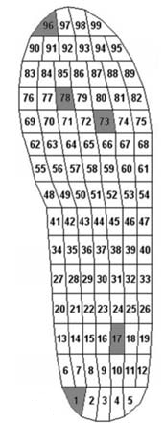The plantar pressure insole (as from now the insole) measures the plantar pressure distribution using 99 cells. The signals in data.insoles.[left/right].pressure are expressed in kPa, therefore, you will have to use the content of data.insoles.[left/right].areato transform the data into the Newton units. Use Figure 3 to segment the insole data. You can select a portion of the insole data by doing data.insoles.[left/right].pressure(:, p:q) where p and q are integers corresponding to pressure cell. This command will return an M by (q-p+1) matrix that contains all that data of the pressure cells between p and q (p and q are included)*.*

Figure 3 - Pressure cells position within the insole.

1) Split the insole in two parts: the rear-foot (cells 1 to 33) and fore-foot (cells 55 to 99) and estimated the total force acting under each part: *F_rear, F_fore*. Using the two force signals and appropriate thresholds complete your script by writing a rule to detect the four gait events describe in Mariani et al. (2013) [1], namely: initial contact or heel strike(HS), toe-strike (TS), heel-off (HO) and terminal contact or toe-off (TO). Justify the values of your thresholds.

*…………………………………………………………………………………………………………………………………………………………………………………………………………………………………………*

2) Add in the frame below a graph showing *F_rear* and *F_Fore* at least two strides of the right foot where *HS*, *TS*, *HO* and *TO* events are correctly detected and show these event in your plot. Do not forget to add labels on each axis and a legend for all signals.

3) For the two cycles above, estimate the foot-flat duration.

*Foot_flat_1 = ms Foot_flat_2 = ms*

4) Choose one foot-flat period and estimate the total vertical force signal recorded by the insole during this period: *Ftot,FF*. Add in the frame below the graph showing *Ftot,FF.*

## Net force and met moment at ankle joint (5 pts)

Here we aim to estimate the net force (*FA, FF*) and moment (*MA, FF* ) during the foot-flat phase using the ground reaction force *Ftot,FF* .

1) Complete the free body diagram (assume that the foot is in the foot-flat phase) and indicate *Ftot,FF* on the diagram.

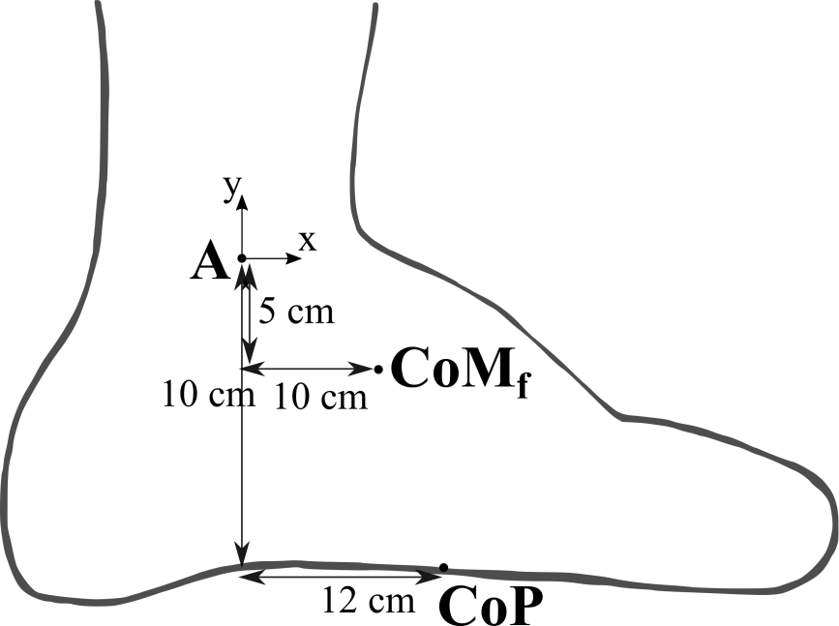

2) Compute the net force (*FA, FF*) and moment (*MA, FF* ) on the ankle for every time sample of foot-flat phase. We assume that the mass of the foot is 1 kg, and the Z component of the ground reaction force is zero while the X component of ground reaction force during foot-flat is parallel to the ground and equal to +10% of *Ftot,FF* . We consider the *CoP*, *CoM* and *A* movement are negligible during this interval and that the weight of the subject is 50 kg.

1. Compute the mean value of *FA, FF and MA, FF* and report it here:

*FA, FF= N MA, FF= Nm*

# References

[1] Mariani, B., Rouhani, H., Crevoisier, X., & Aminian, K. (2013). Quantitative estimation of foot-flat and stance phase of gait using foot-worn inertial sensors. Gait & posture, 37(2), 229-234.

[2] Barrett, R. S., Mills, P. M., & Begg, R. K. (2010). A systematic review of the effect of ageing and falls history on minimum foot clearance characteristics during level walking. Gait & posture, 32(4), 429-435.

[3] Leardini, A., Chiari, L., Della Croce, U., & Cappozzo, A. (2005). Human movement analysis using stereophotogrammetry: Part 3. Soft tissue artifact assessment and compensation. Gait & posture, 21(2), 212-225.

[4] S. N. Whittlesey, D. G. E. Robertson, G. Caldwell, J. Hamill, and G. Kamen, “Two-Dimensional Inverse Dynamics,” in *Research Methods in Biomechanics*, 2004, pp. 103–124.