1,2. We prepared 2 folders, one for each class, in the preprocessing code we read each doc in each folder into a dataframe and labeled political bias docs as “poli” and news fairness docs as “news”.
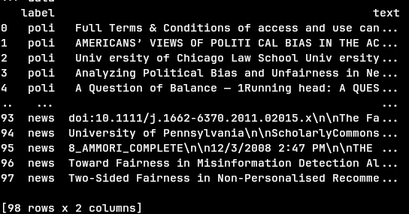

3. All the tokenization and stopwords removal is done inside TfidfVectorizer
4. a static seed was set in numpy to maintain consistent results.
Our pipelines consisted of:
- TfidfVectorizer set to the “english” stopwords removal of sklearn
- One of the classifiers: MultinomialNB, SGD, Kneighbors, RandomForest
We performed 10-fold validation(using sklearn.model_selection.Kfold with shuffle) on each of the classifiers and got the following average scores:
MultinomialNB: 92.89%, SGD: 94.67%, Kneighbours: 91.89%, RandomForest: 88%.(the values before each % are the individual results from each of the 10 folds per classifier)
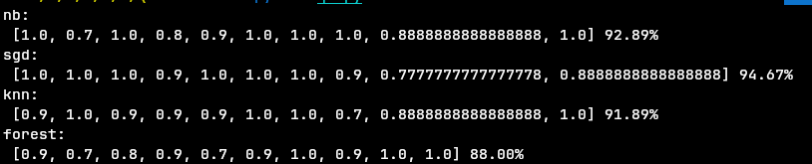
5. Looking at the misclassified documents, we can see multiple things:
1. for the applicable classifiers(all except SGD), looking at the probabilities generated, the misclassified docs are almost always withing 10% of 50%, which means the model is not very certain about them, and usually it is more certain about the correct classifications(but even in correct cases it can be uncertain often)
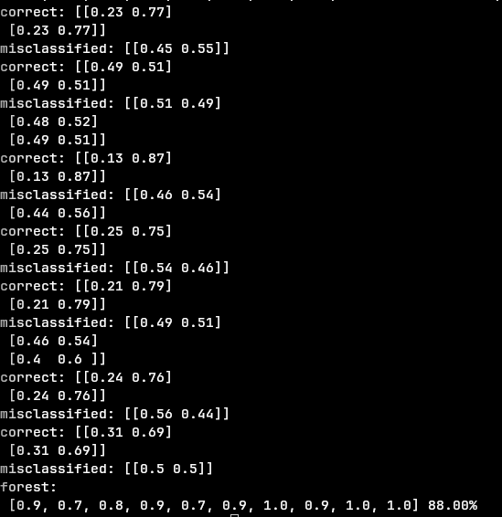
example for probabilities from forest to demonstrate:

2. Looking at the actual text inside the misclassified docs, we can see that political bias docs often also talk about news and not just political bias or the other way around, news fairness docs that also talk about politics, so it is hard to put them in a single class(and in general news and politics tend to be relatively similar subjects).
And looking at the most common words in the docs(=the words that affect the feature vector the most), we can see “news”, “fairness” and related words a lot more in News Fairness related docs than in Political Bias docs(example, in one of the Naive Bayes classifiers, “news” and “fairness” are the 1st and 2nd most common terms among the correctly classified News Fairness docs, and in correctly classified Political Bias docs, these terms are not among the top 10 terms, but “political” is 6th and “bias” is 11th (which do not appear among the most common terms in News Fairness docs), behind a few social media related terms and a few non political/news terms.
On the other hand, in misclassified docs we can see the opposite behavior, News Fairness docs that hardly contain these terms and Political Bias docs that do.
And looking at the most common words in misclassified docs, we can almost always see “news” among the top words in misclassified political bias docs, or “news” or other news related terms barely appear in news fairness docs that were misclassified.
Examples:
quotes from political bias docs that were misclassified:
”A Question of Balance — 1Running head: A QUESTION OF BALANCE A Question of Balance:Are Google News search results politically biased...This study examines search results from the popular online news portal Google News inan effort to determine whether they are politically biased”, and looking at the histogram for the entire doc, “news” is the most common word.
“Political Bias and Factualness in News Sharing across more than 100,000 Online Communitie”, and looking at the histogram, “news” is the 5th most common word, behind 4 non-political words(reddit, links, communities, content)
“Many people view news on social media, yet the production of news items online has come under fire because of the common spreading of misinforma- tion”

quotes from news fairness docs that were misclassified:
“MEDIA BIAS, POLITICAL POLARIZATION,\nAND THE MERITS OF FAIRNES”
“This article asks how the press communicates political issues to citizens during referendum campaign”
“This article asks how the press communicates political issues to citizens during referendum campaigns”
the doc for the article titled “Fairness to Rightness: Jurisdiction, Legality, and the\nLegitimacy of International Criminal Law” hardly contains the word “news” and other news related terms, the term “news” is the 40,413rd most common term.

3. one of the misclassified docs is invalid(essentially an empty doc with some noise):
a misclassified political bias post(in its entirety):
“A c c e l e r a t i n g t h e w o r l d ' s r e s e a r c h . Press Bias and Politics: How the Media Frame Controversial Issues J i m A . K u y p e r s C i t e t h i s p a p e r G e t t h e c i t a t i o n i n M L A , A P A , o r C h i c a g o s t y l e sD o w n l o a d e d f r o m \xa0 A c a d e m i a . e d u \xa0 \uf08e R e l a t e d p a p e r s D o w n l o a d a P D F P a c k o f t h e b e s t r e l a t e d p a p e r s \xa0 \uf08”

