Question 1:
1. preprocessed as described in the intro:
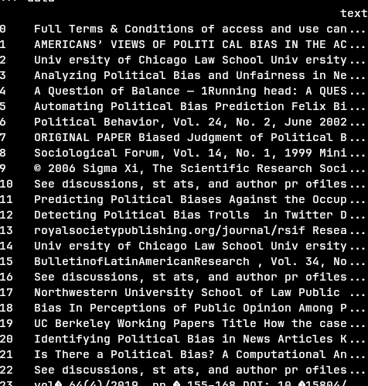

Tokenization is done inside CountVectorizer, along with stopwords removal and casefolding, for stemming we created a custom CountVectorizer that applies the nltk Porter stemmer to each word and a custom CountVectorizer that checks the lowercase forms of words for being stopwords because we were instructed to not perform casefolding yet in that step.
For each step: basic(no steps after tokenization), no stopwords, casefolding, stemming, we looked at the dictionary size, token count and the most common words to learn of the effect of each of the steps.
Results:
Here are the dictionary sizes and token counts for each step, along with the cumulative change from the basic step in our dataset and the relative change from the previous step in our dataset and in the Reuters dataset.
 | Dictionary Size | Cumu.% Change | Rel, % Change | Rel .% Change in Reuters | Token Count | Cumu. % Change | Rel. % Change | Rel. % Change in Reuters
Basic | 37,687 | - | - | - | 455,108 | - | - | -
No Stopwords | 37,135 | -1.5% | -1.5% | -0.04% | 287,365 | -36.9% | -33.9% | -47.3%
Casefolding | 32,314 | -14.3% | -14.6% | -17.4% | 287,365 | -36.9% | -0% | -0%
Stemming | 25,683 | 32.9% | -21.5% | -17.8% | 287,365 | -36.9% | -0% | -0%
Note: Reuters performed the steps in a different order and performed a first initial step of removing numbers, which can affect the cumulative results of a step, but as we can see, the relative change remained relatively similar.
As expected we can see that that:
- Stopwords removal barely affects the dictionary size but masssively reduced the token count.
- Casefolding does not affect the token count at all but does reduce the dictionary size by a significant amount.
- Stemming does not affect the token count at all as well, and also reduced the dictionary size by a significant amount.
All of these behaviors can be seen in both our dataset and the Reuters dataset, the biggest relative difference between the two datasets is that stopwords removal removed a bigger % of words from the dictionary, but because stopwords removal removes a specific amount of words, it makes sense that our dataset was affected more.

Next we will look at the 20 most common words in each step to observe the changes ourselves:
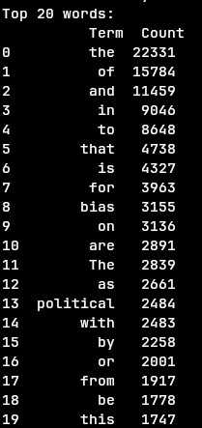
Basic: We can see that almost all of the words in the top 20 list are useless for language modeling(the only apparent exceptions are “political” and “bias”)

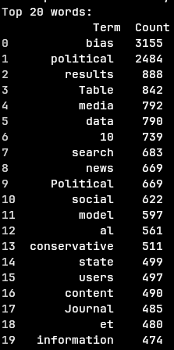
No Stopwords: We can see a very significant improvement over the previous step, most of the words in the list could be helpful for langauge modeling, we can also now see that removal of short words(<2 letters) and numbers might help if neccesary.

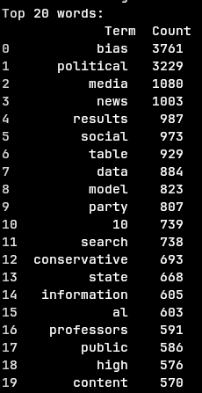
Case Folding: The top 20 list remains largely unchanged, mainly a few words changing positions, this makes sense as there are not a lot of capitilized words in most texts.

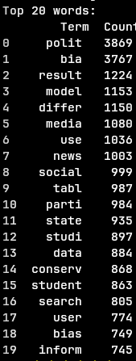
Stemming: with the final step theres are a some changes that have pushed a few remaining useless terms out and added a few more useful terms instead.

