The additional docs were preprocessed in the same way as in question 2 with the exception that to prevent reading errors the files were read with ISO-8859-1 encoding and the added categories were labeled “soci” and “miti” for Social Bias and Bias Mitigation respectively.
And like in question 2, tokenization and stopwords removal was done inside TfidfVectorizer.
We have attempted to use PCA to reduce the very high dimension count of the input vectors but did not see a significant improvent.
Since we were not instructed to use K-Fold or a test set, we fitted K-means on the entire docs set.
The K-means algorithm was seeded to keep the starting centroids consistent.
The results of the fitting:
The rand score of the set is 0.777, meaning ~77.7% of the pairs were clustered together/apart correctly.
Based on the most common label in each cluster, we will choose that label for that cluster and look at the docs with a different label and try to explain why they were put in that cluster.
We will also look at the most common words in each cluster and in specific labels or docs within the cluster.
We wrote a function that shows the 20 highest scoring word of a given set of docs on average.
Top 20 words in each cluster:
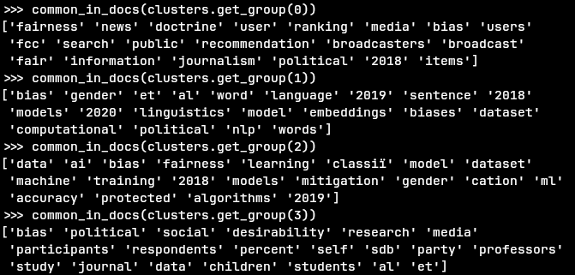
Cluster 0: the most common label is News Fairness(5 Bias Mitigation, 43 News Fairness, 5 Political Bias, 1 Social Bias), which matches the most common terms being “fairness” and “news”
The misclassified docs tend to also talk about news:
quotes from misclassified Political Bias docs:
“This study examines search results from the popular online news portal Google News inan effort to determine whether they are politically biased”
“Many people view news on social media, yet the production of news items online has come under fire because of the common spreading of misinforma- tion”
“Political Bias and Factualness in News Sharing across more than 100,000 Online Communities”
and more
We have already expanded on the common words in these articles as they were also misclassified in question 2.
misclassified Social Bias doc: only one Social Bias doc appears in this cluster and it’s 2nd most common term is “fairness”.
misclassified Bias Mitigation docs: while based on the texts it is less visible than the other misclassified docs why they were misclassified, we can see they are further away from the centeroid than News Fairness docs and are close to being in another cluster(the first group are 3 News Fairness docs and the second group is 5 Bias Mitigation docs, reminder:the left most distance is to this cluster):
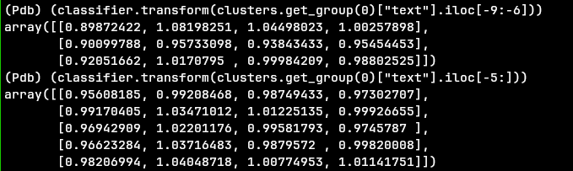
Cluster 1: the most common label is Social Bias, but not by a significant amount compared to other clusters and this is a smaller cluster in general(6 Bias Mitigation, 3 Political Bias, 11 Social Bias)
there are no misclassified News Fairness docs in this cluster, and some misclassfieid Political Bias and Bias Mitigation docs in the cluster, this makes some sense as all 3 of the labels in the cluster are about bias in some way and News Fairness is not(or at least less so).
Unlike in cluster 0, the misclassified docs are generally not further away from the cluster than the Social Bias docs:
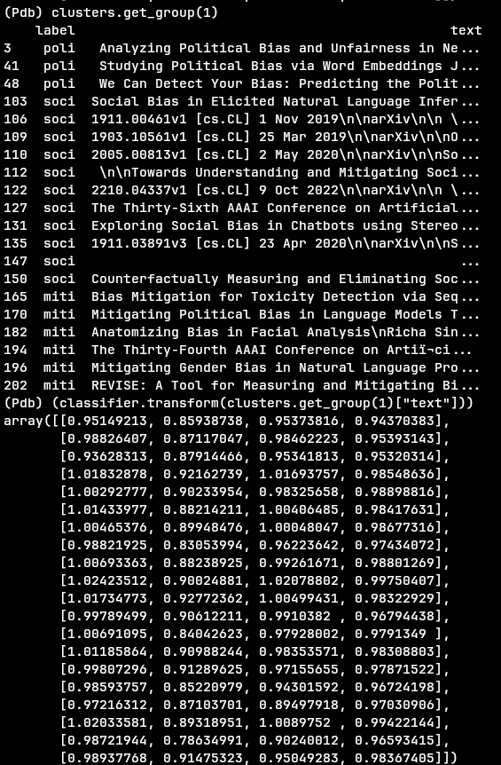

Additionally, looking at the most common terms in each label in this cluster, “bias” is the most common term among them, but it is also very common in clusters 2 and 3 so it doesn’t fully explain the clustering, but the terms “word” and “gender” are common in all 3 labels and are not common in the other clusters, which does explain it.
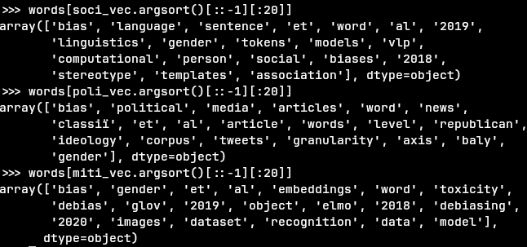
Top 20 words in each label:
Cluster 2: the most common label Bias Mitigation(38 Bias Mitigation, 3 News Fairness, 1 Political Bias, 1 Social Bias), but in reality, it appears that the cluster is actually about AI and machine learning:
Looking at the distances, we can see somewhat more decisive distances for Mitigation Bias docs than other labels(1st is Political Bias, then 3 News Fairness docs and 1 Social Bias doc, followed by a few Bias Mitigation Docs, this cluster is the 3rd column from the left):
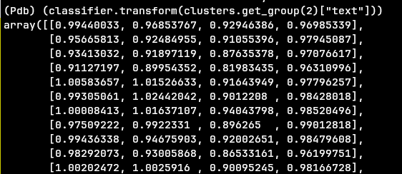
But looking at the common words in the cluster(seen earlier) we can see that the docs in this cluster tend to be more related to AI and machine learning than other clusters, and this holds for each label specifically
Top 20 words in each label:
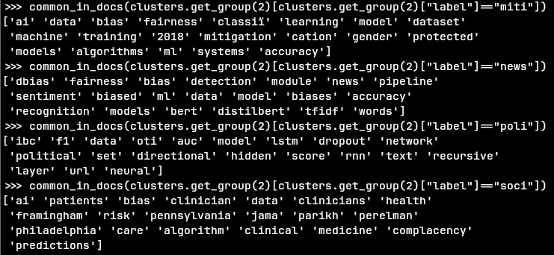
And we can also see that by looking at quotes from the docs:
Political Bias doc: “ An algorithmic approach towards detection of such bias is both intellectu- ally challenging and useful in areas like election prediction”
News Fairness doc: “'Balancing Fairness and Accuracy in Sentiment\nDetection using Multiple Black Box Models”
Social Bias doc: “Addressing Bias in Artificial Intelligence in Health Care”
Bias Mitigation doc: “Mitigating Bias in Deep Nets with Knowledge Bases : the Case of Natural\nLanguage Understanding for Robots”

Cluster 3: the most common label was Social Bias, but not by much, with Political Bias a little behind(1 Mitigation Bias, 3 News Fairness, 40 Political bias, 44 Social Bias).
Looking at the common words, we can see that the commonality between the the Political Bias and Social Bias docs is “bias”, which is expected, but there is also little mention of AI and machine learning, and since Bias Mitigation docs seem to mostly talk about AI and machine learning, this cluster appears to be a “Bias docs that are not AI and machine learning docs” cluster
Top 20 words in each label:
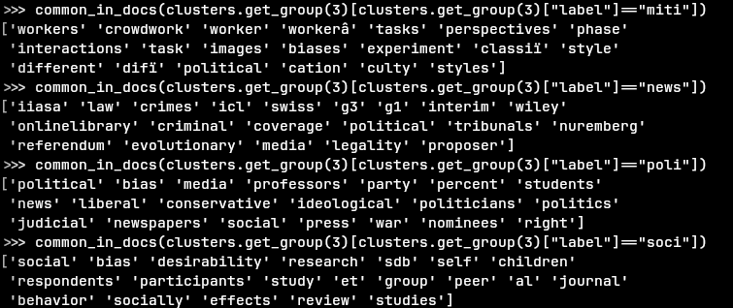
The single Bias Mitigation doc talks about bias in crowdsourcing, unlike most other Bias Mitigation docs, which tend to talk about AI and machine learning, which explains why it is not in the cluster with most other Bias Mitigation docs(which ended up being the “AI” cluster).

