北京航空航天大学

2024－2025 学年 第二学期期末

AI工具辅助科研

班 级__SY24061班 _学 号 SY2406117

姓 名_____陈昊旸____成 绩 _________

2025年5月26日

任务 1 工作划分

1.1 科学研究与学术写作流程图
主要流程分三大阶段：发现研究问题,进行实验设计,论文撰写与修改
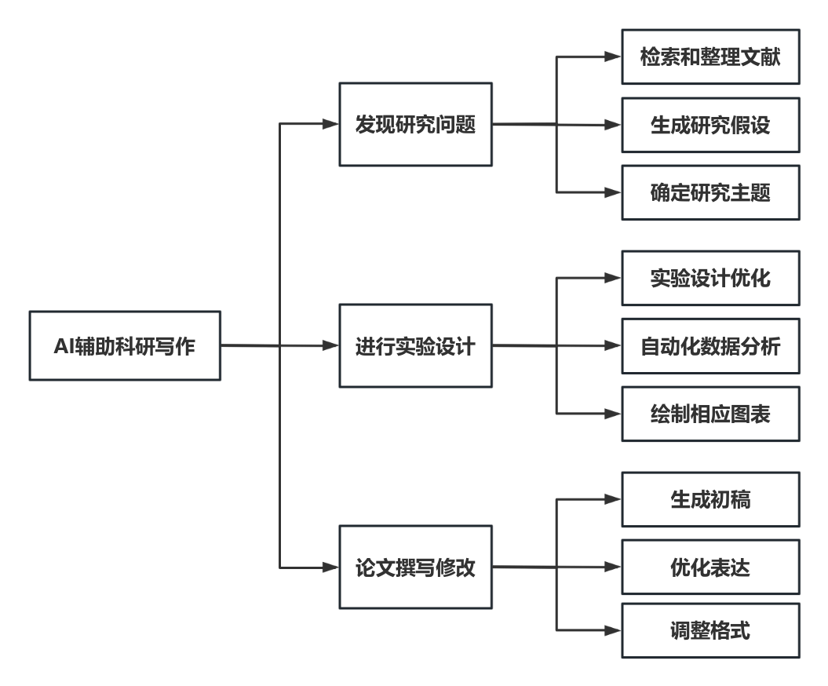
图1 - 科研流程图

1.2 发现研究问题

目的：
· 把握学术前沿动态：通过文献分析及时了解大模型技术最新进展（如MoE架构、对齐方法、多模态融合等）。
· 识别研究空白与痛点：发现当前研究中尚未深入探讨或效果不佳的方向，避免重复劳动。
· 明确研究价值与创新点：围绕“理论创新”“应用场景拓展”或“效率提升”提出有潜力的研究主题。
· 构建研究可行性框架：确保研究假设具备理论基础、技术可实施性和数据支持。
· 聚焦资源与能力匹配问题：选择在数据、算力、算法资源允许范围内的可行课题。

子阶段与任务：
子阶段 | 任务说明 | 要求 | AI-人工分工
检索和整理文献 | 查阅大模型最新论文、综述、会议趋势（如NeurIPS、ACL） | 快速捕捉研究空白 | AI使用如ChatGPT、Elicit辅助检索，人工判别可靠性和筛选文献
生成研究假设 | 基于领域热点（如参数高效微调、对齐技术）提出初步问题 | 具备创新性与可验证性 | 人工提出方向，AI辅助生成假设结构并验证合理性
确定研究主题 | 选定具体问题（如“大模型在特定任务下的泛化能力”） | 明确可操作性、可评估性 | AI生成多个主题建议，人工筛选并结合研究资源定题

1.3 进行实验设计

目的：
· 验证研究假设的科学性：通过合理的实验设置检验理论是否成立。
· 提高实验效率与可复现性：借助AI工具辅助构建清晰、模块化的实验流程。
· 提升分析深度与准确性：自动化处理大规模模型输出，提高数据统计和可视化质量。
· 发现意外结果与边界情况：帮助研究者更早识别模型的偏差、误差来源，及时调整策略。
· 积累实验模板和评估体系：为后续论文撰写或进一步研究打下坚实基础。

子阶段与任务：
子阶段 | 任务说明 | 要求 | AI-人工分工
实验设计优化 | 设定实验变量、对比模型（如LoRA、Adapter） | 控制变量明确，具对比性 | 人工设定框架，AI如ChatGPT/Claude辅助设计和排查问题
自动化数据分析 | 进行训练日志分析、模型对比、误差分析等 | 可重复、可解释 | 使用Python+AI Copilot等分析脚本生成辅助，人工调参和解释结果
绘制相关图表 | 如loss曲线、Attention可视化等 | 数据直观、格式统一 | 使用AI辅助工具如ChatGPT生成matplotlib/seaborn代码，人工审美与调整

1.4 论文撰写与修改

目的：
· 有效表达研究成果与贡献：使同行、评审清晰理解研究内容和意义。
· 提升学术语言的规范性与说服力：通过结构清晰、表达准确的写作增强论文质量。
· 适配期刊或会议投稿标准：规范格式与语言，减少技术性退稿风险。
· 建立清晰研究叙事线索：将问题、方法、数据、结论形成逻辑闭环，提升说服力。
· 提高影响力和传播效率：便于他人引用、理解和应用研究成果，扩大学术影响。

子阶段与任务：
子阶段 | 任务说明 | 要求 | AI-人工分工
生成初稿 | 完成各部分草稿（Introduction、Method、Experiment） | 连贯逻辑、结构清晰 | AI辅助生成段落、格式，人工组织结构与逻辑主线
优化表达 | 改写病句，增强学术性与准确性 | 使用术语准确，语义清晰 | 使用Grammarly、ChatGPT进行润色，人工校审术语与细节
调整格式 | 按照期刊模板调整LaTeX结构 | 严格对齐规范 | AI自动生成LaTeX排版代码，人工校对表格图形嵌入等
1.5 借助AI工具实验记录
指令：请针对这个流程图1具体设计文献调研
模型：Deepseek-R1
评判：Deepseek-R1生成的科研工作划分内容具有很高的条理性和细致程度。每个阶段性任务明确，有助于集中精力攻克当前环节的要点和难点。而且，推荐的AI检索工具具有很强的针对性和实用性，涵盖了科研流程的各个环节。为科研人员提供了一套较为完整的科研工作指导方案。

图2 - Deepseek-R1回复内容截图
指令：请针对这个流程图1具体说明实验内容
模型：GPT-4o
评判：GPT-4o给出具体实验细致步骤，并且划分到每个子任务上通过列表格的形式直观展现。

图3 - GPT-4o回复内容截图
指令：请针对这个流程图1具体说明论文写作
模型：GPT-4o
评判：GPT-4o给出具体实验细致步骤，并且划分到每个子任务上通过列表格的形式直观展现，并且给出了具体示例与参考指令。

图4 - GPT-4o回复内容截图

任务 2 AI工具选取

2.1 AI工具文献调研
AI工具 | 优点 | 缺点
秘塔  AI 搜索 | 学术模式与专业资源聚焦，筛选权威学术资源。  结构化展示与清晰大纲，提升信息获取效率。  信息来源透明与可追溯，增强信息可信度。 | 文献质量参差不齐，可能包含低质量或重复内容。无法通过直观因素筛选文献，增加筛选难度。
赛特新思 | 全网检索功能，多学科覆盖，快速找到相关文献。  中英文支持与对照阅读，方便理解和翻译。  深度分析与可视化，帮助深入理解研究领域动态。 | 检索精度不足，可能难以准确捕捉到目标文献。  信息过载，用户需花费大量时间筛选。
Aminer | 文献概要、创新点总结关键信息提取（方法、结果、结论等），支持智能问答。  能直接下载 PDF。 | 个别文献在添加文献库时会遇到 Bug，需要手动操作重试。
Semantic Scholar | 免费使用。  AI 驱动的算法提供更相关和更具影响力的搜索结果，结果“有用程度高”。 | 文献领域覆盖不全。
Consensus | 检索准确性高。  总结能力较强，可总结指定论文内容、指定领域最新研究成果。 | 基于检索内容生成的示意图中，文字可能存在模糊和错误之处。

推荐顺序：秘塔AI搜索，赛特新思，Aminer，Semantic Scholar，Consensus

2.1.1 秘塔AI搜索
优点：
1.学术模式与专业资源聚焦：提供专门的学术搜索模式，聚焦于专业期刊和论文，筛选权威的学术资源，以规范格式汇总参考文献并提供链接。
2.结构化展示与清晰大纲：采用结构化的方式展示搜索结果，提供清晰的大纲和思维导图，帮助用户快速理解信息脉络，提升信息获取效率。
3.信息来源透明与可追溯：每条搜索结果附带引用源，用户可以轻松验证信息的出处和可靠性，增强信息的可信度。
步骤：
1.在搜索栏中输入文献主题、关键词；
2.点击搜索框左下角的学术，搜索框下的研究；
3.根据AI对文献的总结了解研究概况，点击文献链接查看详情。
图5 - 秘塔 AI 搜索

2.1.2 赛特新思
优点
1.全网检索功能、多学科覆盖：支持全网科学资料的检索，数据库不仅涵盖生物医学领域，还扩展到自然科学、社会科学等多个学科。
2.中英文支持与对照阅读：支持中英文双语显示，并提供中英文对照阅读功能。
3.智能推荐与可视化：基于关键词自动匹配相关文献，并推荐经典文献和核心文献；提供文献大数据分析和可视化功能，如文献关系网络图、发文趋势分析等。
步骤
1. 在网站首页点击 文献检索＆分析 ，选择 文献综合数据库 或 PubMed文献数据库 输入关键词；
2. 根据影响因子、被引次数、发表时间等快速筛选文献；
3. 点击某篇文献可查看摘要，下侧会推荐类似文献并提供链接，右侧可下载全文。
图6 - 赛特新思

2.1.3 Aminer
优点：
1.拥有丰富的学术资源库，包含学术论文/专利、科技图谱、科研项目信息、新闻资讯等。
2.包含多项AI科研辅助工具，可以根据输入的研究主题提供对应的趋势分析、AI写作辅助等功能，帮助使用者提升科研效率。
3.提供学术资讯订阅服务，包括领域内最新论文，所关注学者、期刊和机构的最新论文，以及个人成果被浏览和被引用信息。
步骤：
1.在搜索栏中输入文献主题、关键词，点击搜索可以获取大量文献检索结果；
2.点击高级检索以及左侧筛选栏进行条件筛选，从而缩小检索范围；
3.点击查看某篇论文，通过AI对文章的简易解析，快速获取文章重要信息。
图7 - Aminer

2.1.4 Connected Papers
优点：
1.可视化文献的关联性，智能生成相关论文散点图，更直观地理解领域内的知识网络。
2.可以进行相似度分析，并选取一部分按照相似度生成图谱。
3.简单实用，支持文章主题、标题、DOI号等多种检索依据，一键生成关联性散点图。
图8 - Connected Papers

步骤：
1.在网站首页点击文献检索与分析，选择文献；
2.点击Build a graph后，页面中间呈现文献树。每个圆代表一篇论文，与左边的列表对应。中间紫色圆是我们搜索的文献，其他圆代表其他相关文献，圆越接近、之间的连接线越深代表与搜索文献相似度越高，圆越大代表该文献被引次数越多，圆颜色越深代表该文献越新（点击散点图左下角问号可以查看各符号含义）；
3.点击某篇文献可查看摘要，下侧会推荐类似文献并提供链接，右侧可下载全文。

2.1.5 Consensus
优点：
1.可视化文献的关联性，智能生成相关论文散点图，更直观地理解领域内的知识网络。
2.可以进行相似度分析，并选取一部分按照相似度生成图谱。
3.简单实用，支持文章主题、标题、DOI号等多种检索依据，一键生成关联性散点图。
步骤：
1.在网站首页点击文献检索与分析，选择文献；
2.点击Build a graph后，页面中间呈现文献树。每个圆代表一篇论文，与左边的列表对应。中间紫色圆是我们搜索的文献，其他圆代表其他相关文献，圆越接近、之间的连接线越深代表与搜索文献相似度越高，圆越大代表该文献被引次数越多，圆颜色越深代表该文献越新（点击散点图左下角问号可以查看各符号含义）；
3.点击某篇文献可查看摘要，下侧会推荐类似文献并提供链接，右侧可下载全文。
图9 - Consensus

2.2 AI工具文献阅读
AI工具 | 优点 | 缺点
通义千问 | 1. 文献检索与内容提炼，通过思维导图梳理结构。2. 高效处理大量文献。3. 智能问答与写作建议。 | 1. 生成质量波动，内容可能不完整或出现错误。2. 语境理解有限，尤其在复杂对话中对专业术语的处理不足。3. 总结缺乏层次结构。
星火科研助手 | 1. 支持对话式提问和追问。2. 总结准确精炼，回答有条理和逻辑性。3. 支持做笔记和搜索笔记。4. 推荐相关论文。 | 1. 一次只能对比分析 2-5 篇文献。2. 不同文献的笔记无法互联。3. 推荐论文的相关度较低。4. 多文档对比阅读不支持对话式提问。
智谱清言 | 1. 强大的语言理解与生成能力。2. 多模态应用与文献处理功能。3. 丰富的功能支持，包括翻译和数据分析。 | 1. 无法进行文献对比。2. 长文本处理能力较弱。
kimi | 1. 高效处理长文本，支持高达 200 万字。2. 精准提取关键信息，进行文献对比分析。3. 辅助创作与润色。 | 1. 稳定性有所欠缺。2. 生成的文本字数有限，需要人工二次加工。3. 依赖于用户输入质量。
文心一言 | 1. 多维度解析与评价，识别文献共性和差异性。2. 支持多语言与跨领域应用。 | 1. 依赖提问质量，可能导致检索结果不准确。2. 缺乏深度与个性化表达。3. 对复杂指令的理解能力有限。
推荐顺序：通义千问，星火科研助手，智谱清言，kimi，文心一言

2.2.1 通义千问
图10 - 通义千问
优点：
1.多语言支持与翻译能力：支持多种语言的文献阅读和翻译，能够帮助用户轻松理解外文文献，提升阅读效率。
2.文献检索与内容提炼：快速检索学术资料，整合多篇文献的关键信息，并通过思维导图等形式帮助用户梳理文献结构，提高文献综述的效率。
3.高效处理大量文献：能够处理较大的文献库，提升用户的阅读效率，尤其适合需要阅读大量文献的研究者。
4.智能问答与写作建议：可以提供精准的问答服务，并在写作过程中提供结构构思、论点发展等建议，提高论文质量。
图11 - 通义千问

2.2.2 星火科研助手
优点：
1. 支持对话式提问和追问：用户可以针对上传的论文内容进行提问，系统会根据文章内容提供回答，帮助用户快速理解论文的核心内容和关键信息。
2. 总结准确精炼，回答富有条理和逻辑性：系统能够自动提取论文的摘要、方法和结论等关键信息，并生成简短的知识点分析报告，帮助用户快速掌握论文要点。
3. 支持做笔记和搜索笔记：用户可以在阅读过程中做笔记，方便后续查阅和整理思路。
4. 推荐相关论文：系统可以根据关键词推荐相关论文，拓展用户的学术视野。
图12 - 星火科研助手

2.2.3 智谱清言
优点：
1.强大的语言理解与生成能力：能够理解复杂的自然语言表达，并生成流畅、自然的回答，适合快速阅读和理解文献内容。
2.多模态应用与文献处理功能：可以解析和回答关于论文的问题，包括总结核心论点、结构分析、提供相关论文的问答释义和差异对比，甚至为新论文提供写作思路。
3.高效便捷的创作过程：能够快速回答用户的问题，提供个性化的建议和支持，帮助用户优化文章结构和语言表达。
4.丰富的功能支持：除了文献分析，智谱清言还支持多语言翻译、文本生成、数据分析等功能，满足用户多样化的需求。
图13 - 智谱清言

2.2.4 Kimi
图14 - Kimi
优点：
1.高效处理长文本：能够快速分析、总结和提取长篇文档中的关键信息，节省用户大量时间和精力。其支持一次处理高达200万字的文本信息，这使得它特别适合处理复杂的长篇文献。
2.多格式文件处理：支持多种文件格式，包括PDF、Word、Excel、PPT等，能够处理复杂的数据并将其整理成表格，方便用户进行数据分析。
3.文献对比分析：能够帮助用户识别文献间的联系和差异，指出研究趋势和潜在的研究空白。
4.辅助创作与润色：可以协助用户梳理大纲、续写文章、润色文本，使其更加专业流畅，尤其在论文开题阶段提供专业建议。

2.2.5 文心一言
优点:
1.多维度解析与评价：文心一言支持多维度解析和评价研究素材，能够识别文献中的共性和差异性，帮助用户及时调整研究方向。
2.支持多语言与跨领域应用：文心一言不仅适用于中文文献，还能处理多语言文档，满足不同领域的研究需求。
图15 - 文心一言

2.3 AI工具论文写作
此处工作参考自阿里研究团队联合中国人民大学和上海交通大学共同论文《WritingBench: A Comprehensive Benchmark for Generative Writing》。在 评估AI写作能力时，当前的测评方法主要存在以下局限：
其一，评估范围相对狭隘，主要集中于单一领域以及短文本创作，尤其是文学小说领域，而像商业文书、法律文书以及因社交媒体兴起而产生的营销类写作等领域，基本处于评估的空白地带。
其二，评估标准缺乏灵活性，传统评估方法多运用固定标准来衡量各种不同的复杂场景。例如，对于风格迥异的悬疑小说与儿童启蒙故事，两者本有着不同的价值取向与写作目的，但评估时却采用同一套标准，这显然难以精准地评判其写作质量。
由于以上这些局限，相关数据显示，传统评估方法与人类自身判断的一致性程度相对较低，不足65%，而这在很大程度上对创作型AI的进一步发展产生了制约作用。
在构建评测集的过程中，团队设计了四个主要阶段。起初，模型会从100个子领域需求池中生成初步的简单写作任务。随后，对任务指令进行复杂化处理，包括调整风格、遵循格式、限制长度、实现个性化、细化内容颗粒度以及调整表达语气等方面，并为每个任务提供真实场景下可能需要的素材建议。接着，人工
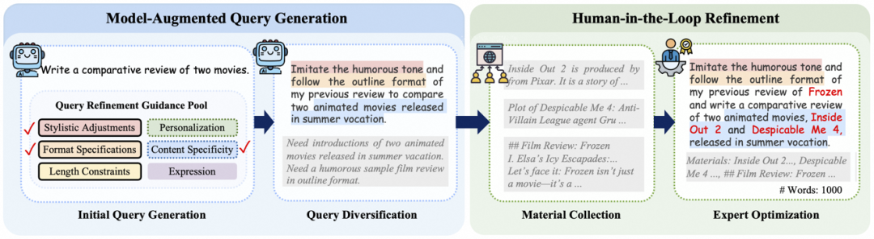
图16 - 评测阶段
介入，补充开源素材，例如财报、法律条文等作为输入料。最后，由专家对所有生成的文本进行内容质检，以确保评测集的质量。文中还展示了一个WritingBench中影视解读向视频脚本的创作需求示例。

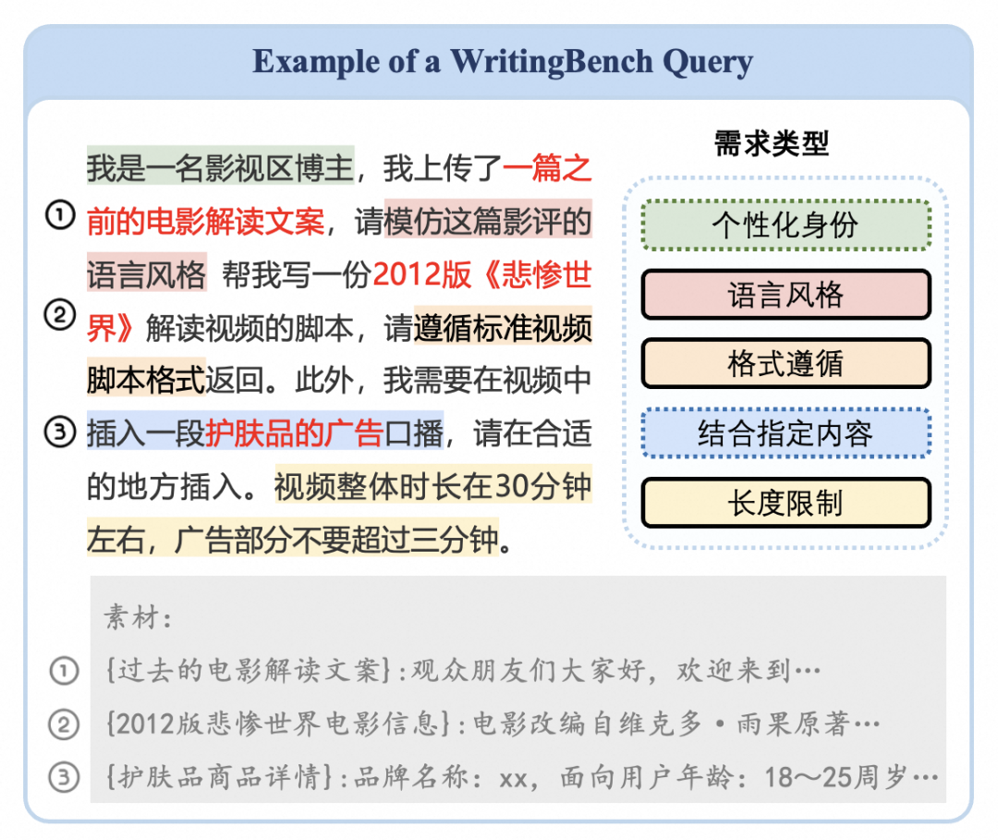
图17 - 评测示例
与其他写作相关评测基准对比，WritingBench领域和素材来源更为广泛，并额外支持了「风格」、「格式」、「长度」维度的能力评测。
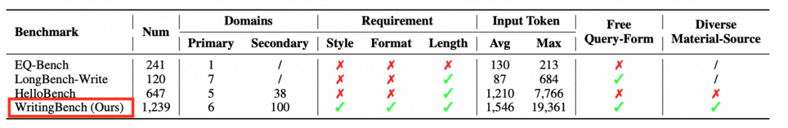
图18 - benchmark对比
传统单一标准的写作评估方式已经难以满足当下多样化的写作需求，例如悬疑小说追求情节反转和氛围营造，而儿童启蒙故事则注重语言简洁与趣味性，两者的价值导向截然不同。针对这一问题，WritingBench创新性地提出了一种基于写作意图的动态评估体系。该体系能够针对每一个写作输入，自动生成五个贴合其特定需求的评测指标，涵盖名称、描述及细则，充分结合素材特点与用户实际需求，如模仿提供的风格、遵循指定格式或依据示例撰写材料。这一策略的人类一致性得分高达87%，并且团队还开发了一个评分模型，可依指标自适应地给出1-10分的量化评分及具体的评分依据。
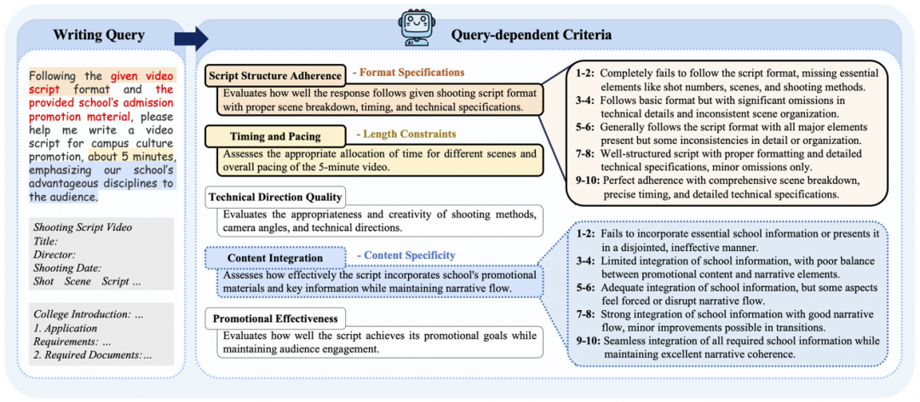
图19 - 动态评估指标示例
教育领域（D5）在各个模型中的表现均较好，其次是学术和工程领域（D1）。文学与艺术（D5）是得分最低的领域，不同模型表现出显著的差异。具备链式思维（CoT）能力的模型如Deepseek-R1和o1-preview在处理叙述性和创意内容上表现优于其非CoT对照模型，表明CoT在处理此类内容时的潜力。
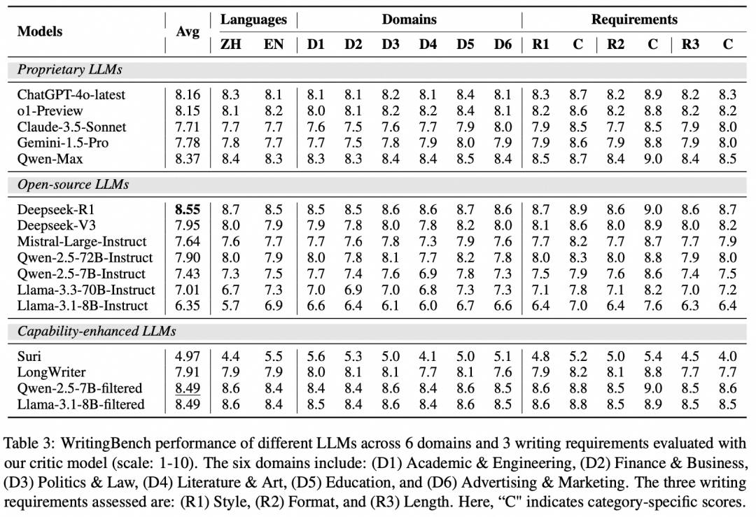
图20 - 实验结果
进一步，在学术与工程领域论文，该实验工作又划分为Paper Outline，Abstract，Introduction，Contributions，Literature Review，Experiments，Conclusion，Limitations，Acknowledgements，Defense Presentation，Defense Script，Research Proposal，Internship Report，Technical Documentation，Engineering Report，Patent，Test Report等文章部分评测，可以看到如下热力图颜色代表评测分数高低。Deepseek-R1模型在所有部分都取得很高的分数。接下来是微调过后的Qwen-2.5-7B和Llama-3.1-8B模型也有差不多成绩。
 | Deepseek-R1 | Qwen-2.5-7B-filtered | Llama-3.1-8B-filtered | Qwen-Max | ChatGPT-4o-latest
Paper Outline | 9 | 9 | 9 | 8 | 8
Abstract | 9 | 9 | 9 | 9 | 8
Introduction | 9 | 9 | 9 | 8 | 8
Contributions | 8 | 9 | 9 | 8 | 8
Literature Review | 8 | 9 | 9 | 8 | 8
Experiments | 8 | 8 | 8 | 8 | 8
Conclusion | 8 | 8 | 8 | 8 | 8
Limitations | 9 | 9 | 8 | 8 | 8
Acknowledgements | 8 | 9 | 9 | 8 | 8
Defense Presentation | 8 | 8 | 9 | 8 | 8
Defense Script | 8 | 8 | 9 | 8 | 8
Research Proposal | 9 | 8 | 8 | 8 | 8
Internship Report | 9 | 8 | 8 | 8 | 8
Technical Documentation | 8 | 8 | 9 | 8 | 8
Engineering Report | 8 | 8 | 8 | 8 | 8
Patent | 8 | 9 | 8 | 8 | 8
Test Report | 8 | 8 | 8 | 8 | 8

推荐顺序：Deepseek-R1,Qwen-2.5-7B(微调)，Llama-3.1-8B（微调），Qwen-Max和ChatGPT-4o-latest。
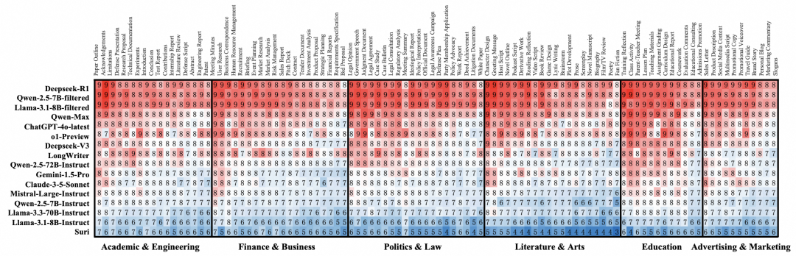
图21 - 实验结果

项目地址：https://modelscope.cn/studios/iic/DeepWriting
项目仓库：https://github.com/X-PLUG/WritingBench
论文出处：https://arxiv.org/abs/2503.05244

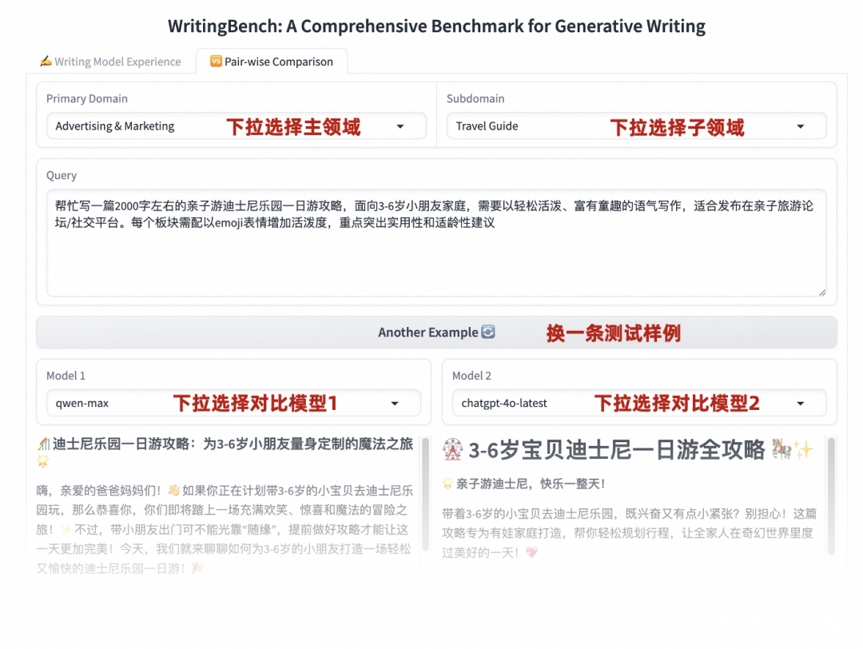
图22 - 项目示例1

图23 - 项目示例2

图24 - 项目示例3

图25 - 项目示例4

图26 - 项目示例5

2.4 dify工具设计写作pipeline
本部分是本人利用dify和xinference等开源根据设计的论文写作pipeline框架。用于自动化辅助论文写作，一键完成标题/摘要、引言、相关工作、方法、实验、结果分析、结论等部分写作任务。
Dify官网：https://docs.dify.ai/v/zh-hans
Dify开发网站：https://cloud.dify.ai/
Xinference官网：https://inference.readthedocs.io/
Dify 是一款开源的大语言模型（LLM）应用开发平台，融合了后端即服务（Backend as Service）和 LLMOps 的理念，使开发者能够快速搭建生产级的生成式 AI 应用。其主要特点和功能如下：
一站式开发平台：内置了构建 LLM 应用所需的关键技术栈，包括对数百个模型的支持、直观的 Prompt 编排界面、高质量的 RAG 引擎、稳健的 Agent 框架、灵活的流程编排等，还提供了一套易用的界面和 API，为开发者节省了大量时间，使其能够专注在创新和业务需求上。
可视化操作：提供了直观的界面，如可视化的 Prompt 编排、数据集管理等功能，即使没有丰富的编程经验，开发者也能通过界面化操作快速上手，轻松构建和管理 AI 应用。
多模型支持：全面支持接入全球各类开源和闭源的大型语言模型，如 GPT、Mistral、Llama3 等，便于用户轻松访问、自由切换并对比不同模型的性能。
强大的扩展能力：通过丰富的插件，用户可以扩展 AI 应用能力，还能利用其强大的工具系统，接入第三方工具或 API，实现更复杂的功能。
数据处理与存储：能够从多样化数据源提取、转化数据，构建索引存入向量数据库，为大型语言模型提供最佳数据准备，并且可以实现数据的私有化存储，满足金融、医疗等敏感行业对数据安全的要求。
开箱即用与灵活部署：支持本地部署和云端服务，用户可以通过 Docker 快速部署 Dify 服务器，并提供了多种发布选项，无需处理后端复杂性，可一键发布应用，灵活满足不同用户的需求。
Prompt IDE：提供可视化的提示词编排界面，用户可以方便地编写、调试和管理提示词，并快速发布 AI 应用。
RAG Pipeline：实现了检索增强生成，能够对文档进行摄入、处理和存储，以便在回答问题时提供相关的上下文信息，提高回答的准确性和相关性。
Agent 框架：具备智能的代理能力，可以模拟智能代理的行为，实现与用户的交互和对话管理，支持多种交互方式和逻辑流程，能够处理复杂的任务和请求。
工作流编排：通过可视化拖拽操作，用户可以直观地构建灵活高效的工作流，实现多个任务的自动化执行和协同工作，提高工作效率和流程的可控性。
模型管理：支持对多种大语言模型的管理和配置，包括模型的加载、参数设置、性能监控等，方便用户根据不同的应用场景选择和优化合适的模型。
数据标注与改进：提供可视化查阅 AI 日志的功能，用户可以观测 AI 的推理过程，并对数据进行改进标注，以不断提高模型的性能和应用的质量。
以下是使用 Dify 设计论文写作的 pipeline：首先要明确论文主题和要求，收集整理相关资料。接着通过 Dify 的 RAG Pipeline 功能进行文档摄入，将各种格式文档提取文本后构建知识库。然后利用 Dify 的提示词 IDE 或工作流生成论文提纲，依据提纲撰写各部分内容，包括引入背景、阐述方法、呈现结果、讨论与分析等。在撰写过程中可借助 Dify 的数据处理、可视化、文本分析等功能辅助。完成初稿后，通过 Dify 的相关功能对论文内容进行优化完善，调整格式，检查质量，最后生成最终文档并导出，同时做好版本管理与备份。
本论文写作辅助项目整体采用线性的、指令驱动的、检索与生成交替迭代的流程。
启动与核心检索准备 (START & Core Search Setup)
流程从"START"开始，预设了一系列必填的核心检索操作指令(如 文档中的标题与摘要、查找文档中的introduction、相关工作等)，它们构成了后续每个检索步骤的关键词，并以此为根据进行生成。
章节撰写循环 (Retrieve-Generate Loop Per Section)
对于论文的每一个核心章节（包括标题/摘要、引言、相关工作、方法、实验、结果分析、结论）：
检索:首先执行对应章节的预定义检索操作。
生成:基于检索到的相关资料和统一的、具体的任务指令，调用大模型生成该章节的初稿内容。
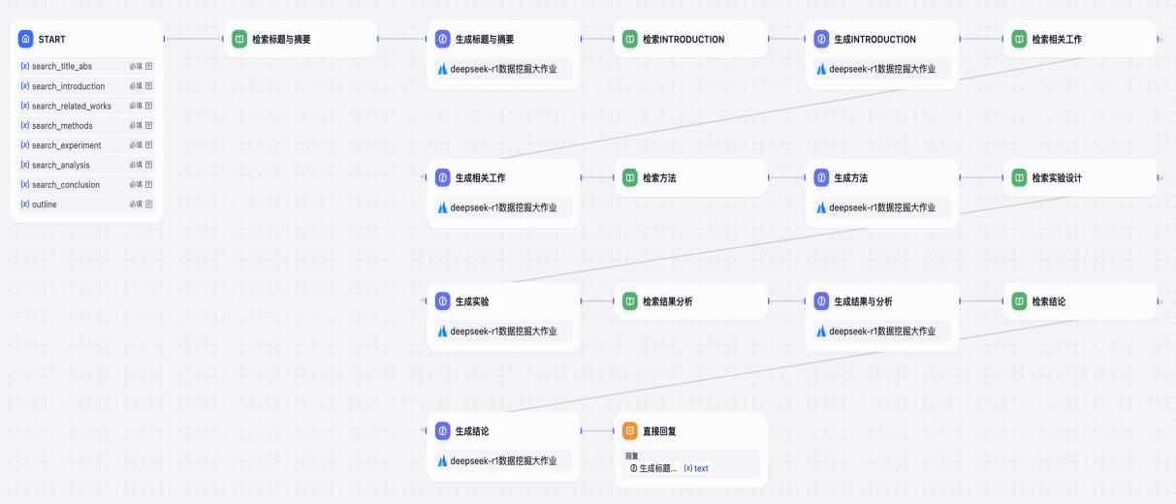
图27 - Dify设计的写作pipeline
通过一个系统提示为大模型说明身份信息，以便更专业地完成论文撰写任务。
对于每个任务，详细专业地描述任务要求、现有内容以及格式要求。

图28 - system prompt


图29 - user prompt 1

图30 - user prompt 2
基于上述的Dify设计并且采用DeepSeek-R1模型,我们为项目设计了如下大纲作为提示词模板。
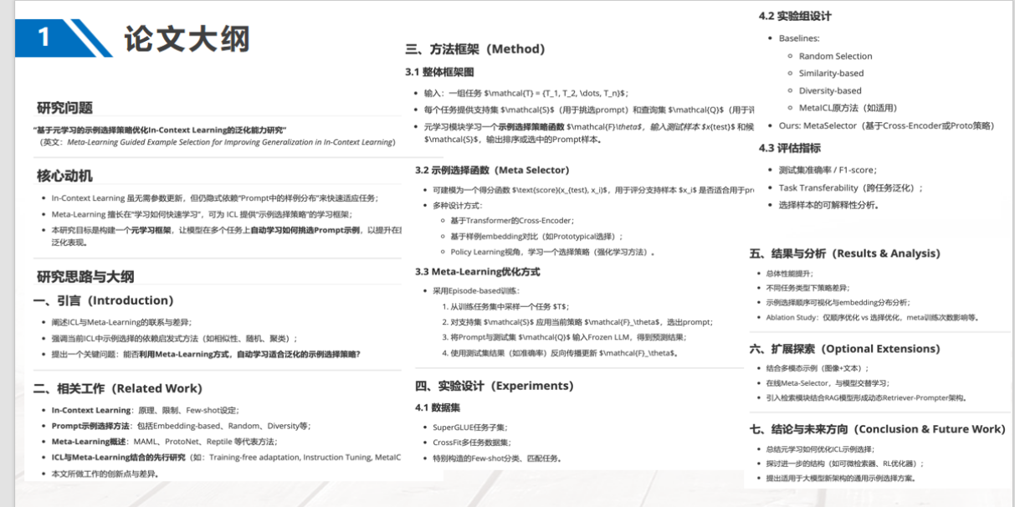
图31 - 论文大纲展示
更多工作可以参考附件PPT
AI论文写作调研.pptx
提示词工程尝试.pptx
dify写作流程设计.pptx

任务 3 指令记录

本实验是根据writingbench的评测记录完成，过程采用的给AI的指令、AI的反馈结果、对AI反馈结果的评判等均参考原有的benchmark给出，对于完整的AI写作应该提供大模型写作参考材料，实验记录内容比较长，并且对比了不同模型的回复和评分。
由于实验数据过多，这里只选择部分数据和模型实验结果作为示例，内容仅供参考。
详细评测数据和结果参考以下链接：

项目地址：https://modelscope.cn/studios/iic/DeepWriting
项目仓库：https://github.com/X-PLUG/WritingBench
论文出处：https://arxiv.org/abs/2503.05244

指令一
**Design and Implementation of a Procurement Cloud Platform Based on Microservice Architecture**

0 Introduction
In today's increasingly competitive business environment, procurement management has become one of the key factors determining the success or failure of an enterprise. As enterprise procurement operations continue to expand and become more complex, the limitations of traditional centralized architectures in scalability, maintainability, and flexibility have gradually emerged. In response to these challenges, more and more enterprises are exploring new procurement management platform architectures [1], among which microservice architecture has received considerable attention due to its high modularity, scalability, and maintainability.
A procurement cloud platform based on microservice architecture can provide enterprises with an efficient, flexible, and scalable procurement management platform. Through modular development, loosely coupled service design, and automated operation and maintenance management, the procurement cloud platform can quickly respond to changes in business demands, improving procurement management efficiency and standards. Therefore, this paper aims to explore the design and implementation of a procurement cloud platform based on microservice architecture, providing enterprises with a practical and feasible procurement management platform solution [2].

1 Overview of Microservice Architecture
1.1 Basic Concept of Microservice Architecture
Microservice architecture is a software design pattern based on service decomposition, where the core idea is to break down complex monolithic applications into a set of smaller, more independent service units. Each service unit can be independently developed, tested, and deployed, and uses the corresponding technology stack. These services collaborate through lightweight communication mechanisms, thus creating a flexible and scalable system [3].
The key to microservice architecture lies in the independence and autonomy of services. Each service is an independent business unit, with its own database, business logic, and application programming interface (API). This reduces the coupling between services, improving system scalability and maintainability. Additionally, since each service can be developed and deployed independently, it allows for faster responses to business changes, improving development efficiency.

1.2 Advantages and Challenges of Microservice Architecture
Microservice architecture brings significant advantages in modern software development and deployment, mainly reflected in the following aspects:
① Independence and scalability. Microservice architecture allows each service to be developed, tested, deployed, and scaled independently, greatly enhancing system flexibility and scalability.
② Flexible technology selection. Since each microservice is independent, the most suitable technology stack can be selected for each service.
③ High fault tolerance. Each service in a microservice architecture is independent, so a failure in one service does not affect the operation of other services.
④ Rapid response to change. Microservice architecture enables organizations to respond more quickly to business changes. When business demands change, only the relevant services need to be modified, tested, and deployed, without redeploying the entire system.

Although microservice architecture offers many advantages, it also faces some challenges:
① Service decomposition and design. How to reasonably decompose services is a challenge. Too fine decomposition can lead to high coupling between services, while too coarse decomposition may result in losing the advantages of microservice architecture.
② Distributed complexity. Microservice architecture introduces the complexity of distributed systems, including network delays, service communication, data consistency, and other issues.
③ Operation and maintenance challenges. Microservice architecture increases the operational complexity of the system. A large number of service instances, configurations, and logs need to be managed, requiring higher technical and management capabilities from the operation and maintenance team.

1.3 Design Principles of Microservice Architecture
The design principles of microservice architecture aim to achieve high cohesion, low coupling, scalability, observability, and autonomy of the system. It encourages breaking down complex systems into a series of independent, autonomous, and deployable services, communicating through clear interfaces to ensure loose coupling and flexible collaboration between services. At the same time, it emphasizes the reusability, scalability, replaceability, and observability of services to quickly respond to changes in business needs and improve system stability and maintainability [4].

1.4 Key Technologies in Microservice Architecture
Key technologies in microservice architecture mainly include service registration and discovery, API gateway, load balancing, configuration management, fault tolerance and recovery, monitoring and tracing, etc. These technologies together form an efficient, flexible, and scalable microservice ecosystem.
Service registration and discovery mechanisms, such as Eureka and Consul, ensure mutual discovery and communication between services. The API gateway, as the entry point to the system, is responsible for routing, authentication, and traffic limiting. Load balancing technologies, such as Nginx and Ribbon, ensure balanced distribution of service requests. Configuration management tools, such as Spring Cloud Config and Apollo, enable unified management and dynamic refresh of configurations. Fault tolerance and recovery technologies, such as circuit breaking, degradation, and traffic limiting, ensure system stability and availability. Monitoring and tracing tools, such as Prometheus and Zipkin, monitor service status in real time and locate issues. These key technologies support the independence, scalability, reliability, and maintainability of microservice architecture.

2 Procurement Cloud Platform Requirements Analysis
2.1 Procurement Business Process Analysis
In the procurement cloud platform, the analysis of the procurement business process mainly covers the entire process from clarifying procurement goals and needs to procurement payment.
(1) Clarifying procurement goals and needs: Define the procurement objectives and accurately describe the details of required products or services, such as quality, packaging, after-sales service, transportation, and inspection methods, to ensure the smooth progression of subsequent processes.
(2) Identifying key process links: Break down the entire procurement process into several key steps and analyze the characteristics and importance of each step.
(3) Evaluating issues and bottlenecks: Identify issues and bottlenecks related to the procurement business process by collecting and analyzing relevant data, as well as communication with procurement personnel and suppliers, to obtain more comprehensive information and feedback.
(4) Optimizing the procurement business process: Based on the analysis results, optimize the procurement process to improve procurement efficiency and outcomes.
(5) Supplier management: Establish a unified supplier file in the procurement cloud platform, including basic supplier information and qualifications.
(6) Demand release and bidding: The procurement unit releases procurement demands on the platform. Eligible suppliers register on the platform and submit bidding documents, including technical proposals, business proposals, price lists, etc. The procurement unit reviews the bidding documents and selects the winning supplier.
(7) Contract signing and payment: The winning supplier signs the procurement contract with the procurement unit, and subsequent operations, such as procurement payment and delivery, are carried out according to the contract terms.

2.2 System Functional Requirements
Focusing on system functionality requirements, the goal is to create a procurement cloud platform based on microservice architecture. This platform not only meets the diverse procurement needs of enterprises, such as for projects, goods, and services, but also offers a series of comprehensive and flexible procurement methods, including tender procurement, non-tender procurement, agreement procurement, e-auction, and inquiry-based procurement.
(1) Procurement demand analysis: Planners from each subsidiary submit procurement demand requests, and the group’s project procurement department consolidates the received demands to create procurement requests. These requests go through an approval process to determine whether to use a tender procurement method. Once approved, the procurement demand is passed to the central purchasing department, which formulates specific procurement strategies. It is noteworthy that the central purchasing department also has the authority to directly input procurement demands.
(2) Tender procurement demand: The owner submits a pre-tender procurement request, and the project manager divides the bid sections and submits them for approval. The tender agent organizes the transaction, publicly announces the invitation to tender, and sends invitation letters to potential suppliers. The project manager prepares electronic tender documents covering technical, business, contract, and evaluation methods, which are published after internal review. In the tendering stage, suppliers register and pay the security deposit to participate in the bid. Projects requiring pre-qualification are reviewed by evaluators, and the shortlisted suppliers are announced. Any objections to the tender documents are addressed by the project manager, and after approval, they are published and responded to by the bidding suppliers. The project manager submits the award announcement, and once approved, it is published on the procurement website, along with notification letters for the award results. Suppliers make online payments for service fees.

2.3 Non-Functional System Requirements
2.3.1 System Stability and Reliability
The procurement system must ensure the accurate, correct, complete, and secure access and storage of data. During software version updates, the system should maintain stable operation without affecting business processes. System response times should meet user experience expectations. In the local area network, the following standards should be met:
① When calling web pages, the response time should not exceed 2 seconds.
② When processing complex reports and graphical data, the response should be within 5 seconds.
③ Support for thousands of concurrent users.
④ The average server load should not exceed 50%.
⑤ Stable uploads of individual files up to 500MB, supporting resume of interrupted uploads.

2.3.2 System Usability
The system must meet the characteristics and management needs of steel enterprise procurement, ensuring efficient operation while aligning with actual management requirements.

2.3.3 System Scalability
The system should have a good structure, easy to adjust and extend to accommodate the development of business functions. Administrators should be able to easily manage user permissions, and the system design should follow extensibility principles.

2.3.4 System Maintainability
The system must be easy to maintain to ensure efficient work by system administrators and maintenance personnel, reducing workload.

2.4 User Role Definitions for the Procurement Cloud Platform
In-depth analysis of software requirements uses use case analysis as a core tool. Use case analysis helps clarify the functions the system should have and clearly defines which user groups can access these functions. Use case analysis begins with identifying the key user roles, which may include system administrators, regular users, suppliers, and procurement personnel. For each user role, specific use cases are defined, indicating a series of operations or tasks that each role will perform in the system, as shown in Figure 1.
(Figure 1 Procurement Owner)

3 Microservice Design for the Procurement Cloud Platform
3.1 Service Decomposition Strategy
Service decomposition is the first step in microservice design, aiming to break down large, complex monolithic applications into a series of small, independent services. In the procurement cloud platform, the service decomposition strategy should be planned based on business capabilities and scenarios. First, it is necessary to identify the core business capabilities of the procurement cloud platform, such as product management, order management, supplier management, etc. Next, services can also be decomposed based on specific business scenarios. Too fine decomposition can make communication between services more complex, while too coarse decomposition may fail to leverage the advantages of microservices.

3.2 Communication Mechanism Between Microservices
In a microservice architecture, communication between services is an important issue. Common communication mechanisms include RESTful APIs, remote procedure calls, and message queues. RESTful APIs are a communication method based on the HTTP protocol that uses standard HTTP methods and URIs to represent resources and operations. RESTful APIs are simple, easy to use, and highly cross-platform, making them a common method for communication between microservices.

3.3 Data Storage and Management Strategy
In a microservice architecture, each service usually has its own data storage and management strategy. Distributed databases can store data across multiple nodes to improve system scalability and fault tolerance. Common distributed databases include Cassandra, HBase, etc.

4 Implementation of Procurement Cloud Platform
4.1 Setting Up the Microservice Environment
When building a microservice architecture, this paper follows object-oriented principles, refining each microservice into a standard three-layer structure to ensure high cohesion and low coupling. The three layers are: control layer, processing layer, and data access layer. This structure not only follows the mainstream architecture idea of three-tier distribution but also ensures independent processing of business logic, allowing microservices to focus on specific business functions, as shown in Figure 2.
(Figure 2 Layered Design Diagram)

4.2 User Interface Design and Implementation
4.2.1 Procurement Service Management
Procurement service management mainly includes the release and query of tender information, user-friendly registration and login processes, timely updates of notifications, specialized services for enterprise procurement, a transparent credit disclosure platform, a convenient e-commerce shopping experience, a detailed help section, professional trading zone services, real-time industry news updates, and comprehensive display of transaction data.

4.2.2 Tender Procurement Module
This module fully implements the online operation of the entire tendering process, including bidding, tender opening, and awarding. In this module, the tender management process can be personalized according to each company's specific needs, including detailed definitions of tender project names, product models, quantities, design drawings, and quality standards, as shown in Figure 3.
(Figure 3 Tender Procurement Page)

5 Testing
5.1 Testing Methods and Strategies
This paper conducts testing on the procurement cloud platform based on microservice architecture through functional testing and performance testing, writing test cases to check whether each microservice works as expected. Test cases should verify the functionality and performance of each service, ensuring seamless integration with other services. Security testing focuses on system security, including authentication, authorization, and data encryption, ensuring the system can withstand potential attacks and threats.

5.2 Performance Testing
This test focuses on a comprehensive performance evaluation of the power grid enterprise procurement platform using the LoadRunner testing tool, simulating real user operations and load conditions. Using LoadRunner, initial concurrent access from 50 users was simulated, and the system load was gradually increased by adding 50 users per second, until the system reached a peak of 300 concurrent users. These simulated users continued to run steadily for 5 minutes to fully simulate and test the actual operation status of the system. After the test, the system load was gradually decreased by reducing 50 users per second until all users completely exited the system.

6 Conclusion
In conclusion, this paper delves into the design, implementation, and testing of a microservice architecture-based platform. Through detailed research and practical validation, it confirms the advantages of microservice architecture in modern software development and provides strong support for its application in the power grid procurement platform. In the future, further research on relevant technologies and best practices in microservice architecture will be conducted to promote continuous improvement and innovation of the power grid enterprise procurement platform., please write an academic abstract of no more than 400 words for this paper on microservices architecture design.

chatgpt-4o-latest回复
Abstract
In the modern business environment, procurement management plays a crucial role in enterprise operations. Traditional monolithic procurement systems often face challenges related to scalability, maintainability, and flexibility, making it difficult to adapt to the evolving demands of enterprises. To address these challenges, this paper explores the design and implementation of a procurement cloud platform based on microservice architecture. By leveraging microservices, the platform achieves high modularity, scalability, and maintainability, ensuring efficient and flexible procurement management.
This study first provides an overview of microservice architecture, highlighting its core principles, advantages, challenges, and key enabling technologies. Microservices decompose complex monolithic applications into independent, loosely coupled services, enabling independent development, deployment, and scaling. However, challenges such as service decomposition, distributed system complexity, and operational management must be addressed to fully realize its benefits.
Following this, the paper conducts a detailed analysis of the procurement business process and system requirements. The procurement cloud platform is designed to support various procurement methods, including tender procurement, non-tender procurement, and agreement procurement. The system is required to ensure stability, scalability, usability, and maintainability while supporting high concurrency and large-scale data processing. User roles, including system administrators, procurement personnel, and suppliers, are clearly defined to ensure efficient interaction with the platform.
The microservice design of the procurement cloud platform is then elaborated, including service decomposition strategies, communication mechanisms, and data management approaches. The platform adopts a modular service decomposition strategy based on business capabilities and scenarios, ensuring high cohesion and low coupling. RESTful APIs and message queues facilitate communication between microservices, while distributed databases enhance data management efficiency.
The implementation of the procurement cloud platform follows a structured approach, including microservice environment setup, user interface design, and functional module development. A three-layer architecture—comprising the control, processing, and data access layers—ensures system modularity and maintainability. Key modules such as procurement service management and tender procurement are designed to enhance procurement efficiency and transparency.
Comprehensive testing, including functional and performance testing, is conducted to validate the platform’s stability, scalability, and security. Performance testing using LoadRunner simulates real-world user scenarios to assess system load capacity and response times. The results demonstrate the platform’s ability to handle high concurrency while maintaining stability.
In conclusion, this study confirms the advantages of microservice architecture in modern procurement systems, offering a scalable and maintainable solution for enterprises. Future research will focus on optimizing microservice design and enhancing system performance to further improve procurement management efficiency.
Keywords: microservice architecture, procurement cloud platform, scalability, maintainability, service decomposition, performance testing

chatgpt-4o-latest的得分细则
Scoring▼

Average Score: 6.40

Scoring Details

architectural_clarity
Score: 7
Criteria Description: Evaluates how clearly and comprehensively the microservice architecture design principles, components, and relationships are explained
Scoring Reason: The response demonstrates clear and detailed architectural explanation with some minor gaps in advanced concepts. Strengths include: 1) Comprehensive explanation of basic microservice concepts in Section 1.1, clearly defining the independence and autonomy of services. 2) Well-structured coverage of advantages and challenges in Section 1.2, including scalability, technology flexibility, and distributed complexity. 3) Clear explanation of key technologies in Section 1.4, covering essential components like service discovery, API gateway, and load balancing. 4) Detailed service decomposition strategy in Section 3.1 that emphasizes business capabilities and scenarios. However, there are some limitations: 1) The communication mechanism section (3.2) could be more detailed, especially regarding patterns like event-driven architecture and circuit breakers. 2) Data management strategies in Section 3.3 are briefly mentioned without sufficient detail on data consistency patterns and inter-service data management. 3) The implementation section could better explain the interaction patterns between the three-layer architecture and microservices. Despite these gaps, the response maintains a strong foundation in explaining microservice architectural principles and their practical application in the procurement platform context.

implementation_specificity
Score: 4
Criteria Description: Assesses the level of technical detail and practical implementation guidance provided
Scoring Reason: The abstract provides only basic implementation concepts without sufficient technical guidance or specifications. While it mentions key components like 'RESTful APIs and message queues facilitate communication between microservices' and 'three-layer architecture—comprising the control, processing, and data access layers,' it lacks specific technical details about how these are implemented. The abstract does not provide concrete implementation steps, configuration details, or technical specifications for the microservices deployment. While it references 'LoadRunner' for testing, it doesn't detail the technical setup or configuration parameters. The mention of 'distributed databases' and 'service decomposition strategies' remains at a conceptual level without practical implementation guidance. The response fails to include specific technical frameworks, tools, or code examples that would be necessary for practical implementation. This level of detail aligns with the '3-4' rating criteria of 'Basic implementation concepts mentioned but lacking specific technical guidance.'

procurement_domain_integration
Score: 7
Criteria Description: Evaluates how well the microservice architecture addresses specific procurement domain requirements
Scoring Reason: The abstract demonstrates strong integration of procurement domain requirements with some minor oversights. Strengths include: 1) Clear identification of procurement-specific needs like 'tender procurement, non-tender procurement, and agreement procurement' methods, 2) Explicit mention of procurement business process analysis and system requirements tailored to procurement operations, 3) Recognition of key procurement stakeholders including 'system administrators, procurement personnel, and suppliers.' However, there are some minor gaps: 1) The abstract could better elaborate on how microservice decomposition specifically maps to procurement workflows, 2) Limited detail on procurement-specific data management challenges and solutions, 3) Could strengthen the connection between performance testing scenarios and procurement-specific use cases. The abstract effectively captures the high-level procurement domain requirements but leaves some room for more detailed procurement-specific architectural considerations.

technical_depth
Score: 6
Criteria Description: Measures the depth of technical analysis and sophistication of architectural solutions
Scoring Reason: The abstract demonstrates moderate technical depth with coverage of key microservice concepts, but lacks detailed exploration of cutting-edge architectural solutions. Strengths include: 1) Clear explanation of core microservice principles including 'independent, loosely coupled services, enabling independent development, deployment, and scaling'; 2) Discussion of technical implementation aspects like 'RESTful APIs and message queues facilitate communication between microservices, while distributed databases enhance data management'; 3) Mention of specific testing tools like 'LoadRunner' for performance validation. However, several limitations prevent a higher score: 1) The technical discussion remains at a high level without diving into specific architectural patterns or implementation details; 2) While mentioning distributed databases, it doesn't elaborate on specific data consistency patterns or challenges; 3) No detailed discussion of modern microservice patterns like CQRS, event sourcing, or service mesh architecture; 4) Limited coverage of specific technical solutions for handling the mentioned challenges like service discovery, circuit breaking, or containerization strategies. The abstract provides a solid foundation but lacks the advanced technical depth required for a higher score.

practical_feasibility
Score: 8
Criteria Description: Evaluates the practicality and real-world applicability of the proposed solution
Scoring Reason: The response demonstrates strong practical feasibility through several concrete elements: 1) Detailed specification of system performance requirements (e.g., '2-second response time for web pages, 5-second for complex reports, support for thousands of concurrent users'), 2) Comprehensive consideration of real-world business processes including supplier management, contract signing, and payment workflows, 3) Practical testing methodology using LoadRunner with specific metrics (50 users increments up to 300 concurrent users for 5 minutes), 4) Clear technical implementation details including three-layer architecture and specific technologies (RESTful APIs, Cassandra, HBase). The solution addresses operational challenges through specific tools (Eureka, Consul, Nginx) and includes practical considerations for maintenance and scalability. Minor implementation uncertainties exist around data consistency in the distributed system and specific details of service-to-service communication patterns, preventing a perfect score. However, the overall approach shows strong consideration of real-world constraints and practical implementation requirements.

deepseek-v3回复
Abstract
This paper explores the design and implementation of a procurement cloud platform based on microservice architecture, addressing the limitations of traditional centralized systems in scalability, maintainability, and flexibility. As procurement management becomes increasingly complex, microservice architecture offers a modular, scalable, and maintainable solution, enabling enterprises to respond swiftly to evolving business demands. The study begins with an overview of microservice architecture, detailing its core concepts, advantages, challenges, and design principles. Key technologies such as service registration and discovery, API gateways, load balancing, and fault tolerance mechanisms are discussed, forming the foundation of an efficient microservice ecosystem.
The paper then conducts a comprehensive analysis of procurement business processes, identifying functional and non-functional requirements, including system stability, usability, scalability, and maintainability. User roles are defined, and use case analysis is employed to clarify system functionalities. The microservice design phase focuses on service decomposition strategies, communication mechanisms, and data storage management, ensuring high cohesion and low coupling.
The implementation of the procurement cloud platform involves setting up a microservice environment with a three-tier architecture (control, processing, and data access layers) and designing user interfaces for procurement service management and tender procurement modules. Functional, performance, and security testing are conducted to validate the system’s reliability and scalability, with performance testing simulating up to 300 concurrent users using the LoadRunner tool.
The study concludes that microservice architecture significantly enhances the flexibility, scalability, and maintainability of procurement systems, providing a robust solution for modern enterprises. Future research will focus on advancing microservice technologies and best practices to further optimize procurement platforms. This work contributes to the growing body of knowledge on microservice architecture, offering practical insights for its application in procurement management systems.
Deepseek-V3的得分细则
Scoring▼

Average Score: 7.20

Scoring Details

architectural_clarity
Score: 7
Criteria Description: Evaluates how clearly and comprehensively the microservice architecture design principles, components, and relationships are explained
Scoring Reason: The abstract provides a clear and detailed architectural explanation with some minor gaps in advanced concepts. Strengths include: 1) Clear articulation of core microservice concepts including 'modular, scalable, and maintainable solution' and key technologies like 'service registration and discovery, API gateways, load balancing, and fault tolerance mechanisms.' 2) Good explanation of the three-tier architecture implementation with 'control, processing, and data access layers.' 3) Coverage of service decomposition strategies and communication mechanisms. However, there are some limitations: 1) The abstract lacks specific details about how the services interact and communicate with each other beyond mentioning 'high cohesion and low coupling.' 2) While testing is mentioned, there's insufficient detail about how the microservice architecture specifically impacts the testing strategy. 3) The description of data management and storage strategies across microservices could be more detailed. Despite these minor gaps, the abstract effectively communicates the fundamental architectural principles and their application in the procurement platform context.

implementation_specificity
Score: 6
Criteria Description: Assesses the level of technical detail and practical implementation guidance provided
Scoring Reason: The abstract provides adequate technical details but lacks crucial implementation specifics in several areas. Strengths include mentioning key technologies (service registration, API gateways, load balancing) and the three-tier architecture implementation (control, processing, data access layers). The performance testing parameters are well-specified (300 concurrent users, LoadRunner tool, 50-user increments). However, there are significant omissions: no specific details about the API design, database technology choices, or service communication protocols. While it mentions 'service decomposition strategies,' it doesn't provide concrete guidelines for how services should be decomposed. The abstract also lacks specific implementation details about security measures, deployment configurations, and containerization strategies. The performance testing methodology is described, but without specific performance metrics or benchmarks achieved. These omissions of crucial technical specifications prevent a higher score, though the abstract maintains an adequate level of technical detail for a high-level overview.

procurement_domain_integration
Score: 8
Criteria Description: Evaluates how well the microservice architecture addresses specific procurement domain requirements
Scoring Reason: The response demonstrates strong integration of microservice architecture with procurement domain requirements, with only minor oversights. Key strengths include: 1) Detailed analysis of procurement business processes in Section 2.1, covering the entire procurement lifecycle from goal-setting to payment. 2) Clear mapping of functional requirements to microservices, especially in sections 2.2 and 3.1, addressing specific procurement needs like tender management, supplier management, and demand analysis. 3) Implementation of domain-specific features in Section 4.2, including tender procurement modules and procurement service management. However, minor gaps exist: 1) Limited discussion of procurement-specific data models in the microservice design. 2) Could have provided more detail on how the microservice architecture specifically handles complex procurement workflows like contract management and supplier evaluation. The strong alignment is particularly evident in the three-layer architecture design (Section 4.1) that accommodates procurement-specific business logic while maintaining service independence. The performance testing (Section 5.2) also specifically addresses procurement platform needs with concurrent user simulation.

technical_depth
Score: 7
Criteria Description: Measures the depth of technical analysis and sophistication of architectural solutions
Scoring Reason: The abstract demonstrates strong technical analysis with a few minor gaps in cutting-edge concepts. Strengths include: 1) Clear explanation of core microservice architectural components including 'service registration and discovery, API gateways, load balancing, and fault tolerance mechanisms'; 2) Detailed coverage of implementation aspects with specific technical layers ('three-tier architecture (control, processing, and data access layers)'); 3) Concrete performance metrics mentioned ('300 concurrent users using the LoadRunner tool'). However, there are some gaps: 1) Limited detail on specific inter-service communication protocols beyond mentioning them; 2) Absence of discussion on modern containerization or orchestration technologies; 3) No mention of specific monitoring or observability solutions. The abstract covers fundamental technical aspects well but could have included more cutting-edge concepts in cloud-native architectures and DevOps practices. The technical depth is evident in the system architecture discussion but could be enhanced with more specific implementation details of advanced microservice patterns and emerging technologies.

practical_feasibility
Score: 8
Criteria Description: Evaluates the practicality and real-world applicability of the proposed solution
Scoring Reason: The response demonstrates strong practical feasibility with well-considered implementation details. Key evidence includes: 1) Specific performance metrics are defined (e.g., '2-second web page response time, 5-second processing for complex reports, support for thousands of concurrent users, 50% server load limit, 500MB file uploads'), showing concrete operational requirements. 2) Real-world testing methodology is detailed using LoadRunner with specific user loads (50-300 concurrent users) and gradual scaling. 3) Practical business process considerations are comprehensively addressed through detailed procurement workflows, supplier management, and tender processes. 4) Technical implementation is grounded in proven technologies (RESTful APIs, distributed databases like Cassandra and HBase). 5) Non-functional requirements are thoroughly considered, including system stability, maintainability, and scalability. Minor implementation uncertainties exist around specific microservice communication patterns and detailed deployment strategies, preventing a perfect score. However, the overall approach shows strong consideration of real-world constraints and practical implementation challenges.

llama-3.3-70b-instruct回复
Here is an academic abstract of no more than 400 words for the paper on microservices architecture design:
Title: Design and Implementation of a Procurement Cloud Platform Based on Microservice Architecture
Abstract:
The increasing complexity of enterprise procurement operations has led to the need for a more scalable, maintainable, and flexible procurement management platform. Microservice architecture has emerged as a promising solution, offering high modularity, scalability, and maintainability. This paper presents the design and implementation of a procurement cloud platform based on microservice architecture, providing a practical and feasible procurement management platform solution for enterprises.
The paper begins by introducing the basic concept of microservice architecture, its advantages, and challenges. It then discusses the design principles of microservice architecture, including high cohesion, low coupling, scalability, observability, and autonomy. The key technologies in microservice architecture, such as service registration and discovery, API gateway, load balancing, and configuration management, are also explored.
The paper then analyzes the procurement business process and identifies the system functional and non-functional requirements for the procurement cloud platform. The system functional requirements include procurement demand analysis, tender procurement, non-tender procurement, and supplier management. The non-functional requirements include system stability and reliability, usability, scalability, and maintainability.
The paper proposes a microservice design for the procurement cloud platform, including service decomposition strategy, communication mechanism between microservices, and data storage and management strategy. The implementation of the procurement cloud platform is also discussed, including setting up the microservice environment, user interface design and implementation, and testing.
The results of the testing, including functional testing, performance testing, and security testing, are presented. The performance testing results show that the system can handle a large number of concurrent users and simulate real user operations and load conditions.
In conclusion, this paper demonstrates the feasibility and effectiveness of microservice architecture in designing and implementing a procurement cloud platform. The proposed platform provides a scalable, maintainable, and flexible procurement management solution for enterprises, and can be used as a reference for future research and development in the field of microservice architecture and procurement management.

llama-3.3-70b-instruct得分细则

Average Score: 6.00

Scoring Details

architectural_clarity
Score: 7
Criteria Description: Evaluates how clearly and comprehensively the microservice architecture design principles, components, and relationships are explained
Scoring Reason: The abstract demonstrates clear architectural explanation with some minor gaps in advanced concepts. Strengths include: 1) Clear introduction of core microservice concepts including 'high modularity, scalability, and maintainability'; 2) Explicit coverage of key architectural components like 'service registration and discovery, API gateway, load balancing, and configuration management'; 3) Clear explanation of design principles including 'high cohesion, low coupling, scalability, observability, and autonomy'. However, there are some limitations: 1) The abstract lacks detail on specific service-to-service interaction patterns and communication protocols; 2) While mentioning 'service decomposition strategy', it doesn't elaborate on the specific decomposition patterns or boundaries used; 3) The data management strategy is mentioned but without specific details on how data consistency is maintained across microservices. The abstract provides a solid overview of the architecture but could benefit from more specific technical details about service interactions and data management patterns.

implementation_specificity
Score: 4
Criteria Description: Assesses the level of technical detail and practical implementation guidance provided
Scoring Reason: The abstract provides only basic implementation concepts while lacking specific technical guidance. While it mentions key components like 'service registration and discovery, API gateway, load balancing, and configuration management,' it doesn't provide concrete implementation details. The abstract broadly states that 'The paper proposes a microservice design' but fails to specify the actual technical specifications, frameworks, or tools used. The implementation section is particularly vague, merely mentioning 'setting up the microservice environment' without detailing how. Even the testing section only mentions 'LoadRunner' but doesn't provide specific configuration details or implementation steps. The abstract fails to include crucial technical aspects such as specific service communication protocols, database choices, or deployment configurations. While it outlines the theoretical framework and goals of the system, it lacks the practical, step-by-step guidance necessary for actual implementation.

procurement_domain_integration
Score: 7
Criteria Description: Evaluates how well the microservice architecture addresses specific procurement domain requirements
Scoring Reason: The response demonstrates strong integration of procurement domain requirements with minor oversights. Specific strengths include: 1) Clear mapping of procurement business processes in Section 2.1, covering the entire cycle from procurement goals to payment. 2) Detailed functional requirements in Section 2.2 addressing specific procurement needs like tender/non-tender procurement, e-auction, and inquiry-based procurement. 3) The microservice decomposition strategy in Section 3.1 explicitly considers procurement-specific capabilities like product management, order management, and supplier management. However, there are some oversights: 1) The abstract could have better emphasized how specific microservice components map to procurement-specific challenges. 2) Limited discussion of how the microservice architecture specifically addresses procurement-specific data consistency challenges across different stages of the procurement cycle. 3) The connection between microservice scalability features and procurement-specific peak load scenarios (like tender submission deadlines) could have been more explicit. While the architecture generally aligns well with procurement domain needs, these gaps prevent it from achieving a perfect alignment score.

technical_depth
Score: 4
Criteria Description: Measures the depth of technical analysis and sophistication of architectural solutions
Scoring Reason: The abstract presents basic technical concepts of microservice architecture but lacks meaningful depth in several critical areas. While it mentions key components like 'service registration and discovery, API gateway, load balancing, and configuration management,' it doesn't delve into their technical implementation or architectural specifics. The abstract only provides surface-level descriptions without exploring the technical challenges or solutions in detail. For example, when discussing 'communication mechanism between microservices' and 'data storage and management strategy,' it doesn't specify the actual technical approaches or patterns used. The performance testing section merely mentions 'concurrent users' without detailed metrics or technical analysis of the system's behavior. The abstract also lacks discussion of critical technical aspects like service mesh, containerization, orchestration, or specific patterns for handling distributed system challenges. While it provides a good overview of the system's components, it fails to demonstrate sophisticated technical analysis or advanced architectural concepts that would be expected in a deep technical discussion of microservices architecture.

practical_feasibility
Score: 8
Criteria Description: Evaluates the practicality and real-world applicability of the proposed solution
Scoring Reason: The response demonstrates strong practical feasibility with detailed real-world implementation considerations: 1) It specifies concrete performance requirements (e.g., '2 seconds response time for web pages, 5 seconds for complex reports, support for thousands of concurrent users, 50% server load limit, 500MB file uploads'). 2) It addresses practical business processes with detailed workflows, including procurement demand analysis, tender management, and supplier interactions. 3) The implementation includes specific technologies and tools (LoadRunner for testing, RESTful APIs for communication, Cassandra/HBase for data storage). 4) It considers operational challenges through three-layer architecture implementation and practical user interface designs. Minor implementation uncertainties exist around security measures and scalability details, but the overall solution is well-grounded in practical considerations. The performance testing methodology using gradual user load increases (50 users per second up to 300 concurrent users) demonstrates real-world validation of the system's capabilities.

指令二
This is a report on the tensile experiment of material mechanics, **Material**

1. Sample Information

Material Name: Low Carbon Steel
Sample Shape: Round Bar
Sample Diameter: 10 mm
Sample Length: 100 mm
Sample ID: A-01

2. Testing Equipment

Testing Machine Name: INSTRON 5569 Tensile Testing Machine
Maximum Load: 100 kN
Tensile Speed: 2 mm/min
Displacement Resolution: 0.001 mm
Strain Measurement System: High-Precision Displacement Sensor
Control System: Digital Control System, supports real-time display of force-displacement curve and data recording

3. Experiment Process

Sample Preparation:
Inspect the sample surface for cracks or defects, ensuring the surface is smooth.
Measure the initial diameter of the sample to be 10.0 mm and the length to be 100 mm using calipers.

Testing Process:
Install the sample in the testing machine grips, ensuring symmetric loading.
Start the tensile testing machine, set the tensile speed to 2 mm/min, and begin loading.

4. Experimental Raw Data

Stress (MPa) Strain (mm/mm) Load (kN) Deformation (mm)
0 0 0 0
50 0.002 0.5 0.2
100 0.004 1.0 0.4
150 0.006 1.5 0.6
200 0.008 2.0 0.8
250 0.010 2.5 1.0
300 0.012 3.0 1.2
350 0.015 3.5 1.4
400 0.018 4.0 1.6
450 0.020 4.5 1.8
500 0.022 5.0 2.0
510 0.023 5.1 2.1

5. Theoretical Calculation

Yield Strength (σ_y)
The yield strength of the stress-strain curve is calculated from the experimental data, assuming the yield point as the point before the stress reaches its maximum value.
Maximum Stress σ_max = 510 MPa
Yield Strength σ_y = 250 MPa (Theoretical Value)

Tensile Strength (σ_b)
The tensile strength is the stress at the maximum load point during stretching.
Theoretical Value σ_b = 510 MPa

Elongation After Fracture (A)
According to the formula:
A = (l_f - l_0) / l_0 × 100%
Where, l_f is the length of the sample after fracture, and l_0 is the original length.
Assume the length after fracture is l_f = 102 mm,
A = (102 - 100) / 100 × 100% = 2%
Elongation After Fracture: 2%

Elastic Modulus (E)
The elastic modulus can be calculated from the slope of the initial linear section of the stress-strain curve:
E = σ / ε
Taking stress as 100 MPa and strain as 0.004:
E = 100 MPa / 0.004 = 25,000 MPa = 25 GPa
Elastic Modulus E = 25 GPa (Theoretical Value)

6. Analysis of Experimental Results

Yield Strength of the Material: The experimental result shows that the yield strength of the sample is 250 MPa, which is close to the theoretical value and meets expectations.
Tensile Strength: The maximum stress reaches 510 MPa, much higher than the yield strength, indicating strong tensile capability of the material.
Elongation After Fracture: The 2% elongation after fracture shows that the material has a certain degree of ductility, making it suitable for applications that require substantial plastic deformation.
Elastic Modulus: The elastic modulus is 25 GPa, indicating high rigidity, consistent with the characteristics of low carbon steel.

7. Conclusion

This tensile test verified the yield strength, tensile strength, and ductility of low carbon steel. Comparing with the theoretical values, the experimental results are in line with the basic principles of material mechanics, proving that this material has good mechanical properties and is suitable for use in structural components that bear large loads.. Please write a discussion section of approximately 3000 words based on this report. From the three dimensions of theoretical foundation, experimental process, and data analysis, elaborate on the reasons for the deviation between the experimental results and the theoretical values. For each deviation reason, propose specific and feasible improvement measures, including instrument selection, optimization of experimental steps, data processing methods, etc.
Deepseek_R1回复
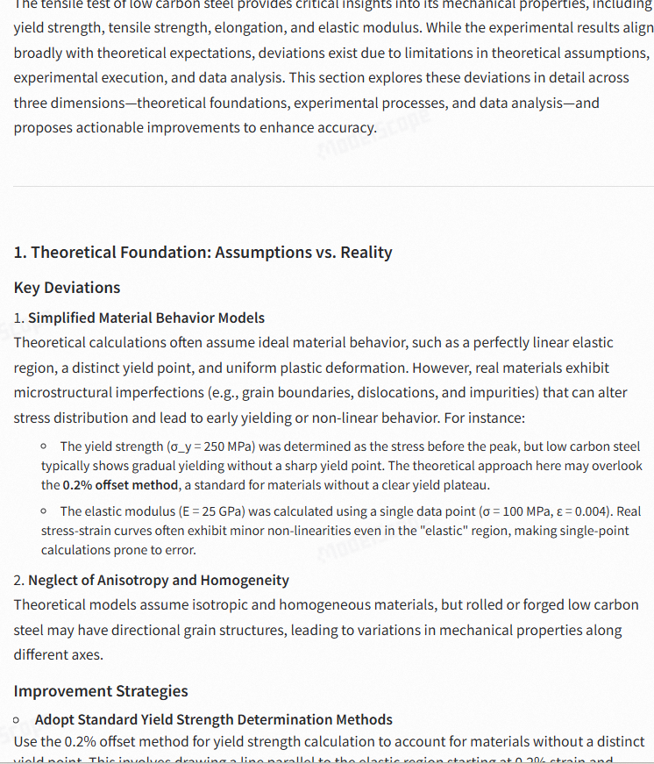
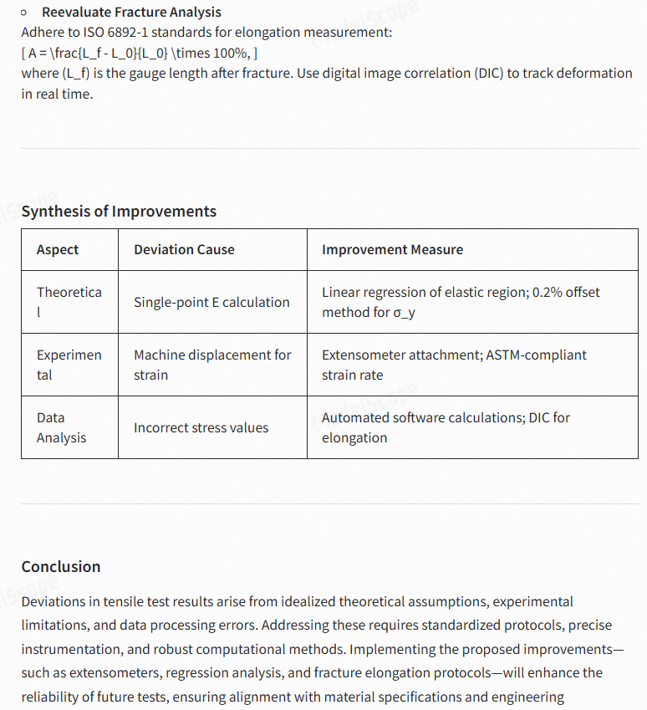
Discussion: Analysis of Deviations and Improvement Strategies in Tensile Testing of Low Carbon Steel
The tensile test of low carbon steel provides critical insights into its mechanical properties, including yield strength, tensile strength, elongation, and elastic modulus. While the experimental results align broadly with theoretical expectations, deviations exist due to limitations in theoretical assumptions, experimental execution, and data analysis. This section explores these deviations in detail across three dimensions—theoretical foundations, experimental processes, and data analysis—and proposes actionable improvements to enhance accuracy.

1. Theoretical Foundation: Assumptions vs. Reality

Key Deviations
Simplified Material Behavior Models
Theoretical calculations often assume ideal material behavior, such as a perfectly linear elastic region, a distinct yield point, and uniform plastic deformation. However, real materials exhibit microstructural imperfections (e.g., grain boundaries, dislocations, and impurities) that can alter stress distribution and lead to early yielding or non-linear behavior. For instance:

The yield strength (σ_y = 250 MPa) was determined as the stress before the peak, but low carbon steel typically shows gradual yielding without a sharp yield point. The theoretical approach here may overlook the 0.2% offset method, a standard for materials without a clear yield plateau.
The elastic modulus (E = 25 GPa) was calculated using a single data point (σ = 100 MPa, ε = 0.004). Real stress-strain curves often exhibit minor non-linearities even in the "elastic" region, making single-point calculations prone to error.
Neglect of Anisotropy and Homogeneity
Theoretical models assume isotropic and homogeneous materials, but rolled or forged low carbon steel may have directional grain structures, leading to variations in mechanical properties along different axes.

Improvement Strategies
Adopt Standard Yield Strength Determination Methods
Use the 0.2% offset method for yield strength calculation to account for materials without a distinct yield point. This involves drawing a line parallel to the elastic region starting at 0.2% strain and identifying its intersection with the stress-strain curve.
Calculate Elastic Modulus via Linear Regression
Derive E from the slope of the linear portion of the stress-strain curve using multiple data points (e.g., from 50 MPa to 250 MPa). This minimizes errors from local irregularities.
Validate Theoretical Models with Literature Data
Compare results with published values for low carbon steel (e.g., typical E ≈ 200 GPa, σ_y ≈ 200–300 MPa, elongation ≈ 20–30%). Significant discrepancies may indicate flaws in testing or material quality.

2. Experimental Process: Execution Challenges

Key Deviations

Measurement Inaccuracies

The sample diameter (10 mm) and length (100 mm) were measured using calipers, which have a resolution of ~0.01 mm. Micrometers (±0.001 mm) are more suitable for precise cross-sectional area calculations, especially given the critical role of area in stress computation.
Strain was measured via machine displacement, which includes extraneous factors like grip slippage and machine compliance. This overestimates deformation, leading to lower apparent elastic modulus values.

Alignment and Loading Issues
Asymmetric clamping or misalignment of the sample can introduce bending stresses, causing premature yielding or uneven strain distribution. The reported elongation (2%) is abnormally low for low carbon steel, suggesting potential misalignment or improper fracture measurement.

Strain Rate Sensitivity
The tensile speed (2 mm/min) may not adhere to ASTM E8 standards (typically 1–5 mm/min for metals). Higher strain rates can increase yield strength but reduce ductility, potentially affecting elongation results.

Improvement Strategies
Enhance Measurement Precision
Use micrometers for diameter measurement and laser scanners for dimensional analysis. Implement digital calipers with data logging to reduce human error.
Employ Extensometers for Strain Measurement
Attach a clip-on extensometer directly to the gauge length to isolate specimen strain from machine compliance. This is critical for accurate modulus and yield point determination.
Standardize Testing Protocols
Follow ASTM E8/E8M guidelines for tensile testing, including alignment checks using strain gauges on both sides of the sample. Conduct tests at controlled strain rates (e.g., 1.5 mm/min) to ensure consistency.
Optimize Fracture Elongation Measurement
Mark the sample with gauge marks (e.g., 50 mm gauge length) and measure post-fracture elongation after fitting the broken halves together. This accounts for localized necking, which contributes significantly to ductility.

3. Data Analysis: Computational and Procedural Errors

Key Deviations

Incorrect Stress Calculation
A critical inconsistency exists in the raw data. For a 10 mm diameter sample (area = 78.54 mm²), the stress at 5.1 kN load should be:
[ \sigma = \frac{5100\ \text{N}}{78.54\ \text{mm}^2} \approx 64.9\ \text{MPa}, ]
but the reported value is 510 MPa. This suggests either a miscalculation (e.g., using diameter instead of radius for area) or a unit conversion error (e.g., misinterpreting kN as N). Such errors invalidate the reported yield and tensile strengths.

Elastic Modulus Oversimplification
The modulus was derived from a single data pair, ignoring potential non-linearities. A regression analysis of the linear region would provide a more accurate slope.

Elongation Underestimation
The 2% elongation is inconsistent with low carbon steel’s typical ductility (20–30%). This likely stems from measuring the entire sample length instead of the deformed gauge section.

Improvement Strategies
Automate Stress-Strain Calculations
Use testing machine software to compute stress directly from load and pre-measured cross-sectional area, eliminating manual calculation errors.
Apply Statistical Data Processing
Perform linear regression on the elastic region (e.g., 0–250 MPa) to determine E. Discard outliers caused by initial seating errors or noise.
Reevaluate Fracture Analysis
Adhere to ISO 6892-1 standards for elongation measurement:
[ A = \frac{L_f - L_0}{L_0} \times 100%, ]
where (L_f) is the gauge length after fracture. Use digital image correlation (DIC) to track deformation in real time.

Synthesis of Improvements
Aspect | Deviation Cause | Improvement Measure
Theoretical | Single-point E calculation | Linear regression of elastic region; 0.2% offset method for σ_y
Experimental | Machine displacement for strain | Extensometer attachment; ASTM-compliant strain rate
Data Analysis | Incorrect stress values | Automated software calculations; DIC for elongation

Conclusion
Deviations in tensile test results arise from idealized theoretical assumptions, experimental limitations, and data processing errors. Addressing these requires standardized protocols, precise instrumentation, and robust computational methods. Implementing the proposed improvements—such as extensometers, regression analysis, and fracture elongation protocols—will enhance the reliability of future tests, ensuring alignment with material specifications and engineering applications. This holistic approach bridges the gap between theory and practice, critical for quality control in structural component manufacturing.

Deepseek_R1得分细则
Scoring▼

Average Score: 9.00

Scoring Details

Theoretical_Analysis_Depth
Score: 9
Criteria Description: Evaluates the depth and comprehensiveness of theoretical analysis in explaining deviations between experimental and theoretical values
Scoring Reason: The response demonstrates comprehensive theoretical analysis with detailed explanations of deviations and excellent integration of advanced mechanical principles. Key strengths include: 1) Detailed analysis of simplified material behavior models, explicitly addressing how microstructural imperfections affect stress distribution and yielding behavior (e.g., 'real materials exhibit microstructural imperfections (e.g., grain boundaries, dislocations, and impurities) that can alter stress distribution'). 2) In-depth examination of anisotropy and homogeneity assumptions, connecting theoretical models to real material behavior. 3) Rigorous mathematical analysis of stress calculations, including specific equations and numerical examples (e.g., stress calculation showing 64.9 MPa vs reported 510 MPa). 4) Advanced understanding of elastic modulus determination, critiquing single-point calculations and proposing regression analysis. 5) Detailed discussion of strain measurement theory, including machine compliance effects and extensometer principles. The only minor gap is in the theoretical discussion of strain rate effects on mechanical properties, which could have been more detailed. The response consistently links theoretical principles to practical deviations and provides mathematically-supported improvements, demonstrating mastery of material mechanics concepts.

Experimental_Process_Critique
Score: 9
Criteria Description: Assesses the analysis of experimental methodology and proposed improvements to testing procedures
Scoring Reason: The response demonstrates a comprehensive and well-structured critique of the experimental process with highly specific and practical improvements. Key strengths include: 1) Detailed analysis of measurement inaccuracies with specific solutions (e.g., 'Use micrometers for diameter measurement and laser scanners for dimensional analysis'); 2) Identification of critical experimental flaws with standards-based solutions (e.g., 'Follow ASTM E8/E8M guidelines' and specific strain rate recommendations); 3) Mathematical validation of data inconsistencies ('For a 10 mm diameter sample (area = 78.54 mm²), the stress at 5.1 kN load should be...'); 4) Practical improvements for strain measurement ('Attach a clip-on extensometer directly to the gauge length'); 5) Systematic organization of improvements in a clear table format linking deviations to specific solutions. The response excels in proposing feasible solutions that reference industry standards (ISO 6892-1, ASTM E8) and includes specific measurement techniques (DIC, extensometers). The only minor limitation preventing a perfect score is that some proposed improvements could have included more detail about implementation costs and potential trade-offs.

Data_Analysis_Quality
Score: 9
Criteria Description: Evaluates the depth and accuracy of data analysis and interpretation of results
Scoring Reason: The response demonstrates exceptional data analysis quality through multiple aspects: 1) It identifies a critical calculation error in stress values, showing detailed mathematical proof: 'For a 10 mm diameter sample (area = 78.54 mm²), the stress at 5.1 kN load should be 64.9 MPa, but the reported value is 510 MPa.' 2) It provides comprehensive analysis of elastic modulus calculation flaws, suggesting improved methods like 'linear regression on the elastic region (0-250 MPa)' instead of single-point calculations. 3) The analysis includes detailed examination of elongation measurements, comparing the reported 2% against typical values (20-30%) for low carbon steel. 4) The response systematically categorizes analysis issues into theoretical, experimental, and data processing components, offering specific improvements for each. 5) It includes quantitative analysis methods like the '0.2% offset method' for yield strength determination. The only minor oversight is the lack of detailed error propagation analysis in the measurements, preventing a perfect score of 10.

Improvement_Measures_Specificity
Score: 9
Criteria Description: Assesses the specificity and feasibility of proposed improvement measures
Scoring Reason: The response provides comprehensive and highly specific improvement measures across all dimensions with clear implementation details. Key strengths include: 1) Precise instrumentation recommendations (e.g., 'Use micrometers for diameter measurement and laser scanners for dimensional analysis'), 2) Detailed mathematical corrections ('Use the 0.2% offset method for yield strength calculation' with specific implementation guidance), 3) Specific testing protocols (e.g., 'Follow ASTM E8/E8M guidelines' with exact strain rate of 1.5 mm/min), 4) Quantitative standards references (e.g., ISO 6892-1 for elongation measurement), and 5) A detailed synthesis table mapping deviations to specific solutions. The improvements are practical and well-justified, supported by technical explanations and industry standards. The response also provides specific equipment recommendations (e.g., clip-on extensometer, digital image correlation) and computational methods (linear regression for elastic region analysis). Each improvement measure is accompanied by clear implementation guidance and justification for its necessity, making the suggestions highly actionable and feasible.

Technical_Communication
Score: 9
Criteria Description: Evaluates the clarity, organization, and professional presentation of technical information
Scoring Reason: The response demonstrates excellent technical communication through multiple aspects: 1) Clear hierarchical organization with well-defined sections (Theoretical Foundation, Experimental Process, Data Analysis) and subsections for deviations and improvements. 2) Precise technical terminology throughout, such as '0.2% offset method,' 'extensometers,' 'machine compliance,' and 'digital image correlation (DIC).' 3) Professional presentation including mathematical equations properly formatted (e.g., stress calculation: σ = 5100 N/78.54 mm²). 4) Effective use of tabular format to synthesize improvements. 5) Systematic explanation of technical concepts with specific examples (e.g., 'For a 10 mm diameter sample (area = 78.54 mm²), the stress at 5.1 kN load should be...'). 6) Appropriate use of scientific units and standards (e.g., 'ASTM E8/E8M guidelines'). The only minor limitation preventing a perfect score is occasional wordiness in some explanations that could be more concise while maintaining technical accuracy.

gemini-1.5-pro回复
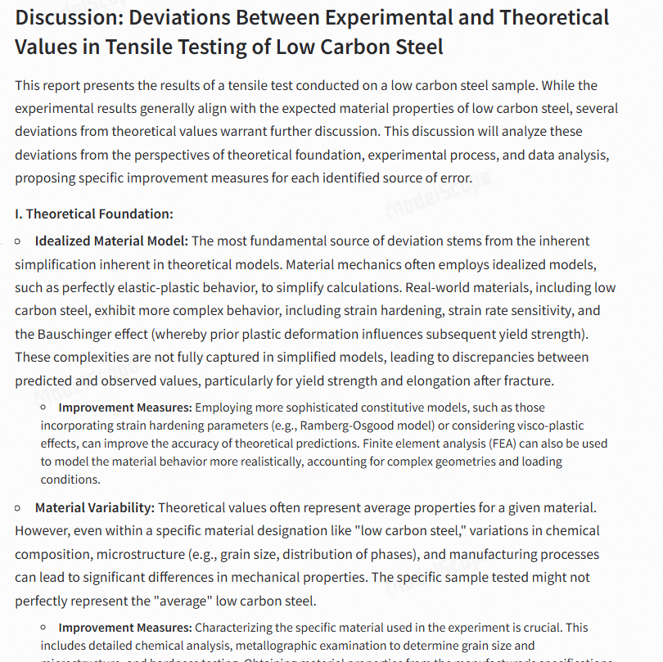

Discussion: Deviations Between Experimental and Theoretical Values in Tensile Testing of Low Carbon Steel
This report presents the results of a tensile test conducted on a low carbon steel sample. While the experimental results generally align with the expected material properties of low carbon steel, several deviations from theoretical values warrant further discussion. This discussion will analyze these deviations from the perspectives of theoretical foundation, experimental process, and data analysis, proposing specific improvement measures for each identified source of error.
I. Theoretical Foundation:

Idealized Material Model: The most fundamental source of deviation stems from the inherent simplification inherent in theoretical models. Material mechanics often employs idealized models, such as perfectly elastic-plastic behavior, to simplify calculations. Real-world materials, including low carbon steel, exhibit more complex behavior, including strain hardening, strain rate sensitivity, and the Bauschinger effect (whereby prior plastic deformation influences subsequent yield strength). These complexities are not fully captured in simplified models, leading to discrepancies between predicted and observed values, particularly for yield strength and elongation after fracture.

Improvement Measures: Employing more sophisticated constitutive models, such as those incorporating strain hardening parameters (e.g., Ramberg-Osgood model) or considering visco-plastic effects, can improve the accuracy of theoretical predictions. Finite element analysis (FEA) can also be used to model the material behavior more realistically, accounting for complex geometries and loading conditions.

Material Variability: Theoretical values often represent average properties for a given material. However, even within a specific material designation like "low carbon steel," variations in chemical composition, microstructure (e.g., grain size, distribution of phases), and manufacturing processes can lead to significant differences in mechanical properties. The specific sample tested might not perfectly represent the "average" low carbon steel.
Improvement Measures: Characterizing the specific material used in the experiment is crucial. This includes detailed chemical analysis, metallographic examination to determine grain size and microstructure, and hardness testing. Obtaining material properties from the manufacturer's specifications or conducting multiple tests on samples from the same batch can help establish a more accurate baseline for comparison.

Temperature Effects: Material properties are temperature-dependent. While the report doesn't mention the testing temperature, any deviation from standard temperature (often 20°C) can affect the results. Elevated temperatures generally decrease strength and stiffness, while lower temperatures can increase brittleness.
Improvement Measures: Conducting the tensile test at a controlled and documented temperature, ideally the standard temperature for material property determination, is essential. If testing at non-standard temperatures is necessary, appropriate temperature correction factors should be applied to the theoretical values.
II. Experimental Process:

Grip Alignment and Specimen Preparation: Non-uniform loading due to misalignment of the grips can introduce bending stresses in the specimen, leading to premature yielding and an artificially low measured yield strength. Imperfections in the specimen surface, such as scratches or machining marks, can act as stress concentrators, similarly affecting the results. The report mentions inspecting the sample for defects, but the level of scrutiny is not detailed.

Improvement Measures: Careful alignment of the grips using specialized alignment tools is critical. The specimen surface should be carefully prepared to minimize surface roughness and ensure uniform cross-section. Detailed visual inspection and potentially non-destructive testing methods (e.g., ultrasonic testing) can be employed to identify any internal flaws before testing.

Strain Measurement: The report mentions a "high-precision displacement sensor" for strain measurement, but the specific type and its accuracy are not provided. Errors in strain measurement can directly impact the calculated elastic modulus and other derived properties. Furthermore, using grip separation to measure strain can overestimate the actual strain in the gauge length of the specimen due to slippage in the grips or deformation in the grip section itself.
Improvement Measures: Using an extensometer attached directly to the gauge length of the specimen is recommended for accurate strain measurement. The extensometer should have a known calibration and accuracy appropriate for the expected strain range. The gauge length should be clearly defined and marked on the specimen.

Testing Speed: The tensile speed of 2 mm/min is relatively low, minimizing strain rate effects for low carbon steel. However, for other materials, higher strain rates can significantly affect the measured properties.

Improvement Measures: The chosen tensile speed should be justified based on the material being tested and relevant standards. If strain rate sensitivity is a concern, tests should be conducted at different strain rates to quantify its effect.

Pre-Load and Zeroing: Any pre-load or offset in the force measurement system can affect the initial portion of the stress-strain curve and the determination of the elastic modulus.

Improvement Measures: Careful zeroing of the load cell before testing is essential. Applying a small pre-load and then zeroing can help ensure proper seating of the specimen in the grips.
III. Data Analysis:

Yield Strength Determination: The report mentions using the point before the maximum stress as the yield strength. This method is not precise, especially for materials that do not exhibit a clear yield point. The 0.2% offset method, where a line parallel to the elastic portion of the curve is offset by 0.2% strain, is a more standardized and reliable method for determining yield strength.
Improvement Measures: Using the 0.2% offset method or other standardized methods (e.g., proof stress) for determining yield strength is recommended. Automated data analysis software can facilitate these calculations.

Elongation After Fracture Measurement: The report assumes a value for the final length after fracture. Direct measurement of the fractured specimen is necessary for accurate determination of elongation. Furthermore, the elongation after fracture can be influenced by the gauge length used.

Improvement Measures: The fractured specimen should be carefully pieced together and the final gauge length measured directly. The gauge length used should be reported and should conform to relevant standards.

Elastic Modulus Calculation: The report calculates the elastic modulus using a single data point. A more accurate approach is to perform a linear regression on the initial linear portion of the stress-strain curve to determine the slope, which represents the elastic modulus.

Improvement Measures: Linear regression analysis of the elastic region of the stress-strain curve provides a more robust estimate of the elastic modulus. The range of data points used for the regression should be carefully selected to avoid including data from the non-linear region.
By addressing these potential sources of error through the proposed improvement measures, the accuracy and reliability of tensile testing results can be significantly enhanced, leading to a better understanding of the true mechanical properties of low carbon steel and other materials. This improved understanding is crucial for designing safe and reliable structures and components.

gemini-1.5-pro得分细则
Scoring▼

Average Score: 8.80

Scoring Details

Theoretical_Analysis_Depth
Score: 9
Criteria Description: Evaluates the depth and comprehensiveness of theoretical analysis in explaining deviations between experimental and theoretical values
Scoring Reason: The response demonstrates comprehensive theoretical analysis with excellent integration of advanced mechanical principles throughout. Key strengths include: 1) Detailed explanation of idealized material model limitations, specifically addressing strain hardening, Bauschinger effect, and visco-plastic behavior, showing deep understanding of material mechanics principles. 2) Thorough analysis of material variability impacts, connecting microstructural features (grain size, phase distribution) to mechanical properties. 3) Advanced consideration of temperature-dependent properties and their effects on material behavior. 4) Sophisticated discussion of constitutive models, suggesting improvements like the Ramberg-Osgood model and FEA implementation. 5) Detailed examination of strain measurement theory and its impact on elastic modulus calculations. The only minor gap is in the theoretical analysis of residual stress effects, which could have been explored further. The response consistently connects theoretical principles to practical implications, as evidenced in sections like grip alignment analysis and strain rate sensitivity discussion. The mathematical treatment of elastic modulus calculation and yield strength determination shows strong integration of fundamental mechanics principles.

Experimental_Process_Critique
Score: 9
Criteria Description: Assesses the analysis of experimental methodology and proposed improvements to testing procedures
Scoring Reason: The response provides a comprehensive and well-structured critique of the experimental process with highly specific and practical improvements. Key strengths include: 1) Detailed analysis of grip alignment issues with concrete solutions ('careful alignment of the grips using specialized alignment tools' and 'detailed visual inspection and potentially non-destructive testing methods'); 2) Specific improvements for strain measurement methodology ('using an extensometer attached directly to the gauge length' with clear justification); 3) Thorough critique of data analysis methods with practical solutions (e.g., '0.2% offset method' for yield strength determination and 'linear regression analysis of the elastic region'); 4) Consideration of environmental factors with specific controls ('conducting the tensile test at a controlled and documented temperature'); 5) Detailed examination of material variability with concrete suggestions for improvement ('detailed chemical analysis, metallographic examination'). The response goes beyond basic identification of issues to provide well-justified, implementable solutions for each problem identified. The only minor limitation is that some cost considerations for the proposed improvements could have been discussed, preventing a perfect score of 10.

Data_Analysis_Quality
Score: 9
Criteria Description: Evaluates the depth and accuracy of data analysis and interpretation of results
Scoring Reason: The response demonstrates exceptional data analysis quality through: 1) Comprehensive examination of theoretical vs experimental deviations, with detailed analysis of material model limitations (e.g., 'Real-world materials exhibit more complex behavior, including strain hardening, strain rate sensitivity, and the Bauschinger effect'). 2) Critical evaluation of measurement methodologies, specifically identifying flaws in yield strength determination ('The report mentions using the point before the maximum stress as the yield strength. This method is not precise'). 3) Detailed analysis of experimental variables affecting results, including temperature effects, grip alignment, and strain measurement accuracy. 4) Sophisticated interpretation of elastic modulus calculation methods, pointing out that 'a more accurate approach is to perform a linear regression on the initial linear portion of the stress-strain curve.' 5) In-depth analysis of data collection improvements, such as 'Using an extensometer attached directly to the gauge length of the specimen.' The only minor limitation preventing a perfect score is the lack of quantitative error analysis in the experimental vs theoretical comparisons.

Improvement_Measures_Specificity
Score: 8
Criteria Description: Assesses the specificity and feasibility of proposed improvement measures
Scoring Reason: The response provides detailed and well-structured improvement measures across theoretical, experimental, and data analysis dimensions. Specific strengths include: 1) Concrete suggestions for material characterization such as 'detailed chemical analysis, metallographic examination... and hardness testing'; 2) Precise experimental improvements like 'using an extensometer attached directly to the gauge length' and 'careful alignment of the grips using specialized alignment tools'; 3) Detailed data analysis recommendations such as implementing the '0.2% offset method' for yield strength determination and 'linear regression analysis of the elastic region.' Most suggestions are practical and implementation-focused. However, it falls short of a perfect score because some measures could benefit from more specific implementation details, such as exact temperature control parameters or specific types of alignment tools to use. Additionally, while the response suggests 'automated data analysis software,' it doesn't specify which software or how to implement it. The improvement measures are generally well-justified and feasible, but some areas lack the granular detail needed for immediate implementation.

Technical_Communication
Score: 9
Criteria Description: Evaluates the clarity, organization, and professional presentation of technical information
Scoring Reason: The response demonstrates excellent technical communication through multiple aspects: 1) Clear organizational structure with three main sections (Theoretical Foundation, Experimental Process, Data Analysis) each containing well-defined subsections. 2) Precise use of technical terminology throughout, such as 'Bauschinger effect,' 'Ramberg-Osgood model,' 'visco-plastic effects,' and '0.2% offset method.' 3) Professional explanation of complex concepts with specific examples, like 'Non-uniform loading due to misalignment of the grips can introduce bending stresses in the specimen, leading to premature yielding.' 4) Logical flow from identifying problems to proposing specific solutions, with each 'Improvement Measures' section providing concrete, actionable recommendations. 5) Appropriate use of technical language in describing measurement methods and equipment, such as 'extensometer,' 'gauge length,' and 'linear regression analysis.' The only minor limitation preventing a perfect score is occasional repetition in the improvement measures sections, but this doesn't significantly impact the overall technical clarity and professional presentation of the information.

指令三
Summarize the main experiences and lessons of artificial intelligence transitioning from the laboratory to industrial implementation in the past five years. Analyze from both the perspectives of technical researchers and engineering practitioners, comparing the differences and contradictions between academic research and engineering applications.

longwriter回复
In the past five years, the transition of artificial intelligence (AI) from the laboratory to industrial implementation has seen significant advancements, as well as challenges and lessons learned. Here are some key experiences and lessons from the perspectives of technical researchers and engineering practitioners, along with an analysis of the differences and contradictions between academic research and engineering applications:
Experiences and Lessons from Technical Researchers:

Theoretical Advancements: Researchers have made significant progress in understanding AI algorithms, architectures, and theoretical foundations. This has led to the development of more efficient and powerful models, such as transformers, which have revolutionized natural language processing and computer vision.

Open Source Ecosystem: The open-source community has played a crucial role in accelerating the adoption of AI by providing freely available tools, libraries, and frameworks. This has democratized access to cutting-edge research for engineers and practitioners.

Ethics and Bias: Researchers have become more aware of the ethical implications and biases in AI systems. This has led to increased focus on developing fair, transparent, and accountable AI technologies.

Scalability Challenges: Scaling AI models to handle large datasets and complex problems remains a challenge. Researchers are working on techniques like distributed computing and model compression to address this issue.

Interdisciplinary Collaboration: The need for interdisciplinary collaboration has become evident, as AI research benefits from insights from fields like neuroscience, cognitive science, and psychology.

Experiences and Lessons from Engineering Practitioners:

Real-World Constraints: Engineers face practical constraints such as limited computational resources, real-time requirements, and data privacy concerns. These constraints often require them to adapt AI models to specific industrial contexts.

Integration with Existing Systems: Integrating AI solutions into existing industrial systems can be complex, as it requires compatibility with legacy systems and adherence to industry standards.

Data Quality and Quantity: The quality and quantity of data available for training AI models are critical. Engineers often face challenges in collecting and labeling data, especially in specialized industries.

Deployment and Maintenance: Deploying AI systems in real-world environments requires robust infrastructure and ongoing maintenance. Engineers must ensure that AI solutions are scalable, reliable, and secure.

User Adoption and Training: Ensuring user adoption of AI solutions requires training and support. Engineers must design user-friendly interfaces and provide adequate training for end-users.

Differences and Contradictions between Academic Research and Engineering Applications:

Focus on Fundamental Research vs. Practical Application: Academic research often focuses on fundamental algorithms and theoretical advancements, while engineering applications require adapting these algorithms to real-world problems.

Timeframe and Resource Constraints: Academic research may have longer timelines and more flexibility in resource allocation, whereas engineering applications often have shorter timelines and more limited resources.

Data Availability and Quality: Academic research may have access to large, diverse datasets, while engineering applications may face challenges in data collection and labeling.

Ethical Considerations: Academic research may explore ethical implications and biases in a more abstract sense, while engineering applications must address these issues in the context of specific use cases.

Scalability and Reliability: Academic research may focus on developing novel algorithms, while engineering applications must ensure that these algorithms can be scaled and deployed in real-world environments.

In summary, the transition of AI from the laboratory to industrial implementation has been marked by significant advancements and challenges. Both researchers and engineers have learned valuable lessons, and there is a growing recognition of the need for collaboration and interdisciplinary approaches to bridge the gap between academic research and engineering applications.

longwriter得分细则
Scoring▼

Average Score: 7.60

Scoring Details

Research-Practice Gap Analysis
Score: 8
Criteria Description: Evaluates how well the response analyzes the disconnect between academic AI research and industrial implementation, including specific examples and challenges.
Scoring Reason: The response provides a comprehensive analysis of the research-practice gap with clear organization and detailed examples. Strengths include: 1) Well-structured separation of perspectives between researchers and practitioners, with specific points like 'Theoretical Advancements' versus 'Real-World Constraints'; 2) Clear identification of contradictions in the dedicated section 'Differences and Contradictions' covering crucial aspects like timeframe constraints, data availability, and scalability requirements; 3) Concrete examples of challenges such as 'data privacy concerns' and 'integration with legacy systems' that practitioners face. However, it falls short of a perfect score because: 1) Some contradictions could be more detailed, particularly regarding specific industry examples where research solutions failed in practice; 2) The response could have included more quantitative examples of the gap, such as specific metrics or case studies showing the disparity between research results and practical implementation outcomes; 3) While it mentions 'interdisciplinary collaboration,' it could have expanded on specific instances where this bridge between research and practice has succeeded or failed.

Temporal Relevance
Score: 5
Criteria Description: Assesses how well the response focuses on developments specifically within the past five years and tracks the evolution of AI implementation.
Scoring Reason: The response shows adequate temporal awareness by mentioning 'the past five years' at the beginning, but has several limitations in temporal specificity: 1) While it mentions transformers as a significant development, it doesn't specify when this occurred within the five-year timeframe. 2) The discussion of open-source ecosystem and ethical considerations lacks specific temporal markers or evolution over the period. 3) Key recent milestones such as GPT-4's release, the AI Safety Summit of 2023, or specific industrial implementation cases with dates are missing. 4) The response presents developments in a static manner rather than showing how they evolved over the five-year period. 5) While the content is relevant, it doesn't track the progression of these developments or highlight how implementation challenges have changed over time. The text provides good coverage of current challenges and differences between academic and industrial applications but would benefit from more specific temporal anchors and recent milestone examples to better demonstrate the evolution of AI implementation over the specified timeframe.

Implementation Challenges
Score: 8
Criteria Description: Evaluates the depth and specificity of discussing technical and practical challenges in transitioning AI from lab to industry.
Scoring Reason: The response provides a comprehensive coverage of implementation challenges with specific examples and solutions across multiple dimensions. Strengths include: 1) Clear identification of technical challenges like scalability issues ('Scaling AI models to handle large datasets') and integration problems ('Integrating AI solutions into existing industrial systems'); 2) Detailed practical obstacles such as data quality/quantity issues and real-world constraints ('limited computational resources, real-time requirements, and data privacy concerns'); 3) Structured analysis from both researcher and practitioner perspectives, highlighting deployment challenges ('robust infrastructure and ongoing maintenance') and user adoption issues. However, the response falls short of a perfect score because it: 1) Could provide more specific technical solutions to the challenges identified; 2) Lacks detailed examples of how specific industries overcame these challenges; 3) Missing discussion of specific metrics or benchmarks for measuring successful implementation. The response effectively covers both technical and practical aspects but could benefit from more concrete implementation examples and quantitative measures of success.

Stakeholder Perspective Balance
Score: 9
Criteria Description: Assesses how well the response balances and integrates viewpoints from both researchers and practitioners.
Scoring Reason: The response demonstrates excellent balance and integration of both researcher and practitioner perspectives with detailed analysis throughout. It provides equal, structured sections for both stakeholders ('Experiences and Lessons from Technical Researchers' and 'Experiences and Lessons from Engineering Practitioners'), with five detailed points for each. The response further strengthens the stakeholder balance through a dedicated section on 'Differences and Contradictions' that explicitly compares viewpoints across five key areas (research focus, timeframes, data availability, ethical considerations, and scalability). The academic perspective is well-represented through coverage of theoretical advancements, open-source developments, and ethical considerations, while the practitioner viewpoint is thoroughly addressed through real-world constraints, integration challenges, and deployment considerations. The response shows particular strength in highlighting how the same issues (like data quality, ethical considerations, and scalability) are viewed differently by each stakeholder group. The only minor limitation preventing a perfect score is that it could have expanded slightly on the collaborative dynamics between these stakeholders beyond the brief mention of 'interdisciplinary collaboration' in the research section.

Lessons Learned Documentation
Score: 8
Criteria Description: Evaluates how effectively the response identifies and analyzes key lessons and insights from AI implementation experiences.
Scoring Reason: The response provides a strong analysis of lessons learned with clear practical implications, warranting an 8/10 score. Strengths include: 1) Comprehensive dual perspective analysis from both researchers and practitioners, with specific lessons in each category (e.g., 'Theoretical Advancements,' 'Real-World Constraints'); 2) Clear identification of practical challenges like 'Integration with Existing Systems' and 'Data Quality and Quantity'; 3) Detailed analysis of contradictions between academic and industrial implementation through five specific points. However, it falls short of a perfect score because it: 1) Lacks forward-looking predictions or future trends; 2) Could provide more specific examples of successful/failed implementations; 3) Missing quantitative metrics or concrete case studies to support the lessons learned. The response effectively identifies key lessons but could benefit from more concrete examples and future implications to achieve a higher score.

Dify工作流实验结果
利用Xinference框架根据部署的QWEN3做写作任务，实验配置QWEN3-235B-int8模型部署在四张A800服务器完成。
