From xG to xD: Expected-Damage Modelling and Spatial Diagnostics of Combat Effectiveness in Counter-Strike: Global Offensive Matchmaking Telemetry
Hrishikesh Damodar Nayak (24BDS1007) and Hardik Omesh Lalla (24BDS1010)
School of Computer Science and Engineering, Vellore Institute of Technology, Chennai Campus, India
Dr. Vijayalakshmi A (Faculty Guide)
School of Computer Science and Engineering, Vellore Institute of Technology, Chennai Campus, India

Abstract—Expected-value metrics such as expected goals (xG) have changed how traditional sports judge individual actions, because they score the context of an action rather than its outcome. Esports analytics for Counter-Strike: Global Offensive (CS:GO) still leans heavily on box-score statistics such as kills, deaths and total damage. This paper adapts the expected-value idea to first-person-shooter combat and introduces Expected Damage (xD): the damage a damage event would typically deliver given the weapon, hit location, engagement distance, sides, bomb state, time in round and the map positions of both players. Using roughly six million damage events from the publicly available ESEA matchmaking telemetry on Kaggle, we describe a reproducible R pipeline that cleans the data, engineers combat features, splits matches into training, validation and test sets to prevent leakage, trains a gradient-boosted tree (XGBoost) regressor with early stopping, and scores every event to obtain a residual (actual minus expected damage). Exploratory analysis shows that rifles account for just over half of all damage events, chest hits dominate hit locations, and total damage is multimodal, with a main mode near 25–30 and a secondary spike near 100. On held-out matches the model reaches an MAE of [MAE], an RMSE of [RMSE] and an R² of [R²]. Per-map heatmaps of xD, actual damage, residual and event density then turn the residual into tactical diagnostics. We discuss validity threats, notably that damage is largely determined by weapon and hit location, and outline how xD can feed an engagement-level win-probability and expected-kills (xK) model.
Keywords—esports analytics, Counter-Strike: Global Offensive, expected damage, gradient boosting, XGBoost, spatial analysis, combat telemetry

I. INTRODUCTION
Counter-Strike: Global Offensive (CS:GO) is one of the most widely played competitive first-person shooters, yet quantitative evaluation of its players remains difficult because esports lacks the accessible data and reproducible analytical frameworks that traditional sports analytics takes for granted [1]. The metric most used by the community, Rating 2.0, is derived from individual box-score numbers and is not designed to capture how a player's actions change the context of a round [2]. A kill is the end of a sequence of events, but the damage dealt along the way, the weapon used, the angle taken and the distance of the fight all shape whether that kill happens.
Traditional sports solved a similar problem by moving from outcomes to expectations. In soccer, an expected-goals (xG) model estimates the probability that a shot becomes a goal from features such as distance and angle [3], and modern variants add positional and event context and use gradient boosting [4]. The key idea is that every action is compared with what a typical player would achieve in the same situation; the difference between the realised and the expected value is a context-adjusted measure of execution.
This paper transfers that idea to CS:GO combat. Because a single damage event delivers a continuous quantity between 0 and roughly 125 points of health and armor damage, the natural analogue is a regression target rather than a goal probability. We therefore define Expected Damage (xD) as the conditional expectation of the damage delivered by an event given its observable context, and we study the residual, actual damage minus xD, at the level of individual events and of map locations. We build the study on the publicly available CS:GO competitive matchmaking damage data [5] and on gradient-boosted decision trees [6], which fit tabular data of this kind efficiently and can be trained on a standard workstation.
The work is organised around three research questions:
- RQ1. How are damage events distributed across weapon types, individual weapons, hit locations and phases of a round?
- RQ2. How accurately can contextual features (weapon, hitbox, distance, sides, bomb state, timing and positions) predict the damage of a single event on matches the model has never seen?
- RQ3. Where on each map does realised damage systematically exceed or fall short of expected damage?
The contributions are: (i) a definition of xD for CS:GO damage telemetry; (ii) a leakage-aware, fully scripted R pipeline for loading, cleaning, feature engineering, match-level splitting, training, evaluation and full-dataset scoring; (iii) a family of per-map spatial diagnostics (xD, actual damage, residual and event density) that can be overlaid on the game radar images; and (iv) an exploratory analysis of roughly six million damage events and a frank discussion of what such a model can and cannot show.
The remainder of the paper is organised as follows. Section II reviews related work, Section III describes the dataset, Section IV details the methodology, Section V presents results, Section VI discusses implications and limitations, and Section VII concludes with future work.

II. RELATED WORK

A. Valuing Players and Actions in CS:GO
Xenopoulos et al. introduced a data model for CS:GO, a graph-based distance measure and a framework that values each player action by the change it causes in the team's chance of winning the round, evaluated on more than 70 million in-game events [1]. Their work shows that identical actions can have very different value depending on context, but it operates at the level of round win probability and requires reconstruction of the full game state. Earlier work on round and match outcome prediction combined rating systems and classical learners; Makarov et al. used TrueSkill, decision trees and logistic regression for CS:GO and Dota 2 [7]. Bednárek et al. addressed the practical side of the problem by documenting how raw demo files can be pre-processed into analysis-ready records [8].
At the player level, Xu and Moka propose plus/minus-based ratings estimated with regularised, Bayesian and logistic models on professional match data and show that such ratings capture contributions that Rating 2.0 misses [2]. These approaches answer who contributes most to winning, not which moment-to-moment conditions make a single engagement effective. On the qualitative side, Wright et al. analysed Counter-Strike as a social and strategic environment and argued that play involves specialised knowledge of positioning and map use as well as mechanical skill [9]. Multimodal resources such as AMuCS, which combines in-game logs with physiological and behavioural signals from 256 participants, show what richer sensing can add but need controlled collection settings that are impractical for routine analytics [10].

B. Win Prediction and Encounter Analysis in Esports
Win prediction is the dominant supervised task in esports analytics. Hodge et al. built live win-prediction models for professional Dota 2 matches with standard machine-learning models and feature engineering, reporting accuracy of up to 85% after five minutes of play [11]. Schubert et al. proposed detecting and modelling encounters, groups of units fighting each other, directly from replay data, so that individual fights can be analysed as events in their own right [12]. Our work shares this focus on the fight as the unit of analysis, but concentrates on the damage delivered in each event and on its spatial distribution.

C. Expected-Value Models in Traditional Sports
Expected-goals models are now a standard analytical tool in soccer. Rathke showed that distance and angle jointly predict goal probability better than either alone [3], and Anzer and Bauer reached state-of-the-art performance with an extreme gradient-boosting model on more than 100,000 Bundesliga shots using synchronised positional and event data [4]. Lucey et al. demonstrated the value of strategic features derived from spatiotemporal data for shot prediction [13]. Beyond shots, Fernández et al. decompose the expected value of an entire possession into separately learned components and produce interpretable probability surfaces [14], and Cervone et al. estimate expected possession outcomes in basketball [15]. Plus/minus ratings, reviewed by Hvattum, provide a complementary results-based route to individual evaluation [16].

D. Research Gap
The CS:GO literature values actions through round win probability, rates players through match results, or studies behaviour qualitatively. What is missing is a lightweight, event-level expectation model for combat itself, trained on accessible telemetry, whose residuals can be read both per event and across the map. The present work fills that gap with expected damage and leaves expected-kills and engagement win probability as natural extensions.

III. DATASET

A. Source and Structure
The data come from the Kaggle collection CS:GO Competitive Matchmaking Data [5], whose description lists damage and grenade entries for more than 410,000 rounds of competitive play. The collection stores event-level records extracted from demo files rather than only final scoreboards. The files used here are the damage events (esea_master_dmg_demos.part1.csv), the match metadata (esea_meta_demos.part1.csv), which supplies the map name of each demo, and the map calibration table (map_data.csv), which relates game coordinates to radar-image pixels. Only the first part file of the damage events is analysed, so the results describe that subset and not the full collection. The raw damage file is about 1.1 GB and contains 5,992,097 records; the cleaned file used for exploration is about 165.5 MB.
Table 1 lists the fields that the pipeline requires or derives. Each row is one damage interaction between an attacker and a victim.
Table 1. Fields of the damage-event file used in this study.
Field(s) | Type | Description
file, round, tick, seconds | ID / numeric | Demo (match) identifier, round number, game-engine tick and seconds elapsed in the round.
att_team, vic_team, att_side, vic_side | Categorical | Team names and sides (Terrorist or Counter-Terrorist) of attacker and victim.
hp_dmg, arm_dmg | Numeric | Health damage and armor damage delivered by the event.
wp, wp_type | Categorical | Specific weapon (e.g., AK47, AWP) and its category (e.g., Rifle, Pistol, Sniper, Grenade).
hitbox | Categorical | Body region hit (e.g., Head, Chest, Stomach, limbs) or Generic for non-bullet damage.
is_bomb_planted, bomb_site | Logical / categorical | Whether the bomb was planted at the time of the event and at which site.
att_pos_x, att_pos_y, vic_pos_x, vic_pos_y | Numeric | Game-world coordinates of attacker and victim.
att_id, vic_id, att_rank | ID / ordinal | Player identifiers and attacker competitive rank; carried in the cache but not used as model features.

B. Characteristics and Constraints
Three properties shape the analysis. First, there is no native label for a good or bad engagement; the only continuous, always-present outcome of a damage event is the damage itself, which motivates the xD formulation. Second, damage events with no attacker position, such as environmental damage, carry no usable coordinates and are removed before modelling. Third, the data are matchmaking games from a third-party service rather than professional tournament play, and they were recorded under legacy CS:GO game versions, so conclusions should be read as describing this population.

IV. METHODOLOGY

A. Overview
The workflow is implemented in four R scripts (Table 2) and summarised in Fig. 1. Package installation, path configuration and hyper-parameters are separated from the analysis code so that every run is reproducible from a single configuration file.
Table 2. R scripts and their roles.
Script | Role
00_install_packages.R | Installs and loads data.table, xgboost, ggplot2, viridis, scales, patchwork, png, grid and jsonlite.
config.R | Dataset, metadata and map-calibration paths; output paths; split fractions; random seed; XGBoost parameters; schema (required columns, feature columns, categorical columns, target); round-phase thresholds; heatmap settings.
pipeline.R | Loading, schema validation, map join, cleaning, feature engineering, match-level split, encoding, training, test evaluation, full-dataset scoring and saving of the model, level table, metrics and inference cache.
heatmaps.R | Reads the inference cache and map calibration and renders xD, actual-damage, residual and density heatmaps per map, plus a 2×2 panel.

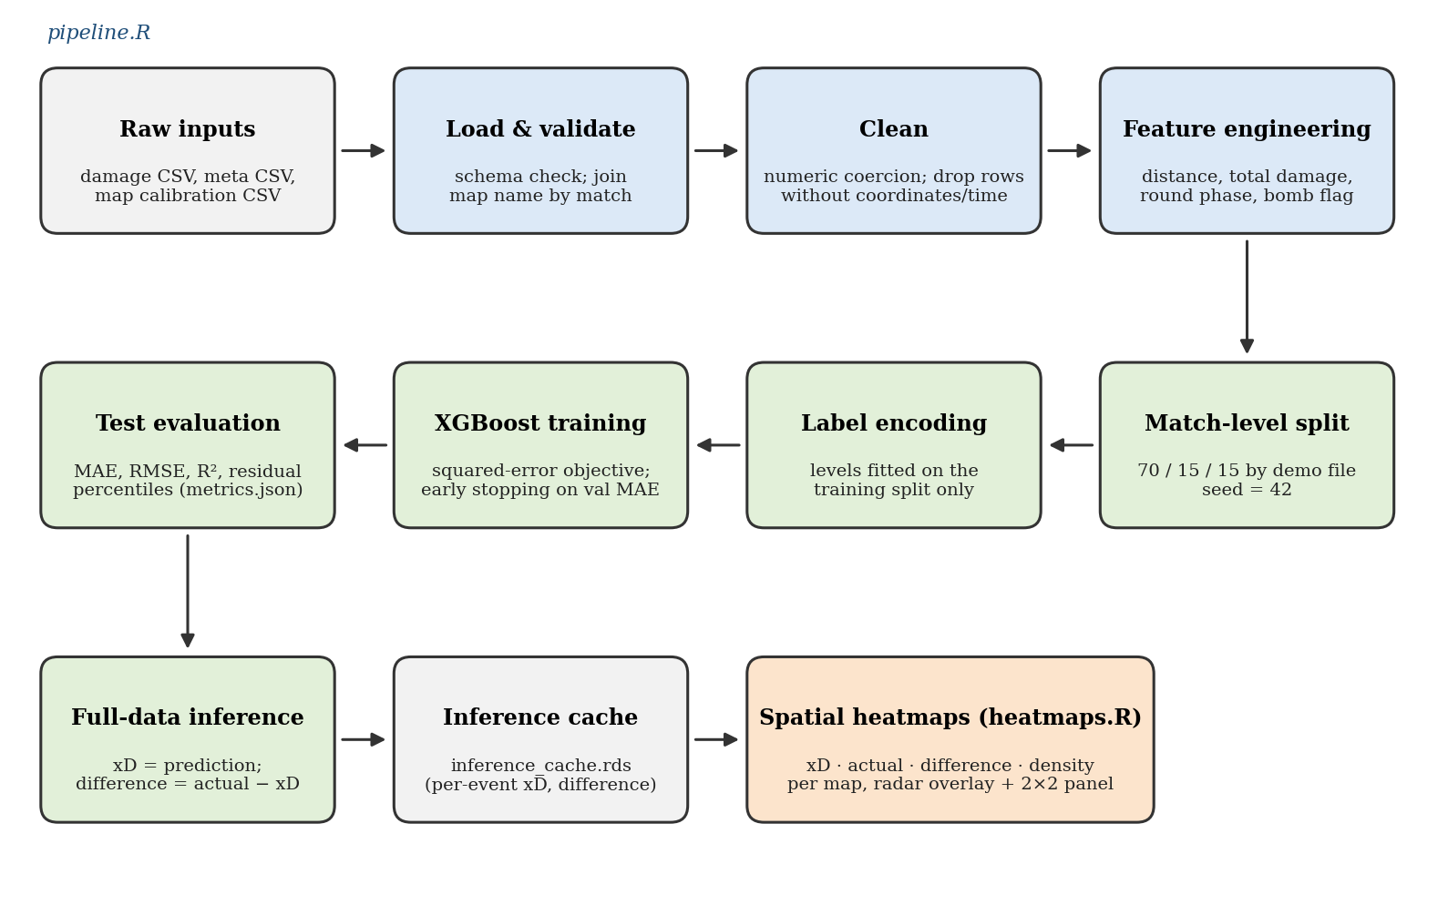
Fig. 1. End-to-end pipeline implemented by pipeline.R (blue and green stages) and heatmaps.R (orange stage).

B. Loading, Validation and Map Attachment
The pipeline reads the damage CSV with data.table and stops with an explicit error if any of the 22 required columns is missing, so that a schema mismatch fails loudly instead of silently corrupting results. Map names are attached by joining the damage events to the de-duplicated metadata table on the demo identifier. If the metadata file is absent the map column is left empty and the spatial-by-map heatmaps cannot be produced.

C. Cleaning
Health and armor damage are coerced to numeric and missing values are set to zero. Position columns are coerced to numeric and rows with any missing coordinate are dropped, as are rows with missing time, weapon, weapon type, hitbox or side. Dropping rather than imputing coordinates avoids placing events at a spurious map origin. Empty bomb-site values are recoded to a none category. In the exploratory stage, the categorical fields were additionally filled with an Unknown label, the misspelling Unkown in the weapon-type field was corrected, environmental damage (attacker team World) was removed, and identifiers, tick and rank columns were dropped before plotting.

D. Feature Engineering
The regression target is total damage per event (Eq. 1). The principal spatial feature is the planar Euclidean distance between attacker and victim (Eq. 2). Seconds elapsed are converted to an ordered round phase, early (up to 20 s), mid (up to 60 s) or late, and the bomb flag is stored as an integer.
y_{i} = hp_dmg_{i} + arm_dmg_{i} (1)
d_{i} = √( (x_{a,i} − x_{v,i})² + (y_{a,i} − y_{v,i})² ) (2)
The final model uses 14 input features, seven categorical and seven numeric or binary (Table 3).
Table 3. Model input features.
Feature | Type | Rationale
wp, wp_type | Categorical | Weapon identity and class determine base damage and effective range.
hitbox | Categorical | Hit location scales damage (e.g., head versus limbs).
engagement_distance | Numeric | Weapon effectiveness changes with range.
att_side, vic_side | Categorical | Side-specific weapon access and map roles.
is_bomb_planted, bomb_site | Binary / categorical | Bomb state changes how fights are taken.
round_phase, seconds | Categorical / numeric | Position of the event in the round timeline.
att_pos_x, att_pos_y, vic_pos_x, vic_pos_y | Numeric | Where the fight took place; enables spatial effects.

E. Match-Level Split
Events from the same match are strongly correlated, so a random split by row would let near-duplicate context leak from training into evaluation. The pipeline therefore shuffles the unique demo files with a fixed seed (42) and assigns 70% of matches to training, 15% to validation and 15% to testing. All events of a match are always in the same partition.

F. Categorical Encoding
Categorical columns are label-encoded using the sorted unique levels observed in the training split only. The level table is saved to disk so that scoring uses the same mapping. A category that never occurs in training is mapped to missing, which XGBoost treats as an absent value. Label encoding imposes an arbitrary integer order, which tree models can partly compensate for by splitting repeatedly, but it is less natural than native categorical handling.

G. Model
The model is a gradient-boosted ensemble of regression trees [6], [17]. Prediction for event i is the sum of K trees (Eq. 3), and training minimises squared error plus a complexity penalty on the trees (Eq. 4). Histogram-based split finding is used for speed.
xD_{i} = Σ_{k=1}^{K} f_{k}(z_{i}) (3)
L = Σ_{i} (y_{i} − xD_{i})² + Σ_{k} Ω(f_{k}) (4)
Table 4 lists the hyper-parameters. Training monitors mean absolute error on the validation partition and stops if it has not improved for 30 rounds, which protects against over-fitting without a separate tuning stage. The squared-error objective and MAE monitor are deliberately different: the former is smooth to optimise, the latter is easy to interpret in damage points.
Table 4. XGBoost configuration.
Parameter | Value
Objective / evaluation metric | reg:squarederror / MAE
Maximum tree depth | 6
Learning rate (eta) | 0.05
Row subsample / column subsample per tree | 0.8 / 0.8
Tree method | hist
Maximum boosting rounds / early-stopping patience | 400 / 30 rounds
Random seed | 42

H. Evaluation Metrics
Performance is measured on the held-out test matches with the mean absolute error, root mean squared error and coefficient of determination, where e = y − xD is the residual of an event and N is the number of test events (Eqs. 5–7). The 5th, 25th, 50th, 75th and 95th percentiles of the residuals are also recorded to describe bias and spread.
MAE = (1/N) Σ |e_{i}| (5)
RMSE = √( (1/N) Σ e_{i}² ) (6)
R² = 1 − Σ e_{i}² / Σ (y_{i} − ȳ)² (7)

I. Residuals and Spatial Aggregation
After training, the model scores all events, including those in the training split, so that every location has an xD value. Each event receives a residual Δ = y − xD (Eq. 8). Heatmaps are built per map from the attacker's position: the mean of xD, of actual damage or of Δ is computed in a 150 × 150 grid of bins by averaging over the events that fall in each bin (Eq. 9), and a separate two-dimensional kernel density estimate [19] with a 256 × 256 grid shows where events cluster. For the residual map the colour range is clipped symmetrically at the 97th percentile of |Δ| (Eq. 10) so that rare extremes do not wash out the pattern, and zero is drawn in the background colour so that unremarkable areas disappear. Radar images are drawn beneath the heat layer when both a calibration entry and an image exist; otherwise a schematic dark background is used. The graphics are produced with ggplot2 [20].
Δ_{i} = y_{i} − xD_{i} (8)
Δ̄_{b} = (1/n_{b}) Σ_{i∈b} Δ_{i} (9)
c = Q_{0.97}(|Δ|), displayed value = clip(Δ̄_{b}, −c, c) (10)
Because xD is computed from the same features that determine the residual's context, a positive Δ means only that the realised damage exceeded what the available features predict; it does not by itself identify the cause. Section VI discusses the likely unobserved factors.

V. RESULTS

A. Exploratory Analysis (RQ1)
The values below are read from the exploratory plots and are therefore approximate. Fig. 2(a) shows that rifles produce just over half of the roughly six million damage events (about 3.1 million), followed by pistols (about 1.2 million), grenades (about 0.7 million), submachine guns (about 0.55 million) and sniper rifles (about 0.3 million); heavy weapons, equipment and unknown weapons are rare. Among individual weapons (Fig. 6), the AK-47 leads with about 1.8 million events, roughly twice the M4A4, and the incendiary and the HE grenade are the most frequent utility sources.
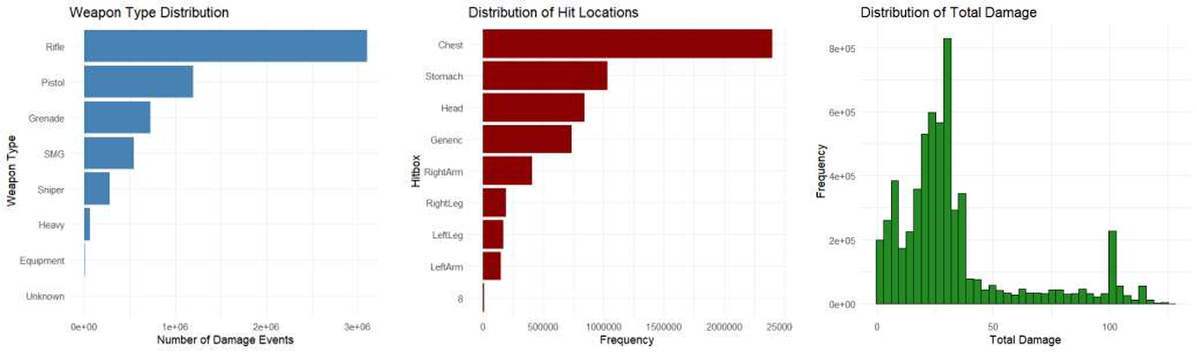
Fig. 2. Exploratory distributions: (a) weapon type, (b) hit location, (c) total damage per event.
Hit locations (Fig. 2(b)) are led by the chest (about 2.4 million), then the stomach (about 1.0 million), the head (about 0.85 million, roughly one event in seven) and the Generic category (about 0.75 million). The Generic count is close to the grenade count, which suggests that it mainly records non-bullet damage such as explosions and fire, although this was not verified against the raw coding. A negligible number of records carry an invalid hitbox code (8), which should be filtered in future cleaning.
Total damage (Fig. 2(c)) is clearly multimodal. Most events fall between roughly 15 and 40 points, with the highest bin (about 830,000 events) near 25–30, which is consistent with rifle body shots. A smaller mode appears at low values and a distinct secondary spike appears near 100, which is consistent with single-shot lethal damage; the tail extends to about 125 points when armor damage is added to health damage.
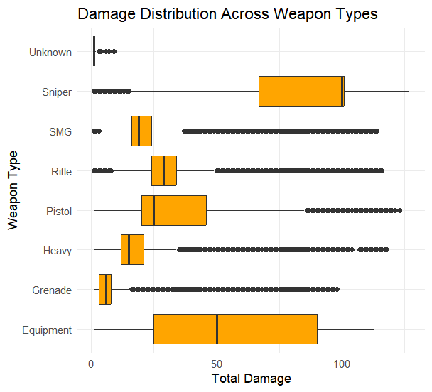
Fig. 3. Distribution of total damage by weapon type.
The weapon-type boxplots (Fig. 3, Table 5) confirm that weapon class largely determines the damage scale. Sniper rifles have a median near 100 and a narrow upper quartile at the cap, while grenades have a median near 6. Pistols have an unusually wide spread, consistent with large variation between weapons in that class, and equipment (which can include melee and taser damage) is the most dispersed. Every class has a long upper tail of outliers except snipers, which are compressed against the maximum.
Table 5. Approximate median and interquartile range of total damage by weapon type (read from Fig. 3).
Weapon type | Median | Interquartile range
Sniper | ≈ 100 | ≈ 67 – 100
Equipment | ≈ 50 | ≈ 25 – 90
Rifle | ≈ 29 | ≈ 24 – 34
Pistol | ≈ 25 | ≈ 20 – 46
SMG | ≈ 19 | ≈ 16 – 24
Heavy | ≈ 15 | ≈ 12 – 21
Grenade | ≈ 6 | ≈ 3 – 8
Unknown | ≈ 1 | very narrow

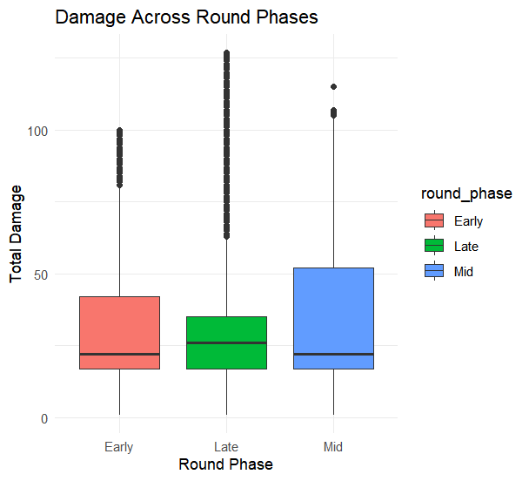
Fig. 4. Total damage by round phase in the exploratory stage (early < 60 s, mid < 120 s, late otherwise).
Round phase has little effect on typical damage (Fig. 4). Medians are close to 22 in the early and mid phases and about 26 in the late phase, although the upper quartile is higher in the mid phase (about 52) than in the early (about 42) or late phase (about 35), and the late phase contains the most extreme values. Note that the exploratory plot used 60 s and 120 s cut-offs, whereas the modelling stage uses finer 20 s and 60 s cut-offs; the two phase definitions are not interchangeable.
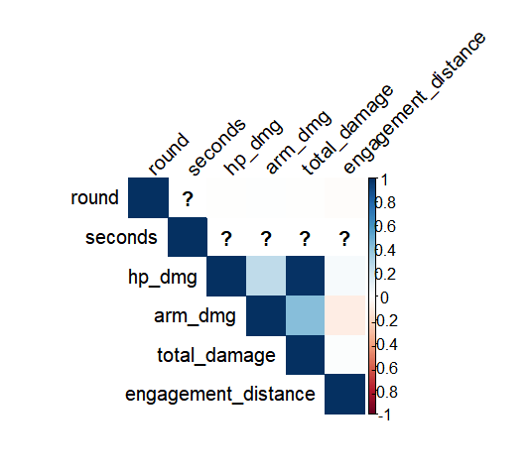
Fig. 5. Pearson correlation matrix of numeric variables (upper triangle).
The correlation matrix (Fig. 5) shows the expected structural relationships: total damage is almost perfectly correlated with health damage because it contains it, and moderately correlated with armor damage, while health and armor damage are only weakly positively correlated. Engagement distance is close to uncorrelated with every damage variable, with a slight negative association with armor damage. This weak linear association does not imply that distance is unimportant: its effect is weapon-specific and non-linear, which a tree ensemble can represent but a single correlation coefficient cannot. The cells for round and seconds are displayed as undefined (question marks), which indicates missing values in those columns when the correlation was computed without handling missing data; the modelling stage removes events without a time value, but this should be verified for the exploratory file.
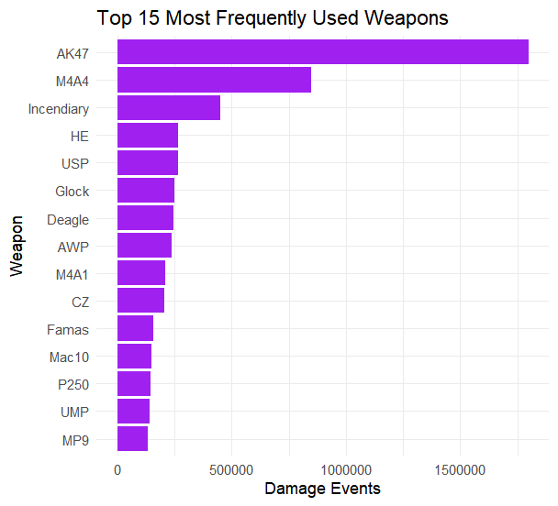
Fig. 6. The 15 most frequent weapons by number of damage events.

B. Predictive Performance (RQ2)
Table 6 reports the held-out test performance of the xD model. The values are produced by pipeline.R and written to metrics.json; they must be copied into the table from that file after the pipeline has been run on the full dataset.
Table 6. Test-set performance of the xD model (values from metrics.json).
Quantity | Value
Matches (total / train / validation / test) | [n_matches / train / val / test]
Events (train / validation / test) | [train_rows / val_rows / test_rows]
Best boosting iteration | [best_iteration]
MAE (damage points) | [mae]
RMSE (damage points) | [rmse]
R² | [r2]
Residual percentiles (5 / 25 / 50 / 75 / 95) | [residual_percentiles]

Two points should guide interpretation of these numbers. First, because the damage of an event is largely set by the weapon and hit location, a high R² is expected and should not be read as tactical insight; the informative quantity is the residual. Second, a useful context for the MAE is a trivial baseline that predicts the mean damage of each weapon and hitbox combination, which can be computed from the same split and reported alongside the XGBoost result [optional: add baseline MAE].

C. Spatial Diagnostics (RQ3)
For every map present in the inference cache, heatmaps.R writes four single-panel images (xD, actual damage, residual and density) and a 2×2 panel, using the radar overlay when available. Fig. 7 shows the layout of the panel; the rendered image for the chosen maps is to be inserted from the output folder.
[Insert Fig. 7 here: output/<map>_panel.png, e.g., de_dust2_panel.png (xD, actual, difference, density)]
Fig. 7. Expected damage, actual damage, residual (actual − xD) and event density for a selected map.
Table 7 summarises how the four layers are read together. These are interpretation rules for the figure and hypotheses about causes, to be confirmed or revised once the maps have been inspected.
Table 7. Reading guide for the spatial layers.
Pattern | Meaning | Candidate explanations to test
High xD, high density | Frequent fights where the context predicts heavy damage. | Rifle-dominated lanes and common hit locations.
Positive residual (warm) | Realised damage exceeds the feature-based expectation. | Unarmored victims, headshot-prone angles, multi-hit sprays, damage not captured by the features.
Negative residual (cool) | Realised damage falls below expectation. | Armored or helmeted victims, damage capped by remaining health, wall penetration, long-range falloff.
Near-zero residual | Context explains the damage. | Typical engagements for the weapon and range.
Low density | Few events, so the mean is unreliable. | Treat cell-level residuals as noisy; consider a minimum-count filter.

VI. DISCUSSION

A. Interpretation
The exploratory results show a dataset dominated by rifle fire at the torso and head, with damage clustered at the characteristic values of a few weapon-and-hitbox combinations. A model that sees weapon, class and hitbox therefore approximates the game's own damage rules, and xD in this sense is a context baseline: it says what damage a typical event of this kind delivers. The value of the construction lies in the second step, comparing the realised damage with that baseline and looking at where, on the map, the two diverge. This mirrors the xG logic of judging execution against expectation [3], [4], but applied to a continuous outcome and to location rather than only to players.

B. Relation to Prior Work
Compared with action valuation based on round win probability [1], xD is much cheaper: it needs only the damage log and one row of context per event, not a reconstruction of the whole game state, and it can be trained on a laptop within the time reported in the pipeline script. The price is that xD values damage, not its consequence for the round; an event that deals 30 damage is valued the same whether or not it decides the round. Compared with plus/minus ratings [2], [16], xD is descriptive of single events and is not a measure of a player's contribution to winning.

C. Limitations and Threats to Validity
- Near-deterministic target. Damage is mostly a function of weapon and hit location, so overall fit metrics overstate how much tactical information the model has learned. The residual and the baseline comparison matter more than R².
- Unobserved context. The feature set omits victim armor and helmet state, victim remaining health, vertical distance and wall penetration. Each of these changes the damage of a hit and therefore ends up in the residual, so residual maps cannot be attributed to player skill without further controls.
- Planar distance. Distance is computed from the horizontal coordinates only, which underestimates the true range on multi-level maps.
- No map feature. Raw coordinates are used as inputs while the map identity is not, so identical coordinates on different maps are indistinguishable to the model. Adding the map as a categorical feature, or training per map, would remove this ambiguity.
- Encoding. Label encoding of categorical variables imposes an arbitrary order; native categorical support or one-hot encoding would be cleaner.
- Sample and population. Only one part file of the collection is analysed, from third-party matchmaking games under legacy game versions, so the findings may not transfer to professional play or to newer versions of the game.
- Evaluation scope. Only one learner is evaluated. The planned comparison with logistic regression and random forests [18] has not been run, and exploratory plots use different round-phase thresholds and filters from the modelling stage.
- Privacy. Player identifiers are dropped in the exploratory stage but retained in the inference cache for player-level aggregation; they should be anonymised before any release of derived data.

VII. CONCLUSION AND FUTURE WORK
This paper introduced expected damage (xD) for CS:GO combat telemetry and presented a leakage-aware R pipeline that trains an XGBoost regressor on match-level splits, scores every damage event, and visualises expected damage, actual damage, residual and density on per-map heatmaps. Exploratory analysis of roughly six million events characterised the dominance of rifles and torso hits and the multimodal damage distribution, and the framework provides a transparent route from event-level expectations to spatial tactical diagnostics. The principal caveats are that damage is largely determined by weapon and hit location and that important context, such as victim armor and health, is not observed.
Future work follows directly from these limitations. (1) Add victim armor, helmet and health, vertical distance and the map identity to the feature set. (2) Benchmark against a per-weapon-and-hitbox baseline, logistic regression and random forests [18]. (3) Move from damage to outcome by predicting engagement win probability and kill probability, with the summed xD of an engagement as an input, which leads to the expected-kills (xK) model that the project aims at. (4) Explain the model with Shapley-value attributions [21] and evaluate calibration and robustness under time-based splits. (5) Extend the analysis to the remaining part files and to the grenade and kill event tables.

REFERENCES
[1] P. Xenopoulos, H. Doraiswamy, and C. Silva, "Valuing player actions in Counter-Strike: Global Offensive," in Proc. IEEE Int. Conf. Big Data, 2020, pp. 1283–1292.
[2] H. Xu and S. Moka, "Rating players of Counter-Strike: Global Offensive based on plus/minus value," arXiv:2409.05052, 2024.
[3] A. Rathke, "An examination of expected goals and shot efficiency in soccer," J. Hum. Sport Exerc., vol. 12, no. 2proc, pp. S514–S529, 2017, doi: 10.14198/jhse.2017.12.Proc2.05.
[4] G. Anzer and P. Bauer, "A goal scoring probability model for shots based on synchronized positional and event data in football (soccer)," Front. Sports Act. Living, vol. 3, Art. no. 624475, Mar. 2021, doi: 10.3389/fspor.2021.624475.
[5] "CS:GO competitive matchmaking data," Kaggle. [Online]. Available: https://www.kaggle.com/datasets/skihikingkevin/csgo-matchmaking-damage (accessed Oct. 3, 2026).
[6] T. Chen and C. Guestrin, "XGBoost: A scalable tree boosting system," in Proc. 22nd ACM SIGKDD Int. Conf. Knowl. Discovery Data Mining, San Francisco, CA, USA, 2016, pp. 785–794.
[7] I. Makarov, D. Savostyanov, B. Litvyakov, and D. I. Ignatov, "Predicting winning team and probabilistic ratings in 'Dota 2' and 'Counter-Strike: Global Offensive' video games," in Analysis of Images, Social Networks and Texts (AIST 2017). Cham, Switzerland: Springer, 2018, pp. 183–196.
[8] D. Bednárek, F. Zavoral, and J. Yaghob, "Data preprocessing of esport game records—Counter-Strike: Global Offensive," in Proc. 6th Int. Conf. Data Sci., Technol. Appl. (DATA), Madrid, Spain, 2017, pp. 269–276.
[9] T. Wright, E. Boria, and P. Breidenbach, "Creative player actions in FPS online video games: Playing Counter-Strike," Game Studies, vol. 2, no. 2, Dec. 2002.
[10] M. Fanourakis and G. Chanel, "AMuCS: Affective multimodal Counter-Strike video game dataset," Sci. Data, 2025. [add volume / article number]
[11] V. J. Hodge, S. Devlin, N. Sephton, F. Block, P. Cowling, and A. Drachen, "Win prediction in multi-player esports: Live professional match prediction," IEEE Trans. Games, vol. 13, no. 4, pp. 368–379, Dec. 2021.
[12] M. Schubert, A. Drachen, and T. Mahlmann, "Esports analytics through encounter detection," in Proc. 10th MIT Sloan Sports Anal. Conf., Boston, MA, USA, Mar. 2016.
[13] P. Lucey, A. Bialkowski, M. Monfort, P. Carr, and I. Matthews, "Quality vs quantity: Improved shot prediction in soccer using strategic features from spatiotemporal data," in Proc. 9th MIT Sloan Sports Anal. Conf., Boston, MA, USA, 2015.
[14] J. Fernández, L. Bornn, and D. Cervone, "A framework for the fine-grained evaluation of the instantaneous expected value of soccer possessions," Mach. Learn., vol. 110, no. 6, pp. 1389–1427, Jun. 2021, doi: 10.1007/s10994-021-05989-6.
[15] D. Cervone, A. D'Amour, L. Bornn, and K. Goldsberry, "A multiresolution stochastic process model for predicting basketball possession outcomes," J. Amer. Statist. Assoc., vol. 111, no. 514, pp. 585–599, 2016.
[16] L. M. Hvattum, "A comprehensive review of plus-minus ratings for evaluating individual players in team sports," Int. J. Comput. Sci. Sport, vol. 18, pp. 1–23, 2019.
[17] J. H. Friedman, "Greedy function approximation: A gradient boosting machine," Ann. Statist., vol. 29, no. 5, pp. 1189–1232, 2001.
[18] L. Breiman, "Random forests," Mach. Learn., vol. 45, no. 1, pp. 5–32, 2001.
[19] B. W. Silverman, Density Estimation for Statistics and Data Analysis. London, U.K.: Chapman & Hall, 1986.
[20] H. Wickham, ggplot2: Elegant Graphics for Data Analysis, 2nd ed. Cham, Switzerland: Springer, 2016.
[21] S. M. Lundberg and S.-I. Lee, "A unified approach to interpreting model predictions," in Proc. Adv. Neural Inf. Process. Syst. (NeurIPS), vol. 30, 2017, pp. 4765–4774.

