October 31, 2025
- Came up with an idea
  - I will be creating a program that will help people who are filming a movie/show. I got inspiration from the Kansas City Film Festival that took place earlier this year. Also, I have always had a fascination with the behind-the-scenes of filmmaking.
  - The program will be user-friendly, meaning I want it to be able to be used by groups ranging from a small number of people to a large-scale production.
  - It should be able to keep track of input personnel. These personnel will range from different types of workers (i.e., cameramen, lighting, makeup, costume, etc.), actors, extras, and volunteers.
  - The user should be able to enter whatever information they have into the program to keep track. Such as type of personnel, name, number, email, address, pay, date of recruitment, etc. Not all of the slots are mandatory, just type of personnel, name, and number/email (I think I might try to give them a choice of which they would prefer).
  - Let the user be able to choose which type of people they want sorted. This way would be easier for them to contact those they need for production at a specific time/date. It should show those types of personnel and their info (if I were more advanced, I would put a lock on the sensitive info and make the user confirm that they were of high status to be viewing the sensitive info)
  - The user should have the option to also type in a name to search for who they are looking for specifically. (Again, if I were more advanced, I would allow them to search using a number or email, etc.)
  - The user will be able to delete a person, too.

November 12, 2025
- Completed a full UML of my idea
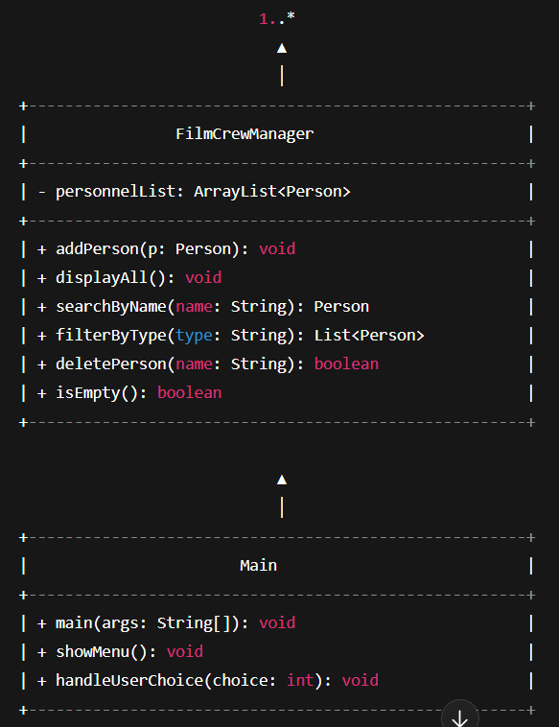
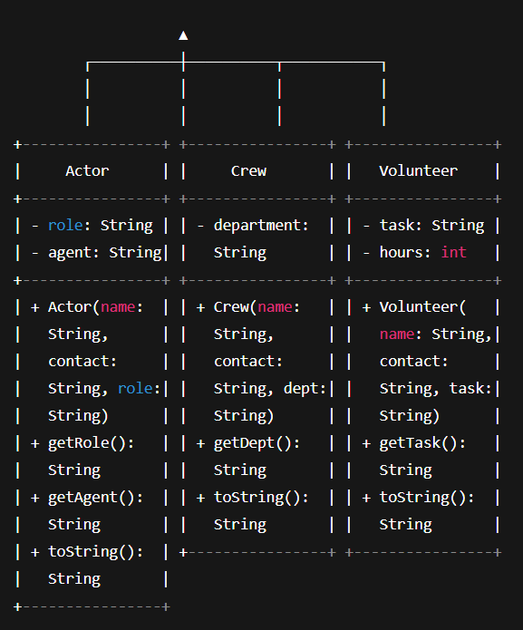
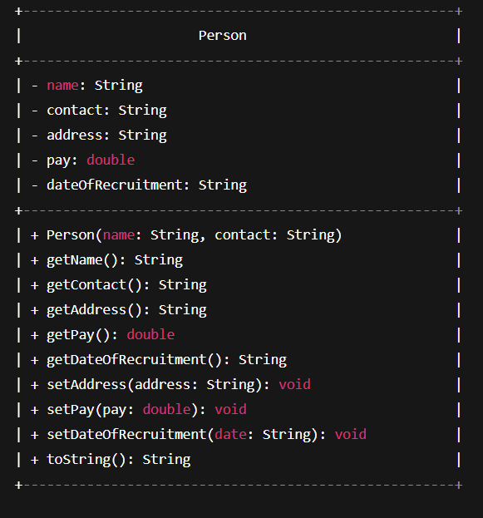
November 21, 2025
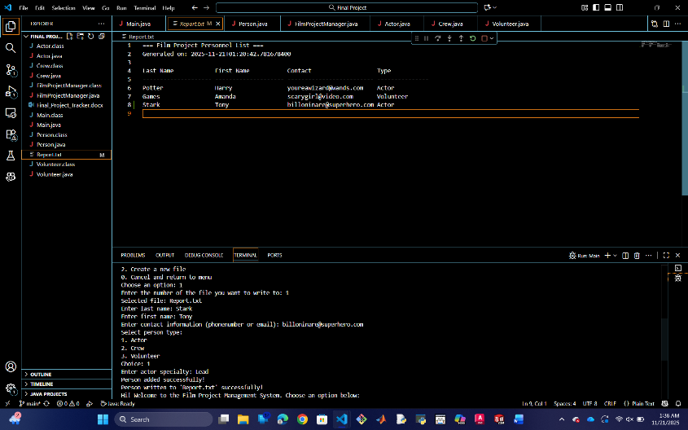
- Coded basic structure of file from UML
- Set up a menu with options
  - Add
  - Remove
  - Search
  - Display
  - File Management
  - Exit
- Only finished implementing the add method
- Able to create a new output file and keep track of them
- Pushed changes to GitHub

