Expertiment:
create a new Postgres Database and expose some API can be used to ”talk” with it. This API will be automatically generated and documented using Swagger and the safrs python package.

The docker compose:
The idea is to have only a docker-compose which will create and handle the maintenance of the database.
This docker-compose will create 3 different dockers. The first one is an instance of influxDB image used to store the request information coming from the FTP server.
The second one is a postgres database. This docker will create a postgres instance with a table called servers that will be used to store information about the running FTP servers.
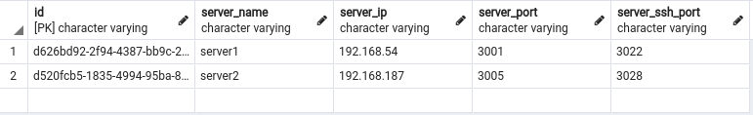Figure 1: Example of info stored in the servers' database
The third docker is a Flask application listening on port 5000 (mapped in the docker-compose file with port 4327). This Flask application allows us to interact with the database through some API automatically generated by the safrs package. There will be API for all the CRUD operation.
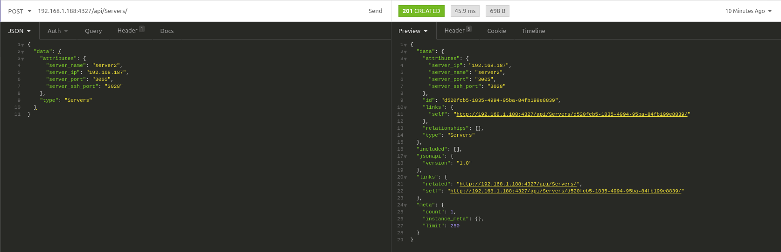Figure 2: Example of POST call used to add a new server to the database.
We can add new servers, get a specific server or a list of servers just by doing some GET or POST request to x.x.x.x:4327/api/Severs/

