DUCKY INTELLIGENCE
Character Design Reference
Animation Team Guide

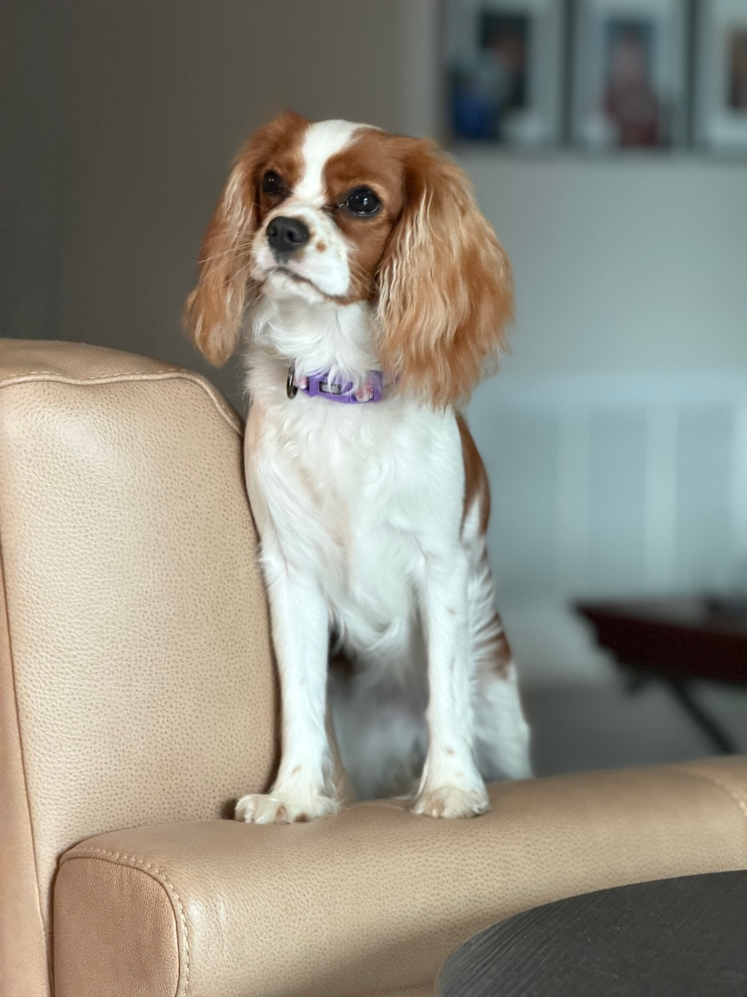

Document ID: CVG-DUCKY-CHARDESIGN-v1.0
Date: March 15, 2026
Owner: Cavaridge, LLC
All intellectual property contained herein is owned exclusively by Cavaridge, LLC.

1. Physical Characteristics

1.1 Breed & Pattern
Ducky is a Cavalier King Charles Spaniel with classic Blenheim coloring. Blenheim is defined by rich chestnut-brown patches on a pearlescent white base coat. The breed is characterized by a gentle, noble expression with large round eyes, long feathered ears, and a silky, moderately wavy coat.

1.2 Defining Features
Feature | Specification
Coat Base | Creamy pearl white (#FAF0E6) — not stark white
Coat Patches | Rich chestnut auburn (#A0522D base, #CD7F32 highlight in direct light)
Blaze | Well-defined white stripe centered between eyes, widening at forehead crown
Eyes | Large, round, deep warm brown (#3B2314). Primary expression vehicle. Always include specular highlight.
Ears | Long, feathered, fully chestnut. Drape below jawline. Silky texture with gentle wave. Physics-enabled for animation.
Nose | Near-black (#1A1A1A), well-defined, slightly moist appearance
Collar | Signature lavender/purple (#9370DB). Always present in standard renders. Floral embroidery detail on buckle.
Body | Petite, compact frame. Slightly exaggerated head-to-body ratio (1:2.5 vs realistic 1:3) for expressiveness.
Tail | Feathered plume; curves upward when happy/alert, rests low when calm/sleeping
Paws | Small, neat. White with occasional chestnut freckles. Front paws placed together when seated.

2. Key Reference Poses
The following photographs establish the canonical poses and expressions for each animation state. These are direct captures of the real Ducky and should be treated as the definitive reference for all character work.

Idle / Listening — Regal Seated Pose

IMG_1768 — Seated on chair arm. Chin up, ears relaxed, composed but attentive. This is the default Ducky state.

Eye Detail — Macro Reference
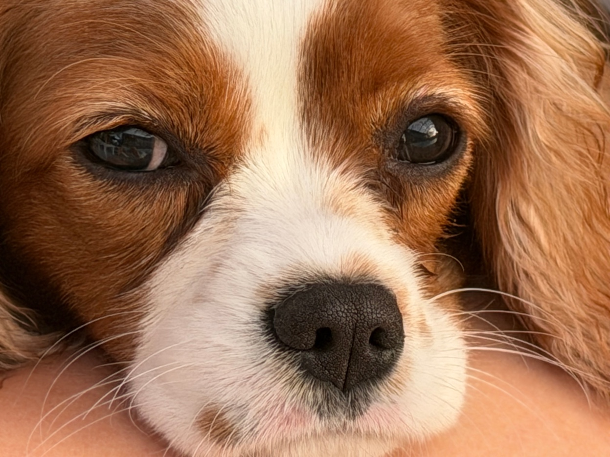
IMG_1399 — Extreme close-up. Note the depth of eye color, specular highlights, nose texture, and whisker placement.

Explaining / Teaching — Active Stride
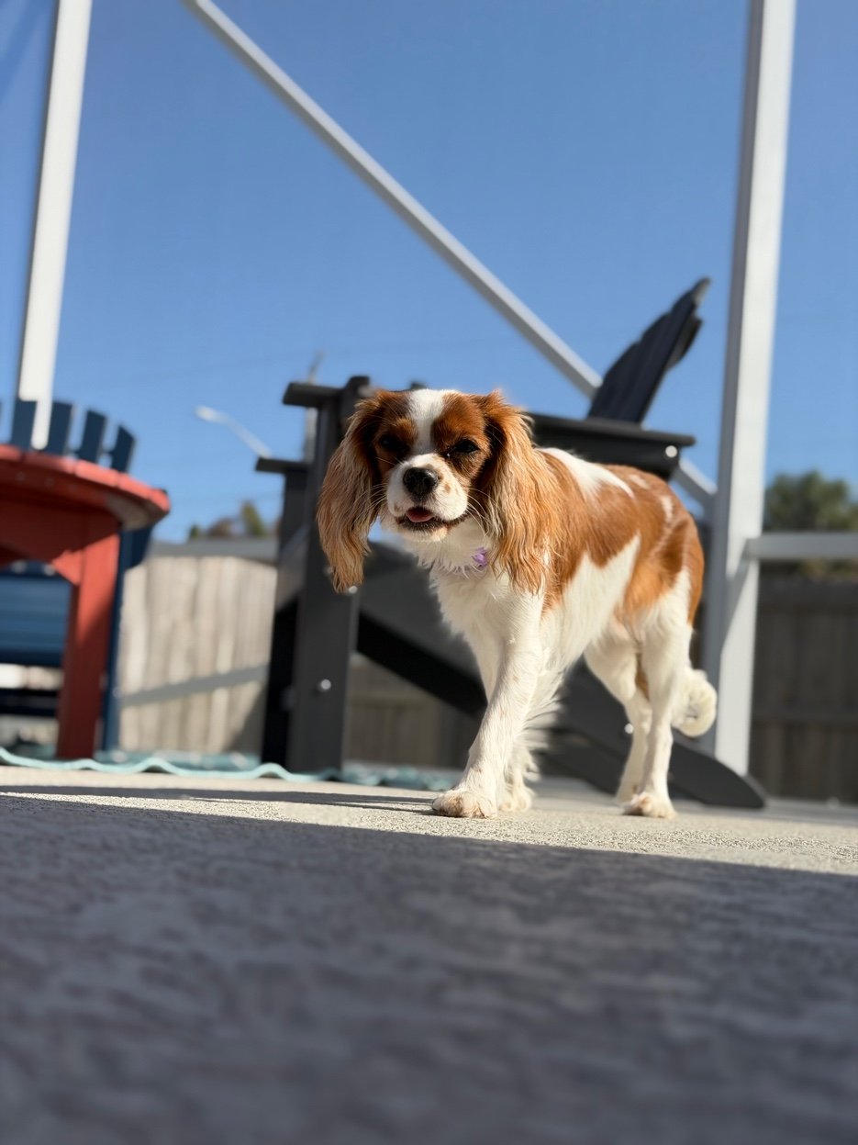
IMG_1931 — Walking toward camera on patio. Alert, mouth slightly open, confident stride. One paw lifted mid-step.

Empathetic / Supportive — Cozy Comfort
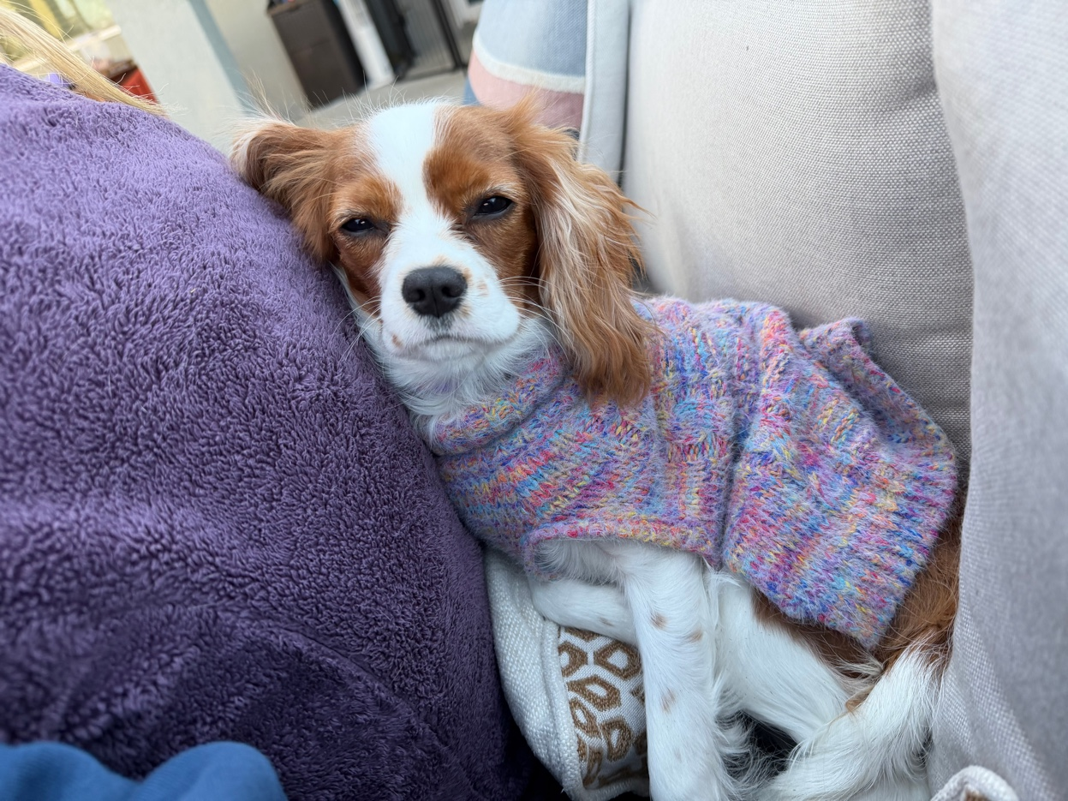
IMG_1508 — Nestled in multicolor knit sweater against purple pillow. Soft eyes, relaxed posture, gentle warmth.

Playful / Encouraging — Puppy Energy
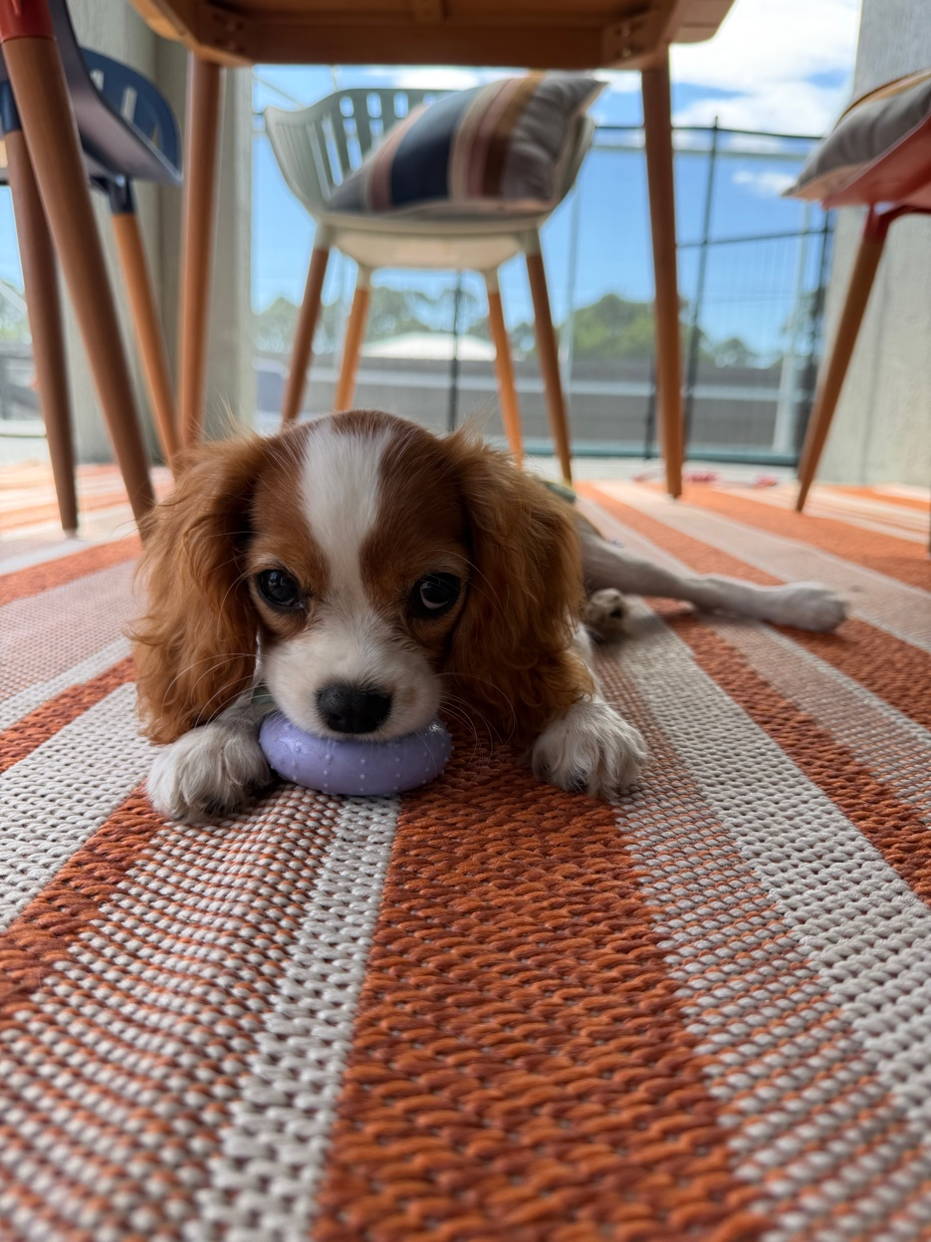
IMG_0664 — Under table with purple toy, chin on ground, wide eyes looking up. Pure playful puppy energy.

Sassy / Pushback — Direct Stare
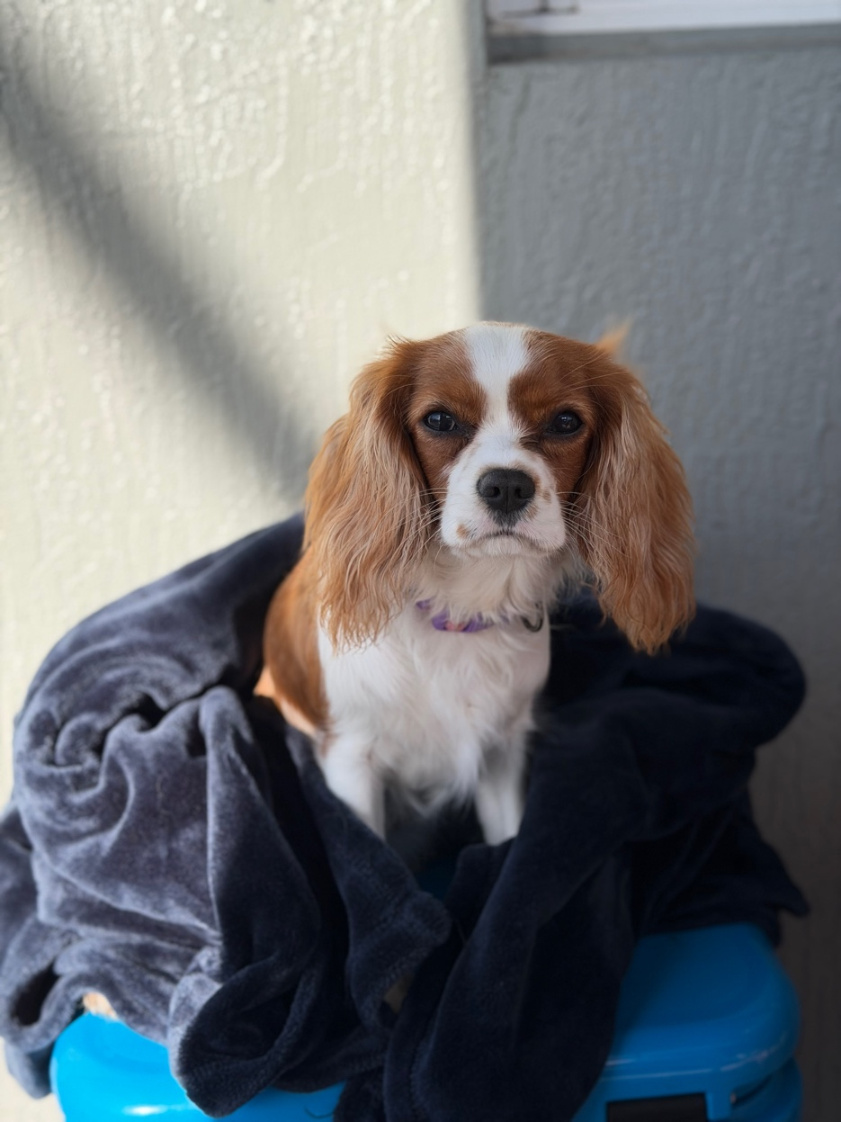
IMG_1634 — Wrapped in dark towel, sitting on blue cooler. Direct, unflinching gaze. "Are you sure about that?" energy.

3. Animation State Map
# | State | Visual | Loop | Ref Image
1 | Idle / Listening | Seated, gentle breathing, occasional blink | 3-4s loop | IMG_1768
2 | Thinking | Head tilt right, ears perk, eyes narrow | 2-3s loop | IMG_1599
3 | Happy / Success | Body wiggle, tail wag, open-mouth smile | 2s burst | IMG_1506
4 | Explaining | Paw raised, alert posture, direct gaze | Sync to content | IMG_1931
5 | Alert | Ears forward, upright, focused gaze | Hold until dismiss | IMG_0032
6 | Playful | Play bow, tongue out, bouncy | 3s loop | IMG_0664
7 | Empathetic | Soft eyes, head lowered, ears drooped | Slow transitions | IMG_1508
8 | Sleeping | Curled up, eyes closed, breathing | 8-10s loop | IMG_0694
9 | Sassy | Head tilt left, raised brow, direct stare | 1.5s expression | IMG_1634

4. Transition Rules
All state transitions use ease-in-out curves with 300-500ms duration. No hard cuts between states. Priority order: Alert and Empathetic override all other states (safety and support come first). Happy auto-decays to Idle after 4 seconds. Sassy auto-decays to Explaining after 2 seconds. Sleeping to any active state includes a wake-up sequence (eyes open, small stretch, ear shake). Ears and tail should have independent physics simulation layered on top of primary animations for natural secondary motion.

5. Official Color Palette
Element | Color Name | Hex | Usage
Chestnut Base | Sienna Auburn | #A0522D | Primary coat
Chestnut Highlight | Warm Copper | #CD7F32 | Sunlit areas
White Coat | Pearl Linen | #FAF0E6 | Base coat
Eyes | Deep Walnut | #3B2314 | Iris fill
Eye Highlight | Amber Glow | #C8A882 | Specular
Nose | Near Black | #1A1A1A | Nose leather
Collar | Ducky Purple | #9370DB | Signature
Inner Ear | Rose Blush | #E8B4B8 | Ear interior

All intellectual property contained in this document is owned exclusively by Cavaridge, LLC.

