Turlington Turmoil
Instruction Manual



Table of Content:
Game Summary:…………………………………………………………….…………2
Startup:…………………………………………………………………………………3
Implementation/ procedures:……………………………………………………….......3
a. Start/ stop……………………………………………………………………3
b. Controls……………………………………………………………………...3
c. Display……………………………………………………………………….3
Finishing:……………………………………………………………………………….4

Game Summary
Turlington Turmoil is a game representation of the congestion in the Turlington area on campus. The user is an orange and blue skateboarder who has to zigzag through the oncoming walkers and bikers. Watch out, because every now and then you will encounter a super fan, a.k.a. a Gator. The objective of level one is to reach the left side of the screen from the right side as many times as possible, within thirty seconds, without touching or invading the personal space of oncoming traffic. If the user does come in contact with the traffic, the skateboarder returns the far right of the screen. Every time the user makes it to the left side of the screen he/she gains one point and is placed back on the right side. Level two incases the same parameters, expect the on traffic increases there speed by a multiple of two.
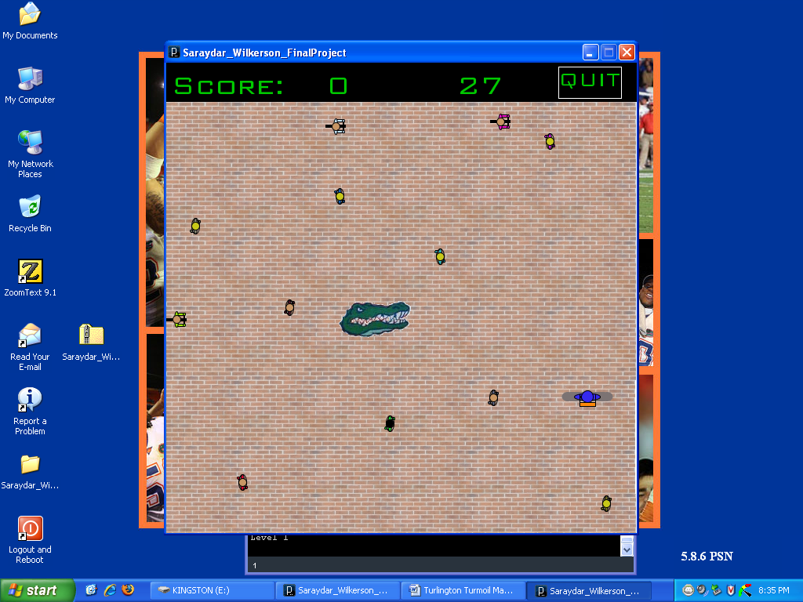

Startup
- Open processing from the start menu found at the left bottom of the screen
  - Processing should be located under the program table
  - Incase processing is not installed please ask the teacher for assistance

- Check to see of the folder labeled “FinalProject” is on the desktop

- Go to file open-desktop- “FinalProject”- final project

  - If the file is not there, ask for assistance.

- Click the play/ run button to begin

Implementation and Procedures
- Start / Stop menu
  - Using the mouse, decide the level you would like to play “Level 1” or “Level 2”.
    - The level lights up when the user passes over the text with the mouse
  - The timer starts immediately after clicking so be ready.
  - To Quit from the start menu click the “Quit” text
    - The user is taken to the end game screen and the program haults
- Controls:
  - UP arrow moves the skateboarder up the screen
  - DOWN arrow moves the skateboarder down the screen
  - LEFT arrow moves the skateboarder to the left of the screen
  - RIGHT arrow moves the skateboarder to the right of the screen
  - The mouse only functions as a way to get to the quit box, located at the top right Corner (stopping the game with the options to play again or not)
- Display:
  - The Score will display at the top left corner of the screen (scoring details see game summary)
  - The timer is a digital countdown starting at 30 to reach 0
  - Quit is located at the top left corner of the screen (highlighted text interaction)

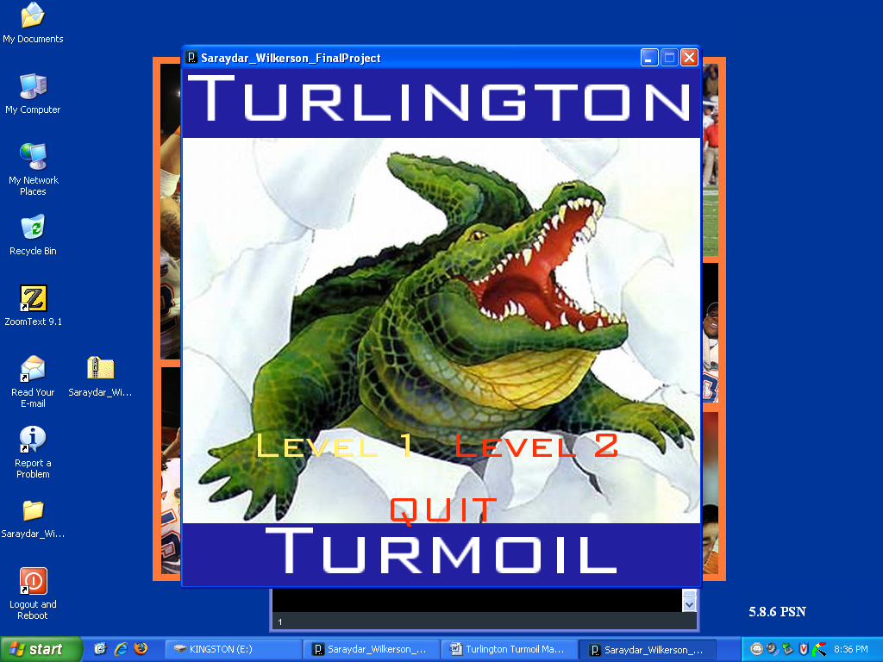
Finishing
Once the timer has either reached 0 or the user clicks the quit button, a screen will appear over the game screen asking of the user would like to play again and displaying their final score. If the user presses the Y key the game will return to the initial menu screen so the user can pick the level they would like to play. If the user presses the N key, the game will display “Peace out” and the game will stop running. Thank you for Playing Turlington Turmoil! 